

BH - 01

Journey through Bhutan – Land of the Thunder Dragon !
Paro – Thimpu - Paro

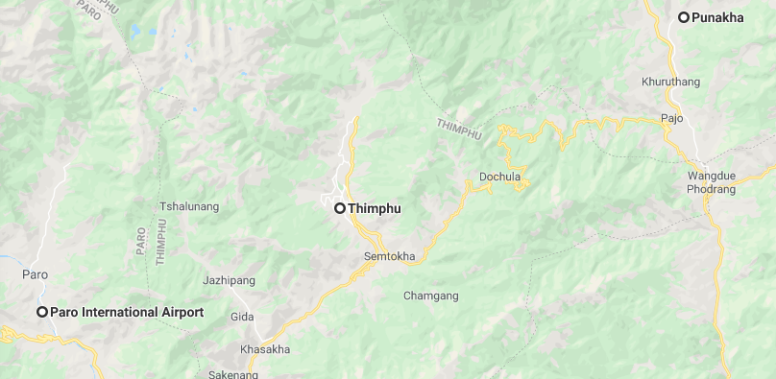

Overview: A travel through Bhutan take you through the spectacular mountain terrain, varied flora and fauna and its unique ancient Buddhist monasteries.

Highlights: Culture
- Explore the cities of Paro and Thimpu
- Visit to the monasteries and
- Hike to Tigers Nest
- Hot stone bath

Day 1: Arrive Paro – Thimupu

Fly into Paro where you will be received by your Travel Counsellor Representative, who will transfer you to to Thimphu (55km, approx. 1.1/2-hour drive) (Altitude 2,320 m)

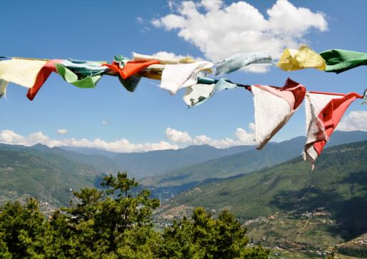
The flight to Paro is one of the most spectacular in entire Himalayas. Whether flying along the Himalayan range from Kathmandu or over the foothills from Kolkatta, the journey offers fascinating views and an exciting descent into the Kingdom. Bhutan’s first gift as you disembark from the aircraft will be cool, clean fresh mountain air. After immigration formalities and baggage collection, you will be met by our representative, and afterwards drive to Thimphu, the capital town of Bhutan with en-route stop at Chuzom, the confluence of Thimphu and Paro rivers. Three different style of stupas; Tibetan, Nepalese and Bhutanese adorn this confluence.

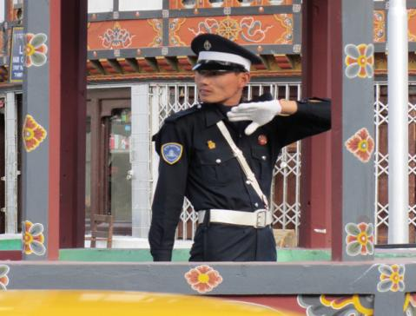
On arrival, in Thimphu check-into the hotel. The capital town of Bhutan and the centre of government, religion and commerce, Thimphu is a unique city with unusual mixture of modern development alongside ancient traditions. With the population of about 1,00,000 it is perhaps still the world’s only capital city without a traffic light.

Later visit Trashichhoedzong, ‘fortress of the glorious religion’. This is the center of government and religion, site of monarch’s throne room and seat of Je Khenpo or Chief Abbot. Built in 1641 by the political and religious unifier of Bhutan, Shabdrung Ngawang Namgyal, it was reconstructed in 1960s in traditional Bhutanese manner, without nails or architectural plans.

Evening an exploratory walk around Thimphu main street and market area.

Day 2: Thimupu

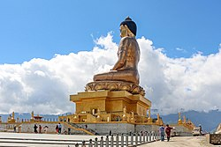
After breakfast, drive to Buddha Point (Kuensel Phodrang). Located at a short drive from Thimphu city centre, visitors can get a good overview of the Thimphu valley from the Buddha point (Kuensel Phodrang). You can pay your obeisance and offer prayers to the Buddha, the largest statue in the country and then walk around and take a glimpse of the valley.

Then, visit King's Memorial Chorten continuously circumambulated by people, murmuring mantras and spinning their prayer wheels. Construction of this landmark was the idea of Bhutan’s third king, His Majesty Jigme Dorji Wangchuk (“the father of modern Bhutan”) who has wished to erect monument to world peace and prosperity. Completed in 1974 after his untimely death, it serves both as a memorial to the Late King and as a monument to peace.

Textile Museum (closed on Government Holidays) next in schedule is worth a visit to experience the living national art of weaving. Exhibitions introduce the major weaving techniques, styles of local dress and textiles made by women and men.

Post lunch visit Folk Heritage Museum (closed on Government holidays). This Museum is dedicated to connecting people with the rich Bhutanese Folk heritage and rural history through exhibits, demonstrations, educational programs and documentation of Bhutanese rural life.
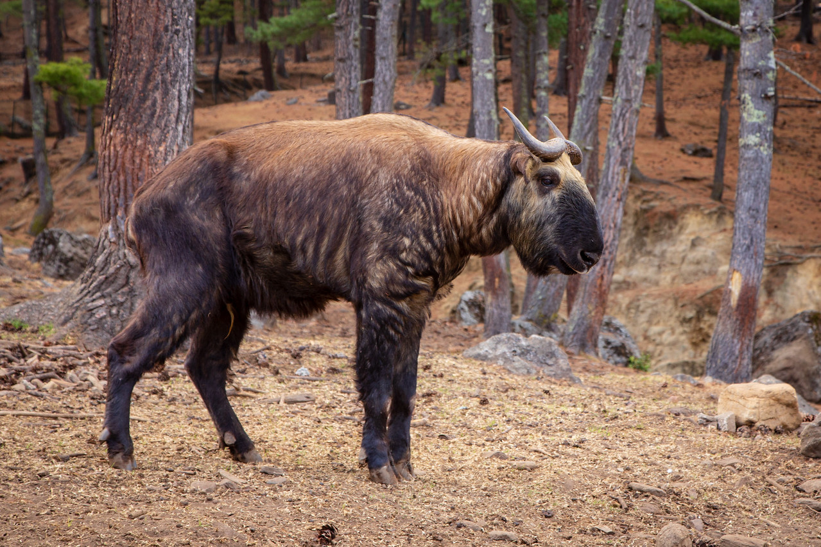
Later visit Institute for Zorig Chusum, commonly known as Arts & Crafts School or Painting School, the Institute offers a six-year course on the 13 traditional arts and crafts of Bhutan. On a visit, one can see students learning the various skills taught at the school.

Then, drive to Takin Preserve. The Takin is national animal of Bhutan and looks like a cross between a cow and goat.

Evening time can be spent strolling through the government-run Handicrafts Emporium and local crafts bazaar, to browse through example of Bhutan's fine traditional arts. Here you can buy hand-woven textiles, thangkha paintings, masks, ceramics, slate and wood carvings, jewelry, interesting items made from local materials.

Day 3: Thimupu – Paro

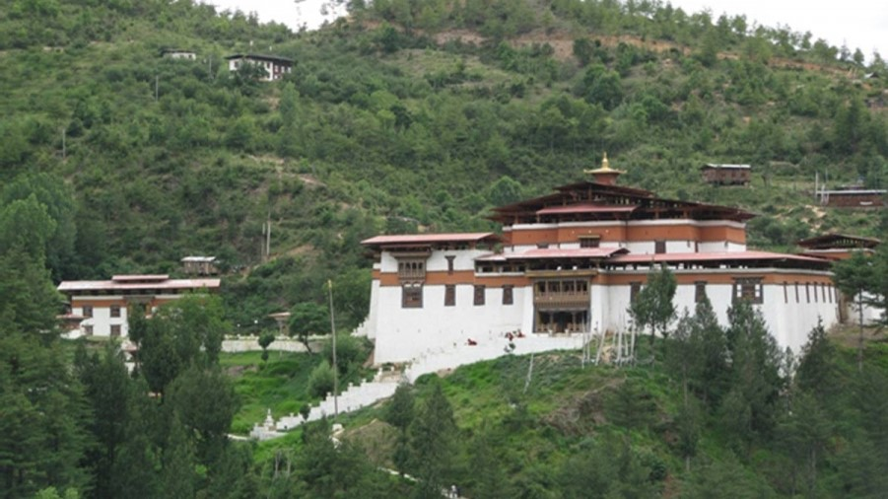
After breakfast return to Paro with a stop enroute at Simtokha Dzong, one of the oldest fortresses of the country and known as the place of profound tantric teaching. This dzong now houses a school for the study of the Dzongkha language.

Later in the day after checking into hotel, proceed to visit Ta Dzong, (closed on Government holidays) originally built as Watchtower, which now houses National Museum. The extensive collection includes antique thangkha paintings, textiles, weapons & armour, household objects and a rich assortment of natural and historic artifacts.

Then walk down the trail to visit Rinpung Dzong, meaning (“fortress of the heap of jewels”), which has a long and fascinating history. Along the wooden galleries lining the inner courtyard are fine wall paintings illustrating Buddhist lore such as four friends, the old man of long life, the wheel of life, scenes from the life of Milarepa, Mount. Sumeru and another cosmic Mandala.

Day 4: Paro

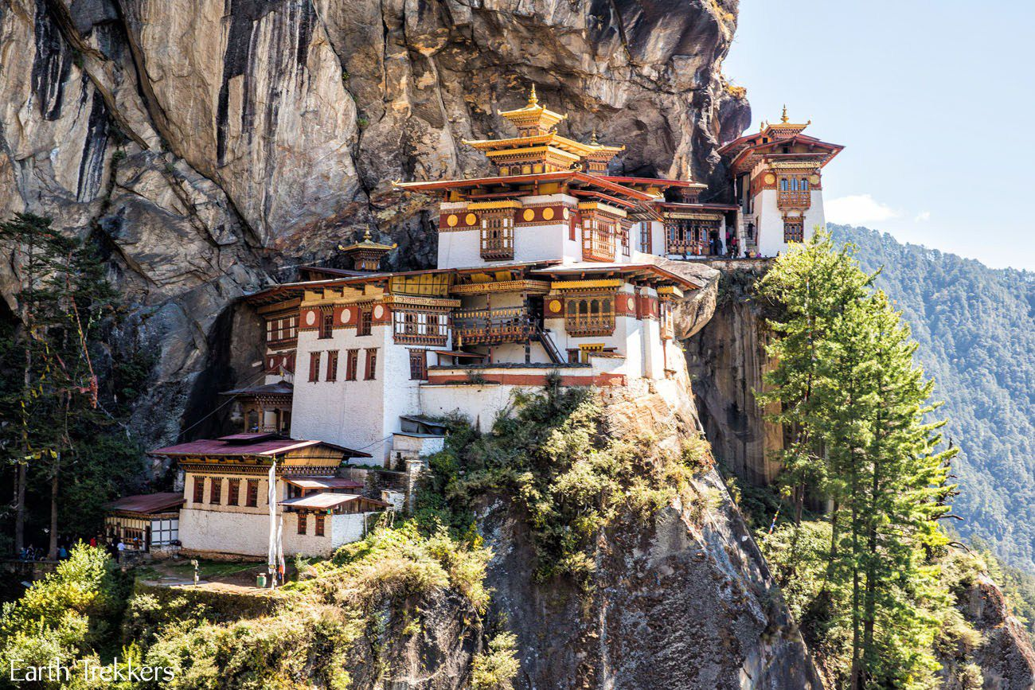
After breakfast excursion to Taktshang Monastery (approx.. 5 hours round trip walk). It is one of the most famous of Bhutan’s monasteries, perched on the side of a cliff 900m above the Paro valley floor. It is said that Guru Rinpoche arrived here on the back of a tigress and meditated at this monastery and hence it is called ‘Tiger’s Nest’. This site has been recognized as a most sacred place and visited by Shabdrung Ngawang Namgyal in 1646 and now visited by all Bhutanese at least once in their lifetime.

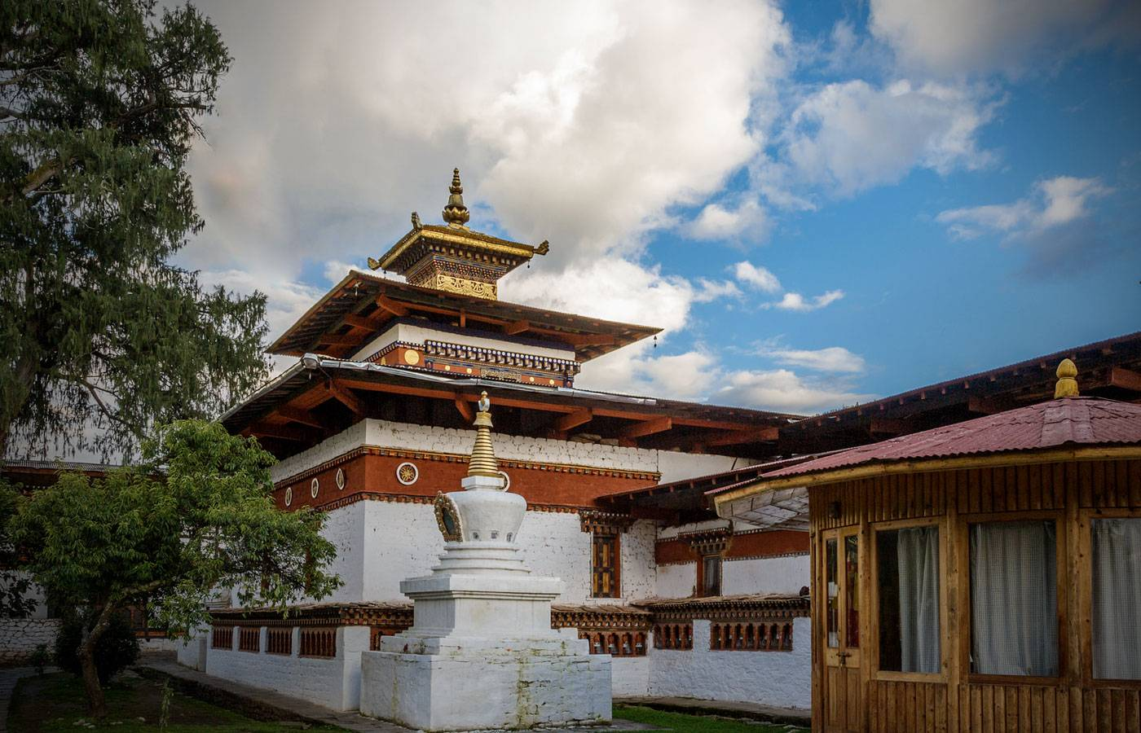
Late afternoon, drive end of the Valley to the base of Drukgyel Dzong, a 17th century fortress burned down in the early 50s. Here we will also see the beautiful typical farmhouse. Bhutanese farmhouses are very colorful, decorative and traditionally built without the use of single nail. The majority of the population of Bhutan continues to live as it has for centuries – in small isolated farms and hamlets, surrounded by terraced fields of rice, maize and buckwheat.

While driving to Paro town, stop en route at the 7th century Kyichu Lhakhang, one of the 108 temples built in the Himalayas by Tibetan King, Songtsen Gampo. The building of this temple marks the introduction of Buddhism in Bhutan.

Day 5: Paro - Departure

At an appropriate time, your Travel Counsellor Representative will assist and transfer you to the airport for the onward flight.

