

The Golden Triangle – 07 Days
Delhi - Agra – Jaipur – Delhi
07 Days / 06 Nights
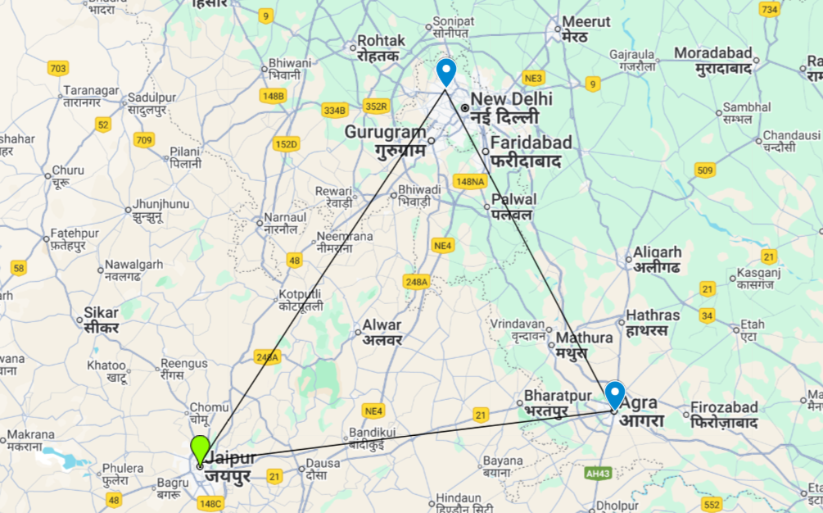
Golden Triangle
This is the classic cultural tour of North India combining New Delhi, Agra and Jaipur (the so-called ‘Golden Triangle’) with a short detour to Ranthambore National Park.
New Delhi, the national capital, offers several key sights and historic monuments while Agra is synonymous with the Taj Mahal – a high-point of Mughal architecture and one of the world’s most celebrated buildings, Rajasthan’s state capital, boasts some of the region’s finest palaces and impressive forts along with an eclectic array of crafts and shopping.

Introduction

Accommodation | Destination | Start | End | Meal Plan | Room Type | Duration
The Lalit New Delhi | New Delhi | Day 01 | Day 03 | BB | Deluxe Room | 02 Night
Courtyard Marriott | Agra | Day 03 | Day 04 | BB | Deluxe Room | 01 Night
Hilton Jaipur | Jaipur | Day 04 | Day 06 | BB | Guest Room | 02 Nights
Vivanta Dwarka | New Delhi | Day 06 | Day 07 | BB | Superior Room | 01 Night

Day 01: Arrival Delhi

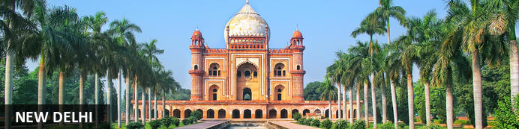
New Delhi, India’s national capital, is a relatively modern confection of imposing government buildings including Parliament, museums and wide leafy boulevards loosely centred on circular Connaught Place (officially now called Rajiv Chowk). To its north lies the formerly walled city of Old Delhi, or Shahjahanabad, built in the 17th-century by the Mughal Emperor Shah Jahan. Though long merged into one metropolis, the two have very different characters. New Delhi has space, parks, distinct neighbourhoods and a clutch of important monuments and architecture that reflect its ancient history. Old Delhi’s crowded streets, lanes and bazaars reflect its colourful medieval character and they cradle some of the city’s most memorable sights.

Day Itinerary
Flight TBA
Arrives Delhi TBA
On arrival in Delhi: Having cleared immigration, collected your luggage and passed through customs, please make your way towards the exit of the terminal building where you will see a bank of people waiting. Amongst them will be Travel Counsellors Representative who will be waiting to greet you with a paging board with your name on.
You will then be transferred to your hotel and assisted with check in.

Overnight: The LaLiT New Delhi
Offering five-star accommodation, The LaLiT New Delhi is located in Connaught Place, India. The hotel boasts 461 luxury rooms and suites with conveniences such as minibars/fridges, electronic safes, TVs, interactive entertainment systems and free Wi-Fi. Guests can delight their palates at an array of on-site restaurants. The hotel also features a spa, an art gallery, a state-of-the-art gym and a swimming pool.
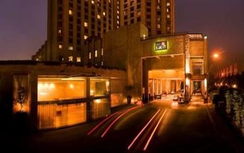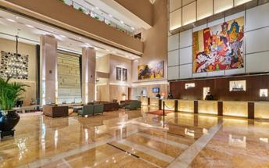

Day 02: Delhi

Day Itinerary
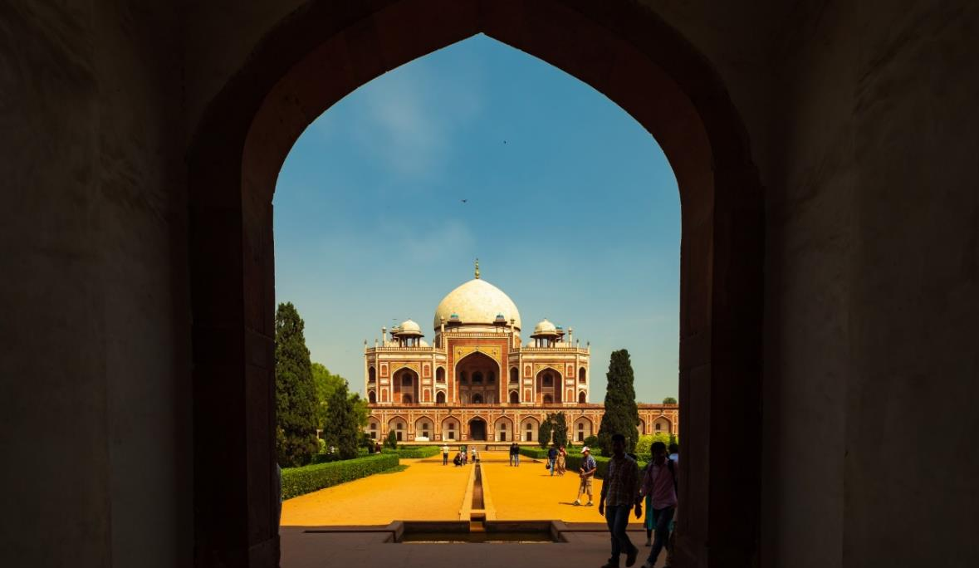
Breakfast at Hotel.
Today proceed for The Five Senses Delhi Tour
A sensory journey through Delhi covering everything from its food, local arts and crafts, the must-see architectural marvels, to expertly navigating and allowing you to witness the organized cultural chaos that is Delhi.
USP - Delhi 101: A complete tour of Old and New Delhi! We’ve carefully curated a selection of experiences that will transport you across Delhi’s rich cultural history. Experience for yourself the syncretism that has served as both Delhi’s greatest strength and vulnerability.
There isn’t a dearth of iconic sightseeing locations in the city, but for this tour, we focus on the two most beloved monuments that became inspirations or templates for all the other beautiful heritage structures. Humayun’s tomb, a spellbinding mausoleum is a favourite for any Delhiite! Your visit will be followed by a heritage craft workshop organised by an all-women NGO group that will touch your heart. Next, take a rickshaw ride through Shahjahanabad. Chaos thrives in the streets of Chandni Chowk, but as you cycle down, you’re transported by the magic in the air to the thriving Mughal era.
Next, you will indulge your sense of smell with an Ittar or perfume-making workshop. Visit an 8th-generation Ittar studio where you will get to smell and mix your unique concoction that can be named after you!
We’ll quickly stop to snack on some mouth-watering street food before proceeding to witness the glory and quietness of the Jama Masjid: a beautiful pocket of calm at the heart of Old Delhi's mayhem.

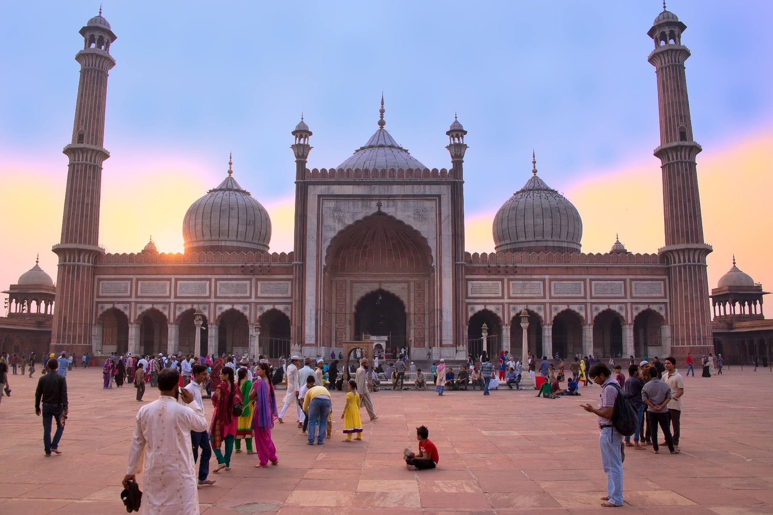
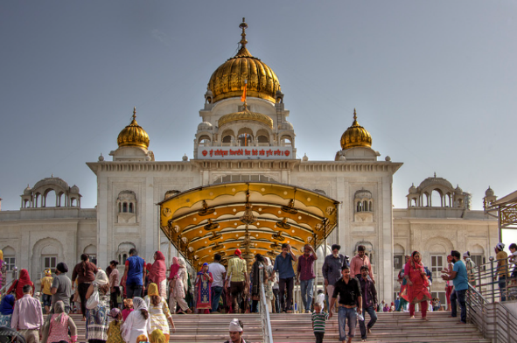
To engage your sense of sound, we bring you to Bangla Sahib. The magic of seva (selfless service) that the Gurudwara envelopes you into is undeniable. What ties together this beautiful experience is the sweet sound of the Gurbani playing in the background. Next, head to calm your favourite sense - taste! You will enjoy a meal at a contemporary Indian restaurant!
Before going back to the hotel, on the way, we show you the parts of Delhi with British influence and talk about the architectural contrast as well as some interesting stories from that time!

Day 03: Delhi - Agra

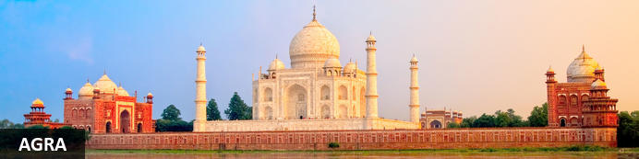
Straddling the broad Yamuna River 180km south of Delhi, Agra’s fame rests almost entirely on one building – the iconic Taj Mahal. Yet from the early 16th-century it was the Mughal empire’s capital endowed with numerous buildings and monuments that still make it a major draw for visitors. Apart from the Taj, Agra Fort (with its strong resemblance to Delhi’s Red Fort), the exquisite Tomb of Itmad-ud-Dalah (often called the ‘Baby Taj’), earthy bazaars and the evocative ‘ghost city’ of Fatehpur Sikri 40km to the west all make it a key tourist destination.

Day Itinerary
Early morning in time you will be picked up and transferred to railway station, board train to Agra. Packed breakfast can be collected from the hotel on departure.

Train Gatimaan Express (AC Executive Chair Car)
Depart Delhi 0810 Hrs
Arrive Agra 0950 Hrs.

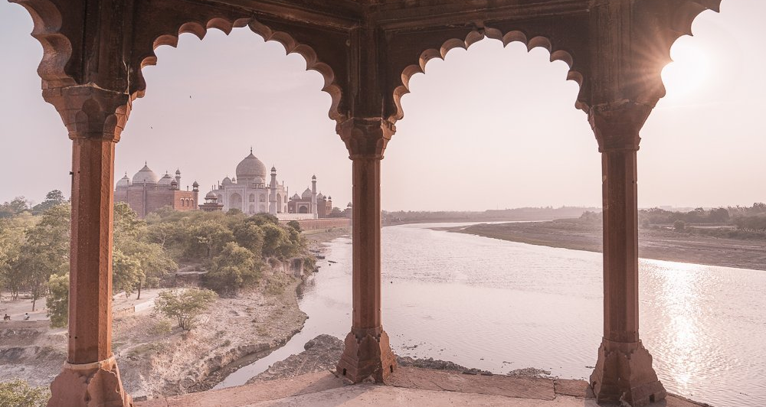
Upon arrival proceed for sightseeing tour of Agra, starting with the splendid Agra Fort built in red sandstone, encapsulating magnificent palaces, halls of public, private audience & beautiful gardens and hundreds of rooms within the Fortified Fort. The worth seeing point of this place from where the Taj Mahal can be seen is the Diwan-I-Khas.
After visit you will be transferred to your hotel for check in (standard check-in time is 1400 hrs).
A trip to Agra is incomplete without experiencing dazzling path beyond the Taj Mahal; A transformative walk tour that goes further than the iconic Taj Mahal and dives into the enticing soul of Agra’s Taj Ganj. A crowded street that holds and narrates the fascinating tales of Agra’s unfolded heritage. Our passionate guides led this tour wanders through the streets of undiscovered places and underrated monuments, giving you an extensive glance of Taj Mahal.
Engage in this unique adventure and go beyond the Taj Walk, fostering healthy interaction with locals and navigating lively streets, experiencing stories of traditions that breathe the Agra City enchantment.

Overnight: Courtyard Agra


Courtyard Agra is located on Fatehabad Road, close to iconic landmarks such as the Taj Mahal and Agra Fort. The hotel offers comfortable rooms with air-conditioning, minibars, and free Wi-Fi. Guests can enjoy dining at MoMo Café, which serves international buffet options and à la carte dishes, or relax at the poolside restaurant, Grills by the Pool. Leisure facilities include an outdoor pool, a spa, and a fitness centre. The hotel also features versatile event venues suitable for business functions and weddings.

Day 04: Agra – Jaipur

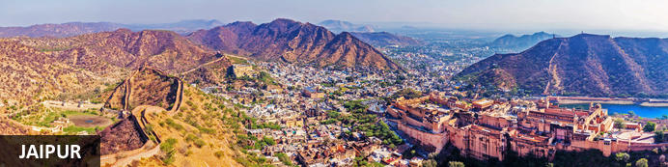
Founded in the early 1700s by Maharaja Jai Singh II as his new capital, the original ‘Pink City’ (so-called because almost all buildings were painted terracotta pink to honour the 1876 visit of the future King Edward VII) was laid out in a traditional grid with colonnaded streets and uniform façades. That layout remains intact and the city, now state capital of Rajasthan, has evolved and expanded into a modern metropolis with its own metro system. Yet its key sights and attractions lie within a relatively compact area.

Day Itinerary
Early this morning witnesses the surreal views of the Taj Mahal. Step inside this eternal symbol of love and appreciate the intricate designs and symmetries that rhyme as a poem written in marble. Taj Mahal is an extravagant display of love, built by Shah Jahan in memory of his beloved wife Mumtaz.

Then return to your hotel, spend some time on relaxing and after breakfast check-out and, you'll make your way to Jaipur – land of the Rajput’s, also is known as the 'Pink City', home to ancient forts and palaces. (Approximately 180 Kms – 4 Hrs)

En Route make a short stop to visit The Chand Baori “Abhaneri” Small village of Rajasthan, which is one of the largest Step well in the world and one of the most beautiful ones.
Upon arrival Jaipur, you will check-in to your hotel

Overnight: Hilton Jaipur
Hilton Jaipur is ideally located on the outskirts of Jaipur, just 1km from Ram Nagar metro stop and 11km from Jaipur International Airport. The accommodation features comfortable guest rooms and suites equipped with modern amenities including coffee makers, LCD TVs, hairdryers, air conditioning, desks and Wi-Fi. Guests can enjoy dining at the on-site restaurant and bar. Leisure facilities include a swimming pool, fitness centre and spa.
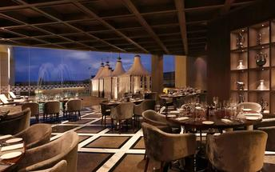

Day 05: Jaipur

Day Itinerary
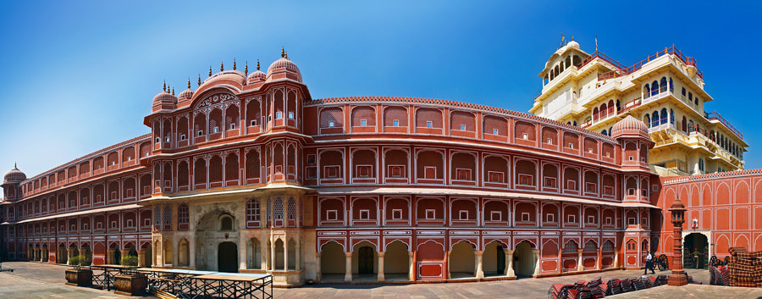
Begin exploring this city visit the City Palace complex which is spread over a large area occupying one-seventh of the old city of Jaipur .It is comprised of two palaces, Chandra Mahal and Mubarak Mahal, museum, a vast array of courtyards, gardens, and buildings. The palace is a blend of the Shilpa Shastra of Indian architecture with Rajput, Mughal, and European styles. Diwan-I-Aam (Hall of Public Audience), Bhaggi Khana (a museum), Pitam Niwas Gate, and Peacock Gate are a must-see. Its outer boundary was built by Raja Jai Singh and the other structures by his successors to add charm to it. It also served as a residence for the former Maharaja of Jaipur, also visit the famous Jantar Mantar (an observatory)

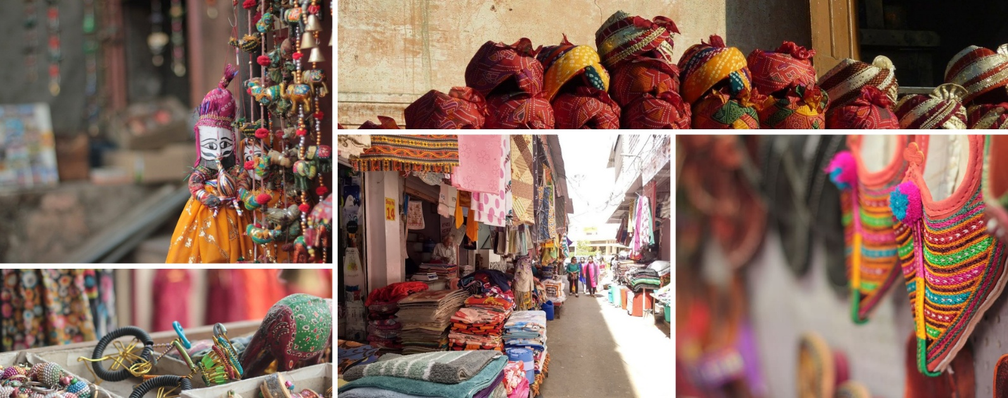
Thereafter, head for a walking tour in the bazaars, this immersive experience offers a unique opportunity to explore the city’s vibrant bazaars, renowned for their exquisite textiles, distinctive artisanal goods, and delectable street food. A specially curated selection of Jaipur’s vibrant textile market and street delicacies, each reflecting the region’s rich culinary and cultural heritage, awaits your discovery.

The textile market, in particular, stands as a testament to Jaipur’s centuries-old tradition of craftsmanship, where intricate patterns, vivid colours, and fine fabrics come together to embody the artistic soul of the Pink City.

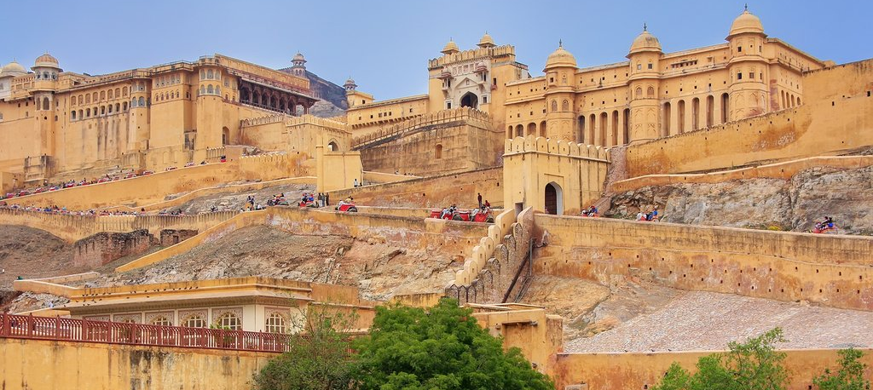
Later in the evening proceed for the majestic Amber Fort that’s perched on a hill on the outskirts of Jaipur. The fort was once the capital of Rajasthan. Former residence of Rajput Maharajas, this fort is notable for its grand architecture showcasing the Hindu style of architecture. The Amber Fort was used by the Rajputs for the dual purpose of defence and for private residence. The fort encompasses charming gardens and magnificent palaces made from marble and precious stones, richly decorated with intricate stonemason works and paintings.

The rest of the day is free for personal activities.

Day 06: Jaipur – Delhi

Day Itinerary
Today morning at leisure and check-out around 12:00 Hrs, you will be driven to Delhi (Approximately 270 Kms – 5 ½ Hrs)

On arrival, you will check in at the hotel. The rest of the day will be at leisure.

Overnight: Vivanta New Delhi Dwarka
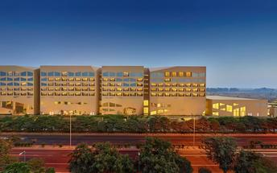
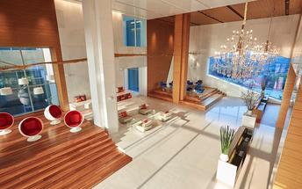
Located in Delhi NCR, Vivanta New Delhi Dwarka offers comfortable accommodation directly connected to the centre of the city. The hotel's elegant rooms feature complimentary Wi-Fi access, flat-screen TVs, coffee makers and telephones. Guests can enjoy delicious dishes at several on-site dining options. Additional amenities include a fitness centre and a spa.

Day 07: Delhi

Day Itinerary
You will be transferred to Delhi international airport to connect flight for onward destination (the recommended check-in time is 3 hours prior to the flight).

