

IN-08

North East Tour
Guwahati (A)- Shillong (B)- Kaziranga National Park (C)- Guwahati
10 Days / 9 Nights
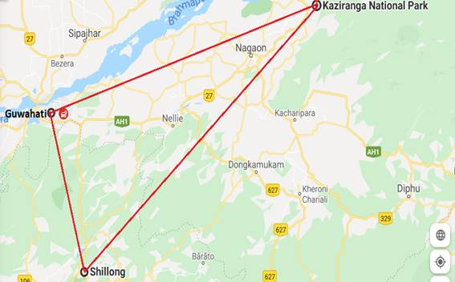

Overview: This journey covers the not much tapped eastern part of India covering Guwahati, Kaziranga & Shillong.

Highlights: Mountains, Nature, Villages, National Park
- Experience games drives in Kazhiranga National Park;
- Explore the villages and enjoy nature walk in Shillong

Day 1: Arrive Guwahati - Shillong

The north-eastern state of Meghalaya (the name means ‘abode of clouds’ in Sanskrit) is an explorer’s dream come true – it boasts many fascinating natural wonders, including roughly 1000 caves. The best known of these can be found near the town of Cherrapunji in the East Khasi Hills district. Aside from being regarded as the ‘wettest place on earth’, it is home to the Krem Mawmluh cave, which extends for seven kilometres, and consists of five river passages and stunning calcite formations, and the Krem Phyllut cave, famous for its narrow entrance way, and massive halls and galleys.

Fly into Guwahati, where you will be met by a Travel Counsellors Representative who assist and drive to your hotel of stay at Shillong, (approx 110 kms/ 2-3 hours drive) the capital city of the state – Meghalaya, as well as the district headquarter of East Khasi Hills District.
Arrive Shillong and check in at the hotel. Spend rest of the day at leisure.

Day 2: In Shillong

After breakfast drive to Mawlynnong Village (located approx. 90 kms south of Shillong). Later visit Living Root Bridge.

Mawlynnong Village
Located approx. 90 kms South of Shillong, the picturesque village offers many interesting sights such as the Living Root Bridge and a strange natural phenomenon of a boulder balanced on a rather small rock.
Located very close to the Indo-Bangla border, this cute and colourful little village is known for its cleanliness. The main occupation of the villagers is agriculture. They mostly grow betel nut. About 82 households live in Mawlynnong. Keeping the surrounding environment clean is an age old tradition. Discover India magazine declared the village as the cleanest in Asia in 2003. Dustbins made out of bamboo are found all along the village. Everyone makes it a point that dirt and waste are not thrown everywhere. All the waste from the dustbins is collected and kept in a pit, which the villagers use as manure. The villagers are now on a mission to ban plastic. The village with cent per cent literacy is conscious and they are spreading the message of conservation and protection of the forest. Locals plant trees to ensure that the virgin forest is kept intact and also replenished.

Living Root Bridge
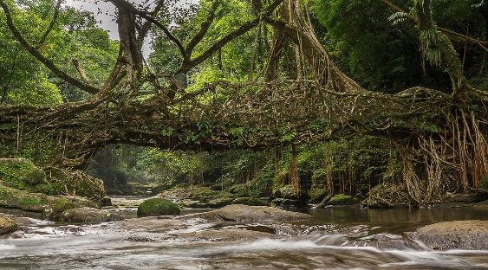
A natural bridge formed with the roots of the trees. A little hiking is required to see the magnificent bridge (hiking approx. 1 hour). Then visit the balancing rock, a small stone holding a big rock by balancing it on above it and the Tree House (watch tower) made by the local people of the village.
After visits return to hotel.

Day 3: In Shillong

Breakfast at the hotel. Later enjoy sightseeing tour of Shillong.

Umium Lake
Umium lake popularly known as Barapani, and the biggest artificial lake in the state, surrounded by sylvan hills and wrapped in the beauty of an assortment of green Khasi-pines and the azure blue skies. Developed upon the reservoir of the Umium Hydro Electric Project, the Water Sports Complex provides a choice of row-boats, paddle- boats, cruise boats, sailing boats, water scooters and speed boats. This is a very popular place for picnic, fishing and watersports.

The Ward’s Lake
A horseshoe-shaped artificial lake close to the Raj Bhavan (Governor’s Residence). The lake abounds in fish (grass carps) and feeding the fish from the bridge, which is the land mark of the lake, is a favorite pastime of the tourists. It is believed that a Khasi prisoner, who requested for some kind of work to get him out of his cell, initiated its construction. The lake has a charming winding walk-a-way in the midst of rolling flowerbeds and fairyland lighting with gradually undulating grounds, hemmed in by lush greens.

Don Bosco Museum (closed on all Sundays apart from the Govt. and other local holidays)
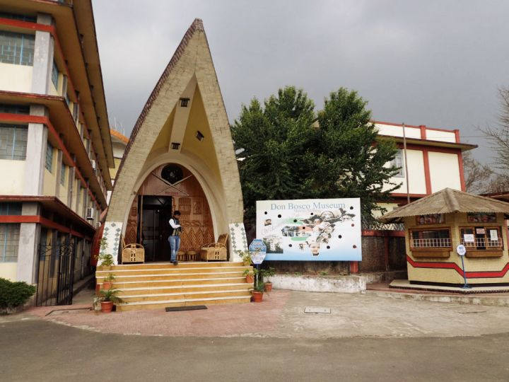
This is a three-in-one Institution combining a museum with a research and publication centre, for promoting and preserving the rich cultural heritage of North E ast India - a unique fusion of all the sister states under one roof. DBCIC contains seventeen galleries displaying cultural artefacts and paintings. It offers study and research facilities throughout its specialized library of 10,000 volumes, a media hall and a conference hall. It is frequented by school students and older research students and anthropologists.

Day 4: In Shillong

Breakfast at the hotel. Day excursion to Cherrapunjee (approx. 55 kms / 2 hours drive) with a stop en-route for a nature walk through the Mawphlang Sacred Forest

Excursion to Cherrapunjee
1300 mt – once the heaviest rainfall area in the world. The drive will give us a spectacular view of deep gorges and the rolling hills luxurious with tropical vegetation that boast an innumerable variety of ferns, moss and orchids.

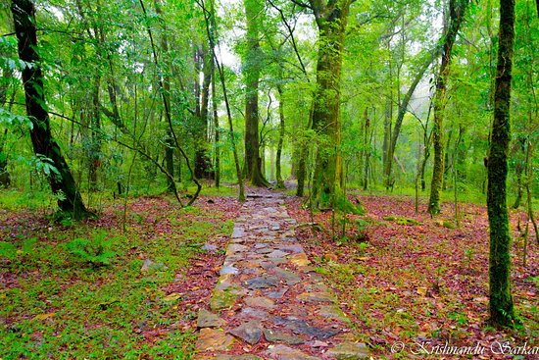
En route stop foe nature walk at Mawphlang Sacred Forest
It’s one of Meghalaya’s most celebrated sacred forests, as the world over, are steeped in spiritual belief and held in great veneration. They also represent some of the earliest representations of preserving the ancient ecosystems. This is a dense forest where the Lyngdoh (chief) used to offer sacrifices and prayers. Not a branch should be broken or else a curse may befall on that person. This grove is surrounded by a lush green valley and a great variety of plants like orchids, include the carnivorous varieties and ferns grow here.

Arwah Lumshynna Cave
Lies in the slope of U Lum Lawshynna Hill. It is approximately one kilometre in length and adorned with different types of carving and formation designed by nature itself which adds lot of beauty to the place. A stream runs through the cave from beginning till the end, making one feel as if we are walking in a river. The cave is covered by a thick forest, called the ‘Law Shynna’. Different types of local species of trees, orchids, wild flowers, shrubs, bamboos and coloured leaves are found in this forest. On the way to the cave, there is a viewpoint, from where one can see the beautiful Wahkaba Falls, the natural landscape and the river which flows to Bangladesh through Nongpriang Village and Sohkhmi Village.
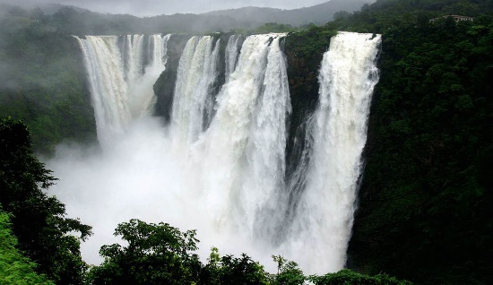
The hill where the cave is located is called ‘U Lum Shynna’. This hill is very high and it overlooked the Sohra town and even the plains of Bangladesh could be seen from this hillock. That is why it is called Lum Shynna which literally means Clearview. All through this hill, from North to South runs the David Scott Bridle path build by the British which once upon a time connects the Brahmaputra Valley and the Surma Valley in Bangladesh. This path was used by people to go to Shillong or Laban, to the market and to Bangladesh for trade. This path is still visible now, while some parts are destroyed due to soil erosion and landslide caused by coal mining. Resting places for those who are tired are also found along the route. At the foot of this hillock, there are the remnants of the ‘Kyntursniang Village’ a historical site where foundation of the present Sohra Syiemship was laid by Buh Sing Syiem and his myntris.

Nohakalikai Falls
A hauntingly beautiful waterfall, cascading down from the top of the gorge to the mystic deep green pool below, reminds one of the tragic legend associated with it- of a grief stricken mother who plunged to her death, unable to overcome her sorrow of the murder of her daughter by her husband.

Day 5: In Shillong

Breakfast at the hotel. Spend rest of the day at leisure.

Day 6: Shillong - Kaziranga National Park

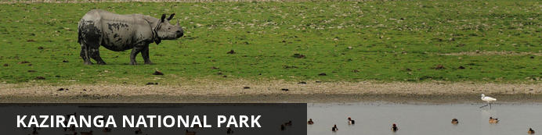
Home of the renowned and endangered one-horned rhinoceros, Kaziranga National Park lies in the Golaghat and Nagaon districts of Assam state. This world heritage site, bordering the southern banks of the Brahmaputra River, boasts many protected wildlife species including one of the largest populations of tiger in the world, as well as large breeding populations of elephant, water buffalo, swamp deer and an abundance of bird life. The extensive grasslands, forested highlands, marshes and flood plains are a wildlife and nature lover’s paradise. A not-to-be-missed experience for visitors, are the Elephant Safaris – the best way to get up close and personal with the park’s famous rhinoceros.

Breakfast at the hotel. Morning leave for Kaziranga (approx. 290 kms/7 hrs). A long day driving through the country side.

Day 7: In Kaziranga National Park

All meals at the lodge.
Enjoy a fully day i.e. morning and afternoon Jeep Safaris at the Park.

Kaziranga National Park
All those who have thought Indian one-horned rhinoceros only existed in Jurassic-era, then a trip to Kaziranga is a must for them. One of the most sought after wildlife holiday destinations in India, Kaziranga National park’s 430 square kilometer area sprinkled with elephant-grass meadows, swampy lagoons, and dense forests is home to more than 2200 Indian one-horned rhinoceros, approximately 2/3rd of their total world population. Formed in 1908 on the recommendation of Mary Curzon, the park is located in the edge of the Eastern Himalayan biodiversity hotspots – Golaghat and Nagaon district. In the year 1985, the park was declared as a World Heritage Site by UNESCO. It is said when Mary Curzon, the wife of the Viceroy of India – Lord Curzon of Kedleston, visited the park to see Indian one-horned rhinoceros; she wasn’t able to found even one. Then she persuaded her husband to take urgent measures to protect the dwindling species which he did by initiating planning for their protection. After a series of meetings and documentations, the Kaziranga Proposed Reserve Forest was created with an area of 232 km2 (90 sq mi) in 1905.

Day 8: In Kaziranga National Park

All meals at the lodge
Enjoy a fully day i.e. morning and afternoon Jeep Safaris at the Park.
Later in the evening visit the Kaziranga Orchid Park cum Biodiversity Conservation Centre.

Kaziranga Orchid Park cum Biodiversity Conservation Centre.
Kaziranga Orchid Park cum Biodiversity Conservation Centre has a photo gallery of 500 orchids, a greenhouse, lakes with boating and angling facilities and small tree-houses, among other attractions. The basic purpose of opening this park was to conserve local varieties of orchids, flowers, fruits, fish and also to spread cultural awareness knowledge. Those visiting the park will also be able to taste juices of local fruits, pithas (local cakes) and enjoy Borgeet and Xattriya dance performances as well.
Experts have been involved to give shape to the park. Khonjit Gogoi, a teacher who has been preserving orchids for the past 20 years pitched in to shape the park. As did Mahan Bora, a farmer, with his 10-year experience in collecting paddy varieties, Kunti Bora, an expert in medicinal plants, who helped in opening a medicinal plants sales counter, Bihu expert, Dhaneswar Saikia who showcases the original Bihu dance forms and music while Xattriya expert, Biplob Baruah for Xattriya dance training.

Day 9: Kaziranga National Park - Guwahati

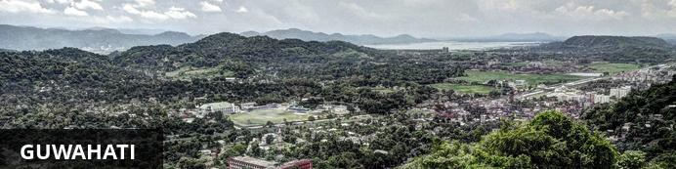
Situated on the banks of the mighty Brahmaputra River in north-eastern India, the city of Guwahati is not only the commercial, sporting and educational hub of the region, but offers numerous natural wonders for visitors. The ‘Gateway to the Seven Sisters’ is renowned for its surrounding tea plantations, rolling green hills and diverse wildlife, including rare animals such as Asian elephants, pythons, tigers and Indian bison. Religious centres, historical monuments and archaeological sites add to its magical aura, making it a popular starting point for visitors to this region of India.

Breakfast at the lodge. Morning leave for Guwahati (approx. 220 kms/5 hours drive). On arrival check in at hotel
Later visit Sualkuchi and Hajo villages.

Sualkuchi village
Located on the banks of the Brahmaputra, 35 kms north of Guwahati, this weaving village that produces some of the best silk in the state. This sleepy little village exudes a charm like no other. Almost every house has an adjacent shed (karkhana) that houses the traditional bamboo loom- the gentle click-clacking of which can be heard from the streets. You can walk into any of the numerous karkhanas and observe the talented weavers weaving intricate patterns on the golden Muga silk. In the early years of the 20th century, Sualkuchi was developed as a “crafts village”. Most of the funds for this development work came from eminent Gandhians across the country who responded to the “back to the villages” slogan of Gandhiji’s swadeshi drive. Although the weaving industry of Sualkuchi remained almost confined to the tanti community till the 1930’s, with encouragement from the government, people from other communities also took up silk weaving. There are about 17000 silk looms in Sualkuchi producing an eclectic range of silk products. Most of Sualkuchi’s silk is woven into mekhela-chadars and gamosas. Owing to the increasing demand, the weavers of Sualkuchi have diversified to saris, shawls and dress material. The silk weaving of Sualkuchi provides direct and indirect employment to more than 25,000 people throughout the year.

Hajo village
The meeting point of Muslim, Buddhist and Hindu faiths on the northern bank of river Brahmaputra, has a number of temples. The chief among them being the Hayagrib Madhab Temple – a place of pilgrimage both for the Hindus and the Buddhists. Hajo’s bell-metal work is renowned for the interesting artifacts made by local craftsmen.

Day 10: Guwahati Departure

At an appropriate time, a Travel Counsellors Representative will assist and provide you the necessary transfer to the international airport to board your flight back home.

