

IN - 10

Gujarat with Mumbai
Mumbai – Ahmedabad – Bhavnagar – Rajkot – Bhuj – Bajana - Ahmedabad
13 Days / 12 Nights
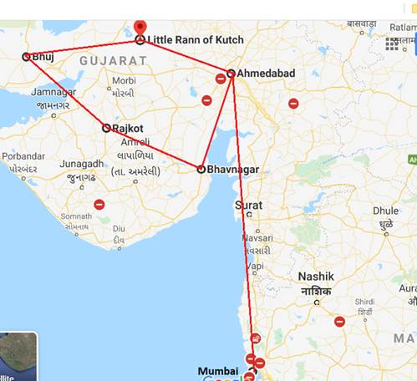

Overview: This journey covers travel in western coast – Gujarat along with Mumbai.

Highlights: Culture and Heritage.

- Explore the glittering city of Bollywood - Mumbai.
- Visit the historic and religious monuments and places of Gujarat
- Visit to Sabarmati Ashram which was once a residence of Mahatma Gandhi.
- Visit to tribal villages at Bhuj

Day 1: Arrive Mumbai

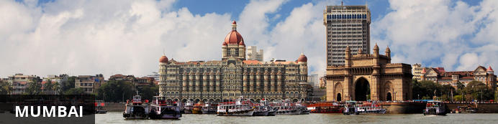
The thriving metropolis of Mumbai is a go-to destination for travellers curious to experience a modern Indian city. Lapped by the Arabian Sea, this urban seaside peninsula is a melting pot of old and new India. Towering office blocks and shiny apartment buildings shoulder crumbling grand dames of architecture. Men play cricket in the leafy central parks, taxis navigate the jam packed streets and families stroll along the seaside promenades of Mumbai, while kilometres away children beg on the peripheries of Asia’s biggest slum. In the wide avenue of Colaba’s high street, western culture overshadows the brightly lit storefronts, where Levi’s, Adidas and McDonalds vie for retail space.

On arrival in Mumbai: Having cleared immigration, collected your luggage and passed through customs, please make your way towards the exit of the terminal building where you will see a bank of people waiting for you. Amongst them will be Travel Counsellors Representative who will be waiting to greet you with a paging board with your name on.
You will be transferred to your hotel and assisted with check in. (Standard check in time at hotel is 1400 hrs).

Day 2: In Mumbai

After breakfast, proceed for Elephanta excursion. Later proceed for half day Mumbai city tour.

Elephanta Caves (Closed on Mondays)
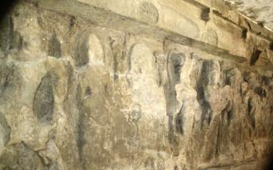
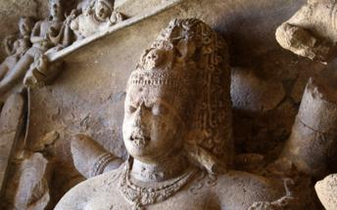
Elephanta Caves is UNESCO World Heritage site is a fine specimen of rock cut architecture and art of medieval India. To state the trivial, there are no elephants in Elephanta! The name was given by the Portuguese as there was a large elephant sculpture in the island, when it was held by them. Otherwise this island was known as Gharapuri. The island is known for the 7th century caves with boldly executed mythical themes.

Half day Mumbai City Tour
Visit to the well-known landmarks, the Gateway of India. Located on the waterfront in Apollo Bunder area in South Mumbai, the Gateway is a basalt arch 26 metres (85 ft) high. It was a crude jetty used by fisher folks and was later renovated and used as a landing place for British governors and other distinguished personages. Next, visit Prince of Whales Museum. It is the main museum in Mumbai, formerly Bombay. It was founded in the early years of the 20th century by prominent citizens of Bombay, with the help of the government, to commemorate the visit of the then prince of Wales. The museum was renamed in the 1990s or early 2000s after Shivaji, the founder of Maratha Empire. The museum building is built in the Indo-Saracenic style of architecture, incorporating elements of other styles of architecture like the Mughal, Maratha and Jain. The museum building is surrounded by a garden of palm trees and formal flower beds. The museum houses approximately 50,000 exhibits of ancient Indian history as well as objects from foreign lands, categorized primarily into three sections: Art, Archaeology and Natural History. Then, visit Malabar Hills. The colonial bungalows that peppered the hillside in the 18th century have now been replaced by the apartment blocks of Mumbai. You will end your tour by driving past Flora Fountain, Dhobi Ghat, Marine Drive.
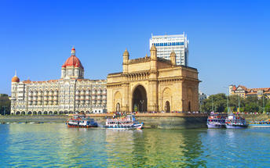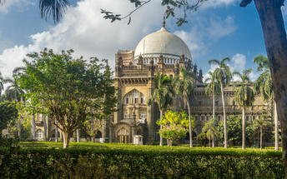

Day 3: Mumbai - Ahmedabad

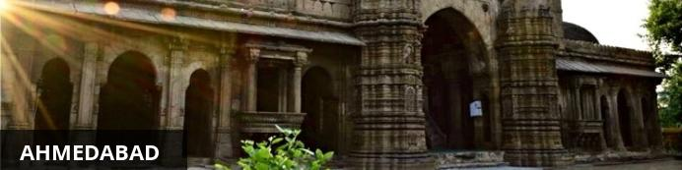
The former capital of the Gujarat state, Ahmadabad is known as one of the home towns of Mahatma Ghandi. The Sabarmati Ashram Museum, also known as Gandhi Ashram, on the banks of the River Sabarmati, was his temporary residence for about twelve years. The commercial hub of Gujarat, Ahmedabad is big, busy and beguiling. The city hosts many colourful festivals, including the Hindu nine-day spiritual celebration of Navratri, invoking music, dance and dress-up across town, and Uttarayan, an annual kite-flying day. Travel back in time by heading to the old quarter where beautiful archways and architecture abound.

After breakfast, your Travel Counsellor Representative will assist & transfer you to Mumbai airport to board the flight for Ahmedabad.
Upon your arrival in Ahmedabad, you will be assisted and transferred to the hotel.
Rest of the day at leisure.

Day 4: In Ahmedabad

After breakfast enjoy full day sightseeing tour of Ahmedabad.

Sabarmati Ashram
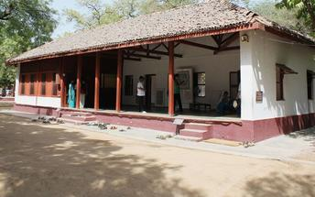
Home to Gandhi ji (the Father of the Nation) from 1917 until 1930 and served as one of the leading centres of the Indian freedom struggle. Over the years, the ashram became home to the ideology that set India free. It aided countless other nations and people in their battles against oppressive forces. Today, the Ashram serves as a source of inspiration and guidance and stands as a monument to Gandhi’s life mission and a testimony to others who have fought a similar struggle.

Sidi Saiyyed Mosque
Set in a small compound and surrounded by trees, the ancient Sidi Saiyyed Mosque is located in the city centre of Ahmedabad. It was built in the 16th century under the command of Sidi Saiyyed. The mosque features ten windows adorned with stunning stone latticework. Of the ten windows, one stands out with the carvings of a tree with intertwined branches, known as the Tree of Life. The mosque is popular for its grandeur architecture.

Adalaj Vav
About 19 kms north of Ahmedabad this stepwell is an architectural wonder built by Queen Rudabai and is certainly one of the finest monuments of Gujarat. It is a seven-storied structure in the form of a well with chambers one behind the other. The ‘Vays’ or stepped wells of Gujarat were used as meeting and resting-places during summer since their cool interiors offered unbelievable respite from the scorching sun outside. In the summer people warmed themselves on the spacious sunny corridors while wide verandahs offered shelter during the rains. Adalaj is a village to the north of Ahmedabad.

Vechaar Utensil Museum
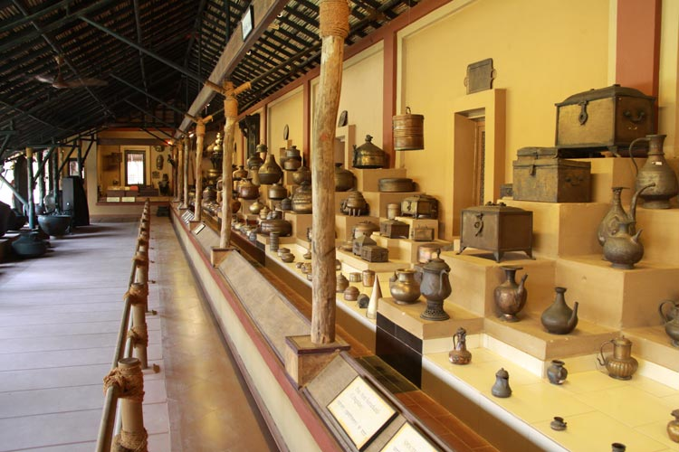
Built in 1981 within the vicinity of Vishalla Village Restaurant is the VECHAAR (Vishalla Environmental Centre for Heritage of Art, Architecture and Research) Utensils Museum, a brainchild of architect Mr. Surender C. Patel. It is an effort to cherish and preserve our rich cultural heritage and rare artistic skills and wisdom of our craftsmen. It is an extensive study of utensils from thousand years old to present times, that have evolved over different periods of history as a result of our changing needs and environment. The range varies from leaves or a gourd jug, to modern stainless steel and glass utensils. The metal utensils cover everything from brass, copper, bronze, zinc to German silver.

Day 5: Ahmedabad - Lothal - Bhavnagar

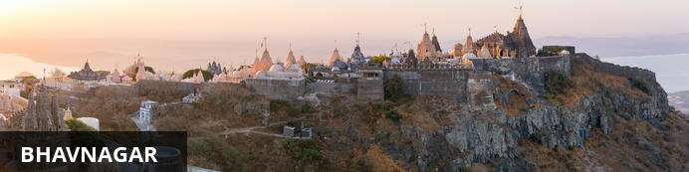
With its bustling markets, numerous educational institutions and its range of exquisite temples, Bhavagar offers an intriguing combination of modernism and traditionalism. This busy port city is located along the coastal area of the Saurashtra peninsula in India’s Gujarat region. The city serves as an ideal base for touring the variety of attractions in the surrounding area such as Shatrunjaya and Blackbuck National Park. Popular sites in the city itself include: the charming old town with its busy markets and overhanging wooden balconies; the fascinating Gandhi Smriti Museum; Mangalsinhji Mahal Palace, an impressive example of traditional Kathiawari architectural principles; and the Takhteshwar Temple resting on a hilltop and offering panoramic views over the city and the Gulf of Cambay. This hectic, sprawling industrial centre with its colourful old core has plenty to offer visitors from all walks of life.

After breakfast, leave with your private chauffeur driven vehicle to Bhavnagar (approx. 200 kms / 04 hours drive) with a stop en-route at Lothal. Arrive Bhavnagar and check in at the hotel.

Lothal Ancient Place Gujarat
Lothal is an archaeological site located in proximity to the small town of in Ahmedabad. The site is believed to have been a major trading centre with ornaments, gems, and beads as the prime merchandise. Archaeological findings from excavations include residential buildings, drains, a dockyard, a township, mounds as well as a marketplace. Visitors will also find interesting objects and artefacts from excavations, in the on-site museum.

Day 6: Bhavnagar - Palitana - Rajkot

Dubbed the ‘Jewel of the West, Gujarat is a vast state encompassing 1600 kilometres of coastline and myriad natural habitats, ranging from the undulating hills of Saputara, to the salt plains of Kutch and the forests of Gir National Park, where the last wild population of Asiatic lions still roam free. The birthplace of Mahatma Gandhi, Gujarat is home to a varied array of religious groups: Hindus, Muslims, Buddhists, Zoroastrians, Jews and Christians, as well as one of India’s most prominent Jain communities, a devout sect that follows a strict path towards liberation and is responsible for the region’s impressive white marble temples, and delicious vegetarian cuisine (as well as the prohibition laws that have been in place there since 1961).
After breakfast you will be driven to Rajkot. (approx 220 kms/ 5 hours drive) with a stop at Palitana Jain Temple .

Palitana
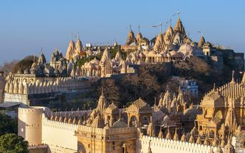
Palitana is said to be an entirely vegetarian-only city and the only one of its kind in the whole world. Visitors can look forward to climbing the 3000 steps up Shatrunjaya hill, which for the Jains represents the ascent to greater knowledge along the path to liberation. Dubbed ‘The City of Temples’, Palitana features over 900 ornate temples stretching over two hilltops that visitors can look forward to exploring. Don’t miss a visit to the most famous temples of Adinath, Kumarpal, Vimalshah, Samprati Raja and Chaumukh which is the highest.

Day 7: Rajkot - Bhuj

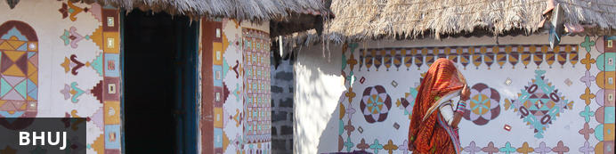
The historical town of Bhuj serves as the district headquarters of the Kachchh District. The town is known for its picturesque lake and for its lovely little local houses, ornately decorated with mud and mirrors forming intricate designs. Bhuj also features an array of ancient temples and palaces including the magnificent white marble Shree Swaminayan Temple; the Gothic style Pragmahal Palace; and Aina Mahal, an 18th-century palace covered with mirrors and pieces of Venetian glass. Bhuj makes an excellent base for exploring the numerous villages of the surrounding area which are known for producing exquisite local handicrafts.

After breakfast you will be driven to Bhuj (approx. 230 kms/ 5 hours drive). Arrive and proceed directly to the collector office to obtain the permit to visit restricted Banni villages. (Office is closed on all public holidays including Saturdays and Sundays). Later visit the local bazaar and Aina Mahal Palace.
Aina Mahal Palace
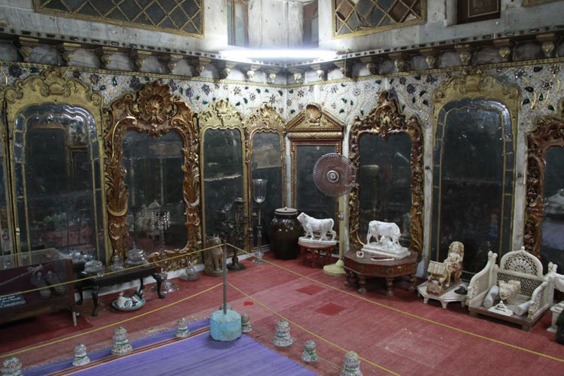
It’s the 18th century creation of the extravagant Rao Lakhpatji (1741-1760). He sent a local craftsman Ramsingh Malam to Europe to perfect his skills in glassmaking and iron founding. He commissioned Ramsingh Malam to construct Aina Mahal with its hall of mirrors of venetian glass. The hall of Mirror has white marble walls covered with mirrors and gilded ornaments and the floor is a pleasure pool lined with tiles, with a platform above it surrounded by a series of fountains operated by an elaborated system of pumps below a Venetian chandelier.

Day 8 - 9: In Bhuj

After breakfast day excursion to visit Banni Villages (Lodlya, Khavda, Bhirandiyara, Hodka & Dhorado) see local tribes and their textiles.
Banni Villages
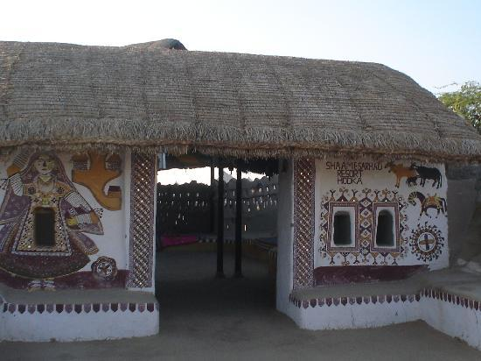
Amidst the Desert land of infinite dimensions, are suspended, quaint little villages. These are the last villages on the India-Pakistan border. Here you will come across master craft people' exposing their traditional art, turning our master pieces every day. Their ornaments, clothes, utensils, everything they use - will make you feel as if you have stepped into lifestyle museum leaving you spellbound. Some of the important embroidery work are known as Rabari embroidery, Ahir embroidery, Bavalia embroidery or’ Kutchi Bharat’, Sindhi embroidery, Aari work, Soof embroidery also known as ‘Sodha Bharat’, Mutva embroidery in Banni (Dhorodo village) is famous for Gotam stick or Sindhi Kadai. In Banni area the embroidery work is also done on leather shoes or’Mojdi’, purses bags, belts, wallets etc. Hodko village in Banni is famous for Meghwal embroidery and leather work.

Day 10: Bhuj - Bajana

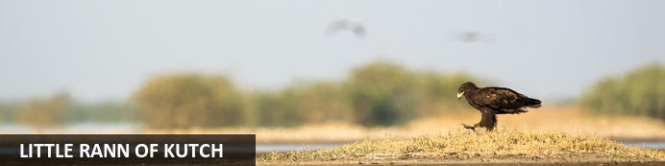
Set along an ancient trading route in western Gujarat, the Little Rann of Kutch, also known as the Little Desert of Kutch, is set amidst a harsh, stark and desolate landscape in beautiful India. Stretching over 4950 square kilometres, the terrain is characterised by a medley of barren salt flats, scrubland, desert grassland, marshes and lakes. The Little Rann of Kutch boasts a rich biodiversity and is home to the last remaining population of the endangered two-toned chestnut-coloured Asiatic wild ass. Visitors flock here to view the abundant wildlife wondering the grass-covered plains as well as the countless migratory waterfowl such as flamingos, pelicans, cranes and much more. Don’t miss the opportunity to visit the Wild Ass Sanctuary.

After breakfast, you will be transferred to Dasada (approx 300 Kms / 6 hours drive) with a stop en-route at Ajarakhpur & Bhujodi.

Ajarakhpur
Ajrakhpur is a new village established by the traditional Muslim Khatri hand block printers after the earth quake that struck in 2001. This is a craft village where you will find artisans practicing traditional hand block printing in the resist technique on cotton/silk fabrics using the age old Ajrakh prints as well as new design motifs. Visit Ismail Khatri, a master artisan who has been awarded an honorary ph.D. Degree by De Montfort University for his knowledge of natural dye practices. You can also visit a number of block printing units like that of Abdul Rahim, Abdul Gani Hasam, Abdul Raheman Buddha, and Adam.
Bhujodi
A small town just 8 km southeast of Bhuj, Bhujodi is a major textile center of Kutch, with the vast majority of the 1200 inhabitants involved in textile handicraft production. Here you can meet weavers, tie-dye artists and block printers, most of whom belong to the Vankar community. Many will let you watch them work; just ask around.

Day 11: In Bajana

Morning take a desert safari across the Little Rann of Kutch, a salt marsh, looking for wild ass and water birds followed by a visit to the villages renowned for their embroideries.
Little Rann of Kutch
In the region of North Gujarat, especially in the region of Kutch one of the most interesting ethnic communities is Rabaris. Once a nomadic people, Rabaris follow an interesting lifestyle and customs. Today, most of the Rabaris are settled, though some still continue to be semi-nomadic, raising cattle, camels and goats in the arid deserts of Kutch and western India. Those settled live in small hamlets either in villages or in small towns, sometimes jointly with other ethnic communities and sometimes as a single ethnic unit. Rabaris can be easily identified by looking at their women folk, who are usually clad with long black head scrapes, distinctive heavy brass earrings which hang low, stretching the earlobes. Their jewellery is modest in comparison to other tribal women. There is an interesting myth about their black wearing.

Day 12: Bajana - Patan - Modhera - Ahmedabad

After breakfast, you will be driven to Ahmedabad, (approx. 250 Kms/ 5-6 Hours drive) with a stop enroute at Patan and Modhera.
Patan
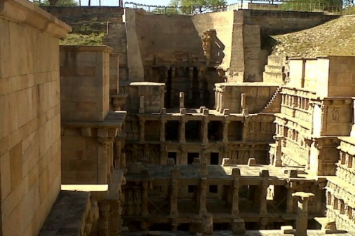
Home of the famous patola silk saris, Patan is a beautiful old town with Jain temples and carved wooden houses. Ranikivav (step well) is an excellent example of subterranean architecture of Gujarat. The exquisitely carved side walls, pillars, beams, series of steps & platforms lead to the elaborately carved water well. Every surface is adorned with finely chiselled sculptures of maidens & Hindu deities, religious motifs & geometrical patterns. Rani ki Vav represents the finest of the Indian sculptures and architecture.

Modhera.
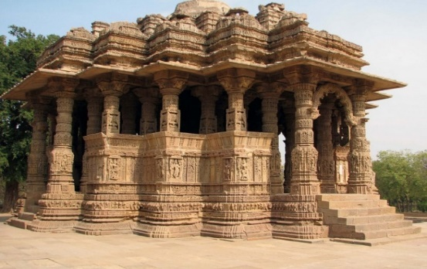
The Sun temple of Modhera is one of the finest examples of Indian architecture of its period. Built in 1026 A.D. the temple is dedicated to the Sun-God, Surya and stands high on a plinth overlooking a deep stone-steeped tank. Every inch of the edifice, both inside and outside is magnificently carved with Gods and Goddesses, birds, beasts and flowers. Sun Temple of Modhera was built by King Bhimdev I (1026-27) and bears some resemblance to the later, and far better known, Sun Temple of Konark in the state of Orissa, which it predates by some 200 years. Like that temple, it was designed so that the dawn sun shone on the image of Surya, the sun God, at the time of the equinoxes. The main hall and shrine are reached through a pillared porch and the temple exterior is intricately and delicately carved. As with the temple of Somnath, this fine temple was ruined by Mahumad of Ghazni.

Day 13: Ahmedabad Departure

At an appropriate time, your Travel Counsellor Representative will provide the necessary transfer to the airport for your onward flight back home.

