ss

IN - 13

Culinary tour through South India
Chennai - Puducherry - Chettinad - Madurai - Munnar - Thekkady - Alappuzha - Kochi
15 Days / 14 Nights
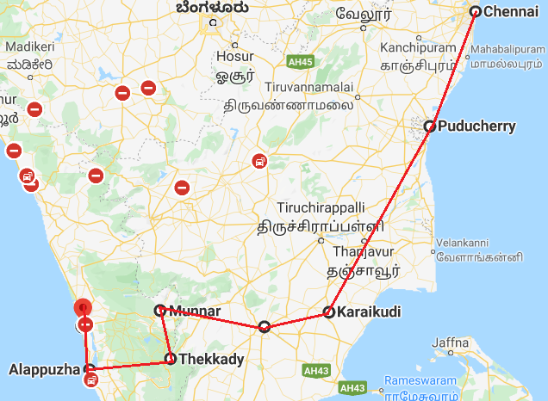
Enjoy diverse cultures as the journey takes you through the Southern States of Tamil Nadu, Pondicherry and Kerala. Each with distinctive traditions, exquisite architectural jewels, and exceptional cuisine. This exceptional and exclusive 15-day tour will give you an opportunity to understand the elegance and traditions of a by-gone opulent colonial lifestyle, mingling with the people at traditional rural villages, experiencing the hospitality of special families and their marvelous culinary heritage!

Day 1: Arrive Chennai

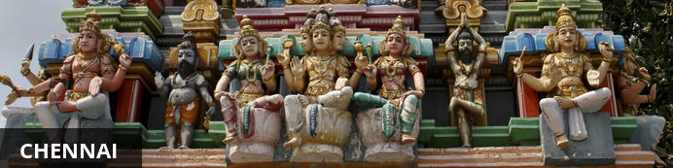
Chennai is the coastal capital of the state of Tamil Nadu and one of India’s financial, cultural and tourism hubs. Attractions include the city’s beaches, museums, shopping areas and historical sites, particularly the centrally located Kapaleeshwar Temple – a historical shrine to dedicated to the goddess “parvati and the group of ancient rock-carved temples at Mahabalipuram, a UNESCO World Heritage site located roughly 60 kilometres from the city centre.

Fly into Chennai where you will be bet by your Travel Counsellors Representative, who will transfer you to hotel of stay. Rest of the day is at leisure.

Day 2: Chennai

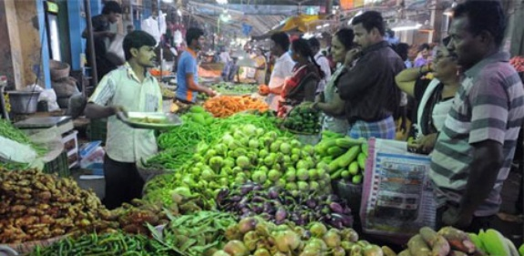
The day will begin with a visit to the vegetable / flower market at Koyambedu - Asia’s largest wholesale market distributes vegetables, fruits, flowers and other goods to whole Tamil Nadu and to the neighbouring states.

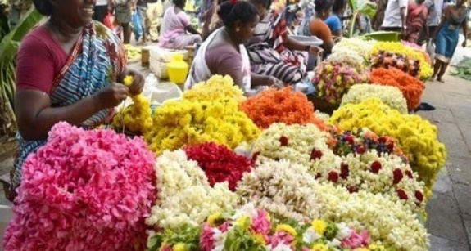
A normal South Indian breakfast consists of “idli” (steamed rice cakes), “dosai” (a pancake made from a batter of rice) and lentils crisp fried on a pan, “vada” (deep fried doughnuts made from a batter of lentils), “pongal” (a mash of rice and lentils boiled together and seasoned with ghee, cashew nuts, pepper and cumin seed), “upuma” (cooked semolina seasoned in oil with mustard, pepper, cumin seed and dry lentils). Most of the dishes in Tamil Nadu are eaten with coconut chutney and sambar (seasoned lentil broth)
After the breakfast, do a heritage tour of the city covering the San Thome church, Fort. St. George, Marina beach and Kapaleeshwarer temple.
The temple was built around the 7th century and is a good example of Dravidian architecture. It has some beautiful sculptures among which are the bronze idols of 63 Saivite saints or the Nayanmars. These adorn the outer courtyard within the temple precinct.
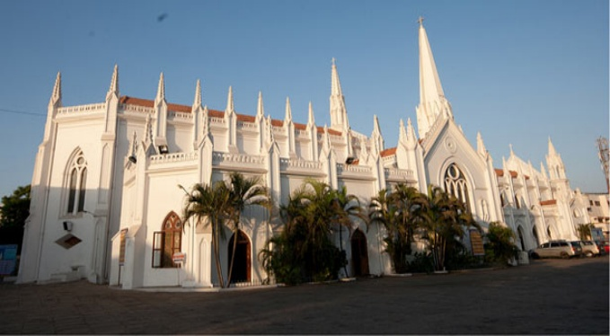
St. Thomas church” also known as “National Shrine of St.Thomas Basilica” or “San Thome church is a Roman Catholic minor Basilica and is built over the tomb of Apostle St. Thomas, one of Jesus’s twelve disciples. He arrived in India in 52 AD and spent seven years preaching Christianity in areas surrounding Chennai. It was during his stay, that a log of wood was washed ashore at San home. Interestingly, San Thome is one of the three churches in the world that is built over the tomb of an apostle. Built in Neo-Gothic style, this church is spotless white and the current structure was built by the British in the late 19th century. The central area known as the nave is colossal and measures 112 feet by 33 feet. The church and its slender towers reach a maximum of 155 feet from the ground.
A traditional South Indian Thali meal at a local restaurant “Sarvana Bhawan” - very high quality vegetarian restaurant.

Day 3: Chennai – Puducherry (Pondicherry)

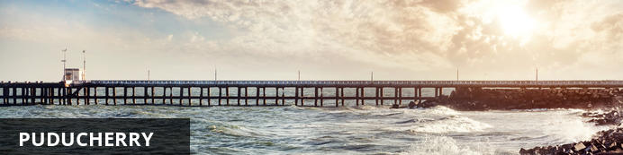
Puducherry – previously known as Pondicherry – is made up of four entirely separate enclaves along the Indian coast, all of which were colonised by the French in the 18th century. Named after the largest of these enclaves, this union territory has retained a strong European culture that makes it unlike any other place in India. Nowhere is this more evident than in Puducherry district, dubbed the ‘French Riviera of the East’, where antiquated colonial buildings line the quiet cobbled streets and tree-lined avenues of the old town, and many people still speak French as their first language.

Leave for Pondicherry (approx. 110 kms / 3hrs) with a visit of Mahabalipuram en-route.

Mahabalipuram
Mahabalipuram – the UNESCO World Heritage- is a city with full of rock-cut monuments built between the 7th and 9th centuries. Mahabalipuram is located right on the Coromandel Coast next to the Bay of Bengal. It was a well-established sea port during the the Pallava dynasty, and has flourished accordingly. These structures, most of which were built to honor Hindu gods, are some of the oldest existing examples of Dravidian architecture.
Visit several cave temples and sculpted reliefs including Five Rathas, Krishna Mandapam, Mahishasuramardhini Cave, Krishna Butterball, Arjuna's Penance and the Shore Temple.

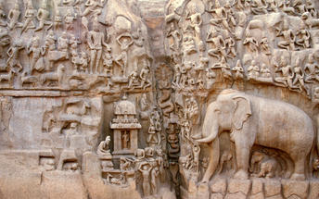
Five Rathas are the rock-cut temples which are rated as excellent examples of Pallava art. Shaped in different styles, the five structures are named after the Pandava brothers of the Mahabharatha. These are monolithic temples, each created in a different style. They are also known as the Pancha Pandava Rathas, and the four of the rathas are supposed to have been scooped out of a single rock formation.

Arjuna's Penance is the world's largest bas-relief measuring 27m x 9m is the pride of Mahabalipuram. This huge whale-back shaped rock contains figures of gods, demigods, men, beasts, and birds and in fact, can be said to represent creation itself. Krishna Mandapam cave has a big bas-relief, notable for its realistic representation. The panel relates one of the stories of Lord Krishna.
After the visit proceed to Pondicherry. The road from Chennai to Pondicherry, the East Coast Road, commonly called ECR, is a scenic highway and the journey in the early hours would take about 2 ½ to 3 hrs maximum.
Arrive Pondicherry and check-in at the Resort.
Later in the day, it time permitting, do a heritage walk around the streets of the “French Quarter”. This part of city still retains a strong connection to its French roots, which can be seen in the names of the streets and the buildings and even layout of the area.

Day 4: Puducherry

Day Itinerary
Morning visit the local market with the chef to buy the local ingredients and take a hand on experience with the chef to prepare the fresh catch along with the preparations of “Pongal” (a mash of rice and lentils boiled together and seasoned with ghee, cashew nuts, pepper and cumin seeds) and “sambhar” a vegetable stew based on a broth made with tamarind and “toor dal” (split pigeon peas), and is very popular in the cooking of southern regions of India especially in Tamil Nadu, Kerala, Karnataka and Andhra Pradesh. Each state in the South prepares it with a typical variation, adapted to its taste and environment.
After lunch, drive to Auroville – the “universal township”, with lush fields, beautiful architecture and a wonderful sense of history. Auroville sheds light on a very unique aspect of South Indian culture. Visit an Organic farm and learn on farming, cultivation, market conditions etc,. Before returning to the hotel, visit a cheese factory to understand how it was started and their present marketing strategy.

Day 5: Puducherry – Chettinad

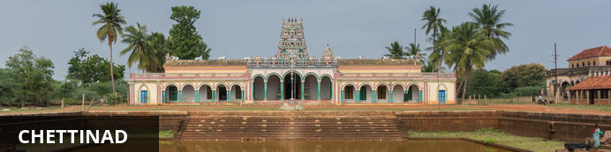
Chettinad is a place known for mansions, cuisines, temples and saris. A par to the area is commonly referred to as Karaikudi. Chettinad cuisine which is synonymous with spicy fare even to the Indian palate. The cuisine is influenced by the hot, arid nature of the region and are legendary for their hospitality and the size of their kitchens and their lavish banquet halls are testimony to this.

Leave for Chettinad – approx. 6 to 7 hrs drive. Though it is a long drive, it is an interesting drive through the country side with beautiful temples and villages.

Day 6: Chettinad – Madurai

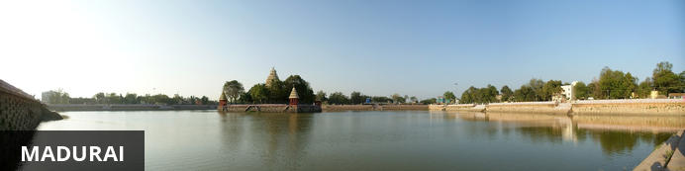
Madurai is the oldest existing city on the Indian peninsula, and one of the oldest continuously inhabited cities in the world, with a recorded history spanning more than 2500 years. It is known as ‘the city of temples’ due to its countless ancient Hindu shrines, including the great Meenakshi-Sundareswar Temple, spread over 6 hectares and featuring a series of 50-metre-high gateway towers that can be seen from afar. The best time to visit Madurai is between October and March, when temperatures are between 20-35 degrees.

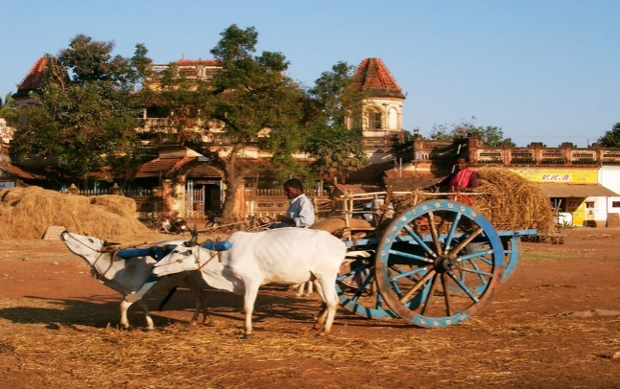
Morning explore the village in Karaikudi – visiting the ornate mansions, the local craft of tile making, enjoy a bullock cart ride etc. After lunch at Karaikudi, leave for Madurai (approx. 3 hrs)
Evening witness bed ceremony at the temple. With lots of noise and commotion, the fish-eyed goddess and her husband are carried from their separate day time places to the inner sanctum, and placed together, for a night of love.

Day 7: Madurai – Munnar

Early morning visit the flower market and later visit of Meenakshi Temple, then leave for Munnar (approx. 4 hrs) .

Meenakshi Temple
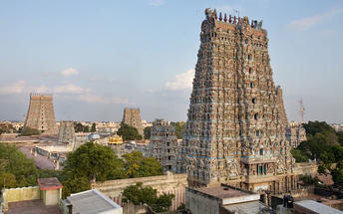
Meenakshi Amman Temple is dedicated to Parvati, known as Meenakshi, and her consort, Shiva, here named Sundareswarar. Built between 1623 and 1655 CE, it houses 14 gopurams (gateway towers), ranging from 45–50m in height. The tallest is the southern tower, 51.9 metres (170 ft) high,and two golden sculptured vimanas, the shrines over the garbhagrihas (sanctums) of the main deities. The temple attracts 15,000 visitors a day, around 25,000 on Fridays, and receives an annual revenue of sixty million INR. There are an estimated 33,000 sculptures in the temple It was on the list of top 30 nominees for the "New Seven Wonders of the World". The annual 10-day Meenakshi Tirukalyanam festival, celebrated during April and May, attracts 1 million visitors

Day 8: Munnar

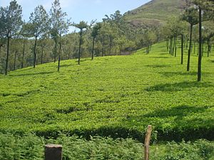
This day visit the tea plantation, the tea museum and the Srishti Welfare Centre.. Closed on Sundays.
The centre runs various programmes for the developmental activities in rehabilitative education (DARE) in training, educating and rehabilitating disabled children on the plantation workers
Visit the houses of the locals who works in the tea gardens.

Day 9: Munnar – Thekkady

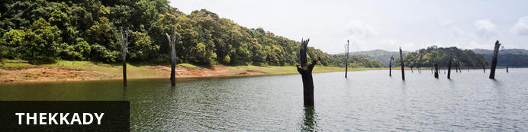
Thekkady comprises evergreen forests and savanna grasslands, and is known for its natural spices such as black pepper, cardamom, cinnamon, nutmeg, ginger and clove. Also famed for the Periyar Wildlife Sanctuary situated on the banks of the artificial Periyar lake and the spice plantations. Here the high ranges of the Western Ghats are clothed in dense evergreen, moist deciduous forests and savannah grasslands. Elephants, tigers, sambar and many other species inhabit the park.

This day leave for Periyar– approximate 4 hrs through the winding ghat roads – one of the scenic drive – the entire route is of high terrains with mountains covered with tea plantations and cardamom estates.
Evening: Hands-on experience to prepare “cassava” (kappa) – with Bird eye chilly mix with yogurt - staple meal of Kerala.

Day 10: Thekkady

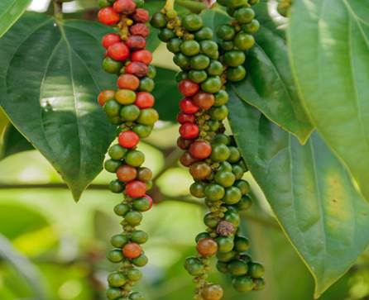
Morning enjoy a Nature walk in to the park. Different nature trails traversing diverse habitats form the trekking routes, generally 4 to 5 km. in length. The trails often pass through evergreen and moist deciduous forests interspersed with marshy grasslands. Each nature trail, accompanied by a trained tribal guide. The Nature walk is the right program to feel nature, hear her whispers and smell her flowers.
Later visit the Spice Plantation and learn about the spices such as cardamom, pepper, vanilla, clove, cinnamon, nutmeg along with ayurvedic herbs etc.

Day 11: Thekkady – Alappuzha

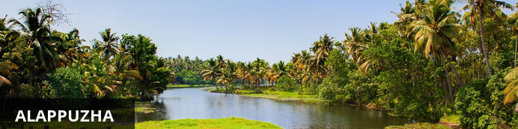
Dubbed the ‘Venice of the East’, it is renowned for its houseboat cruises which float along the tranquil backwater canals. It is said to be one of the most popular tourist centres in the state. While cruising the palm-shaded canals is the main attraction, visitors can also enjoy visiting Alappuzha’s beautiful beaches, exploring the little riverside villages dotting the lush countryside and discovering an array of resplendent temples.

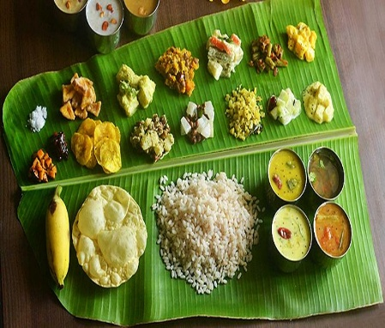
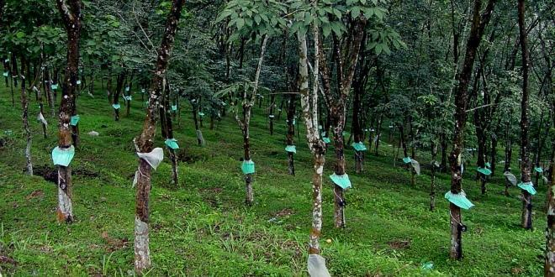
Leave for Alleppey - down the hills towards the midlands (approx. 4 hours)’ on the winding roads through tea, rubber and pineapple plantations.
En-route stop at Vaikom village for a typical Kerala meal served on banana leaves. Visit a coconut grove for a talk / demonstration on the ubiquitous “Coconut”- a complete source of food. Demonstration of “Toddy” tapping - toddy is the sap taken from the inflorescence of the coconut tree. The technique of extracting the toddy is an indigenous technique known to the specialized people who does it and is transferred to generations.
Later proceed to Alleppey visiting Kottayam – the city is of unique characteristics and it is known as the land of letters, legends, latex and lakes.

Day 12: Alleppey

Morning hands on experience with the chef to prepare the breakfast, which will consists of "Puttu"(steamed rice cake) and “kadala curry" (variety of gram), Appam (pan cakes), "stew”, Iddiappam “string hoppers” .
By Noon board the House boats for cruise through “Kuttand” - one of the places in the world where farming is done below sea level. The inland waterways flow above the land level, and this is an amazing feature of this land. This beautiful countryside with its waterways also has a rich crop of banana, cassava and yam. Stop at a paddy field for a talk on rice – from the “ordinary” to the “exotic” – a myriad of dishes prepared with different varieties of rice.
Hands-on experience with the chef on the boat to prepare “pazham pori” a sweet dish made with ripe plantains dipped in flour mixed with sugar.
Late in the afternoon dis-embark boat and return to the hotel

Day 13: Alleppey – Kochi

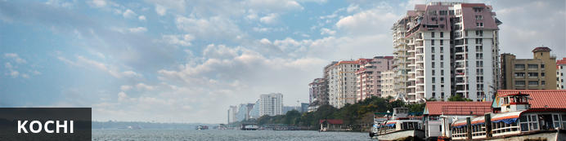
Also known as Cochin, this attractive city has served as a popular port for over 600 years and is known for its eclectic architecture and its array of religious monuments, museums, galleries, cafes and antique shops. The city stretches across a number of peninsulas and islands, which can be reached by a network of water taxis and bridges. The majority of Kochi’s visitor highlights can be found on the peninsula of Fort Kochi. These highlights include the St Francis Church, the oldest European-built church in India; and Mattancherry Palace, which dates back to 1557 and contains some exceptional Kerala murals and temple art. Other must-see attractions include the Kerala Folklore Museum, displaying more than 4,000 cultural and ethnic artifacts; the 16th-century Jewish Synagogue; and the local market, where the air is filled with the aroma of exotic spices.

Morning leave for Kochi with a heritage tour of Alleppey followed by a Syrian Christian meal with a family! The host will give a talk on the Nazarani (Syrian Christians) cuisine and we have the opportunity to learn how to prepare some of the delicacies.
Nazranis have been around a long time in Kerala. Popular theory suggests Christianity was well established here, at least three centuries before it wore the official robes of a religion in Europe. The rulers of ancient Malabar gave the Christian community the grant of privileges perhaps for their social and economic eminence and the traces of those privileges have survived to this very day. Some of the privileges granted to them were curious, the use of the umbrella, the spreading cloth to walk upon, doubling up the end of the banana leaf which serve as a plate etc...
Arrive Kochi and check-in at the hotel
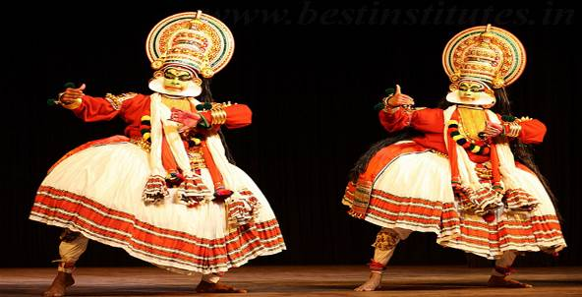
In the evening enjoy Kathakali – the traditional dance drama of Kerala, it dates from the 17th century and is rooted in Hindu mythology. Kathakali is one of the most complicated, highly stylized Indian art form that is basically a Dance Drama noted for its heavy and attractive larger than life make up, elaborate costumes, detailed body movements, synchronized eye-hands movements and thematic presentation of stories with rhythmic steps.

Day 14: In Kochi

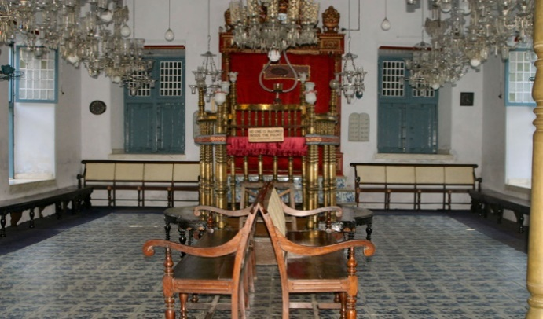
Morning do a walking tour of Fort Kochi area. Visit the local vegetable market. Try your luck to get a fresh catch on the Chinese fishing nets with the locals. Later visit the famous Jewish Synagogue in the heart of the Jewish quarter, the Dutch Palace.
Later visit the Folk lore museum – a treasure trove that showcases the rich heritage that exudes through its numerous art and dance forms. Artifacts that bear the scent of bygone era like masks, sculptures, in wood, stone and bronze, costumes of traditional and ritual art forms, musical instruments, traditional jewelry, manuscripts of rare medicinal and astrological secrets, and Stone-Age utensils are all preserved in this museum with utmost care.

Day 15: Kochi Departure

At an appropriate time, your Travel Counsellor Representative will assist and provide you the necessary transfer to the international airport.

