

IN-01 Forts and Palaces of Rajasthan
New Delhi - Agra - Jaipur - Bikaner - Jaisalmer - Jodhpur - Udaipur
15 Days / 14 Nights
2 Persons

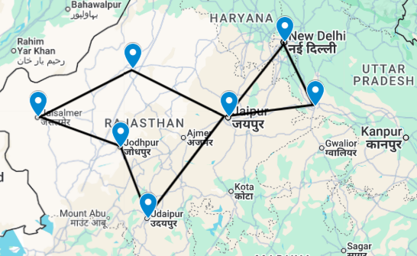

Introduction

Start | Accommodation | Destination | Room Type | Duration
Day 1 | The LaLiT New Delhi | New Delhi | Deluxe Room | 2 Nights
Day 3 | DoubleTree by Hilton Agra Hotel | Agra | Guest Room | 1 Night
Day 4 | Hilton Jaipur | Jaipur | Guest Room | 2 Nights
Day 6 | Narendra Bhawan Bikaner | Bikaner | Residence Room | 2 Nights
Day 8 | Fort Rajwada Hotel | Jaisalmer | Palace Room | 2 Nights
Day 10 | Ajit Bhawan Palace | Jodhpur | Deluxe Room | 2 Nights
Day 12 | Fateh Niwas | Udaipur | Deluxe Room | 2 Nights
Day 14 | Vivanta New Delhi Dwarka | New Delhi | Superior City View Room | 1 Night

Day 1: Arrive New Delhi

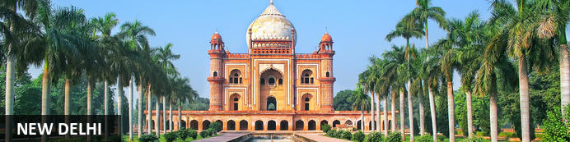
New Delhi, India’s national capital, is a relatively modern confection of imposing government buildings including Parliament, museums and wide leafy boulevards loosely centred on circular Connaught Place (officially now called Rajiv Chowk). To its north lies the formerly walled city of Old Delhi, or Shahjahanabad, built in the 17th-century by the Mughal Emperor Shah Jahan. Though long merged into one metropolis, the two have very different characters. New Delhi has space, parks, distinct neighbourhoods and a clutch of important monuments and architecture that reflect its ancient history. Old Delhi’s crowded streets, lanes and bazaars reflect its colourful medieval character and they cradle some of the city’s most memorable sights.

Day Itinerary
Flight TBA
Arrive Delhi TBA Hrs.

On arrival in Delhi: Having cleared immigration, collected your luggage and passed through customs, please make your way towards the exit of the terminal building where you will see a bank of people waiting for you. Amongst them will be Travel Counsellors Representative who will be waiting to greet you with a paging board with your name on.

You will be transferred to your hotel and assisted with check in. Standard check in time is 1400 hrs.

Overnight: The LaLiT New Delhi
Offering five-star accommodation, The LaLiT New Delhi is located in Connaught Place, India. The hotel boasts 461 luxury rooms and suites with conveniences such as minibars/fridges, electronic safes, TVs, interactive entertainment systems and free Wi-Fi. Guests can delight their palates at an array of on-site restaurants. The hotel also features a spa, an art gallery, a state-of-the-art gym and a swimming pool.
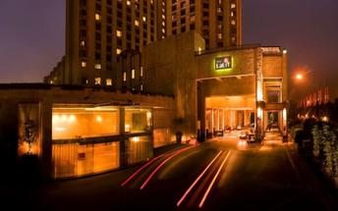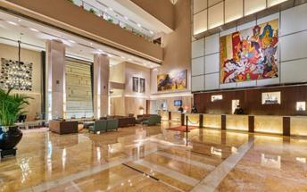

Day 2: In New Delhi

Day Itinerary
Breakfast at Hotel.
Today proceed for The Five Senses Delhi Tour
A sensory journey through Delhi covering everything from its food, local arts and crafts, the must-see architectural marvels, to expertly navigating and allowing you to witness the organized cultural chaos that is Delhi.
USP - Delhi 101: A complete tour of Old and New Delhi! We’ve carefully curated a selection of experiences that will transport you across Delhi’s rich cultural history. Experience for yourself the syncretism that has served as both Delhi’s greatest strength and vulnerability.

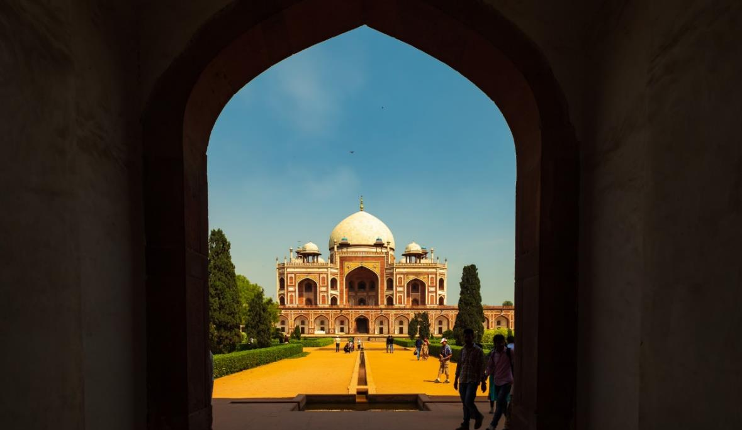
There isn’t a dearth of iconic sightseeing locations in the city, but for this tour, we focus on the two most beloved monuments that became inspirations or templates for all the other beautiful heritage structures. Humayun’s tomb, a spellbinding mausoleum is a favourite for any Delhiite! Your visit will be followed by a heritage craft workshop organised by an all-women NGO group that will touch your heart. Next, take a rickshaw ride through Shahjahanabad. Chaos thrives in the streets of Chandni Chowk, but as you cycle down, you’re transported by the magic in the air to the thriving Mughal era.
Next, you will indulge your sense of smell with an Ittar or perfume-making workshop. Visit an 8th-generation Ittar studio where you will get to smell and mix your unique concoction that can be named after you!
We’ll quickly stop to snack on some mouth-watering street food before proceeding to witness the glory and quietness of the Jama Masjid: a beautiful pocket of calm at the heart of Old Delhi's mayhem.
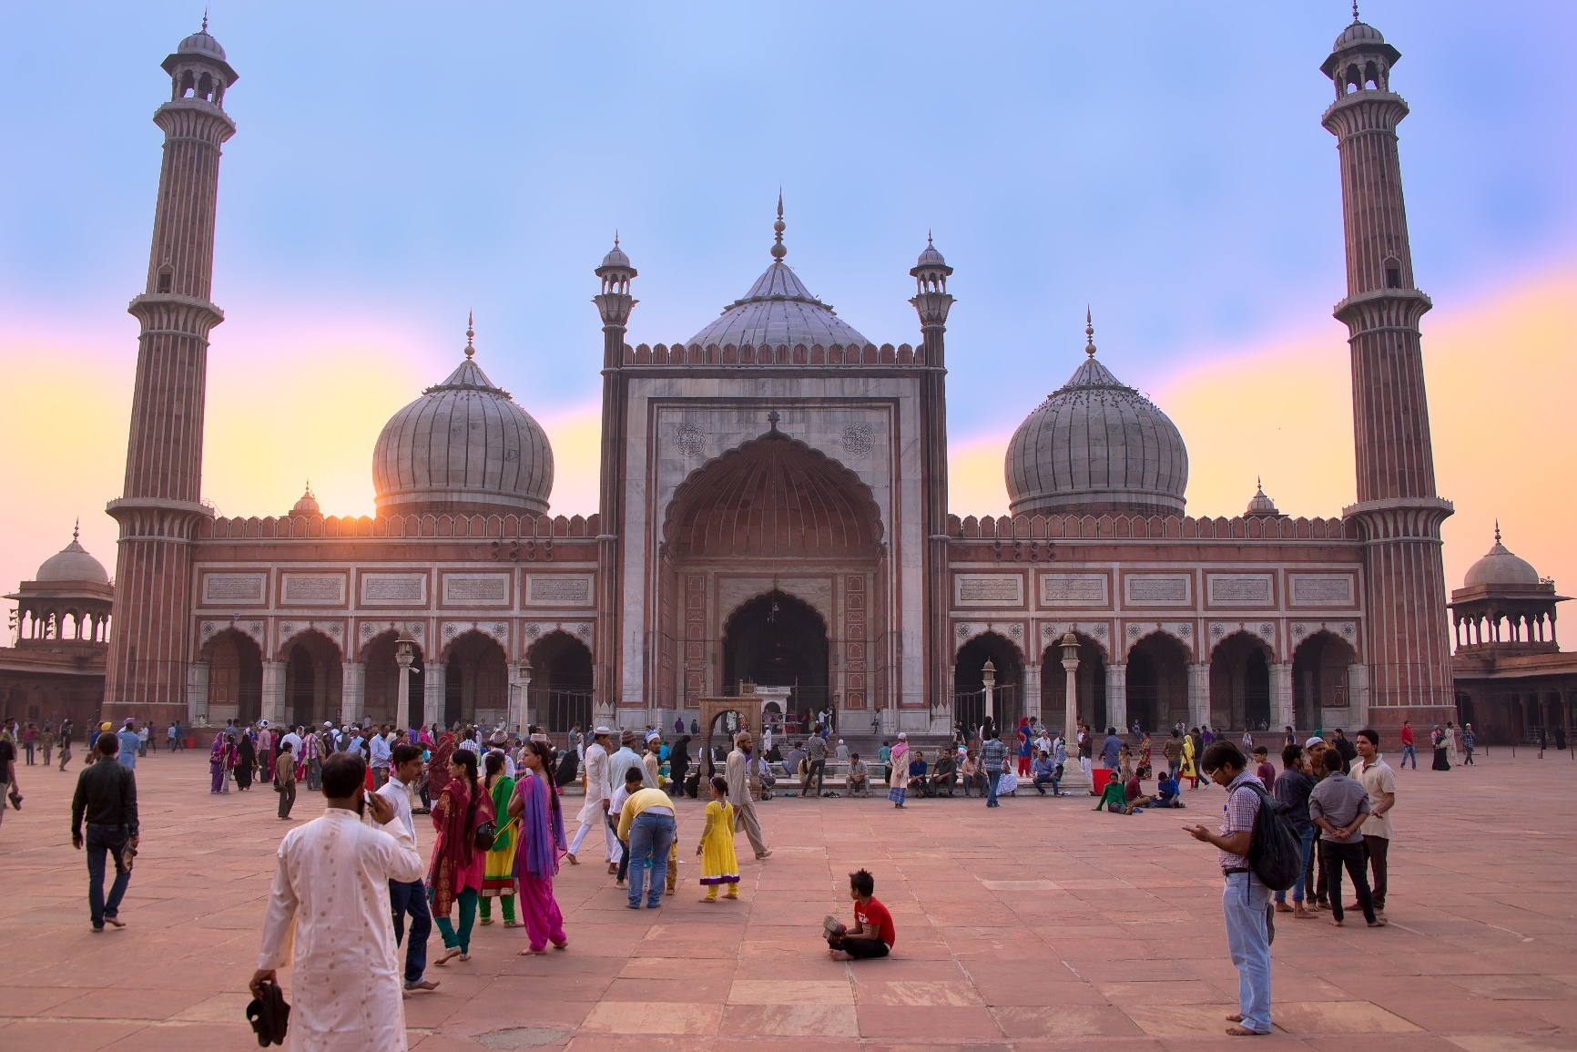
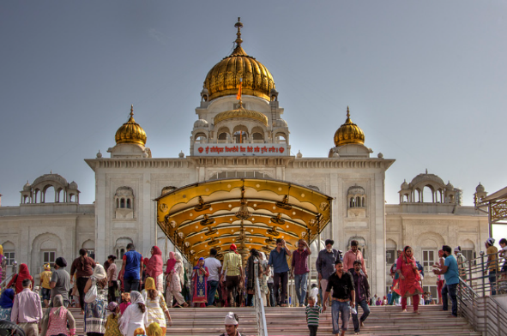
To engage your sense of sound, we bring you to Bangla Sahib. The magic of seva (selfless service) that the Gurudwara envelopes you into is undeniable. What ties together this beautiful experience is the sweet sound of the Gurbani playing in the background. Next, head to calm your favourite sense - taste! You will enjoy a meal at a contemporary Indian restaurant!
Before going back to the hotel, on the way, we show you the parts of Delhi with British influence and talk about the architectural contrast as well as some interesting stories from that time!

Overnight at the hotel.

Day 3: New Delhi – Agra

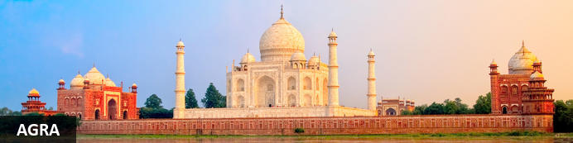
Straddling the broad Yamuna River 180km south of Delhi, Agra’s fame rests almost entirely on one building – the iconic Taj Mahal. Yet from the early 16th-century it was the Mughal empire’s capital endowed with numerous buildings and monuments that still make it a major draw for visitors. Apart from the Taj, Agra Fort (with its strong resemblance to Delhi’s Red Fort), the exquisite Tomb of Itmad-ud-Dalah (often called the ‘Baby Taj’), earthy bazaars and the evocative ‘ghost city’ of Fatehpur Sikri 40km to the west all make it a key tourist destination.

Day Itinerary
After breakfast, you will be transferred to railway station to board the train to Agra.

Train Gatimaan Express [The train does not operate on Fridays]
Departs Delhi 0810 Hrs.
Arrives Agra 0950 Hrs.

Upon arrival at Agra, you will be assisted & transferred to the hotel. (Standard check in time at the hotel is 1400 Hrs.).

Drop your bags at the hotel and freshen up. You will then proceed for a tour of Agra Fort.

Agra Fort
With its striking resemblance to Delhi’s Red Fort, Agra Fort’s massive sandstone walls stretch for over two kilometres with their eastern flanks overlooking a bend in the Yamuna River. Commissioned by the Mughal Emperor Akbar in 1573, its 90-acres of part-manicured gardens, imposing pavilions, royal apartments and audience halls are an impressive counterpoint to the Taj Mahal’s more delicate beauty and finesse. Built as a virtually self-contained imperial city, the fort came to symbolise Mughal military power. Here famously the Taj’s builder Emperor Shah Jahan was imprisoned by his own son and spent his final days gazing across the river at his beloved Taj Mahal.
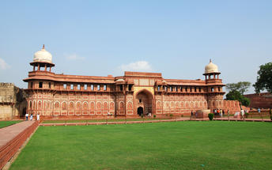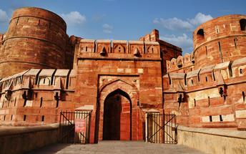

After the visit, return to your hotel for check in and relax.

Overnight: DoubleTree by Hilton Agra Hotel
The DoubleTree by Hilton Agra Hotel is situated near the Taj Mahal. All rooms and suites feature air-conditioning, a television, and various amenities for a comfortable stay. There are two on-site restaurants, a bar, and a cafe. Additional amenities include an outdoor pool, a fitness centre, a spa, and concierge service.
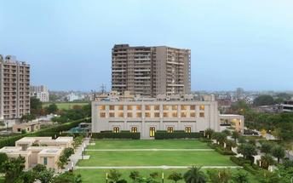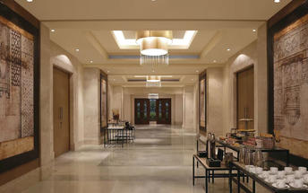

Day 4: Agra – Jaipur

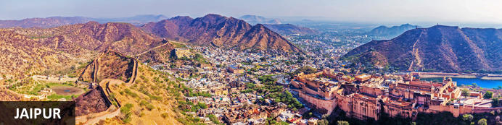
Founded in the early 1700s by Maharaja Jai Singh II as his new capital, the original ‘Pink City’ (so-called because almost all buildings were painted terracotta pink to honour the 1876 visit of the future King Edward VII) was laid out in a traditional grid with colonnaded streets and uniform façades. That layout remains intact and the city, now state capital of Rajasthan, has evolved and expanded into a modern metropolis with its own metro system. Yet its key sights and attractions lie within a relatively compact area. From vibrant bazaars and craft shops to grand palaces and huge forts, an extraordinary outdoor observatory and even one of the country’s most famous cinemas, Jaipur ticks every cultural, architectural and shopping box.

Day Itinerary
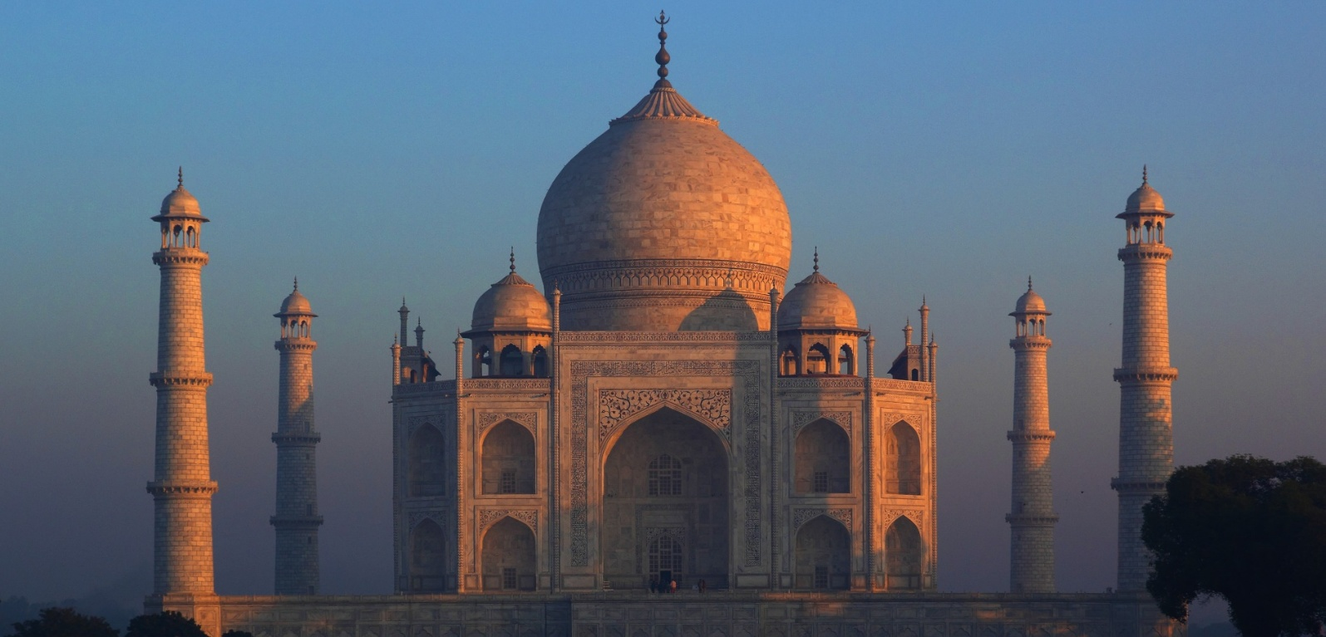
Early this morning witnesses the surreal views of the Taj Mahal [Taj Mahal remains closed on Fridays]. Step inside this eternal symbol of love and appreciate the intricate designs and symmetries that rhyme as a poem written in marble. Taj Mahal is an extravagant display of love, built by Shah Jahan in memory of his beloved wife Mumtaz.

After the visit, return to your hotel for breakfast.

Post breakfast, you will be driven to Jaipur [approx. 5 hours' drive]

Arrive Jaipur and check in at the hotel and relax.

Overnight: Hilton Jaipur
Hilton Jaipur is ideally located on the outskirts of Jaipur, just 1km from Ram Nagar metro stop and 11km from Jaipur International Airport. The accommodation features comfortable guest rooms and suites equipped with modern amenities including coffee makers, LCD TVs, hairdryers, air conditioning, desks and Wi-Fi. Guests can enjoy dining at the on-site restaurant and bar. Leisure facilities include a swimming pool, fitness centre and spa.
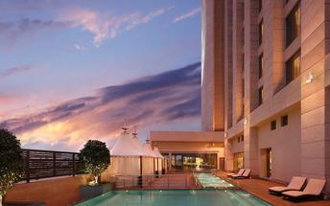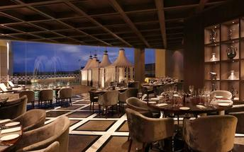

Day 5: In Jaipur

Day Itinerary
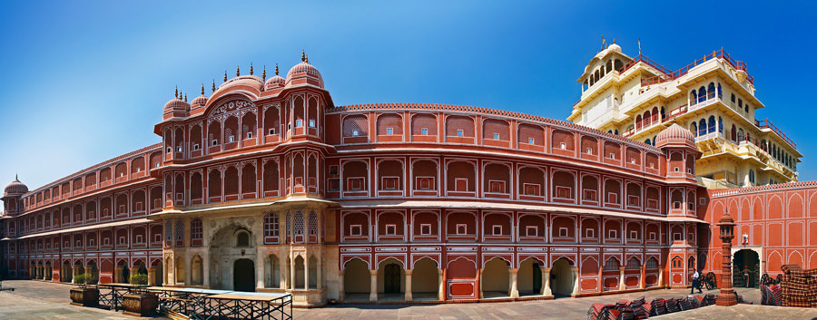
Begin exploring this city visit the City Palace complex which is spread over a large area occupying one-seventh of the old city of Jaipur. It is comprised of two palaces, Chandra Mahal and Mubarak Mahal, museum, a vast array of courtyards, gardens, and buildings. The palace is a blend of the Shilpa Shastra of Indian architecture with Rajput, Mughal, and European styles. Diwan-I-Aam (Hall of Public Audience), Bhaggi Khana (a museum), Pitam Niwas Gate, and Peacock Gate are must-see. Its outer boundary was built by Raja Jai Singh and the other structures by his successors to add charm to it. It also served as a residence for the former Maharaja of Jaipur, also visit the famous Jantar Mantar (an observatory)

Thereafter, head for a walking tour in the bazaars, this immersive experience offers a unique opportunity to explore the city’s vibrant bazaars, renowned for their exquisite textiles, distinctive artisanal goods, and delectable street food. A specially curated selection of Jaipur’s vibrant textile market and street delicacies, each reflecting the region’s rich culinary and cultural heritage, awaits your discovery.

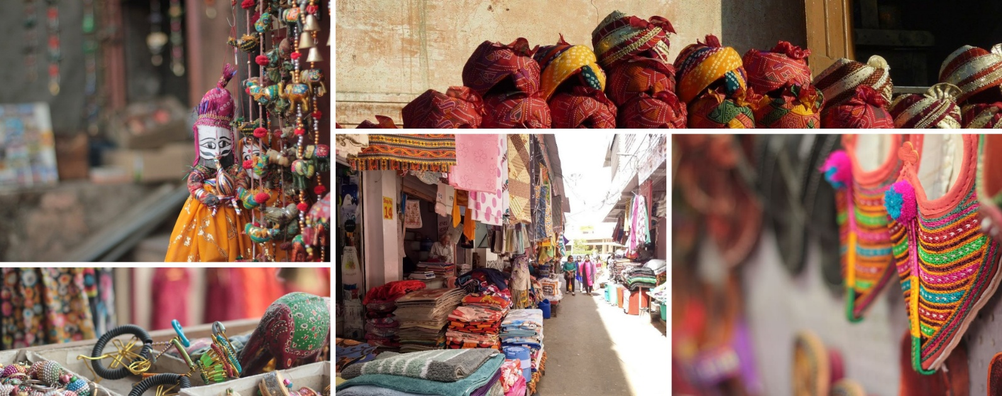
The textile market, in particular, stands as a testament to Jaipur’s centuries-old tradition of craftsmanship, where intricate patterns, vivid colours, and fine fabrics come together to embody the artistic soul of the Pink City.

Later in the evening proceed for the majestic Amber Fort that’s perched on a hill on the outskirts of Jaipur. The fort was once the capital of Rajasthan. Former residence of Rajput Maharajas, this fort is notable for its grand architecture showcasing the Hindu style of architecture. The Amber Fort was used by the Rajputs for the dual purpose of defence and for private residence. The fort encompasses charming gardens and magnificent palaces made from marble and precious stones, richly decorated with intricate stonemason works and paintings.
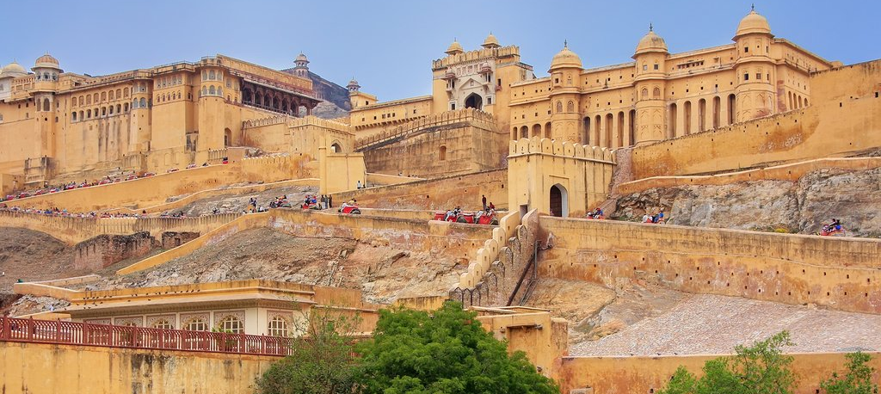
To ascend up the fort, we will arrange a Jeep for a short ride up to the fort gate!

The rest of the day is free for personal activities.

Day 6: Jaipur – Bikaner

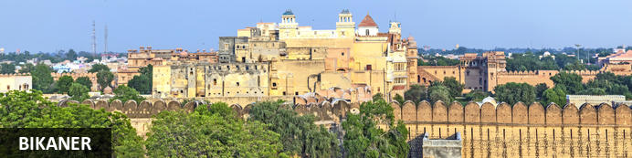
One of the most loved snack exports out of India has its origins in this Rajhastani city. Bikaneri Bhujia, an Indian version of potato chips, has become popular across the globe and today the crispy snack, using gram flour and spices, provides employment to over 2.5 million people. Bikaner boasts many unique architectural features such as the Bikaner Havelis – manifold mansions lining the narrow lanes of old town, signalling a glorious and opulent heyday in Bikaner history – and the beautiful Junagarh Fort, with its tall ochre walls extending for almost a kilometre around the impressive structure.

Day Itinerary
After breakfast, you will be driven to Bikaner. [approx. 5 hours' drive)
Arrive Bikaner and check in at the hotel.
Spend rest of the day at leisure.

Overnight: Narendra Bhawan Bikaner
Ideally located in Rajasthan in India, Narendra Bhawan Bikaner is an ideal accommodation option for leisure travellers. The hotel features a selection of stylish rooms which are comfortably furnished to ensure guests enjoy a relaxing stay. The en-suite guest rooms are equipped with modern amenities. The hotel features a selection of dining and drinking establishments to suit all guests’ gastronomic preferences. Amenities include a gymnasium and a swimming pool.
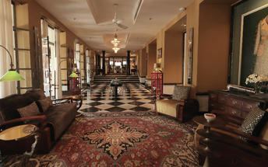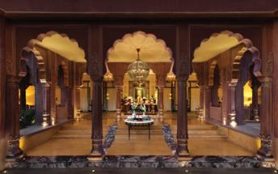

Day 7: In Bikaner

Day Itinerary
After breakfast enjoy half day sightseeing tour of Bikaner.

Junagarh Fort
Junagarh Fort is located in the princely state of Bikaner in India. The fort is a unique illustration of composite culture. It contains antique monuments and objects of art such as the symbolic hands of Sati, seven historic gates, nine attractive temples, and little shrines of various deities. The fort also features four deep wells, three beautiful gardens, post-medieval stables and barracks, an old jail, and armoury stones on the ground floor.
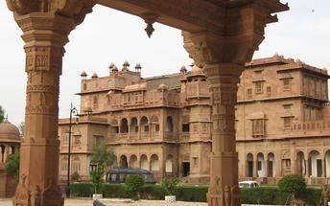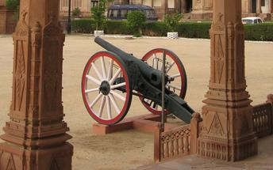

Prachina Museum
The Prachina Museum is located in the Junagarh Fort complex in Bikaner, India. The museum preserves Bikaner's rich cultural diversity and showcases the monolithic identity of Bikaner. Some of the collections include royal costumes and textiles, family portraits of the former rulers and the changing cultural milieus from generation to generation. Also displayed are items portraying Western influences, ritualism and religious accessories, as well as the legacy of the patronage which survives in Bikaner's contemporary arts and crafts till date.
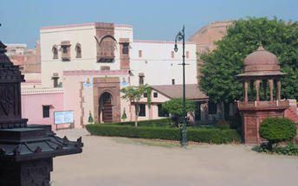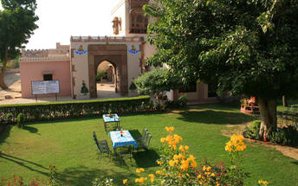

Day 8: Bikaner – Jaisalmer

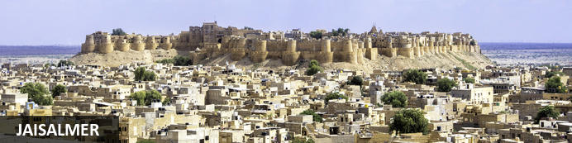
Situated amid the vast expanse of the Thar Desert on the far western border of India’s Rajasthan state, the city of Jaisalmer is home to the world's only inhabited medieval living fort. This 12th-century city served as a bustling trading post along the famous Silk Road and still to this day features markets selling silk, cashmere, silver jewellery, bronze statues and much more. The undeniable star attraction of this city is the spectacular Jaisalmer Fort, which rises from the desert floor like a gigantic sandcastle and encompasses winding streets filled with shops, temples, hotels and ancient mansions. Visitors can also look forward to taking jeep and camel safaris into the surrounding desert and exploring a variety of grand palaces, elaborate Jain temples and ornate havelis.

Day Itinerary
After breakfast, leave with your private chauffeur driven vehicle to Jaisalmer [approx. 5-6 hours’ drive]
Arrive Jaisalmer and check in at the hotel.
Rest of the day will be at leisure.

Overnight: Fort Rajwada Hotel
Fort Rajwada is a successful attempt by Late Shri Dilip Singh Rathore to rediscover and restore the art and craft that made Bharat the 'eternal golden sparrow'. Built on 6 acres of land, the princely home has breath taking interiors done in traditional style. Located in the peaceful countryside on the outskirts of the golden city is the oasis of serenity and comfort.

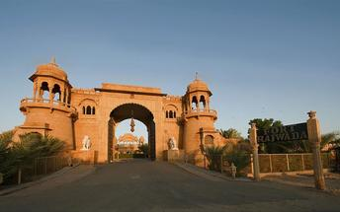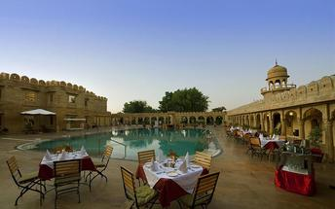

Day 9: In Jaisalmer

Day Itinerary
After breakfast do a tour of Jaisalmer visiting Jaisalmer Fort and Gadisar Lake.

Opportunity to do a visit to the dunes in the evening.

Jaisalmer Fort
The Jaisalmer Fort also goes by the name Sonar Quila (Golden Fort) as it rises from the desert itself and seems to become one with the golden hues of the sand. The setting sun adds its own magic and shrouds the fort with mystique. The fort is constructed in the classic style of the royals by local craftsmen. This fort is a world heritage site and forms an important plot point in one of Satyajit Ray’s famous Feluda stories and corresponding movie, Sonar Kela (The Golden Fortress).

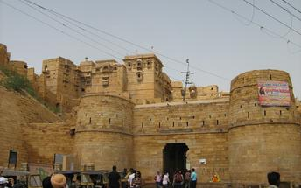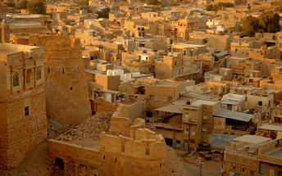

Gadisar Lake
The Gadisar Lake is located in the southern part of Jaisalmer, India, and is a lake that was constructed by Raja Rawal Jaisal, the first ruler of the city. Tourists can enter the historical site through a yellow sandstone archway, which is known as the Tilon-Ki-Pol. The site features various shrines and temples which are set on the banks of the lake. Visitors can view a variety of migratory bird species as well as view the domed pavilion set in the centre of the lake.
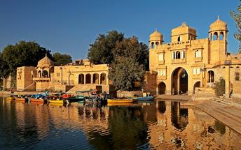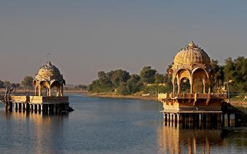

Day 10: Jaisalmer – Jodhpur

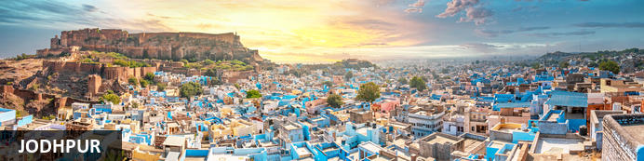
Rajasthan’s second city and the former capital of the Kingdom of Marwar, Jodhpur lies on the eastern edge of the Thar desert which stretches away into neighbouring Pakistan. Found in the 1450s by Rao Jodha, a Rajput chief, it’s a large modern city but the focus for visitors remains its striking fort cresting a pronounced ridge. At its foot clusters the old town, a maze of lanes, alleys and bazaars with many of it houses painted shades of blue – explanations for which range from residents associating themselves with the god Shiva (myths tell how he turned blue after consuming poison) to underlining their Brahmin caste status to warding of termites. Even if you’re not staying in the vast Umaid Bhawan Palace, it’s a key destination on most Rajasthan itineraries.

Day Itinerary
After breakfast you will be driven to Jodhpur [approx. 5 hours' drive]
Arrive Jodhpur and check in at the hotel.

Overnight: Ajit Bhawan Palace Resort
Ajit Bhawan Palace Resort is nestled between the Umaid Bhawan Palace & the Mehrangarh Fort that towers over Jodhpur. The accommodation features stylish rooms and suites equipped with modern amenities LCD flat-screen TVs, spacious closets and WI-Fi access. Guests can enjoy a meal at the restaurant or relax at the swimming pool.

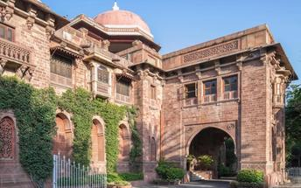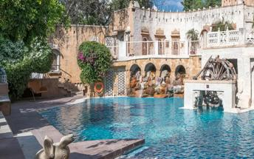

Day 11: In Jodhpur

Day Itinerary
After breakfast do the tour of the city covering the majestic Mehrangarh Fort and Jaswant Thada.

Mehrangarh Fort
Mehrangarh Fort is situated in Jodhpur, Rajasthan, India. The fort was constructed in 1459 by Rajput ruler Rao Jodha and stands a hundred feet in splendour on a perpendicular cliff, four hundred feet above the skyline of Jodhpur. The fort's boundaries house several palaces with intricate carvings, expansive courtyards, and a museum featuring various relics.
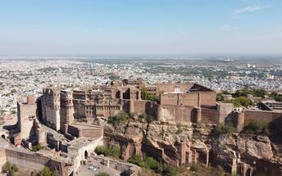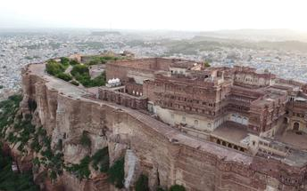

Jaswant Thada
If you’re looking for a quiet place in Jodphur head to Jaswant Thada, popularly known as the ‘Taj Mahal of Marwar’. This architectural landmark was built in 1899 by Maharaja Sardar Singh of Jodhpur State, in memory of his father, Maharaja Jaswant Singh I. Built from intricately carved marble sheets and boasting some beautiful carved marble lattice work, the impeccable design and architecture is symbolic of the fine craftsmanship of a bygone era. Beautiful sculptures, carved gazebos and frescos characterise the cenotaph, with the tiered garden offering superb views across to the fort and over the city.
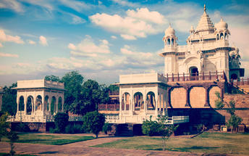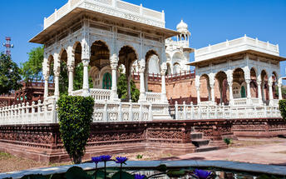

Day 12: Jodhpur – Udaipur

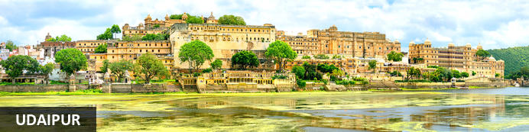
Cradled by the Aravalli Hills and watered by five lakes, Udaipur was founded in 1559 by Udai Singh, ruler of the Kingdom of Mewar. The city became his new capital complete with man-made lakes (hence the common epithet ‘Lake City’) and palaces. It’s still considered one of Rajasthan’s most romantic destinations, a reputation enhanced by the celebrated Lake Palace Hotel and given an unlikely if not surreal global boost by featuring in a James Bond movie.

Day Itinerary
After breakfast, leave with your private chauffeur driven vehicle to Udaipur (approx. 5-6 hours' drive) with a stop at the magnificent 15th century Jain temples at Ranakpur.

Ranakpur
The small town of Ranakpur is home to what is arguably the most spectacular of all India’s Jain temples. The complex rests on a lush mountain slope and encompasses a series of temples dating to the 15th century, all constructed from white marble and featuring exquisite decorative detail. The main temple, Chamukha, is a multi-tiered structure with no less than 80 domes and over 1400 pillars, all of which are intricately carved with unique designs – no two are alike. As the light changes during the day, so does the colour of the temple interior, shifting from golden to cream and then pale blue at dusk.

Note: Leather items like Belts, purses or wallets etc. are not allowed inside Ranakpur Temple complex. Also, local guides are not available at the temple, only audio guide will be provided.

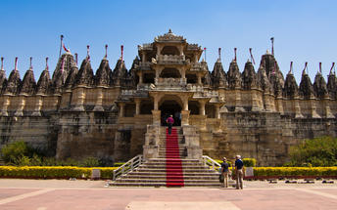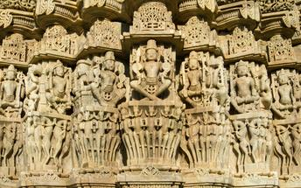
Arrive Udaipur and check in at the hotel.

Overnight: Fateh Niwas
Fateh Niwas Udaipur is a strategically located property in the city, offering a cultural experience in an antiquated setting. Enjoy breath-taking views of The City Palace, Jagmandir, Monsoon Palace, Lake Pichola and the Aravalli hills from our roof top pool and restaurant. Reliving the Antiquated- An ideal venue for weddings and events in Udaipur amongst recreated ruins of old temples. Fateh Niwas has 4 different venues with 2 swimming pools and a conference hall.
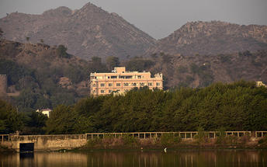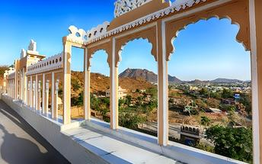

Day 13: In Udaipur

Day Itinerary
After breakfast, proceed for a half day sightseeing tour of Udaipur
In the afternoon have a shared boat ride on Lake Pichola [Subject to water level].

Udaipur City Palace
Overlooking the eastern shore of Lake Pichola, Udaipur’s largest lake, City Palace is a monumental complex of palaces, quadrangles, gateways and halls built by more than twenty generations of royals over 400 years. Towers, cupolas and projecting balconies lend an almost whimsical charm while interior murals, mosaic mirror-work, glass inlay and acres of marble combine solidity with indulgence. Parts of the complex are now a luxury hotel. One of its most remarkable sections is the ‘Crystal Gallery’ with extraordinary sets of furniture and crockery made entirely from crystal; ordered from London by a maharaja who died before they arrived, it’s claimed the cases were delivered but remained unopened for over a century.

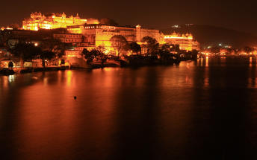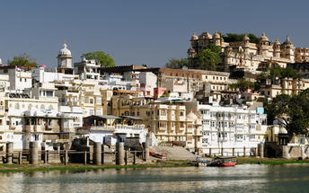

Jagdish Temple
Completed in 1651, Jagdish Temple is situated just outside the royal palace. The temple can be seen as soon as visitors enter the city. Puja’s and prayer time are the best time to visit when melodious chants from devotees float through the small interior. Visitors should make a point of climbing the temple's many steps which invite them on a journey of discovery of the rich and vibrant history of Udaipur.

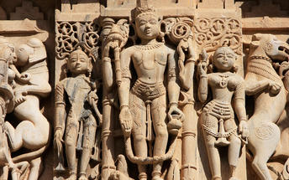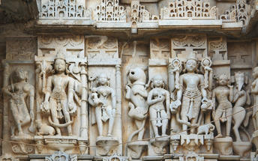

Saheliyon-ki-Bari
Located in Udaipur, India, Saheliyon-ki-Bari is situated in the northern part of the bustling city. The garden is popular amongst local and tourists offering lush green gardens and beautiful fountains. The garden was built by King Rana Sangram Singh for his wife and her 48 maids, to keep them far from political enticements. A small museum can be found on the property which was once a safe haven for the queen and her main servers.

Boat ride at Lake Pichola
Although Udaipur’s best-known lake predates the city’s founding by centuries, it was Mewar’s earliest maharajas who expanded it (and developed others with dams) to safeguard their water supply. Today Pichola spans nearly seven square kilometres framed by the Aravallis with its eastern and northern shores seeing the most development. Boat rides capture the best of the city’s romance with unmatched views of City Palace glowing at sunset plus other lakeside ablutions and bathing at nearby ghats (steps). You can also see if not visit a handful of small islands, one now the celebrated Lake Palace Hotel while the Jag Mandir is a kind of royal pleasure garden.
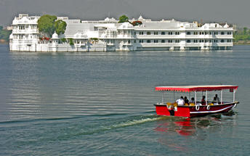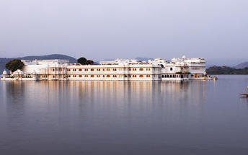

Day 14: Udaipur – New Delhi

Day Itinerary
Breakfast at the hotel.

Later you will be transferred to Udaipur airport for your flight to Delhi.

Flight TBA
Departs Udaipur TBA Hrs.
Arrive Delhi TBA Hrs.

Arrive Delhi and transfer to your hotel.

Overnight: Vivanta New Delhi Dwarka
Located in Delhi NCR, Vivanta New Delhi Dwarka offers comfortable accommodation directly connected to the centre of the city. The hotel's elegant rooms feature complimentary Wi-Fi access, flat-screen TVs, coffee makers and telephones. Guests can enjoy delicious dishes at several on-site dining options. Additional amenities include a fitness centre and a spa.

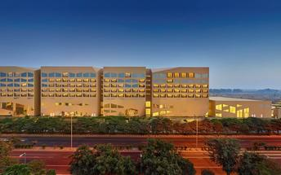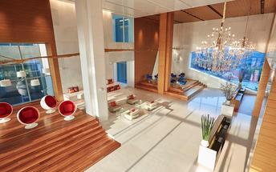

Day 15: Depart New Delhi

Day Itinerary
At appropriate time, you will be met and transferred to Delhi airport to board the flight for onward journey.

Flight TBA
Departs Delhi TBA Hrs.

**** END OF SERVICES ****

NOTE:
- The distances and time taken for the travel is approximation only this will differ based on the traffic conditions and other unforeseen circumstances.

