

IN: 05

Highlights of Rajasthan
Delhi - Agra - Ranthambore - Jaipur - Jodhpur - Narlai - Udaipur - Mumbai
16 Days / 15 Nights
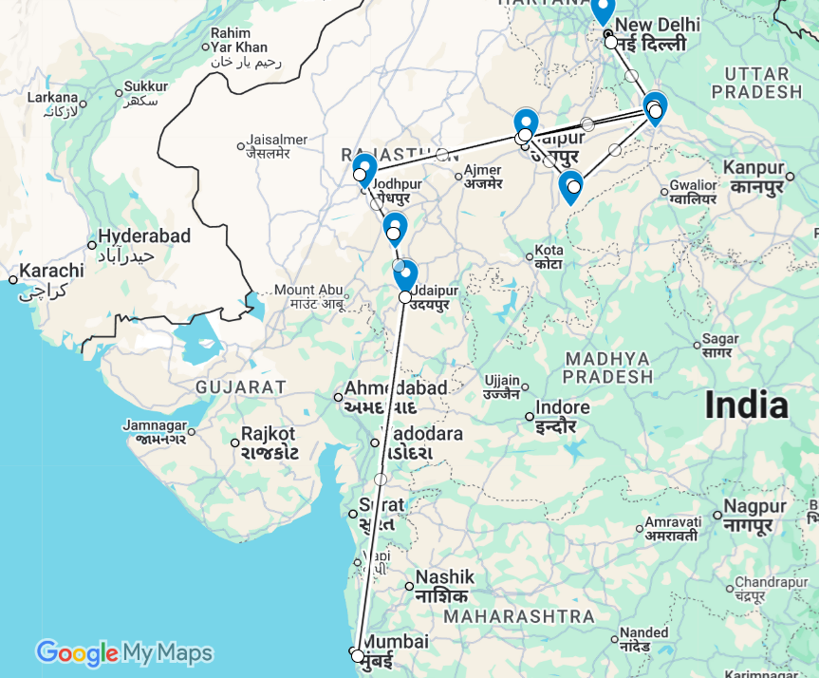

Overview: The journey covers the highlights of Rajasthan along with and Ranthambore National Park and Mumbai – the commercial capital of India.
New Delhi, the national capital, offers several key sights and historic monuments while Agra is synonymous with the Taj Mahal – a high-point of Mughal architecture and one of the world’s most celebrated buildings. Nearby Fatehpur Sikri, one-time capital of the Mughal dynasty, is an extraordinary example of a planned medieval city. Ranthambore offers superb wild tiger sightings in a rugged hilly landscape while Jaipur, Rajasthan’s state capital, boasts some of the region’s finest palaces and impressive forts along with an eclectic array of crafts and shopping. Jodhpur and Udaipur were the historic capitals of major Rajput princely states. Jodhpur’s fascinating old town is still overlooked by huge 15th-century Mehrangarh Fort perched atop a rocky ridge while its vast Umaid Bhawan Palace hotel is a unique blend of Indo-Saracenic and Art Deco styles. Udaipur – or ‘Lake City’ after its lakeside location – is probably the state’s most picturesque city with an imposing palace complex overlooking Lake Pichola and a charming island palace, now a famous luxury hotel.
Mumbai, India’s most populous city is also its economic powerhouse – the most commercial, go-ahead and thrusting modern face of India with Bollywood a prominent face of its glitz and glamour. It’s not merely a major international gateway; a clutch of handsome Raj-era buildings and monuments testify to the city’s significant imperial heritage while markets, museums and various shrines can easily fill a day or two’s sightseeing. Elephanta Island’s ancient rock-cut temples make a pleasing excursion away from the city’s almost frantic bustle.
Days | Nights | City | Hotels [Room Category] | Meal Type
Day 01-03 | 02 | Delhi | The Suryaa [Deluxe Room] | BB
Day 03-04 | 01 | Agra | Courtyard by Marriott [Deluxe Room] | BB
Day 04-06 | 02 | Ranthambore | Ranthambore Kothi [Regal room] | FB
Day 06-08 | 02 | Jaipur | Hilton [Guest Room] | BB
Day 08-10 | 02 | Jodhpur | Welcom Jodhpur [Deluxe room] | BB
Day 10-12 | 02 | Rawla Narlai | Rawla Narlai [Grand Heritage room] | HB
Day 12-14 | 02 | Udaipur | Manuscript Jhilwara Haveli [Superior room] | BB
Day 14-16 | 02 | Mumbai | IHCL Taj President [Superior Room] | BB

Day 1: Arrive Delhi

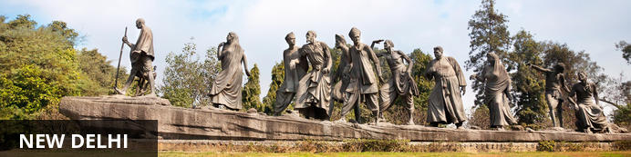
New Delhi, India’s national capital, is a relatively modern confection of imposing government buildings including Parliament, museums and wide leafy boulevards loosely centred on circular Connaught Place (officially now called Rajiv Chowk). To its north lies the formerly walled city of Old Delhi, or Shahjahanabad, built in the 17th-century by the Mughal Emperor Shah Jahan. Though long merged into one metropolis, the two have very different characters. New Delhi has space, parks, distinct neighbourhoods and a clutch of important monuments and architecture that reflect its ancient history. Old Delhi’s crowded streets, lanes and bazaars reflect its colourful medieval character and they cradle some of the city’s most memorable sights.

On arrival in Delhi: Having cleared immigration, collected your luggage and passed through customs, please make your way towards the exit of the terminal building where you will see a bank of people waiting for you. Amongst them will be Travel Counsellors Representative who will be waiting to greet you with a paging board with your name on.
You will be transferred to your hotel and assisted with check in. Standard check in time is 1400 hrs.
Overnight at Hotel The Suryaa

Day 2: In Delhi

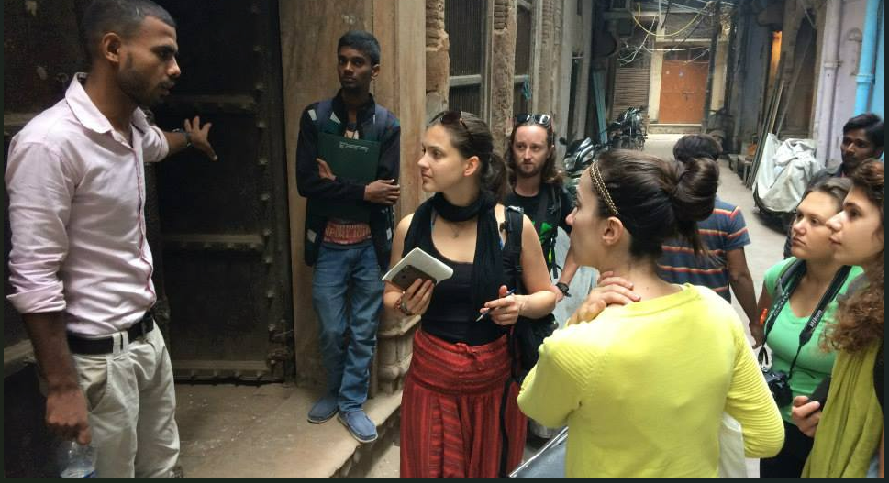
After early breakfast morning you would be taken for half day tour of Old Delhi with Salaam Balak Trust guide.
Established in 1988, the Salaam Baalak Trust is a Delhi-based NGO committed to supporting ‘street children’ across the city. The name roughly translates as ‘salute a child’ and its mission is to secure the futures of children who for a variety of social and family reasons have ended up living precariously if not dangerously on the margins of society, either in slums or on the streets.
Salaam Baalak Trust City Walk
Begin the day with the walk in Old Delhi with an English-speaking guide from Salaam Balaak Trust (A NGO supporting Street children) including rickshaw ride in Old Delhi followed by a tour of New Delhi visiting the UNESCO world heritage sites.
The Trust’s programmes encompass various outreach projects, health & nutrition, education & skill building and rehabilitation. One facet of this are guided walks led by former street children who have shrugged off adversity, gone on to study and forged independent lives within mainstream society. On foot and by rickshaw, this guided tour takes an immersive look at the atmospheric lanes, markets and bazaars of Old Delhi. Between the great Jami Masjid mosque and the famous thoroughfare of Chandni Chowk, you’ll see everyday life in one of Delhi’s most characterful neighbourhoods – spice markets, wedding paraphernalia, street food and hidden havelis, or merchants’ mansions.
Afternoon visit of monuments in New Delhi and later drive past India Gate.
Qutub Minar
In the southern reaches of Delhi’s Mehrauli neighbourhood, this extraordinary 72-metre-high sandstone minar, or tower, was erected in stages between 1199 and 1369 by some of the earliest Muslim dynasties to reach India. With alternating rounded and angular flutings along with mainly koranic inscriptions, it’s the most striking part of a large ensemble of buildings – a tomb, a madrasa (or religious school) and various gateways – that combine Muslim and Hindu architecture. Here too stands an enigmatic 4th-century iron pillar that doesn’t rust; it’s common to see visitors encircling it with their arms attempting to touch fingers in the belief that any wish will then be granted.
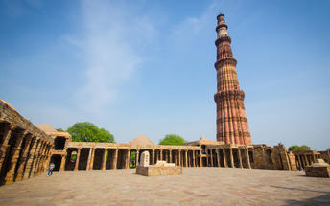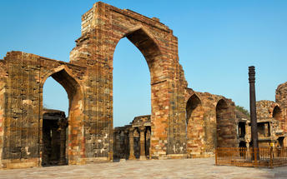
Humayun's Tomb
Completed in 1572 this was the first so-called ‘garden tomb’ to be built in the Indian subcontinent. Humayun was the second Mughal emperor, and his widow commissioned a posse of Persian and Indian craftsmen to build the Mughal empire’s most magnificent mausoleum over a period of seven years. The striking use of red sandstone inlaid with marble, a pioneering double-dome and 30-acre gardens with channels and a quadrilateral layout – all enclosed by walls and lofty gateways – marked a new monumental scale of tomb building. Its innovations ultimately culminated in the construction of the Taj Mahal.
Drive past India Gate
India Gate, a significant monument in New Delhi, serves as a memorial for Indian soldiers who perished in World War I and the Afghan War of 1919. Designed by Edwin Lutyens, it features the Amar Jawan Jyoti, an eternal flame honouring soldiers from the Indo-Pakistan War of 1971. The structure is illuminated at night and is surrounded by expansive green lawns, making it a popular spot for visitors. The monument stands at one end of Rajpath, with the area around it commonly referred to as ‘India Gate’. The lawns are a favoured picnic spot, especially on summer evenings.
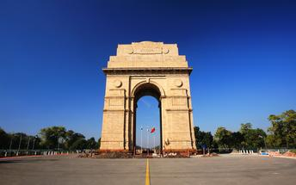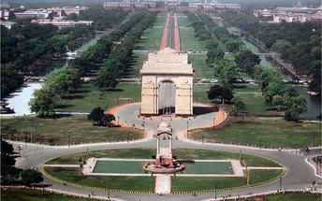

Day 3: Delhi- Agra

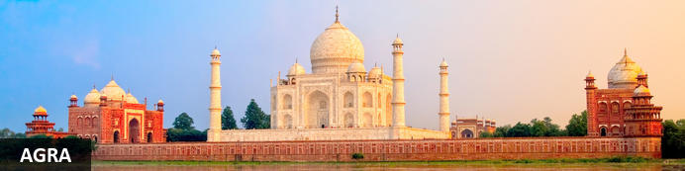
Straddling the broad Yamuna River 180km south of Delhi, Agra’s fame rests almost entirely on one building – the iconic Taj Mahal. Yet from the early 16th-century it was the Mughal empire’s capital endowed with numerous buildings and monuments that still make it a major draw for visitors. Apart from the Taj, Agra Fort (with its strong resemblance to Delhi’s Red Fort), the exquisite Tomb of Itmad-ud-Dalah (often called the ‘Baby Taj’), earthy bazaars and the evocative ‘ghost city’ of Fatehpur Sikri 40km to the west all make it a key tourist destination.

Day Itinerary
After breakfast, you will be transferred to railway station to board the train to Agra.
Train Gatimaan Express (operates daily except on Fridays)
Departs Delhi 0810 Hrs
Arrives Agra 0950 Hrs

Upon arrival at Agra, you will be assisted & transferred and taken directly to Agra Fort for the visit followed by check-in at the hotel. (Standard check in time at the hotel is 1400 Hrs).

Agra Fort
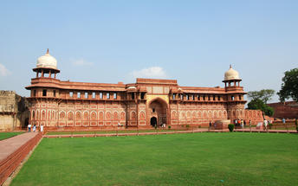
Known as the Red Fort of Agra, this walled imperial city was founded in 1565 by the Emperor Akbar (1556-1605) and is a well-deserving UNESCO World Heritage site, located just 2.5 kilometres from the famous Taj Mahal. Its palaces, grand mosques and elaborate public hall are crafted from pink-red sandstone and are testament to an era when Indo-Muslim art, strongly marked by influences from Persia, was at its height. Emperor Shah Jahan, who built the Taj Mahal for his deceased wife, was imprisoned by his son Aurangzeb in Agra Fort. He is said to have died in the Musamman Burj, a marble tower he himself built, with one of the most alluring views of the Taj Mahal.
Evening enjoy Heritage Walk in Old Agra [Duration 02 Hrs.]
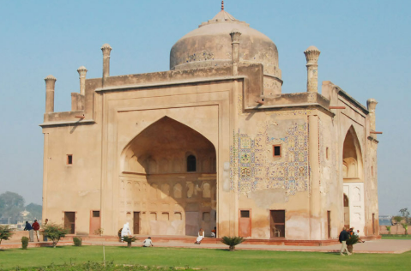
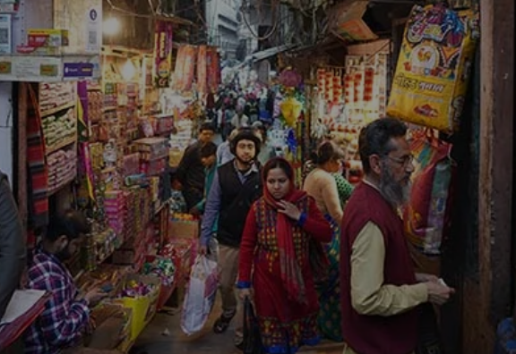
Agra is a city steeped in history and culture, but there's more to it than just the Taj Mahal. With an Agra walking tour, you can uncover the city's hidden gems and experience its authentic charm. Set out on a magical trip that will transport you to the heart of Agra’s best-kept secrets; With the Agra walking tour, we promise an extraordinary adventure that unwraps the lesser-known yet immensely intriguing facts covering every corner of this historical wonderland. Escape the ordinary and uncover, indulge and immerse in the magic of the Agra Street Walk like never before. Prepare yourself for a captivating thrill as the Agra Walk tour promises a magical exploration of the heart of Agra's secret old city, where you'll discover hidden temples, mosques, and markets. You'll also have the chance to marvel at stunning Mughal-inspired architecture, including the Jama Masjid and the Chini ka Rauza. One secret at a time!
Overnight at Hotel Courtyard Agra

Day 4: Agra- Ranthambore


Ranthambore National Park, in the western state of Rajasthan, is one of the most visited wildlife parks in India. Spanning over an impressive 1300-square-kilometer stretch of wilderness, the park’s outstanding natural beauty is characterized by its dense jungle, golden savanna, dramatic cliffs and lotus-filled lakes. Considered the best spot to catch a glimpse of tigers in the wild, the park offers visitors a spellbounding combination of mystical temples, wild beauty and crumbling ruins. While the main attraction is undoubtedly the elusive Bengal tiger, the park provides a sanctuary for other wildlife including, among others: sambar, gazelle, caracal, black buck, crocodile, chital, wild boars and a wide array of birds. Don’t miss the ancient Ranthambore Fort, perched high on the cliffs overlooking the vast expanse of this spectacular park.

Early morning visit Taj Mahal at Sunrise (Closed on Fridays)
Sunrise visit to Taj Mahal
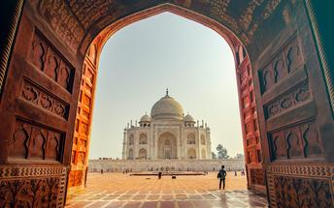
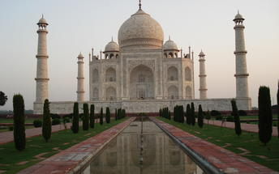
Standing at the head of formal gardens beside the Yamuna River, the Taj Mahal is one of the world’s most extraordinary buildings. Built by Emperor Shah Jahan in 1653 to entomb his wife Mumtaz, its construction took two decades, utilised over 20,000 labourers and a thousand elephants. The finest craftsmen from India and Persia utilised Indian marble, Chinese jade, Tibetan turquoise and Afghan lapus lazuli. In all almost thirty types of precious and semi-precious stones were inlaid into the milky-white marble. It cost an absolute fortune even by the standards of the day; nothing on this scale had been attempted before or since. It still has a powerful ethereal beauty – the delicate onion dome rising above dainty kiosks, slender taping minarets, marble whose ever-changing hue reflects the ambient light and symmetrical gardens with water channels and fountains. Widely regarded as the height of Mughal architecture, the Taj has come to symbolise India itself.

After breakfast check out from the hotel and leave with your private chauffeur driven vehicle to Fathepur Sikri.

After the visit, proceed to Bharatpur train station for the train ride to Sawai Madhopur.

Fatehpur Sikri
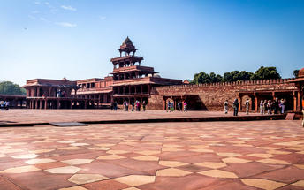
A highlight in the province of Uttar Pradesh, Fatehpur Sikri served briefly as the capital of the Mughal Empire from 1571 to 1585. This world heritage site is rated as one of the best-preserved collections of Mughal architecture in India. Surrounded by a six-kilometre wall, with the fourth being a lake at the time, a day can be spent exploring the elaborate structures within. Marvel at the impressive Jama Masjid mosque, the detailed palaces built for Emperor Akbar’s wives, the public and private discussion halls and vast ornamental pool; all of which took over 15 years to conceptualise and build.
After the visit, your Travel Counsellor Representative will transfer you to Bharatpur railway station (approx 25 kms/ 40 minutes) to board the train to Sawai Madhopur

Train Kota Jn Shatabdi
Departs Bharatpur 1430 Hrs
Arrive Sawai Madhopur 1715 Hrs

Upon arrival at Sawai Madhopur, you will be met and taken to the hotel for check in.

Overnight at Hotel Ranthambore Kothi

Day 5: In Ranthambore

Enjoy morning and afternoon game drive in to the park with a local naturalist.
The game drive is either by shared jeep (max. 6 persons in a jeep)

Tentative Safari Timings
Morning : 0600 – 0930 hrs.
Afternoon : 1500 – 1800 hrs.

Ranthambore National Park
Named after a rambling 10th-century fortress which still stands sentinel on a 200m-high plateau, Ranthambore is one of India’s most famous national parks. One a royal hunting ground, today its 1334km² of dry forests, grassy meadows, lakes, streams and rugged picturesque hills are home to a sizeable population of wild tigers. Other wildlife includes leopards, antelopes, deer, hyenas, jackals, sloth bears, crocodiles and over three hundred species of birds. Access is closely regulated with a set number of vehicles, visitors and driving routes allocated each day to evenly distribute the human impact on its flora and fauna.
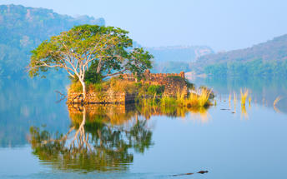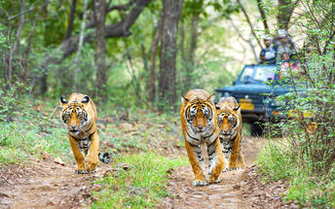

Day 6: Ranthambore - Jaipur

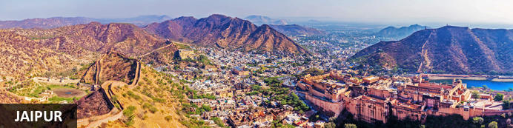
Founded in the early 1700s by Maharaja Jai Singh II as his new capital, the original ‘Pink City’ (so-called because almost all buildings were painted terracotta pink to honour the 1876 visit of the future King Edward VII) was laid out in a traditional grid with colonnaded streets and uniform façades. That layout remains intact and the city, now state capital of Rajasthan, has evolved and expanded into a modern metropolis with its own metro system. Yet its key sights and attractions lie within a relatively compact area. From vibrant bazaars and craft shops to grand palaces and huge forts, an extraordinary outdoor observatory and even one of the country’s most famous cinemas, Jaipur ticks every cultural, architectural and shopping box.

After breakfast, check-out and leave with your private chauffeur driven vehicle to Jaipur (approx 145 kms./ 04 hours drive)

Arrive Jaipur and check-in at the hotel.

Rest of the day is at leisure.

Overnight at Hilton Jaipur

Day 7: In Jaipur

Morning proceed for visit of City Palace, Govind Dev temple, Jantar Mantar.
Jaipur City Palace
Up until India’s Independence in 1947, Jaipur’s City Palace was the ceremonial and bureaucratic seat of power of the Maharaja of Jaipur. Standing in the heart of the Old City founded by his ancestor, the 18th-century palace remains one of the city’s key sights. It’s a huge complex of courtyards, opulent audience halls, royal apartments, temples and pretty pavilions, some of which are still occupied by the royal family. It’s also home to a large museum with galleries devoted to textiles, armaments and painting.
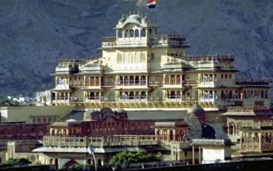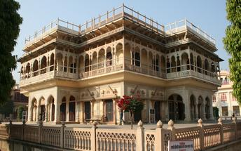
Govind Dev Ji Temple
Nestled within the glorious confines of Jaipur's iconic City Palace, an architectural marvel stands as a beacon of spiritual enlightenment. This enchanting temple shrouded in reverence is known as the Govind Dev Ji Temple. As you wander through the City Palace, the Govind Dev Ji Temple emerges with its towering rose-hued spires and domes. This exquisite religious sanctuary, built in the 18th century, is a stunning example of Rajasthani craftsmanship. Its intricate carvings, marble inlays, and vibrant frescoes capture the senses and transport you to timeless beauty and spirituality.
Jantar Mantar Jaipur
The Jantar Mantar (which translates as ‘calculating instrument’) is an ensemble of nineteen astronomical instruments built by the city’s founder, Maharaja Sawai Jai Singh, in 1734. Jai Singh was almost obsessed by astronomy and mathematics and this complex is one of several he constructed in various cities. Superficially resembling a rather whimsical playground, these instruments are surprisingly sophisticated and capable of, for example, measuring sunrise and sunset, azimuth, the coordinates of stars and planets, and time. The ensemble includes a giant sundial – at 27m tall one of the world’s largest – with a visibly moving shadow.
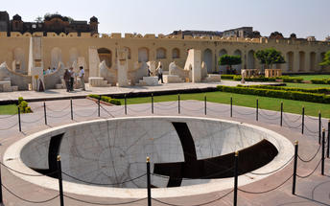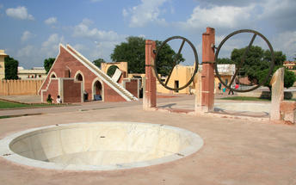
Photo stop at Hawa Mahal (Palace of Winds)
One of Jaipur’s most iconic buildings, the Palace of Winds’ intricate lattice-work façade was constructed in 1799 as an extension of the royals’ City Palace. Hundreds of tiny arched windows along with niches and hood-like mouldings present a striking appearance bolstered by its salmon-pink walls. Designed to allow ladies of the royal household to view the outside world without themselves being seen by strangers, this tradition of purdah, or female seclusion, was steadfastly observed by Rajasthan’s royal families. The latticed façade also helpfully funnelled cooling breezes while its overall shape reputedly resembled the crown of Krishna, one of Hinduism’s most important deities.
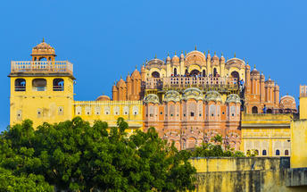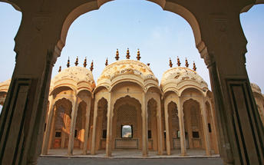
Late afternoon you will be taken for visiting the Amer Fort, enjoy a jeep ride to ascend to the fort.
Amer Fort
Cresting a stark rocky ridge on the hilly northern fringes of Jaipur, 16th-century Amber (or Amer) Fort is one of the finest examples of a Rajput fort-palace. Overlooking a lake and enclosed by kilometres of wide crenellated walls that wriggle across the enclosing hills, this huge complex of audience halls, pavilions and royal apartments is a compelling blend of Hindu and Mughal architecture. Although its once lavish interiors are now diminished, sufficient part-marble interiors, decorative frescoes, coloured glass and mirror-mosaics still reveal some of the grandeur of life in a maharaja’s court in what was one of Rajasthan’s most powerful princely states.
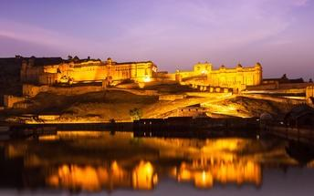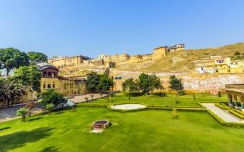

Day 8: Jaipur- Jodhpur

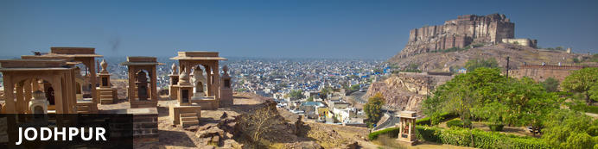
Known as the gateway to the Thar Desert, Jodhpur is the second largest city in the state of Rajasthan, India. It is a popular tourist destination featuring a variety of ornate palaces, age-old forts and sacred temples. Dubbed “The Blue City", most houses in the old city are painted a beautiful shade of indigo. While Jodhpur is largely a sprawling modern metropolis, enclosed within its old city walls is a labyrinth of winding, narrow medieval streets and bazaars. Jodhpur is home to one of the largest forts in India, the massive 15th-century Mehrangarh Fort, which towers over the city from its sandstone plinth. Other must-see attractions include the Umaid Bhawan Palace, one of the world's largest private residences; and the Jaswant Thada, an intricately carved white marble mausoleum.

After breakfast, leave with your private chauffeur driven vehicle to Jodhpur. (Approx. 295 kms / 6 hours’ drive)
Arrive Jodhpur and check in at the hotel.

Rest of the day is at leisure.

Day 9: In Jodhpur

After breakfast do the tour of the city covering the majestic Mehrangarh Fort and Jaswant Thada.
Later explore the clock Tower market area.

Mehrangarh Fort
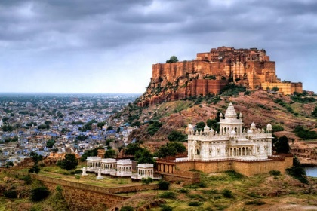
Mehrangarh Fort rises four hundred feet above the skyline of Jodhpur from its rock precipice on Bhaurcheeria hill. The foundation of Mehrangarh Fort was laid on May 12, 1459 by Rao Jodha, the fifteenth Rathore ruler who wanted to shift the capital from nearby Mandore to Jodhpur. In all its history, Mehrangarh Fort has never been taken in a siege. Mammoth and imposing from the outside, the interiors of the fort are light and detailed in contrast. Several palaces can be found inside the complex, boasting intricate carvings and sprawling courtyards.

Jaswant Thada
If you are looking for a quiet place in Jodphur head to Jaswant Thada, popularly known as the ‘Taj Mahal of Marwar’. This architectural landmark was built in 1899 by Maharaja Sardar Singh of Jodhpur State, in memory of his father, Maharaja Jaswant Singh I. Built from intricately carved marble sheets and boasting some beautiful carved marble lattice work, the impeccable design and architecture is symbolic of the fine craftsmanship of a bygone era. Beautiful sculptures, carved gazebos and frescos characterise the cenotaph, with the tiered garden offering superb views across to the fort and over the city.

Day 10: Jodhpur- Rawla Narlai

After breakfast, leave with your private cheauffeur driven vehicle to Rawla Narlai (approx 2 & ½ hours drive)
Arrive at Rawla Narlai and check in at the hotel.

Late afternoon enjoy a village walk in surrounding areas.

Enjoy a Journey of Village Tour with our knowledgeable escort on an expedition to Narlai village, once called as Narad Puri. Partake in a traditional lunch in a local household to savour the authentic flavours of Rajasthani cooking. Village tours are a great way to connect with the locals and get under the skin of rural Rajasthan, with its vibrant traditions and strong sense of history.

Overnight at Rawla Narlai

Day 11: Rawla Narlai

After breakfast proceed to enjoy a shared jeep Wildlife safari [Duration : 2 & ½ Hrs]

Into the wilds of Narlai, wander with our experts on guided Safari Tours and anticipate an intense experience meeting the rich flora and fauna of Aravallis. Spot the elusive leopards in their natural habitats, or fly with the vibrant migratory birds to the lakeside and tress; reach the bunkers of mongoose or climb the hills with troops of monkeys; learn to identify and distinguish the various flowers and trees and herbs while you wander around in the forests with our team – a vivid experience full of surprises on the way. The rugged Godwad countryside around Narlai is an ideal site for Leopards. Ending with Tea and Snacks at a favourable spot.
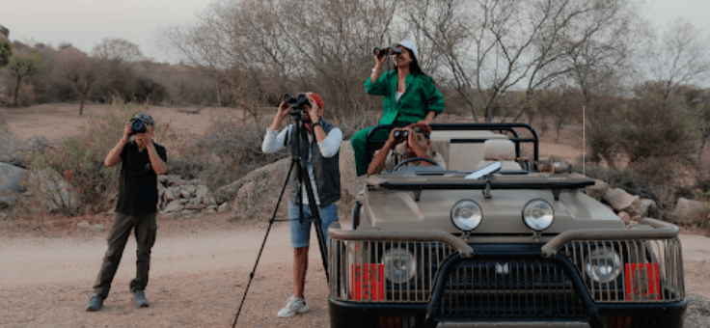

Day 12: Narlai - Udaipur

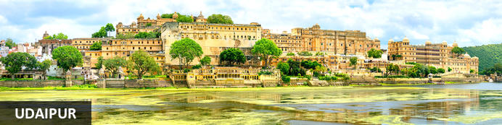
Cradled by the Aravalli Hills and watered by five lakes, Udaipur was founded in 1559 by Udai Singh, ruler of the Kingdom of Mewar. The city became his new capital complete with man-made lakes (hence the common epithet ‘Lake City’) and palaces. It’s still considered one of Rajasthan’s most romantic destinations, a reputation enhanced by the celebrated Lake Palace Hotel and given an unlikely if not surreal global boost by featuring in a James Bond movie.

After breakfast, leave with your private chauffeur driven vehicle to Udaipur (approx 3-4 hours drive) with a stop at the magnificent 15th century Jain temples at Ranakpur.

Ranakpur
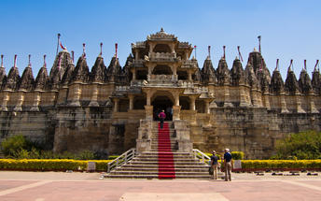
The small town of Ranakpur is home to what is arguably the most spectacular of all India’s Jain temples. The complex rests on a lush mountain slope and encompasses a series of temples dating to the 15th century, all constructed from white marble and featuring exquisite decorative detail. The main temple, Chamukha, is a multi -tiered structure with no less than 80 domes and over 1400 pillars, all of which are intricately carved with unique designs – no two are alike. As the light changes during the day, so does the colour of the temple interior, shifting from golden to cream and then pale blue at dusk.

Note : Leather items and shoes are not allowed inside the temple premises, no guides are allowed inside temple, so driver will arrange an audio guide.
Arrive Udaipur and check in at the hotel.
Overnight at Hotel Manuscript Jhilwara Haveli

Day 13: In Udaipur

After breakfast, do a tour city tour of Udaipur covering City Palace, Jagdish temple and Saheliyon ki Bari and later in the evening enjoy shared boat ride at lake pichola. (Subject to water level)

Udaipur City Palace
Situated above Lake Pichola, Udaipur City Palace has housed many royals over four centuries who have each added their own unique preferences to the establishment. The palace is a one of a kind in Rajasthan. Udaipur City Palace was constructed entirely out of marble and granite which makes it highly luxurious. The inside is even more so with its inlays of coloured glass, engravings, towers, and balconies.
Crystal Gallery
Crystal Gallery has been hailed as probably the single largest private collection of crystal anywhere in the world. The visitors here are privy to one of the most exclusive and exquisite crystal collections. It was in 1877 that Maharana Sajjan Singh (period of reign: 1874-1884) ordered the crystal collection from the Birmingham-based F&C Osler company. The collection includes a bewildering number of objects d'art, dinner sets, perfume bottles, decanters, glasses, washing bowls and even furniture.

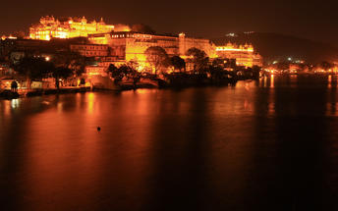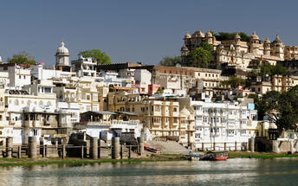

Jagdish Temple
Completed in 1651, Jagdish Temple is situated just outside the royal palace. The temple can be seen as soon as visitors enter the city. Puja’s and prayer time are the best time to visit when melodious chants from devotees float through the small interior. Visitors should make a point of climbing the temple's many steps which invite them on a journey of discovery of the rich and vibrant history of Udaipur.
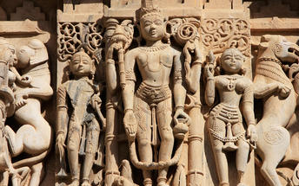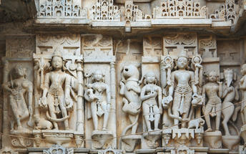

Saheliyon-ki-Bari
Located in Udaipur, India, Saheliyon-ki-Bari is situated in the northern part of the bustling city. The garden is popular amongst local and tourists offering lush green gardens and beautiful fountains. The garden was built by King Rana Sangram Singh for his wife and her 48 maids, to keep them far from political enticements. A small museum can be found on the property which was once a safe haven for the queen and her main servers.

Evening enjoy shared Boat ride on Lake Pichola.

Pichola Lake is one of the most beautiful lakes in Rajasthan. Located in the heart of Udaipur, Pichola is the oldest and one of the largest lakes in all of Udaipur. In 1362 AD Pichola Lake was built by Banjara. Later, Maharana Udai Singh, affected by the charm of this lake and extended the lake when he founded the city of Udaipur and also built a dam made of stone that is in the Badipol region on the shore of the lake. Pichola Lake is enveloped by lofty Palaces, temples, bathing ghats and elevated hills on all its sides.
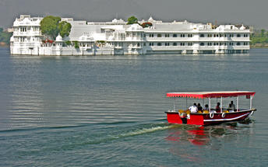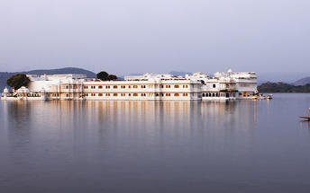

Day 14: Udaipur- Mumbai (Flight)

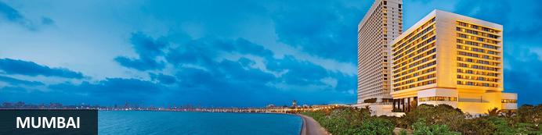
Although it isn’t India’s capital city, Mumbai often feels like it is or perhaps could be. With over twelve million people, it’s certainly India’s most populous city and the larger ‘greater Mumbai’ region homes over twenty million (making it one of the world’s most populous metropolitan regions). It’s long been India’s economic powerhouse – a place to which even the humblest outsiders might arrive, hit the big time through hard work, luck and acumen, and make a fortune. ‘Maximum City’, as it was once called, is sometimes defined by comparisons with Delhi: Delhi is bureaucrats while Mumbai is Bollywood. It’s simplistic but with a grain of truth: the city presents the most commercial, go-ahead, thrusting modern face of India and Bollywood is just one prominent face of its glitz and glamour.
Just a handful of Mumbai neighbourhood names – especially Colaba, Parel and Mahim – reflect its original geography of seven distinct islands. Initially captured by Portuguese trading fleets in the 1500s, they were given to Britain’s King Charles II in 1661 as part of his dowry when he married Catherine Braganza. Soon after that they were leased to the East India Company and quickly became its headquarters so that by the mid-1700s it was a major trading town. By the mid-19th century the islands had merged into one landmass after a series of massive land reclamation projects and seen the launch of India’s first railway line after which it became a major Arabian Sea port.
Today it’s not merely a practical international gateway but a destination showcasing modern India. Marine Drive’s curving Arabian Sea frontage has an almost Mediterranean feel while a clutch of gracefully ageing yet handsome Raj-era buildings stand witness to Mumbai’s significant imperial back-story. Thriving markets and bazaars, Hindu temples, Muslim shrines and a handful of excellent museums can easily fill a day or two’s sightseeing. Often filled with cricket-playing youth, the city’s maidans, or parks, and Dhobi Ghat, the curious open-air laundry, help lend colour, character and vitality to ‘maximum city’.

Breakfast at the hotel. Later at an appropriate time, your Travel Counsellors representative will provide you the necessary transfer to the airport to board the flight to Mumbai.

Flight TBA

Upon arrival at Mumbai airport, you will be assisted & transferred to the hotel for check in.
Rest of the day is at leisure.

Overnight at IHCL Taj President

Day 15: In Mumbai

Breakfast at hotel.
Morning proceed for a half day sightseeing tour of Mumbai. You will end your tour by driving past Flora Fountain, Dhobi Ghat, Marine Drive.
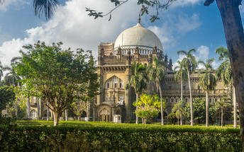
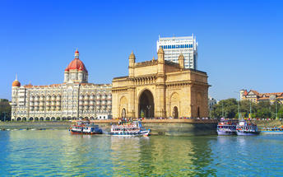

Visit Gateway of India: The Gateway of India is an arch-monument built in the early 20th century in the city of Mumbai, India. It was erected to commemorate the landing of King-Emperor George V, the first British monarch to visit India, a monument built in the Indo-Saracenic style, incorporating elements of 16th-century Gujarati architecture. The final design of the monument by architect George Wittet was sanctioned only in 1914, and construction was completed in 1924.
Drive past Marine Drive: Marine Drive is a 3-kilometre-long Promenade was constructed by Pallonji Mistry. It Marine Drive is situated on reclaimed land facing west-south-west. Marine Drive is also known as the Queen's Necklace because, when viewed at night from an elevated point anywhere along the drive, the street lights resemble a string of pearls in a necklace.
Drive past Chowpatty Beach: Girgaon Chowpatty is a quaint beach in the southern part of Mumbai and is known widely for its street food, rather than sunbathing or other water activities. Girgaon Chowpatty sea face is flocked with tourists and street food vendors. Girgaon Chowpatty is one of the most crowded tourist attractions in Mumbai, with locals frequenting this place with family and friends after a tiring day at work.
Drive past Malabar Hill: Malabar Hill is a hillock and upmarket residential neighbourhood in South Mumbai, Maharashtra, India. Malabar Hill is the most exclusive residential area in Mumbai. It is home to several business tycoons and film personalities. As of 2014 it is one of the most expensive areas in the world regularly featuring in the top 10 world-wide localities.

Mani Bhavan: Mani Bhavan is a place where Gandhiji lived and interacted with his colleagues to mould the freedom movement in the image of the cherished ideals of Truth and Non-violence. It was from Mani Bhavan that his followers and devotees went forth in the world inspired and charged with a sense of service and sacrifice. Even today, Mani Bhavan is a source of inspiration for the lovers of freedom and peace the world over.
Drive past Dhobi Ghat: The world’s largest outdoor laundry! See the dhobiwallahs, or washermen, scrubbing sheets from Mumbai’s largest hospitals and hotels at this busy outdoor laundry area.
Drive past CST Station: See the famous facade of CST and visit inside one of the busiest railway stations in the country. Gaze up at the station’s Victorian Gothic architecture as you learn about Mumbai’s only UNESCO World Heritage Site.
Colaba Causeway: Colaba Causeway is a commercial street, it lies close to the Fort area, and also close by many Mumbai's famous landmarks like, the Gateway of India and Taj Mahal Palace & Tower. The place is famous for various shopping options including cheap, street clothes to fashionable shops, this lane offers everything. One can stroll through the footpaths and window shop for clothes, shoes, purses, jewellery etc. It also has several restaurants. The place is generally crowded in most of the time and a good place for some interesting photo stops.
After visit drop back at hotel, rest afternoon at leisure.

Day 16: Mumbai Departure

At an appropriate time, your Travel Counsellors representative will provide you the necessary transfers to the airport.
Standard check out at 1200 Hrs.

Flight TBA

**End of Services**

