

IN-07 Karnataka with Beach
Bangalore - Mysuru - Hassan - Hampi - Badami - Goa
16 Days / 15 Nights
2 Persons

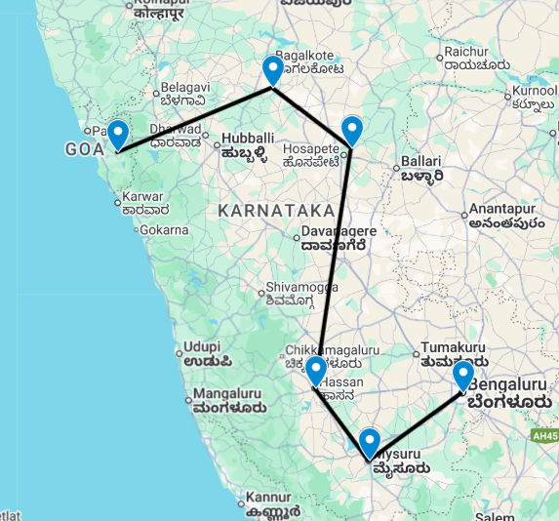

Overview: This journey covers travel in western coast of India including Karnataka and Goa. Karnataka is famous for its natural, cultural and architectural heritage and Goa is famous for its beautiful beaches, nightlife party, and hospitality, carnival and water sports.

Highlights: Culture, Heritage, Beach, Family Holiday.

- Explore Bangalore – the Silicon Valley
- Visit the historic city of Mysore.
- Visit the rich culture, ancient monuments and temples of Hassan, Hampi and Badami.
- Enjoy the lively culture of Goa and of course the pristine beaches

Introduction

Start | Accommodation | Destination | Room Type | Duration
Day 1 | Taj West End | Bangalore | Luxury Room Heritage Wing | 2 Nights
Day 3 | Royal Orchid Metropole | Mysuru | Luxury Heritage Room | 2 Nights
Day 5 | Hoysala Village Resort | Hassan | Superior Cottage | 2 Nights
Day 7 | Heritage Resort Hampi | Hampi | Superior Cottage | 2 Nights
Day 9 | Wada 1 | Badami | Deluxe Room | 2 Nights
Day 11 | The Radisson Goa Candolim | Goa | Standard Room | 5 Nights

Day 1: Arrive Bangalore

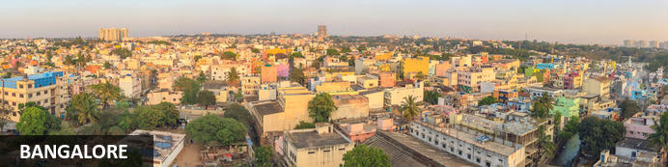
Three thousand feet up on the Deccan Plateau, the state capital of Karnataka’s relatively mild climate and abundance of broad leafy roads and parks has helped earn it the ‘Garden City of India’ label. These days that moniker might seem a stretch: it’s a booming city of eight million with thriving IT and bio-tech sectors that have given rise to another – the Silicon Valley of India. Unlike many other Indian cities, Bangalore has a more modern and sophisticated buzz oiled by an array of cosmopolitan restaurants, lively bars and even an ‘underground’ music scene.

Day Itinerary
Flight TBA
Arrives Bangalore TBA Hrs.

On arrival in Bangalore: Having cleared immigration, collected your luggage and passed through customs, please make your way towards the exit of the terminal building where you will see a bank of people waiting for you. Amongst them will be Travel Counsellors Representative who will be waiting to greet you with a paging board with your name on.

You will be transferred to your hotel and assisted with check in. Standard check in time is 1400 hrs.

Overnight: Taj West End Bengaluru
Set in the heart of Bengaluru, Taj West End blends colonial charm with modern luxury. The spacious rooms and suites offer modern amenities such as flat-screen TVs, minibars, and Wi-Fi access. Guests can indulge in a diverse culinary journey at award-winning restaurants such as Blue Ginger, Loya, Machan, and the sophisticated Blue Bar. This storied landmark also features a traditional Indian wellness spa, fitness centre, and expansive indoor and outdoor event spaces.
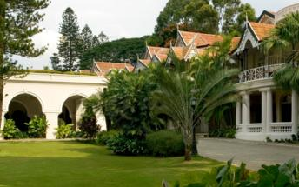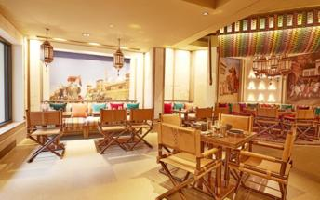

Day 2: In Bangalore

Day Itinerary
After breakfast, enjoy half day Bangalore city tour covering the Bull Temple followed by Tipu Palace. Drive past the local markets (Vegetables & Fruits), Vidhan Soudha (State Parliament), the botanical gardens at Lalbagh. Rest of the day is at leisure to explore the city on your own.
Bull Temple
Bull Temple is among the oldest temples in the city, which is dedicated to Nandi, the wagon of Lord Shiva. Associated with mythological and religious significance, the shrine is a renowned worship place. Situated atop a mountain, the temple was built in the 16th Century, during the Vijayanagara Rule. The temple is relatively small in size, but houses one of the largest Nandi sculptures in the world. It boasts a monolithic statue of deity Nandi, which is 4.5 meters tall and 6 meters long. Carved from a granite rock, the sculpture reflects Dravidian artwork.
Tipu Sultan's Summer Palace
Tipu Sultan Summer Palace was initially built by Kempe Gowda, the founder of Bengaluru, the palace was later extended by Tipu Sultan, the Emperor of Mysore. Located near the City Market, the fort dates back to the year 1537. This majestic fort stands as a witness to the struggle of the Mysore Emperor against the British domination. The arches are intricately carved and have been built as per Islamic architectural style. One of the major attractions of the fort is the well-preserved Ganapati temple, which is situated inside the fort. Within the fort there is Tipu Sultan Palace, which dates back to year 1790.
Drive past the local markets (Vegetables & Fruits) and later proceed to Lalbagh Botanical Garden, Lal Bagh is one of the most famous gardens of Bangalore. Hyder Ali laid out this famous botanical garden and his son added horticultural wealth to it by importing trees and plants from several countries. The garden today houses over 1000 species of flora, which include rare and enchanting collection of tropical plants, trees and herbs. The Glass House, modelled along London's Crystal Palace, is the center of attraction in this 2400-acre park. Bi-annual flower shows attracting participants from all over India is held in the Glass House.

Overnight at the hotel.

Day 3: Bangalore – Mysuru

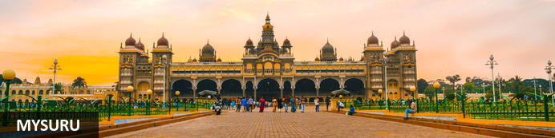
Until recently known as Mysore, Mysuru is Karnataka's second city. Yet for centuries it was the capital of the enduring Wadiyar dnyasty – the 'Kingdom of Mysore' – whose rule over the region was interrupted for barely four decades in the late 1700s. Today Mysuru is known for its sandalwood carving and silk industries, and partly through its ancient style of painting is regarded as one of southern India's cultural capitals. Its cultural tag is probably most tangible during the annual Dussehra festival which is celebrated across most of India in September or October; Mysuru's exuberant 10-day festivities take things to a new level and draw thousands of visitors. It culminates in a huge torch-lit procession of elephants, camels and horses accompanied by musicians and dancers transporting an idol from Mysore's extraordinary royal palace, one of several that grace the city

Day Itinerary
After breakfast you will be driven to Mysore in your private chauffeur driven vehicle [approx. 4 hours' drive] with a stop at Somnathpur Temple (close to Mysore).
Somnathpur Temple
On the banks of Holy River Kaveri is a tiny tranquil town of Somanathapura. Here stands the finest and most exemplary monument of Hoysala architecture known as the famous Prasanna Chennakesava Temple or simply the Kesava Temple. Consecrated in the year 1258 CE, it is a Vaishnav Hindu Temple dedicated to might and beauty of Lord Krishna (Chenna= Beautiful and Kesava= Krishna). Tourists from near and far come to visit the temple to get a view of the beautiful place. The Chennakesava temple is one of the 1500 Temples built by the Hoysala Empire kings in different parts of their kingdom and is said to be the climax development in Hoysala temple style and yet is unique in many other ways.
After the visit transfer to your hotel in Mysore.

Overnight: Royal Orchid Metropole
A 4-star grand heritage hotel, the Royal Orchid Metropole depicts the history and culture of Mysore. Built in 1920 to host guests, the guesthouse still retains its imperial arches, pillars and ornate corridors capturing the old world charm.
A variety of rooms and suites provide accommodation. A stay at the Royal Orchid Metropole comes with complimentary breakfast as well as 24-hour room service and access to satellite TV. Notable features include the swimming pool, a fitness centre and an outdoor restaurant serving exotic delicacies.
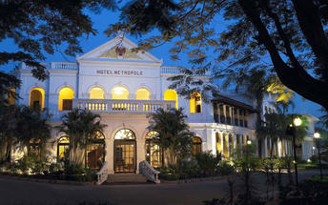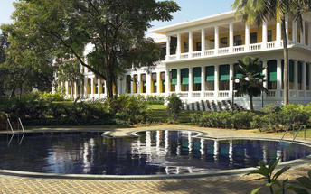

Day 4: In Mysuru

Day Itinerary
Breakfast at the hotel.
Later proceed for a visit to Srirangapatna and Mysore Palace.
Srirangapatna
Located in Karnataka, India, Srirangapatna alternatively known as Shrirangapattinam is a religious, cultural and historically significant town. This river island town's name is sourced from the famous Ranganathaswamy Temple which dominates the town, and this temple resembles Hoysala and Vijayanagar architecture as it was restrengthened and modified after its initial construction in the 9th century.
Mysore Palace
Welcome to the Royal Splendour of Mysuru, the home of the Wodyers who ruled Mysuru for more than 500 years, known as the City of Palaces, Mysuru retains a quaint charm, that never fails to enchant. Mysuru is a popular tourist destination, offering several attractions ranging from the royal splendour of Mysuru City and its fabulous Dasara Festival to exquisite temples, pilgrimage centres and scenic spots. The royal lineage can be traced back to 1399, when Yaduraya, a royal prince of the Yadava dynasty, was on a pilgrimage visit to Chamundi Temple with his brother Vijaya. They took shelter in the Kodi Bhairava temple on the banks of Doddakere, the ‘Big Lake’. There they came to learn that the local royal family was in great danger. Their ruler had just died, and Maranayaka, a neighboring chief, was threatening the queen. He wanted her daughter’s hand in marriage. The queen and the princess were in very vulnerable position. With the help of Jangama (Wadiyar) killed Maranayaka and married the daughter of Chamaraja and succeeded to the Mysuru principality. And so the Wodyer dynasty was established – a succession of 25 kings who ruled until 1947, when Mysuru became part of the Indian Union. The Wadiyars were great patrons of the arts, and the finest craftsmen in the state were employed to work on the Palaces. Wadiyar period was a new era of prose literature as an independent literary medium and it was in other words a prose writing in the form of the history of the Mysuru rulers. Chamaraja Wadiyar encouraged Kannada scholars like Ramachandra, author of Hayasaara Samuchchaya.

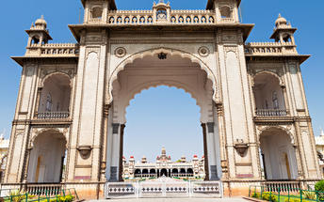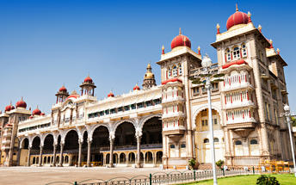
Overnight at the hotel.

Day 5: Mysuru – Hassan

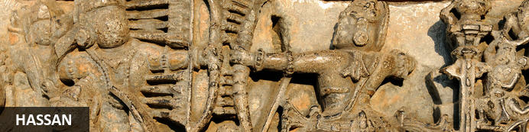
As one of the oldest towns in India’s Karnataka State, Hassan has a long and rich history. The town was founded by Channa Krishnappa Naik in the 11th century and remained under the rule of the Hoysala dynasty until the 13th century. It is the unique Hoysala architecture of this time that has made Hassan a popular tourist attraction as, during this period, numerous architectural marvels including a number of exquisite temples were constructed, many of which remain well-preserved today. However, it is not only the diverse variety of temples and unique architecture that draws visitors to Hassan, but also the town’s lovely markets, delicious local cuisine and remarkable natural beauty of the town itself and its extraordinarily scenic surrounding areas.

Day Itinerary
After breakfast you will be driven to Hassan [approx. 3 hours' drive].
On arrival at Hassan, check into your hotel.
Rest of the day will be at leisure.

Overnight: Hoysala Village Resort
The Hoysala Village Resort is located in Hassan and provides accommodation within the comfort of nature with the eco-friendly resort being constructed with rosewood and traditional materials. The interior is decorated with a variety of artefacts while trees and flower gardens decorate the exterior. The accommodation comprises of 3 options with each being exquisitely decorated, well-appointed and fitted with an air conditioner, Tv, telephone and ensuite bathroom. The inhouse restaurant Belur serves a variety of local and Malnad cuisine with all meals being prepared using local and fresh ingredients. A swimming pool and games room are available to guests as well as cycling, volleyball, badminton, yoga sessions and going on bullock cart rides. Musical concerts and cultural shows also take place regularly at the Hoysala Village Resort. Hassan is also an important landmark on the tourism map of Karnataka. It has a rich history and heritage making the resort the perfect stop-over to explore several important attractions in and around Hassan like Belur, Halebidu, Shravanabelagola, Manzarabad fort, Shettyhalli Church and Backwater.

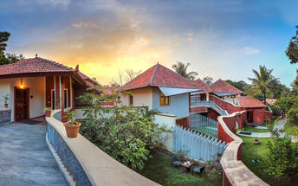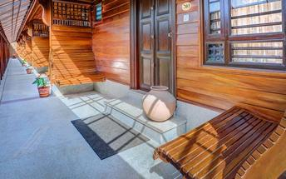

Day 6: In Hassan

Day Itinerary
Breakfast is at the hotel. In the morning take a tour of Belur and Halebid.

Belur
Set on the banks of Yagachi River in the Hassan District in the state of Karnataka, Belooru, or more commonly known as Belur is set amidst lush surrounds. It boasts a rich cultural heritage, historical significance and a variety of sacred temples. Belur is a popular tourist destination in the state of Karnataka. It features the Chennakeshava Temple Complex, is a 12th-century Hindu temple displaying some of the best of Hoysala architecture in the country. Other highlights include: Panduranga Temple, Shankaralingeshwara Temple, and Hoysaleshwara Temple and the spectacular Jain temples in Halebidu.
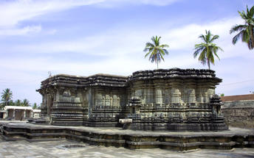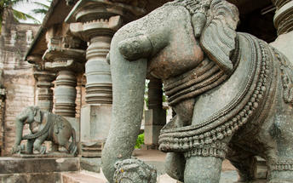
Halebidu
Halebid is known for the presence of two architectural splendors. Hoysaleshawara and Kedareshwara temples are internationally famous and draws in large number of Hindu pilgrims from all over. Two Jain basadi are also the major attractions for the tourists visiting Halebid in Karnataka. You can find two huge pools in front of the temples. It is from these lakes, that the temples have been named. The Hoysaleshwara temple has two nandi bull figures built of monolithic rock at the side of it.
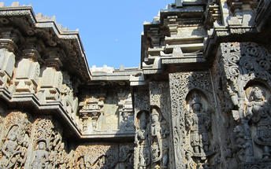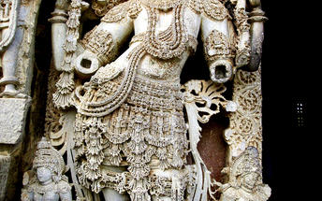
Overnight at the hotel.

Day 7: Hassan – Hampi

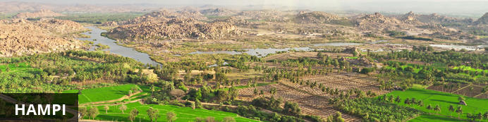
An enchanting ancient city and hippy backpacker destination, Hampi offers the perfect heady mix of Indian charms that make it hard for visitors to leave. Here history and modernity meet: impressive ancient remnants of Vijayanagara, the former capital of the Vijayanagara Empire, are dotted around the congested buildings of Hampi town. Cross the river and you will find laid back restaurants and rooms bordered by banana plantations and paddy fields, with a view over the river and ruins. Sightseeing can take up most of your time but do not neglect to visit the Monkey Temple, a 572-stair climb, to catch the sunset.

Day Itinerary
After breakfast you will be driven to Hampi [approx. 6 hours' drive].
Upon arrival in Hampi, check in at the hotel and relax.

Overnight: Heritage Resort Hampi
Spread across 8-acres of land, Heritage Resort Hampi offers luxurious accommodation in Karnataka, India. Guest rooms at the hotel are lovingly decorated and equipped with all the modern amenities necessary to ensure a relaxing and comfortable stay. At the on-site wellness spa, guests can indulge in numerous Ayurveda therapies that focus on aligning their mind-body-soul and restoring inner balance.
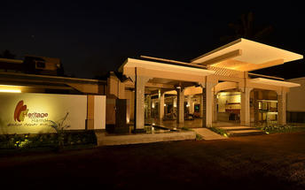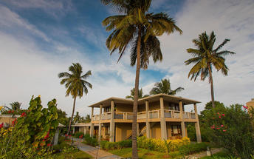

Day 8: In Hampi

Day Itinerary
After breakfast, explore the Hampi Ruins.

Hampi
Hampi, The World Heritage Center, is the most beautiful and evocative of all the ruins of Karnataka. Capital of Vijayanagar kingdom is full of delightful surprises, viz., Kings Balance where kings were weighed against grain, gold or money which was then distributed to the poor, other attractions are Queen's Bath with its arched corridors, projecting balconies, Lotus Mahal Vittala Temple, Virupaksha Temple, Ugra Narasimha are not to be missed.
The best way to experience this World Heritage Site is to take a leisurely stroll through the eloquent ruins. Most of the important structure and ruins are located in tow areas, which are generally referred to as the Royal Centre and the Sacred Centre. The Royal Centre contains structures that seem to have been palaces, baths, pavilions, royal stables, and temples for ceremonial use. The sacred center is situated on the banks of the holy Tungabhadra River. Visit Vittthala temple and Virupaksha temple.

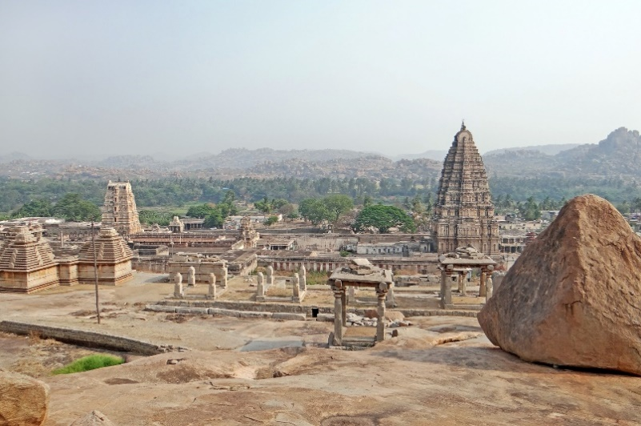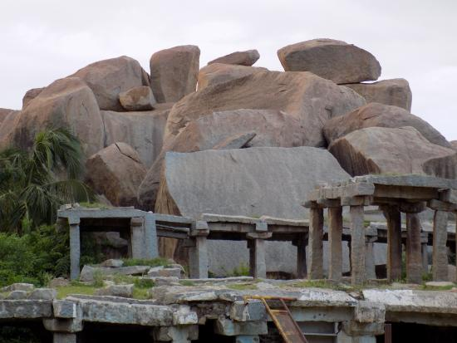

Overnight at the hotel.

Day 9: Hampi – Badami

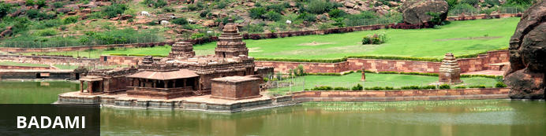
Situated in northern Karnataka, the quiet village of Badami is home to a series of ancient cave temples. Between the 6th and 7th centuries Badami was the capital of the Early Chalukyas, who ruled much of Karnataka and Andhra Pradesh. They carved out sacred spaces into the rust-coloured cliffs above Agstya Lake, and decorated the walls of these holy caves with bold, detailed reliefs of their deities. Out of the shimmering waters below rise the steps of the Bhutanatha temple complex, a cluster of sandstone shrines devoted to this god.

Day Itinerary
Today you will be driven to Badami [approx. 3 hours' drive].
On arrival check-in at hotel.
Rest of the day will be at leisure.

Overnight: Wada 1
Wada 1 is a beautifully restored hotel located in the Aihole Temple Complex, of India. The hotel provides tastefully appointed rooms with tea/coffee-making facilities, private bathrooms and Wi-Fi access. The on-site restaurant Savour, offers traditional food from North Karnataka. Other facilities include a tower lounge. Guests can enjoy taking part in tours of the Aihole Temples.
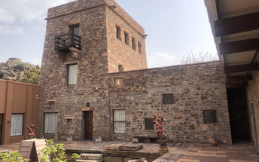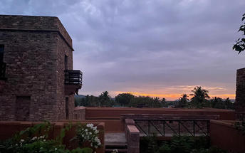

Day 10: In Badami

Day Itinerary
Breakfast at the hotel.
Later proceed for a half day tour.
Badami
Situated in northern Karnataka, the quiet village of Badami is home to a series of ancient cave temples. Between the 6th and 7th centuries Badami was the capital of the Early Chalukyas, who ruled much of Karnataka and Andhra Pradesh. They carved out sacred spaces into the rust-coloured cliffs above Agstya Lake, and decorated the walls of these holy caves with bold, detailed reliefs of their deities. Out of the shimmering waters below rise the steps of the Bhutanatha temple complex, a cluster of sandstone shrines devoted to this god.
Aihole
The ancient walled city Aihole, which dates back to the 6th century in Karnakata served as the former capital of the region during the early Chalukyas period. Visitors can enjoy exploring the historic fortified complex comprised of over a hundred stone temples featuring a blend of fascinating architectural styles, Jain monuments, and ancient caves displaying unique traditional art depicting Hindu deities and legends.
Pattadakal
Declared a world heritage site in 1987, Pattadakal, situated on the banks of the Malaprabha river in the Bagalkot district of Karnataka, represents the high point of temple architecture under the Chalukya dynasty in the 7th and 8th centuries. Earlier called Kisuvolal or Pattada Kisuvolal, that literally translates to City of Crown Rubies, Pattadakal along with Aihole and Badami provide an incredible concentration of religious monuments that reveal a beautiful fusion of north (Nagara, Indo-Aryan) and south (Dravidian) Indian architectural forms.

Overnight at the hotel.

Day 11: Badami – Goa

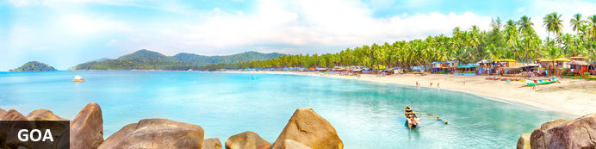
Midway along the Konkan coast facing the Arabian Sea, the former Portuguese territory of Goa with its long tropical beaches backed by swaying palms has long been synonymous with sun-seeking hippies, ravers and an ‘alternative’ lifestyle. Originally stemming from the 1960s backpacker trail to Kathmandu – some travellers paused in or detoured to Goa and just couldn't bring themselves to leave – that reputation seems rather dated now. Although the ‘alternative scene’ remains (especially in places like Anjuna’s flea market) though somewhat less vigorous now, Goa has also gone mainstream; the clientele is far broader and there’re plenty of upmarket hotels and resorts. Yet the key ingredients of the state's appeal remain: picturesque beaches (such as Palolem), fine seafood cuisine and an enduring Portuguese-Catholic cultural heritage that lends the region a distinctive character.

Day Itinerary
Today you will be driven to Goa [approx. 6-7 hours' drive].
Arrive Goa and check-in at the hotel.

Overnight: The Radisson Goa Candolim
Boasting refined accommodation, a relaxing spa, exquisite on-site dining and a convenient location just 500 metres from Candolim Beach, the Radisson Goa Candolim is an unbeatable hotel choice for your vacation.
Situated only three kilometres from the famous Calangute beach and in proximity to National Highway 17, the Radisson makes it easy to explore the numerous attractions surrounding Candolim, North Goa. Take advantage of the hotel's proximity to area highlights including the historic Fort Aguada, the ancient churches of Old Goa and excellent shopping in Panjim.
With amenities like complimentary Wi-Fi, a mini gymnasium, conferencing facilities, an outdoor swimming pool, spa and even a salon, the Radisson Goa Candolim has everything you need to enjoy an unforgettable stay in one of the region's top leisure destinations.
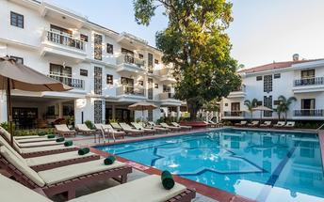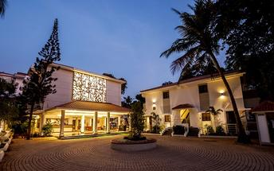

Day 12-15: In Goa

Day Itinerary
Breakfast at the hotel.

These days, you will be at leisure in Goa. No vehicle will be at disposal.

Overnight at the hotel.

Day 16: Depart Goa

Day Itinerary
At an appropriate time, you will be transferred to the airport for your flight to onward destination.

Flight TBA
Departs Goa TBA Hrs.

**** END OF SERVICES ****

NOTE:
- The distances and time taken for the travel is approximation only this will differ based on the traffic conditions and other unforeseen circumstances.

