

Karnataka with Kerala
Bangalore - Mysuru - Ooty - Kochi - Periyar - Alappuzha - Mararikulam
14 Days / 13 Nights
Date of Issue: 20 September 2024

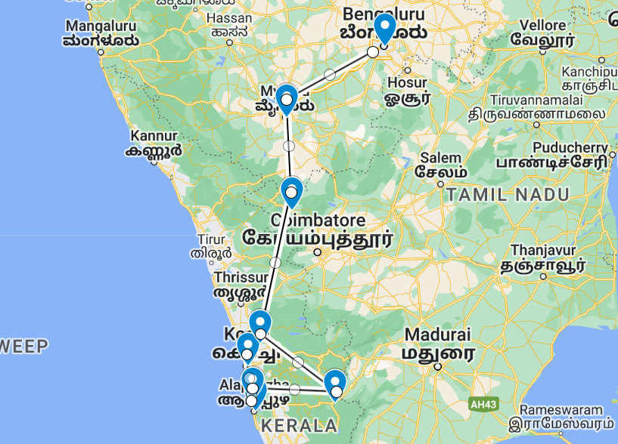
Often overlooked Karnataka state holds a wealth of sights with its two main cities showcasing historic links to the once dominant Wadiyar dynasty and the more modern cosmopolitan feel of one of modern India’s IT hubs. Down on the south-western coast, Kerala is one of the country’s scenic and cultural gems: lush tropical beaches and landscapes threaded by coastal lagoons and waterways while inland the Western Ghats offer pretty vistas of undulating hills dotted with spice plantations.
Mysore’s vast royal palace and Bangalore’s imposing Legislative Assembly building top city attractions encompassing botanical gardens, ancient shrines and a celebrated tradition of sandalwood carving. Cochin, the state’s largest city, has expanded well beyond the original settlement of Fort Kochi which retains its cosy heritage atmosphere and sights. Up in the Western Ghats, Periyar National Park’s forested hills and montane grasslands cradle some of the region’s highest peaks and are home to tigers and elephants along with thriving spice plantations. Charming houseboats ply the so-called ‘backwaters’, or pretty inland lagoons along with Vembanad Lake, between Alappuzha (Alleppey) and Kumarakom and beyond. For relaxing beach downtime, Mararikulam is a notably untouched fishing village with fine golden sands and relaxing low-key atmosphere.

Introduction

Start | Accommodation | Type | Destination | Room Type | Duration
Day 1 | The Paul Bangalore |  | Bangalore | Studio Suite | 1 Night
 | → The Taj West End Hotel | alternate
Day 2 | Royal Orchid Metropole |  | Mysuru | Royal Wing | 2 Nights
Day 4 | Savoy IHCL SeleQtions Ooty |  | Ooty | Superior Room | 2 Nights
Day 6 | Fragrant Nature Kochi |  | Kochi | Dukes Chamber | 2 Nights
 | → The Brunton Boatyard | alternate
Day 8 | Cardamom County |  | Periyar | Periyar Cottage | 2 Nights
Day 10 | Alleppey Deluxe Houseboat |  | Alappuzha | 1 Bedroom Housboat | 1 Night
Day 11 | Marari Beach Resort |  | Mararikulam | Garden villa | 3 Nights

Day 1: Arrive Bangalore

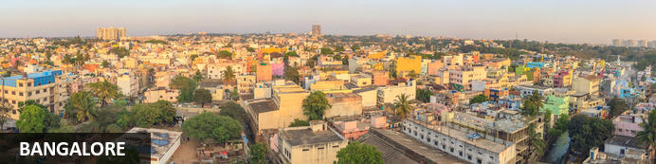
Three thousand feet up on the Deccan Plateau, the state capital of Karnataka’s relatively mild climate and abundance of broad leafy roads and parks has helped earn it the ‘Garden City of India’ label. These days that moniker might seem a stretch: it’s a booming city of eight million with thriving IT and bio-tech sectors that have given rise to another – the Silicon Valley of India. Unlike many other Indian cities, Bangalore has a more modern and sophisticated buzz oiled by an array of cosmopolitan restaurants, lively bars and even an ‘underground’ music scene.

Day Itinerary
On arrival in Bangalore: Having cleared immigration, collected your luggage and passed through customs, please make your way towards the exit of the terminal building where you will see a bank of people waiting for you. Amongst them will be Travel Counsellors Representative who will be waiting to greet you with a paging board with your name on.
You will be transferred to your hotel and assisted with check in. (Standard check in time at hotel is 1400 hrs).

Overnight: The Paul Bangalore
The place to unwind. With all the space to relax, refresh, and be pampered. Carefully conceived and designed to offer unlimited luxury to the discerning traveler, The Paul Bangalore with its 57 suites is a 5 star business hotel in Bangalore that invites visitors to relish luxury of a different kind. Creating higher heights of comfort and redefining new meanings to luxury, this hotel dedicates its efforts to maintaining world-class standards while constantly providing personal service without intruding on privacy. Strategically located in the heart of Bangalore, India’s IT hub, and bespeaking absolute comfort in a luxuriously spacious environment, The Paul Bangalore presents an ambience that assures a memorable stay
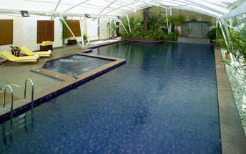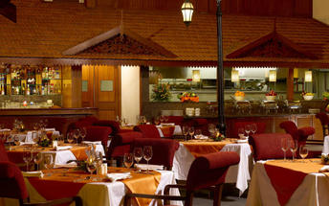

Alternate: The Taj West End Hotel
Like any other Taj property, the Taj West End is an ideal establishment for guests. There are comfortable amenities as well as exclusivity with the Taj Club Floor and Lounge allowing access to special privileges.
The hotel has a wide selection of rooms and suites for guests to choose from that matches their individual accommodation needs.
There's plenty to see and experience at the Taj West End hotel. Staff are available to assist guests in organizing daily activities for the duration of their stay. From shopping excursions to spa treatments to workouts at the fitness centre, a customized hotel experience can be arranged.
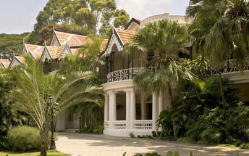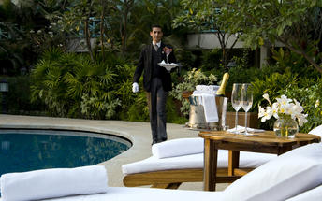

Day 2: Bangalore - Mysuru

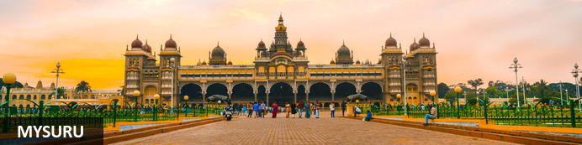
Until recently known as Mysore, Mysuru is Karnataka's second city. Yet for centuries it was the capital of the enduring Wadiyar dnyasty – the 'Kingdom of Mysore' – whose rule over the region was interrupted for barely four decades in the late 1700s. Today Mysuru is known for its sandalwood carving and silk industries, and partly through its ancient style of painting is regarded as one of southern India's cultural capitals. Its cultural tag is probably most tangible during the annual Dussehra festival which is celebrated across most of India in September or October; Mysuru's exuberant 10-day festivities take things to a new level and draw thousands of visitors. It culminates in a huge torch-lit procession of elephants, camels and horses accompanied by musicians and dancers transporting an idol from Mysore's extraordinary royal palace, one of several that grace the city

Day Itinerary
Leave after breakfast with your private chauffeur driven vehicle to Mysore [Approx. 160 kms / 4 hrs] with a stop enroute at Srirangapatnam.
Srirangapatna
Srirangapatna alternatively known as Shrirangapattinam is a religious, cultural and historically significant town. This river island town's name is sourced from the famous Ranganathaswamy Temple which dominates the town, and this temple resembles Hoysala and Vijayanagar architecture as it was restrengthened and modified after its initial construction in the 9th century.
On arrival at Mysore, check into your hotel.

Overnight: Royal Orchid Metropole
A 4-star grand heritage hotel, the Royal Orchid Metropole depicts the history and culture of Mysore. Built in 1920 to host guests, the guesthouse still retains its imperial arches, pillars and ornate corridors capturing the old world charm.
A variety of rooms and suites provide accommodation. A stay at the Royal Orchid Metropole comes with complimentary breakfast as well as 24 hour room service and access to satellite TV. Notable features include the swimming pool, a fitness centre and an outdoor restaurant serving exotic delicacies.
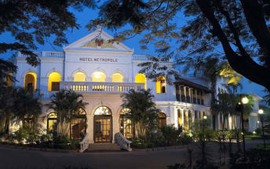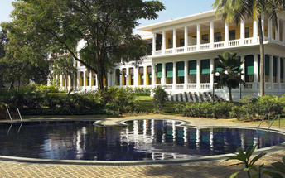

Day 3: In Mysuru

Day Itinerary
Enjoy a walking tour Mysore followed by a tour of Mysore Palace and Chamundeshwari temple.
The walking tour starts with K.R circle & Small clock tower, followed with Devaraj Market, It is about more than a hundred year old market which has lot to be explore in and around.Coffee break at Hotel Dasaprakash, to experience the local people & food. Sayyaji Rao Road It is the local shopping street of the city with ongoing local trade.

Day 4: Mysuru - Ooty

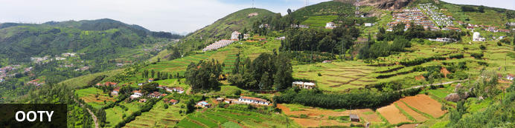
Resting in an amphitheatre amid the Nilgiri mountain range, in India’s Tamil Nadu state, Udhagamandalam, also called Ooty is a beautiful hill station surrounded by terraced rolling hills dotted with 19th-century tea plantations. Perched at an altitude of 2240 metres above sea level, this misty mountain town once served as a summer retreat for the British elite who enjoyed its crisp cool climate. Known as the Queen of Hill Stations, the combination of scenic natural surrounds, Hindu temples and the Indian bustle make this a popular destination for visitors. Must-see attractions include: the Botanical Gardens, featuring ferns, orchids and a prehistoric fossilized tree; the Government Museum, showcasing the history of the Tamil Nadu region; and the Mudumalai Wildlife Sanctuary, recently declared a tiger reserve and a World Heritage Site.

Day Itinerary
Leave in the morning to Ooty. [Approx. 125 kms / 4 hrs]
Ooty now called Ootacamund, is the Queen of slope stations and the capital of Nilgiri region. It is situated in Nilgiri hills, also known as the Blue Mountains. Ooty served as the summer capital of Madras Presidency and other small kingdoms. The place was much visited by British during the colonial days. Lofty mountains, great lakes, dense forests, sprawling grasslands, miles of tea gardens and eucalyptus trees greet the travelers. The hill station itself is a land of picturesque picnic spots.

Overnight: Savoy IHCL SeleQtions Ooty
Savoy IHCL SeleQtions Ooty is situated in Tamil Nadu, India, near the Government Rose Garden, the Ooty Toy Train Tourist Park, the Ooty Golf Course, the Government Museum and the Government Botanical Garden. Units feature a satellite television, a minibar, a personal safety deposit box and a bathroom. There is an on-site restaurant where guests can enjoy meals. Additional amenities include a bar, a tea lounge, a spa, a fitness centre, room service, parking and complimentary Wi-Fi.
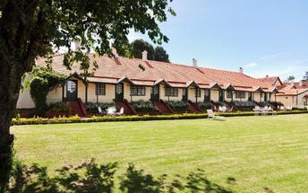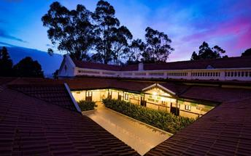

Day 5: In Ooty

Day Itinerary
Enjoy a toy train ride to Coonoor today. Later in the day do a tour of the Botanical Gardens and St. Stephens Church.
The Nilgiri Mountain Railway toy train is the highlight of a visit to the popular hill station of Ooty, in south India's Tamil Nadu state. Established in the early 19th century by the British as the summer headquarters of the Chennai government, Ooty now draws tourists wanting to escape the stifling summer heat. The railway opened 1899 and was completed in 1908. It was declared a UNESCO World Heritage site in 2005. The quaint toy train pulls blue and cream wooden carriages with large windows.
Head off for a mesmerizing railway journey as you board Toy Train from Ooty to Coonoor. The almost nostalgic toy train gives visitors a revitalizing travel experience moving through lush green tea estates, thick forests, tall eucalyptus trees and lofty mountains. Covering a distance of 19 kms the Ooty to Coonoor route offers the most spectacular scenery along its way. The journey is slow and gives you ample opportunity to discover nature’s bounties.

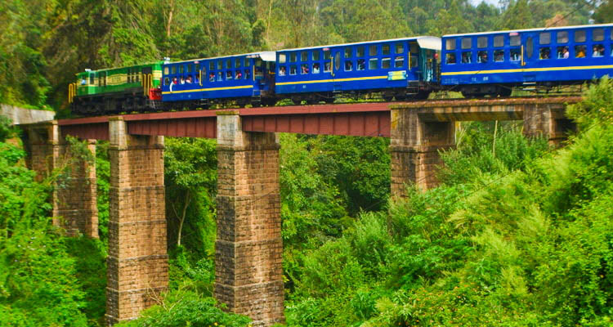
Divided into several sections, The Botanical Garden, cover an area of around 22 hectares, and lie on the lower slopes of Doddabetta peak. The garden has a terraced layout. It is maintained by the Tamil Nadu Horticulture Department. Its architect was William Graham McIvor. The Marquis of Tweedale prepared the initial layout during the late 1840s. During that time Ootacamund (Ooty) was under British control. The Gardens have around a thousand species, both exotic and indigenous, of plants, shrubs, ferns, trees, herbal and bonsai plants. In the centre of the Gardens lie a fossilized tree trunk estimated to be 20 million years old.
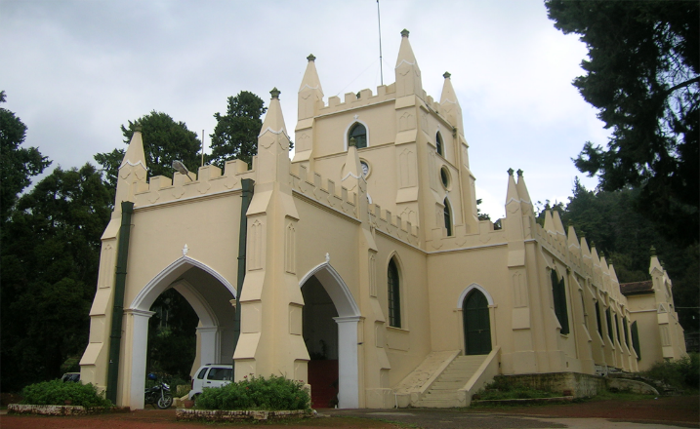
The St. Stephen's Church in Ooty is indeed a marvellous and breathtaking architectural marvel that the British left for us after they finally gave us our independence. The Church is one of the earliest churches that you will find in the Nilgiris district. The structure dates to the 19th century and was built by the British government. The date of the commencement of construction was cleverly chosen to coincide with the birthday of King George IV. The fabulous pale-yellow building of the St Stephen’s Church bears testimony to the marvels of British architecture that existed during those times. This grandeur is also reflected in the painting of 'The Last Supper' that can be found in the Church.

Day 6: Ooty - Kochi

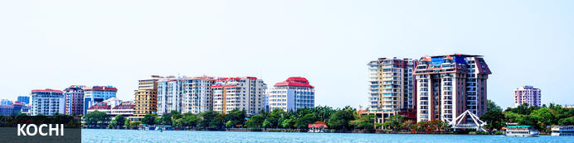
A major spice trading centre since the 14th century, Kochi (previously Cochin) is Kerala’s largest city and an essential destination for travelers to southern India. From ancient times it was known to an array of traders from Arabs to Portuguese, Greeks to Chinese, and was also home to India’s oldest Jewish community. Straddling several islands, a peninsula and part of the mainland, the city faces both ocean and backwaters so – unusually for India – all but the narrowest exploration of its sights involves bridges, ferries and water taxis. The main highlights are on Fort Kochi peninsula: built in 1503 the Church of St Francis is one of India’s oldest churches (and briefly interred the remains of Portuguese explorer Vasco da Gama) while the 16th-century Mattancherry Palace displays an extensive set of medieval murals inspired by the great Indian epics.

Day Itinerary
Leave after breakfast with your private chauffeur driven vehicle to Kochi [Approx. 6 hrs]. Arrive and check-in at the hotel. Rest of the day is at leisure.

Overnight: Fragrant Nature Kochi
Fragrant Nature Kochi is within walking distance of Mattancherry Palace. Jawaharlal Nehru Stadium Kochi is only a short car ride from the hotel. Boasting a swimming pool, it also features 24-hour room service, valet parking and an executive floor.
There are 41 rooms at Fragrant Nature Kochi, each offering all the necessities to ensure a comfortable stay. On-site dining options include a restaurant, which is a convenient place to have a meal. In the evening, guests are able to wind down in the comfortable lounge bar.
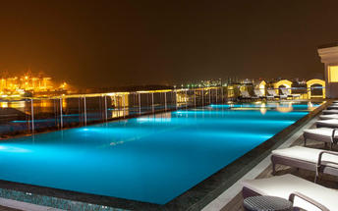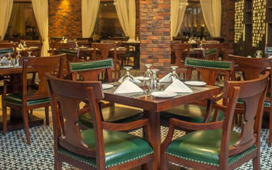

Alternate: The Brunton Boatyard
The Brunton Boatyard Hotel has been resurrected from a Victorian ship building yard, based on the historic Cochin's harbour. The hotel's interiors are an eclectic blend of English, Portuguese and Dutch influence.The Brunton Boatyard has 22 rooms, all of which has an en-suite bathroom. Each room opens up to views of the sea.
The main attractions of this establishment is the harbour cruise, touring the historic Fort Cochin, visiting the Spice Market and walking to the Chinese fishing nets.
Guests can dine at History Cafe , a multi cuisine restaurant, the Terrace Grill and the Armoury, a coffee shop and bar. Hotel facilities include a swimming pool and the Ayurveda centre.
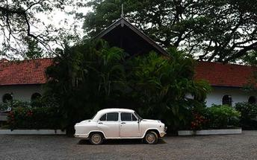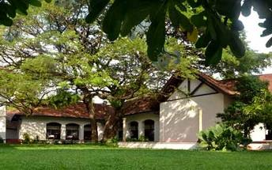

Day 7: In Kochi

Day Itinerary
A day to explore the city visiting Fort Kochi, Chinese fishing nets, the Jewish Synagogue, Dutch Palace and witness a Kathakli dance performance at a local theatre in the evening.
Fort Kochi
Fort Kochi takes its name from a long-gone fort which was built during its occupation by the Portuguese. The Portuguese were followed by the Dutch, who left their own legacy, and hot on their heels came the British with their own unique ways. Independent now for many years, Fort Kochi remains a colourful melting pot of diversity, retaining its colourful history in its architecture and culture.
Jewish Synagogue (Closed on Friday afternoon and Saturdays)
This synagogue was built in 1568 by the Malabar Yehudans or Cochin Jewish community. It was built close to the Mattancherry Palace Temple on the land gifted by King Rama Varma, a former ruler of Kochi. The Mattancherry Palace Temple and the Mattancherry synagogue share a common wall. This synagogue is the oldest one in the Commonwealth of Nations.
As one approaches the synagogue on Jew Street, its white facade begins to appear very prominently. A clock tower can also be seen, towering over and close to the facade. This was built in 1760 by Ezekiel Rahabi an affluent Jewish businessman. Of the four faces of the clock, the one facing the maharaja's palace showed the time in Malayalam. And among the other three, the face with etchings in Roman numerals was meant for the traders. Of the remaining two faces of the clock, one had writings in Hebrew while the other remains blank.
Stepping inside the Synagogue, one's eyes would easily go to the glass chandeliers and blue willow-patterned Chinese floor tiles. The chandeliers are of Belgian origin. Also of interest are the Scrolls of the Law housed here and the several gold crowns received as gifts and the brass-railed pulpit. And for some exclusive pieces from history, the synagogue also houses the copper plates of privileges given to Joseph Rabban, the earliest known Cochin Jew, dating from the 10th century, written in Tamil, by the ruler of the Malabar Coast.
Kathakali
Kathakali is a highly stylized classical kerala dance performance noted for its attractive make-up of characters, their elaborate costumes, detailed gestures and well-defined body movements presented in tune with the anchor playback music and complementary percussion.
Kathakali is said to have evolved from other performing arts like Kootiyattam (a classical Sanskrit drama existing in Kerala), Krishnanattam and Kalarippayattu. Kathakali explicates ideas and stories from the Indian epics and Puranas.
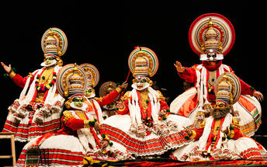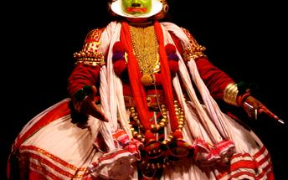

Day 8: Kochi - Periyar

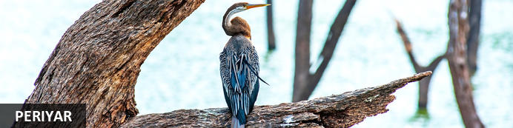
High in the evocatively-named Cardamom Hills by the state border with Tamil Nadu, Kerala’s Periyar National Park is known for its rolling thickly forested hills, montane grasslands, temperate climate and array of flora and fauna, some of it endemic. These are southern India’s loftiest peaks – the highest exceed 6,500ft – and their rolling topography forms the watershed for two of Kerala’s major rivers. Within the park lies Periyar Lake, a strangely convoluted 31-square kilometre stretch of water created in the 1890s by the Mullaperiyar Dam. While nearly 2000 species of flowering plants including 140 orchids might fade into the background, Periyar’s forests of teak, sandalwood, banyan and bamboo lend a more prominent backdrop to an array of wildlife. Elephants and tigers head a list of mammals including sloth bears, bison, flying squirrels, jungle cats, wild dogs along with around 270 species of birds, among them hornbills, flycatchers and storks.
Other nearby attractions include Chellarkovil waterfalls (the former at its best doing the monsoon season) and nearby Pandikuzhi, a lofty viewpoint. Just north of Periyar in Kumily town, the Kadathanadan Kalari Centre is a cultural centre featuring displays of kathakali (traditional Keralan theatre) and kalaripayattu (an ancient form of martial arts)

Day Itinerary
This day you will be driven to Periyar by your private vehicle, on arrival check-in a hotel. [Approx 4 Hrs.]
Rest of the day at leisure.

Overnight: Cardamom County
Muthoot Cardamom County sits between the Periyar National Park and Tiger Reserve and its lush highland forest and wetlands ecosystem and a spice-trading community of hill stations. It is within walking distance from both the entry to the Periyar and the village.
The rooms and cottages all provide expansive views of the reserve. The resort has a wellness centre, Ayura Spa, offering therapies and yoga sessions.
Muthoot Cardamom County organizes carbon-neutral activities such as nature walks, jungle patrols, border hiking, bamboo rafting, tribal heritage visits and Periyar tiger trails, bullock cart rides and visits to the elephant park. Other activities hosted by the resort that are not entirely carbon-neutral include full day Jeep safaris, plantation tours and visits to Gavi and Grampi.
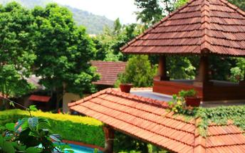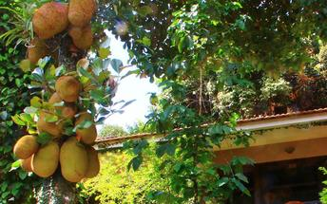

Day 9: In Periyar

Day Itinerary
This day proceed for a Nature walk at Periyar National park.
Different nature trails traversing diverse habitats form the trekking routes, generally 4 to 5 km. in length. This is an interpretive program offering excellent opportunity to watch birds, butterflies and other wildlife. The trails often pass through evergreen and moist deciduous forests interspersed with marshy grasslands. The program is offered between 7.00 am and 10.30 am and between 2.00 pm. and 3.00 pm. and lasts for about 3 hours. A maximum of 5 persons can go for trekking at a time along each nature trail, accompanied by a trained tribal guide. The Nature walk is the right program to feel nature, hear her whispers and smell her flowers.
Return to the hotel for breakfast.
Later in the afternoon, visit the Spice Plantation. Gift wrapped in lush green spice plantations, Periyar is the heartland of spices. The trip covers spice plantations such as cardamom, pepper, vanilla, clove, cinnamon, nutmeg, ayurvedic herbs etc. Over twelve varieties of spices including ginger, garlic, cardamom, vannilla, pepper, cinnamon, coffee, tea, clove and nutmeg is cultivated in Thekkady and its neighbouring villages.

Day 10: Periyar - Alappuzha

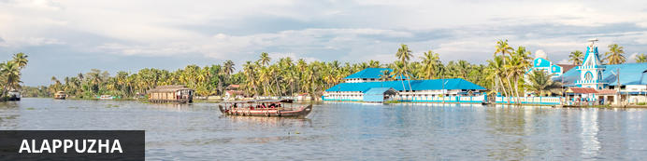
Located in the Indian state of Kerala, the bustling city of Alappuzha, also known as Alleppey, is set along the coast of the beautiful Laccadive Sea. Dubbed the ‘Venice of the East’, it is renowned for its sublime houseboat cruises which float along the tranquil canals of Kerala. Alappuzha is also said to be one of the most beloved tourist centres in the state. While cruising the palm-shaded canals is the most popular thing to do, visitors can also enjoy visiting Alappuzha’s beautiful beaches, exploring the little riverside villages dotting the lush countryside and discovering an array of resplendent temples. Don’t miss the annual Nehru Trophy Boat Race held at Punnamada Lake.

Day Itinerary
This day drive to Alleppey [Approx. 135 Km – 4 Hrs.] to arrive and board the Houseboat at around 1230-1300 hrs for a cruise over the backwaters of Kerala.
Cruise is followed by lunch at houseboat. These houseboats or Kettuvallam as they are traditionally called were at one time the mode of transportation for man and goods. Today, these are made to cater to the discerning guests who can lay back and enjoy the gentle cruise. Cruise the backwaters from the main Vembanad Lake through the small estuaries that link small villages to the mainland. Today, these are refurbished, and all modern conveniences have been added for tourists who visit this beautiful water locked region of the country.

Overnight: Houseboat
The Kerala houseboats takes tourists on a cruise along the emerald waterways. Modified to meet a novel concept of holidaying, the kettuvalloms (houseboats) are comfortably furnished with an open lounge, one or two bath attached bedrooms and a kitchenette, and are extremely eco-friendly, merging smoothly into the panorama. Every houseboat is manned by a crew of 3 men, usually a cook, guide and oarsman.
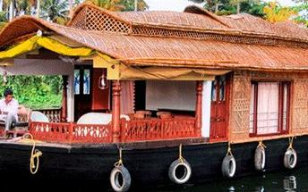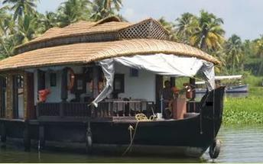

Day 11: Alappuzha - Mararikulam

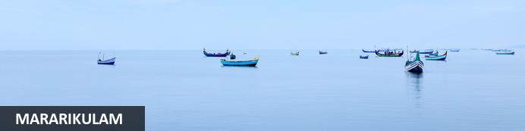
Situated only 40 km from the city of Cochin, in the Alappuzha district of Kerala, Mararikulam is a charming little coastal village known for its pristine sand beaches, swinging coconut palms, and quiet, laidback atmosphere. The village has managed to avoid the mass development associated with many of the other beach towns in the area resulting in an untouched natural environment dotted with only a handful of small resorts. The main attraction here is the exquisite Marari beach where you will find fishermen heading out daily to explore the Malabar coast, much as their ancestors have done for generations.

Day Itinerary
Disembark the the boat and then leave for Mararikulam (Approx. 30 minutes.)
Arrive Marari and you will be transferred to your hotel.

Overnight: Marari Beach Resort
Marari Beach is part of the CGH Group and provides an authentic experience of Kerala traditional and recreation. The small resort is set in the coconut grove at the sandy Marari Beach surrounded by flowering plants and herb gardens.
Deluxe pool villas and cottages provide accommodation at the Marari Beach Resort. Most cottages have French windows opening up to a private garden. All materials used are naturally resourced and processed using simple methods as a means of practising ecological methods in the day to day running.
There’s plenty to experience at the Marari Beach Resort. The locals often host festivals showcasing their traditions and culture. At the Ayurveda Centre, guests can experience an authentic Kerala massage from trained therapists. Also available are yoga classes from a master yoga teacher. Furthermore, visitors have the option of attending a cooking class at the Farm Kitchen.
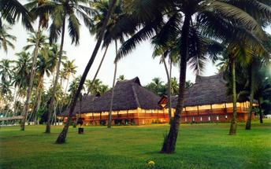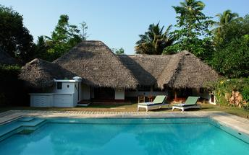

Day 12-13: In Mararikulam

Day Itinerary
Days are at leisure at the resort. Option to take yoga/meditations, visit to the fishermans village, fishlanding, cycling through the village or to rejuvenate with some spa/ayurveda massages

Day 14: Mararikulam – Kochi Depart

Day Itinerary
At an appropriate time, you will be transferred to Kochi international airport [approx. 2 hours drive] to board your flight back home.
**End of Services**

