

IN-12 Central India with Wildlife
Mumbai - Bhopal - Satpura National Park - Pench National Park - Kanha National Park - Mumbai
12 Days / 11 Nights
2 Persons

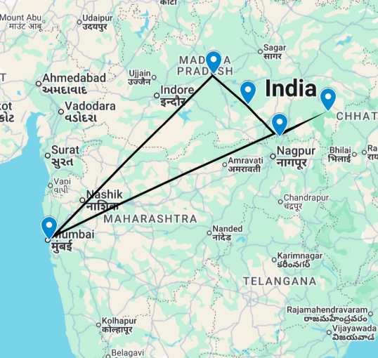

This journey covers Mumbai – the bustling commercial capital of India along with Bhopal and the wildlife parks of central India, namely – Satpura, Pench and Kanha.

Introduction

Start | Accommodation | Destination | Room Type | Duration
Day 1 | ITC Grand Central | Mumbai | Executive Club Room | 2 Nights
Day 3 | Jehan Numa Retreat | Bhopal | Premium Room | 2 Nights
Day 5 | Denwa Backwater Escape | Satpura National Park | AC Cottage | 2 Nights
Day 7 | Pench Tree Lodge | Pench National Park | AC Cottage | 2 Nights
Day 9 | Kanha Earth Lodge | Kanha National Park | Deluxe AC Bungalow | 2 Nights
Day 11 | ITC Maratha | Mumbai | Executive Club Room | 1 Night

Day 1: Arrive Mumbai

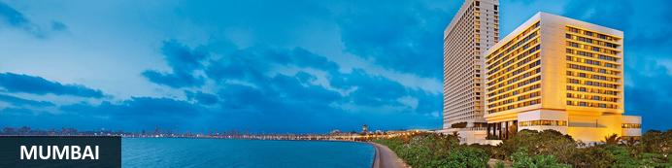
Although it isn’t India’s capital city, Mumbai often feels like it is or perhaps could be. With over twelve million people, it’s certainly India’s most populous city and the larger ‘greater Mumbai’ region homes over twenty million (making it one of the world’s most populous metropolitan regions). It’s long been India’s economic powerhouse – a place to which even the humblest outsiders might arrive, hit the big time through hard work, luck and acumen, and make a fortune. ‘Maximum City’, as it was once called, is sometimes defined by comparisons with Delhi: Delhi is bureaucrats while Mumbai is Bollywood. It’s simplistic but with a grain of truth: the city presents the most commercial, go-ahead, thrusting modern face of India and Bollywood is just one prominent face of its glitz and glamour.
Just a handful of Mumbai neighbourhood names – especially Colaba, Parel and Mahim – reflect its original geography of seven distinct islands. Initially captured by Portuguese trading fleets in the 1500s, they were given to Britain’s King Charles II in 1661 as part of his dowry when he married Catherine Braganza. Soon after that they were leased to the East India Company and quickly became its headquarters so that by the mid-1700s it was a major trading town. By the mid-19th century the islands had merged into one landmass after a series of massive land reclamation projects and seen the launch of India’s first railway line after which it became a major Arabian Sea port.
Today it’s not merely a practical international gateway but a destination showcasing modern India. Marine Drive’s curving Arabian Sea frontage has an almost Mediterranean feel while a clutch of gracefully ageing yet handsome Raj-era buildings stand witness to Mumbai’s significant imperial back-story. Thriving markets and bazaars, Hindu temples, Muslim shrines and a handful of excellent museums can easily fill a day or two’s sightseeing. Often filled with cricket-playing youth, the city’s maidans, or parks, and Dhobi Ghat, the curious open-air laundry, help lend colour, character and vitality to ‘maximum city’.

Day Itinerary
Flight TBA
Arrive Mumbai TBA Hrs.

On arrival in Mumbai: Having cleared immigration, collected your luggage and passed through customs, please make your way towards the exit of the terminal building where you will see a bank of people waiting for you. Amongst them will be Travel Counsellors Representative who will be waiting to greet you with a paging board with your name on.

You will be transferred to your hotel and assisted with check in. Standard check in time is 1400 hrs.

Overnight: ITC Grand Central
ITC Grand Central carries forth the culture and builds it's character through a fine blend of British colonial style with modern contemporary design.
ITC Grand Central is a 5-star hotel offering luxury accommodation - an area known as the Peace Zone. This luxury hotel has 242 guest rooms including 19 suites, non-smoking floors and a sophisticated security and building management system.
The Celebration Zone hosts fine dining experiences at renowned restaurants, sky-high split level lounge – Point of View and its luxury spa services at Kaya Kalp – The Spa.
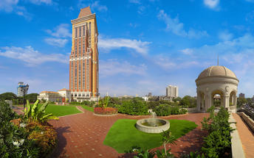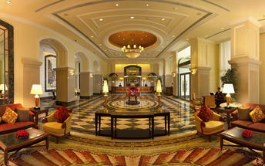

Day 2: In Mumbai

Day Itinerary
After breakfast, proceed for a half day tour of Mumbai.

Mumbai City Tour
Completed in 1924 to commemorate the landing point of King-Emperor George V, the Indo-Saracenic-style 26metre-tall Gateway of India is probably the city’s most iconic monument. Its seafront location on an open square beside jetties and close to the landmark Taj Mahal Palace hotel – an area almost continuously thronged with families, tourists and roving photographers – makes it feel like the city’s heart. Nearby the Chhatrapati Shivaji Maharaj Vastu Sangrahalay (originally known as the Prince of Wales Museum when it opened in 1922) is among the city’s finest museums dedicated to art, archaeology and natural history. It’s one of several Indo-Saracenic gems, an architectural style drawing on traditional Mughal and Hindu forms that was popularised across India with numerous public Raj-era buildings.
Chhatrapati Shivaji Terminus (formerly Victoria Terminus) is another iconic Mumbai landmark. Completed in 1887, this major railway station – still one of India’s busiest – was built in the Victorian Gothic Revival style yet also blended elements of Indian architecture. In fusing two distinct cultures it effectively forged a new style unique to Mumbai and for good reason it’s now a UNESCO World Heritage Site.
With views of Back Bay, Nariman Point and Chowpatty Beach, Malabar Hill is one of Mumbai’s prime real estate neighbourhoods with some of India’s most expensive properties. Most of the colonial-style bungalows that once peppered its gentle slopes have long been replaced by apartment blocks though a hint of ‘old Malabar’ just about survives at Banganga Tank, a large rectangular water body (still enclosed by high-rise blocks) with mythical associations to the Hindi deity Lord Rama.
A trip down three-kilometre long Marine Drive – sometimes referred to as the ‘Queen’s Necklace’ – framed by numerous art deco-style apartment blocks might end at Dhobi Ghat, an extraordinary open-air laundry space constructed in 1890. It still employs thousands of dhobis, or washermen, with reputedly over 100,000 garments drawn from across the city washed each day.
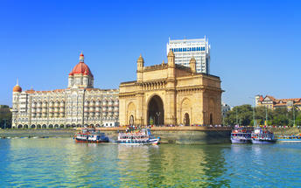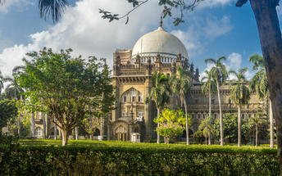
Return to the hotel after the visit.
Overnight at the hotel.

Day 3: Mumbai – Bhopal

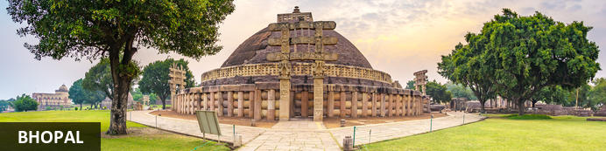
Known as the City of Lakes, Bhopal is the capital city of the central Indian state of Madhya Pradesh. The city is famed for its exquisite landscapes characterised by lush forests, green hills and several natural and artificial lakes. While the old part of the city features a maze of narrow winding alleyways lined with grand old mosques, ancient palaces and bustling bazaars, the newer part contains some excellent museums and galleries, manicured parks and gardens, and upmarket hotels and restaurants. Bhopal serves as a gateway to the nearby UNESCO World Heritage Site of Sanchi, one of Asia's most impressive Buddhist monuments. Other must-see attractions in the area include the Van Vihar National Park, home to tigers, lions and leopards, and the State Museum, displaying fossils, paintings and rare Jain sculptures.

Day Itinerary
Today you will be transferred to the airport for your flight to Bhopal.

Flight AI 633
Departs Mumbai 1030 Hrs.
Arrives Bhopal 1205 Hrs.

Arrive Bhopal and you will be transferred to your hotel.

Rest of the day is at leisure.

Overnight: Jehan Numa Retreat
Jehan Numa Retreat is an exquisite boutique resort located on the outskirts of Bhopal, India. This retreat is known for its luxurious rooms and impressive amenities, and it has become a popular destination for visitors worldwide. Guests can enjoy comfortable rooms with modern furnishings and access to high-end amenities such as a spa, swimming pool, fitness centre and fine dining options. Visitors can also take advantage of the 24-hour room service, complimentary Wi-Fi, and proximity to many of the city's attractions.
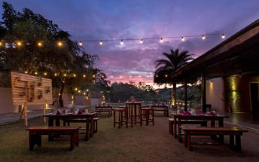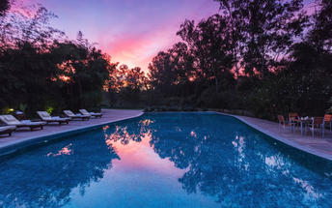

Day 4: In Bhopal

Day Itinerary
After breakfast, proceed for a tour of the city covering:
Taj-ul-Masjid, named as the ‘The Crown of Mosques’. Sultan Shah Jehan Begum of Bhopal (1868-1901) started the construction of this mosque. However, it was completely built only after 1971 by the great efforts of Allama Mohammad Imran Khan Nadwi Azhari of Bhopal.
Tribal Museum - Built over seven acres of land next to the Archaeological Museum, it is housed in a striking building designed by Revathi Kamath. The museum stands out from all others in the country because of the way its exhibits are put up. It does not conform to the old, sedate style of showing individual artworks as distinct masterpieces, with little contextual information. Instead, it celebrates the ways of life practiced by the seven major tribes in the state – the Gond, Bheel, Korku, Baiga, Sahariya, Kol and Bhariya – through their crafts. In a series of riotously colourful galleries whose roofs soar as high as three-storey buildings, the dramatically lit artefacts project tribal living, aesthetics, and spiritual beliefs.
The Shaukat Mahal is one of the architectural curiosities of Bhopal. It was designed by a Frenchman, a descendant of the Bourbon Kings of France. Post Renaissance and Gothic styles have been combined in an enchanting manner in the building.
Return to the hotel after the visits.
Overnight at the hotel.

Day 5: Bhopal – Satpura National Park

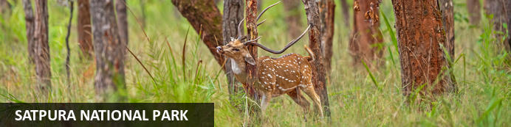
Tucked away in the spectacularly scenic Satpura hills, the Satpura National Park is comprised of 524 square-kilometers of pristine wilderness. The area is known for its towering sandstone peaks and rugged hills, which are cloaked in dense forests and intersected by glistening streams. The park also features a number of narrow gorges and ravines which provide an ideal secluded environment for a diverse array of wildlife including tiger, leopard, four-horned antelope, sambar, nilgai, chital, wild dog, chinkara, wild boar and bison. In addition to the usual game drives by jeep, visitors can look forward to exploring the park on guided safari walks, elephant back safaris, or by canoe or kayak.

Day Itinerary
Breakfast at the hotel.

Later you will be driven to Satpura National Park [approx. 3 hours' drive].

Leave in the morning for for Satpura National Park. The park is a part of Pachmarhi Biosphere Reserve and covers an area of 524 sq.kms. Along with its surrounding buffer-zone area, the park has a much better population of wildlife which are rarely seen in other national parks of state. Here we can find 50 species of mammals, 254 species of birds, 30 species of reptiles, 50 species of butterflies and much more. Attractive birds’ species includes, Malabar whistling Thrush, Paradise Fly-catcher, Honey Buzzard, Malabar pied Hornbill etc. Presence of various flower species, moist conditions offers ideal conditions for various butterfly species to flourish like Oakleaf, Black Rajah, Great Eggfly, Blue Pancy etc.

Arrive your Lodge and check in.

Rest of the day will be at leisure.

Overnight: Denwa Backwater Escape
Denwa Backwater Escape is located overlooking the mesmerizing backwaters of a dam built on Denwa River in Satpura National Park, the area is popularly known as Madhai. It is built on 10 acres of forested land along the river and across the river lies the national park which is approached by a boat and then by jeeps to go deeper into forest. The lodge offers stunning views of the Denwa River, grasslands across and rolling Pachmari hills.
The lodge has been mainly built using local materials like stone, baked tiles but the design is contemporary safari style. The rooms are done up in style with unique leather safari furniture, crisp cotton upholstery, linen and local crafts. The main building and the pool are done up with vintage iron furniture and hand crafted wooden furniture, the wood for which is sourced from old furniture and sleeper wood. The lodge estate is gifted with a unique undulating landscape, water bodies, indigenous forest with a variety of flora and fauna and stunning river views.
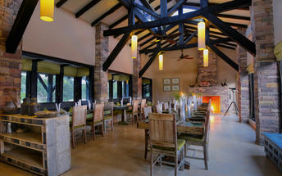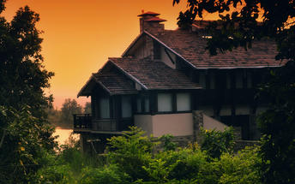

Day 6: In Satpura National Park

Day Itinerary
All meals at the hotel.

Enjoy early morning and afternoon exclusive jeep safaris at Satpura National Park.

Note: National Parks in Central India are closed every Wednesday for afternoon safaris.

Overnight at the hotel.

Day 7: Satpura National Park – Pench National Park

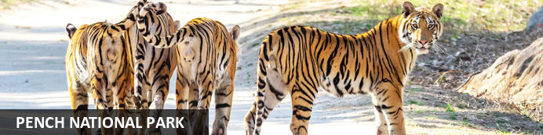
Resting in the lower southern reaches of the Satpuda Hills, in the central Indian state of Madhya Pradesh, Pench National Park is renowned for having the highest concentration of prey, compared to any other park in India. Visitors, therefore, have an increased chance of spotting predatory cats such as leopard and tiger. This impressive expanse of wilderness features a typical central Indian teak jungle and is bisected by the scenic Pench River. Aside from the river, the park also contains several bamboo-lined jungle streams providing a valuable water source for the local wildlife, which includes, among others: wild dog, sloth bear, wolf, jungle cat, hyena, jackal, gaur, sambar, and chital. Pench is also a bird lover's paradise, with over 250 species inhabiting the area, including; parakeets, hornbills, kingfishers, orioles, wagtails and a large selection of birds of prey.

Day Itinerary
After breakfast, you will be driven to Pench National Park [approx. 6 hours' drive].
Arrive Pench and you will be transferred to your Lodge.

Overnight: Pench Tree Lodge
Pench Tree Lodge, located in the Karmajhiri area of Pench National Park, Madhya Pradesh, offers a unique eco-luxe experience. The lodge features tree houses and cottages equipped with air conditioning, ensuite bathrooms, and private decks. Guests can enjoy meals made with ingredients sourced from the lodge’s organic garden and a variety of local and global cuisines. Additional amenities and services include an outdoor swimming pool, safari drives, and guided nature walks.
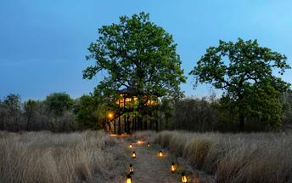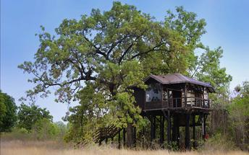

Day 8: In Pench National Park

Day Itinerary
All meals at the hotel.

Enjoy early morning and afternoon exclusive jeep safaris at Pench National Park.

Note: National Parks in Central India are closed every Wednesday for afternoon safaris.

Overnight at the hotel.

Day 9: Pench National Park – Kanha National Park

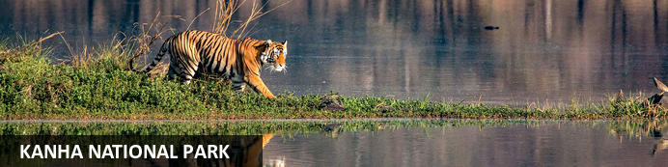
With a core area of almost a thousand square kilometres, Kanha National Park in Madhya Pradesh is the largest of central India’s tiger reserves. The undulating Maikal Hills with their flat-topped plateaux and extensive grasslands boast lush landscapes with sal and bamboo forests along with numerous meandering streams, tranquil water bodies and open meadows.
Kanha’s fauna includes leopards, wild dogs, jackals, deer and sloth bears as well as a population of rare barasingha, or swamp deer. Around 300 species of birds and a particularly large range of flowering plants and shrubs add to its impressive biodiversity.

Day Itinerary
After breakfast, you will be driven to Kanha National Park [approx. 4 hours' drive].
Arrive Kanha and transfer to your Lodge.

Overnight: Kanha Earth Lodge
Kanha Earth Lodge is nestled in a natural forest, bordering the buffer zone of Kanha National Park in Madhya Pradesh, India. The lodge features luxury bungalows equipped with ensuite bathrooms, large verandahs, and air-conditioning. Dining options include a multi-cuisine dining hall offering regional, Indian, and continental dishes made from locally sourced ingredients. Additional amenities include an infinity pool, a lounge and reading room, and an organic garden.
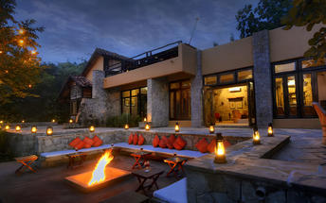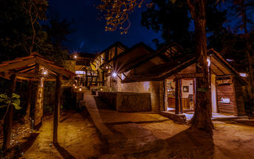

Day 10: In Kanha National Park

Day Itinerary
All meals at the hotel.

Enjoy early morning and afternoon exclusive jeep safaris at Kanha National Park.

Note: National Parks in Central India are closed every Wednesday for afternoon safaris.

Overnight at the hotel.

Day 11: Kanha National Park – Jabalpur – Mumbai

Day Itinerary
Today you will be driven to Jabalpur airport [approx. 4 hours' drive] for your flight to Mumbai.

Flight 6E 6678
Departs Jabalpur 1305 Hrs.
Arrives Mumbai 1455 Hrs.

Arrive Mumbai and transfer to your hotel.

Overnight: ITC Maratha A Luxury Collection Hotel Mumbai
A short distance away from the airport, this luxury hotel reaffirms the grandeur and ethos of Maharashtrian hospitality. It features interior expressing a fusion of old and contemporary with Maharashtrian art and furnishings within a modern architectural setting.
ITC Maratha hotel has restaurants serving Indian, Continental, East and South East Asian dishes along with both local and well-renowned beverages. The Peshwa Pavilion, an open-to-skylight 24-hour restaurant forms the pivot of activity,
This luxury hotel also provides hospitality with a gentle touch of nature. Expressing the value of ‘responsible luxury’ - 80% of the hotel’s energy is derived from renewable sources.
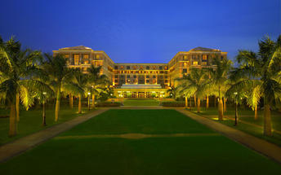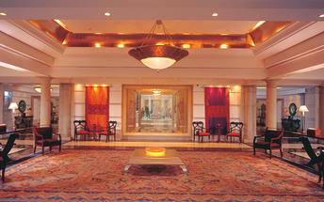

Day 12: Depart Mumbai

Day Itinerary
At an appropriate time, your Travel Counsellor Representative will assist and transfer you to the airport for your flight to onward destination.

Flight TBA
Departs Mumbai TBA Hrs.

**** END OF SERVICES ****

NOTE:
- The distances and time taken for the travel is approximation only this will differ based on the traffic conditions and other unforeseen circumstances.

