

IN-16

Himachal Trail
Amritsar – Dharamsala – Pragpur – Shimla - New Delhi
11 Days / 10 Nights

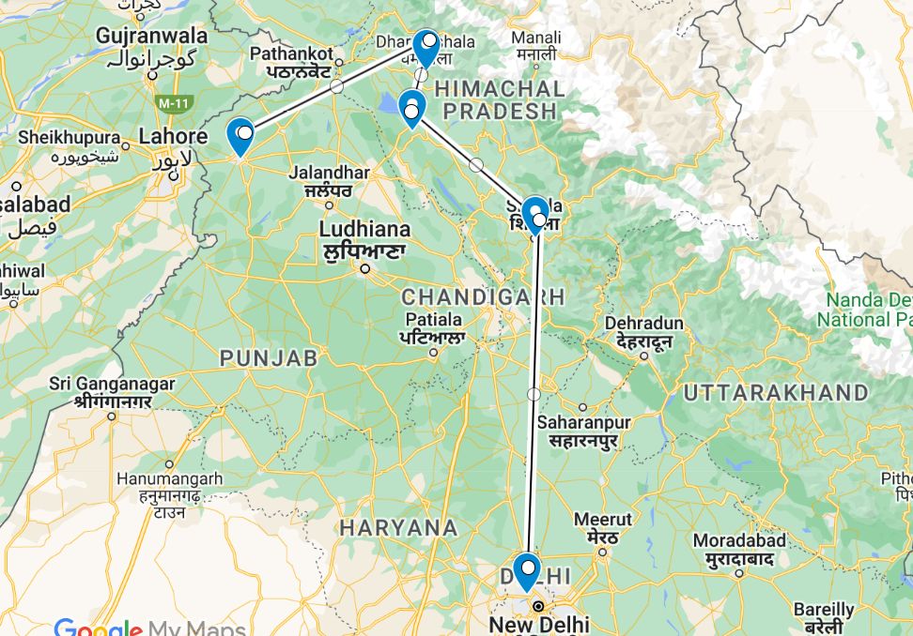
The journey covers travel to northern region of India covering Amritsar- the Holy city for Sikh religion and to Dharamsala – the seat of Dalai Lama in India.

Day 1: Arrive Amritsar

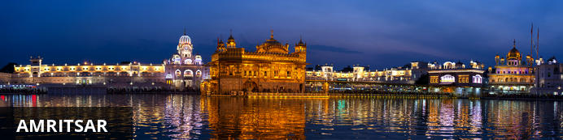
Armritsar is the spiritual capital of the Sikhs and gained its name, meaning ‘Holy Pool of Nectar’, from the body of water around Harmandir Sahib, the Golden Temple. The temple itself is a must see, receiving well over 100 000 people every day, who come to worship at the holy shrine. It is located just 28 kilometres from the Pakistani border post, and a highlight of the area is the Wagah border ceremony that occurs every evening at sunset. Full of pomp and flair, soldiers from both sides parade and lower the two nation’s flags in a ceremony punctuated with theatrics.
Fly into Amritsar where you will be met by your Travel Counsellors Representative who will transfer you to your hotel.
Evening witness Palki ceremony at Golden Temple.
Situated in the middle of a sacred lake fed by an underground spring, the golden structure is a unique blend of Hindu and Muslim architectural styles. Within the temple is the Adi Grantha, the sacred scripture of the Sikhs, displayed on a jewel-studded platform. Dozens of devotee’s act as a human conveyor belt to carry the Granth Sahib (a shrine containing the Adi Grantha) from the main shrine to the sanctum, where it is kept until the opening ceremony the following morning. Visitors may participate in the ceremony, taking their turn to shoulder the weight of the enormous shrine.
Overnight: Holiday Inn Amritsar
Holiday Inn Amritsar is located in Amritsar’s commercial district, Ranjit Avenue, with the famous Golden Temple and Jallianwala Bagh located only a short distance away. All rooms are comfortably designed with TVs, air conditioning, and hairdryers. After a relaxing night, guests can start each morning with a delicious breakfast. Other services and facilities include parking, a swimming pool, a fitness centre, business services, and restaurants.
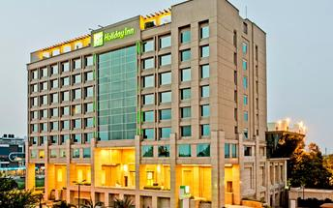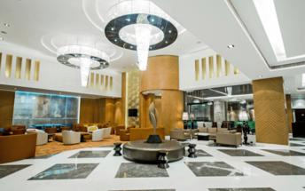

Overnight: Taj Swarna Amritsar
Taj Swarna Amritsar, located in the heart of Amritsar, offers a luxurious stay with a variety of room types, including Deluxe Rooms, Luxury Rooms, and Suites, all equipped with modern amenities such as free Wi-Fi, flat-screen TVs, and bathroom essentials. Guests can enjoy facilities like the J Wellness Circle Spa, a fitness centre, and an outdoor swimming pool. Activities available to guests include exploring nearby attractions such as the Golden Temple, Jallianwala Bagh, and the vibrant local markets.
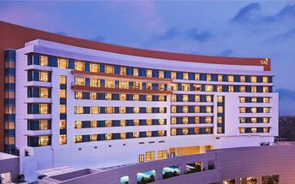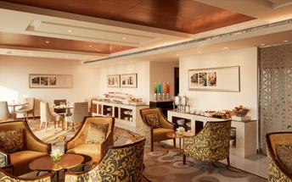

Day 2: In Amritsar

Day Itinerary
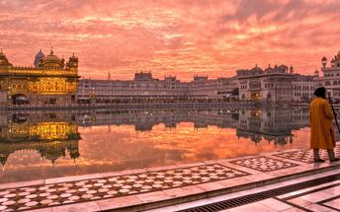
After breakfast, enjoy a half day sightseeing tour of Amritsar city.

The Golden Temple
Everybody, irrespective of cast, creed or race can seek spiritual solace and religious fulfilment without any hindrance here. It also represents the distinct identity, glory and heritage of the Sikhs. To pen-down the philosophy, ideology, the inner and outer beauty, as well as the historical legacy of Sri Harimandir Sahib is a momentous task. It is a matter of experience rather than of description.

Take part Guru Ka Langar (Langar Hall): Community Kitchen
Everyone is welcomed to share the Langar; no one is turned away. Each week a family or several families volunteer to provide and prepare the Langar. This is very generous, as there may be several hundred people to feed, and caterers are not allowed. All the preparation, the cooking and the washing-up is done by volunteers and or by voluntary helpers (Sewadars). In the Golden Temple Community Kitchen at an average 75,000 devotees or tourists take langar in the Community Kitchen daily; but the number becomes almost double on special occasions. On average 100 Quintal Wheat Flour, 25 Quintal Cereals, 10 Quintal Rice, 5000 Ltr Milk, 10 Quintal Sugar, 5 Quintal Pure Ghee is used a day. Nearly 100 LPG Gas Cylinders are used to prepare the meals. 100’s of employees and devotees render their services to the kitchen.

The Jallianwala Bagh Garden
Home to a national memorial, which serves as a lasting tribute to an innocent crowd of peaceful celebrators who lost their lives during a massacre by the British army. Today, the garden is mostly visited by tourists to learn about the killings and to admire the vast greenery or simply for relaxation and meditation.

Wagah Border
The border serves as a transit point for goods and commuters between India and Pakistan and plays host to the daily lowering of the flag ceremony performed by the Border Security Force of India and the Pakistan Rangers in Pakistan. This ceremony commemorates the unity and cooperation between the two nations who were once rivals.

Day 3: Amritsar - Dharamshala

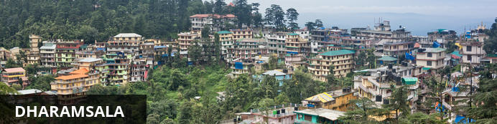
Situated in the upper reaches of the Kangra Valley, Dharamsala is one of Himal Pradesh’s most irresistible destinations. Famous as the home of the exiled Dalai Lama, this small market town is the centre of the Tibetan world in India. Most travellers head 10 kilometres uphill to the suburb of McLeod Ganj, also known as Upper Dharamsala. Surrounded by dense coniferous forest, this beautiful hill station attracts Buddhists, pilgrims, students and bohemian travellers seeking spiritual enlightenment and a possible encounter with this holy man.

Breakfast at the hotel.

After breakfast, you will be driven to Dharamshala. Enroute visit Masroor Rock cut temple (Amritsar to temple – approx. 4 hr, temple to Dharamshala – approx. 1.5 hr).

Masroor Rock Cut Temple
The spectacular Masroor Rock Cut Temple is located in the state of Himachal Pradesh in India. This monolithic Hindu temple is set on a hilltop at 2,500 feet above sea level. The temple is a good example of Nagara architecture; it features a sanctum, a sacred pool, a sculpture of several deities and bas-reliefs. The temple offers vintage views of the Beas River and beyond. Visitors can take advantage of stunning photo opportunities

After the visit, continue with your drive to Dharamshala.

Arrive and check-in at the hotel.
Overnight: Fortune Park Moksha McLeod Ganj
Nestled in the scenic Strawberry Hills with beautiful views of the snow-capped Dhauladhar mountain range and the pristine Dharamshala valley, Fortune Park Moksha is located just 6 km from the main square. This leisure hotel in McLeod Ganj provides guests easy access to all the main tourist attractions in and around the town. Located at a driving distance from Delhi-NCR, this is a hotel for recreation, family and corporate bonding, and a select venue for conferences.
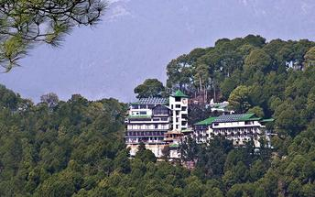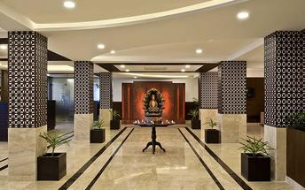

Overnight: Norbu The Montanna Dharamshala IHCL SeleQtions
Nestled in the majestic Kangra Valley, Norbu The Montanna Dharamshala IHCL SeleQtions offers comfortable accommodations with beautiful views of the Dhauladhar mountain range. The hotel's stylish suites and villas feature air-conditioning, fully equipped kitchens and room service. Guests can enjoy delicious dishes at the on-site restaurant. Additional amenities include a fitness centre, an outdoor swimming pool and a coffee shop.
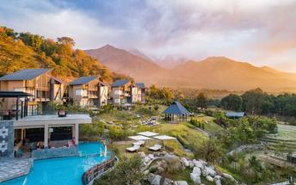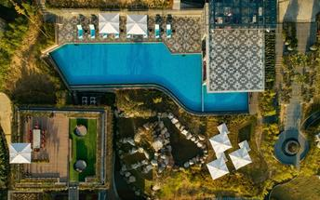

Day 4: Dharamshala

Breakfast at the hotel. Enjoy half day sightseeing tour of Dharamshala.
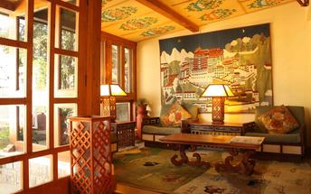

Norbulingka Institute
Norbulingka Institute is a unique institute dedicated to the preservation of Tibetan arts and culture. The institute is a self-sustaining community and is dedicated to ensuring that the integrity of Tibetan artistic traditions are maintained for future generations. The studios produce museum quality artwork using methods that have been practiced and passed down for many centuries.
Tsug la Khang, The Dalai Lama’s temple
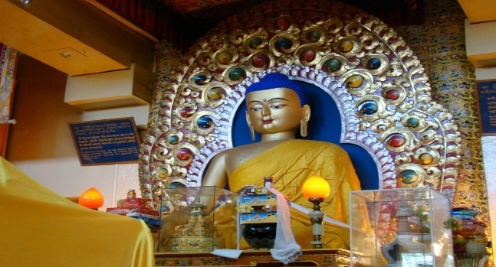
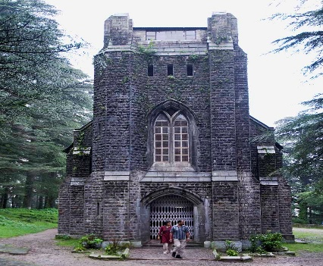
This is the life-blood of the village. It houses the Namgyal Monastery and shrine rooms. The largest shrine contains a huge gilded statue of the Buddha, along with two smaller statues of Chenresig and Guru Rinpoche. Parts of these statues were brought at great sacrifice from Tibet. The Dalai Lama’s residence and administrative offices are adjacent to the monastery. The temple is always busy. Services are held daily and are attended by lamas, monks, nuns and lay people. In the shrine, you might come across a group of monks building an intricate sand mandala, and outside in the courtyard on Thursdays, monks debate Buddhist philosophy. Around the temple hill there is a long meditation trail — LingKhor — with small shrines, stupas, and a massive chorten. The shrines near the chorten are always covered in thousands of prayer flags placed by devotees. The temple is located a short walk down the hill from the main square at the centre of town.

St. John’s Church [Closed on Sundays]
Immerse in the composure of nature and a church amidst its greenest foliage! St. John’s Church is the most ancient structure of the town and it is a gothic stone shrine amidst the forest in between Mcleod Ganj and Forsyth Ganj. It is an Anglican structure that is a tribute to John the Baptist. ‘St. John in the Wilderness’ is no more a hidden entity.

Day 5: In Dharamshala

Day at leisure to pursue independent activities.

Day 6: Dharamshala - Pragpur

Morning after breakfast leave for Pragpur (approx. 65 Kms / 2 Hrous drive)
With its cobblestone alleyways, mud plastered and slate roofed houses, and its array of historically significant sites, a visit to Pragpur feels like a journey back in time. The village’s most popular tourist attraction is ‘The Taal’, a pond located in the heart of the village which serves as a recreational space. It was constructed by the village brotherhood, which has maintained this ancient water system since the mid-1800s. The Taal is surrounded by many fascinating heritage structures including, among others: the Bhutail Niwas, the Radha Krishna Mandir and Nehar Bhawan. Don’t miss the Judge’s Court, a grand manor showcasing the Indo-European style of architecture..
Evening take a walk through the village.
Overnight: The Judge's Court
One of India's finest Country Hotels, The Judge´s Court is a Country Manor located in the medieval hamlet of Pragpur, on the edge of the Himalaya Mountains, at an elevation of 2000 ft. in the Kangra Valley of the North Indian State of Himachal Pradesh. The property is classified as "Heritage" and this makes it India's first classified Heritage Country Manor with an ambiance reminiscent of the turn of the 20th Century. The Judge's Court's elegant accommodation comprises of 10 Double Rooms 3 of which are suites inclusive of the cottage in the ancestral courtyard. The Judge's Court substantially grows its own fruit, vegetables, wheat, maize and oil seeds. All efforts are made towards creating environment. Milk is from an owned dairy on the premises. Water is exclusively piped from an ancestral mountain spring.
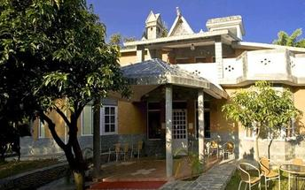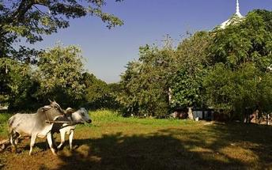

Day 7: Pragpur - Shimla

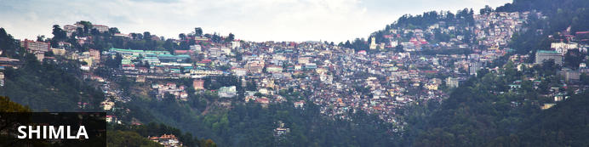
Sitting at an altitude of 2159 metres, the city is blessed with a cool climate and beautiful views of river valleys, pine forests, apple orchards and steep mountains covered with maize terraces. The Mall, a long, winding pedestrian-only walkway, is the commercial and social hub of Shimla, while those looking for natural beauty should head uphill through the forest to Jakhu Temple or follow one of the many forest trails in the eastern part of Shimla. To the south of the city, the bazaars bustle with local flavour.
Morning after breakfast, leave for Shimla (approx 200 kms/ 4 hours drive)

Overnight: Radisson Shimla
Radisson Hotel enjoys beautiful views of the surrounding cedar forests and mountains. Offering free Wi-Fi, it also has a seasonal outdoor pool, pampering spa treatments and a gym. Fitted with both air-conditioning and heating, the large rooms are equipped with a flat-screen TV and a minibar.
A personal safe and tea/coffee making facilities are included. Bathrooms have shower facilities. Radisson Hotel is less than 200 metres from Jakhu Temple and The Mall. It is 1.3 km from Himachal State Museum. Shimla Airport is 26 km away. Free parking is available.
Day trips and car rentals can be arranged at the tour desk. The hotel also provides a business centre and laundry services. The front desk operates 24 hours.
Opening out to a garden, Cafe Valley Vue serves international cuisine. Drinks can be enjoyed at Pulse Terrasse Bar.
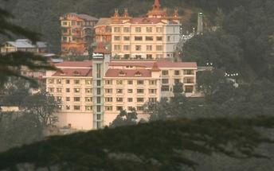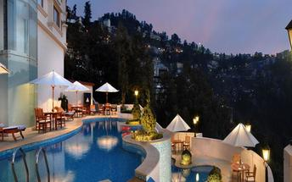

Overnight: The Oberoi Cecil
Set amidst the majestic Himalayan ranges, The Oberoi Cecil is an opulent accommodation situated in the quieter end of the bustling Mall Road. Guest rooms and suites each feature air-conditioning, high-speed internet, a mini bar, a 32" LCD television and a DVD player. Hotel facilities include a restaurant, an expansive swimming pool and a spa. Guests can learn about the country’s colonial history by stopping by notable sites including Gorton Castle, St. Michael's Cathedral, and The Mall.
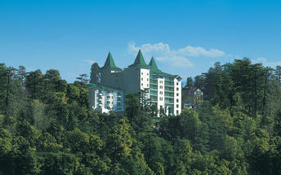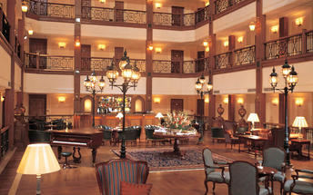

Day 8: In Shimla

Morning proceed for short ride on the UNESCO World Heritage Toy Train from Shimla to Tara Devi (45 minutes ride)
Toy Train - The Shimla – Kalka rail route, offers the charm of old-world travel amidst lofty pines and lush green, misty mountains. This is one of the four narrow gauge rail routes on hill terrain in the country. Laid out on a 96 km long narrow gauge track that passes through 103 tunnels and across more than 800 bridges and viaducts, it is one of the most beautiful hill railways in India. It was considered the "crown jewel" of the Indian National Railways during British times. Flanked by hills on both sides, the rail line, like twin threads of silver, clings to the steep cliffs and ventures boldly over bridges, built over tiny streams that show off their radiance in the sunlight. The cool breeze sweeps across your face as the train makes an arduous climb of almost 4800 feet.
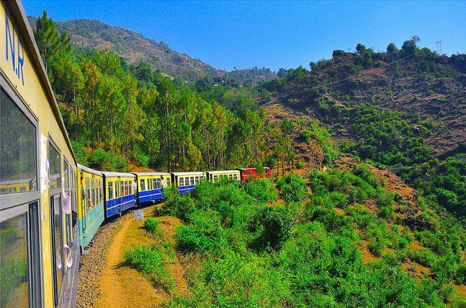
Later enjoy half day sightseeing tour of Shimla.

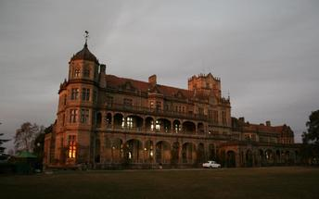
Indian Institute of Advanced Study (Closed on Monday)
Also called the Viceregal Lodge, the Indian Institute of Advanced Study is a research institute set in a historical building. As a residential centre for research, it encourages creative thinking in areas of deep human significance. The environment of the institute is eminently suitable for academic pursuits, especially in select areas of the humanities, Indian culture, religion and the social and natural sciences. It also has a comprehensive library and documentation facilities.

Sankat Mochan Temple
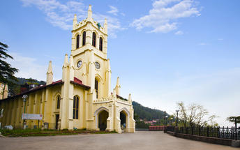
A famous temple of Lord Hanuman in the region is located amidst the mist-clad mountains, providing a serene and scenic environs, making visitors get lost in the mesmerizing atmosphere of the place. The temple was built in the decade of 1960s. Originally dedicated to Lord Hanuman, the temple now also bears the idols of Lord Rama, Lord Shiva, and Lord Ganesha in various complexes.

Visit Shimla Mall Road
The Mall Road is one of the most popular tourist attractions in Shimla that enfolds many hotels, restaurants, clubs, bars, banks, shops snd offices. The Mall road is connected to the Ridge at the Scandal point, where a statue of the nationalist leader Lala Lajpat Rai has been erected.

Day 9: In Shimla

A day at leisure

Day 10: Shimla - Chandigarh - Delhi

After breakfast leave for Chandigarh airport (approx 110 kms/ 4 hours drive) to board the flight for Delhi.
Upon arrival at Delhi, you will be assisted & transferred to the hotel for check in.

Overnight: Novotel New Delhi Aerocity
Novotel New Delhi Aerocity is located in New Delhi. The accommodation features stylish guest rooms and suites equipped with modern amenities such as LED TVs, air conditioning, electronic safes, workstations and Wi-Fi access. Guests can enjoy a meal at the on-site restaurant and have a refreshing drink at the hotel bar. Leisure facilities include a swimming pool fitness centre and a spa.
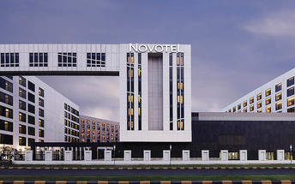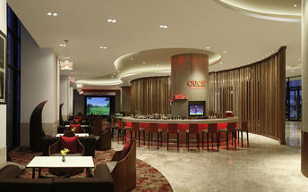

Alternate: Pullman New Delhi Aerocity
Pullman New Delhi Aerocity is situated in the bustling Aerocity district, close to Indira Gandhi International Airport. The hotel offers a range of rooms and suites, equipped with modern amenities such as TVs, Wi-Fi, and minibars. Guests can enjoy facilities like an outdoor swimming pool, a Pullman Spa & Salon, and a fitness centre. The hotel also provides various activities including visiting nearby attractions such as National Rail Museum and Qutub Minar.
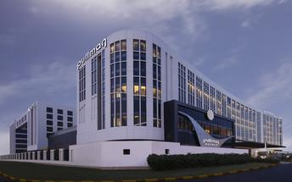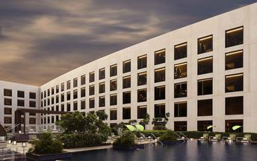

Day 11: Delhi Departure

At an appropriate time, you will be assisted & transferred to Delhi airport to board the flight for onward journey.

**End of Services**

