

Tamil Nadu and Kerala Tour
Chennai - Puducherry - Thanjavur - Chettinad - Madurai - Periyar - Kochi - Alappuzha - Mararikulam
17 Days / 16 Nights

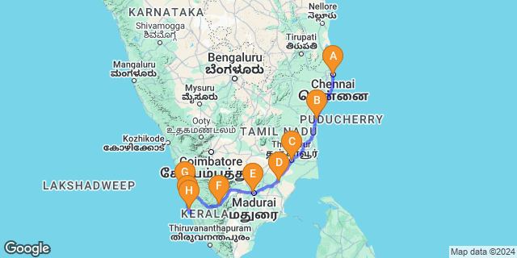
This itinerary distils the best key sights of southern India across two states. From Tamil Nadu’s venerable ‘temple towns’ with huge temple complexes to a former French enclave and on into the scenic Western Ghats, the tour winds down in Kerala’s tranquil backwaters and its main city.
Chennai, one of south India’s main gateways, offers an eclectic mix Raj-era heritage, characterful neighbourhoods clustered around a large Hindu temple and one of India’s largest city-beaches. A little south, Mahabalipuram’s ancient temple-monuments and tradition of stone carving culminate in the remarkable Shore Temple while the former French enclave of Pondicherry exudes a subtle Gallic charm. The great temple towns of Tanjore (Thanjavur), and Madurai are unmatched anywhere else in India for the age, size and vigour of their huge temple complexes with ornamental towered gateways dominating their respective skylines. Kerala’s lush Periyar National Park boasts rolling forested hills and montane grasslands along with the south’s loftiest peaks and an array of flora and fauna including elephants and tigers. Overlooking Vembanad Lake, Kumarakom resorts offer fine food, yoga and ayurvedic treatments while charming houseboats ply the so-called ‘backwaters’, or inland lagoons. Although Cochin, Kerala’s largest city, has expanded well beyond the original settlement of Fort Kochi, the latter retains its cosy heritage atmosphere and sights.

Introduction

Accommodation | Destination | Start | End | Room Type | Duration
Taj Club House | Chennai | Day 1 | Day 2 | Superior Room | 1 Night
Maison Perumal | Puducherry | Day 2 | Day 4 | Standard Room | 2 Nights
Mantra Koodam - CGH Earth, Kumbakonam | Kumbakonam | Day 4 | Day 6 | Mantra Cottage | 2 Nights
Visalam CGH Earth hotel Chettinad | Chettinad | Day 6 | Day 7 | Chettinad Room | 1 Night
Heritage Madurai | Madurai | Day 7 | Day 9 | Deluxe Club Room | 2 Nights
Cardamom County | Periyar | Day 9 | Day 11 | Periyar Cottage | 2 Nights
Forte Kochi | Kochi | Day 11 | Day 13 | Classic Room | 2 Nights
Alleppey Deluxe Houseboat | Alappuzha | Day 13 | Day 14 | 1-bedroom Deluxe Houseboat | 1 Night
Marari Beach Resort | Mararikulam | Day 14 | Day 17 | Garden Villa | 3 Nights

Day 1: Arrive Chennai

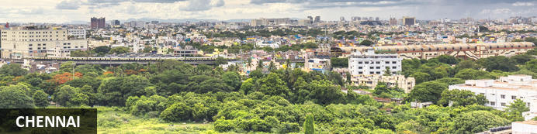
Facing the Bay of Bengal, Tamil Nadu’s state capital is among the country’s largest cities and an important gateway to south India for tourism – especially the health sector – and business. In the early 17th-century the region comprised a clutch of modest fishing villages and hamlets. To further secure its lucrative spice trade, the East India Company sought out a potential port that was also relatively close to the Strait of Malacca, a vital shipping lane between peninsular Malaysia and Sumatra. The company settled here, built Fort St. George – the first British fortress in India – in 1644, and the settlement gradually evolved from trading port to naval base and administrative centre.
Today it’s a dense sprawling metropolis somewhat tempered by a huge sandy beach. Its significant economic clout ranges from tech and IT to healthcare and automobiles. For tourists its usually seen as more of a gateway than a destination in its own right though there’s enough here to occupy a day or two’s sightseeing before moving on. 50Km south of the city, Mahabalipuram (a UNESCO World Heritage Site) is an obvious day excursion.

Day Itinerary
Flight TBA
Arrive Chennai TBA Hrs

On arrival in Chennai: Having cleared immigration, collected your luggage and passed through customs, please make your way towards the exit of the terminal building where you will see a bank of people waiting for you. Amongst them will be Travel Counsellors Representative who will be waiting to greet you with a paging board with your name on.
You are then transferred to your hotel. Check-in as per standard time 1400 hrs.
Afternoon, proceed for tour of Chennai covering the Santhome Cathedral, Fort St. George, Kapaleeshwarar temple etc.

Kapaleeshwarar Temple
One of the sacred shrines in Tamil Nadu is Arulmigu Kapaleeswarar Temple in Mylapore, in Chennai City.It is a Siva Temple, and the name of the Lord is ARULMIGU KAPALEESWARAR. The name of the Goddess is ARULMIGU KARPAGAMBAL.It is a loverly temple with a Stately Spire or ‘Gopuram’ as it is called. There is a big tank on its West. The temple and the tank are surrounded by Broad streets on the four sides. The view of the temple and the tank is picturesque. The Legend Behind The Temple The name Mylapore is derived from the legend that the Goddess Uma worshipped Siva in the form of a peacock (or mayil in Tamil). One can see a representation of this legend on stone in a small Shrine under a Punnai tree in the Courtyard of the temple.
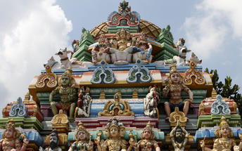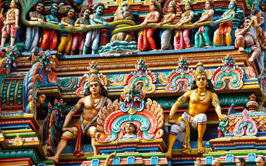

Santhome
Santhome is situated in Mylapore in the Chennai District of India. The name Santhome originated from Saint Thomas, whose tomb can be found beneath San Thome Church. The Santhome Cathedral is a local attraction where travellers around the world come to visit or pray at the tomb.

Overnight: Taj Club House
The Taj Club House is located on Clubhouse Road, off the historic Mount Road. This 5 star esablishment is an ideal venue for travellers and tourists. It is within walking distance to nearby attractions such as Spencer Plaza, Express Avenue and the LIC Building.
The accommodation structure is spread over 7 floors with 220 well-appointed rooms and suites. The Taj Club House offers guests thoughtful amenities to enjoy within a personal space creating a comfortable environment.
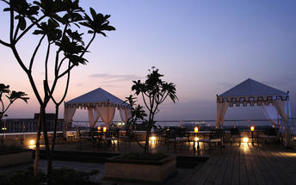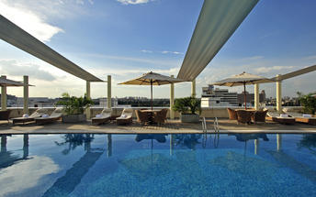

Day 2: Chennai - Puducherry

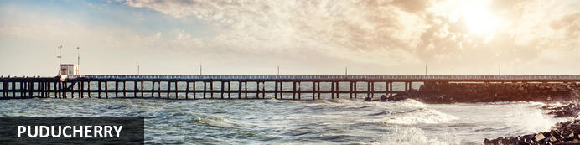
Set by the Bay of Bengal nearly a hundred miles south of Chennai, capital of Tamil Nadu state, Puducherry was among the first places in southern India that saw early colonial powers gain a foothold. First came the Portuguese in the 1520s followed by the Danes and the Dutch. But it was France that really made its mark in 1674 with the beginnings of a French-style settlement that grew into a town – the heart and largest of Puducherry’s four separate and unconnected districts. Their rivalry with the British saw ‘Pondy’ (as it’s sometimes referred to affectionately) seized briefly several times but essentially France retained control until 1954. Yet, uniquely in India, a subtle French flavour endures in its architecture, tree-lined streets and cuisine.

Day Itinerary
After breakfast you will be driven to Pondicherry [approx 160 kms/ 04 hours drive]
En route you will visit Mahabalipuram.

Mahabalipuram
The ancient port town of Mammallapuram is a charming tourist hub which has been attracting travellers for centuries. It was known already in Marco Polo’s day as the “Seven Pagodas" alluding to the seven tiered towers that once stood on the shore, of which one - the Shore Temple, still stands. The port is famous for its stone carvings, which have World Heritage Site status. Impressive cave temples, monolithic rathas (chariots) and sculpted reliefs built by the Pallavas in the 7th and 8th centuries form this group of monuments. After sightseeing, enjoy an Indian thali meal or chai tea at one of the bustling diners in town.
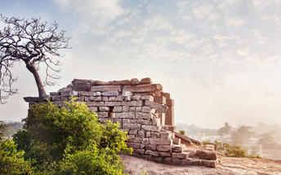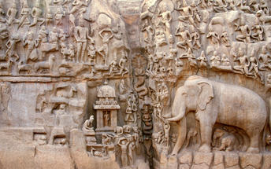
Arrive Pondicherry and check in at the hotel.

Overnight: Maison Perumal
Maison Perumal has 10 rooms offering accommodation - 2 of which are twin rooms. All rooms are air-conditioned and has a quiet elegant atmosphere.
The hotel serves local and international dishes. Local produce is used to prepare dishes. Guests staying at the Maison Perumal can explore the town on foot on by cycling. Pondicherry has beautiful heritage buildings, restaurants, shopping centres and a beach.
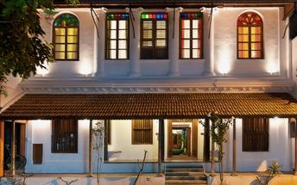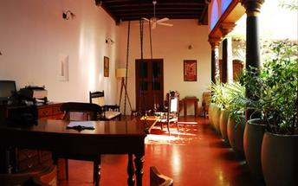

Day 3: Puducherry

Day Itinerary
After breakfast, enjoy the walking tour of Pondicherry.
The walk starts from the Sri Aurobindo Ashram, the white town and the old town.
Later Visit Auroville.

Activities
Sri Aurobindo Ashram
Auroville

Sri Aurobindo Ashram
Located in Puducherry, India, Sri Aurobindo Ashram has grown from a small group into a large community. The focus of community life is the Ashram main building which consists of blocks of houses which are adjoined. This is also where Sri Aurobindo and the Mother lived for most of their lives.
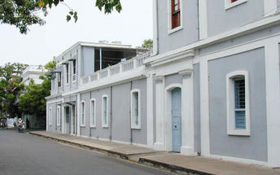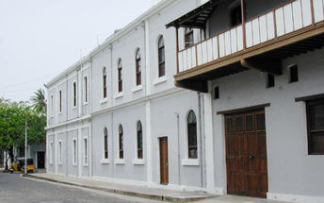

Auroville
Located in Puducherry, India, Auroville is a community that was born on the 28 February 1968. Its founder created the Auroville Charter which consists of four main ideas, underpinning her vision for Auroville. When Auroville came into being, All India Radio (AIR) broadcast the charter live in 16 languages. Aurovilians apply the ideas of the Auroville Charter in their daily life, in policy-development, and decisions, big and small. The charter thus forms an omnipresent referent that silently guides the people who choose to live and work for Auroville.
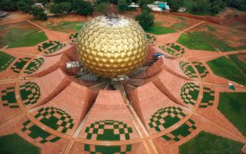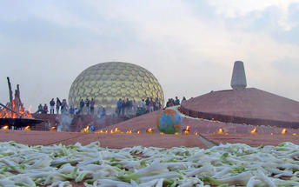

Day 4: Puducherry - Kumbakonam

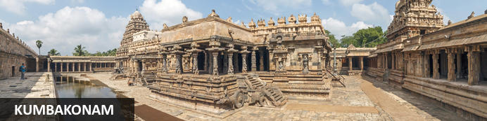
Sandwiched between two great rivers of southern India, Cauvery and Arsala, the charming temple town of Kumbakonam is known for its history and culture. As one of India’s oldest cities, temples adorn every street, and the city is known for its rich Hindu heritage, while maintaining a wonderful religious diversity and tolerance. One of the most famous temples in the city is the Mahamaham Tank Temple, known for its holy waters and festival which takes place every twelve years, as well as the Adi Kumbeswarar Temple, an enormous colourful temple covered with statues of deities. The vegetarian cuisine, predominantly authentic Tamil and South Indian flavours, are unique to the area. Don’t miss the chance to try Kumbakonam’s coffee, which is known as some of the best in the world.

Day Itinerary
Breakfast at the hotel.

After breakfast leave Pondicherry for Kumbakonam visiting some of the beautiful temples at Chidambaram, Gangaikondacholapuram and Darasuram (approx. 170 kms / 5 to 6 hrs including stops)

Chidambaram Temple is a Hindu temple dedicated to Lord Shiva located in the heart of the temple town of Chidambaram,Tamil Nadu).The temple , 78 km south of Pondicherry and 235 Km from Chennai, the capital of Tamil Nadu state of southeastern India. The Sangam classics refer to Viduvelvidugu Perumtaccan, respected clan of traditional Vishwakarmas, as being the chief architect of the temple renovation. There have been several renovations in its history, particularly during the days of Pallava/Chola emperors in ancient and pre-medieval periods. Chidambaram is one of the five holiest Shiva temples, each representing one of the five natural elements; Chidambaram represents akasha (aether). The other four temples in this category are: Thiruvanaikaval Jambukeswara,Trichy (water), Kanchi Ekambareswara (earth)Kanchipuram, Thiruvannamalai Arunachaleswara (fire),Thiruvanna malai and Kalahasti Nathar (wind),Kalahasti.
Gangaikonda Cholapuram Temple
Gangaikonda Cholapuram Temple is located in the beautiful town of Ariyalur, India. The temple is renowned for having the largest Shivalingam in India and features a four-meter-high lingam dedicated to Lord Shiva. The temple also features five shrines, a lion well and various sculptures around the walls of the sanctum. Travellers can visit the exquisite temple using public transport from anywhere within the Tamil Nadu.

Darasuram
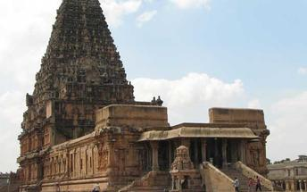
The temple at Darasuram was built by Raja Raja Chola dedicated to Lord Siva, is either called as Drasuram temple or Airavateswara Temple. This is well preserved temple of the 12th century Chola Kingdom. The columns of the temple have unique and excellent miniature sculptures. This is termed as one of the Great Living Chola Temples along with Big Temple and the Gangaikondan Cholapuram temple. During the 14th century the large stone statues surrounding the temple was replaced with brick and mortar statues similar to that of Big Temple at Thanjavur. Archaeological Survey of India has restored the temple. UNESCO declared it as World Heritage Monument in its 2004 list.

Arrive Kumbakonam and check in at the hotel.

Spend rest of the day at leisure.

Overnight: Mantra Koodam
Mantra Koodam is ideally tucked away in a quiet corner of Veppathur Village in Kumbakonam, India. Accommodation options consist of elegant cottages and bungalows with tea/coffee-making facilities, hairdryers, and private bathrooms. Facilities and services include a swimming pool, event/meeting spaces, a cafe, and Wi-Fi.
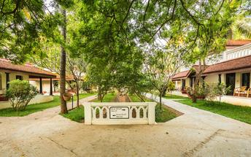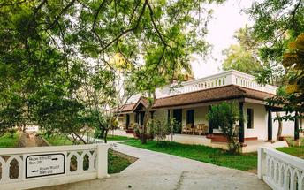

Day 5: Kumbakonam - Thanjavur - Kumbakonam

Day Itinerary
After breakfast, proceed for excursion to Thanjavur visiting Brihadeeswarar Temple and Thanjavur Royal Palace Museum.

Brihadeeswarar Temple
Peruvudaiyar Kovil, which is also famous as Brihadeeswarar Temple, Rajarajeswaram and RajaRajeshwara Temple, is located at Thanjavur in Tamil Nadu state of India. It is one Hindu temple, which they dedicate towards Lord Shiva. It is one luminous example of major heights, which Cholas achieves within Tamil architecture. This temple is one tribute and one reflection of power of its supporter Raja Raja Chola I. this temple remains as India’s largest and Indian architecture’s one of greatest glories. It is also a part of UNESCO World Heritage Site as “Great Living Chola Temples”.
This great temple is India’s one of most prized site for its architecture. It stands in middle of fortified walls added probably in sixteenth century. There is one temple tower, which people call as Vimana. It is 216 feet or 66 meters high. It is also one among tallest tower in whole world in its kind. Kumbam, Chikharam or Kalasha, which is bulbous, or apex structure on top of temple, people believe that it is made out of a single stone carving.
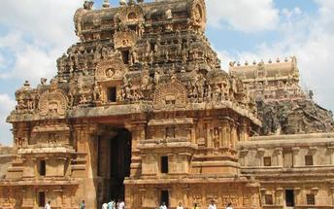
Thanjavur Royal Palace Museum
The Thanjavur Maratha Palace Complex, known locally as Aranmanai, is the official residence of the Bhonsle family who ruled over the Tanjore region from 1674 to 1855. The original name of Thanjavur Palace is Sivaganga Fort, which is rarely used these days. A remarkable collection of South Indian sculptures and paintings is housed in the old palace buildings at Thanjavur (Tanjore). Today, the town is a flourishing centre for bronze sculpture, stonework and paintings. The palace was originally built by the Nayak rulers of Tamil Nadu. It was this dynasty that added to and enlarged many of the temples, with ornate and often huge sculptures. The palace building, set within a large compound, also contains the Saraswati Library and the Sangeetha Sabha, or Music Hall. This museum is best known for its bronze sculpture collection, of rare artistic quality.

Day 6: Kumbakonam - Chettinad

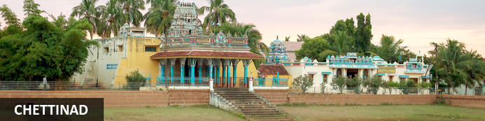
Situated in the heart of Tamil Nadu state in India, the region of Chettinad is well-known for its agriculture, architecture, and unique cuisine. This region holds important cultural and historical treasures including French Art-Deco style palatial mansions peppered across the region, the magnificent Raja’s palace in Kanadukathan, and the 17th-century hilltop Thirumayam Fort. Browse antique markets in Karaikudi, sample the region’s flavourful and fiery cuisine featuring the famous Chettinad chicken, and visit to one of the impressively ornate temples. The town is also famous for its beautiful, hand-printed cotton fabric and traditional brightly-coloured Athangudi tiles.

Day Itinerary
Morning visit Trichy and later leave for Karaikudi (Chettinad)
The most famous land mark of Tiruchirappalli is Rockfort Temple. It is also called as Ucchi Pillaiyar Kovil. It is in the heart of the city. This is a275 ft. tall rock structure. It is reached by a step flight of 437 steps cut into the rock. Halfway up is the Sri Thayumanaswamy Temple, dedicated to Lord Shiva. It has a 100 pillared hall, and a Vimana. There are inscription in these temple that date back to 3rd century B.C.
Check in on arrival at Karaikudi/Chettinad.
Later explore the village, interact with the local people.

Overnight: Visalam CGH Earth hotel Chettinad
Visalam is a lovely hotel that is also a landmark heritage property located in Chettinad, India. Accommodation at the hotel consists of beautiful, comfortable rooms and suites with high ceilings each equipped with hairdryers, shaving kits, tea/coffee makers, air-conditioning, and complimentary Wi-Fi. Guests can look forward to experiencing interactive cooking at the on-site restaurant and also enjoy an outdoor pool with a café to savour a satisfactory lunch. Facilities available at the hotel include an outdoor swimming and a wellness spa.
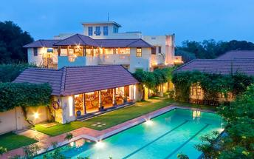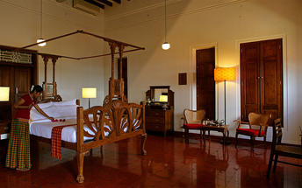

Day 7: Chettinad - Madurai

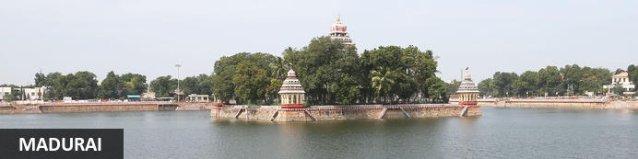
Few cities in south India are as compelling – and none quite so ancient – as Madurai. Tamil Nadu's cultural capital has a recorded history dating back at least 2500 years; for around a millennia it was the Pandyan dynasty's capital and was trading with ancient Rome and China. These days the city is famed above all else for its enormous Sri Meenakshi-Sundareshwarar temple, still one of India's largest temple complexes with spectacular towered gateways and a seemingly endless cycle of worship and rituals servicing thousands of pilgrims each day. This makes Madurai a key destination for travellers to south India.

Day Itinerary
After breakfast, enjoy sightseeing tour of the city Chettinad, visiting Chettinad mansions, Tile making demonstration.
Later you will be driven to Madurai. Arrive Madurai and check in at the hotel.
Rest of the day at leisure.

Overnight: Heritage Madurai
Heritage Madurai rings with historic charm that echoes in every hallway and every room. Lounge by the Olympic-sized temple tank pool, or luxuriate in a plunge pool in your own private villa. Dine under a 200-year-old banyan tree, serenaded by bird calls while enjoying the perfect meal prepared by your own personal chef, perfectly tempered to your particular taste buds. Take a leisurely ‘historic’ walk through the corridors where every stone has a story to tell.
One of the main attractions around Madurai is the cultural experience of visiting the Meenakshi Amman temple and the Nayakar Mahal. Recreational activities for guests at the hotel are swimming, playing badminton and hiring out mountain bikes to explore the surrounding area. There is also a choice of 3 dining options namely the Banyan Restaurant, the Swig & Tee Bar, and the Coffee Shop.
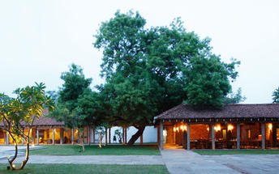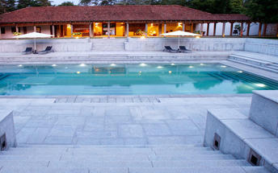

Day 8: Madurai

Day Itinerary
Morning sightseeing tour of Madurai.

After breakfast proceed for a city tour of Madurai visit Meenakshi Temple, Thirumalai Nayak Palace and Gandhi Memorial Museum.

Rest of the day at leisure.

Activities
Meenakshi Temple
Thirumalai Nayak Palace
Gandhi Memorial Museum

Meenakshi Temple
Meenakshi Amman Temple is a historic Hindu temple located on the southern bank of the Vaigai River in the temple city of Madurai, Tamil Nadu, India. It is dedicated to Parvati, known as Meenakshi, and her consort, Shiva, here named Sundareswarar. The temple forms the heart and lifeline of the 2,500 year old city of Madurai and is a significant symbol for the Tamil people, mentioned since antiquity in Tamil literature though the present structure was built between 1623 and 1655 CE.It houses 14 gopurams (gateway towers), ranging from 45–50m in height. The tallest is the southern tower, 51.9 metres (170 ft) high and two golden sculptured vimanas, the shrines over the garbhagrihas (sanctums) of the main deities. The temple attracts 15,000 visitors a day, around 25,000 on Fridays, and receives an annual revenue of sixty million INR. There are an estimated 33,000 sculptures in the temple. It was on the list of top 30 nominees for the "New Seven Wonders of the World". The annual 10-day Meenakshi Tirukalyanam festival, celebrated during April and May, attracts 1 million visitors
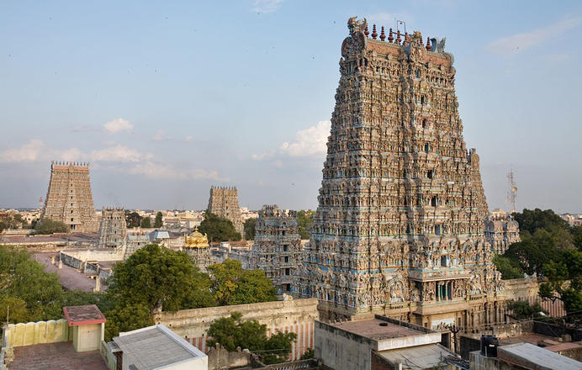

Thirumalai Nayak Palace
Thirumalai Nayak Palace of India is an example of architectural grandeur and was built by King Thirumalai Nayak in 1636 AD. The palace was designed by an Italian Architect and served as the residence of the King. It is situated at a distance of 2.5 km from the Meenakshi temple of Madurai. The palace is divided into two major parts, Swargavilasa and Rangavilasa, which include the royal residence, theater, shrine, apartments, armory, palanquin place, royal bandstand, quarters, pond and garden. During his reign, King Nayak conducted daily dance and music performances in the Thirumalai Nayak Palace. He used to offer prayers to Goddess Rajrajeswari every morning in the palace shrine. The shrine is richly carved in stone and its dome was once covered with gold. Later, the palace was destroyed by his grandson Chokkanatha Nayak and the valuables were shifted to other places, so that he could build his own palace. The original Nayak Palace Complex was four times bigger than the present structure.

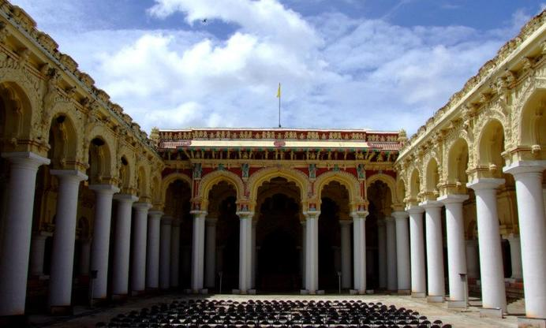

Gandhi Memorial Museum
Gandhi Memorial Museum not only offers a glimpse into the aspects of Mahatma Gandhi, but also holds a high historical significance.

Day 9: Madurai - Periyar

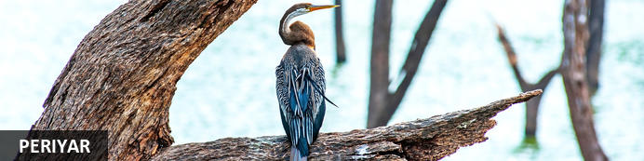
High in the evocatively-named Cardamom Hills by the state border with Tamil Nadu, Kerala’s Periyar National Park is known for its rolling thickly forested hills, montane grasslands, temperate climate and array of flora and fauna, some of it endemic. These are southern India’s loftiest peaks – the highest exceed 6,500ft – and their rolling topography forms the watershed for two of Kerala’s major rivers. Within the park lies Periyar Lake, a strangely convoluted 31-square kilometre stretch of water created in the 1890s by the Mullaperiyar Dam. While nearly 2000 species of flowering plants including 140 orchids might fade into the background, Periyar’s forests of teak, sandalwood, banyan and bamboo lend a more prominent backdrop to an array of wildlife. Elephants and tigers head a list of mammals including sloth bears, bison, flying squirrels, jungle cats, wild dogs along with around 270 species of birds, among them hornbills, flycatchers and storks.
Other nearby attractions include Chellarkovil waterfalls (the former at its best doing the monsoon season) and nearby Pandikuzhi, a lofty viewpoint. Just north of Periyar in Kumily town, the Kadathanadan Kalari Centre is a cultural centre featuring displays of kathakali (traditional Keralan theatre) and kalaripayattu (an ancient form of martial arts)

Day Itinerary
After breakfast leave Madurai for Thekkady (approx. 4 hrs).
Check in on arrival at the hotel.
Later in the day visit Spice Plantation

Spice Plantation
The trip covers spice plantations such as cardamom, pepper, vanilla, clove, cinnamon, nutmeg, ayurvedic herbs etc. Over twelve varieties of spices including ginger, garlic, cardamom, vannilla, pepper, cinnamon, coffee, tea, clove and nutmeg is cultivated in Thekkady and its neighbouring villages.

Overnight: Cardamom County
Cardamom County is located in the heart of Kerala's Forest Reservoir and overlooks the Periyar Hills. The guest rooms are comfortably furnished and equipped with modern amenities, including air conditioning, a minibar, a tea and coffee maker, a TV, Wi-Fi access, a hairdryer, and a private bathroom. Guests can enjoy Indian, continental and Chinese cuisine at the onsite restaurant. Additional facilities and services include a swimming pool, a spa and wellness centre, a bar, and meeting facilities.
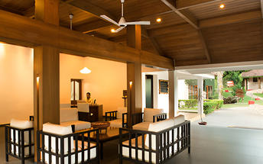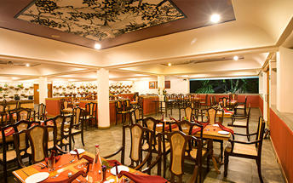

Day 10: Periyar

Day Itinerary
Breakfast at hotel.
Early morning, proceed for a Nature walk at Periyar National park.
Nature Walk: Early morning, proceed for a Nature walk at Periyar National park. Later in the afternoon take a tour of the spice plantations. Nature Walk Different nature trails traversing diverse habitats form the trekking routes, generally 4 to 5 km. in length. The trails often pass through evergreen and moist deciduous forests interspersed with marshy grasslands. The program is offered between 7.00 am and 10.30 am and between 2.00 pm. and 3.00 pm. and lasts for about 3 hours. A maximum of 5 persons can go for trekking at a time along each nature trail, accompanied by a trained tribal guide. The Nature walk is the right program to feel nature, hear her whispers and smell her flowers.
Evening enjoy the Kalaripayattu show (local martial art).
Kalaripayattu-the oldest of martial arts-is a gift to the modern world and known as the mother of all martial arts. legend traces the 3000-year old art form to sage Parasurama-the master of all martial art forms and credited to be the re-claimer of Kerala from the arabian sea. Kalaripayattu originated in ancient south India. Kung-fu, popularized by the monks of the shaoline temple traces its ancestry to Bodhi Dharma-an Indian Buddhist monk and Kalaripayattu master.
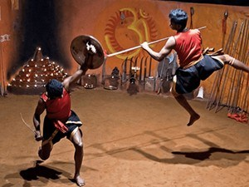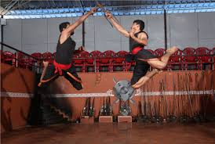

Day 11: Periyar - Kochi

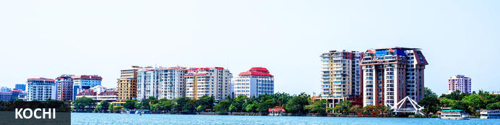
A major spice trading centre since the 14th century, Kochi (previously Cochin) is Kerala’s largest city and an essential destination for travelers to southern India. From ancient times it was known to an array of traders from Arabs to Portuguese, Greeks to Chinese, and was also home to India’s oldest Jewish community. Straddling several islands, a peninsula and part of the mainland, the city faces both ocean and backwaters so – unusually for India – all but the narrowest exploration of its sights involves bridges, ferries and water taxis. The main highlights are on Fort Kochi peninsula: built in 1503 the Church of St Francis is one of India’s oldest churches (and briefly interred the remains of Portuguese explorer Vasco da Gama) while the 16th-century Mattancherry Palace displays an extensive set of medieval murals inspired by the great Indian epics.

Day Itinerary
Morning you will be driven to Kochi (approx. 4½ hrs). On arrival check in at the hotel.
Rest of the day at leisure to explore the Fort Kochi area on own.

Overnight: Forte Kochi
Forte Kochi shines like a pearl among the hotels in Fort Kochi - one of the oldest cosmopolitan port cities in the world. A town so strategically placed that many a battle had been fought and many a ship burnt to lay claim to its generous shores. Forte Kochi has welcomed weary travellers for centuries from Arab and Chinese traders to Jews seeking shelter and new lives. The town has witnessed many a conquest and has been colonised by the Portuguese, the Dutch and the British in succession.
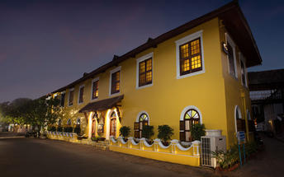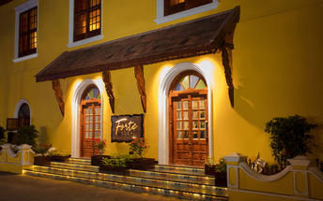

Day 12: Kochi

Day Itinerary
After breakfast visit of Fort Kochi, Dutch Palace, Jewish Synagogue and St Francis Church.

Fort Kochi
Fort Kochi takes its name from a long-gone fort which was built during its occupation by the Portuguese. The Portuguese were followed by the Dutch, who left their own legacy, and hot on their heels came the British with their own unique ways. Independent now for many years, Fort Kochi remains a colourful melting pot of diversity, retaining its colourful history in its architecture and culture.
The best way to experience Fort Kochi is on foot and tour operators offer a variety of walking tours where visitors are taken to sites such as the historical Santa Cruz Basilica, Cochin Bishop House, the Dutch Cemetery, the Parade Ground, the famous St Francis Church, and the Indo-Portuguese Museum. Visitors can also buy a map and go on a self-guided tour.

Jew Town
The history of Jew Town dates back to 1492 when a group of Sephardic Jews came to Kochi after being expelled from the Iberian Peninsula. In 1524 more Jews faced persecution and were granted refuge by the Raja of Cochin who granted them land near his own palace. In 1568 the Paradesi Synagogue, which still functions today and is the oldest in India, was built, and the Jew Town neighbourhood developed around it.

Jewish Synagogue
Stepping inside the Synagogue, one's eyes would easily go to the glass chandeliers and blue willow-patterned Chinese floor tiles. The chandeliers are of Belgian origin. Also of interest are the Scrolls of the Law housed here and the several gold crowns received as gifts and the brass-railed pulpit. And for some exclusive pieces from history, the synagogue also houses the copper plates of privileges given to Joseph Rabban, the earliest known Cochin Jew, dating from the 10th century, written in Tamil, by the ruler of the Malabar Coast.

Dutch Palace
The Dutch Palace is a beautiful palace that was originally built by the Portuguese. It was only during the 17th century that the Dutch took it over, modified it and then presented it to the Raja of Kochi. The main attractions here are the outstanding collection of mural paintings found inside. These murals beautifully depict scenes from the Hindu epics of Mahabharatha and Ramayana.

Chinese Fishing Nuts
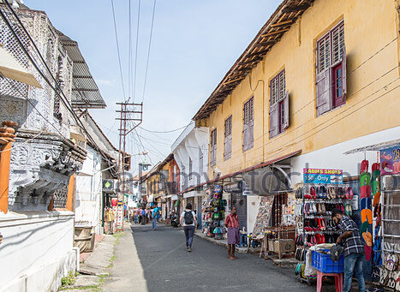
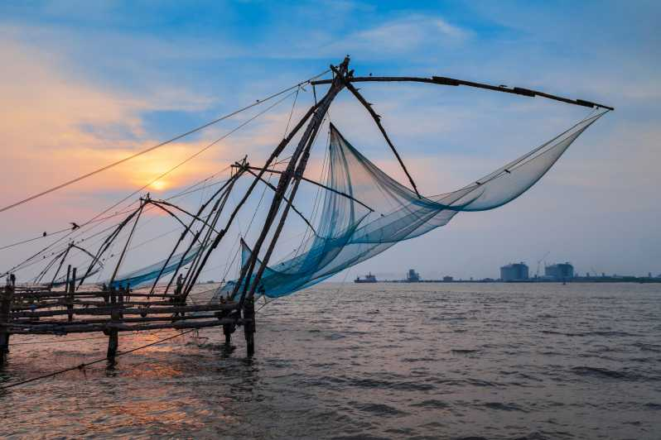
Chinese fishing nets are a type of stationary lift net in India. They are fishing nets that are fixed land installations for fishing. While commonly known as "Chinese fishing nets" in India, the more formal name for such nets is "shore operated lift nets".

St Francis Church
St. Francis Church is located in Kochi (previously called Cochin). It is one of the ancient European churches in the country and is a marvelous specimen of Portuguese architecture in the country. It is a mark of the colonial struggle of the Europeans to make their presence felt in India at that time. This church, built in 1503 by Portuguese traders, was where Vasco da Gama was buried when he died in 1524 AD. However, fourteen years later, his remains were shifted to Lisbon. Earlier, the church was named after Santo Antonio which was changed by Anglican Communion after the name of patron Saint Francis. It is now considered integral to the history and tourism of Kochi. In April 1923, this church became a protected monument under the Protected Monuments Act of 1904. In 1920, the Cenotaph was set up in the memory of the inhabitants of Kochi who died in the World War-I. Apart from all this, one interesting fact to observe is that, despite being very modest in its architecture, the model of this church has been followed by many churches India.
Afternoon, enjoy the cooking class followed by lunch.

Day 13: Kochi - Alleppey Deluxe Houseboat

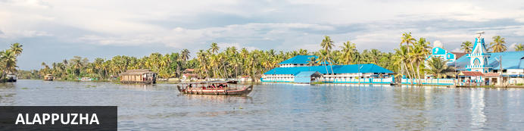
Located in the Indian state of Kerala, the bustling city of Alappuzha, also known as Alleppey, is set along the coast of the beautiful Laccadive Sea. Dubbed the ‘Venice of the East’, it is renowned for its sublime houseboat cruises which float along the tranquil canals of Kerala. Alappuzha is also said to be one of the most beloved tourist centres in the state. While cruising the palm-shaded canals is the most popular thing to do, visitors can also enjoy visiting Alappuzha’s beautiful beaches, exploring the little riverside villages dotting the lush countryside and discovering an array of resplendent temples. Don’t miss the annual Nehru Trophy Boat Race held at Punnamada Lake.

Day Itinerary
After breakfast, leave Kochi for Alleppey (approx. 2 hrs) – reach Alleppey by Noon and board the Houseboat for an overnight cruise on the backwaters.
Cruise over the backwaters enjoying the narrow canals and visiting the local villages.
NOTE:
- Check in time: 12.30 pm, Check out time: 9.30 am.
- Air conditioner in Deluxe Houseboat bedrooms will be ON only from 09 pm to 07 am.

Overnight: Alleppey Deluxe Houseboat
The Kerala houseboats takes tourists on a cruise along the emerald waterways. Modified to meet a novel concept of holidaying, the kettuvalloms (houseboats) are comfortably furnished with an open lounge, one or two bath attached bedrooms and a kitchenette, and are extremely eco-friendly, merging smoothly into the panorama. Every houseboat is manned by a crew of 3 men, usually a cook, guide and oarsman.
The Deluxe Houseboat has 2 bedrooms containing one bed that caters to a maximum of 2 passengers per room. Then there's another 2 bedrooms with 2 beds in each catering to 4 passengers per room. And lastly, there's 1 bedroom that features 3 beds catering to a maximum of 6 passengers.
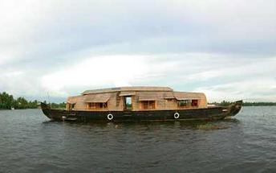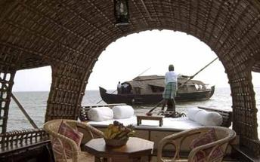

Day 14: Alleppey - Mararikulam

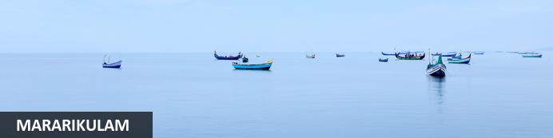
Situated only 40 km from the city of Cochin, in the Alappuzha district of Kerala, Mararikulam is a charming little coastal village known for its pristine sand beaches, swinging coconut palms, and quiet, laidback atmosphere. The village has managed to avoid the mass development associated with many of the other beach towns in the area resulting in an untouched natural environment dotted with only a handful of small resorts. The main attraction here is the exquisite Marari beach where you will find fishermen heading out daily to explore the Malabar coast, much as their ancestors have done for generations.

Day Itinerary
After breakfast, disembark the houseboat and drive to Marari hotel [approx. 1 hrs drive]
On arrival in Marari, check in to hotel.
Rest of the day at leisure.

Overnight: Marari Beach Resort
Marari Beach is part of the CGH Group and provides an authentic experience of Kerala traditional and recreation. The small resort is set in the coconut grove at the sandy Marari Beach surrounded by flowering plants and herb gardens.
Deluxe pool villas and cottages provide accommodation at the Marari Beach Resort. Most cottages have French windows opening up to a private garden. All materials used are naturally resourced and processed using simple methods as a means of practising ecological methods in the day to day running.
There’s plenty to experience at the Marari Beach Resort. The locals often host festivals showcasing their traditions and culture. At the Ayurveda Centre, guests can experience an authentic Kerala massage from trained therapists. Also available are yoga classes from a master yoga teacher. Furthermore, visitors have the option of attending a cooking class at the Farm Kitchen.
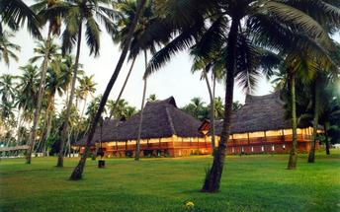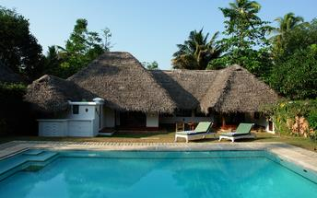

Day 15-16: Mararikulam

Day Itinerary
Breakfast at the hotel.

These days are at leisure with beach activities, yoga/mediation or to rejuvenate with some Ayurveda massages (on direct payment)

Day 17: Mararikulam - Cochin Depart

Day Itinerary
In time, you will be met & transferred to Cochin airport (approx. 2½ hrs) to board your flight for onward journey.
Flight TBA
Depart Kochi TBA Hrs

**** END OF SERVICES ****
NOTE:
- The distances and time taken for the travel is approximation only this will differ based on the traffic conditions and other unforeseen circumstances.

