

IN-19 Best of Karnataka
Bangalore - Mysuru - Kabini Forest Reserve - Coorg - Chikmagalur - Hampi - Badami - Goa
18 Days / 17 Nights
2 Persons

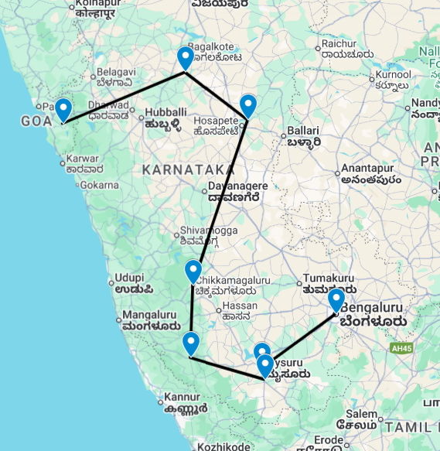

Overview: This journey covers the much sought after “Karnataka with its beautiful temples, UNESCO world heritage sites, the wildlife National Park along with the beautiful baches and churches of Goa.

Introduction

Start | Accommodation | Destination | Room Type | Duration
Day 1 | Taj West End Bengaluru | Karnataka | Luxury Room Heritage Wing | 1 Night
Day 2 | Royal Orchid Metropole | Mysuru | Luxury Heritage | 2 Nights
Day 4 | Red Earth Resort | Kabini Forest Reserve | Standard Room | 2 Nights
Day 6 | Heritage Resort Coorg | Coorg | Superior Cottage | 2 Nights
Day 8 | The Gateway Hotel Chikmagalur | Chikmagalur | Standard Room | 1 Night
Day 9 | Heritage Resort Hampi | Hospet | Superior Cottage | 2 Nights
Day 11 | Wada 1 | Karnataka | Deluxe Room | 2 Nights
Day 13 | The Radisson Goa Candolim | Candolim | Standard Room | 5 Nights

Day 1: Arrive Bangalore

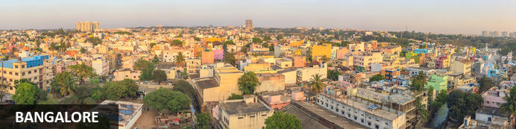
Three thousand feet up on the Deccan Plateau, the state capital of Karnataka’s relatively mild climate and abundance of broad leafy roads and parks has helped earn it the ‘Garden City of India’ label. These days that moniker might seem a stretch: it’s a booming city of eight million with thriving IT and bio-tech sectors that have given rise to another – the Silicon Valley of India. Unlike many other Indian cities, Bangalore has a more modern and sophisticated buzz oiled by an array of cosmopolitan restaurants, lively bars and even an ‘underground’ music scene.

Day Itinerary
Flight TBA
Arrives Bangalore TBA Hrs.

On arrival in Bangalore: Having cleared immigration, collected your luggage and passed through customs, please make your way towards the exit of the terminal building where you will see a bank of people waiting for you. Amongst them will be Travel Counsellors Representative who will be waiting to greet you with a paging board with your name on.

You will be transferred to your hotel and assisted with check in. Standard check in time is 1400 hrs.

Overnight: Taj West End Bengaluru
Set in the heart of Bengaluru, Taj West End blends colonial charm with modern luxury. The spacious rooms and suites offer modern amenities such as flat-screen TVs, minibars, and Wi-Fi access. Guests can indulge in a diverse culinary journey at award-winning restaurants such as Blue Ginger, Loya, Machan, and the sophisticated Blue Bar. This storied landmark also features a traditional Indian wellness spa, fitness centre, and expansive indoor and outdoor event spaces.
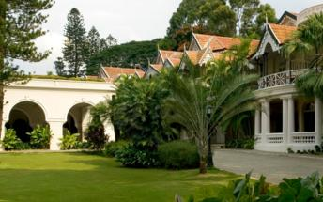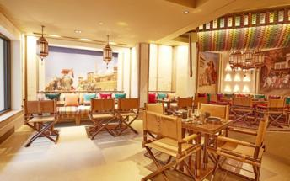

Day 2: Bangalore – Mysuru

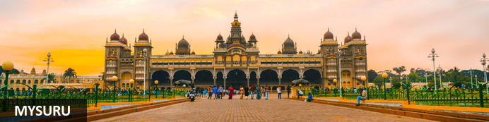
Until recently known as Mysore, Mysuru is Karnataka's second city. Yet for centuries it was the capital of the enduring Wadiyar dnyasty – the 'Kingdom of Mysore' – whose rule over the region was interrupted for barely four decades in the late 1700s. Today Mysuru is known for its sandalwood carving and silk industries, and partly through its ancient style of painting is regarded as one of southern India's cultural capitals. Its cultural tag is probably most tangible during the annual Dussehra festival which is celebrated across most of India in September or October; Mysuru's exuberant 10-day festivities take things to a new level and draw thousands of visitors. It culminates in a huge torch-lit procession of elephants, camels and horses accompanied by musicians and dancers transporting an idol from Mysore's extraordinary royal palace, one of several that grace the city

Day Itinerary
After breakfast you will be driven to Mysore in your private chauffeur driven vehicle [approx. 4 hours' drive].
Srirangapatna
Located in Karnataka, India, Srirangapatna alternatively known as Shrirangapattinam is a religious, cultural and historically significant town. This river island town's name is sourced from the famous Ranganathaswamy Temple which dominates the town, and this temple resembles Hoysala and Vijayanagar architecture as it was restrengthened and modified after its initial construction in the 9th century.
After the visit transfer to your hotel in Mysore.

Overnight: Royal Orchid Metropole
A 4-star grand heritage hotel, the Royal Orchid Metropole depicts the history and culture of Mysore. Built in 1920 to host guests, the guesthouse still retains its imperial arches, pillars and ornate corridors capturing the old world charm.
A variety of rooms and suites provide accommodation. A stay at the Royal Orchid Metropole comes with complimentary breakfast as well as 24 hour room service and access to satellite TV. Notable features include the swimming pool, a fitness centre and an outdoor restaurant serving exotic delicacies.
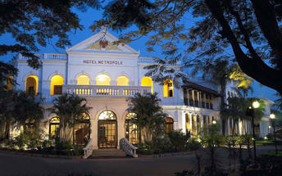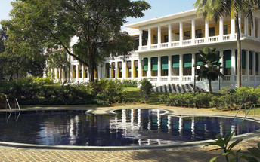

Day 3: In Mysuru

Day Itinerary
Breakfast at the hotel.
Later proceed for a visit to Mysore Palace and local market.
Mysore Palace
Welcome to the Royal Splendour of Mysuru, the home of the Wodyers who ruled Mysuru for more than 500 years, known as the City of Palaces, Mysuru retains a quaint charm, that never fails to enchant. Mysuru is a popular tourist destination, offering several attractions ranging from the royal splendour of Mysuru City and its fabulous Dasara Festival to exquisite temples, pilgrimage centres and scenic spots. The royal lineage can be traced back to 1399, when Yaduraya, a royal prince of the Yadava dynasty, was on a pilgrimage visit to Chamundi Temple with his brother Vijaya. They took shelter in the Kodi Bhairava temple on the banks of Doddakere, the ‘Big Lake’. There they came to learn that the local royal family was in great danger. Their ruler had just died, and Maranayaka, a neighboring chief, was threatening the queen. He wanted her daughter’s hand in marriage. The queen and the princess were in very vulnerable position. With the help of Jangama (Wadiyar) killed Maranayaka and married the daughter of Chamaraja and succeeded to the Mysuru principality. And so the Wodyer dynasty was established – a succession of 25 kings who ruled until 1947, when Mysuru became part of the Indian Union. The Wadiyars were great patrons of the arts, and the finest craftsmen in the state were employed to work on the Palaces. Wadiyar period was a new era of prose literature as an independent literary medium and it was in other words a prose writing in the form of the history of the Mysuru rulers. Chamaraja Wadiyar encouraged Kannada scholars like Ramachandra, author of Hayasaara Samuchchaya.

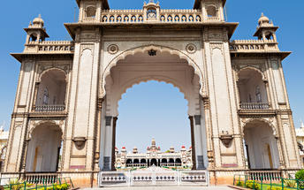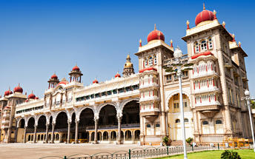
Overnight at the hotel.

Day 4: Mysuru – Kabini Forest Reserve

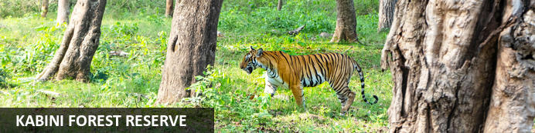
Resting on the banks of the mighty River Kabini, the Kabini Forest Reserve (or the Kabini Wildlife Sanctuary) is a vast expanse of unspoiled wilderness. Encompassing forestland, water-bodies, and steep fertile valleys, this extraordinary reserve forms the south-eastern section of the Nagarhole National Park and is home to the world’s largest population of Asiatic elephants (estimated at around 6,000). Visitors are also likely to spot a number of endangered and rare animal species including, among others, leopard, tiger, panther, sambhar, spotted deer, python, sloth bear, cheetah, crocodile, and over 250 species of bird.

Day Itinerary
Today you will be driven to Kabini [approx. 2 hours' drive].
Arrive Kabini and transfer to your hotel.

Overnight: Red Earth Resort
Set on the peaceful backwaters of Kabini Dam, Red Earth Kabini Resort welcomes guests with its beautiful gardens, an outdoor pool overlooking the serene backwaters and 20 exclusive cottages spread over ten acres. The verdant landscape punctuated by glimmering pools of water and picturesque farmland earmark Red Earth Kabini as the ideal getaway. It’s rich biodiversity and conservation programmes have earned Kabini a place among the world’s top five destinations for viewing wildlife. The weather is sublime throughout the year. Red Earth Kabini is located in beautiful surroundings absolutely untouched by development and yet very close to civilization.
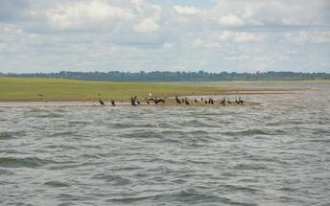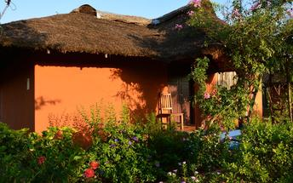

Day 5: In Kabini Forest Reserve

Day Itinerary
Morning and evening enjoy shared safaris [subject to availability].
Later enjoy cycling beyond the property, immersing yourself in the beauty of landscapes and wildlife.
Recapture the thrill of childhood adventures with all-terrain cycling – across trails with breath-taking views, and acquaint yourself with the local flora. Man against machine for an unforgettable trip.

Overnight: Red Earth Resort

Day 6: Kabini Forest Reserve – Coorg

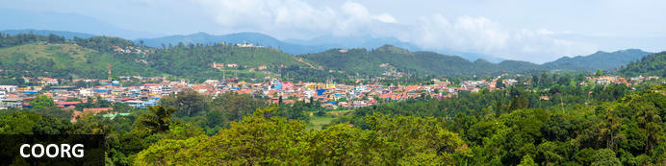
Up in the Western Ghats roughly midway between Mysuru (Mysore) and the Arabian sea coast, Coorg (or Kodagu) is a lush hill region dotted with spice and particularly coffee plantations. It’s Karnataka state’s most thinly populated district and the relatively mild climate coupled to an easy-going charm make it a somewhat offbeat destination – somewhere to step back and slow down for a few days though there’re plenty of hiking, angling and even golfing opportunities too. Most visitors are likely to pass through Madikeri, Coorg’s ‘capital’, with a handful of low-key sights but the region’s most distinctive accommodation lies outside town amidst spice and coffee plantations. A little east of Madikeri towards Mysore stand a clutch of Tibetan settlements and surprisingly large Buddhist monasteries – all established by Tibetan exiles in the 1960s after fleeing their homeland.

Day Itinerary
After breakfast leave for Coorg [approx. 03 hours’ drive]. En-route stop at Bylakuppe [The Golden Temple].

Bylakuppe Monastery (Golden Temple)
Around 35km east of Maikeri, Bylakuppe township lies at the heart of a Tibetan enclave established by the state government in the 1960s to help Tibetan exiles fleeing their homeland. The approximately 70,000-strong Tibetan community – reputedly one of the largest outside Tibet – has farms, schools, lodges and, above all, several thriving monasteries. Namdroling Monastery, sometimes referred to as the Golden Temple (though not to be confused with that in Amritsar), is the largest with around 4000 monks, 800 nuns and several teaching institutions and schools. Founded in 1972 Tashi Lhunpo is the re-established offshoot of one of Tibet’s most famous 15th-century monasteries which still stands but is widely regarded as a shadow of its former role and integrity. Monastery visits provide a glimpse into the look and feel of monastic life broadly similar to that in Ladakh, Himachal Pradesh and Darjeeling (in the Indian Himalaya) plus to a lesser extent Tibet itself while the tranquil town offers an array of Tibetan handicrafts and cuisine.

Overnight: Heritage Resort Coorg
The word 'heritage' denotes 'old world', 'inheritance' and all things that are enduring and cherished. It also conjures up a world that is pristine and untouched. Living in cities as most of us do most of the time, a chance to connect with nature in clean surroundings is a dream. To make that dream come true, Heritage Resort - among the finest Coorg Resorts - offers you a getaway that you will return to in your memories again and again.
Bird watching, cycling, trekking all that and more can be part of your plan when you are here. Breathe in the pure forest air. Coorg with Madikeri as its headquarters is a year round holiday destination near Bangalore. Every season has its delights.
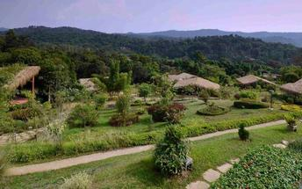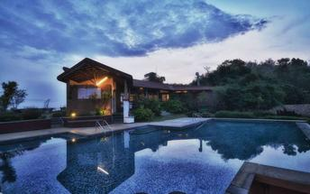

Day 7: In Coorg

Day Itinerary
Breakfast at the hotel.
Day at leisure to enjoy the different activities as offered by the resort.

Overnight: Heritage Resort Coorg

Day 8: Coorg – Chikmagalur

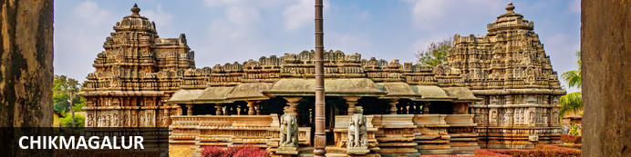
Situated in the state of Karnataka in southwest India, the hill station of Chikmagalur is remarkable for its stunning natural scenery, extraordinary temples, and delicious coffee. Boasting bright green hills and mountains jutting into the sky at extreme angles, Chikmagalur’s terrain is one that inspires near disbelief. A wealth of waterfalls, accessed by picturesque trails through dense forests on the slopes and coffee plantations in the valleys, provide wonderful spots for refreshing dips. Several ancient and exquisitely decorated temples adorn the landscape. The area is known for its abundance of coffee plantations and delicious varietals. Don’t miss the opportunity to visit the Bhadra Wildlife Sanctuary, home to elephants, tigers and leopards; the three holy caves in the Baba Budangiri Mountain Range; and the pretty Mahatama Gandhi Park.

Day Itinerary
After breakfast leave for Chikmagalur [approx. 5 hours' drive]. En-route visit the magnificent temples at Belur and Halebeedu.

Belur
Set on the banks of Yagachi River in the Hassan District in the state of Karnataka, Belooru, or more commonly known as Belur is set amidst lush surrounds. It boasts a rich cultural heritage, historical significance and a variety of sacred temples. Belur is a popular tourist destination in the state of Karnataka. It features the Chennakeshava Temple Complex, is a 12th-century Hindu temple displaying some of the best of Hoysala architecture in the country. Other highlights include Panduranga Temple, Shankaralingeshwara Temple, and Hoysaleshwara Temple and the spectacular Jain temples in Halebidu.
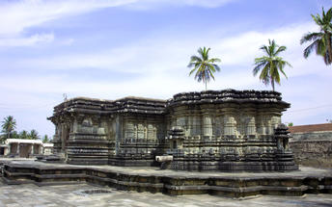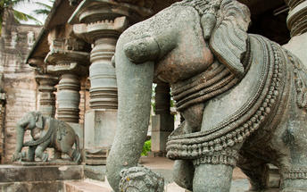

Halebidu Temple
Halebid situated at a distance of about 27 Kms. north-west of Hassan town and about 7 Kms. east of Belur, was once the regal capital of the Hoysala Empire. The place was known as Dorasamudra or Dwarasamudra founded in the early 11th century A.D. It came to be known as ‘Halebeedu’ after it was plundered by the Delhi Sultan’s armies two times in 1311 and 1327 and deserted. Halebeedu means ruined city. The ornate Kedareshwara and Hoysaleswara temples here are remarkable monuments of Hoysala architecture. The Kedareshwara temple is Trikutachala built by Ballala II and his consort Abhinava Ketala Devi in 1219. Hoysaleshwara and Shanthaleswara temples were built by Ketamala to attributed Vishnuvardhana, the Hoysala ruler. It enshrines Hoysaleswara and Shantaleswara, named after the temple builder Vishnuvardhana Hoysala and his wife, Queen Shantala.
Arrive Chikmagalur and transfer to your hotel.

Overnight: The Gateway Hotel Chikmagalur
Hideaway in the coffee country surrounded by the mountains and snowy white blossoms. The Gateway Hotel KM Road Chikmagalur offers serenity, privacy and exquisitely restored colonial architecture. Located in the coffee district of Karnataka, the hotel surrounds guests with the tranquil sights and sounds of nature.
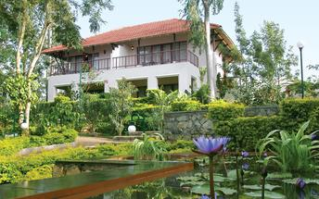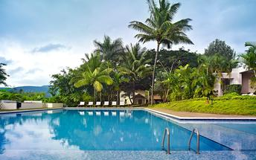

Day 9: Chikmagalur – Hampi

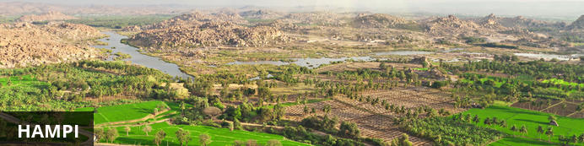
An enchanting ancient city and hippy backpacker destination, Hampi offers the perfect heady mix of Indian charms that make it hard for visitors to leave. Here history and modernity meet impressive ancient remnants of Vijayanagara, the former capital of the Vijayanagara Empire, are dotted around the congested buildings of Hampi town. Cross the river and you will find laid back restaurants and rooms bordered by banana plantations and paddy fields, with a view over the river and ruins. Sightseeing can take up most of your time but do not neglect to visit the Monkey Temple, a 572-stair climb, to catch the sunset.

Day Itinerary
Today, you will be driven to Hampi [approx. 6 hours' drive].
Upon arrival in Hampi, check in at the hotel and relax.

Overnight: Heritage Resort Hampi
Spread across 8-acres of land, Heritage Resort Hampi offers luxurious accommodation in Karnataka, India. Guest rooms at the hotel are lovingly decorated and equipped with all the modern amenities necessary to ensure a relaxing and comfortable stay. At the on-site wellness spa, guests can indulge in numerous Ayurveda therapies that focus on aligning their mind-body-soul and restoring inner balance.
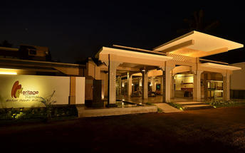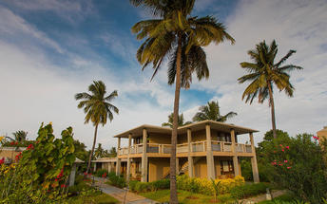

Day 10: In Hampi

Day Itinerary
After breakfast, explore the Hampi Ruins.

Hampi
Hampi, The World Heritage Center, is the most beautiful and evocative of all the ruins of Karnataka. Capital of Vijayanagar kingdom is full of delightful surprises, viz., Kings Balance where kings were weighed against grain, gold or money which was then distributed to the poor, other attractions are Queen's Bath with its arched corridors, projecting balconies, Lotus Mahal Vittala Temple, Virupaksha Temple, Ugra Narasimha are not to be missed.
The best way to experience this World Heritage Site is to take a leisurely stroll through the eloquent ruins. Most of the important structure and ruins are located in tow areas, which are generally referred to as the Royal Centre and the Sacred Centre. The Royal Centre contains structures that seem to have been palaces, baths, pavilions, royal stables, and temples for ceremonial use. The sacred center is situated on the banks of the holy Tungabhadra River. Visit Vittthala temple and Virupaksha temple.

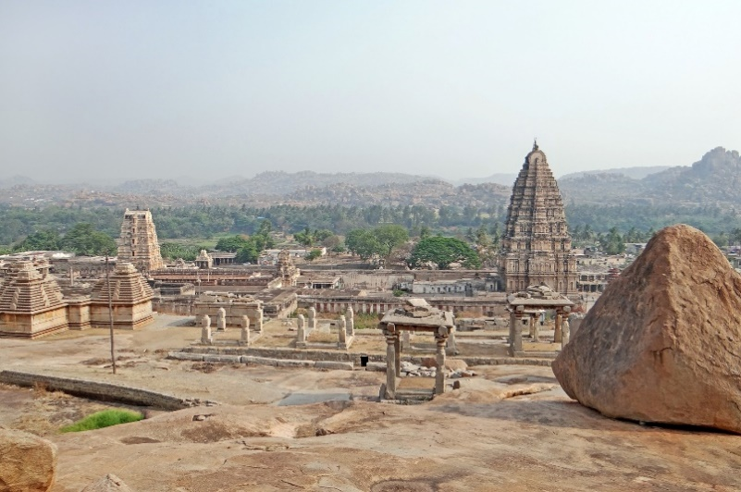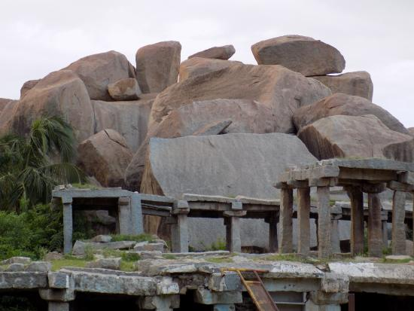

Overnight: Heritage Resort Hampi

Day 11: Hampi – Badami

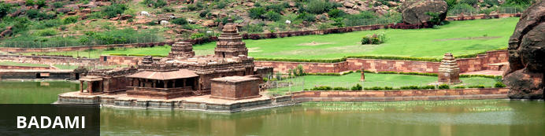
Situated in northern Karnataka, the quiet village of Badami is home to a series of ancient cave temples. Between the 6th and 7th centuries Badami was the capital of the Early Chalukyas, who ruled much of Karnataka and Andhra Pradesh. They carved out sacred spaces into the rust-coloured cliffs above Agstya Lake, and decorated the walls of these holy caves with bold, detailed reliefs of their deities. Out of the shimmering waters below rise the steps of the Bhutanatha temple complex, a cluster of sandstone shrines devoted to this god.

Day Itinerary
Today you will be driven to Badami [approx. 3 hours' drive].
On arrival check-in at hotel.
Rest of the day will be at leisure.

Overnight: Wada 1
Wada 1 is a beautifully restored hotel located in the Aihole Temple Complex, of India. The hotel provides tastefully appointed rooms with tea/coffee-making facilities, private bathrooms and Wi-Fi access. The on-site restaurant Savour, offers traditional food from North Karnataka. Other facilities include a tower lounge. Guests can enjoy taking part in tours of the Aihole Temples.
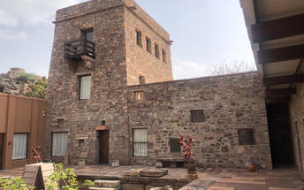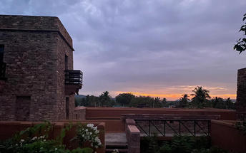

Day 12: In Badami

Day Itinerary
Breakfast at the hotel.
Later proceed for a half day tour.
Badami
Situated in northern Karnataka, the quiet village of Badami is home to a series of ancient cave temples. Between the 6th and 7th centuries Badami was the capital of the Early Chalukyas, who ruled much of Karnataka and Andhra Pradesh. They carved out sacred spaces into the rust-coloured cliffs above Agstya Lake, and decorated the walls of these holy caves with bold, detailed reliefs of their deities. Out of the shimmering waters below rise the steps of the Bhutanatha temple complex, a cluster of sandstone shrines devoted to this god.
Aihole
The ancient walled city Aihole, which dates back to the 6th century in Karnakata served as the former capital of the region during the early Chalukyas period. Visitors can enjoy exploring the historic fortified complex comprised of over a hundred stone temples featuring a blend of fascinating architectural styles, Jain monuments, and ancient caves displaying unique traditional art depicting Hindu deities and legends.
Pattadakal
Declared a world heritage site in 1987, Pattadakal, situated on the banks of the Malaprabha river in the Bagalkot district of Karnataka, represents the high point of temple architecture under the Chalukya dynasty in the 7th and 8th centuries. Earlier called Kisuvolal or Pattada Kisuvolal, that literally translates to City of Crown Rubies, Pattadakal along with Aihole and Badami provide an incredible concentration of religious monuments that reveal a beautiful fusion of north (Nagara, Indo-Aryan) and south (Dravidian) Indian architectural forms.

Overnight: Wada 1

Day 13: Badami – Goa

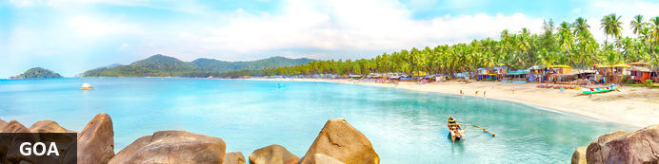
Midway along the Konkan coast facing the Arabian Sea, the former Portuguese territory of Goa with its long tropical beaches backed by swaying palms has long been synonymous with sun-seeking hippies, ravers and an ‘alternative’ lifestyle. Originally stemming from the 1960s backpacker trail to Kathmandu – some travellers paused in or detoured to Goa and just couldn't bring themselves to leave – that reputation seems rather dated now. Although the ‘alternative scene’ remains (especially in places like Anjuna’s flea market) though somewhat less vigorous now, Goa has also gone mainstream; the clientele is far broader and there’re plenty of upmarket hotels and resorts. Yet the key ingredients of the state's appeal remain: picturesque beaches (such as Palolem), fine seafood cuisine and an enduring Portuguese-Catholic cultural heritage that lends the region a distinctive character.

Day Itinerary
Today you will be driven to Goa [approx. 6-7 hours' drive].
Arrive Goa and check-in at the hotel.

Overnight: The Radisson Goa Candolim
Boasting refined accommodation, a relaxing spa, exquisite on-site dining and a convenient location just 500 metres from Candolim Beach, the Radisson Goa Candolim is an unbeatable hotel choice for your vacation.
Situated only three kilometres from the famous Calangute beach and in proximity to National Highway 17, the Radisson makes it easy to explore the numerous attractions surrounding Candolim, North Goa. Take advantage of the hotel's proximity to area highlights including the historic Fort Aguada, the ancient churches of Old Goa and excellent shopping in Panjim.
With amenities like complimentary Wi-Fi, a mini gymnasium, conferencing facilities, an outdoor swimming pool, spa and even a salon, the Radisson Goa Candolim has everything you need to enjoy an unforgettable stay in one of the region's top leisure destinations.
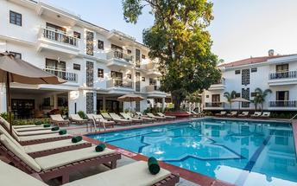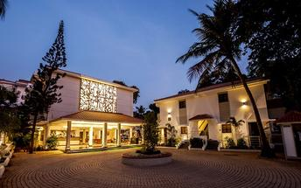

Day 14-17: In Goa

Day Itinerary
Breakfast at the hotel.

These days, you will be at leisure in Goa. No vehicle will be at disposal.

Overnight: The Radisson Goa Candolim

Day 18: Depart Goa

Day Itinerary
At an appropriate time, you will be transferred to the airport for your flight to onward destination.

Flight TBA
Departs Goa TBA Hrs.

**** END OF SERVICES ****

NOTE:
- The distances and time taken for the travel is approximation only this will differ based on the traffic conditions and other unforeseen circumstances.

