

IN-26 Golden Triangle with Kerala
New Delhi - Agra - Jaipur - Kochi - Mararikulam
12 Days / 11 Nights
2 Persons

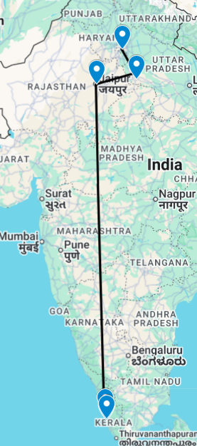

This is the classic cultural tour of North India combining New Delhi, Agra and Jaipur (the so-called ‘Golden Triangle’).
New Delhi, the national capital, offers several key sights and historic monuments while Agra is synonymous with the Taj Mahal – a high-point of Mughal architecture and one of the world’s most celebrated buildings. Jaipur, Rajasthan’s state capital, boasts some of the region’s finest palaces and impressive forts along with an eclectic array of crafts and shopping.

Tucked away on India’s south-western coast, Kerala is one of the country’s scenic and cultural gems: lush tropical beaches and landscapes and beaches threaded by coastal lagoons and waterways while inland the Western Ghats offer pretty vistas of undulating hills dotted with spice plantations.
Cochin, the state’s largest city, has expanded well beyond the original settlement of Fort Kochi which retains its cosy heritage atmosphere and sights. Up in the Western Ghats, while charming houseboats ply the so-called ‘backwaters’, or inland lagoons. Mararikulam is a notably untouched fishing village with a fine beach and relaxing low-key atmosphere.

Introduction

Start | Accommodation | Destination | Room Type | Duration
Day 1 | The LaLiT New Delhi | New Delhi | Deluxe Room | 2 Nights
Day 3 | DoubleTree by Hilton Agra | Agra | Guest Room | 1 Night
Day 4 | Hilton Jaipur | Jaipur | Guest Room | 2 Nights
Day 6 | Fragrant Nature Kochi | Kochi | Duke's Chamber | 2 Nights
Day 8 | Deluxe Houseboat | Alleppey | 1 Bedroom | 1 Night
Day 9 | Flamingo Marari | Mararikulam | Deluxe Room | 3 Nights

Day 1: Arrive New Delhi

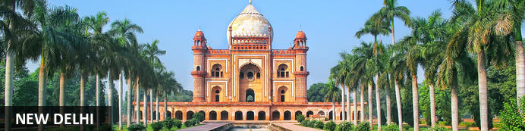
New Delhi, India’s national capital, is a relatively modern confection of imposing government buildings including Parliament, museums and wide leafy boulevards loosely centred on circular Connaught Place (officially now called Rajiv Chowk). To its north lies the formerly walled city of Old Delhi, or Shahjahanabad, built in the 17th-century by the Mughal Emperor Shah Jahan. Though long merged into one metropolis, the two have very different characters. New Delhi has space, parks, distinct neighbourhoods and a clutch of important monuments and architecture that reflect its ancient history. Old Delhi’s crowded streets, lanes and bazaars reflect its colourful medieval character and they cradle some of the city’s most memorable sights.

Day Itinerary
Flight TBA
Arrive Delhi TBA Hrs.

On arrival in Delhi: Having cleared immigration, collected your luggage and passed through customs, please make your way towards the exit of the terminal building where you will see a bank of people waiting for you. Amongst them will be Travel Counsellors Representative who will be waiting to greet you with a paging board with your name on.

You will be transferred to your hotel and assisted with check in. Standard check in time is 1400 hrs.

Overnight: The LaLiT New Delhi
Offering five-star accommodation, The LaLiT New Delhi is located in Connaught Place, India. The hotel boasts 461 luxury rooms and suites with conveniences such as minibars/fridges, electronic safes, TVs, interactive entertainment systems and free Wi-Fi. Guests can delight their palates at an array of on-site restaurants. The hotel also features a spa, an art gallery, a state-of-the-art gym and a swimming pool.

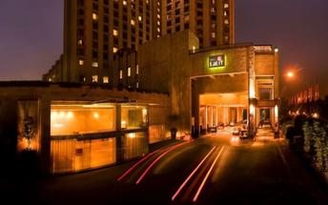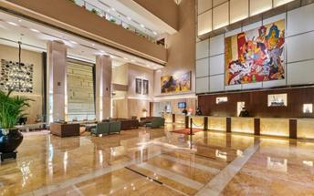

Day 2: In New Delhi

Day Itinerary
Breakfast at Hotel.
Today proceed for The Five Senses Delhi Tour
A sensory journey through Delhi covering everything from its food, local arts and crafts, the must-see architectural marvels, to expertly navigating and allowing you to witness the organized cultural chaos that is Delhi.

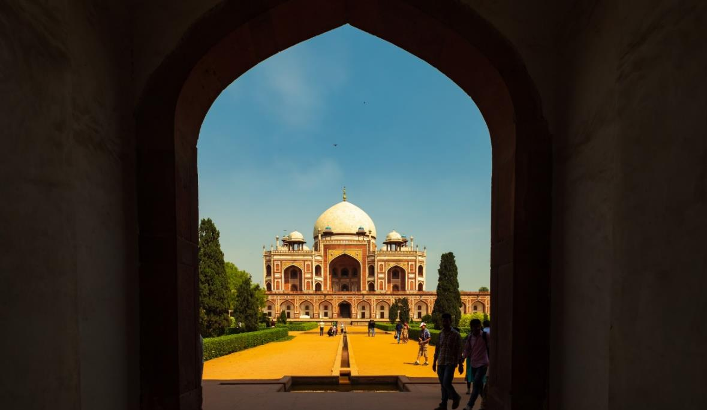
USP - Delhi 101: A complete tour of Old and New Delhi! We’ve carefully curated a selection of experiences that will transport you across Delhi’s rich cultural history. Experience for yourself the syncretism that has served as both Delhi’s greatest strength and vulnerability.
There isn’t a dearth of iconic sightseeing locations in the city, but for this tour, we focus on the two most beloved monuments that became inspirations or templates for all the other beautiful heritage structures. Humayun’s tomb, a spellbinding mausoleum is a favourite for any Delhiite! Your visit will be followed by a heritage craft workshop organised by an all-women NGO group that will touch your heart. Next, take a rickshaw ride through Shahjahanabad. Chaos thrives in the streets of Chandni Chowk, but as you cycle down, you’re transported by the magic in the air to the thriving Mughal era.

Next, you will indulge your sense of smell with an Ittar or perfume-making workshop. Visit an 8th-generation Ittar studio where you will get to smell and mix your unique concoction that can be named after you!

We’ll quickly stop to snack on some mouth-watering street food before proceeding to witness the glory and quietness of the Jama Masjid: a beautiful pocket of calm at the heart of Old Delhi's mayhem.
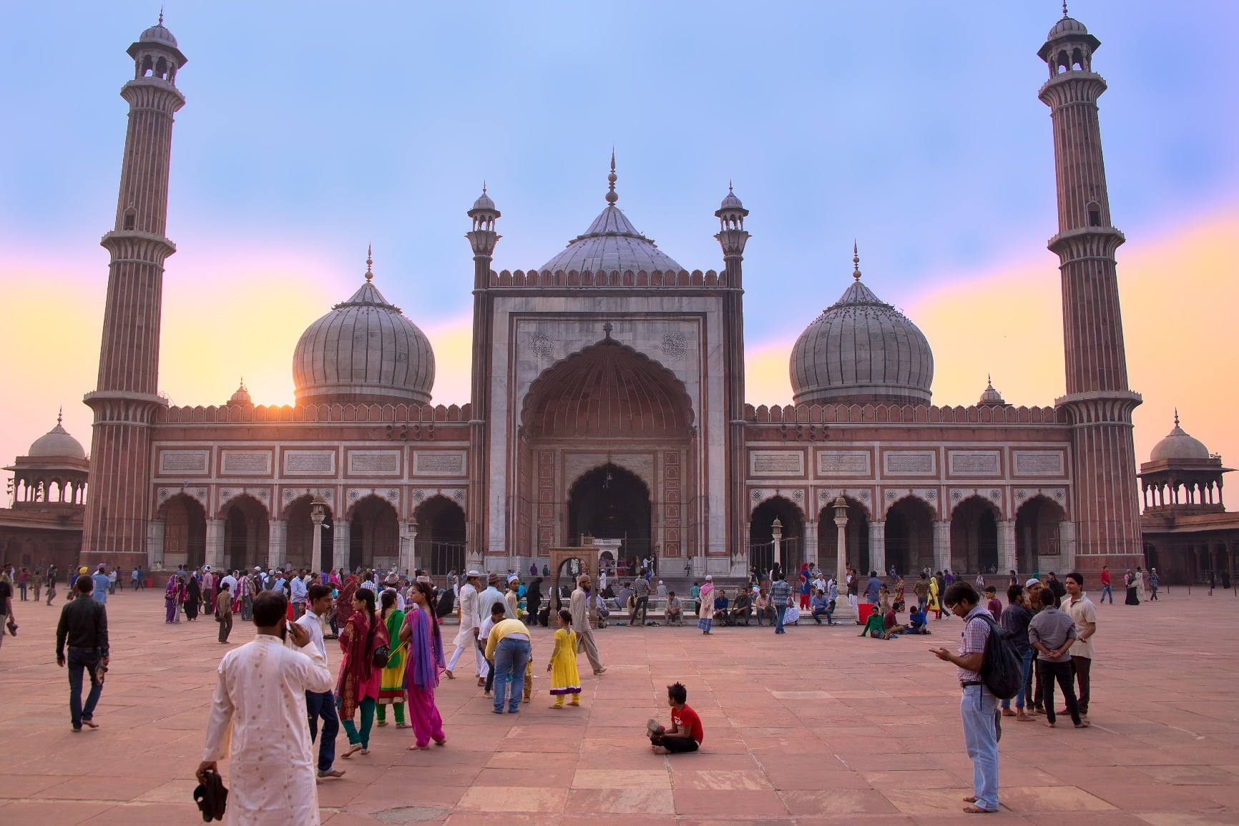
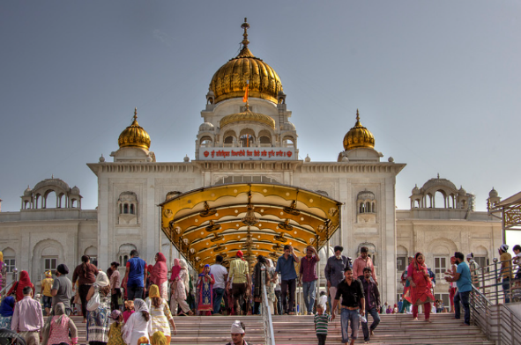
To engage your sense of sound, we bring you to Bangla Sahib. The magic of seva (selfless service) that the Gurudwara envelopes you into is undeniable. What ties together this beautiful experience is the sweet sound of the Gurbani playing in the background. Next, head to calm your favourite sense - taste! You will enjoy a meal at a contemporary Indian restaurant!

Before going back to the hotel, on the way, we show you the parts of Delhi with British influence and talk about the architectural contrast as well as some interesting stories from that time!

Overnight at the hotel.

Day 3: New Delhi – Agra

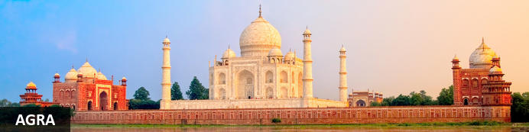
Straddling the broad Yamuna River 180km south of Delhi, Agra’s fame rests almost entirely on one building – the iconic Taj Mahal. Yet from the early 16th-century it was the Mughal empire’s capital endowed with numerous buildings and monuments that still make it a major draw for visitors. Apart from the Taj, Agra Fort (with its strong resemblance to Delhi’s Red Fort), the exquisite Tomb of Itmad-ud-Dalah (often called the ‘Baby Taj’), earthy bazaars and the evocative ‘ghost city’ of Fatehpur Sikri 40km to the west all make it a key tourist destination.

Day Itinerary
After breakfast, you will be transferred to railway station to board the train to Agra.

Train Gatimaan Express [The train does not operate on Fridays]
Departs Delhi 0810 Hrs.
Arrives Agra 0950 Hrs.

Upon arrival at Agra, you will be assisted & transferred to the hotel. (Standard check in time at the hotel is 1400 Hrs.).

Drop your bags at the hotel and freshen up. You will then proceed for a tour of Agra Fort.

Agra Fort
With its striking resemblance to Delhi’s Red Fort, Agra Fort’s massive sandstone walls stretch for over two kilometres with their eastern flanks overlooking a bend in the Yamuna River. Commissioned by the Mughal Emperor Akbar in 1573, its 90-acres of part-manicured gardens, imposing pavilions, royal apartments and audience halls are an impressive counterpoint to the Taj Mahal’s more delicate beauty and finesse. Built as a virtually self-contained imperial city, the fort came to symbolise Mughal military power. Here famously the Taj’s builder Emperor Shah Jahan was imprisoned by his own son and spent his final days gazing across the river at his beloved Taj Mahal.

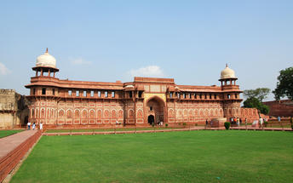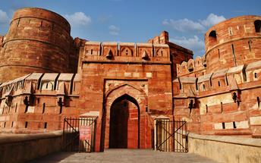

After the visit, return to your hotel for check in and relax.

Overnight: DoubleTree by Hilton Agra Hotel
The DoubleTree by Hilton Agra Hotel is situated near the Taj Mahal. All rooms and suites feature air-conditioning, a television, and various amenities for a comfortable stay. There are two on-site restaurants, a bar, and a cafe. Additional amenities include an outdoor pool, a fitness centre, a spa, and concierge service.

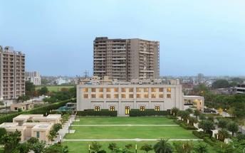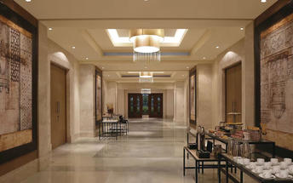

Day 4: Agra – Jaipur

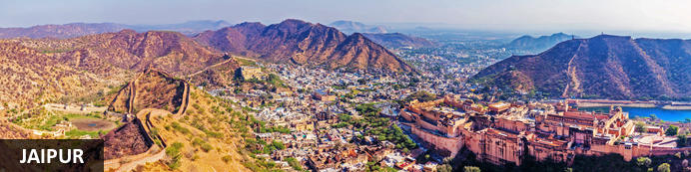
Founded in the early 1700s by Maharaja Jai Singh II as his new capital, the original ‘Pink City’ (so-called because almost all buildings were painted terracotta pink to honour the 1876 visit of the future King Edward VII) was laid out in a traditional grid with colonnaded streets and uniform façades. That layout remains intact and the city, now state capital of Rajasthan, has evolved and expanded into a modern metropolis with its own metro system. Yet its key sights and attractions lie within a relatively compact area. From vibrant bazaars and craft shops to grand palaces and huge forts, an extraordinary outdoor observatory and even one of the country’s most famous cinemas, Jaipur ticks every cultural, architectural and shopping box.

Day Itinerary
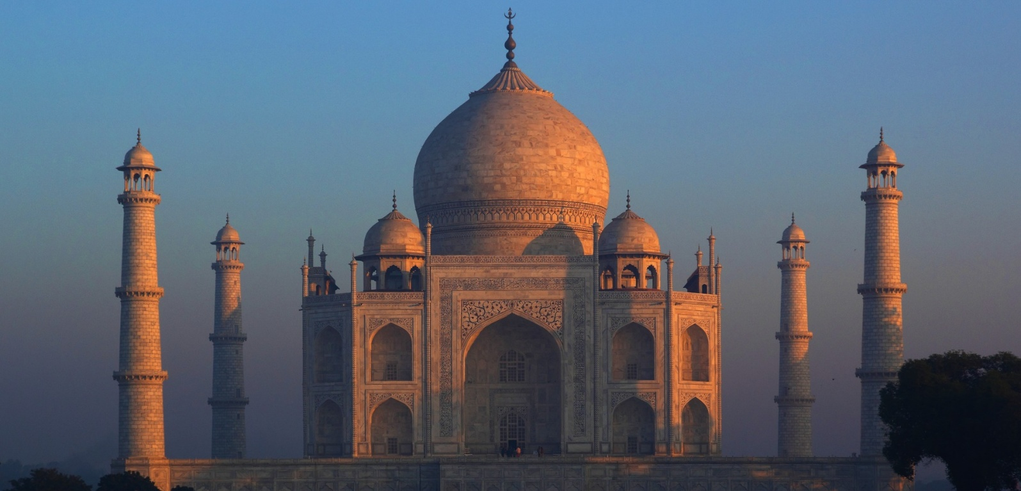
Early this morning witnesses the surreal views of the Taj Mahal [Taj Mahal remains closed on Fridays]. Step inside this eternal symbol of love and appreciate the intricate designs and symmetries that rhyme as a poem written in marble. Taj Mahal is an extravagant display of love, built by Shah Jahan in memory of his beloved wife Mumtaz.

After the visit, return to your hotel for breakfast.

Post breakfast, you will be driven to Jaipur [approx. 5 hours' drive]

Arrive Jaipur and check in at the hotel and relax.

Overnight: Hilton Jaipur
Hilton Jaipur is ideally located on the outskirts of Jaipur, just 1km from Ram Nagar metro stop and 11km from Jaipur International Airport. The accommodation features comfortable guest rooms and suites equipped with modern amenities including coffee makers, LCD TVs, hairdryers, air conditioning, desks and Wi-Fi. Guests can enjoy dining at the on-site restaurant and bar. Leisure facilities include a swimming pool, fitness centre and spa.
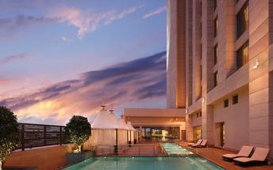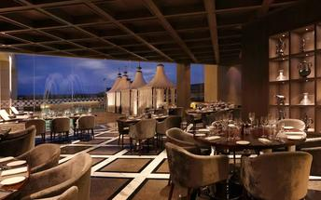

Day 5: In Jaipur

Day Itinerary
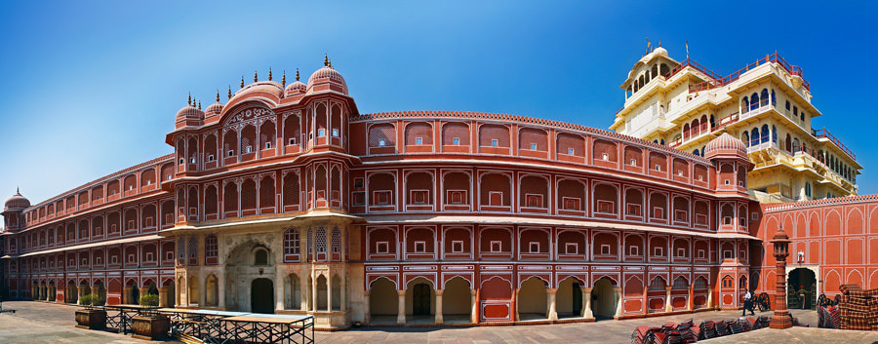
Begin exploring this city visit the City Palace complex which is spread over a large area occupying one-seventh of the old city of Jaipur. It is comprised of two palaces, Chandra Mahal and Mubarak Mahal, museum, a vast array of courtyards, gardens, and buildings. The palace is a blend of the Shilpa Shastra of Indian architecture with Rajput, Mughal, and European styles. Diwan-I-Aam (Hall of Public Audience), Bhaggi Khana (a museum), Pitam Niwas Gate, and Peacock Gate are must-see. Its outer boundary was built by Raja Jai Singh and the other structures by his successors to add charm to it. It also served as a residence for the former Maharaja of Jaipur, also visit the famous Jantar Mantar (an observatory)

Thereafter, head for a walking tour in the bazaars, this immersive experience offers a unique opportunity to explore the city’s vibrant bazaars, renowned for their exquisite textiles, distinctive artisanal goods, and delectable street food. A specially curated selection of Jaipur’s vibrant textile market and street delicacies, each reflecting the region’s rich culinary and cultural heritage, awaits your discovery.

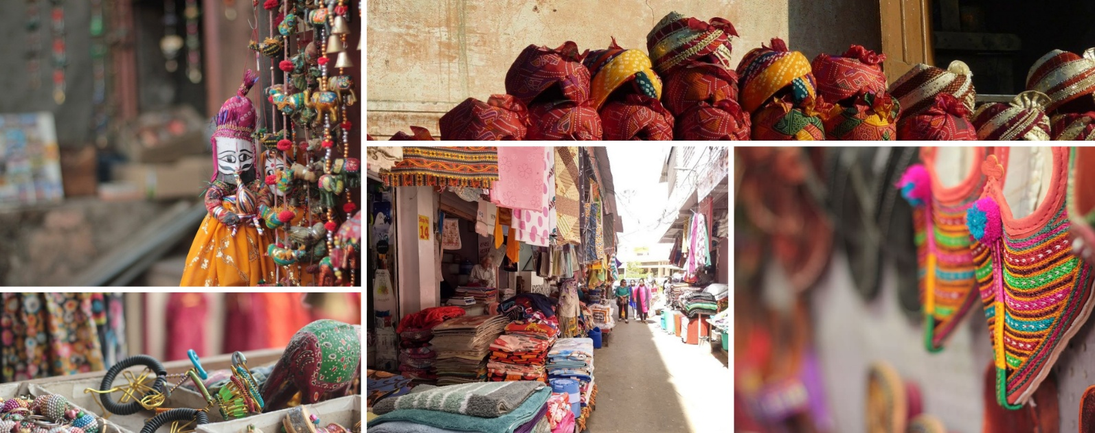
The textile market, in particular, stands as a testament to Jaipur’s centuries-old tradition of craftsmanship, where intricate patterns, vivid colours, and fine fabrics come together to embody the artistic soul of the Pink City.

Later in the evening proceed for the majestic Amber Fort that’s perched on a hill on the outskirts of Jaipur. The fort was once the capital of Rajasthan. Former residence of Rajput Maharajas, this fort is notable for its grand architecture showcasing the Hindu style of architecture. The Amber Fort was used by the Rajputs for the dual purpose of defence and for private residence. The fort encompasses charming gardens and magnificent palaces made from marble and precious stones, richly decorated with intricate stonemason works and paintings.
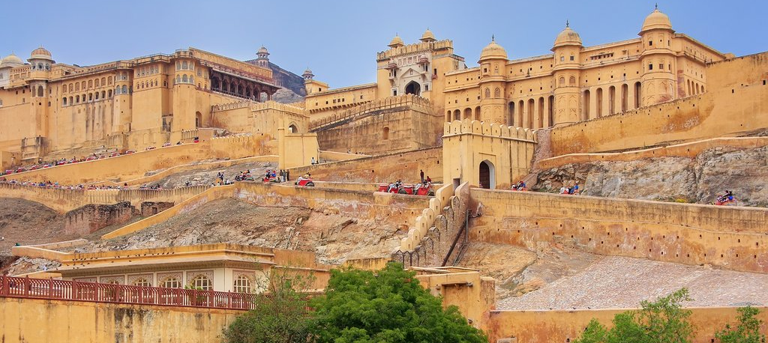

The rest of the day is free for personal activities.

Day 6: Jaipur – Kochi

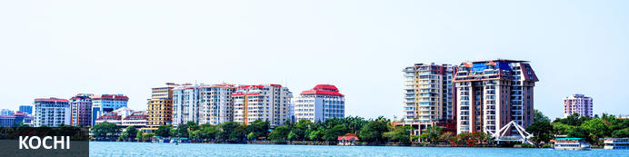
A major spice trading centre since the 14th century, Kochi (previously Cochin) is Kerala’s largest city and an essential destination for travelers to southern India. From ancient times it was known to an array of traders from Arabs to Portuguese, Greeks to Chinese, and was also home to India’s oldest Jewish community. Straddling several islands, a peninsula and part of the mainland, the city faces both ocean and backwaters so – unusually for India – all but the narrowest exploration of its sights involves bridges, ferries and water taxis. The main highlights are on Fort Kochi peninsula: built in 1503 the Church of St Francis is one of India’s oldest churches (and briefly interred the remains of Portuguese explorer Vasco da Gama) while the 16th-century Mattancherry Palace displays an extensive set of medieval murals inspired by the great Indian epics.

Day Itinerary
Today you will be transferred to Jaipur airport for your flight to Kochi (01 stop flight).

Flight 6E 498
Departs Jaipur 1150 Hrs.
Arrive Bengaluru 1415 Hrs.

On arrival ptoceed to connect onward flight to Kochi

Flight 6E 602
Departs Bengaluru 1530 Hrs.
Arrive Kochi 1640 Hrs.

Arrive Kochi and transfer to your hotel.

Overnight: Fragrant Nature Kochi
Fragrant Nature Kochi is within walking distance of Mattancherry Palace. Jawaharlal Nehru Stadium Kochi is only a short car ride from the hotel. Boasting a swimming pool, it also features 24-hour room service, valet parking and an executive floor.

There are 41 rooms at Fragrant Nature Kochi, each offering all the necessities to ensure a comfortable stay. On-site dining options include a restaurant, which is a convenient place to have a meal. In the evening, guests are able to wind down in the comfortable lounge bar.
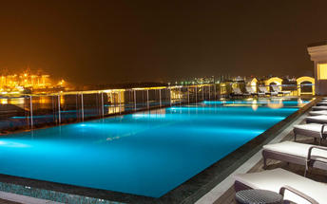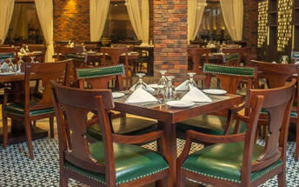

Day 7: In Kochi

Day Itinerary
Breakfast at the hotel
Morning you will be taken for half day tour of Kochi.
Fort Kochi
Fort Kochi takes its name from a long-gone fort which was built during its occupation by the Portuguese. The Portuguese were followed by the Dutch, who left their own legacy, and hot on their heels came the British with their own unique ways. Independent now for many years, Fort Kochi remains a colourful melting pot of diversity, retaining its colourful history in its architecture and culture.
Jew Town
Jew Town is located in Mattancherry in the southern Indian city of Kochi. The history of Jew Town dates back to 1492 when a group of Sephardic Jews came to Kochi after being expelled from the Iberian Peninsula. In 1524 more Jews faced persecution and were granted refuge by the Raja of Cochin who granted them land near his own palace. In 1568 the Paradesi Synagogue, which still functions today and is the oldest in India, was built, and the Jew Town neighbourhood developed around it.
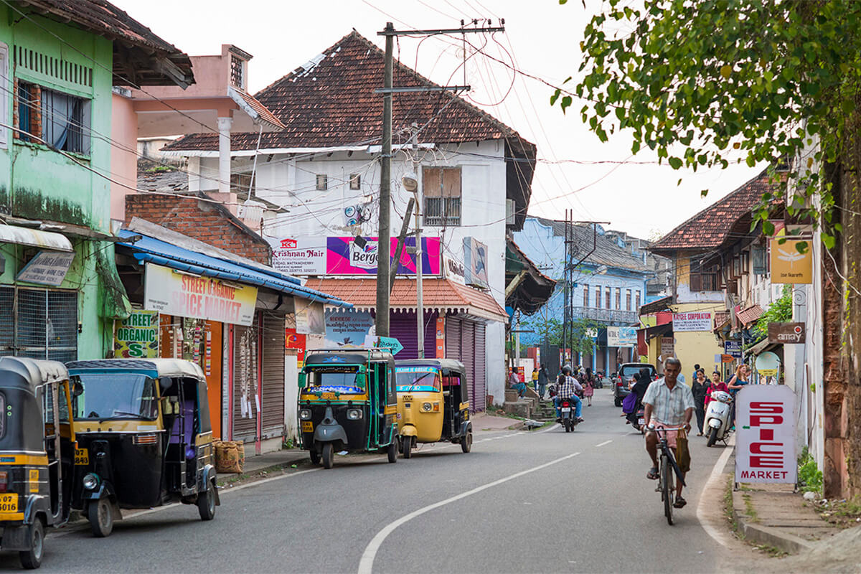
Jewish Synagogue (Closed on Fridays afternoon and Saturdays Full day)
Stepping inside the Synagogue, one's eyes would easily go to the glass chandeliers and blue willow-patterned Chinese floor tiles. The chandeliers are of Belgian origin. Also of interest are the Scrolls of the Law housed here and the several gold crowns received as gifts and the brass-railed pulpit. And for some exclusive pieces from history, the synagogue also houses the copper plates of privileges given to Joseph Rabban, the earliest known Cochin Jew, dating from the 10th century, written in Tamil, by the ruler of the Malabar Coast.

Dutch Palace (Closed on Fridays)
The Dutch Palace is a beautiful palace that was originally built by the Portuguese. It was only during the 17th century that the Dutch took it over, modified it and then presented it to the Raja of Kochi. The main attractions here are the outstanding collection of mural paintings found inside. These murals beautifully depict scenes from the Hindu epics of Mahabharatha and Ramayana.

St Francis Church
St. Francis Church is located in Kochi (previously called Cochin). It is one of the ancient European churches in the country and is a marvelous specimen of Portuguese architecture in the country. It is a mark of the colonial struggle of the Europeans to make their presence felt in India at that time. This church, built in 1503 by Portuguese traders, was where Vasco da Gama was buried when he died in 1524 AD. However, fourteen years later, his remains were shifted to Lisbon. Earlier, the church was named after Santo Antonio which was changed by Anglican Communion after the name of patron Saint Francis. It is now considered integral to the history and tourism of Kochi. In April 1923, this church became a protected monument under the Protected Monuments Act of 1904. In 1920, the Cenotaph was set up in the memory of the inhabitants of Kochi who died in the World War-I. Apart from all this, one interesting fact to observe is that, despite being very modest in its architecture, the model of this church has been followed by many churches India.

Chinese Fishing Nets
Chinese fishing nets are a type of stationary lift net in India. They are fishing nets that are fixed land installations for fishing. While commonly known as "Chinese fishing nets" in India, the more formal name for such nets is "shore operated lift nets".

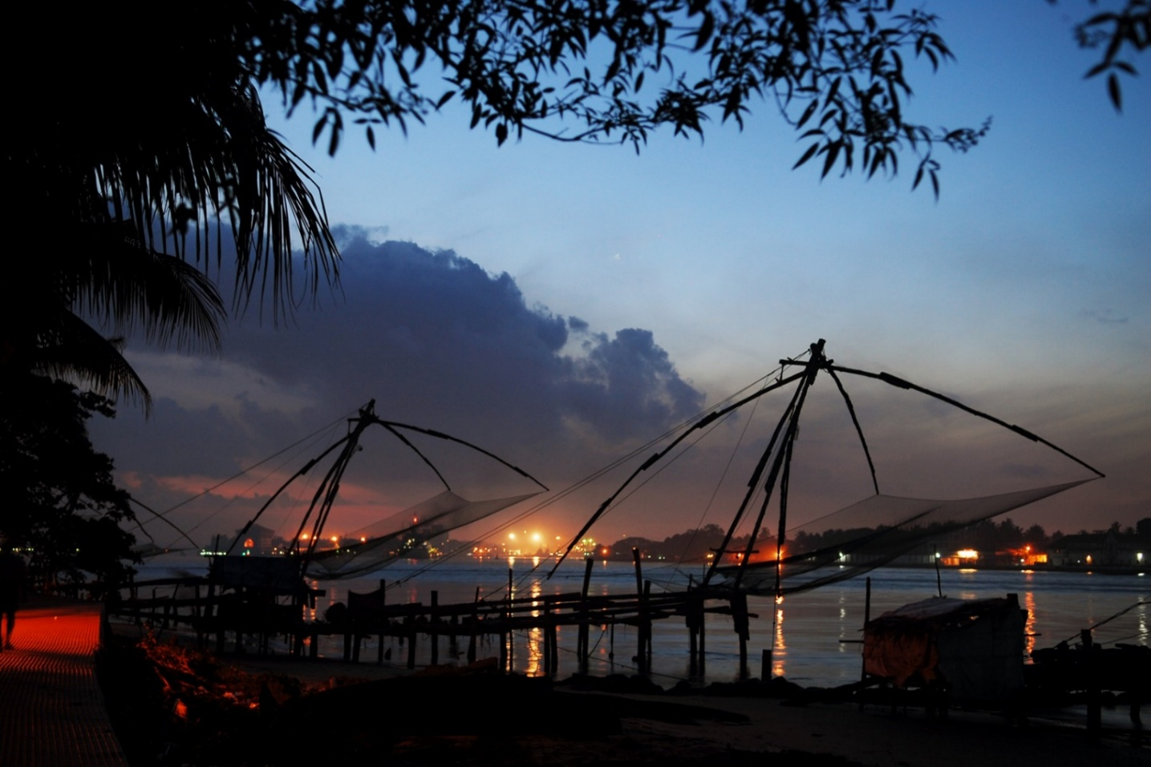

Kathakali
Kathakali is a highly stylized classical kerala dance performance noted for its attractive make-up of characters, their elaborate costumes, detailed gestures and well-defined body movements presented in tune with the anchor playback music and complementary percussion. Kathakali is said to have evolved from other performing arts like Kootiyattam (a classical Sanskrit drama existing in Kerala), Krishnanattam and Kalarippayattu. Kathakali explicates ideas and stories from the Indian epics and Puranas.

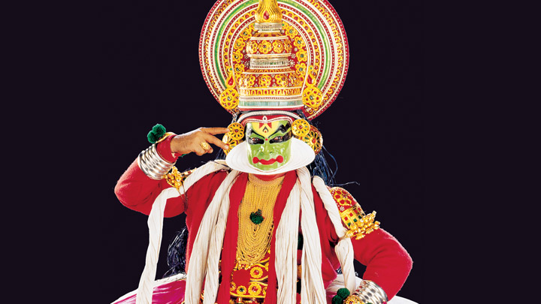

Day 8: Kochi – Alleppey

Day Itinerary
Breakfast at the hotel.

Later you will be driven to Alleppey [approx. 2 hours' drive]. On arrival, you will check in at the houseboat on the backwaters by 1230 Hrs.

Cruise on the backwater and overnight stay on the houseboat.

Note:
The check-in time on the Houseboat is at 1230 Hrs. - 1300 Hrs. and the boat then sets off cruising along the backwaters of Alleppey and Kumarakom till sunset. Around 1800 Hrs. the boat will be anchored to avoid interfering with the fishermen of the lake and their nets. The boats come with en-suite bedrooms that are air-conditioned (from 1900 Hrs. to 0700 Hrs.). On the following day after breakfast, you will be dropped back to the jetty by about 1000 Hrs.

Overnight: Deluxe Houseboat
The houseboats or Kettuvallam as they are traditionally called were at one time the mode of transportation for man and goods. Today, these are made to cater to the discerning guests who can lay back and enjoy the gentle cruise. Cruise the backwaters from the main Vembanad Lake through the small estuaries that link small villages to the mainland. Today, these are refurbished and all modern conveniences have been added for tourists who visit this beautiful water locked region of the country.

The houseboat cruise takes you through the intricate maze of backwaters, mesmerizing and surprising you at every turn with its serene beauty & simple charm. Enjoy the countryside of Kerala at its best. Soak your eyes & soul with array of coconut trees & endless paddy fields. You will also get chance to take a small stroll through the villages & interact with the locals.
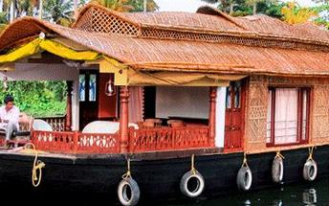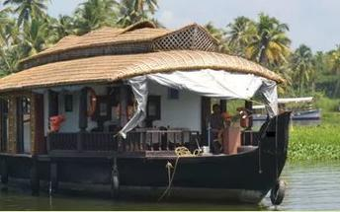

Day 9: Alleppey – Mararikulam


Situated only 40 km from the city of Cochin, in the Alappuzha district of Kerala, Mararikulam is a charming little coastal village known for its pristine sand beaches, swinging coconut palms, and quiet, laidback atmosphere. The village has managed to avoid the mass development associated with many of the other beach towns in the area resulting in an untouched natural environment dotted with only a handful of small resorts. The main attraction here is the exquisite Marari beach where you will find fishermen heading out daily to explore the Malabar coast, much as their ancestors have done for generations.

Day Itinerary
After breakfast disembark the houseboat.
You will then be driven to Mararikulam for the beach stay, check in on arrival at the resort [approx. 40 minutes' drive].

Overnight: Flamingo Marari
Flamingo Marari is located in the beach village of Mararikulam, in the Alleppey district. The hotel provides spacious rooms, suites, and villas with air conditioning, TVs, and private bathrooms. Guests can visit the on-site restaurant and indulge in delicious meals. Hotel amenities include an Ayurvedic spa, a swimming pool, Wi-Fi, and yoga sessions.
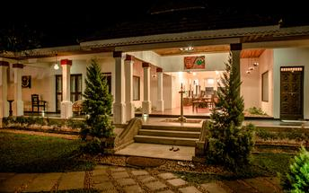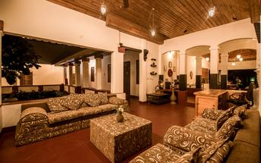

Day 10-11: In Mararikulam

Day Itinerary
Breakfast at the hotel.

These days you will be at leisure in Mararikulam. No vehicle will be at disposal.

Overnight at the hotel

Day 12: Mararikulam – Kochi airport departure

Day Itinerary
At an appropriate time, you will be transferred to Kochi airport [approx. 2.5 hours' drive] for your flight back home.

Flight TBA
Departs Kochi TBA Hrs.

**** END OF SERVICES ****

NOTE:
- The distances and time taken for the travel is approximation only this will differ based on the traffic conditions and other unforeseen circumstances.

