

IN - 27

KERALA TOUR
Kochi – Munnar – Periyar – Alleppey – Mararikulam
11 Days / 10 Nights

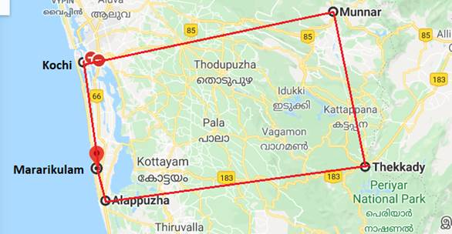

Day 1: Arrive Kochi

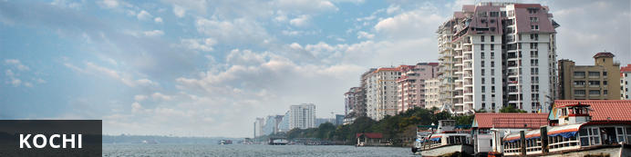
Also known as Cochin, Kochi is a city in southwest India's coastal Kerala state. This attractive city has served as a popular port for over 600 years and is known for its eclectic architecture and its array of religious monuments, museums, galleries, cafes and antique shops. The city stretches across a number of peninsulas and islands, which can be reached by a network of water taxis and bridges. The majority of Kochi’s visitor highlights can be found on the peninsula of Fort Kochi. These highlights include the St Francis Church, the oldest European-built church in India; and Mattancherry Palace, which dates back to 1557 and contains some exceptional Kerala murals and temple art. Other must-see attractions include the Kerala Folklore Museum, displaying more than 4,000 cultural and ethnic artifacts; the 16th-century Jewish Synagogue; and the local market, where the air is filled with the aroma of exotic spices.

Flight TBA
Arrive Kochi TBA Hrs
On arrival you will be received by a Travel Counsellor Representative and he will transfer you to your hotel for check in. (Standard check in time – 1400 Hrs)
Rest of the day at leisure.

Overnight: Fragrant Nature Kochi
Fragrant Nature Kochi is within walking distance of Mattancherry Palace. Jawaharlal Nehru Stadium Kochi is only a short car ride from the hotel. Boasting a swimming pool, it also features 24-hour room service, valet parking and an executive floor.
There are 41 rooms at Fragrant Nature Kochi, each offering all the necessities to ensure a comfortable stay. On-site dining options include a restaurant, which is a convenient place to have a meal. In the evening, guests are able to wind down in the comfortable lounge bar.
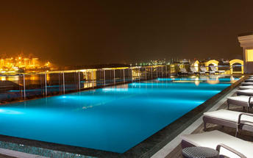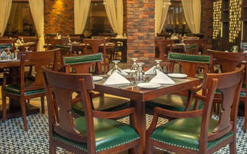

Day 2: In Kochi

A day to explore the city visiting Fort Kochi, Chinese fishing nets, the Jewish Synagogue, Dutch Palace and witness a Kathakli dance performance at a local theatre.

Fort Kochi
Fort Kochi takes its name from a long-gone fort which was built during its occupation by the Portuguese. The Portuguese were followed by the Dutch, who left their own legacy, and hot on their heels came the British with their own unique ways. Independent now for many years, Fort Kochi remains a colourful melting pot of diversity, retaining its colourful history in its architecture and culture.

Jewish Synagogue (Closed on Friday afternoon and Saturdays)
This synagogue was built in 1568 by the Malabar Yehudans or Cochin Jewish community. It was built close to the Mattancherry Palace Temple on the land gifted by King Rama Varma, a former ruler of Kochi. The Mattancherry Palace Temple and the Mattancherry synagogue share a common wall. This synagogue is the oldest one in the Commonwealth of Nations.
As one approaches the synagogue on Jew Street, its white facade begins to appear very prominently. A clock tower can also be seen, towering over and close to the facade. This was built in 1760 by Ezekiel Rahabi an affluent Jewish businessman. Of the four faces of the clock, the one facing the maharaja's palace showed the time in Malayalam. And among the other three, the face with etchings in Roman numerals was meant for the traders. Of the remaining two faces of the clock, one had writings in Hebrew while the other remains blank.
Stepping inside the Synagogue, one's eyes would easily go to the glass chandeliers and blue willow-patterned Chinese floor tiles. The chandeliers are of Belgian origin. Also of interest are the Scrolls of the Law housed here and the several gold crowns received as gifts and the brass-railed pulpit. And for some exclusive pieces from history, the synagogue also houses the copper plates of privileges given to Joseph Rabban, the earliest known Cochin Jew, dating from the 10th century, written in Tamil, by the ruler of the Malabar Coast.

Kathakali
Kathakali is a highly stylized classical kerala dance performance noted for its attractive make-up of characters, their elaborate costumes, detailed gestures and well-defined body movements presented in tune with the anchor playback music and complementary percussion.
Kathakali is said to have evolved from other performing arts like Kootiyattam (a classical Sanskrit drama existing in Kerala), Krishnanattam and Kalarippayattu. Kathakali explicates ideas and stories from the Indian epics and Puranas.
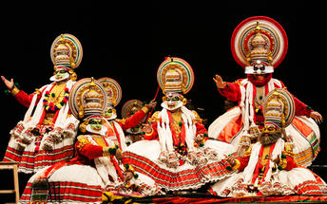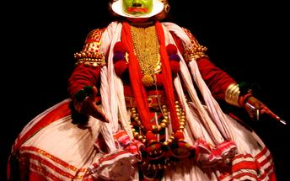

Day 3: Kochi – Munnar

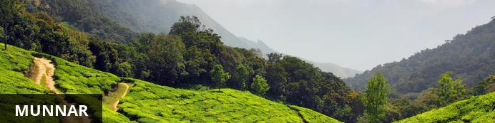
Idyllically set at the confluence of three mountain streams, Munnar is a beautiful hill station in the Western Ghats mountain range. The village once served as a popular vacation resort for the British Raj elite who flocked to here to enjoy the pleasant cool climate and the scenic natural surroundings characterised by rolling hills dotted with colonial bungalows, streams, waterfalls and 19th-century tea plantations. The main attraction in the area is the extraordinary Eravikulam National Park, which is famous for its diverse array of wildlife including the endangered mountain goat known as Nilgiri tahr. The park is also home to the exquisite Lakkam Waterfalls, some excellent hiking trails, and the impressive 2,695m-tall Anamudi Peak.

Leave for Munnar (approx. 4 hrs). Arrive and check-in at the hotel.
Rest of the day at leisure.

Overnight: The Tall Trees Munnar
Not far away from the most sought-after wild-life sanctuaries of South India and close to one of the most popular hill stations on the Western Ghats, the Tall Trees Resorts nestles on a verdant slope among misty mountains and evergreen forests. It is a unique property of 66 acres that has successfully preserved the pristine nature without any change to the delicate ecologic equilibrium, even though all the modern creature comforts are tastefully arranged in each of the well-appointed cottages nestling among the greenery. The property has hundreds of old and tall trees overshadowing the resort landscape covered with stretches of preserved wilderness, carefully nurtured cardamom plantations, gurgling streams, rocky formations, wet and green with moss and lichens and the numerous orchids and wild plants covering the tree barks and rocks. The highly endemic species of birds, butterflies, moths, small and harmless wild animals and several varieties of wild flowers all cohabit and make this piece of nature a reflection of the Garden of Eden.
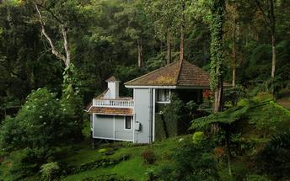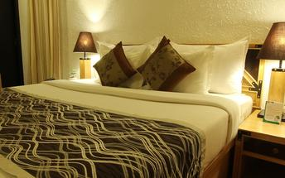

Day 4: In Munnar

After breakfast you will proceed for visiting Tea Plantations and Tea Factory

Tea Factory
Visit to the Lockhart Tea factory. Tea was first brought to Munnar by James Finlay & Sons who formed the Kannan Devan Hill Produce Company which has ultimately become Tata Tea Company. A visit to the tea factory gives one an insight into the fascinating process of tea.

Option to visit Srishti – the center which takes care of the differently abled children of the tea pluckers and the unit run by them.
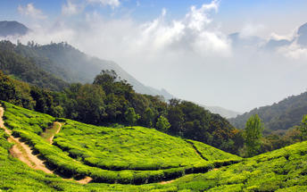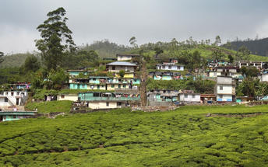

Day 5: Munnar – Thekkady

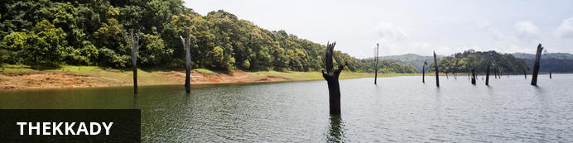
Thekkady comprises evergreen forests and savanna grasslands, and is known for its natural spices such as black pepper, cardamom, cinnamon, nutmeg, ginger and clove. Elephants, tigers, sambar and many other species inhabit the park. Top attractions include the exquisite ancient Mangla Devi Temple, the aromatic Abraham’s spice garden, and the massive waterfall at the sleepy, picturesque village of Chellarkovil. Take in panoramic views of the extraordinary landscape from the Chellarkovil viewpoint, and picnic on the rolling, lush green lawns at Pandikuzhi. Don’t miss the opportunity to visit the Kadathanadan Kalari Centre, to see demonstrations of the best traditional martial arts. Thekaddy is home to India’s sole Tiger Reserve, and has a rich living tribal culture.

Leave for Thekkady (approx. 4 hrs), on arrival check-in at hotel.
Day at leisure in Thekkady.

Overnight: Cardamom County
Muthoot Cardamom County sits between the Periyar National Park and Tiger Reserve and its lush highland forest and wetlands ecosystem and a spice-trading community of hill stations. It is within walking distance from both the entry to the Periyar and the village. The rooms and cottages all provide expansive views of the reserve. The resort has a wellness centre, Ayura Spa, offering therapies and yoga sessions. Muthoot Cardamom County organizes carbon-neutral activities such as nature walks, jungle patrols, border hiking, bamboo rafting, tribal heritage visits and Periyar tiger trails, bullock cart rides and visits to the elephant park. Other activities hosted by the resort that are not entirely carbon-neutral include full day Jeep safaris, plantation tours and visits to Gavi and Grampi.
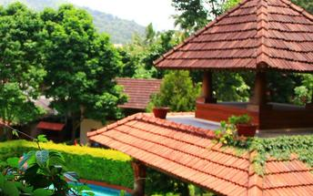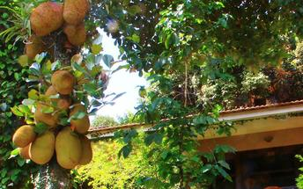

Day 6: In Thekkady

Early morning, proceed for a Nature walk at Periyar National park. Later in the afternoon take a tour of the spice plantations.

Nature Walk
Different nature trails traversing diverse habitats form the trekking routes, generally 4 to 5 km. in length. The trails often pass through evergreen and moist deciduous forests interspersed with marshy grasslands. The program is offered between 7.00 am and 10.30 am and between 2.00 pm. and 3.00 pm. and lasts for about 3 hours. A maximum of 5 persons can go for trekking at a time along each nature trail, accompanied by a trained tribal guide. The Nature walk is the right program to feel nature, hear her whispers and smell her flowers.

Spice Plantation
The visit take you to the plantation where one can see, learn about the spices such as cardamom, pepper, vanilla, clove, cinnamon, nutmeg, ayurvedic herbs etc.

Overnight at hotel

Day 7: Thekkady – Alleppey – Board Houseboat

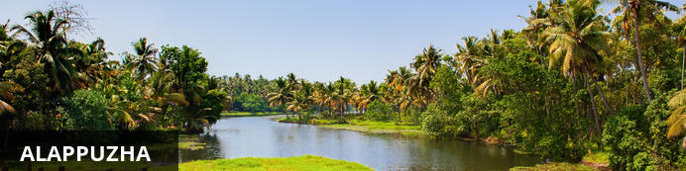
Dubbed the ‘Venice of the East’, it is renowned for its houseboat cruises which float along the tranquil backwater canals of Kerala. It is said to be one of the most popular tourist centres in the state. While cruising the palm-shaded canals is the main attraction, visitors can also enjoy visiting Alappuzha’s beautiful beaches, exploring the little riverside villages dotting the lush countryside and discovering an array of resplendent temples.

Morning drive to Alleppey (Approx. 120 Kms / 4 Hrs) to board Houseboat for overnight stay.

The houseboats or Kettuvallam as they are traditionally called were at one time the mode of transportation for man and goods. Today, these are made to cater to the discerning guests who can lay back and enjoy the gentle cruise. Cruise the backwaters from the main Vembanad Lake through the small estuaries that link small villages to the mainland. Today, these are refurbished and all modern conveniences have been added for tourists who visit this beautiful water locked region of the country.

The houseboat cruise takes you through the intricate maze of backwaters, mesmerizing and surprising you at every turn with its serene beauty & simple charm. Enjoy the countryside of Kerala at its best. Soak your eyes & soul with array of coconut trees & endless paddy fields. You will also get chance to take a small stroll through the villages & interact with the locals.

Overnight: Alleppey Deluxe Houseboat

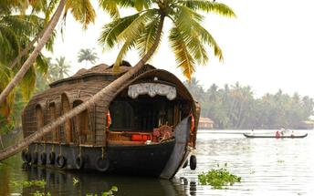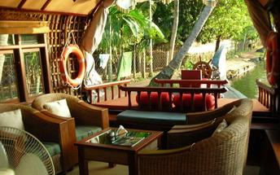

Day 8: De-board Houseboat – Mararikulam

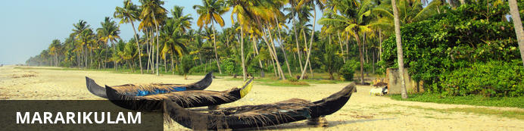
Mararikulam is a charming little coastal village known for its pristine sand beaches, swinging coconut palms and quiet, laidback atmosphere. The village has managed to avoid the mass development associated with many of the other beach towns in the area resulting in an untouched natural environment dotted with only a handful of small resorts. The main attraction in the area is the exquisite Marari beach where you will find fishermen heading out daily to fish the waters of this stretch of the Malabar coast, much as their ancestors have done for generations.

After breakfast on board, dis-embark the boat and transfer to Mararikulam (approx. 30 minutes)
Upon arrival, check in at the hotel. Remainder of the day at leisure.

Overnight: Marari Beach Resort
Marari Beach is part of the CGH Group and provides an authentic experience of Kerala traditional and recreation. The small resort is set in the coconut grove at the sandy Marari Beach surrounded by flowering plants and herb gardens.
Deluxe pool villas and cottages provide accommodation at the Marari Beach Resort. Most cottages have French windows opening up to a private garden. All materials used are naturally resourced and processed using simple methods as a means of practising ecological methods in the day to day running.
There’s plenty to experience at the Marari Beach Resort. The locals often host festivals showcasing their traditions and culture. At the Ayurveda Centre, guests can experience an authentic Kerala massage from trained therapists. Also available are yoga classes from a master yoga teacher. Furthermore, visitors have the option of attending a cooking class at the Farm Kitchen.
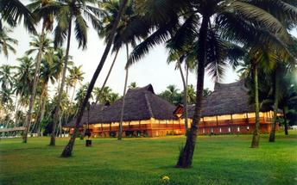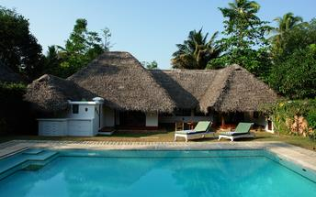

Day 9 - 10: In Mararikulam

Breakfast is at the hotel.

Days at leisure with beach activities, yoga/mediation or to rejuvenate with some Ayurveda massages

Overnight at hotel

Day 11: Mararikulam – Kochi – International departure

At an appropriate time, your Travel Counsellor Representative will assist and transfer you to Kochi international airport [approx. 2 ½ Hrs drive] to board your flight back home.

