

Karnataka - Culture with wildlife-IN11
Bangalore - Mysuru - Hassan - Kabini Forest Reserve
9 Days / 8 Nights
2 Persons
Date of Issue: 16 June 2025

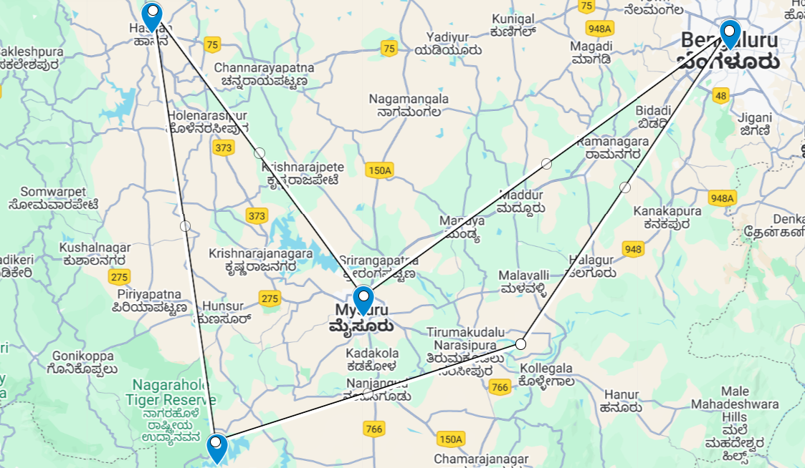

Day 1: Arrive Bangalore

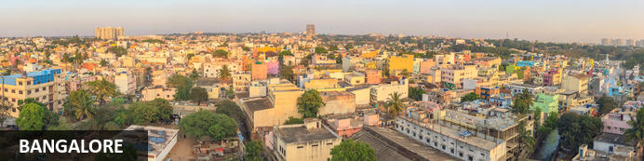
Three thousand feet up on the Deccan Plateau, the state capital of Karnataka’s relatively mild climate and abundance of broad leafy roads and parks has helped earn it the ‘Garden City of India’ label. These days that moniker might seem a stretch: it’s a booming city of eight million with thriving IT and bio-tech sectors that have given rise to another – the Silicon Valley of India. Unlike many other Indian cities, Bangalore has a more modern and sophisticated buzz oiled by an array of cosmopolitan restaurants, lively bars and even an ‘underground’ music scene.

Day Itinerary
Upon arrival in Bangalore Airport, your Travel Counsellors Representative will meet and assist for your transfer to hotel. He will further assist you for the check-in at the hotel.

Overnight: The Taj West End Hotel
Like any other Taj property, the Taj West End is an ideal establishment for guests. There are comfortable amenities as well as exclusivity with the Taj Club Floor and Lounge allowing access to special privileges.
The hotel has a wide selection of rooms and suites for guests to choose from that matches their individual accommodation needs.
There's plenty to see and experience at the Taj West End hotel. Staff are available to assist guests in organizing daily activities for the duration of their stay. From shopping excursions to spa treatments to workouts at the fitness centre, a customized hotel experience can be arranged.
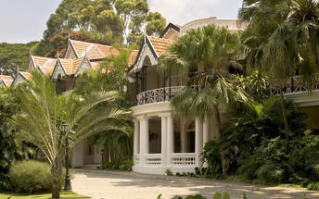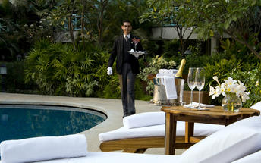

Day 2: In Bangalore

Day Itinerary
Today, enjoy a colonial walk of Bangalore.

Did you know that the events that unfolded in Bangalore are linked to the American War of Independence, the French Revolution, and the Battle of Waterloo? On this tour, we will uncover Bangalore’s colonial connections and learn how local events had far-reaching impacts, shaping the city into what it is today.
Discover the lives of the sahibs (sir) and memsaabs (ma’am) of the British Raj by exploring the remnants of their way of life. Be captivated by stories of fascinating characters who lived in Bangalore, such as Winston Churchill and Ronald Ross. Experience this history through visits to colonial churches, bungalows, and pubs that define Colonial Bangalore.

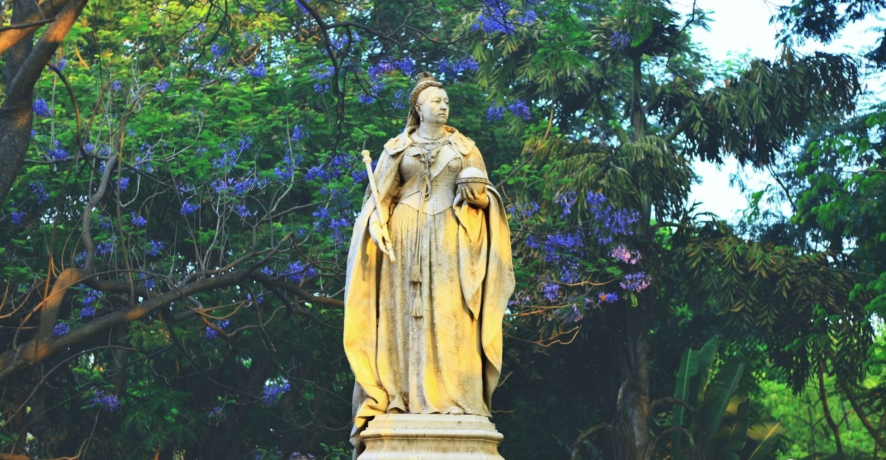
Overnight at the hotel

Day 3: Bangalore - Mysuru

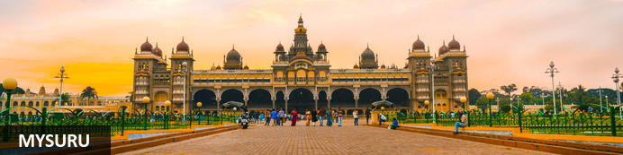
Until recently known as Mysore, Mysuru is Karnataka's second city. Yet for centuries it was the capital of the enduring Wadiyar dnyasty – the 'Kingdom of Mysore' – whose rule over the region was interrupted for barely four decades in the late 1700s. Today Mysuru is known for its sandalwood carving and silk industries, and partly through its ancient style of painting is regarded as one of southern India's cultural capitals. Its cultural tag is probably most tangible during the annual Dussehra festival which is celebrated across most of India in September or October; Mysuru's exuberant 10-day festivities take things to a new level and draw thousands of visitors. It culminates in a huge torch-lit procession of elephants, camels and horses accompanied by musicians and dancers transporting an idol from Mysore's extraordinary royal palace, one of several that grace the city

Day Itinerary
After breakfast you will be driven to Mysore (Approx. 150 kms / 04 hours drive) with a stop enroute at Srirangapatanam.

A 20-minute drive from Mysore transports you to Srirangapatna, a picturesque island embraced by the River Cauvery. This was once the capital of the renowned Tipu Sultan.
Gain insights into the Anglo-Mysorean Wars that unfolded in this region, intertwined with its intriguing connections to the American War of Independence, the French Revolution, and the Battle of Waterloo. Discover why Srirangapatna holds significance as a religious center and witness Hindu death rituals firsthand. Marvel at the majestic forts and temples of Srirangapatna amidst lush greenery and experience the rustic charm of life on this serene island paradise.

Overnight: Royal Orchid Metropole
A 4-star grand heritage hotel, the Royal Orchid Metropole depicts the history and culture of Mysore. Built in 1920 to host guests, the guesthouse still retains its imperial arches, pillars and ornate corridors capturing the old world charm.
A variety of rooms and suites provide accommodation. A stay at the Royal Orchid Metropole comes with complimentary breakfast as well as 24 hour room service and access to satellite TV. Notable features include the swimming pool, a fitness centre and an outdoor restaurant serving exotic delicacies.
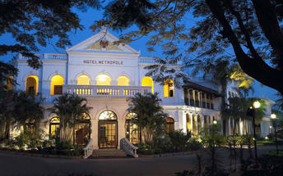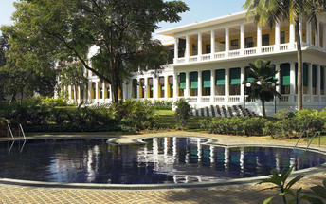

Day 4: In Mysuru

Day Itinerary
After breakfast, enjoy a royal walk of Mysore.

Embark on an expert-guided tour through the heart of the city, where we stroll past majestic old structures and delve into the captivating history of Mysore. Along the way, discover the lavish lifestyles of the Mysore maharajas, among the wealthiest individuals in the world at their time. Immerse yourself in the vibrant hues of a century-old market, a true delight for photographers.
Indulge in Mysore Pak, the city's renowned culinary delight—a sweet that melts in your mouth, crafted from ghee, sugar, and gram flour at its place of origin. Conclude the tour leisurely at a heritage hotel with a cup of tea or coffee.
Later proceed to visit the Mysore Palace. The Mysore Palace, also known as the Amba Vilas Palace, stands as one of the country's most frequented monuments and remains the residence of the erstwhile royal family, the Wodeyars.
On this tour of this magnificent structure, delve into the challenges and triumphs of constructing one of India's grandest palaces, and uncover its hidden stories as we explore its every corner.

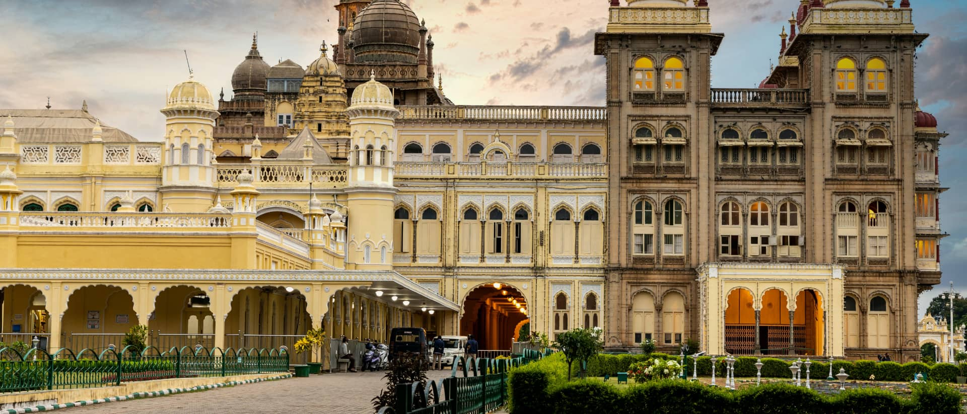

Overnight at the hotel

Day 5: Mysuru - Hassan

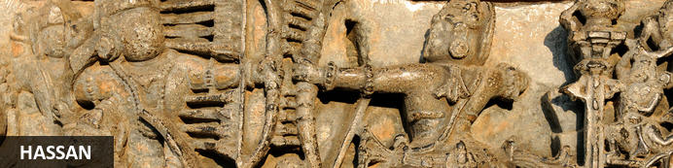
As one of the oldest towns in India’s Karnataka State, Hassan has a long and rich history. The town was founded by Channa Krishnappa Naik in the 11th century and remained under the rule of the Hoysala dynasty until the 13th century. It is the unique Hoysala architecture of this time that has made Hassan a popular tourist attraction as, during this period, numerous architectural marvels including a number of exquisite temples were constructed, many of which remain well-preserved today. However, it is not only the diverse variety of temples and unique architecture that draws visitors to Hassan, but also the town’s lovely markets, delicious local cuisine and remarkable natural beauty of the town itself and its extraordinarily scenic surrounding areas.

Day Itinerary
After breakfast you will be driven to Hassan (approx. 140 kms/ 04 hours drive).

On arrival, you will check-in at the hotel.

Overnight: Hoysala Village Resort
The Hoysala Village Resort is located in Hassan and provides accommodation within the comfort of nature with the eco-friendly resort being constructed with rosewood and traditional materials. The interior is decorated with a variety of artefacts while trees and flower gardens decorate the exterior. The accommodation comprises of 3 options with each being exquisitely decorated, well-appointed and fitted with an air conditioner, Tv, telephone and ensuite bathroom. The inhouse restaurant Belur serves a variety of local and Malnad cuisine with all meals being prepared using local and fresh ingredients. A swimming pool and games room are available to guests as well as cycling, volleyball, badminton, yoga sessions and going on bullock cart rides. Musical concerts and cultural shows also take place regularly at the Hoysala Village Resort. Hassan is also an important landmark on the tourism map of Karnataka. It has a rich history and heritage making the resort the perfect stop-over to explore several important attractions in and around Hassan like Belur, Halebidu, Shravanabelagola, Manzarabad fort, Shettyhalli Church and Backwater.
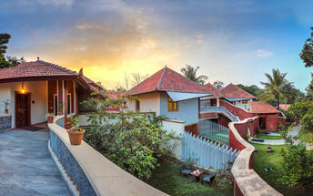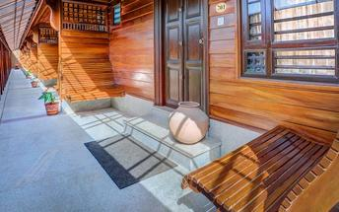

Day 6: In Hassan

Day Itinerary
After breakfast, visit the beautiful Hoysala temples at Belur and Halebid.

Belur – Set on the banks of Yagachi river, Belur boasts a rich cultural heritage. It features the 12th century Chennakeshava temple, displaying some of the best of Hoysala architecture.

Halebidu again features the Hoysala structures, the Hoysaleswara, Kedareswara and Jain temples.

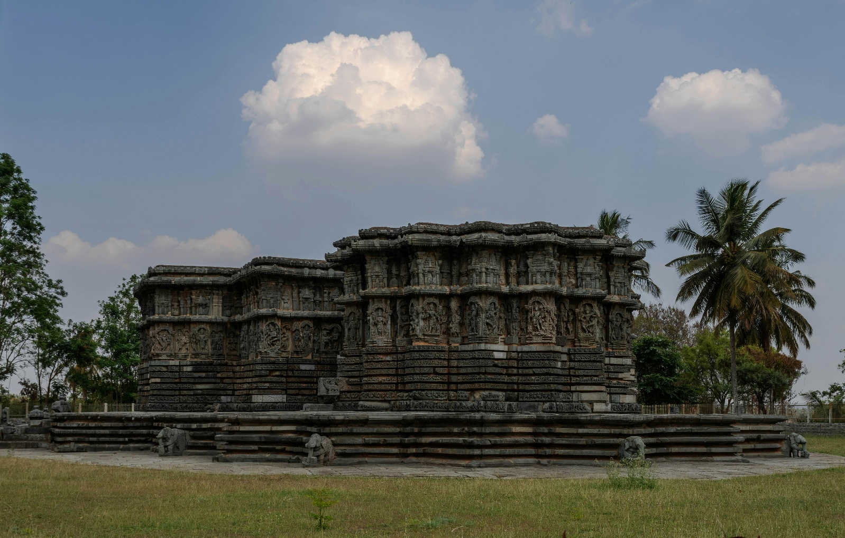

Overnight at the hotel

Day 7: Hassan - Kabini

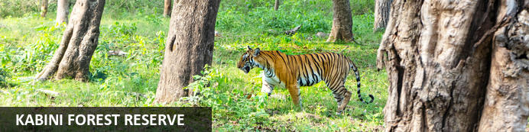
Resting on the banks of the mighty River Kabini, the Kabini Forest Reserve (or the Kabini Wildlife Sanctuary) is a vast expanse of unspoiled wilderness. Encompassing forestland, water-bodies, and steep fertile valleys, this extraordinary reserve forms the south-eastern section of the Nagarhole National Park and is home to the world’s largest population of Asiatic elephants (estimated at around 6,000). Visitors are also likely to spot a number of endangered and rare animal species including, among others, leopard, tiger, panther, sambhar, spotted deer, python, sloth bear, cheetah, crocodile, and over 250 species of bird.

Day Itinerary
After breakfast you will be driven to Kabini (approx. 145 kms/ 3-4 hours drive).

On arrival, you will check in at the resort/lodge.

Overnight: Evolve Back Kuruba Safari Lodge
Evolve Back Kuruba Safari Lodges Spirit of the land philosophy finds its most intimate expression at Kabini, where visitors are drawn into the vibrant social tapestry of the local Kadu Kuruba tribe. While discovering a vernacular dimension to luxury that’s truly liberating, the resort gives a wildlife experience like no other. Inspired in design by the Hadis or tribal villages, this picturesque resort of sweeping panoramic vistas, is bordered on two sides by the Kabini River.
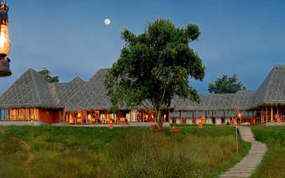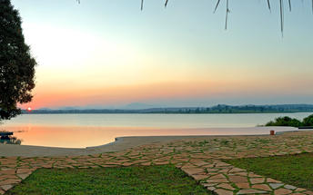

Day 8: In Kabini

Day Itinerary
In the morning, Vehicle Safari into the Nagarhole National Park. Return to the resort for dinner.

Afternoon, enjoy a ‘Boat Safari’ on the river Kabini into the Nagarhole & Bandipur National Parks

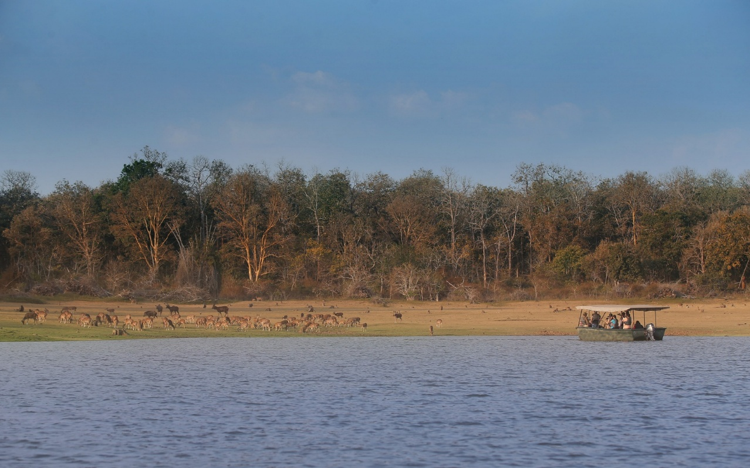

Overnight at the lodge

Day 9: Kabini – Bangalore - End of Itinerary

Day Itinerary
After breakfast, you will be driven to Bangalore (Approx. 220 kms / 5 hours drive] airport to board flight back home.

