

NP - 01

The best of Nepal

Kathmandu –Pokhara - Chitwan – Kathmandu

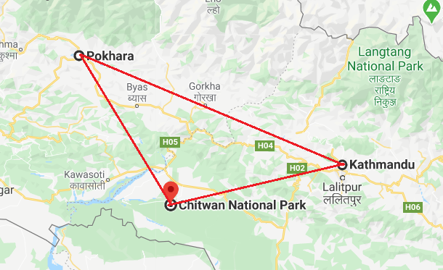

Day 1: Arrive Kathmandu

Upon arrival in Kathmandu, meeting & assistance at the airport by a Travel representative and transfer to Hotel.

Kathmandu City - known as Kantipur, the capital of the Kingdom of Nepal. Here you will visit the temple of the Living Goddess, who acknowledges the greetings of the devotees from the balcony of her temple residence. The Durbar Square are with its array of temples overlooked by the Hanuman Dhoka Palace, the ancient place of the Nepalese Royalty.

Day 2: Kathmandu

Breakfast at Hotel.
Full day tour covering Kathmandu Durbar Square, Swayambhunath and Patan Durbar Square.
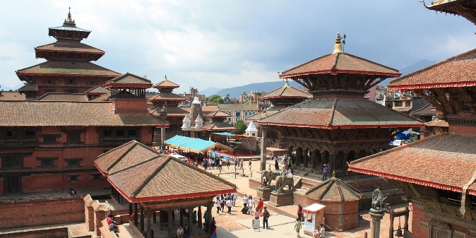
Swayambhunath - located approximately 4 km/2.5 miles from the city centre, the Buddhist stupa here is said to be 2000 years old. The stupa which forms the main structure is composed of a solid hemisphere of brick and earth supporting a lofty conical spire capped by a pinnacle of copper gilt. Painted on the four sided base of the spire are the all seeing eyes of Buddha. This hill is a mosaic of small Chaityas and Pagoda temples.

Patan also known as Lalitpur, is the city of fine arts, enclosed within 4 stupas said to be built in 3rd century AD, by Emperor Ashoka. The Patan Durbar which houses a bronze collection, the Krishna Temple built by King Siddhi Narsingh Malla.

Day 3: Kathmandu

Breakfast at Hotel.
Full day tour of Boudhnath, Pashupatinath & Bhaktapur Durbar Square.
Pashupatinath - situated 5 km east of Kathmandu city, the temple here is one of the holiest Hindu temple dedicated to Lord Shiva. Situated, amidst a lush green natural setting on the bank of the sacred Bagmati river, the temple built in pagoda style has gilted roof and richly carved silver doors. Visitors will be permitted to view the temple from the east bank of River Bagmati, entrance in the temple being strictly forbidden to all non-Hindus. Pashupatinath is the centre of annual pilgrimage on the day of Shivaratri which falls in the month of February/March. Behind the temples are the cremation grounds.
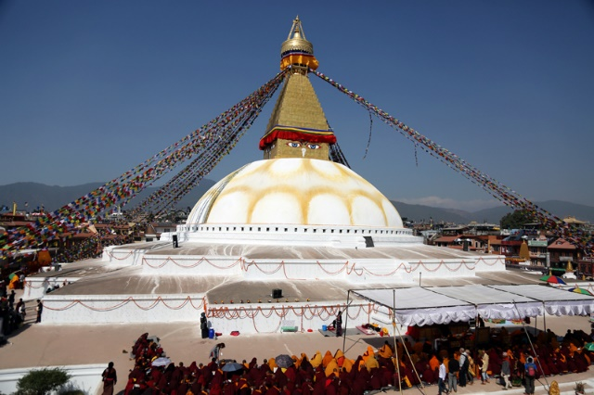
Boudhnath - this stupa, eight kilometres east of Kathmandu City is one of the biggest in the world of its kind. It stand with four pairs of eyes in the four cardinal direction keeping watch for righteous behaviour and human prosperity. This Buddhist stupa was built by King Man Deva at the advice of Goddess Mani Jogini. It is built on an octagonal base inset with prayer wheels. The shrine is ringed by houses of Lamas or Buddhist priests.

Bhadgaon - also known as Bhaktapur meaning the city of devotees, this place is the home of medieval art and architecture. Lying 14 km/9 miles east of the Kathmandu City, this place was founded in the 9th century and is shaped like a conch shell. The city is at the height of 4600 ft. above sea level. In Bhadgaon you will visit the Durbar Square with it's array of temples overlooked by the Palace of 55 windows built by King Bhupatindra Malla. The Nyatapola Temple also built by King Bhupatindra Malla, is the best example of Pagoda style and stands of five terraces on each of which stands a pair of figures two famous strong men, two elephants, two lions, two famous strong men, two elephants, two lions, two griffins and two goddesses.

Day 4: Kathmandu - Pokhara

Breakfast at Hotel in Kathmandu
Then drive Pokhara which takes approx. 6 hrs under normal road condition

Day 5: Pokhara

Sunrise visit to Sarangkot followed by a tour of the city covering Bindebasini Temple and the Tibetan Village. Option to do a boating in Phewa lake
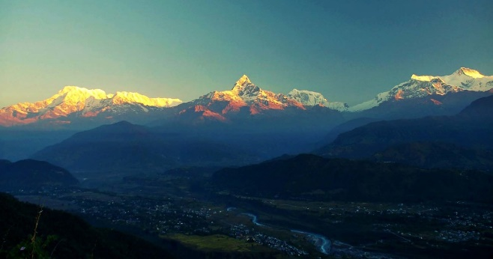
Bindyabasini Temple - it is located on the top of a small hill at the north end of the old bazaar. This is believed as one of the oldest temples in the valley, and is most famous in Pokhara.
Tibetan Village - since 1959, a group of Tibetan refugees have been living in Nepal. One such is Tashiling Tibetan Refugee Settlement at Chhorepatan, which is located near two popular sightseeing sites i.e., Devi's Fall and Gupteshwor Mahadev Cave.

Day 6: Pokhara – Chitwan National Park

Breakfast at Hotel
Then drive to Chitwan which takes about 5 hrs under normal road condition.
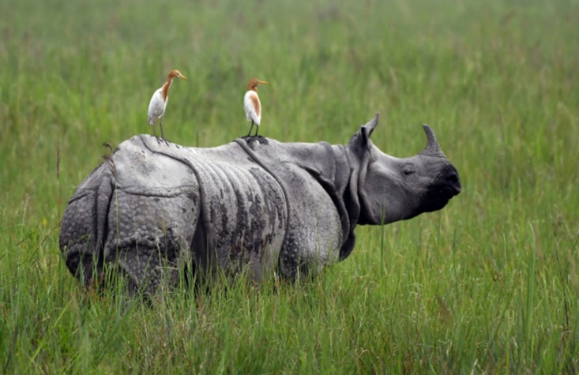
Idyllically set in the Terai Lowlands of south-central Nepal, the Chitwan National Park is known for its extraordinary biodiversity. This impressive UNESCO World Heritage Site is characterised by lush forests, grasslands, rich flood-plains, rolling hills, beautiful rivers, and ox-bow lakes. The park is one of Nepal’s most celebrated nature reserves as it serves as one of the world’s last refuges of the Bengal tiger and the one-horned Asiatic rhinoceros. There are also deer, monkeys, leopards, Indian elephants, crocodiles, sloth bears and over 500 species of bird inhabiting this spectacularly scenic expanse of protected wilderness. Don’t miss the chance to explore the northern reaches of the Rapti River by traditional dugout canoe, or to visit the Balmiki Ashram, which is a popular Hindu pilgrimage site.

At evening sunset view at the verse of Rapti river

Day 7: Chitwan National Park

Breakfast at Resort.
Full day jungle activities as per the resorts program.

Day 8: Chitwan National Park - Kathmandu

Breakfast at Hotel
Then transfer to Bharatpur airport for a short flight to Kathmandu.
Upon arrival in Kathmandu, transfer to Hotel and rest of the day at leisure.

Day 9: Depart Kathmandu

