

NP - 02

Best of Pokhara
Kathmandu – Pokhara - Kathmandu
8 Days / 7 Nights
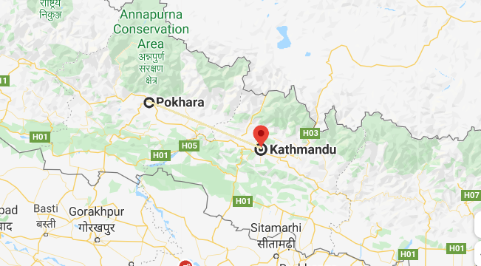

Day 1: Arrive Kathmandu

Upon arrival in Kathmandu, meeting & assistance at the airport by a Travel representative and transfer to Hotel.
Kathmandu City - known as Kantipur, the capital of the Kingdom of Nepal. Here you will visit the temple of the Living Goddess, who acknowledges the greetings of the devotees from the balcony of her temple residence. The Durbar Square are with its array of temples overlooked by the Hanuman Dhoka Palace, the ancient place of the Nepalese Royalty.

Day 2: Kathmandu

Breakfast at Hotel.
Full day tour covering Kathmandu Durbar Square, Swayambhunath and Patan Durbar Square.
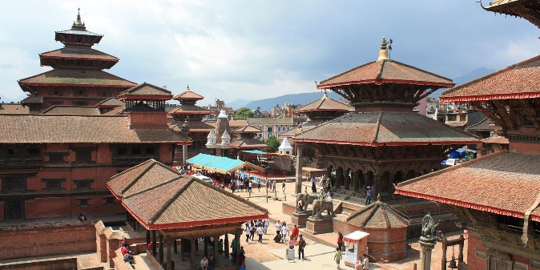
Swayambhunath - located approximately 4 km/2.5 miles from the city centre, the Buddhist stupa here is said to be 2000 years old. The stupa which forms the main structure is composed of a solid hemisphere of brick and earth supporting a lofty conical spire capped by a pinnacle of copper gilt. Painted on the four sided base of the spire are the all seeing eyes of Buddha. This hill is a mosaic of small Chaityas and Pagoda temples.
Patan also known as Lalitpur, is the city of fine arts, enclosed within 4 stupas said to be built in 3rd century AD, by Emperor Ashoka. The Patan Durbar which houses a bronze collection, the Krishna Temple built by King Siddhi Narsingh Malla. Patan Durbar square is one of the seven monument zones that makes Kathmandu valley UNESCO World Heritage site.

Day 3: Kathmandu

Day at leisure

Day 4: Kathmandu - Pokhara

Breakfast at Hotel in Kathmandu
Then drive Pokhara which takes approx. 6 hrs under normal road condition

Day 5 to 7: Pokhara

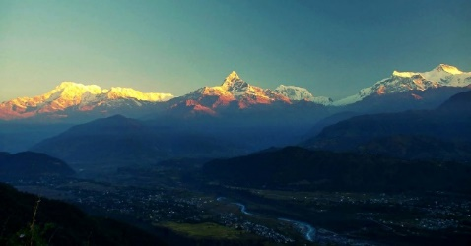
Sunrise visit to Sarangkot followed by a tour of the city covering Bindebasini Temple and the Tibetan Village. Option to do a boating in Phewa lake
Bindyabasini Temple - it is located on the top of a small hill at the north end of the old bazaar. This is believed as one of the oldest temples in the valley, and is most famous in Pokhara.

Day 8: Pokhara – Kathmandu and departure

