

NP – 03

Nepal and Bhutan Tour
Kathmandu - Nagarkot - Thimphu - Punakha – Paro - Kathmandu
12 Days / 11 Nights
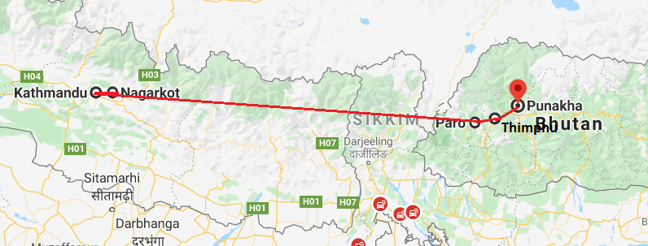

Day 1: Arrive Kathmandu

Upon arrival in Kathmandu, meeting & assistance at the airport by a Travel representative and transfer to Hotel.
Kathmandu City - known as Kantipur, the capital of the Kingdom of Nepal. Here you will visit the temple of the Living Goddess, who acknowledges the greetings of the devotees from the balcony of her temple residence. The Durbar Square are with its array of temples overlooked by the Hanuman Dhoka Palace, the ancient place of the Nepalese Royalty.

Day 2: Kathmandu

Breakfast at Hotel.
Full day tour covering Kathmandu Durbar Square, Swayambhunath, Boudhanath and Pashupatinath
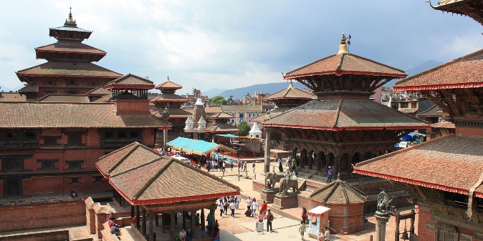
Swayambhunath - located approximately 4 km/2.5 miles from the city centre, the Buddhist stupa here is said to be 2000 years old. The stupa which forms the main structure is composed of a solid hemisphere of brick and earth supporting a lofty conical spire capped by a pinnacle of copper gilt. Painted on the four sided base of the spire are the all seeing eyes of Buddha. This hill is a mosaic of small Chaityas and Pagoda temples.
Pashupatinath - situated 5 km east of Kathmandu city, the temple here is one of the holiest Hindu temple dedicated to Lord Shiva. Situated, amidst a lush green natural setting on the bank of the sacred Bagmati river, the temple built in pagoda style has gilted roof and richly carved silver doors. Visitors will be permitted to view the temple from the east bank of River Bagmati, entrance in the temple being strictly forbidden to all non-Hindus. Pashupatinath is the centre of annual pilgrimage on the day of Shivaratri which falls in the month of February/March. Behind the temples are the cremation grounds.
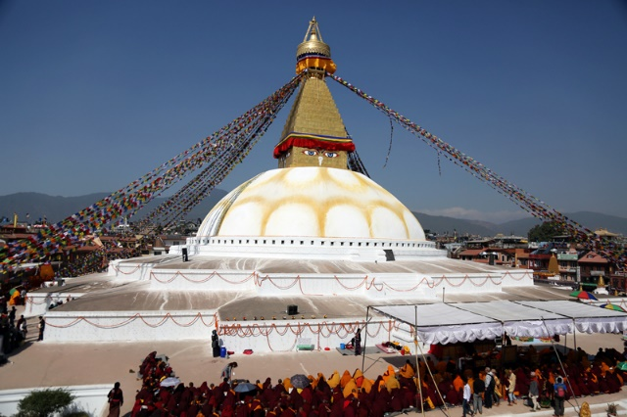
Boudhnath - this stupa, eight kilometres east of Kathmandu City is one of the biggest in the world of its kind. It stand with four pairs of eyes in the four cardinal direction keeping watch for righteous behaviour and human prosperity. This Buddhist stupa was built by King Man Deva at the advice of Goddess Mani Jogini. It is built on an octagonal base inset with prayer wheels. The shrine is ringed by houses of Lamas or Buddhist priests.

Day 3: Kathmandu – Nagarkot

Leave in the morning to Nagarkot and check in at the hotel. Rest of the afternoon at leisure to explore the local market and in the evening enjoy a fabulous sunset over the Himalayas.
The village of Nagarkot lies 30 kilometres from the hub of Kathmandu. Although the journey is notoriously slow (taking about two hours to complete), visitors will be richly rewarded by Nagarkot, which boasts famously scenic views of the Himalayas (including Mount Everest) and a number of excellent hiking trails. Active travellers will relish the climb to the remarkable lookout point of Nagarkot View Tower, as well as the wonderful Nagarkot Panoramic Hiking Trail (which incorporates both the Nagarkot Nature Trail and Tamang Village Walk), while there are also challenging mountain bike routes leading all the way to neighbouring Bhaktapur. Finally, accommodation in the village is plentiful, with a range of hotels offering stunning views - best enjoyed between October and December, or March and April, when skies are clearest.

Day 4: Nagarkot – Kathmandu

Early Morning enjoy sunrise over the Himalayas and later proceed to Kathmandu with a stop at Bhaktapur. Later in the day browse through Thamel area.
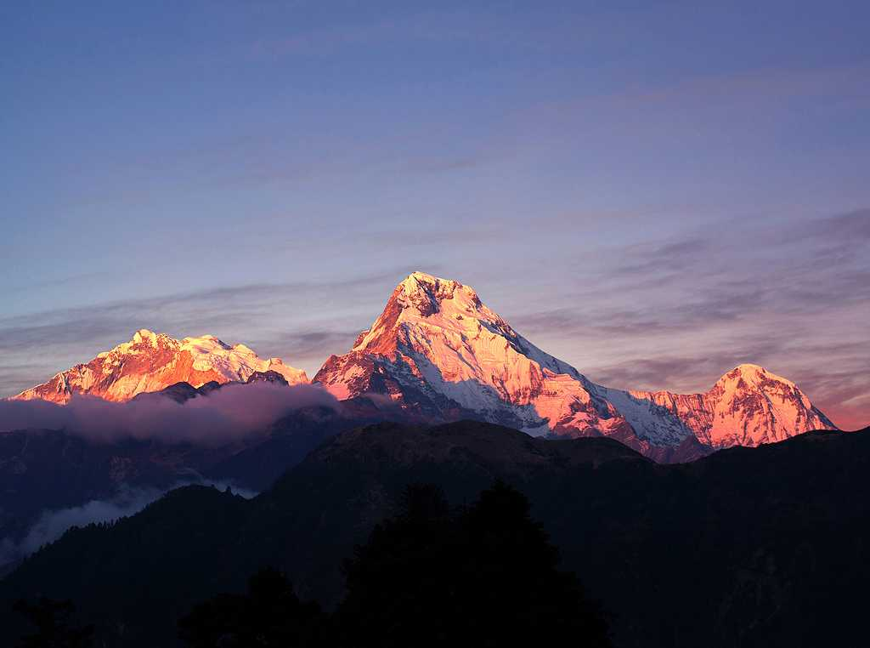
Situated approximately 20 km east of Kathmandu, Bhaktapur is listed as a UNESCO World Heritage site and is one of the three royal cities of the scenic Kathmandu Valley. This predominantly pedestrian city, dating back to the 12th century, has managed to preserve many of its local traditions and old medieval architectural structures. The city is commonly referred to as a living museum due to its medieval squares lined with elaborate temples and palaces, impressive terracotta monuments with ornately carved wood columns, and quaint winding alleyways weaving their way between traditional red-brick homes and quaint hidden courtyards. Visitors can also look forward to experiencing the Bhaktapur’s rich cultural life as the town’s squares are filled with artisans weaving cloth, making exquisite pottery and chiseling timber in plain view of tourists passing by.

Day 5: Kathmandu

Full day visit of Patan, Bungamati and Khokana – twin Newari Village

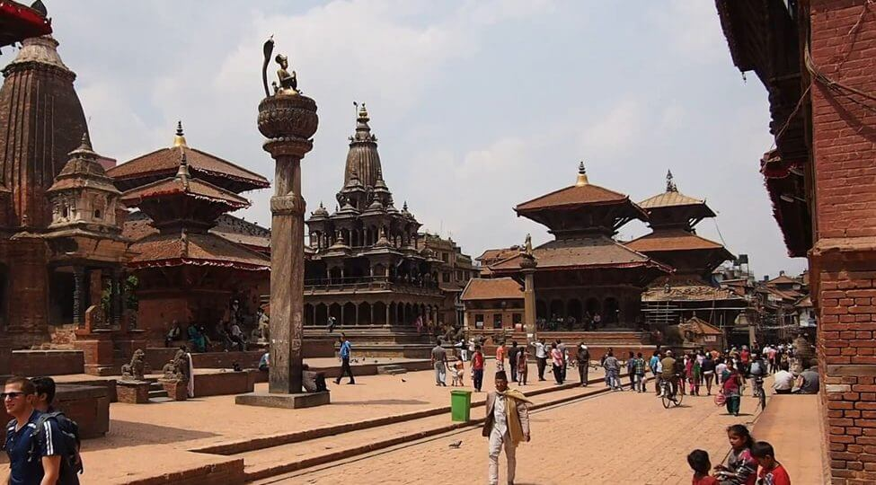
Also known as Lalitpur, the city of artisans, and home to the valley’s finest craftsmen who have preserved such ancient techniques as the repousse and lost wax process used to produce exquisite sculptures. The city retains much of the old charm with its narrow streets, brick houses and multitude of well-preserved Hindu temples, Buddhist monasteries (vihars) and monuments. As in Kathmandu, Hinduism and Buddhism have co-existed here for ages, influencing each other, and the religious harmony is exemplary. Patan Durbar square is one of the seven monument zones that makes Kathmandu valley UNESCO World Heritage site.

Bungmati & Khokana
The twin villages of Bungmati & Khokana date from the 16th century and are located south of Kathmandu, down a rutty road dotted with Chaityas. Bungmati is the winter home of lord Rato Machhendranath, the protector God of Patan. The shrine of Karya Binayak is located between the two villages. At Khokana ancient oil presses can be seen at work in village houses.

Day 6: Kathmandu – Paro - Thimphu

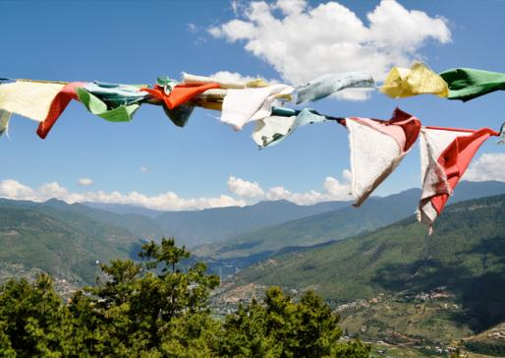
Fly into Bhutan by the National carrier
The flight to Paro is one of the most spectacular in entire Himalayas. Whether flying along the Himalayan range from Kathmandu or over the foothills from Kolkatta, the journey offers fascinating views and an exciting descent into the Kingdom. Bhutan’s first gift as you disembark from the aircraft will be cool, clean fresh mountain air. After immigration formalities and baggage collection, you will be met by our representative, and afterwards drive to Thimphu, the capital town of Bhutan with en-route stop at Chuzom, the confluence of Thimphu and Paro rivers. Three different style of stupas; Tibetan, Nepalese and Bhutanese adorn this confluence.

On arrival, in Thimphu check-into the hotel. The capital town of Bhutan and the centre of government, religion and commerce, Thimphu is a unique city with unusual mixture of modern development alongside ancient traditions. With the population of about 1,00,000 it is perhaps still the world’s only capital city without a traffic light.

Later visit Trashichhoedzong, ‘fortress of the glorious religion’. This is the center of government and religion, site of monarch’s throne room and seat of Je Khenpo or Chief Abbot. Built in 1641 by the political and religious unifier of Bhutan, Shabdrung Ngawang Namgyal, it was reconstructed in 1960s in traditional Bhutanese manner, without nails or architectural plans.

Day 7: Thimphu

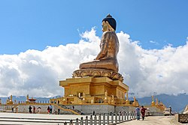
After breakfast, drive to Buddha Point (Kuensel Phodrang). Located at a short drive from Thimphu city centre, visitors can get a good overview of the Thimphu valley from the Buddha point (Kuensel Phodrang). You can pay your obeisance and offer prayers to the Buddha, the largest statue in the country and then walk around and take a glimpse of the valley.

Then, visit King's Memorial Chorten continuously circumambulated by people, murmuring mantras and spinning their prayer wheels. Construction of this landmark was the idea of Bhutan’s third king, His Majesty Jigme Dorji Wangchuk (“the father of modern Bhutan”) who has wished to erect monument to world peace and prosperity. Completed in 1974 after his untimely death, it serves both as a memorial to the Late King and as a monument to peace.

Textile Museum (closed on Government Holidays) next in schedule is worth a visit to experience the living national art of weaving. Exhibitions introduce the major weaving techniques, styles of local dress and textiles made by women and men.

Post lunch visit Folk Heritage Museum (closed on Government holidays). This Museum is dedicated to connecting people with the rich Bhutanese Folk heritage and rural history through exhibits, demonstrations, educational programs and documentation of Bhutanese rural life.
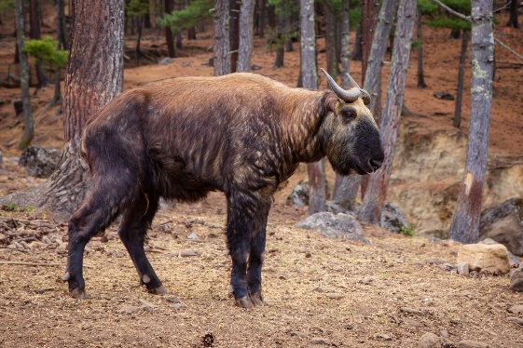
Later visit Institute for Zorig Chusum, commonly known as Arts & Crafts School or Painting School, the Institute offers a six-year course on the 13 traditional arts and crafts of Bhutan. On a visit, one can see students learning the various skills taught at the school.

Then, drive to Takin Preserve. The Takin is national animal of Bhutan and looks like a cross between a cow and goat.

Evening time can be spent strolling through the government-run Handicrafts Emporium and local crafts bazaar, to browse through example of Bhutan's fine traditional arts. Here you can buy hand-woven textiles, thangkha paintings, masks, ceramics, slate and wood carvings, jewelry, interesting items made from local materials.

Day 8: Thimphu – Punakha

After breakfast, drive to Punakha across Dochu La. Located at a height of 3,088m/ 10,130 ft, Dochula is a scenic location with chorten, mani wall, and prayer flags which decorate this highest point on the road. If skies are clear, it may be possible to see the following peaks from this pass in the order left to right: Masagang (7,158m), Tsendagang (6,960m), Terigang (7,060m ), Jejegangphugang (7,158 m), Kangphugang (7,170 m ), Zongphugang (7, 060 m ), a table mountain that dominates the isolated region of Lunana - finally Gangkar puensum, the highest peak in Bhutan at 7,497m.
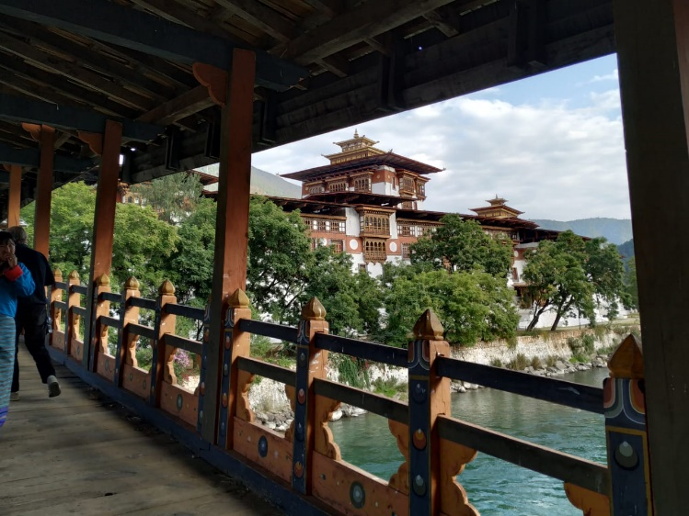
Afternoon visit Punakha Dzong or (Palace of Great Happiness), built in 1637 by Shabdrung Ngawang Namgyal, at the junction of the Phochu and Mochu rivers. This majestic dzong served as both the religious and the administrative center of Bhutan in the past. It measures some 600 by 240 feet and has a six-story, gold-domed tower. Inside are courtyards and religious statuary that hint at the depth of history and spiritual tradition embodied here. Your guide will illuminate your understanding of this intricate culture that is exotic to us, though long established here.

Later in the day excursion to Chimi Lhakhang.
The Chimi Lhakhang, situated on a hillock in the centre of the valley, is also known as the temple of fertility. It is widely believed that couples who do not have children and wanting one, if they pray at this temple, they are usually blessed with a child very soon. A walk through the village near the temple will give you rare glimpses into the daily life and lifestyle of the villagers.

Day 9: Punakha - Paro

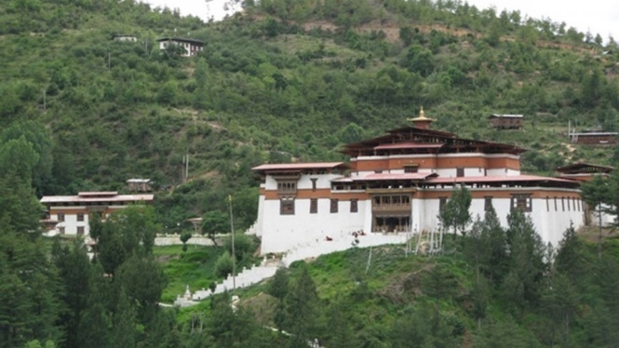
After breakfast return to Paro with a stop enroute at Simtokha Dzong, one of the oldest fortresses of the country and known as the place of profound tantric teaching. This dzong now houses a school for the study of the Dzongkha language.

Later in the day after checking into hotel, proceed to visit Ta Dzong, (closed on Government holidays) originally built as Watchtower, which now houses National Museum. The extensive collection includes antique thangkha paintings, textiles, weapons & armour, household objects and a rich assortment of natural and historic artifacts.

Then walk down the trail to visit Rinpung Dzong, meaning (“fortress of the heap of jewels”), which has a long and fascinating history. Along the wooden galleries lining the inner courtyard are fine wall paintings illustrating Buddhist lore such as four friends, the old man of long life, the wheel of life, scenes from the life of Milarepa, Mount. Sumeru and another cosmic Mandala.

Evening local dress wearing session at the hotel: The National dress of Bhutan is one of the most distinctive and visible aspects of Dragon Kingdom’s unique character. Men wear Gho, a long robe similar to Tibetan Chhuba, that is raised till knee, folded backwards and then tied around the waist by Kera (belt). While women wear, ankle length robe called Kira. The Bhutanese textile is made from fine, hand-woven or milled fabric, with the colorful distinctive patterns.

Day 10: Paro

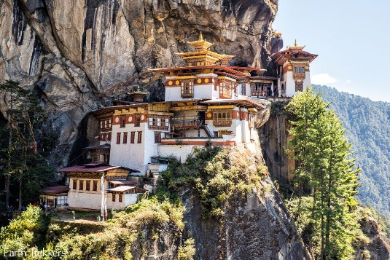
After breakfast excursion to Taktshang Monastery (approx.. 5 hours round trip walk). It is one of the most famous of Bhutan’s monasteries, perched on the side of a cliff 900m above the Paro valley floor. It is said that Guru Rinpoche arrived here on the back of a tigress and meditated at this monastery and hence it is called ‘Tiger’s Nest’. This site has been recognized as a most sacred place and visited by Shabdrung Ngawang Namgyal in 1646 and now visited by all Bhutanese at least once in their lifetime.

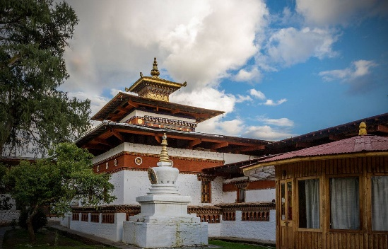
Late afternoon, drive end of the Valley to the base of Drukgyel Dzong, a 17th century fortress burned down in the early 50s. Here we will also see the beautiful typical farmhouse. Bhutanese farmhouses are very colorful, decorative and traditionally built without the use of single nail. The majority of the population of Bhutan continues to live as it has for centuries – in small isolated farms and hamlets, surrounded by terraced fields of rice, maize and buckwheat.

While driving to Paro town, stop en route at the 7th century Kyichu Lhakhang, one of the 108 temples built in the Himalayas by Tibetan King, Songtsen Gampo. The building of this temple marks the introduction of Buddhism in Bhutan.

Day 11: Paro - Kathmandu

Fly back to Kathmandu and spend the rest of the day at leisure.

Day 12: Depart Kathmandu

