

NP - 04

Nepal Trekking Tour
Kathmandu - Bandipur - Pokhara – Australian Camp- Dhampus- Pokhara- Kathmandu- Nagarkot- Kathmandu
13 Days / 12 Nights
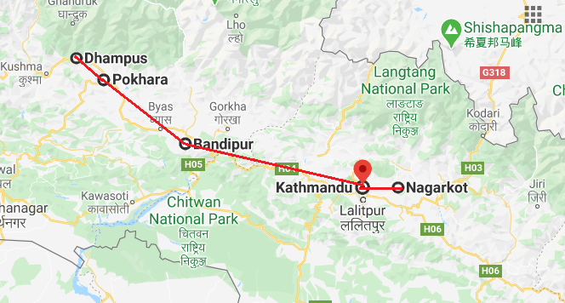

Day 1: Arrive Kathmandu

Upon arrival in Kathmandu, meeting & assistance at the airport by a Travel representative and transfer to Hotel.
Kathmandu City - known as Kantipur, the capital of the Kingdom of Nepal. Here you will visit the temple of the Living Goddess, who acknowledges the greetings of the devotees from the balcony of her temple residence. The Durbar Square are with its array of temples overlooked by the Hanuman Dhoka Palace, the ancient place of the Nepalese Royalty.

Day 2: Kathmandu

Breakfast at Hotel.
Full day tour covering Kathmandu Durbar Square, Swayambhunath and Patan Durbar Square.
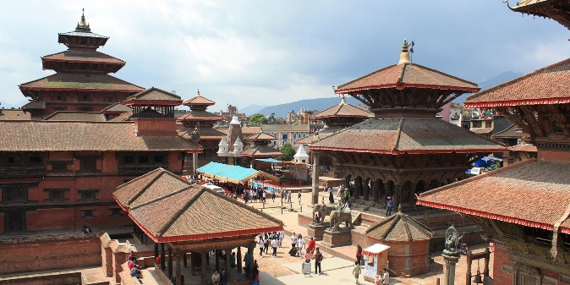
Swayambhunath - located approximately 4 km/2.5 miles from the city centre, the Buddhist stupa here is said to be 2000 years old. The stupa which forms the main structure is composed of a solid hemisphere of brick and earth supporting a lofty conical spire capped by a pinnacle of copper gilt. Painted on the four sided base of the spire are the all seeing eyes of Buddha. This hill is a mosaic of small Chaityas and Pagoda temples.
Patan also known as Lalitpur, is the city of fine arts, enclosed within 4 stupas said to be built in 3rd century AD, by Emperor Ashoka. The Patan Durbar which houses a bronze collection, the Krishna Temple built by King Siddhi Narsingh Malla. Patan Durbar square is one of the seven monument zones that makes Kathmandu valley UNESCO World Heritage site.

Day 3: Kathmandu

Day at leisure to explore Thamel area

Day 4: Kathmandu - Bandipur

Resting on a hilltop above the highway town of Dumre, Bandipur is an ancient trading town in the Himalayan foothills of Nepal. This attractive and remarkably well preserved village is known for its fascinating Newari culture and its quaint traditional Newari houses. With its impressive 18th-century architecture, lack of motorised vehicles and a vibrant bazaar offering alfresco dining, Bandipur offers a wonderfully authentic cultural experience. Visitors can look forward to some spectacular views of the dramatic Annapurna Range as well as the peaks of Dhaulagiri, Manaslu and Langtang. The surrounding hills provide excellent hiking trails which lead through tribal villages, holy caves, lush forests, and hilltop shrines which once doubled as fortresses.
Morning leave for Bandipur [approx. 180 kms/ 05 hours drive]. Arrive Bandipur and check in at the hotel.
Later in the afternoon, explore the local village of Bandipur.

Day 5: Bandipur - Pokhara

The second-largest city in Nepal, Pokhara sits on the shores of Phewa Lake in the central region of the country. Often called the ‘Adventure and Leisure Capital of Nepal’, and known as the gateway to the Annapurna Circuit, Pokhara is a popular hub offering plenty to see and do. The range of activities on offer is almost overwhelming, with lakes and waterfalls to admire; yoga, reiki and meditation classes to attend; caves (such as Mahendra) to explore; boating, canoeing and whitewater rafting on the waterways surrounding the Lake to enjoy; and a number of challenging hikes to test your fitness, with the viewpoint of Sarangkot being particularly rewarding. Meanwhile, serious trekkers can access the Annapurna Base Camp from Pokhara, the first stop for a number of impressive trails through the spectacular mountain range.
Leave for Pokhara [approx. 80 kms/ 03 hours drive]. Arrive Pokhara and check in at the hotel.
Spend rest of the day at leisure.

Day 6: Pokhara- Kande- Australian Camp [Thula Kharka]

After breakfast we drive around 1 hour to Kande enjoying marvelous views of the Annapurna Himalaya from where we will begin our walking. It is also a starting point of Mardi Himal trek. Following the right side, we start our trek passing through small villages and houses. Walking through uphill we enter the forest of rhododendron and red sandlwood with a beautiful himalayan views. Around 2 hours later we reach to a beautiful village called Thula Kharka in Nepali and Australian Camp in English. You can have a beautiful views of Annapurna mountain, mount manaslu, mount Dhaulagiri, Mount Fishtail and a view of Pokhara valley. You can spend rest of the day exploring around, talking with local people and surrounding views.

Day 7: Thula Kharka- Dhampus

After breakfast start the walk. Today we walk around 2 all the way to Dhampus. Both the Australia camp and Dhampus village are equally beautiful village. Travellers can have a wounderful views of landscape and mountains, a local gurung community, flowers, mustard field etc. With all these meomries we descend down to Dhampus. Lunch will be at a local restaurant enroute.
Dhampus, a name of a fabulous Gurung village, is situated at an altitude of 1,750 M above sea level offering mesmerizing view of the Annapurna mountain range. Dhampus is a gateway to Annapurna Conservation Area. It also serves as one of the main entry points to the Annapurna Base Camp and other trekking trails of Annapurna Region.

Day 8: Trek to Phedi- Pokhara

From Dhampus, the trail becomes steeper as you hike up to Phedi village (02 Hours), passing through settlements of various ethnic groups and beautiful subtropical forest. You may see trekkers on the trail to Annapurna Base Camp here. From Phedi, transfer to Pokhara Hotel (max 45 min drive).

Day 9: In Pokhara

Day at leisure in Pokhara

Day 10: Pokhara- Nagarkot

The village of Nagarkot lies only 30 kilometres from the hub of Kathmandu. Although the journey is notoriously slow (taking about two hours to complete), visitors will be richly rewarded by Nagarkot, which boasts famously scenic views of the Himalayas (including Mount Everest) and a number of excellent hiking trails. Active travellers will relish the climb to the remarkable lookout point of Nagarkot View Tower, as well as the wonderful Nagarkot Panoramic Hiking Trail (which incorporates both the Nagarkot Nature Trail and Tamang Village Walk), while there are also challenging mountain bike routes leading all the way to neighbouring Bhaktapur. Finally, accommodation in the village is plentiful, with a range of hotels offering stunning views - best enjoyed between October and December, or March and April, when skies are clearest.
Take a flight to Kathmandu and from there proceed to Nagarkot (approx. 2 hrs)

Day 11: In Nagarkot
Early morning enjoy sunrise view at Nagarkot [subject to weather condition]. Rest of the day at leisure

Day 12: Nagarkot- Kathmandu – Departure

Return to Kathmandu to connect the international flight back home.

