

NP : 05

Exclusive Nepal
Kathmandu - Nagarkot - Chitwan National Park - Pokhara - Tirkhedhunga - Ghorepani – Tadapani
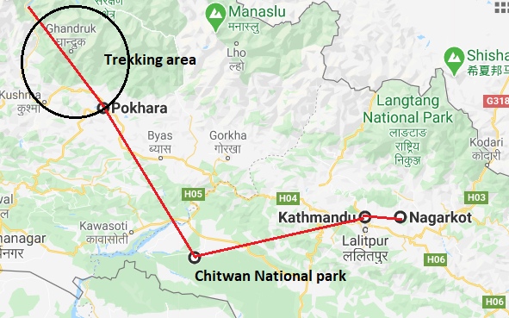

Day 1: Arrive Kathmandu

Upon arrival in Kathmandu, meeting & assistance at the airport by a Travel representative and transfer to Hotel.
Kathmandu City - known as Kantipur, the capital of the Kingdom of Nepal. Here you will visit the temple of the Living Goddess, who acknowledges the greetings of the devotees from the balcony of her temple residence. The Durbar Square are with its array of temples overlooked by the Hanuman Dhoka Palace, the ancient place of the Nepalese Royalty.

Day 2: Kathmandu – Nagarkot

Leave in the morning to Nagarkot and check in at the hotel. Rest of the afternoon at leisure to explore the local market and in the evening enjoy a fabulous sunset over the Himalayas.
The village of Nagarkot lies 30 kilometres from the hub of Kathmandu. Although the journey is notoriously slow (taking about two hours to complete), visitors will be richly rewarded by Nagarkot, which boasts famously scenic views of the Himalayas (including Mount Everest) and a number of excellent hiking trails. Active travellers will relish the climb to the remarkable lookout point of Nagarkot View Tower, as well as the wonderful Nagarkot Panoramic Hiking Trail (which incorporates both the Nagarkot Nature Trail and Tamang Village Walk), while there are also challenging mountain bike routes leading all the way to neighbouring Bhaktapur. Finally, accommodation in the village is plentiful, with a range of hotels offering stunning views - best enjoyed between October and December, or March and April, when skies are clearest.

Day 3: Nagarkot – Kathmandu

Early Morning enjoy sunrise over the Himalayas and later proceed to Kathmandu with a stop at Bhaktapur. Later in the day browse through Thamel area.
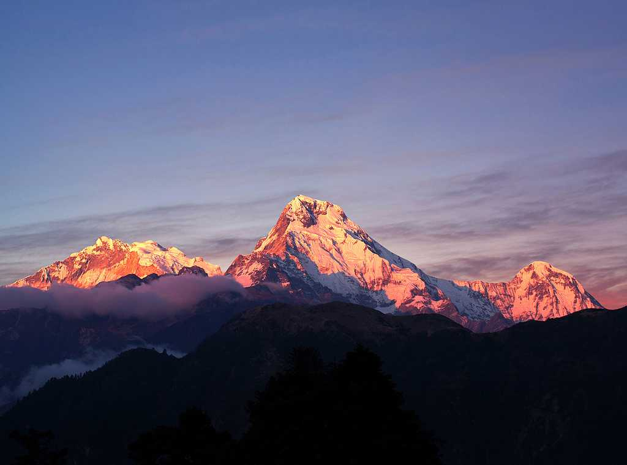
Situated approximately 20 km east of Kathmandu, Bhaktapur is listed as a UNESCO World Heritage site and is one of the three royal cities of the scenic Kathmandu Valley. This predominantly pedestrian city, dating back to the 12th century, has managed to preserve many of its local traditions and old medieval architectural structures. The city is commonly referred to as a living museum due to its medieval squares lined with elaborate temples and palaces, impressive terracotta monuments with ornately carved wood columns, and quaint winding alleyways weaving their way between traditional red-brick homes and quaint hidden courtyards. Visitors can also look forward to experiencing the Bhaktapur’s rich cultural life as the town’s squares are filled with artisans weaving cloth, making exquisite pottery and chiseling timber in plain view of tourists passing by.

Day 4: In Kathmandu

Excursion to Dakshinkali Temple, Pharping village and Chobar Gorge

Dakshinkali Temple
Dakshinkala Temple is located outside the village of Pharping in the Kathmandu Valley. It is one of the most popular Hindu temples in Nepal and attracts many pilgrims throughout the year.

Pharping Village
Pharping lies in the Southern part of the Kathmandu Valley on the way to Dakshin Kali. It is an important Pilgrimage site for Vajrayana Buddhists. Outside of the town on the hillside there are three very important sacred sites: a major Vajrayogini temple, a cave where Padmasambhava meditated with his (or Vishnu's depending on one's faith) footprints in a stone in front of the cave, and a self-arising Tara below the cave complex. Because of this wealth of sacred tradition, there are a number of new Tibetan Buddhist monasteries being built across the area, including one with a large 100 ft. Padmasambhava that dominates one of the hillsides. Padmasambhava is believed to be a manifestation of The great Guru Rinpoche, and achieved the state of Mahamudra here in Pharping.

Chobar Gorge
The Chobar Gorge is south of the Patan and the Bagmati River cuts through the edge of the Chobar hill, the highest hill along this side of the valley. The pretty village of Chobar tops the hill and a stone paved track runs from the river’s edge right to the top of the hill where the Adinath Lokeshwar Temple forms the centre of the settlement. Down by the river, just south of the gorge, is another important temple, the Jal Binayak . The valley’s first cement factory is a more recent and less pleasing addition to the scenery. A neat little suspension bridge spasm the river; it was manufactured in Aberdeen in Scotland in 1903. From the bridge there are fine views of the gorge on one side and the Jal Binayak Temple on the other.

Day 5: Kathmandu – Chitwan National Park
Idyllically set in the Terai Lowlands of south-central Nepal, the Chitwan National Park is known for its extraordinary biodiversity. This impressive UNESCO World Heritage Site is characterised by lush forests, grasslands, rich flood-plains, rolling hills, beautiful rivers, and ox-bow lakes. The park is one of Nepal’s most celebrated nature reserves as it serves as one of the world’s last refuges of the Bengal tiger and the one-horned Asiatic rhinoceros. There are also deer, monkeys, leopards, Indian elephants, crocodiles, sloth bears and over 500 species of bird inhabiting this spectacularly scenic expanse of protected wilderness. Don’t miss the chance to explore the northern reaches of the Rapti River by traditional dugout canoe, or to visit the Balmiki Ashram, which is a popular Hindu pilgrimage site.

Fly Kathmandu to Bharatpur (20 minutes) and from there proceed to Chitwan (an hour)
Arrive Bharatpur and you will be transferred to your hotel in Chitwan.
Later in the afternoon, visit Tharu Village

Day 6: In Chitwan National Park
A day to enjoy Jungle activities including Jeep Safari, Canoe ride, visit to crocodile breeding center, Bird watching and Jungle walk

Day 7: Chitwan – Pokhara
The second-largest city in Nepal, Pokhara sits on the shores of Phewa Lake in the central region of the country. Often called the ‘Adventure and Leisure Capital of Nepal’, and known as the gateway to the Annapurna Circuit, Pokhara is a popular hub offering plenty to see and do. The range of activities on offer is almost overwhelming, with lakes and waterfalls to admire; yoga, reiki and meditation classes to attend; caves (such as Mahendra) to explore; boating, canoeing and whitewater rafting on the waterways surrounding the Lake to enjoy; and a number of challenging hikes to test your fitness, with the viewpoint of Sarangkot being particularly rewarding. Meanwhile, serious trekkers can access the Annapurna Base Camp from Pokhara, the first stop for a number of impressive trails through the spectacular mountain range.
Fly Chitwan to Pokhara (30 minutes). Afternoon will be at leisure with option to do boating on Phewa lake

Day 8: Pokhara – Tirkhedhunga (5 Hrs. Walk)
The small riverside village of Nayapul sits at an impressive height of 2070 meters in the magnificently scenic Annapurna region. This charming little one-road town serves as the main starting point for trekkers heading off on the challenging Annapurna Base Camp Trek as well as the more manageable Poon Hill Trek. The village consists of a few local restaurants and a number of roadside stalls catering to trekkers. Nayapul is also home to the Annapurna Conservation Area Checkpoint where are required to have your permit checked prior to setting off on your trekking adventure.
Leave in the morning to Nayapul, which is about an hour & half from Pokhara. Nayapul is a small trading town situated at the bank of MODI River. It is about an hour walk from this place to BHURJUNG KHOLA, which passes via BIRETHANTI, a larger Village with many Local Inns and Tea Houses. Lunch will be taken en-route. After Lunch it is a steep climb on stone paved path for almost a good hour and half to HILLE. From here the trail is easier all the way to TIRKHEDHUNGA.

Day 9: Tirkhedhunga – Ghorepani (6 to 7 Hrs. Walk)
The small village of Ghorepani lies in the scenic Annapurna Mountain Range of central Nepal. A popular stop on the Poon Hill Trek, the country’s most popular hiking trail, Ghorepani is a charming destination with cobbled streets, panoramic views and a large variety of guest houses and restaurants on offer. With most travellers starting the trek in Pokhara, Ghorepani is usually visited after accessing the breath-taking lookout point of Poon Hill. However - as the village lies only 45 minutes away from this spot - Ghorepani is a popular choice for trekkers who wish to prolong the trail beyond its usual four or five days and enjoy some additional hiking and climbing opportunities in the region, as well as for those who need to rest before continuing on.
After early breakfast, the trail descends and after crossing the BHURUNDI Stream, a steep climb begins to reach ULLERI. It takes about 3 Hours from Tirkhedhunga to Ulleri. From here one can have a very close view of Annapurna and Machhapuchare - the Fishtail Mountain. Lunch will be taken a little further at NAYA THANTI. After Lunch the trail climbs steadily through a rhododendron forest for about four hours to reach Ghorepani.

Day 10: Ghorepani – Tadapani (2590 m)/Ghandrung (8 to 9 Hrs. Walk)
Tadapani is a small village lying in the high-altitude reaches of the Annapurna Mountain Range of central Nepal. A popular stop on the Poon Hill Trek – the country’s most accessible long-distance hiking route – Tadapani is usually visited on day three of the trail, following a steep descent from the magnificent outcrop of Poon Hill itself. The approach to the village winds through lush forests with rich bird life, and down more than one thousand stone steps: a notoriously difficult section, especially after some extensive climbing on the previous day of the trek. Thankfully, Tadapani is replete with comfortable guest houses and cosy restaurants, making it a great place to refresh before rejoining the trail to Jhinu Danda the following day.
After early breakfast, an excursion to Poon Hill (3210 m.) can be organised for those with a spirit of adventure. Poon Hill is the spot to view the majestic panorama of the Himalayas. A close up view of Dhaulagiri and the Annapurna Massif including Machhapuchare the sacred Mountain await for you at Poon Hill. The uphill hike to Poon Hill and back is approximately two and half-hour.Then trail from Ghorepani to Tadapani goes through thick pine and rhododendron forest with occasional ascends and descends. The major part of the trail is descending downhill through scattered villages. The trail descends all the way to the fairly large Gurung settlement of Ghandrung Village. Lunch will be taken enroute.

Day 11: Tadapani – Pokhara
After breakfast, the trail descends down to SEULI BAZAR for about two hours and then an easy walk for about 2 hours to reach Nayapul via Birethanti (Pokhara-Baglung highway). From here, drive back to Pokhara and check in at the hotel.

Day 12: Pokhara – Kathmandu
Fly Pokhara to Kathmandu. Rest of the day at leisure in Kathmandu

Day 13: Depart Kathmandu

