

North India Tour - 12 Days
New Delhi – Jaipur – Agra – Jhansi – Orchha – Khajuraho – Varanasi – Delhi
12 Days / 11 Nights
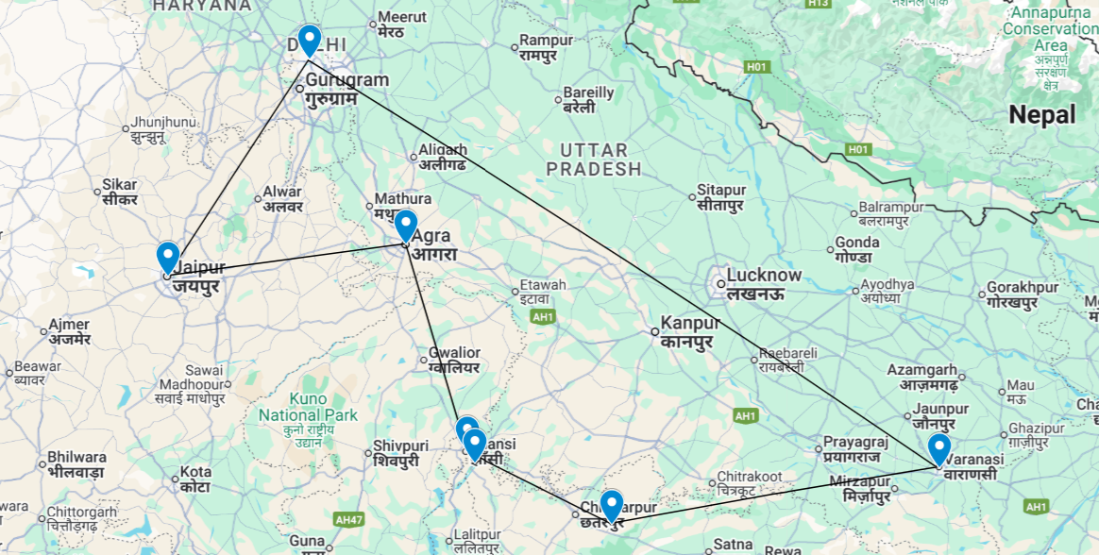

North India Tour

This is the classic cultural tour of North India combining New Delhi, Agra and Jaipur (the so-called ‘Golden Triangle’), New Delhi, the national capital, offers several key sights and historic monuments while Agra is synonymous with the Taj Mahal – a high-point of Mughal architecture and one of the world’s most celebrated buildings. Jaipur, Rajasthan’s state capital, boasts some of the region’s finest palaces and impressive forts along with an eclectic array of crafts and shopping. On the banks of the River Ganges – one of India’s most sacred rivers – Varanasi exerts a strange allure in keeping with its pivotal role in some of Hinduism’s most important traditions. Its riverside ghats, or steps, and adjoining temple-filled old city lend an earthy unforgettable mix of colour and vitality. While you can easily stroll through its tiny lanes and wander between the various ghats and temples, the sheer spectacle is best appreciated from a sunrise or sunset boat ride. Conducted by priests waving oil lamps and blowing conches, the evening aarti ceremony is particularly memorable.

Introduction

Accommodation | Destination | Start | End | Meal Plan | Room Type | Duration
The Lalit New Delhi | New Delhi | Day 01 | Day 03 | BB | Deluxe Room | 02 Nights
Hilton Jaipur | Jaipur | Day 03 | Day 05 | BB | Guest Room | 02 Nights
Courtyard Marriott | Agra | Day 05 | Day 07 | BB | Deluxe Room | 02 Nights
Radisson Blu Jass | Khajuraho | Day 07 | Day 09 | BB | Superior Room | 02 Nights
Taj Ganges Varanasi | Varanasi | Day 09 | Day 11 | BB | Superior Room | 02 Nights
Vivanta Dwarka | New Delhi | Day 11 | Day 12 | BB | Superior Room | 01 Night

Day 01: Arrival Delhi

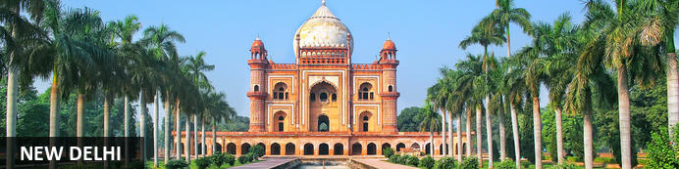
New Delhi, India’s national capital, is a relatively modern confection of imposing government buildings including Parliament, museums and wide leafy boulevards loosely centred on circular Connaught Place (officially now called Rajiv Chowk). To its north lies the formerly walled city of Old Delhi, or Shahjahanabad, built in the 17th-century by the Mughal Emperor Shah Jahan. Though long merged into one metropolis, the two have very different characters. New Delhi has space, parks, distinct neighbourhoods and a clutch of important monuments and architecture that reflect its ancient history. Old Delhi’s crowded streets, lanes and bazaars reflect its colourful medieval character and they cradle some of the city’s most memorable sights.

Day Itinerary
Flight TBA
Arrives Delhi TBA
On arrival in Delhi: Having cleared immigration, collected your luggage and passed through customs, please make your way towards the exit of the terminal building where you will see a bank of people waiting. Amongst them will be Travel Counsellors Representative who will be waiting to greet you with a paging board with your name on.
You will then be transferred to your hotel and assisted with check in.

Overnight: The LaLiT New Delhi
Offering five-star accommodation, The LaLiT New Delhi is located in Connaught Place, India. The hotel boasts 461 luxury rooms and suites with conveniences such as minibars/fridges, electronic safes, TVs, interactive entertainment systems and free Wi-Fi. Guests can delight their palates at an array of on-site restaurants. The hotel also features a spa, an art gallery, a state-of-the-art gym and a swimming pool.
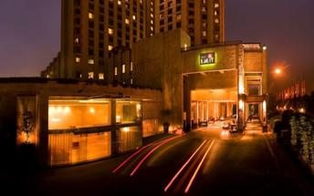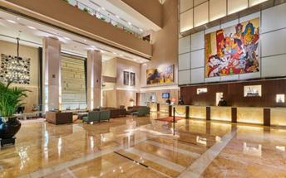

Day 02: Delhi

Day Itinerary
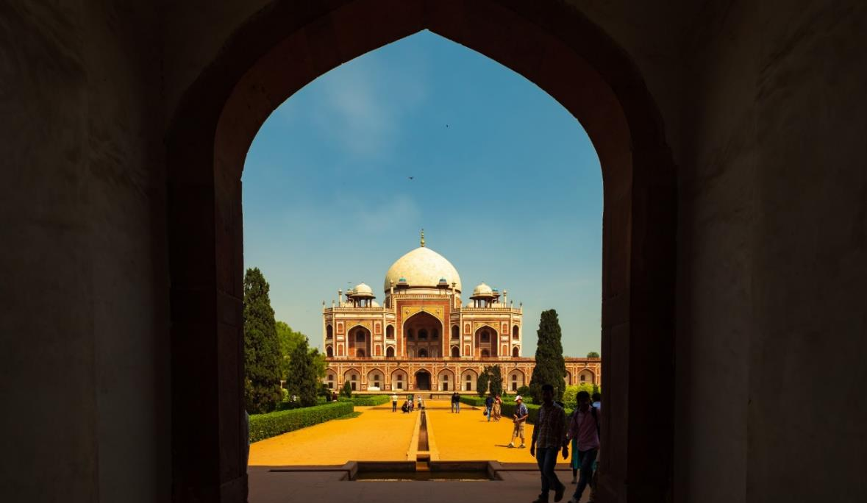
Breakfast at Hotel.
Today proceed for The Five Senses Delhi Tour
A sensory journey through Delhi covering everything from its food, local arts and crafts, the must-see architectural marvels, to expertly navigating and allowing you to witness the organized cultural chaos that is Delhi.
USP - Delhi 101: A complete tour of Old and New Delhi! We’ve carefully curated a selection of experiences that will transport you across Delhi’s rich cultural history. Experience for yourself the syncretism that has served as both Delhi’s greatest strength and vulnerability.
There isn’t a dearth of iconic sightseeing locations in the city, but for this tour, we focus on the two most beloved monuments that became inspirations or templates for all the other beautiful heritage structures. Humayun’s tomb, a spellbinding mausoleum is a favourite for any Delhiite! Your visit will be followed by a heritage craft workshop organised by an all-women NGO group that will touch your heart. Next, take a rickshaw ride through Shahjahanabad. Chaos thrives in the streets of Chandni Chowk, but as you cycle down, you’re transported by the magic in the air to the thriving Mughal era.
Next, you will indulge your sense of smell with an Ittar or perfume-making workshop. Visit an 8th-generation Ittar studio where you will get to smell and mix your unique concoction that can be named after you!
We’ll quickly stop to snack on some mouth-watering street food before proceeding to witness the glory and quietness of the Jama Masjid: a beautiful pocket of calm at the heart of Old Delhi's mayhem.
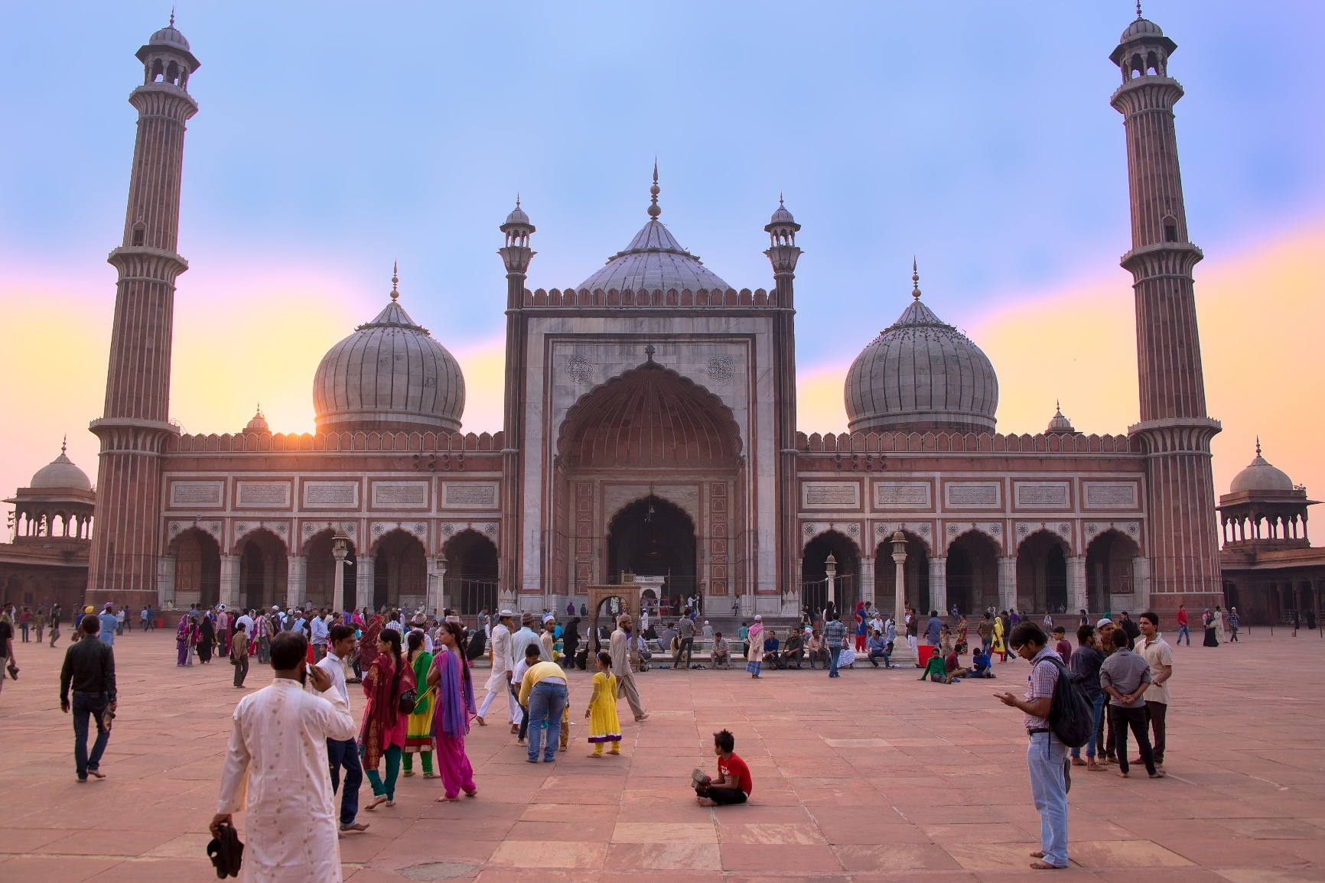
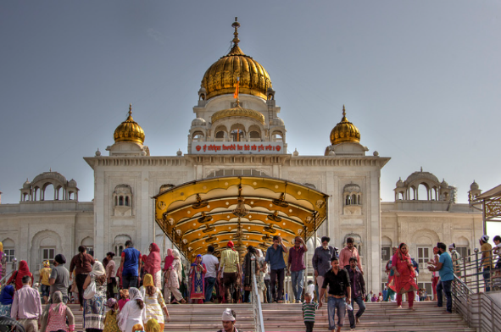
To engage your sense of sound, we bring you to Bangla Sahib. The magic of seva (selfless service) that the Gurudwara envelopes you into is undeniable. What ties together this beautiful experience is the sweet sound of the Gurbani playing in the background. Next, head to calm your favourite sense - taste! You will enjoy a meal at a contemporary Indian restaurant!
Before going back to the hotel, on the way, we show you the parts of Delhi with British influence and talk about the architectural contrast as well as some interesting stories from that time!

Day 03: Delhi – Jaipur

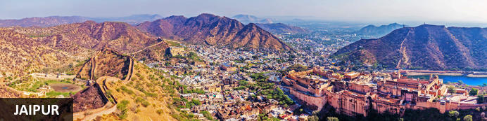
Founded in the early 1700s by Maharaja Jai Singh II as his new capital, the original ‘Pink City’ (so-called because almost all buildings were painted terracotta pink to honour the 1876 visit of the future King Edward VII) was laid out in a traditional grid with colonnaded streets and uniform façades. That layout remains intact and the city, now state capital of Rajasthan, has evolved and expanded into a modern metropolis with its own metro system. Yet its key sights and attractions lie within a relatively compact area. From vibrant bazaars and craft shops to grand palaces and huge forts, an extraordinary outdoor observatory and even one of the country’s most famous cinemas, Jaipur ticks every cultural, architectural and shopping box.

Day Itinerary
After breakfast check-out and, you'll make your way to Jaipur – land of the Rajput’s, also is known as the 'Pink City', home to ancient forts and palaces. (Approximately 280 Kms – 5 Hrs), Upon arrival you will then be transferred to your hotel and assisted with check in.

Overnight: Hilton Jaipur
Hilton Jaipur is ideally located on the outskirts of Jaipur, just 1km from Ram Nagar metro stop and 11km from Jaipur International Airport. The accommodation features comfortable guest rooms and suites equipped with modern amenities, Leisure facilities include a swimming pool, fitness centre and spa.
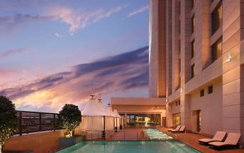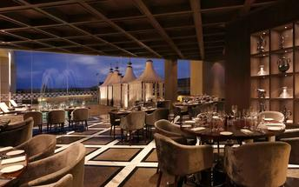

Day 04: Jaipur

Day Itinerary
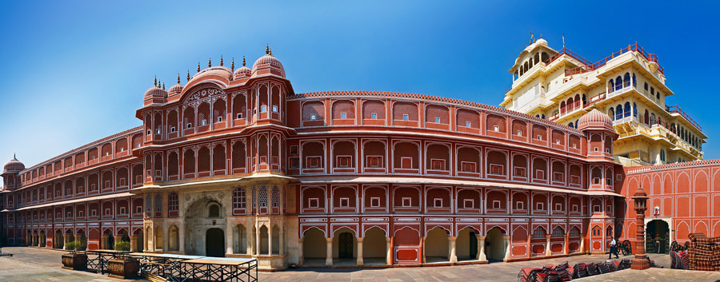
Begin exploring this city visit the City Palace complex which is spread over a large area occupying one-seventh of the old city of Jaipur .It is comprised of two palaces, Chandra Mahal and Mubarak Mahal, museum, a vast array of courtyards, gardens, and buildings. The palace is a blend of the Shilpa Shastra of Indian architecture with Rajput, Mughal, and European styles. Diwan-I-Aam (Hall of Public Audience), Bhaggi Khana (a museum), Pitam Niwas Gate, and Peacock Gate are a must-see. Its outer boundary was built by Raja Jai Singh and the other structures by his successors to add charm to it. It also served as a residence for the former Maharaja of Jaipur, also visit the famous Jantar Mantar (an observatory)
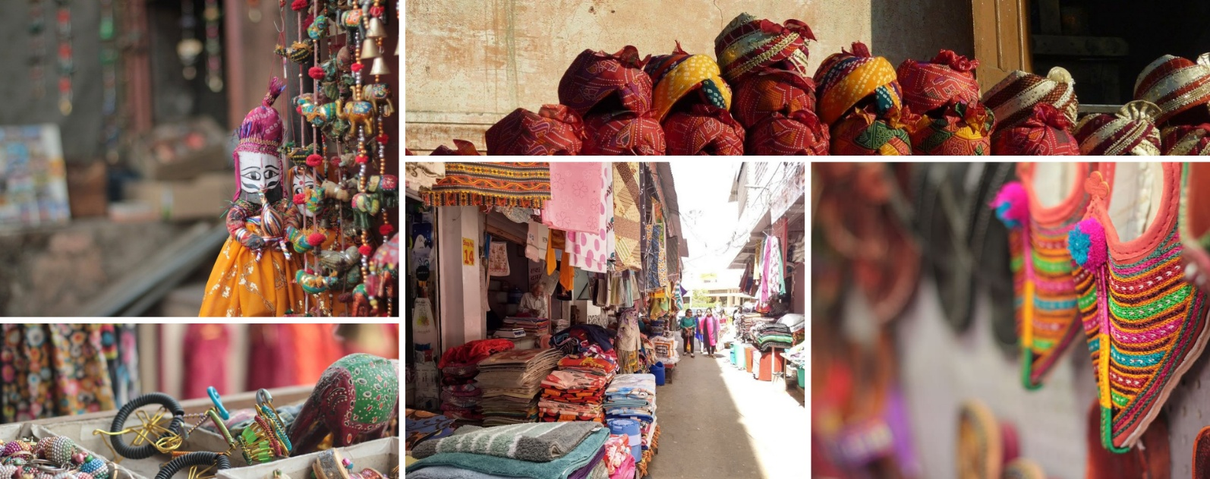
Thereafter, head for a walking tour in the bazaars, this immersive experience offers a unique opportunity to explore the city’s vibrant bazaars, renowned for their exquisite textiles, distinctive artisanal goods, and delectable street food. A specially curated selection of Jaipur’s vibrant textile market and street delicacies, each reflecting the region’s rich culinary and cultural heritage, awaits your discovery.

The textile market, in particular, stands as a testament to Jaipur’s centuries-old tradition of craftsmanship, where intricate patterns, vivid colours, and fine fabrics come together to embody the artistic soul of the Pink City.

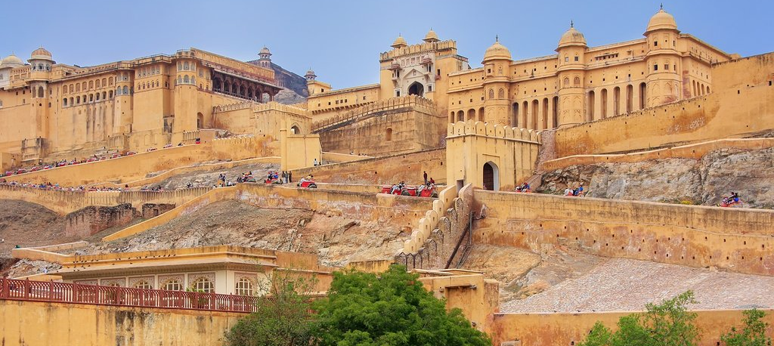
Later in the evening proceed for the majestic Amber Fort that’s perched on a hill on the outskirts of Jaipur. The fort was once the capital of Rajasthan. Former residence of Rajput Maharajas, this fort is notable for its grand architecture showcasing the Hindu style of architecture. The Amber Fort was used by the Rajputs for the dual purpose of defence and for private residence. The fort encompasses charming gardens and magnificent palaces made from marble and precious stones, richly decorated with intricate stonemason works and paintings.

The rest of the day is free for personal activities.

Day 05: Jaipur – Agra

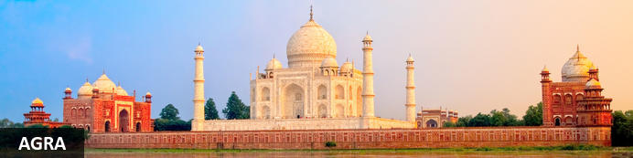
Straddling the broad Yamuna River 180km south of Delhi, Agra’s fame rests almost entirely on one building – the iconic Taj Mahal. Yet from the early 16th-century it was the Mughal empire’s capital endowed with numerous buildings and monuments that still make it a major draw for visitors. Apart from the Taj, Agra Fort (with its strong resemblance to Delhi’s Red Fort), the exquisite Tomb of Itmad-ud-Dalah (often called the ‘Baby Taj’), earthy bazaars and the evocative ‘ghost city’ of Fatehpur Sikri 40km to the west all make it a key tourist destination.

Day Itinerary
After breakfast check-out and, you'll make your way to Agra – the home of the magnificent Taj Mahal.
(Approximately 240 Kms – 4 ½ Hrs)

En Route make a short stop to visit The Chand Baori “Abhaneri” Small village of Rajasthan, which is one of the largest Step well in the world and one of the most beautiful ones.
Upon arrival you will then be transferred to your hotel and assisted with check in.

Overnight: Courtyard Agra
Courtyard Agra is located on Fatehabad Road, close to iconic landmarks such as the Taj Mahal and Agra Fort. The hotel offers comfortable rooms with air-conditioning, minibars, and free Wi-Fi. Guests can enjoy dining at MoMo Café, which serves international buffet options and à la carte dishes, or relax at the poolside restaurant, Grills by the Pool. Leisure facilities include an outdoor pool, a spa, and a fitness centre. The hotel also features versatile event venues suitable for business functions and weddings.


Day 06: Agra

Day Itinerary
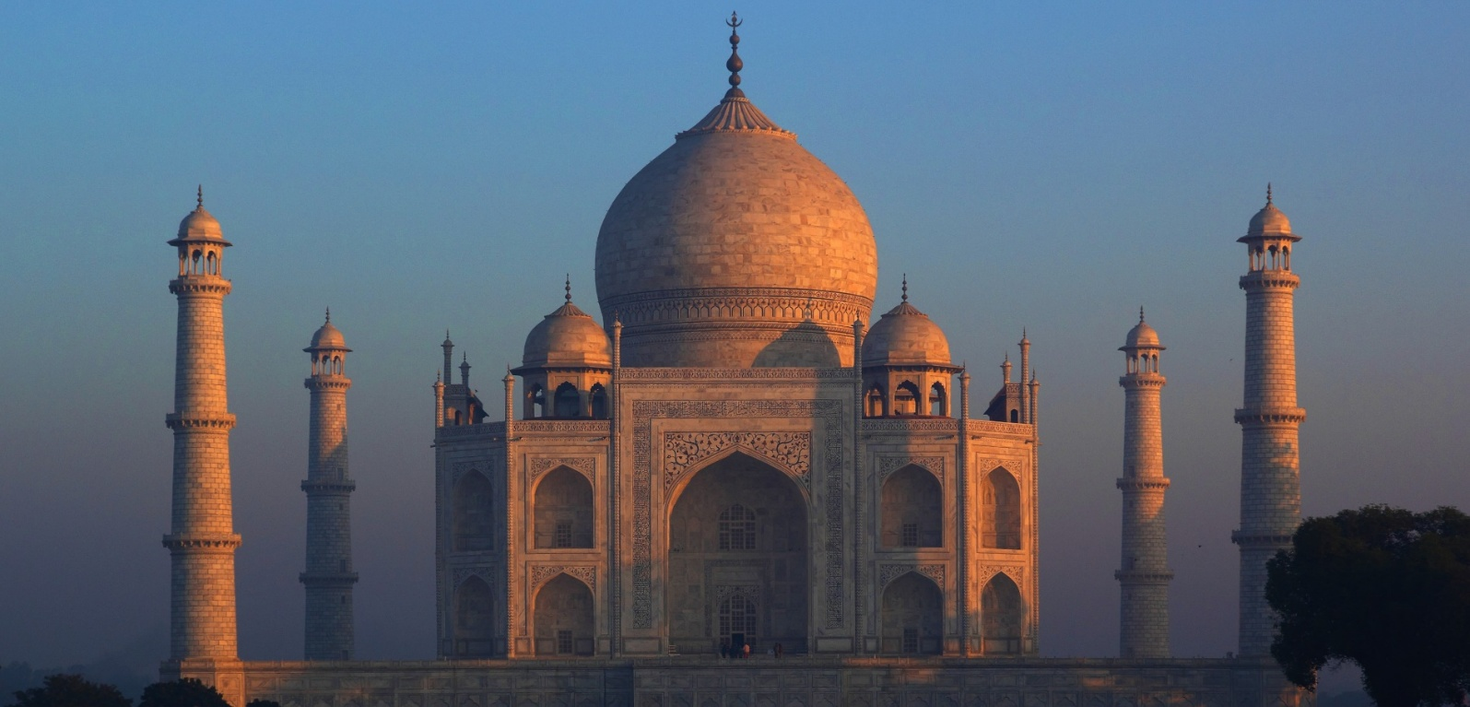
Early this morning witnesses the surreal views of the Taj Mahal. Step inside this eternal symbol of love and appreciate the intricate designs and symmetries that rhyme as a poem written in marble. Taj Mahal is an extravagant display of love, built by Shah Jahan in memory of his beloved wife Mumtaz.

Then return to your hotel, spend some time on relaxing and after breakfast check-out and, proceed for sightseeing tour of Agra, starting with the splendid Agra Fort built in red sandstone, encapsulating magnificent palaces, halls of public, private audience & beautiful gardens and hundreds of rooms within the Fortified Fort. The worth seeing point of this place from where the Taj Mahal can be seen is the Diwan-I-Khas.
A trip to Agra is incomplete without experiencing dazzling path beyond the Taj Mahal; A transformative walk tour that goes further than the iconic Taj Mahal and dives into the enticing soul of Agra’s Taj Ganj. A crowded street that holds and narrates the fascinating tales of Agra’s unfolded heritage. Our passionate guides led this tour wanders through the streets of undiscovered places and underrated monuments, giving you an extensive glance of Taj Mahal.
Engage in this unique adventure and go beyond the Taj Walk, fostering healthy interaction with locals and navigating lively streets, experiencing stories of traditions that breathe the Agra City enchantment.

Day 07: Agra – Jhansi – Orchha – Khajuraho

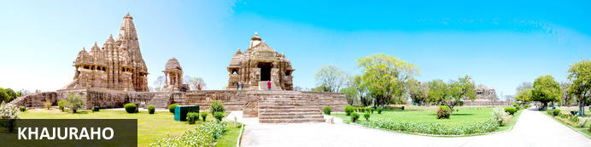
The modern town that’s grown around the site is primarily there because of tourism. Khajuraho is a UNESCO World Heritage Site, its three distinct temple clusters showcasing the pinnacle of temple architecture and adornment in northern India. Built of sandstone and standing on decorative plinths, it is their elaborate virtuoso carving and sculpture depicting sacred and domestic themes – from musicians and dancing elephants to nymphs and amorous couples – that give these temples an exceptional vibrancy.

Day Itinerary
Early morning in time you will be picked up and transferred to railway station, board train to Jhansi. Packed breakfast can be collected from the hotel on departure.

Train Shatabdi Express (AC Executive Chair Car)
Depart Agra 07:55 Hrs
Arrive Jhansi 10:45 Hrs.

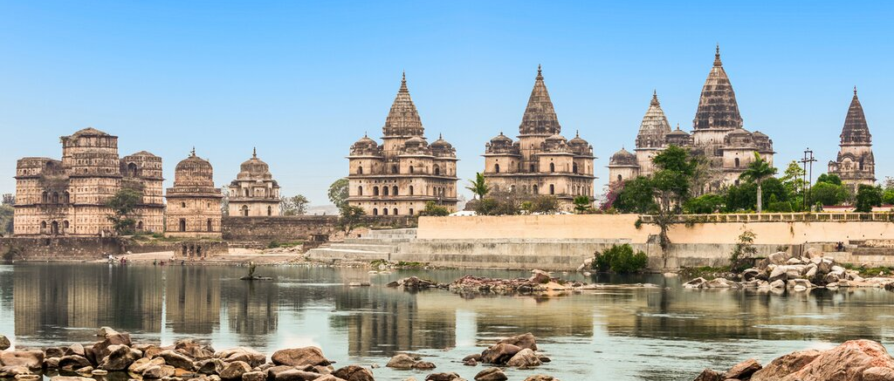
Upon arrival at Jhansi station, you will proceed for Khajuraho en route stop at Orchha for the sightseeing tour of temples.
You'll travel by car to Orchha - a popular location for temple tours in the country, as it's home to medieval temples and forts. Some of its most important sites are Chaturbhuj Temple, Ram Raja Temple, and Jahangir Palace. Its 14 cenotaphs set on the River Betwa's banks are also must-see.

Once the capital of the Bundela dynasty, the small rural village has impressive monuments. The largest of these is the palace complex, where the Raj Mahal and Jahangir Mahal have a unique combination of Hindu and Muslim architecture, painted decorations, and ornate tile work. Then you'll visit the Chaturbhuj Temple and the enormous riverside cenotaphs (chhatris), which are memorials for Orchha royalty. Throughout the tour, you'll have plenty of opportunities to take photographs.

Later drive to Khajuraho and upon arrival check-in to your hotel for 01-night stay!

Overnight: Radisson Hotel Jass Khajuraho
Radisson Hotel Jass Khajuraho is located near the Civil Aerodrome Khajuraho airport and close to historic Hindu and Jain temples, including the Western Group of Temples. Guests can explore Panna National Park and Pandav Falls nearby. The hotel offers rooms with modern furnishings, flat-screen TVs, free Wi-Fi and an in-room safe. Dining options include the Temple Café, serving European and Indian cuisine, and Pulse Bar for drinks. Leisure facilities feature an outdoor pool, a spa, and a recreation area with puppet shows. The hotel also provides meeting and event spaces for various occasions.
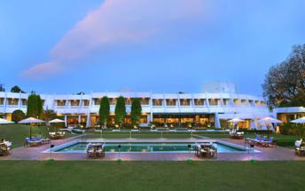

Day 08: Khajuraho

Day Itinerary
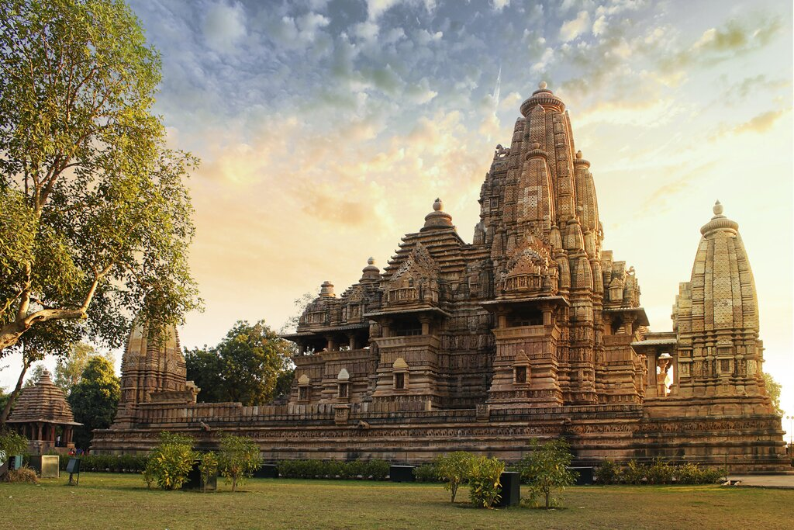
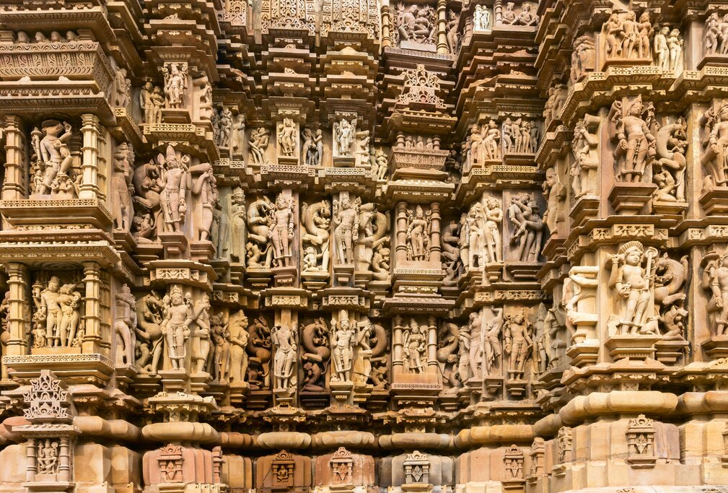
Today after breakfast, you will first visit the Eastern Group of Temples, which are split between those dedicated to Hindu gods and goddesses and those dedicated to the Jain gods. While the group of temples in the west is better known, this group is well worth a visit. Sculptures here depict everyday life rather than sensual subjects.
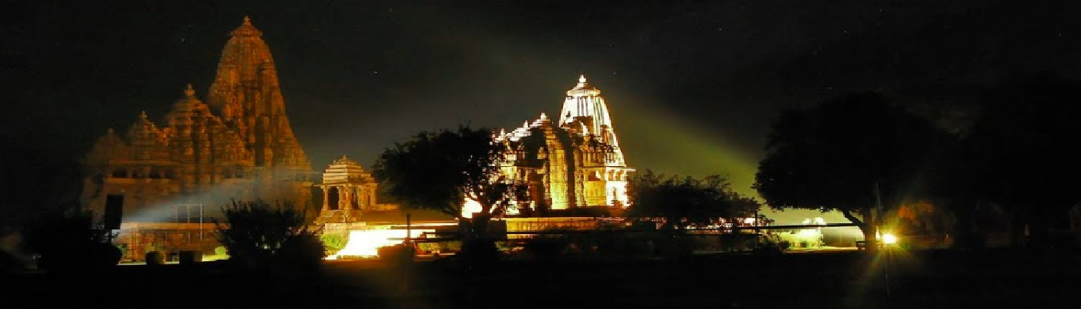
Then visit the Western Group of Temples, which are the best-preserved and well-known in Khajuraho. Lakshmana is the oldest temple of the Western group, dating from around 950 CE, and is well preserved, with some erotic carvings. Kandariya Mahadeva is the largest, with a huge selection of sculptures that are considered some of the greatest masterpieces of Indian art. Take your time to enjoy the marvelous architecture and the setting of the temple complex.

In evening you can't afford to miss the Khajuraho light and sound show while you're there. The entire production takes place on the temple grounds, making it one of the most spectacular displays you'll ever witness. After sundown, you can enjoy the entertainment narrated in English. The Program reveals the history and inspiration of the Khajuraho temples, and it can be an entertaining way to learn more about this tourist site, with beautiful lighting effects and voiceover in the temple, you can learn more about this place’s historical and cultural significance. Guests can watch the event under a starry sky from the comfort of their seats.

Day 09: Khajuraho – Varanasi

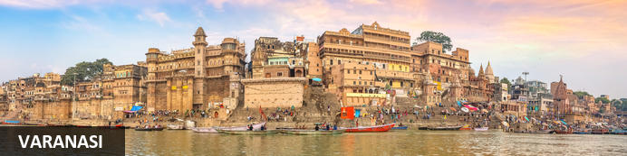
One of the world’s oldest continuously inhabited cities, Varanasi (sometimes still called Benares) is pivotal to some of the Hinduism’s most important traditions involving pilgrimage, death and mourning. Since medieval times it has also been a vital cultural and education centre. Here on the banks of the River Ganges – itself one of India’s most sacred rivers that can wash away all sins – Varanasi exerts a strange allure: at once compelling, if not beautiful, with its numerous ghats, or steps, leading down to the river and yet earthy, if not unsettling, with its venerable tradition of riverside cremations. A labyrinthine knot of cramped temple-filled lanes and alleys near the river – what you might call the old city – adds uncompromising atmosphere, colour and vitality making the city an unforgettable destination.

Today after breakfast at an appropriate time you will be drop at Khajuraho Airport to board your flight for Varanasi also renowned as Banaras is one of the oldest living cities in the world. Varanasi`s prominence in Hindu mythology is virtually unrevealed. It has always attracted many pilgrims and worshippers and was mentioned in the holy epics Ramayana and Mahabharata. Varanasi is also renowned for its rich tapestry of music, arts, crafts, education and silk weaving.

Flight 6E 5082 (IndiGo)
Depart Delhi 11:00 Hrs
Arrive Varanasi 11:55 Hrs.

Upon arrival in Varanasi, we will be transferred to the hotel to check in.

Overnight: Taj Ganges
Nestled amidst 40 acres of lush gardens, the Taj Ganges is just 6 kilometres from the commercial hub of Varanasi, also known as The Chowk. The hotel is also near many popular attractions like Vishwanath Temple. The hotel features 130 spacious, modern rooms and suites with various amenities, including complimentary Wi-Fi. The hotel has two on-site restaurants, as well as a bar. Other hotel facilities include a spa offering a selection of massages, a fitness centre, and an outdoor swimming pool.
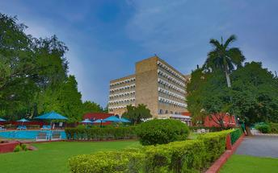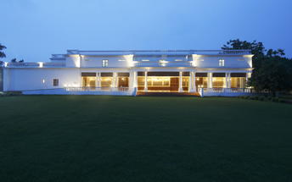

Day 10: Varanasi

Day Itinerary
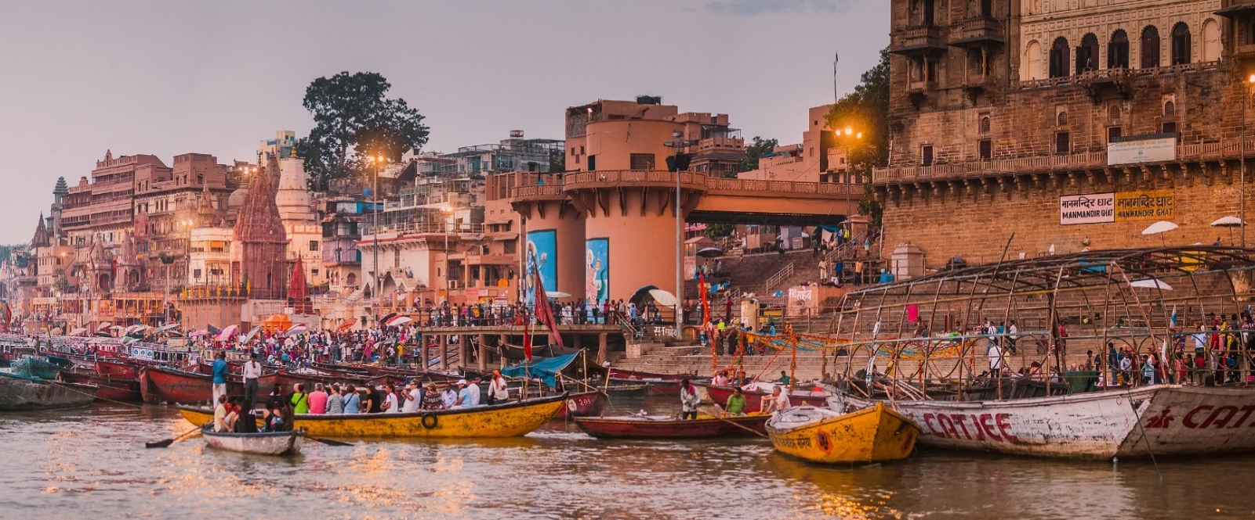
Rise early to enjoy a sunrise boat ride on the Holy River Ganges. See the ‘bathing ghats’ where thousands of pilgrims pay homage to the Sun God by immersing themselves in the holy water of River Ganges, and the ‘burning ghats’ where cremations are conducted. The ghats of River Ganges in Varanasi are believed to be most sacred, engulfing the entire circle of life and death.

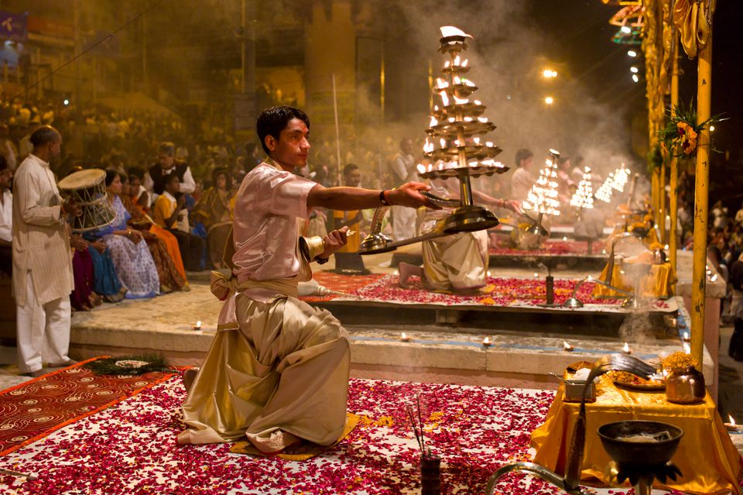
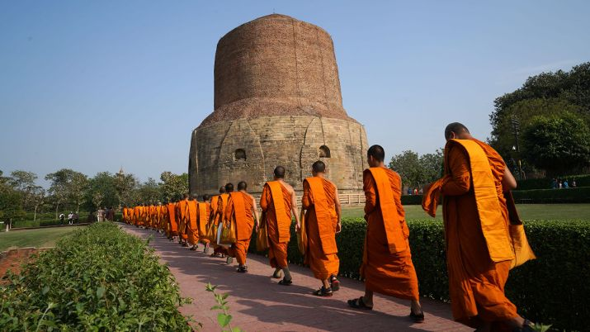
Follow the boat cruise with a guided walk through the old city, seeing morning life in the historic and ancient bylines of Varanasi. You get an opportunity to closely observe some morning rituals at the various small street temples along the way. The most sacred and important temple here is Kashi Visvanathan temple. Return back to hotel for breakfast and freshen up.

Later enjoy sightseeing tour of Sarnath followed by a visit to Silk Weaving Workshop. Sarnath is one of the top four Buddhist pilgrimage destinations in the world where the Lord Buddha gave his first sermon. Buddhists look upon India as the land of Buddha which makes Sarnath a popular tourist attraction. The Emperor Ashoka, who spread the Buddha’s message of love and compassion throughout his vast empire, visited Sarnath around 234BC, and erected a stupa here. Several Buddhist structures were raised at Sarnath between the 3rd century BC and the 11th century AD.
This evening, you visit Dashashwamedh, the prime attraction in Varanasi. It is the oldest and holiest ghat in Varanasi. The Ghat is the venue for the renowned evening Ganga Aarti. The aarti is performed daily by a group of young pandits (saints). Blowing of conch shells, waving of incense sticks and circular movement of lamps by the saints makes it a highly choreographed ceremony.

Day 11: Varanasi – Delhi

Day Itinerary
Today enjoy your breakfast, check-out and proceed for Varanasi Airport to take your flight for Delhi
Flight 6E 2321 (IndiGo)
Depart Varanasi 13:00 Hrs
Arrive Delhi 14:30 Hrs.

Upon your arrival, you will be met by our representative at the Delhi Airport. After a warm welcome, get transfer to your hotel in Delhi.

Overnight: Vivanta New Delhi Dwarka
Located in Delhi NCR, Vivanta New Delhi Dwarka offers comfortable accommodation directly connected to the centre of the city. The hotel's elegant rooms feature complimentary Wi-Fi access, flat-screen TVs, coffee makers and telephones. Guests can enjoy delicious dishes at several on-site dining options. Additional amenities include a fitness centre and a spa.
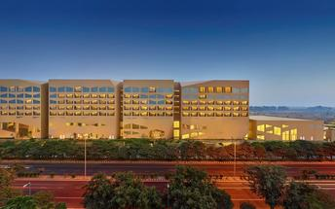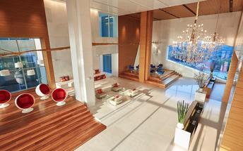

Day 12: Delhi – Departure

Day Itinerary
You will be transferred to Delhi international airport to connect flight for onward destination (the recommended check-in time is 3 hours prior to the flight).
Flight TBA
Departure Delhi TBA

