

IN 32 Maharaja Express Heritage of India plus Mumbai & Delhi
Mumbai – Udaipur – Jodhpur – Bikaner – Jaipur – Ranthambore and Fatehpur Sikri – Agra and Delhi
11 Days / 10 Nights

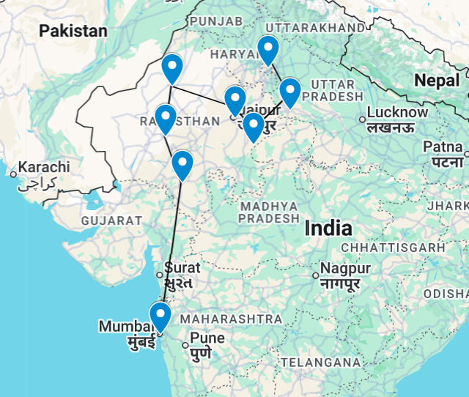

Introduction

Accommodation | Destination | Start | End | Basis | Room Type | Duration
Taj Mahal Palace Mumbai | Mumbai | Day 1 | Day 3 | BB | Luxury Grande Sea View | 2 Nights
Maharajas' Express Heritage of India | Mumbai to Delhi | Day 3 | Day 9 | FB | Deluxe Cabin | 6 Nights
The Imperial | New Delhi | Day 9 | Day 11 | B&B | Heritage Room | 2 Nights

Day 1: Arrive Mumbai (Friday)

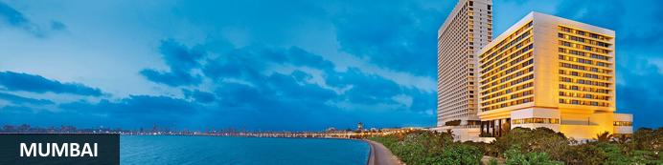
Although it isn’t India’s capital city, Mumbai often feels like it is or perhaps could be. With over twelve million people, it’s certainly India’s most populous city and the larger ‘greater Mumbai’ region homes over twenty million (making it one of the world’s most populous metropolitan regions). It’s long been India’s economic powerhouse – a place to which even the humblest outsiders might arrive, hit the big time through hard work, luck and acumen, and make a fortune. ‘Maximum City’, as it was once called, is sometimes defined by comparisons with Delhi: Delhi is bureaucrats while Mumbai is Bollywood. It’s simplistic but with a grain of truth: the city presents the most commercial, go-ahead, thrusting modern face of India and Bollywood is just one prominent face of its glitz and glamour.
Just a handful of Mumbai neighbourhood names – especially Colaba, Parel and Mahim – reflect its original geography of seven distinct islands. Initially captured by Portuguese trading fleets in the 1500s, they were given to Britain’s King Charles II in 1661 as part of his dowry when he married Catherine Braganza. Soon after that they were leased to the East India Company and quickly became its headquarters so that by the mid-1700s it was a major trading town. By the mid-19th century the islands had merged into one landmass after a series of massive land reclamation projects and seen the launch of India’s first railway line after which it became a major Arabian Sea port.
Today it’s not merely a practical international gateway but a destination showcasing modern India. Marine Drive’s curving Arabian Sea frontage has an almost Mediterranean feel while a clutch of gracefully ageing yet handsome Raj-era buildings stand witness to Mumbai’s significant imperial back-story. Thriving markets and bazaars, Hindu temples, Muslim shrines and a handful of excellent museums can easily fill a day or two’s sightseeing. Often filled with cricket-playing youth, the city’s maidans, or parks, and Dhobi Ghat, the curious open-air laundry, help lend colour, character and vitality to ‘maximum city’.

Day Itinerary
Flight TBA
Arrives Mumbai TBA
On arrival in Mumbai: Having cleared immigration, collected your luggage and passed through customs, please make your way towards the exit of the terminal building where you will see a bank of people waiting. Amongst them will be Travel Counsellors Representative who will be waiting to greet you with a paging board with your name on.
You will then be transferred to your hotel and assisted with check in. (Standard check-in time is 1500 hrs)

Overnight: Taj Mahal Palace Mumbai
Taj Mahal Palace Mumbai overlooks the majestic Gateway of India and has played host to kings, dignitaries and eminent personalities from across the globe. Strategically located in the city's prime historical and commercial hub, the hotel is within walking distance of Colaba Causeway, known for its touristy tiny roadside shops. The guest rooms and suites are bright, luxurious and elegantly furnished, equipped with air conditioning, Wi-Fi, TVs, tea/coffee makers and private bathrooms. The suites boast generous floor space, separate living rooms and dining areas. Guests can enjoy dining at any of the four on-site restaurants serving delectable Indian, Chinese, Japanese and international cuisine or relax at one of the well-stocked bars with a refreshing drink. Additional amenities and services include a large outdoor pool, expansive outdoor sitting areas, comfortable lounges, a spa, a salon, a fitness centre, a patisserie, yoga, a business centre, parking and a reception.
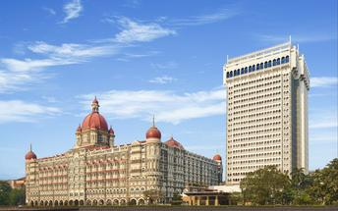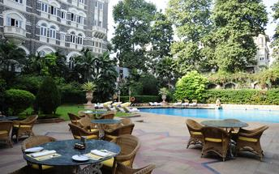

Day 2: Mumbai

Day Itinerary
Breakfast at the hotel.
After breakfast proceed for Five Senses Tour of Mumbai.
Welcome to the amazing Five Senses tour! Explore captivating Mumbai like never before.
Mumbai is more than just monuments; it's a vibrant city with fascinating stories and diverse cultures. Our tour celebrates the entirety of Mumbai, going beyond history lessons for a day filled with fun and immersive experiences. Prepare for an unforgettable day with engaging activities that will deepen your appreciation for Mumbai. Get ready to tingle your senses, one step at a time.

Let's start with sight. We'll guide you through Mumbai's heritage precinct, showcasing iconic landmarks like Gateway, VT, Taj, and the Yacht Club. Hear captivating stories about the city's past and keep an eye out for the efficient dabbawalas (lunchbox delivery men).
Now, let's turn up the volume and immerse ourselves in sound. Groove to the beats of Bollywood music in a contemporary dance studio. With your Bollywood dance choreographer, unleash your moves and embrace Mumbai's vibrant spirit.
Speaking of taste, let's satisfy your taste buds! Indulge in Mumbai's incredible food with a delightful feast. Experience the quintessential flavours and spices that make Mumbai's cuisine extraordinary. This 45-minute stop will reaffirm your decision to join our tour.
Join us on a train ride, offering a glimpse into the daily lives of Mumbaikars who rely on this mode of transportation.
Lastly, let's explore smell. Take a stroll through Mumbai's famous Spice Market, where the aroma of spices fills the air. Purchase a variety of spices and witness the fascinating process of dry roasting and grinding them into customised masala mixes.
Experience Mumbai's history, culture, flavours, aromas, and warm-hearted people in a whole new way. Prepare to fall in love with this extraordinary city!
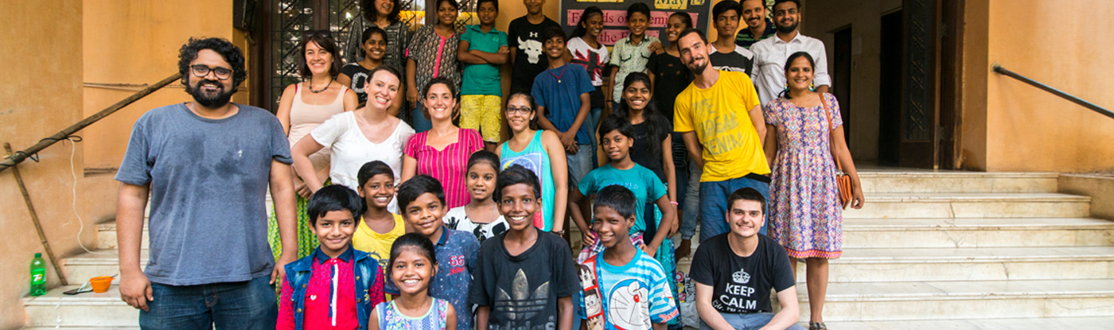

Day 3: Mumbai - Maharajas' Express Heritage of India (Sunday)

Day Itinerary
Breakfast at the hotel.

After breakfast you will be picked up from Taj Mahal Palace Hotel Mumbai to board Maharajas Express – Heritage of India journey.

- 08:30 Welcome and registration followed by tour briefing at the Hotel Taj Mahal Palace
- 09:45 Proceed for Chhatrapati Shivaji Maharaj Terminus (CSMT) Railway Station, Mumbai to board Maharajas’ Express
- 10:50 Maharajas’ Express proceeds to Udaipur
- 13:00 Lunch on-board
- 19:00 Dinner on-board

Overnight: Maharajas' Express
Welcome aboard the Maharajas' Express, bestowed the "World's Leading Luxury Train" award at the World Travel Awards for seven consecutive years from 2012 to 2018. The Maharajas' Express has redefined the luxury travel experience by offering guests the opportunity to explore fabled destinations providing a glimpse of rich cultural heritage of Incredible India which will leave you with fond memories of this train journey to be cherished.

There are four categories of cabins/Suites in this Luxury train. The Cabins on the Maharajas' Express are the most Lavish among all the International Luxury Tourist Trains. The Lavish Interiors, distinct theme supplemented by the latest International safety features such as Electronic smoke detection system.

The state of the art facilities in all the cabins of the train includes OTT subscription, Wi-fi Internet, Intercom connectivity, DVD player, LED screen, wardrobe, Personal electronic safe, air conditioning and en-suite bathroom facilities such as shower cubicle with running hot & cold water, W.C . To make your stay Lavish and relaxed, we provide amenities such as bathrobe, slippers, hairdryer, range of Luxury toiletries made of essential oils.

Each car of the train is attended by personalized valets to provide you with attentive, friendly and un-intrusive service throughout your Luxury rail tour. The high ratio of staff to guests in the train ensures prompt services, should you need any assistance during the rail journey or during off-board excursions. No wonder these Lavish and unique features of this Luxury train has enhanced the comfort levels of the guests and aided Maharajas' Express to receive the internationally acclaimed World's Leading Luxury Train Award.

The train coaches of Deluxe Cabin are named after the precious gems Hakik(Agate), Firoza(Torquoise), Katela(Amethyst), Beruz(Aquamarine) & Pitoniya(Bloodstone) to indicate the lavishness present in the overall experience provided in the tour Packages of Maharajas' Express. The train has 20 Deluxe Cabins of which 12 are twin bedded and 8 double bedded.

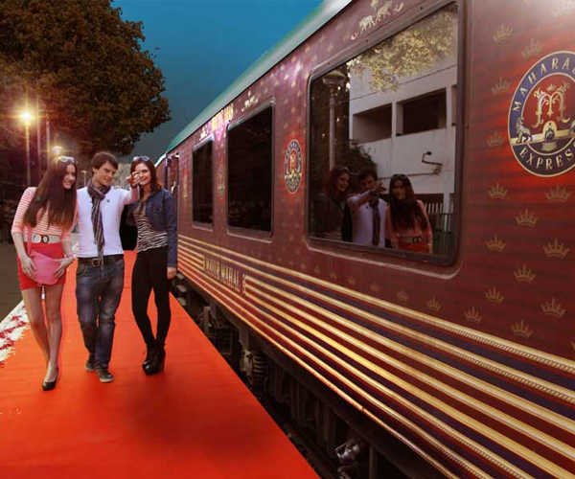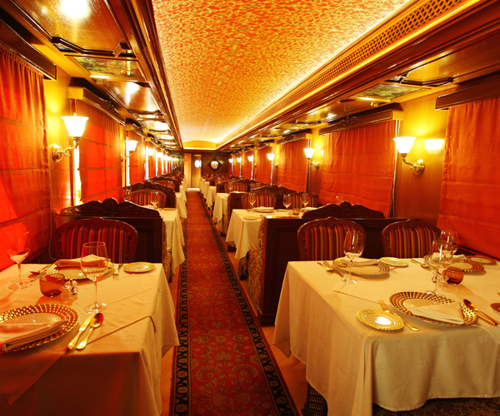

Day 4: On board Maharajas' Express – Udaipur (Monday)

Day Itinerary
- 08:00 Breakfast on-board.
- 09:30 Proceed for Shared Boat ride on Lake Pichola followed by visit to City Palace and Crystal Gallery
- 13:00 Exclusive lunch at Satkar Hall of Fateh Prakash Palace, a heritage hotel
- 15:00 Return to the comforts of Maharajas’ Express. Relax on-board or you may choose optional activities
- 19:30 Dinner on-board.
- 21:25 Maharajas’ Express proceeds to Jodhpur.
Shared Boat ride at Lake Pichola
Pichola Lake is one of the most beautiful lakes in Rajasthan. Located in the heart of Udaipur, Pichola is the oldest and one of the largest lakes in all of Udaipur. In 1362 AD Pichola Lake was built by Banjara. Later, Maharana Udai Singh, affected by the charm of this lake and extended the lake when he founded the city of Udaipur and also built a dam made of stone that is in the Badipol region on the shore of the lake. Pichola Lake is enveloped by lofty Palaces, temples, bathing ghats and elevated hills on all its sides.

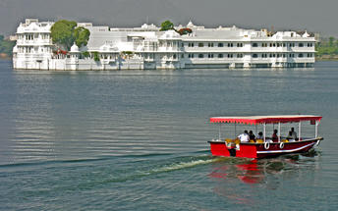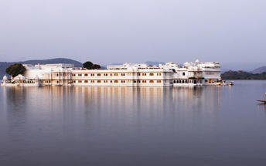

Udaipur City Palace
Situated above Lake Pichola, Udaipur City Palace has housed many royals over four centuries who have each added their own unique preferences to the establishment. The palace is a one of a kind in Rajasthan. Udaipur City Palace was constructed entirely out of marble and granite which makes it highly luxurious. The inside is even more so with its inlays of coloured glass, engravings, towers, and balconies.

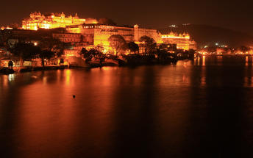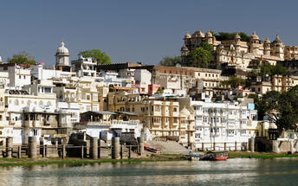

Crystal Gallery
Crystal Gallery has been hailed as probably the single largest private collection of crystal anywhere in the world. The visitors here are privy to one of the most exclusive and exquisite crystal collections. It was in 1877 that Maharana Sajjan Singh (period of reign: 1874-1884) ordered the crystal collection from the Birmingham-based F&C Osler company. The collection includes a bewildering number of objects d'art, dinner sets, perfume bottles, decanters, glasses, washing bowls and even furniture. The Crystal Gallery also houses the only crystal bed in the world! The collection has been customised for the House of Mewar; the Crest of Mewar being delicately etched on the crystal, adding yet another amazing facet.

The Durbar Hall Sabhagaar, which adorns the Fateh Prakash Palace, is of historical significance. In 1909, Lord Minto the Viceroy of India, laid its foundation stone and, in his honour, the hall was originally called Minto Hall. Today its opulent interiors - with huge chandeliers and special lights, portraits of the Maharanas of Mewar, royal artifacts and the legendary armory of the Mewar dynasty - transport you to times past when the Maharanas held forth in The Durbar Hall Sabhagaar.

The Audio Guide Service at Crystal Gallery narrates the history and anecdotes about how the present Custodian of the House of Mewar, Shriji Arvind Singh Mewar of Udaipur, conceptualised the Gallery; how the crystal was unpacked after it had been in crates for over half a century!

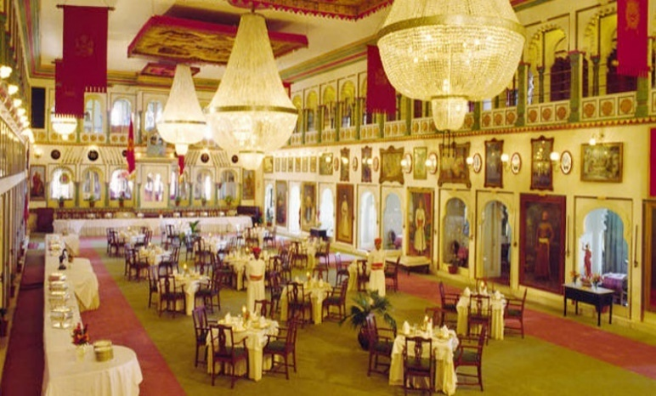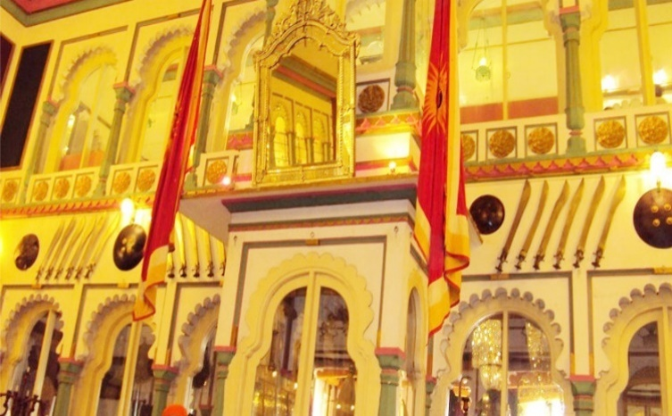

Day 5: On Board Maharajas' Express – Jodhpur (Tuesday)

Day Itinerary
- 07:00 Enjoy countryside while having breakfast on-board
- 09:00 Relax on-board or you may choose optional activities
- 10:30 Arrival at Jodhpur
- 13:00 Lunch on-board
- 14:30 Proceed to visit the Mehrangarh Fort followed by a Tuk Tuk ride and a walking tour of the Old Clock Tower market.
- 17:30 Proceed for an exclusive cocktail dinner at Khaas Bagh, a heritage hotel
- 21:00 Return to the comforts of Maharajas' Express

Mehrangarh Fort
Mehrangarh Fort rises four hundred feet above the skyline of Jodhpur from its rock precipice on Bhaurcheeria hill. The foundation of Mehrangarh Fort was laid on May 12, 1459 by Rao Jodha, the fifteenth Rathore ruler who wanted to shift the capital from nearby Mandore to Jodhpur. In all its history, Mehrangarh Fort has never been taken in a siege. Mammoth and imposing from the outside, the interiors of the fort are light and detailed in contrast. Several palaces can be found inside the complex, boasting intricate carvings and sprawling courtyards.

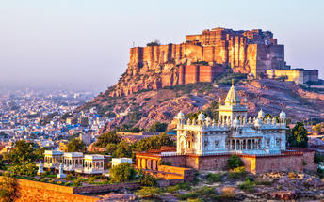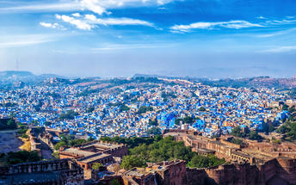

Day 6: On board Maharajas' Express – Bikaner (Wednesday)

Day Itinerary
- 08:00 Enjoy countryside while having breakfast on-board
- 09:00 Arrive into Bikaner. Relax on-board or you may choose optional activities
- 13:00 Lunch on-board
- 14:30 Visit to Junagarh Fort followed by sundowners at Sand Dunes
- 17:30 Arrive at the Sand Dunes followed by cocktails, bar-be-que and folk dances
- 20:30 Return to the comforts of the Maharajas' Express
- 21:45 Maharajas’ Express proceeds to Jaipur

Junagarh Fort, Bikaner
Junagarh is an impregnable bastion that holds the distinction of having never been captured. It was constructed in 1588 AD by Raja Rai Singh, one of Emperor Akbar’s most distinguished generals. The fort complex houses some magnificent palaces constructed in red sandstone and marble and visitors can feast their eyes on an attractive assortment of courtyards, balconies, kiosks and windows.

Day 7: on Board Maharajas' Express – Jaipur (Thursday)

Day Itinerary
- 07:00 Enjoy countryside while having breakfast on-board.
- 08:30 Arrive into Jaipur. Proceed for a visit to Amber Fort
- 13:00 After sightseeing proceed to Rambagh Palace Hotel for lunch
- 16:00 Return to the comforts of Maharajas’ Express. Relax on-board or you may choose optional activities
- 19:30 Dinner on-board
- 23:00 The Maharajas' Express proceeds to Sawai Madhopur (Ranthambore)

Amer Fort
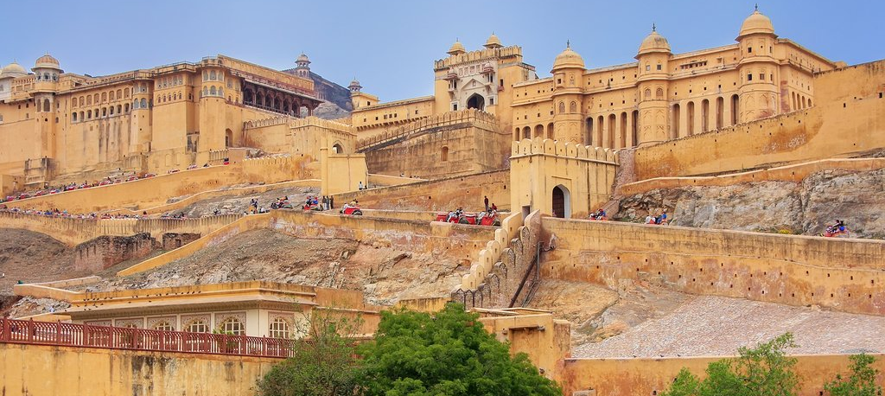
Amer Fort, officially known as the ‘Amer Palace’, is one of the most famous forts of Rajasthan attracting around 4000 to 5000 visitors a day during peak tourist season. The palace was named after the small town of Amer, where it is situated - only eleven kilometres from Jaipur. Perfectly picturesque, this 16th century hillside residence is well preserved, boasting grand pavilions and mirrored halls that open onto flourishing gardens and courtyards. Although the palace’s main construction started in 1592 by Maharaja Man Singh, it was added to over the years by successive rulers and continued to be occupied by them until Jaipur was built.

Day 8: On Maharajas' Express – Ranthambore – Fatehpur Sikri (Friday)

Day Itinerary
- 06:30 Proceed for a game drive using Shared Canter at Ranthambore National Park
- 09:45 Return to the comforts of Maharajas' Express and breakfast on-board
- 10:15 Maharajas' Express proceeds for Fatehpur Sikri
- 13:30 Lunch on-board
- 14:45 Arrive into Fatehpur Sikri
- 15:00 Visit the deserted Mughal City of Fatehpur Sikri
- 18:00 Return to the comforts of Maharajas' Express as train proceeds to Agra
- 19:30 Enjoy an “Indian Evening” followed by dinner on-board
- 20:00 Arrive into Agra. Overnight at Agra

Game drive using Shared Canter at Ranthambore National Park
Located in the Sawai Madhopur district, the Ranthambore National Park, in the western state of Rajasthan, is one of the most visited wildlife parks in India. Spanning over an impressive 1300-square-kilometer stretch of wilderness, the park’s outstanding natural beauty is characterized by its dense jungle, golden savanna, dramatic cliffs and lotus-filled lakes. Considered the best spot to catch a glimpse of tigers in the wild, the park offers visitors a spellbounding combination of mystical temples, wild beauty and crumbling ruins. While the main attraction is undoubtedly the elusive Bengal tiger, the park provides a sanctuary for other wildlife including, among others: sambar, gazelle, caracal, black buck, crocodile, chital, wild boars and a wide array of birds.

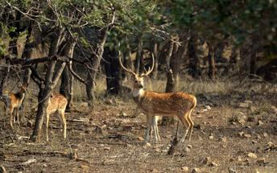

Day 9: Dis-embark Maharajas Express Agra – Delhi (Saturday)

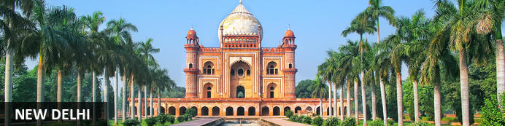
New Delhi, India’s national capital, is a relatively modern confection of imposing government buildings including Parliament, museums and wide leafy boulevards loosely centred on circular Connaught Place (officially now called Rajiv Chowk). To its north lies the formerly walled city of Old Delhi, or Shahjahanabad, built in the 17th-century by the Mughal Emperor Shah Jahan. Though long merged into one metropolis, the two have very different characters. New Delhi has space, parks, distinct neighbourhoods and a clutch of important monuments and architecture that reflect its ancient history. Old Delhi’s crowded streets, lanes and bazaars reflect its colourful medieval character and they cradle some of the city’s most memorable sights.

Day Itinerary
- 06:30 Proceed to visit Taj Mahal
- 10:00 Return to the comforts of Maharajas' Express and breakfast on-board
- 10:30 Maharajas' Express proceeds to Delhi
- 13:00 Lunch on-board
- 14:40 Disembark and bid farewell to the Maharajas' Express as your journey comes to an end!

Itinerary, sightseeing, timings and scheduled destinations may change without prior notice due to local/ weather conditions.

De-board at Safdarjung railway station in Delhi, you will be met by a TC representative and transferred to hotel.

Taj Mahal
The iconic Taj Mahal is not only an architectural masterpiece, a UNESCO World Heritage Site and one of the new Seven Wonders of the World – it’s also the enduring legacy of a royal love story. It was commissioned in the 15th century by the Mughal Emperor Shah Jahan after the death of his third and favourite wife, Mumtaz Mahal, to serve as her final resting place and a symbol of his eternal affection for her. Combining Islamic, Persian, Ottoman Turkish and Indian design elements, it’s an awe-inspiring structure of elegant domes and white marble, which changes colour along with the light – pink at sunrise, pearly white in the afternoon and silver-gold in the full moon.

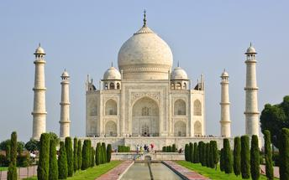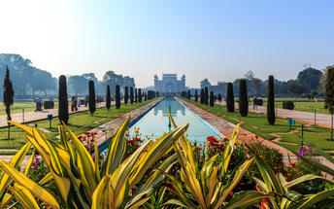

Overnight: The Imperial
The Imperial is a luxury hotel located in New Delhi, India. The hotel is near several attractions, such as Jantar Mantar, the National Philatelic Museum and the Sri Bangla Sahib Gurudwara. Away from the city's hustle and bustle, the hotel is an oasis of calm and comfort, offering guests a peaceful atmosphere. The accommodation is elegant and spacious, with rooms and suites fitted with modern amenities such as minibars, flat-screen TVs, Wi-Fi and private bathrooms. Guests can enjoy delicious dishes and drinks at any one of the several on-site restaurants and bars. Additional amenities include a spa and a salon.
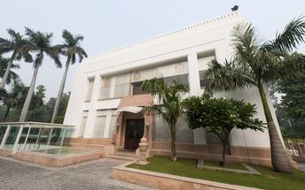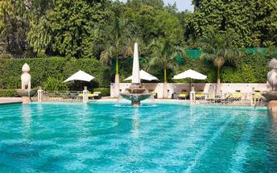

Day 10: Delhi (Sunday)

Day Itinerary
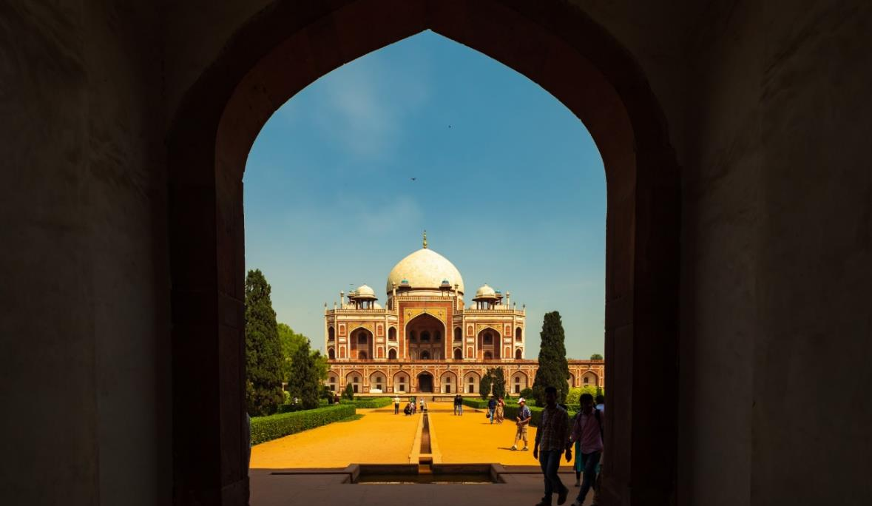
Breakfast at Hotel.
Today proceed for The Five Senses Delhi Tour
A sensory journey through Delhi covering everything from its food, local arts and crafts, the must-see architectural marvels, to expertly navigating and allowing you to witness the organized cultural chaos that is Delhi.
USP - Delhi 101: A complete tour of Old and New Delhi! We’ve carefully curated a selection of experiences that will transport you across Delhi’s rich cultural history. Experience for yourself the syncretism that has served as both Delhi’s greatest strength and vulnerability.
There isn’t a dearth of iconic sightseeing locations in the city, but for this tour, we focus on the two most beloved monuments that became inspirations or templates for all the other beautiful heritage structures. Humayun’s tomb, a spellbinding mausoleum is a favourite for any Delhiite! Your visit will be followed by a heritage craft workshop organised by an all-women NGO group that will touch your heart. Next, take a rickshaw ride through Shahjahanabad. Chaos thrives in the streets of Chandni Chowk, but as you cycle down, you’re transported by the magic in the air to the thriving Mughal era.
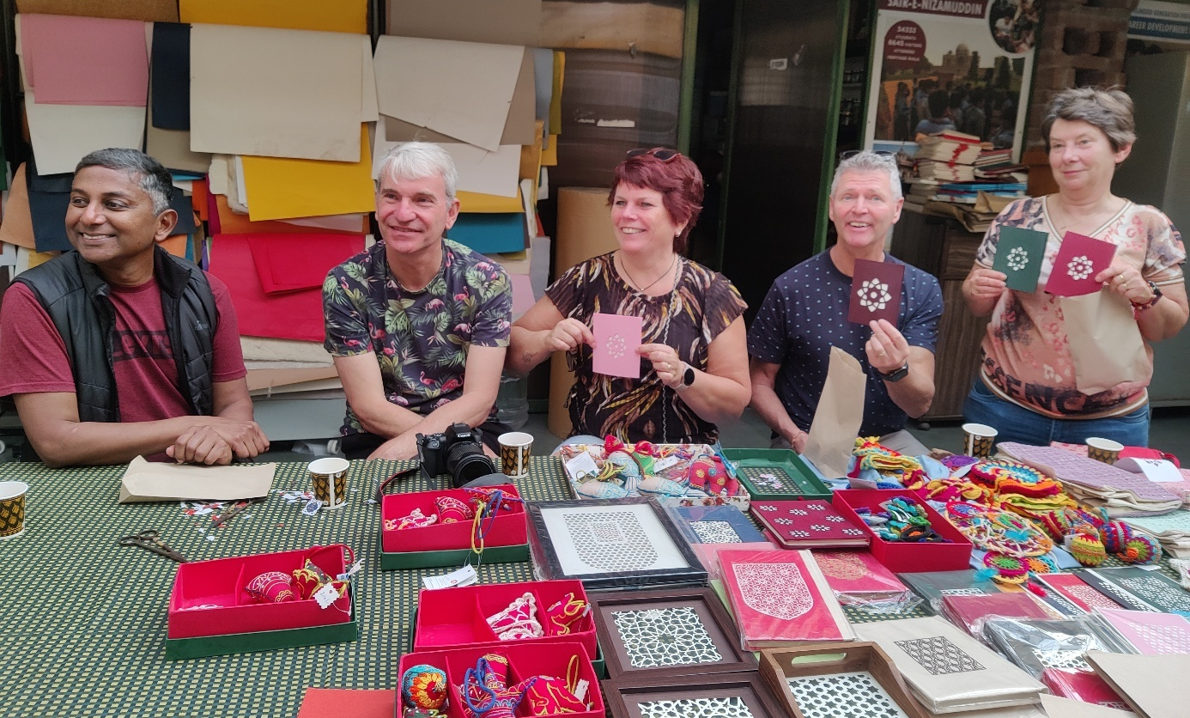

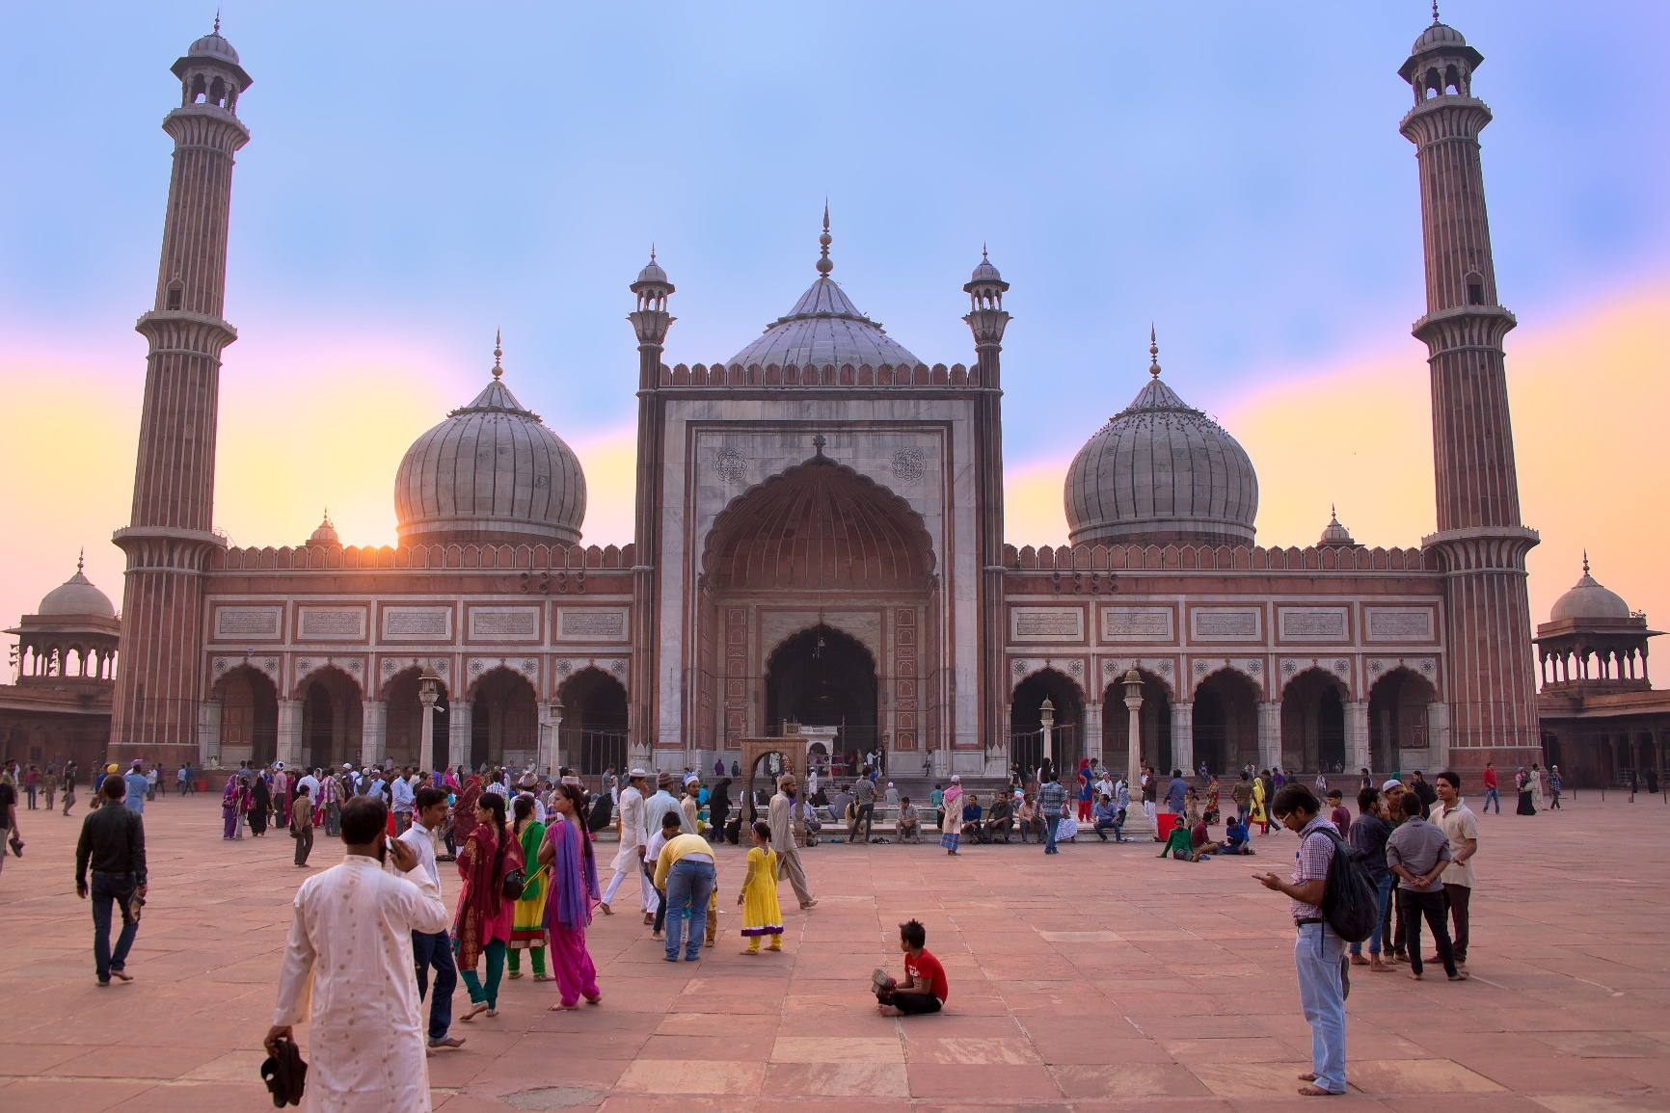
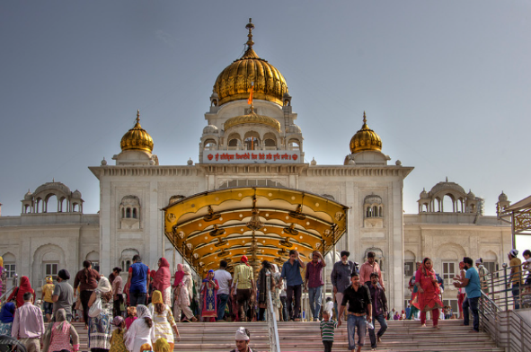
Next, you will indulge your sense of smell with an Ittar or perfume-making workshop. Visit an 8th-generation Ittar studio where you will get to smell and mix your unique concoction that can be named after you!
We’ll quickly stop to snack on some mouth-watering street food before proceeding to witness the glory and quietness of the Jama Masjid: a beautiful pocket of calm at the heart of Old Delhi's mayhem.

To engage your sense of sound, we bring you to Bangla Sahib. The magic of seva (selfless service) that the Gurudwara envelopes you into is undeniable. What ties together this beautiful experience is the sweet sound of the Gurbani playing in the background. Next, head to calm your favourite sense - taste! You will enjoy a meal at a contemporary Indian restaurant!
Before going back to the hotel, on the way, we show you the parts of Delhi with British influence and talk about the architectural contrast as well as some interesting stories from that time!

Day 11: Depart Delhi (Monday)

Day Itinerary
At appropriate time, you will be transferred to Delhi international airport to connect flight for onward destination (the recommended check-in time is 3 hours prior to the flight).
Flight TBA
Depart Delhi TBA
*****END OF SERVICES *****

NOTE:
Itinerary, sightseeing, timings and scheduled destinations may change without prior notice due to local/ weather conditions.
Maharajas’ Express Heritage of India Departure Dates for season 2025 - 2026
Month | The Heritage of India  (6 Nights/7 Days)
October 2025 | Sunday, October 19, 2025
November 2025 | Sunday, November 16, 2025
December 2025 | Sunday, December 14, 2025
January 2026 | Sunday, January 11, 2026
February 2026 | Sunday, February 8, 2026
March 2026 | Sunday, March 8, 2026
April 2026 | Sunday, April 5, 2026

