IN-34

Maharaja Express – Indian panorama
(Delhi – Jaipur – Ranthambore and Fatehpur Sikri – Agra – Orchha and Khajuraho – Varanasi – Delhi)
09 Days / 08 Nights

Day 1 (Sat): Arrive Delhi
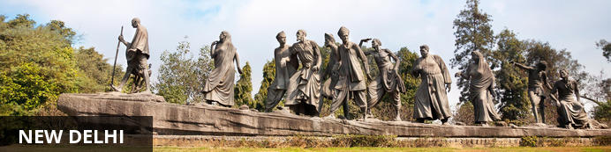
India’s largest city, Delhi, has been one of the country’s commercial and economic hubs for centuries and, as a result, is incredibly rich in culture and history. Made up of the ancient walled city of Old Delhi and the more modern sector, New Delhi, the city encompasses a staggering array of beautiful architecture, notable monuments and age-old temples, including three UNESCO World Heritage Sites – the Red Fort, Qutab Minar and Humayun's Tomb. Other key attractions include the 17th century Chandni Chowk marketplace – still one of the city’s most popular retail centres today, particularly for jewellery and traditional Indian saris; the iconic Bahà’i Lotus Temple – an award-winning architectural gem; and the Jama Masjid, India’s largest mosque.

On arrival in Delhi: Having cleared immigration, collected your luggage and passed through customs, please make your way towards the exit of the terminal building where you will see a bank of people waiting for you. Amongst them will be Travel Counsellors Representative who will be waiting to greet you with a paging board with your name on.
You will be transferred to your hotel and assisted with check in. (Standard check in time at hotel is 1400 hrs).

Day 2 (Sun): Delhi - Board Maharajas’ Express - Jaipur
Early morning, you will be assisted & transferred to Safdarjung railway station to embark the Luxury train Maharaja Express.
- 07:30 Welcome and Check in at Delhi Safdurjung Railway Station
- 08:00 Breakfast onboard
- 08:30 Maharajas’ Express proceeds to Jaipur
- 13:00 Lunch onboard
- 14:30 Arrive into Jaipur
- 15:00 Proceed to visit City Palace Galleries followed by dinner at Rambagh Palace Hotel
- 20:30 Return to the comforts of Maharajas’ Express. Overnight on train at Jaipur

Jaipur City Palace

City Palace forms one of the most famous tourist attractions and a major landmark in Jaipur. The beautiful palace was built by Maharaja Sawai Jai Singh during his reign. Among the various forts and palaces of Jaipur, City Palace stands apart, with its outstanding art and architecture.
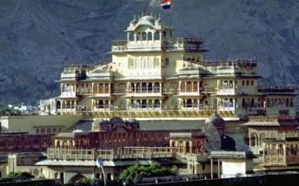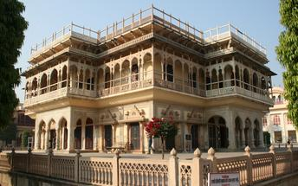

Overnight: On Board Maharaja Express
Travellers can explore India by rail on one of five fascinating journeys offered by the luxurious Maharajas Express. The train’s décor recreates the elegance and pageantry of erstwhile Maharajas and guests can enjoy state-of-the-art facilities in the spacious, well-appointed cabins and suites. There are two dining cars where guests can feast on gourmet dishes served on gold-edged plates and drink wine from hand-cut Swarovski crystal glasses. Cocktails and snacks can be enjoyed in the Safari Bar while the lounge car also offers a well-stocked bar, library, souvenir shop, and board and card games. Other onboard facilities include live television and CCTV cameras in all public areas, free Wi-Fi, a 24-hour paramedic on board, and an air ambulance in case of emergencies. Activities offered include guided tours to historical and World Heritage sites and cultural experiences such as folk dances.

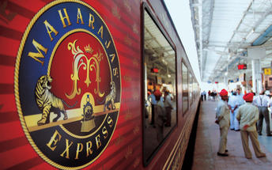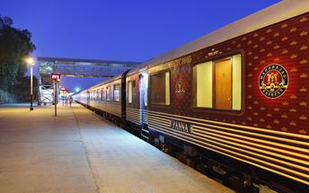

Day 3 (Mon): On Board Maharajas' Express (Jaipur- Ranthambhore)
- 07:00 Breakfast onboard
- 08:00 Visit the Amber Fort
- 12:30 Return to the Maharajas' Express for lunch onboard. After lunch you may choose the Optional Activities - Spa at a hotel or a Local City Tour
- 19:30 Dinner onboard
- 23:00 Maharajas' Express leaves for Sawai Madhopur (Ranthambore)

Amer Fort
Amer Fort, officially known as the ‘Amer Palace’, is one of the most famous forts of Rajasthan attracting around 4000 to 5000 visitors a day during peak tourist season. The palace was named after the small town of Amer, where it is situated - only eleven kilometres from Jaipur. Perfectly picturesque, this 16th century hillside residence is well preserved, boasting grand pavilions and mirrored halls that open onto flourishing gardens and courtyards. Although the palace’s main construction started in 1592 by Maharaja Man Singh, it was added to over the years by successive rulers and continued to be occupied by them until Jaipur was built.
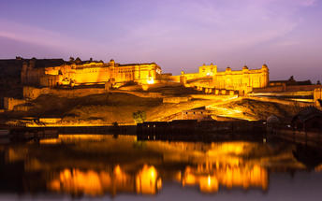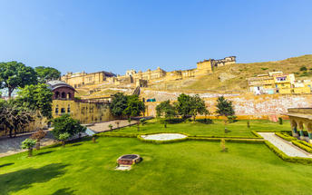

Overnight: On Board Maharaja Express

Day 4 (Tue): On Board Maharajas' Express (Ranthambhore- Fatehpur Sikri)
- 06:00 Proceed for an exciting Game Drive at Ranthambore National Park
- 09:30 Return to the comforts of Maharajas' Express
- 09:45 Breakfast onboard
- 10:15 Maharajas' Express proceeds for Fatehpur Sikri
- 13:30 Lunch onboard
- 14:30 Arrive into Fatehpur Sikri
- 15:30 Visit the deserted Mughal City of Fatehpur Sikri
- 18:00 Return to the comforts of Maharajas' Express
- 20:00 Dinner onboard. Overnight on train at Fatehpur Sikri

Ranthambore National Park
Located in the Sawai Madhopur district, the Ranthambore National Park, in the western state of Rajasthan, is one of the most visited wildlife parks in India. Spanning over an impressive 1300-square-kilometer stretch of wilderness, the park’s outstanding natural beauty is characterized by its dense jungle, golden savanna, dramatic cliffs and lotus-filled lakes. Considered the best spot to catch a glimpse of tigers in the wild, the park offers visitors a spellbounding combination of mystical temples, wild beauty and crumbling ruins. While the main attraction is undoubtedly the elusive Bengal tiger, the park provides a sanctuary for other wildlife including, among others: sambar, gazelle, caracal, black buck, crocodile, chital, wild boars and a wide array of birds. Don’t miss the ancient Ranthambore Fort, perched high on the cliffs overlooking the vast expanse of this spectacular park.

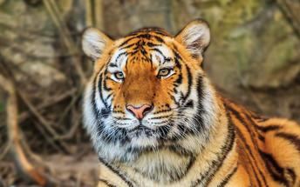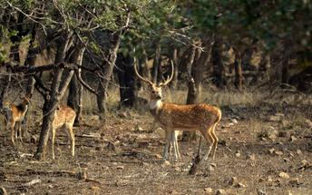

Fatehpur Sikri
A highlight in the province of Uttar Pradesh, Fatehpur Sikri served briefly as the capital of the Mughal Empire from 1571 to 1585. This world heritage site is rated as one of the best preserved collections of Mughal architecture in India. Surrounded by a six kilometre wall, with the fourth being a lake at the time, a day can be spent exploring the elaborate structures within. Marvel at the impressive Jama Masjid mosque, the detailed palaces built for Emperor Akbar’s wives, the public and private discussion halls and vast ornamental pool; all of which took over 15 years to conceptualise and build.
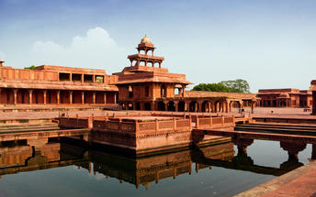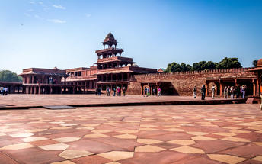

Overnight: On Board Maharaja Express

Day 5 (Wed): On Board Maharajas' Express (Agra)
- 06:30 Arrive into Agra and proceed to visit the Taj Mahal
- 09:30 Champagne Breakfast at Taj Khema
- 11:00 Return to the comforts of Maharajas’ Express
- 13:00 Lunch onboard. After lunch you may choose Optional Activities such as Spa at a Hotel or Visit to Itmad-ud-daula or Agra Fort or a Local City Tour or Mohabbat the Taj Show
- 17:30 Dinner onboard
- 03:00 Maharajas’ Express proceeds to Orchha.

Taj Mahal
The iconic Taj Mahal is not only an architectural masterpiece, a UNESCO World Heritage Site and one of the new Seven Wonders of the World – it’s also the enduring legacy of a royal love story. It was commissioned in the 15th century by the Mughal Emperor Shah Jahan after the death of his third and favourite wife, Mumtaz Mahal, to serve as her final resting place and a symbol of his eternal affection for her. Combining Islamic, Persian, Ottoman Turkish and Indian design elements, it’s an awe-inspiring structure of elegant domes and white marble, which changes colour along with the light – pink at sunrise, pearly white in the afternoon and silver-gold in the full moon.
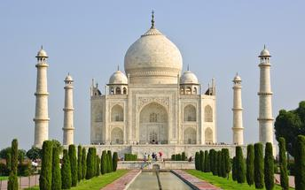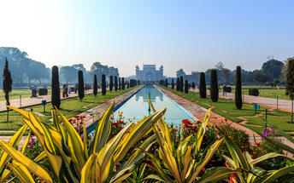

Overnight: On Board Maharaja Express

Day 6 (Thu): On Board Maharajas' Express (Orchha- Khajuraho)
- 06:30 Breakfast onboard
- 07:15 Deboard at Jhansi to reach Orchha by Road. Visit Orchha Fort and Village Tour by Tuk Tuks
- 10:00 Return to the comforts of Maharajas’ Express and Maharajas Express proceeds to Khajuraho
- 12:00 Lunch onboard
- 15:30 Arrive into Khajuraho and proceed to visit the Western Group of Temples
- 18:00 Return to the comforts of Maharajas’ Express
You may choose Optional Activities – Spa facility at a hotel or Light and Sound Show or Dances of India Show
- 20:00 Dinner Onboard
- 23:10 Maharajas’ Express proceeds to Varanasi

Orchha
Situated on the banks of Betwa River, laid back Orchha is often overshadowed by its neighbour, Khajuraho, famous for its erotic sculptures. But Orchha has charms of its own: this sleepy and timeless destination resembles a medieval Indian town, dominated by impressive ochre coloured palaces, forts and temples. Most of these date to between the 15th and 18th century – when the city was the thriving seat of government for the Bundela kings – and make for a sensory day of sightseeing, with main attractions including the intricate palace of Jahangir Mahal, the 14 Cenotaphs and the white-washed Ram Raja Temple.
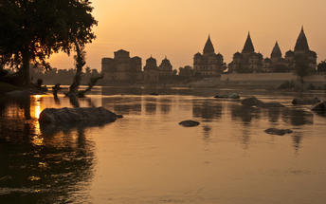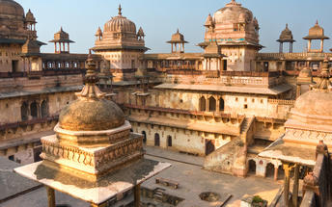

Khajuraho group of temples
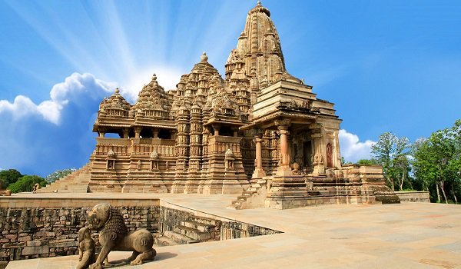
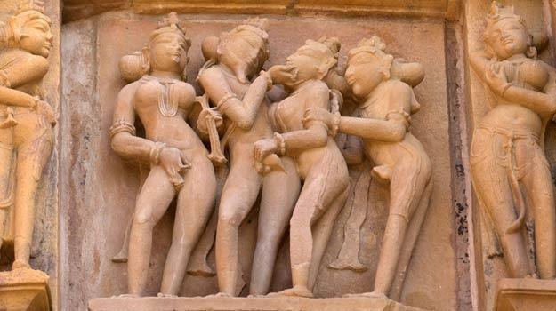
The name Khajuraho is derived from its Sanskrit nomenclature ‘Kharjuravahaka’ which is the confluence of two Sanskrit words ‘Kharjur’ meaning date palm and ‘Vahaka’ meaning bearer. There are about 25 temples spread over an area of approximately 6 square Km. The tem ples a re grouped into three categories depending on their orientation – the Western Group of Temples, the Eastern Group of Temples and the Southern Group of Temples. These temples are dedicated to several Hindu Gods and Goddesses along with deities in Jain beliefs. Among the temples that are standing till now, 6 are dedicated to Lord Shiva, 8 to Lord Vishnu, 1 each to Lord Ganesha and the Sun God, while 3 are dedicated to Jain Tirthankaras. The largest of the temples is the Kandariya Mahadeo Temple that is dedicated to the glory of lord Shiva. It makes Khajuraho one of the four holy sites dedicated to the glory of Lord Shiva, the other three being Gaya, Kashi and Kedarnath.

Overnight: On Board Maharaja Express

Day 7 (Fri): On Board Maharajas' Express (Varanasi)
- Today the train will station at Varanasi, a holy Indian city known for its Hindu and Buddhist pilgrimage sites. 08:00 Breakfast onboard
- 12:00 Arrive into Varanasi. Proceed for Lunch at Taj Ganges Hotel
- 14:30 Visit Sarnath ruins followed by visit to silk weaving centre
- 16:30 Proceed for Boat ride on the Ganges to witness Evening Aarti
- 17:30 Enjoy an exclusive vegetarian Dinner with Kathak Dance at Brij Rama Palace at Ghats
- 21:00 Returns to the comforts of the Maharajas’ Express
- 21:15 Maharajas’ Express proceeds to Delhi

Sarnath
Sarnath is one of the most important Buddhist pilgrimage centres in India. It is here that Buddha came after reaching enlightenment at Bodh Gaya (present-day Bihar), and where he first began his teachings of Dharma and the four noble truths to his five disciples. It is also an important place for the followers of Jainism. While many of the ancient buildings and structures at Sarnath were damaged or destroyed by the Turks, relics remain in the form of ruins that can be visited, or artefacts held in the Sarnath Archeological Museum, which also houses some of the greatest treasures of Indian Buddhist art, including almost 300 images. The Deer Park, which is the site of Buddha’s first teachings, is maintained as an animal park and still home to resident deer.
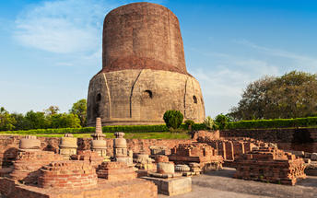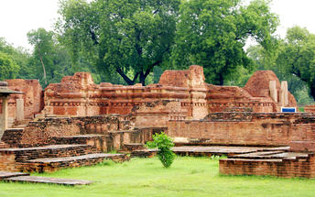

Evening Aarti at Ghat
Varanasi is a sacred and oldest city located at the banks of the holy River Ganga. Where, Ganges Aarti is performed daily in the evening by a group of priests at the Dashashwamedh Ghat near famous Kashi Vishwanath Temple as a dedication to Shiva, Gange, Surya (Sun), Agni (Fire), and the entire universe.
The whole ritual of the Ganges Aarti is performed by the seven students of the Vedas and Upanishads lead by the head priest of the Gangotri Seva Samiti in a well choreographed manner with a great synchronization. The whole event takes around 45 minutes. An announcement at 7.00 pm indicates the beginning of the Aarti.
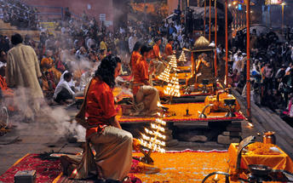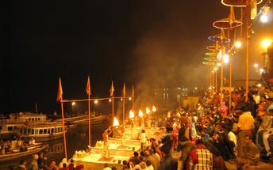

Overnight: On Board Maharaja Express

Day 8 (Sat): Disembark Maharajas' Express - Delhi
- 07:15 Breakfast onboard
- 13:00 Lunch onboard
- 15:00 Disembark and bid farewell to the Maharajas’ Express as your journey comes to an end!
You will be picked up at railway station and transferred to the hotel for check In.

Day 09 (Sun): Delhi departure
At an appropriate time, your Travel Counsellor Representative will provide the necessary transfer to the airport for your onward flight back home.

