

SL-06

Hidden Gems of Sri Lanka
Polonnaruwa - Kandy - Ceylon Valley - Koggala - Negombo
13 Days / 12 Nights

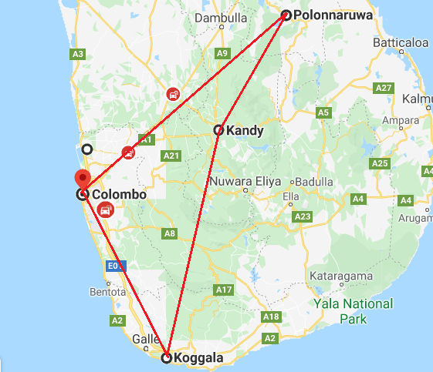

Day 1: Arrive Colombo - Polonnaruwa

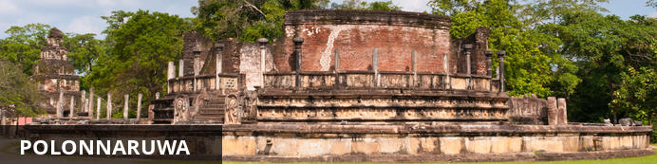
In the North Central Province of Sri Lanka lies the extraordinary ancient city of Polonnaruwa. The city is comprised of two distinct parts: the New Town area, known as Kaduruwela; and the royal ancient city of the Kingdom of Polonnaruwa, the second oldest of Sri Lanka’s ancient kingdoms. This rich archeological treasure trove contains countless fascinating ruins all conveniently grouped into one compact and easily accessible tourist site
Arrive Colombo where you will be met and transferred to your hotel at Polonnaruwa (approx. 195 kms / 5 hrs) by your private chauffer driven vehicle.
Rest of the day at leisure.
Evening: Enjoy a Boat ride on Parakarma Lake and tea at Bird Island at Sunset, where you can watch hundreds of Birds whilst enjoying a cup of tea served in a vintage tea set.

Day 2: In Polonnaruwa

After breakfast, visit the ruins at Polonnaruwa by bike.
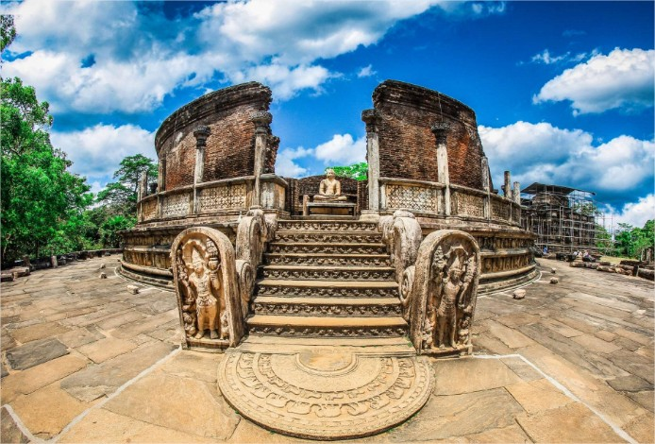
Rising with the decline of Anuradhapura, the city of Polonnaruwa - medieval capital & crown jewel of King Parakramabahu I - remains superior proof of ancient culture & heritage blended with religious beliefs. Walk across its scattered walls of the World Heritage Site - blessed by stupas, resting Buddha statues, irrigation canals and fantastically carved Hindu sculptures - while observing the relic house - Watadage - that boasts of beautiful stone carvings.

Take a close glance and you will realize a subtle Hindu influence on architecture and statues found in Polonnaruwa. Or sit by the side of Galviharaya and observe the absolute beauty gushing out of every bend of its huge Buddhist statues. Nissankamalla Council Chamber is however, a head-spinning beauty to just sit back and observe with its swaying pillars reminding the aesthetics of a powerful kingdom which rests beside Parakrama Samudraya - sea of Parakramabahu & masterpiece of irrigation!

Late afternoon climb the Sigiriya Rock Fortress

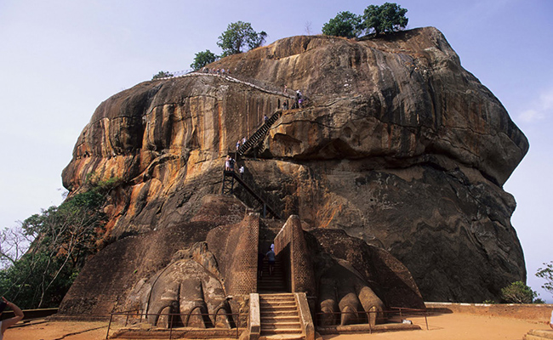
The 5th century rock citadel of King Kasyapa and World Heritage Site - Sigiriya - does not only boasts of ancient Sri Lankan engineering & urban planning supremacy but also acclaims to be one of the finest monuments of art & culture. Step through the gigantic 'Lion Paws' - overlooking the symmetrical royal gardens below - to comprehend the absolute splendor that once dominated this rock fortress. Surrounded by ramparts & moats the Lion Rock - resembling the mythological 'City of Gods' - is coated by frescoes that relate to Gupta style paintings found in Ajanta caves of India.

Walk in the shade of an eminent 'mirror wall' embracing the Western face of Sigiriya representing an artistic hundred meters laminated with graffiti. Wander into the well-fabricated museum downstairs for an epic journey of yesteryears to realize how the citadel floated above citizens with the castle, ponds and irrigation systems that pumped water right onto its summit with an ingenious hydraulic system describing a colossal masterpiece of the great king, which remained a wonder in Asia for centuries.

Day 3: Polonnaruwa - Kandy

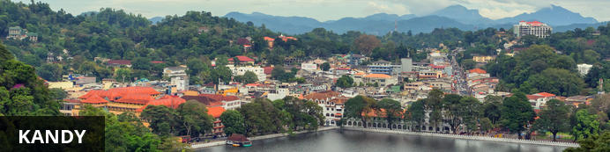
The second major city in Sri Lanka (the other being Colombo) lies in the midst of the Plateau, an area of tropical tea plantations. A prominent feature is Kandy Lake, to the north of which lies the golden-roofed Temple of The Tooth, a UNESCO World Heritage Site and important place for Buddhist worship, as it is said to house a tooth relic of Buddha. Other fascinating places include the Ceylon Tea Museum, the Buddhist Publication Society, the Ayurvedic centre in the Amaya Hills nearby, the Kandyan Art Association and Cultural Centre, where crafts people can be seen at work.
Morning leave by your private chauffer driven vehicle to Kandy with a stop at Dambulla to visit the magnificent cave temples and the spice plantations at Matale (approx. 110 kms / 6 hour including the visit)
Visit Dambulla Cave Temples. The Rock Temple houses some of the unique drawings in magnificently constructed 5 cave temples flanking the golden temple of Dambulla. Observe how exquisitely cave paintings are done along walls that shelter 150 statues of Lord Buddha. As you enter the retreat, look straight up to the gigantic Buddha statue glittering in gold over a land, which today houses an important junction in the country's economic and cultural uplifting.

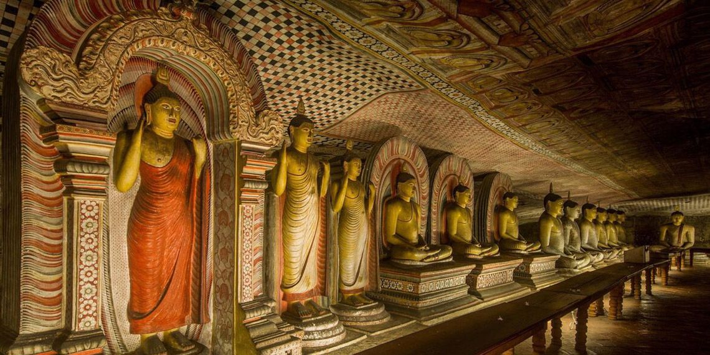
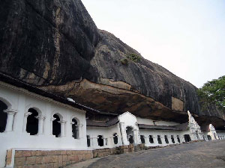

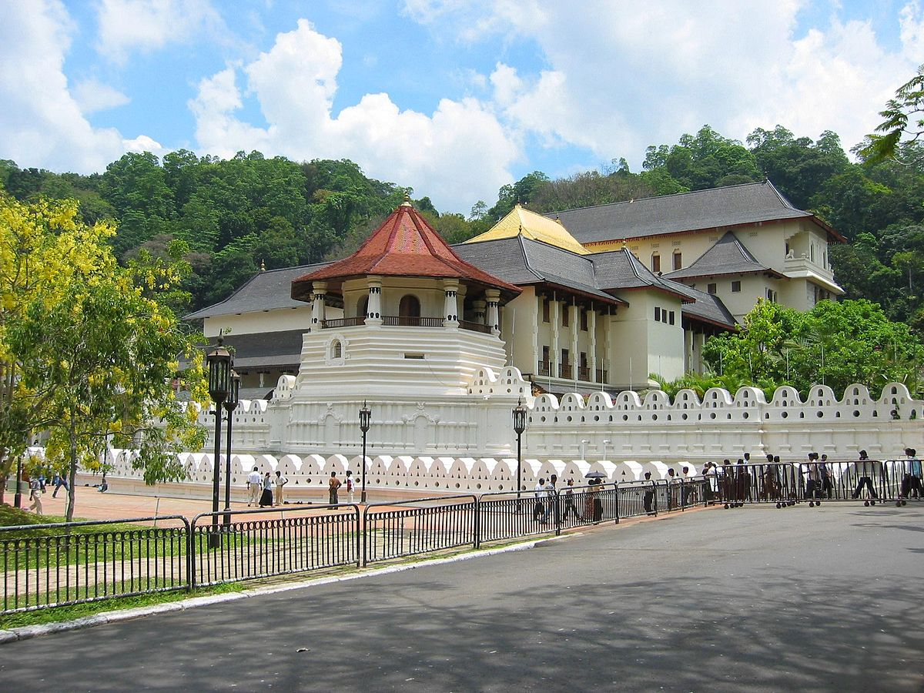
After the visit continue on to Matale - an agricultural zone in the Central Province, Matale seldom drops off the maps due to its remarkable contribution through flagship crops of the island extending from tea, rubber & vegetables to spices. Spearheading the Rebellion back in 1848, Matale today takes immense pride in its story woven around spices. Stop by the side of a spice garden - into which you will be most welcome - and observe the therapeutic values of spices & processes over a refreshing cup of herbal tea! Or spend some time idling on the hardened streets if you mean a real town adventure filled with voices and colors.
Arrive Kandy and check-in at the resort.
Evening option to visit the temple of tooth - experience an ancient Kandyan legacy engraved around its crown jewel, the temple of the sacred tooth relic of Lord Buddha. A stroll across this small lakeside town - cradled among the misty hills - will feature the Kandy City Centre - bundled with latest and world-class brands, bazaar, an arts & crafts centre.

Day 4: Kandy - Hatton

Morning after breakfast you will be taken by your private chauffer driven vehicle to Peradeniya railway station for a mountain train journey to Hatton - one of the most scenic train journeys in the world.
De-board the train and visit a tea plantation – learn the process “leaf to cup”
In 1873, the tea export industry of Sri Lanka began with a modest 23 lbs. being shipped to London.
Tea will grow only on rolling terrain and is classified by elevation into low grown, medium grown and high grown into 3 main groups. Today more than 200,000 hectares in highlands and other areas are under Tea and around 300 million Kilograms, with a 25% of world tea exports are done by Sri Lanka as the World’s largest Tea exporter

Day 5: Day in Hatton

Morning at leisure or you can do a hike around the area and return to the resort by lunch.

Evening tea experience with a resident tea planter
Sri Lanka, Tea and Tourism are words which cannot be separated. Take a tour to the cold & misty hills that take pride of an ultimate tea tour, covering lush green blankets of tea plantations. Or just step into a tea factory processing the prestigious brand of Ceylon Tea, to observe a rich tradition kept alive up to date. As you observe the hissing and swishing of machines, inhaling the heavenly scent arising from these facilities, make sure to end your day in style over a perfectly blended cup of pure Ceylon Tea.

Day 6: Hatton - Belihuloya

Morning after breakfast you will be taken by your private chauffer driven vehicle to Ahaspokuna (approx. 95 kms / 3 hrs)
Important Note: Guest need to check-in at before 1300hrs and it involves a walk of approx. 2 kms to the Hotel. The resort is located in the jungle and is very romantic and unique.
Enjoy the facilities at this unique resort – in the evening take a trek and enjoy Tea on the cliff

Overnight: Ahaspokuna Bush Walks Camp
This all-suite camp provides experiences that are all about bush walks in an environment that provides new experiences around every corner. Enjoy Sri Lanka's famous warmth and hospitality at its finest and make your walking safari dreams come true. At Ahaspokuna, you will be guided by professional naturalists and expert bushmen who have lived in this forested area for several generations.
Ahaspokuna is a mosaic of habitats. Wide grasslands, cave systems used by elephants that go there for salt, an eclectic variety of plants and herbs, some of which have medicinal value, streams, hidden waterfalls, and a plethora of mammals and birds, make Ahaspokuna what it is – a magical experience.
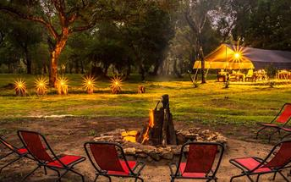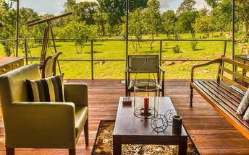

Day 7: In Ahaspokuna Bush Walks Camp

Breakfast at Ahaspokuna Bush Walks Camp.
Morning leave for Udawalawe with picnic lunch (approx.45 minutes) to be there by Noon to see the feeding of young elephants. Arrive and visit Udawalawe Elephant Transit Home
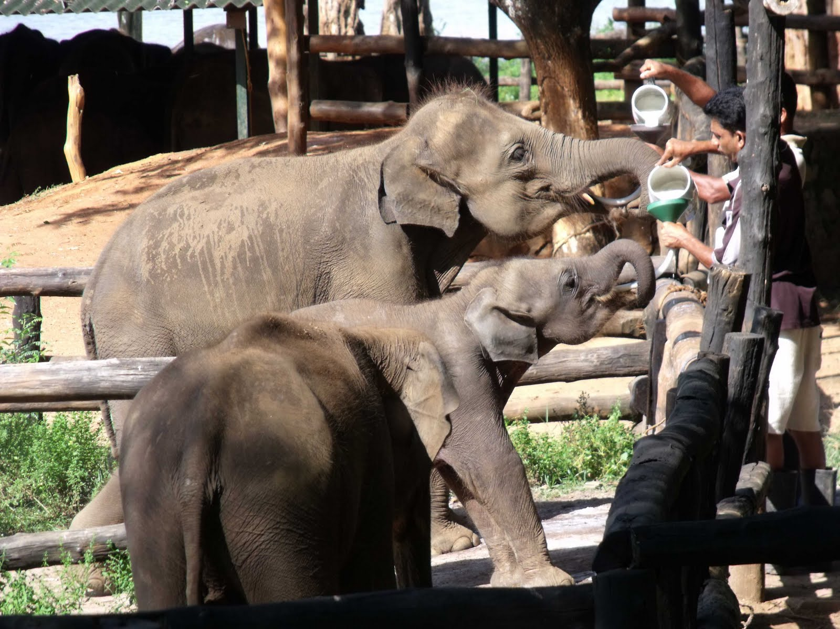
Udawalawe Elephant Transit Home bears a different story. Established in 1995, it caters to all injured elephants found in the area before releasing them into their natural habitat. So, make sure to just watch - rather than touch - these gentle giants as they feed, play and mingle with each other, before heading into the wild with one another.

Evening Safari at Udawalawe National Park @ 1530hrs

Udawalawe truly is a sanctuary for the big footed & tusked. Marked by relatively large herds of elephants, the national park proves to be one of the best places one could observe them in their natural habitat. Hop into a safari jeep and head into the park, you are most likely to drive into your first herd of giants within the maiden hundred meters. Turn on your radar into other species - such as potted deer, sambar, barking deer, water buffalo and jackal - found within the park. Meanwhile, Udawalawe Elephant Transit Home bears a different story. Established in 1995, it caters to all injured elephants found in the area before releasing them into their natural habitat. So, make sure to just watch - rather than touch - these gentle giants as they feed, play and mingle with each other, before heading into the wild with one another.

Day 8: Belihuloya - Thalpe

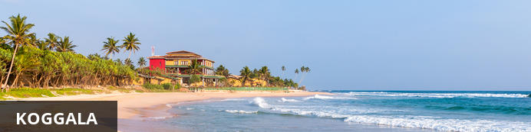
The village of Koggala on Sri Lanka’s south coast offers stretches of exquisite beaches – and good surf – for those seeking a quiet holiday surrounded by nature. Enjoy fresh seafood at one of the little beach restaurants with the picturesque bay as a backdrop. Buddhist hermitages, situated on the islets of Koggala Lake may be visited with prior arrangement, or pop into the Martin Wickramasinghe Folk Art Museum for a sample of the local traditions. Alternatively, you can arrange a catamaran ride or fishing expedition on the lake with one of the villagers, or take a tuk tuk along the dirt tracks to the lake and enjoy the indigenous flora, and fauna, including the elusive monitor lizard.
Morning after breakfast you will be taken by your private chauffer driven vehicle to Koggala (approx. 180 kms / 3 hrs). Arrive and check-in at the resort.
Rest of the day at leisure.

Day 9 & 10: In Thalpe

While at Thalpe you have the option to do a rainforest trek at Kanneliya Rainforest with lunch.

The Kanneliya rainforest is Sri Lanka’s lesser known forest reserve, with two of Sri Lanka’s main rivers running through it and a diverse range of wildlife living within its thick canopy. Neatly tucked away just 35 km away from Galle, the forest reserve also houses around 78 villages. Start with a trek through the rainforest with your tracker, whose home is on the edges of the forest reserve itself. Expect to see plenty of birdlife, perhaps a few monkeys, some unique bugs and creepy crawleys, and maybe even some snakes. The rainforest provides a lush habitat for a wide range of flora and fauna. If you’re feeling adventurous you can even crawl through a cave underneath the rainforest floor!

Take a quick break for a Milo and a piece of cake at a beautiful and fairly isolated waterfall. The water tends to be a little rough but strong swimmers might want to take a quick dip. It’s also a great place to dip your feet in the water as you take a short break.

Finish the walk with a hearty authentic Sri Lankan lunch of rice and curry, cooked by your tracker’s wife in their nearby home and served onto a table inside one of the large lakes running through the forest. The scenery in the area is straight out of the Jungle Book. If the event of rain the lunch will be served at a nearby home overlooking the lake, with a rope swing in the garden leading on to the lake that will provide endless fun for children.

Day 11: Thalpe – Mathugama

Morning after breakfast you will be taken by your private chauffer driven vehicle to Mathugama (approx. 65 kms / 1 ½ hrs). Arrive and check-in at the Resort.
Rest of the day at leisure.

Day 12: Muthugama - Negombo

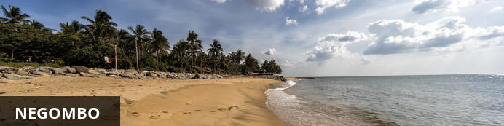
This bustling, fishing town on the west coast of Sri Lanka (and close to the Bandaranaika International Airport), had a rather turbulent colonial history involving the Dutch, Portuguese and British due to the cinnamon trade. In fact, the wild cinnamon that grew in the region was described as ‘the very best in the universe as well as the most abundant’. The remnants of this colonial period remain with the strong Catholic Church influence in the town. The Negombo Lagoon and the many canals offer superb birdwatching, the town’s Old Quarter is worth a visit, and the community is friendly and welcoming.
Spend the morning at Muthugama and later in the day leave for Negombo and stay overnight at an airport hotel.

Day 13: Depart Colombo

Transfer to airport to board your onward flight back home.

