

SL-08

Wildlife and Beach – Sri Lanka
Negombo - Wilpattu National Park - Habarana - Pasikudah
13 Days / 12 Nights

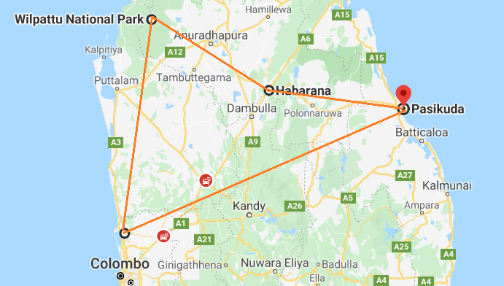

Day 1: Arrive Colombo - Negombo

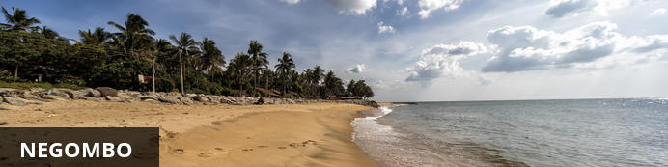
This bustling, fishing town on the west coast of Sri Lanka (and close to the Bandaranaika International Airport), had a rather turbulent colonial history involving the Dutch, Portuguese and British due to the cinnamon trade. In fact, the wild cinnamon that grew in the region was described as ‘the very best in the universe as well as the most abundant’. The remnants of this colonial period remain with the strong Catholic Church influence in the town. The Negombo Lagoon and the many canals offer superb birdwatching, the town’s Old Quarter is worth a visit, and the community is friendly and welcoming.
Flight TBA
Arrive Colombo TBA hrs
Arrive at Katunayake International Airport (BIA) where the guests will be received by their chauffeur-guide, who will take them to the hotel in Negombo (Driving Time approx. 30 minutes)
Check-in at the hotel (standard Check in time 14:00 Hrs).
Rest of the day at leisure.

Day 2: Negombo - Wilpattu National Park

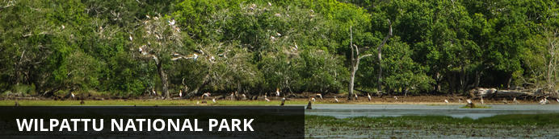
Located along the stunning west coast, the off-the-beaten-track Wilpattu National Park is set close to the historical city of Anuradhapura. Dubbed the ‘Land of Lakes’, the park’s main feature is the many natural lakes, of which the park is named, that dot the northwest coast.
Breakfast at the hotel and proceed to Wilpattu (Approx. 3 hours drive).
Evening Jeep Safari at Wilpattu National park

Wilpattu National Park
Nature lovers will delight in the unspoilt wilderness, where eagle-eyed visitors can look forward to catching a glimpse of the local wildlife. Discover the area’s history and find the ancient ruins in the park, venture through the thick untouched jungle for a true wilderness safari experience and soak up the scenic landscapes blanketed in scrublands, wetlands and thick jungle. Commonly spotted species include: leopard, elephant, mongoose, sloth bear and a variety of wetland bird species such as egret, whistling teal, spoonbill, white Ibis, and many more.
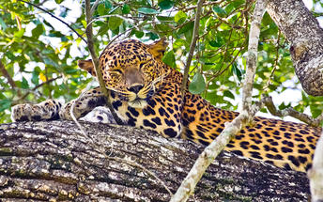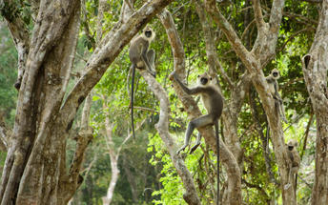

Day 3: Wilpattu National Park - Habarana

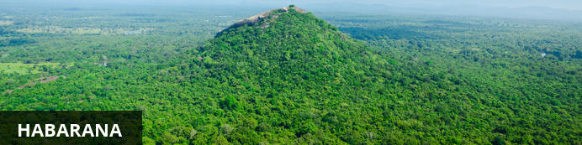
Situated towards the centre of the island of Sri Lanka, northeast of Dambulla, Habarana is the gateway to many of the region’s top attractions. The central highlight of the town is the beautiful Habarana Lake, around which bananas grow and elephants wander and bathe. Wildlife enthusiasts flock to the Minneriya and Kaudulla National Parks which are well populated with elephants and other wildlife. For those looking to take in some Sri Lankan culture, the sacred city of Anuradhapura, cave temples in Dambulla, and the UNESCO world heritage site of the Sigiriya Rock Fortress are all accessible from Habarana. A short 30 minute drive will take visitors to the magnificent Golden Buddha in Dambulla. The temple is built inside a hill, and contains five rooms filled with countless exquisite Buddha statues.
Morning Jeep Safari at Wilpattu National Park and in the afternoon drive to Habarana.
Upon arrival transfer and check in at the hotel. Rest of the day at leisure.

Day 4: Habarana

Morning Climb Sigiriya rock fortress

Sigiriya Lion Rock
The well-preserved site is one of the earliest examples of ancient urban planning and has been declared a UNESCO World Heritage Site. Sigiriya was established as a stronghold by a rogue king over 1,500 years ago, due to its elevated position which offers 360-degree views of the surrounds. The king built his palace on top of the rock, and the colourful frescoes that it was decorated with, are still visible. A gateway in the form of a lion stands on a small plateau halfway up the side of the rock, giving it its name. After the king’s death, the site was abandoned until it was taken over by a monastery, which functioned there until the 14th century.
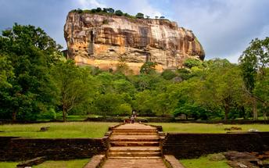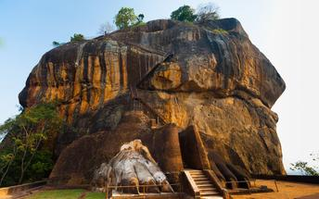
Later in the afternoon drive to Minneriya national park for a Jeep safari.

Minneriya National Park
Spreading over 8800 hectares, this is a sanctuary for elephants. Minneriya is home to herds of deer and ample birdlife, but its spotlight remains between swaying trunks & flapping ears. Park your jeep on the bank of the reservoir and switch off its engine. Watch carefully as herds of elephants - one by one - roll on to the grass-covered banks, to feed on tender shoots. In fact, this is the largest elephant gathering in the world - over 300 at a time - which has garnished the park to become a magnet for wildlife enthusiasts across the globe.

Day 5: Habarana

Breakfast at the hotel and visit Polonnaruwa historical city.

Polonnaruwa
The city is comprised of two distinct parts: the New Town area, known as Kaduruwela; and the royal ancient city of the Kingdom of Polonnaruwa, the second oldest of Sri Lanka’s ancient kingdoms. This rich archeological treasure trove contains countless fascinating ruins all conveniently grouped into one compact and easily accessible tourist site. 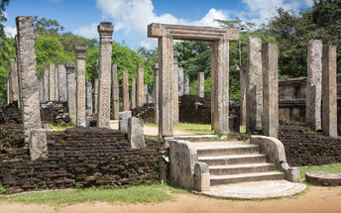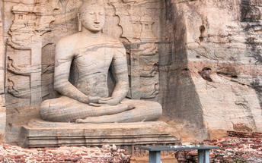
Evening Visit Dambulla cave temple

Dambulla Cave Temple
It is the largest and best-preserved cave temple complex in Sri Lanka. The rock towers 160 m over the surrounding plains. There are more than 80 documented caves in the surrounding area. Major attractions are spread over 5 caves, which contain statues and paintings. These paintings and statues are related to Lord Buddha and his life. There total of 153 Buddha statues, 3 statues of Sri Lankan kings and 4 statues of gods and goddesses. The latter include two statues of Hindu gods, the god Vishnu and the god Ganesh. The murals cover an area of 2,100 square metres. Depictions on the walls of the caves include the temptation by the demon Mara, and Buddha's first sermon.
Prehistoric Sri Lankans would have lived in these cave complexes before the arrival of Buddhism in Sri Lanka as there are burial sites with human skeletons about 2700 years old in this area, at Ibbankatuwa near the Dambulla cave complexes.

Day 6: Habarana - Pasikudah

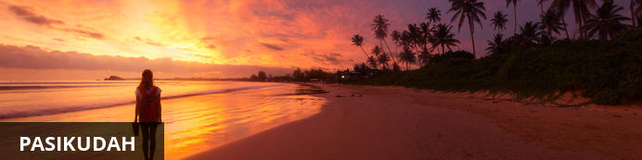
Pasikudah is a small seaside resort town known for its expansive golden bay which features one of the longest stretches of shallow coastline in the world where you can wade for 50m out to sea. This wonderful coastal setting provides an ideal environment for a range of water sports including snorkelling around the coral reef which is teeming with exotic marine life. Scuba diving around the wreck of the HMS Hermes, a WW2 British naval ship. Water skiing or whizzing around on a bouncy banana boat ride, or setting out on an exhilarating deep sea fishing adventure. Sailing trips are also available and include sunset cruises, whale watching excursions and overnight charters. Inland activities include adventurous safaris where you can trek through nature reserves where elephants and other wildlife can be spotted.
After breakfast, drive to Passikudah. (Approx. 2.5 hours’ drive). Upon arrival transfer and check in at the hotel.
Rest of the day at leisure.

Day 7-11: Pasikudah

These days are at Leisure

Day 12: Pasikudah - Negombo

After breakfast, drive your way to Makandura (Approx. 5 hours)
Upon arrival transfer and check in at the hotel. Rest of the day at leisure.

Day 13: Depart Colombo

Breakfast at the hotel. Standard check out at 1200 hrs.
In time, departure transfer from hotel to Colombo airport (Driving Time approx. 1 hour) to board flight for onward destination.
Flight TBA
Depart Colombo TBA Hrs

