

Northern Kerala Tour
Kochi - Vythiri - Thalassery - Nileshwaram
12 Days / 11 Nights
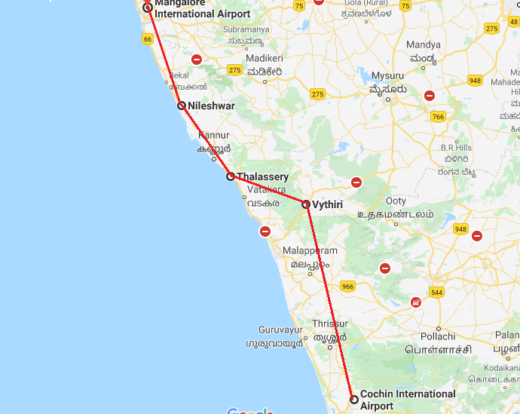

Day 1: Arrive Kochi
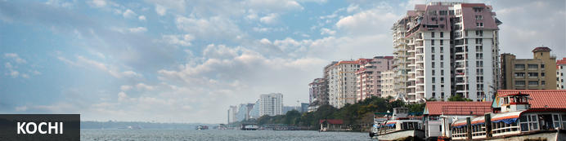
This attractive city has served as a popular port for over 600 years and is known for its eclectic architecture and its array of religious monuments, museums, galleries, cafes and antique shops. The city stretches across a number of peninsulas and islands, which can be reached by a network of water taxis and bridges. The majority of Kochi’s visitor highlights can be found on the peninsula of Fort Kochi. These highlights include the St Francis Church, the oldest European-built church in India; and Mattancherry Palace, which dates back to 1557 and contains some exceptional Kerala murals and temple art. Other must-see attractions include the Kerala Folklore Museum, displaying more than 4,000 cultural and ethnic artefacts; the 16th-century Jewish Synagogue; and the local market, where the air is filled with the aroma of exotic spices.

Flight TBA

Arrives Kochi TBA

On arrival at Kochi airport you will be received by a Travel Counsellors' representative and he will transfer you to your hotel. (Standard check in time - 1400 Hrs).

Rest of the day at leisure.

Day 2: In Kochi
Morning enjoy half day sightseeing tour of Cochin. The tour allows you to explore the charming Fort Cochin, Jewish Synagogue, Dutch Palace and St Francis church.

In the evening Enjoy Kathakali Dance Drama in a local theatre.

Jewish Synagogue (Closed on Friday afternoon and Saturdays)
This synagogue was built in 1568 by the Malabar Yehudans or Cochin Jewish community. It was built close to the Mattancherry Palace Temple on the land gifted by King Rama Varma, a former ruler of Kochi. The Mattancherry Palace Temple and the Mattancherry synagogue share a common wall. This synagogue is the oldest one in the Commonwealth of Nations.
As one approaches the synagogue on Jew Street, its white facade begins to appear very prominently. A clock tower can also be seen, towering over and close to the facade. This was built in 1760 by Ezekiel Rahabi an affluent Jewish businessman. Of the four faces of the clock, the one facing the maharaja's palace showed the time in Malayalam. And among the other three, the face with etchings in Roman numerals was meant for the traders. Of the remaining two faces of the clock, one had writings in Hebrew while the other remains blank.
Stepping inside the Synagogue, one's eyes would easily go to the glass chandeliers and blue willow-patterned Chinese floor tiles. The chandeliers are of Belgian origin. Also of interest are the Scrolls of the Law housed here and the several gold crowns received as gifts and the brass-railed pulpit. And for some exclusive pieces from history, the synagogue also houses the copper plates of privileges given to Joseph Rabban, the earliest known Cochin Jew, dating from the 10th century, written in Tamil, by the ruler of the Malabar Coast.

Dutch Palace (Closed on Friday for full day)
The Dutch Palace is a beautiful palace that was originally built by the Portuguese. It was only during the 17th century that the Dutch took it over, modified it and then presented it to the Raja of Kochi. The main attractions here are the outstanding collection of mural paintings found inside. These murals beautifully depict scenes from the Hindu epics of Mahabharatha and Ramayana.

St Francis Church
It is one of the ancient European churches in the country and is a marvellous specimen of Portuguese architecture in the country. It is a mark of the colonial struggle of the Europeans to make their presence felt in India at that time. This church, built in 1503 by Portuguese traders, was where Vasco da Gama was buried when he died in 1524 AD. However, fourteen years later, his remains were shifted to Lisbon. Earlier, the church was named after Santo Antonio which was changed by Anglican Communion after the name of patron Saint Francis. It is now considered integral to the history and tourism of Kochi. In April 1923, this church became a protected monument under the Protected Monuments Act of 1904. In 1920, the Cenotaph was set up in the memory of the inhabitants of Kochi who died in the World War-I. Apart from all this, one interesting fact to observe is that, despite being very modest in its architecture, the model of this church has been followed by many churches India.

Chinese Fishing Nets
Chinese fishing nets are a type of stationary lift net in India. They are fishing nets that are fixed land installations for fishing. While commonly known as "Chinese fishing nets" in India, the more formal name for such nets is "shore operated lift nets". Try your luck with the locals to get the fresh catch of the day with the nets.

Kathakali
Kathakali is a highly stylized classical kerala dance performance noted for its attractive make-up of characters, their elaborate costumes, detailed gestures and well-defined body movements presented in tune with the anchor playback music and complementary percussion.
Kathakali is said to have evolved from other performing arts like Kootiyattam (a classical Sanskrit drama existing in Kerala), Krishnanattam and Kalarippayattu. Kathakali explicates ideas and stories from the Indian epics and Puranas.
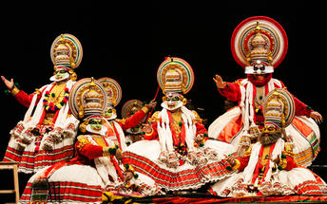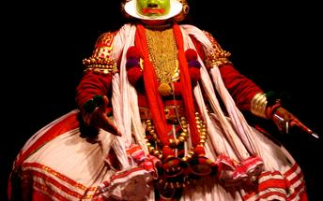

Day 3: Kochi - Calicut - Wayanad
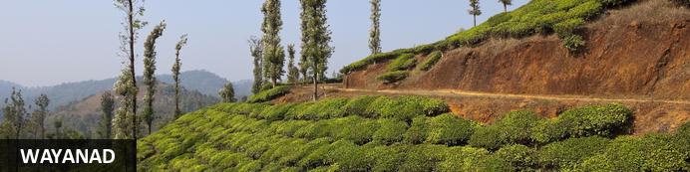
This spectacularly scenic area is ideal for trekking and is characterised by towering, mist-cloaked mountains, serene fresh water lakes, dense emerald green forests, breath-taking waterfalls, and paddy fields as far as the eye can see. Wayanad features a number of luxury resorts and elegant eco-hideaways where visitors can base themselves while exploring the many attractions on offer. Chief among these is the Wayanad Wildlife Sanctuary, which was established in 1973 and is now an integral part of the Nilgiri Biosphere Reserve. This sanctuary is one of the best place in India to spot Elephant in the wild as well as a number of other large mammals such as Indian bison, deer and tiger.
After breakfast, you will be transferred to Ernakulam Railway station to board train to Calicut.

Train Jan Shatabdi Express
Departs Cochin 0930 Hrs
Arrives Calicut 1315 Hrs

Upon arrival at Calicut Railway station, you will drive to Vythiri Resort. (Approx. 2 hours drive). On arrival you will be transferred to your hotel.

Day 4: In Vythiri (Wayanad)
Full day at leisure to enjoy the activities offered by the Resort.

Day 5: Wayanad - Thalassery
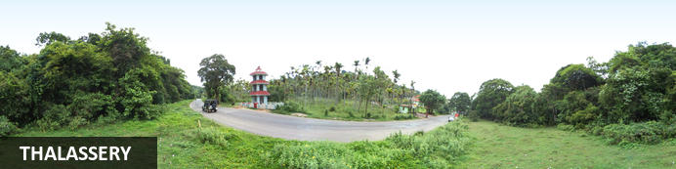
Situated on the Malabar Coast, a vibrant hub of progressive politics and culture, Thalassery offers a wide and varied range of attractions. Some key historical sights include the 18th-century Thalassery Fort, the beautifully carved Thiruvangad Sree Ramaswamy Temple and the Odathil Mosque. History lovers will want to visit Gundert Bungalow, the former home of the author of the first Malayalam dictionary. Muzhappilangad Beach offers swimming, as well as popular boat trips to near-lying and densely forested Dharmadam Island, and Thalassery Pier - built in 1910 - extends attractively into the Arabian Sea.

After breakfast, you will be driven to Thalassery. [Approx. 100 kms / 03 hours drive). Arrive Thalassery and check in at the unique homestay.

Day 6: In Thalassery
Morning after breakfast, leave with the host to the local market. Visit the spice, vegetable, Fish market, buy the fresh produce and return to the home for a hand on experience with the host to make your choice of meal for lunch.
Mrs. Faiza Moosa, the hostess conducts cooking classes to add up the entertainment to the guests. As a part of the baggage, there is always the booklet of recipes given to the guests by this master cook. No Kerala meal is complete without the spicy Biryani accompanied by Chutneys and Pickles. It is made of rice, chicken or beef and spices, which is a popular dish in Kerala. The other recipes at this place which are sure to leave your taste buds longing for more, are, pathiri, neypathil, petipathiri, muttamala, alisas, unnakai, erachipathil and of course, the yummy taste of fresh seafood recipes. The mussels, fishes and prawns are marinated and fried to give a whole new taste to the seafood.

Day 7: Thalassery - Nileshwaram
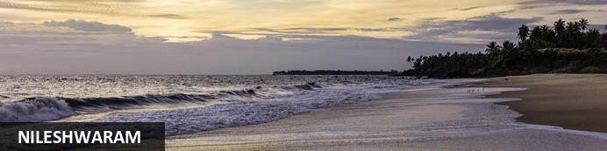
Nileshwaram is known as the state’s cultural capital, and offers an authentic experience of India. The town is abundant in folk arts, music, dance, vibrant festivals, sacred groves and ancient markets. The Theyyam Dance is a special regional dance which can be seen at several temples in Nileshwaram. Visitors can enjoy a cruise on a houseboat along one of the two rivers; visit the Thaikadappuram Beach, famous for the rare Olive Ridley Turtles; meet the skilled artisans at Weavers’ Street; and walk over the longest footbridge of Kerala spanning 400 metres. The city is also famous for its numerous yoga and natural treatment centres, where visitors can experience traditional naturopathy.

After breakfast, you will be driven to Neeleshwar, on arrival check-in at hotel. [Approx. 03 hours drive).

Day 8 & 9: In Neeleshwar
These days will be at leisure to relax at hotel, on beach or visiting the local village and interact with the locals.
Optional Excursion to Bekal Fort.

Bekal Fort
The massive yet well-maintained fort is believed to be the largest in the region. The fort was a significant military garrison housing large canyons used for defence. Besides its historical importance, the fort offers stunning views of the adjoining seashore and the Arabian Sea from its observation tower. The lawns are beautifully lush green and worth exploring from end to end.
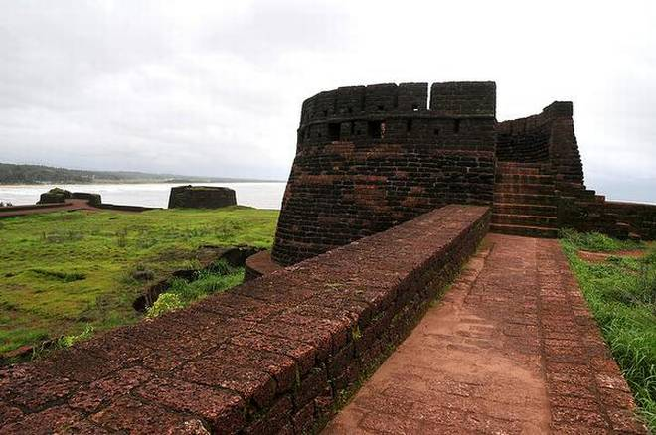

Day 10: Neeleshwar - The Lotus Houseboat, Nileshwaram
After breakfast transfer to The Lotus Houseboat and stay overnight at Houseboat.
Your cruise today covers about 25 kms of the Valiyaparamba backwater, a large inland lake several miles due east of The Hermitage. Depending on the time taken for visits en route, the journey lasts about 3 hours. It begins from Lotus Point, a small jetty about ten minutes drive south from Neeleshwar Hermitage, situated on the banks of the Tejaswini River that joins the backwaters after a long, slow descent from high above the tea and coffee plantations of the Coorg Hills.
Once you have boarded The Lotus and enjoyed a welcome drink from the staff, you will be taken to your room: either Sukhima (‘Happiness’) or Lalima (‘Beauty’) to relax and settle in. Not long after we leave the jetty a small cluster of colorful boats announces the Snake temple, dedicated to the fierce Goddess Badarkali, a delighted spot with bright carvings sacred to the local fishing community. The nearby fish-landing point attracts flocks of sea-birds that wheel and dip over the arrival of each fresh catch. These are the first of many that will accompany on your trip: black snake-necked cormorants perched on trees and posts in the water, imperiously elegant white Great Egrets, orange-breasted kingfishers with iridescent turquoise wings. As verdant islands appear ahead of us, we approach Valiyaparamba Village, a long strip of land between the backwater and the open sea. Here colored houses can be seen peeping through the dense fringe of coconut palms that lines the waterfront.
The backwater has four tides a day, so those who sail here need to know every yard of here shifting sandbanks, different depths of water and subtle changes of mood. The further south you go, the quieter the scene becomes; soon even the waterfront activity has died away and the only sound is the lapping of water or the occasional jumping of huge red snappers. Those of you who wish can fish for your own supper... Today’s cruise end with a guided visit to a small scale Women Khadi handloom industry, just 20 minutes walk from Edayilakkadu Jetty. It is a small factory being run by 12 local ladies.
Back to The Lotus for high tea and another 20 minutes cruising before we anchor in the middle of the lake for the night. Then you have time to relax on your elevated deck, watch the evening birds and fishing canoes return home for the night, and enjoy the sunset with a drink before a delicious dinner under the canopy of stars.

Day 11: In The Lotus Houseboat, Nileshwaram
The day begins with Bed Tea served with flowers; you can take it out onto your own private verandah and watch the changing light as the day begins. Breakfast is served around 9, then we move south for another hour towards the softly rolling contours of the Ezhi Elimala range. Legend has it that on his journey back from the Himalayas bearing the life-saving herbs of Ayurveda, Lord Hanuman let fall part of the sacred mountains to make these seven hills. Next to the boat whole shoals of tiny fish leap together to form one shower of silver sparks; further away fishermen wade up to their shoulders setting their nets. On land, the occasional minaret rises up above the soporific sway of coconut palms.
After an hour or so we reach Kotti jetty, from where a three-kilometer auto-rickshaw ride takes us to the remarkable temple dedicated to Lord Subramanyam, second son of Shiva. The shrine dates from about 800 AD and is the living heart of Payyannur, a town famed all over India for its expertise in the sacred science of astrology. As well as the elegant building with its fine carvings in wood and brass you can see the daily ritual when the silver image of the deity is processed three times around the temple compound. Then, quench your thirst with chai from an open-air tea- shop by the temple before heading back to The Lotus.
Relax on board after lunch on the second day. Then, after lunch proceeds back to Oori point. Enjoy the guided evening village walk in Oori village and then the boat will halt for the night near Oori point.

Day 12: Dis-embark Houseboat - Mangalore
After an early breakfast, you will dis-embark from the Houseboat and drive to Mangalore airport (approx. 2 hours drive) to board flight your flight back home.

Flight TBA

Departs Mangalore TBA

