

In Search of the wild
New Delhi – Ranthambore – Barli – Bera/Jawai – Mumbai – Gir - Mumbai
16 Days / 15 Nights
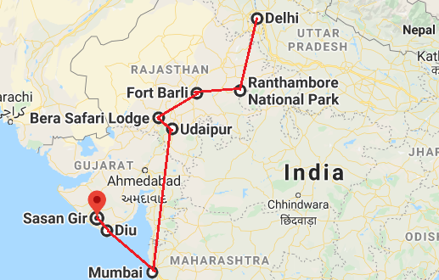

Day 1: Arrive Delhi
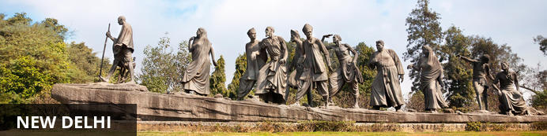
India’s largest city, Delhi, has been one of the country’s commercial and economic hubs for centuries and, as a result, is incredibly rich in culture and history. Made up of the ancient walled city of Old Delhi and the more modern sector, New Delhi, the city encompasses a staggering array of beautiful architecture, notable monuments and age-old temples, including three UNESCO World Heritage Sites – the Red Fort, Qutab Minar and Humayun's Tomb. Other key attractions include the 17th century Chandni Chowk marketplace – still one of the cities most popular retail centres today, particularly for jewellery and traditional Indian saris; and the Jama Masjid, India’s largest mosque.
On arrival in Delhi: Having cleared immigration, collected your luggage and passed through customs, please make your way towards the exit of the terminal building where you will see a bank of people waiting for you. Amongst them will be Travel Counsellors Representative who will be waiting to greet you with a paging board with your name on.
You will be transferred to your hotel and assisted with check in. Standard check in time is 1400 hrs.

Day 2: In Delhi
After breakfast, proceed for a full day sightseeing tour of Delhi, beginning with a heritage walk through Old Delhi followed by a visit through the UNESCO world heritage sites in New Delhi

Heritage Walk
Delhi is one of very few places where the ancient and modern co-exist side by side complementing each other perfectly. This Heritage walk helps you explore the Delhi’s rich, culture, heritage, history and cuisine in a fun and exciting way. The tour includes exploring the streets of Old Delhi on foot and on cycle rickshaw. The tour takes you through the narrow lanes and bazaars of Old Delhi where you will get to know about the basic ingredients used in traditional Indian meals.
Drive past the imposing India Gate, the Parliament building and the Rashtrapati Bhawan, the President’s residence.

Qutub Minar
Standing tall at 73-metres, the tower consists of 5 storeys with a flight of spiral stairs leading to its top. The walls are adorned with decorative motifs and Quranic inscriptions. At the foot of the tower lie other monuments of historical significance, such as the Quwwat-ul-Islam Mosque and the Iron Pillar of Delhi. The Amazing race Australia used this site as a pitstop in the second series. Visitors can take advantage of stunning photo opportunities.
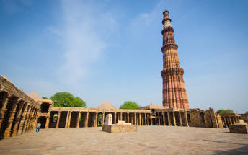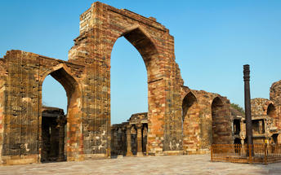

Humayun's Tomb
The mausoleum complex of Humayun, India’s second Mughal Emperor, was commissioned by his widow in 1565 and was the first garden tomb to be built in India, taking seven years to complete. Humayun had travelled widely in Persia and Central Asia during his lifetime, and many of the architectural principles he brought back from these journeys were incorporated into the building at his wife’s instructions. With its double domes, decorative inlaid marble and vast garden with pools connected by channels, this 16th Century building set the stage for the style that culminated in the Taj Mahal almost 100 years later.
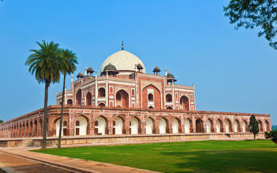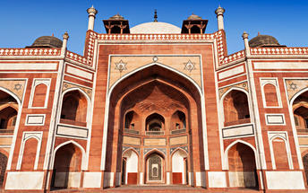

Day 3: Delhi - Ranthambore
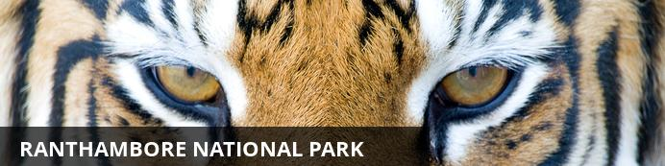
Ranthambore National Park, in the western state of Rajasthan, is one of the most visited wildlife parks in India. Spanning over an impressive 1300-square-kilometer stretch of wilderness, the park’s outstanding natural beauty is characterized by its dense jungle, golden savanna, dramatic cliffs and lotus-filled lakes. Considered the best spot to catch a glimpse of tigers in the wild, the park offers visitors a spellbounding combination of mystical temples, wild beauty and crumbling ruins. While the main attraction is undoubtedly the elusive Bengal tiger, the park provides a sanctuary for other wildlife including, among others: sambar, gazelle, caracal, black buck, crocodile, chital, wild boars and a wide array of birds. Don’t miss the ancient Ranthambore Fort, perched high on the cliffs overlooking the vast expanse of this spectacular park.
After breakfast check out from the hotel and transferred to railway station for train ride to Sawai Madhopur.
Upon arrival at Sawai Madhopur, you will be met and taken to the hotel for check in.

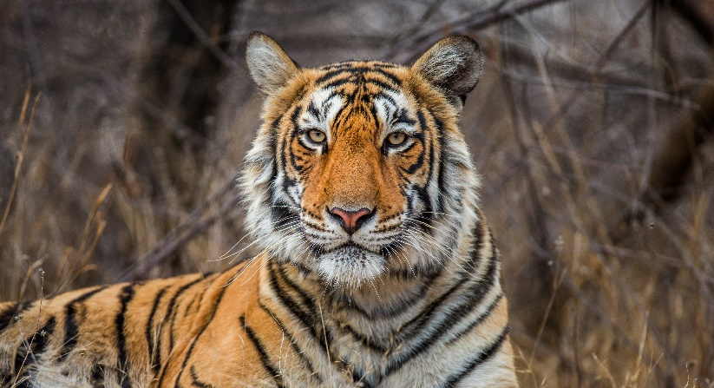
Day 4 & 5: In Ranthambore
Enjoy morning and afternoon game drive in to the park.
The game drive is either by shared jeep or by open bus (canter – max 20 person). The schedule of the game drive is :
Morning : 0600 – 0930 hrs
Afternoon : 1500 – 1800 hrs

Ranthambore National Park
In Ranthambore there is a fairly good chance of spotting a tiger. A network of four tracks crisscross the park. A maximum of three open jeeps are allowed on each trail at a time. Rides into the jungle in open jeeps are pretty safe as most of the wild animals are accustomed to human presence. Each safari takes about three hours. Best known for its tigers, it also boasts of a large number of other wild species including leopards, the highly endangered caracal, jungle cat, hyena, jackal, sloth bear, wild boar, marsh crocodile, porcupine, common langur, spotted deer, Indian gazelle, sambar (Asiatic stag) and nilgai (bluebull). Ranthambore is also rich in migratory, water, and woodland birds.

Day 6: Ranthambore - Barli

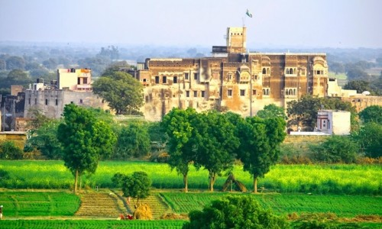
Barli is a wonderful rural village in Ajmer, in Rajasthan. It’s brilliantly located approximately three hours from Jaipur, approximately four hours from Jodhpur and just over four hours from Udaipur, making it a perfect two night stop en route. The village itself is very authentic, with tiny winding streets full of life. Here it’s possible to meet the local people, visit the school, see pottery artists at work as well as seeing their local temples.

After breakfast, you will driven to Barli. Approx. 240 Kms / 5 Hrs drive.

On arrival, check in at your hotel.

Day 7: Barli

After breakfast, explore the beautiful fort, meet with the local people, a school and the village or indulge in a ayurveda massage or attend a cooking demonstration.

Day 8: Barli – Bera/Jawai
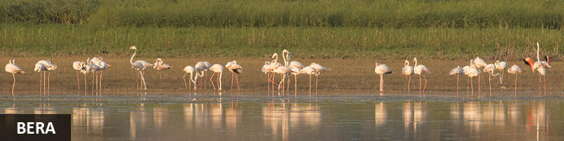
Tucked away in the Aravali mountain range, Bera is a tiny hamlet surrounded by some spectacularly scenic countryside. This surrounding wilderness area is characterised by a desert landscape of forest plains and rocky outcrops inhabited by an impressive array of wildlife species including Indian wolf, sloth bear, Indian leopard, striped hyena, golden jackal, and jungle cat.

After breakfast, you will be driven to Bera/Jawai. Approx. 240 Kms / 5-6 Hrs drive.

Day 9-10: In Bera/Jawai

Morning and afternoon enjoy guided Leopard safari in Jawai region.

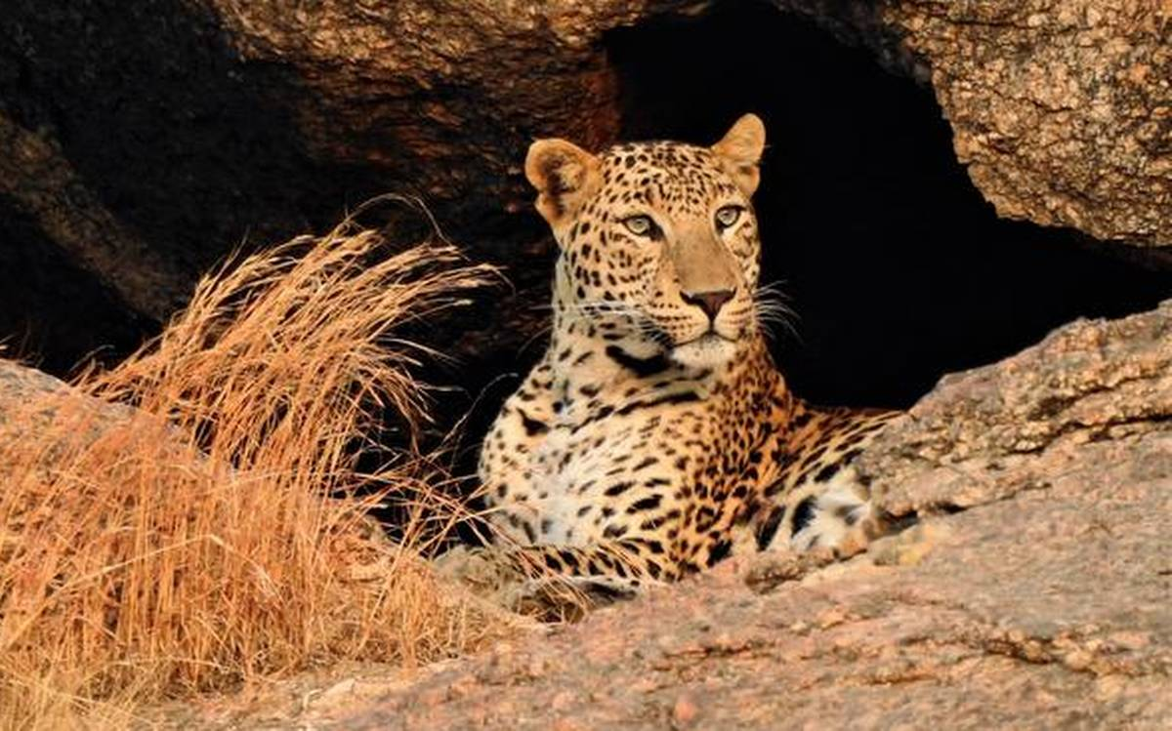
The schedule of the game drive is :

SUMMER SEASON –
Morning: 0500 – 0800 Hrs
Evening: 1700 – 2000 Hrs

WINTER SEASON –
Morning: 0630 – 0900 Hrs
Evening: 1700 – 1900 Hrs

Leopard Safari by Jeep
Jawai Conservation Reserve was established in the year 2013. This project was proposed to promote ecotourism and safeguard the wellbeing of flora & Fauna in this area.
Ancient Rocks of the pre-Cambrain period, Represents Bera in the Aravalli Range which runs diagonally across the state, The southern part of the range is formed by granite and raise to their highest summit Mt Abu (1722 msl) Bera Region lies between Kumbalgarh National Park and Mt Abu Sanctuary, this area has granite hills, These large granite formation are scattered with Anogeissus scrub, and rocky dry river beds the kopjes are scattered with religious shrines and temples. The leopards of Bera have accepted these as a part of their habitat and it is the most incredible sight to see villagers at prayer and leopards sitting quite calmly and watching the ceremonies. Traditionally the area was maintained for grazing livestock and farming, with the creation of watering holes and feeding stations for wildlife. A healthy population of 50+ Leopards is there in Bera/Jawai Region, and its one of the few places on earth where among human settlements leopards thrive, The area is Inhabited by Rabari Tribe (The Shepherds/Herdsmen) and where they is pray predators follow. The Region is also called as leopard & shepherds country and has attracted interest of many international filmmakers from BBC, National Geographic, Animal Planet and Discovery Channel.

Day 11: Bera/Jawai – Udaipur - Mumbai
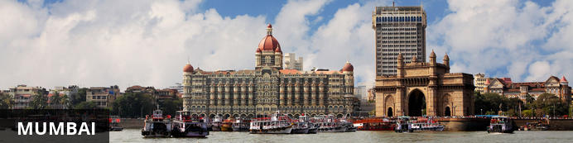
The thriving metropolis of Mumbai is a go-to destination for travellers curious to experience a modern Indian city. Lapped by the Arabian Sea, this urban seaside peninsula is a melting pot of old and new India. Towering office blocks and shiny apartment buildings shoulder crumbling grand dames of architecture. Men play cricket in the leafy central parks, taxis navigate the jam-packed streets and families stroll along the seaside promenades of Mumbai, while kilometres away children beg on the peripheries of Asia’s biggest slum. In the wide avenue of Colaba’s high street, western culture overshadows the brightly lit storefronts, where Levi’s, Adidas and McDonalds vie for retail space.
Breakfast at the hotel. Later at an appropriate time, you will be driven to Udaipur airport [Approx. 145 Kms / 3 Hrs drive] to board the flight to Mumbai.
Upon arrival at Mumbai airport, you will be assisted & transferred to the hotel for check in. Rest of the day is at leisure.

Day 12: Mumbai – Diu – Sasan Gir
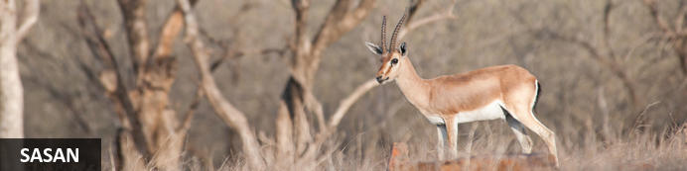
Gir National Park in Gujarat is the only place in the world where you can spot lions roaming free in the wild. The real discovery channel of India is situated approximately 65 Kms South East of Junagarh District. The Government notified the large geographical extent of Sasan Gir as wildlife sanctuary on 18th September, 1965 in order to conserve the Asiatic Lion. It covers total area of 1412 square kilometers of which 258 Km forms the core area of the National Park. Indiscriminate hunting by the people of Junagarh led to their decrease in population drastically, while they were completely wiped out from the other parts of Asia. It was the kind effort of Nawabs of Junagarh who protected the queen royalty in his own private hunting grounds. Later in due course of time Department of Forest Officials came forward to protect the world’s most threatened species. From a population of approximately 20 lions in 1913, they have risen to a comfortable 523 according to 2015 census.
Today, you will be transferred to the airport to board your flight to Diu (Note – The flight from Mumbai -Diu sector operates on the selected days in a week).
On arrival in Diu, you will be driven to Gir [Approx. 95 Kms / 2 ½ - 3 Hrs drive] followed by check-in at your hotel.

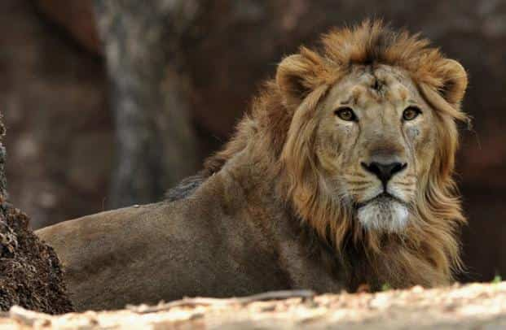
Day 13-15: Sasan Gir

Enjoy morning and afternoon game drive in to the park. The game drive is provided the by shared jeep.

The schedule of the game drive is :

Morning: 0645 - 0945 Hrs & 0830 - 1130 Hrs
Afternoon: 1500 - 1800 Hrs

Day 16: Sasan Gir – Diu – Mumbai Departure
Today, you will be driven to Diu airport [Approx. 95 Kms / 2 ½ - 3 Hrs drive] to board your flight to Mumbai. (Note – The flight from Diu - Mumbai sector operates on the selected days in a week).
On arrival in Mumbai, you will board your onward flight.
Flight TBA
Departs Mumbai TBA

