

IN - 42

Golden Triangle and Corbett National Park
New Delhi - Jaipur - Agra – New Delhi - Jim Corbett National Park – New Delhi
11 Days / 10 Nights

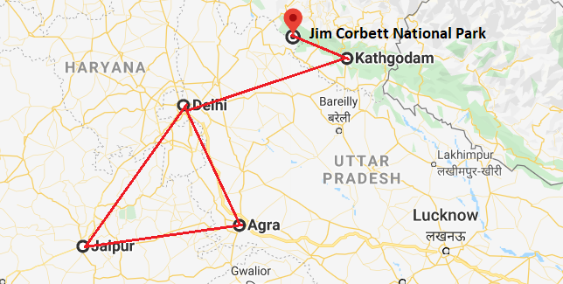

Day 1: Arrive New Delhi

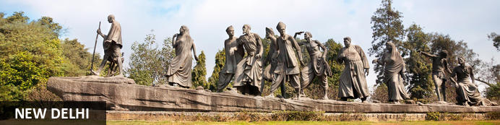
India’s largest city, Delhi, has been one of the country’s commercial and economic hubs for centuries and, as a result, is incredibly rich in culture and history. Made up of the ancient walled city of Old Delhi and the more modern sector, New Delhi, the city encompasses a staggering array of beautiful architecture, notable monuments and age-old temples, including three UNESCO World Heritage Sites – the Red Fort, Qutab Minar and Humayun's Tomb. Other key attractions include the 17th century Chandni Chowk marketplace – still one of the city’s most popular retail centres today, particularly for jewellery and traditional Indian saris; the iconic Bahà’i Lotus Temple – an award-winning architectural gem; and the Jama Masjid, India’s largest mosque.

Day Itinerary
Arrive Delhi. Upon arrival at Delhi International Airport, you will be received by our representative who will thereafter assist you for your transfer to the hotel. Hotel's check-in time is 1400 hrs.

Day 2: In New Delhi

Day Itinerary
After breakfast, proceed for a full day sightseeing tour of Old Delhi and New Delhi.

Old Delhi
Old Delhi is an ancient walled city, also known as Shahjahanabad. The city was founded in the 17th century during the reign of the Mughal emperor, Shah Jahan. Old Delhi once boasted fourteen great gates, mansions, the Red Fort, a congregational mosque and elegant gardens. Today, some of its ruins still stand making it a symbolic city as well as a famous attraction for tourists and locals alike.

Chandni Chowk
Chandni Chowk – meaning ‘moonlit square’ – is one of the city’s oldest, busiest and most famed shopping areas, built in the 17th century and originally intersected by (now defunct) canals that were designed to capture and reflect the moonlight. It’s a shopper’s paradise – with an eclectic diversity of wares ranging from traditional Indian sweets and other delicacies, to leather goods, electronics, intricately embellished saris and tailor-made suits. But even if you’re not up for any retail therapy, the sights, sounds and atmosphere of this pulsing, labyrinthine marketplace are captivating enough in their own right.
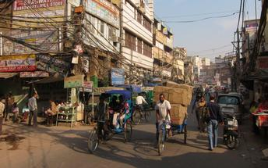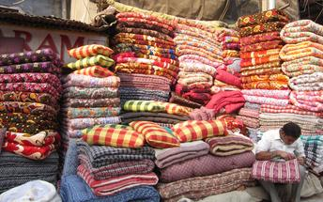

Raj Ghat
Raj Ghat is a memorial to Mahatma Gandhi, marking the spot where he was cremated after his assassination in 1948. Housed in an open-air garden area inside a walled complex, the memorial consists of a simple, flat black platform (reflecting the simplicity of Gandhi’s life) that is kept constantly decorated with an abundance of fresh flowers. An eternal flame burns at one end, symbolising the ever-lasting legacy of this great man. Two museums devoted to Mahatma Gandhi, his life and teachings are located nearby.
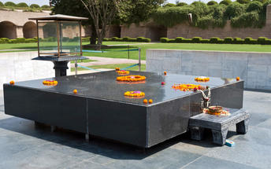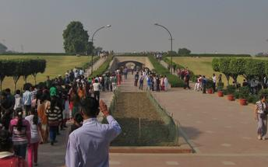

Qutub Minar
Standing tall at 73-metres, the tower consists of 5 storeys with a flight of spiral stairs leading to its top. The walls are adorned with decorative motifs and Quranic inscriptions. At the foot of the tower lie other monuments of historical significance, such as the Quwwat-ul-Islam Mosque and the Iron Pillar of Delhi. The Amazing race Australia used this site as a pitstop in the second series. Visitors can take advantage of stunning photo opportunities.
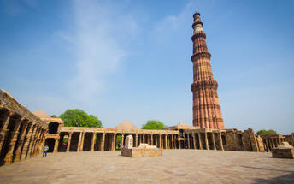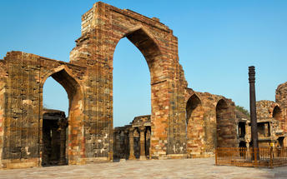

Humayun's Tomb
The mausoleum complex of Humayun, India’s second Mughal Emperor, was commissioned by his widow in 1565 and was the first garden tomb to be built in India, taking seven years to complete. Humayun had travelled widely in Persia and Central Asia during his lifetime, and many of the architectural principles he brought back from these journeys were incorporated into the building at his wife’s instructions. With its double domes, decorative inlaid marble and vast garden with pools connected by channels, this 16th Century building set the stage for the style that culminated in the Taj Mahal almost 100 years later.
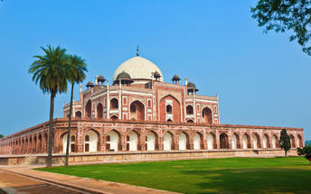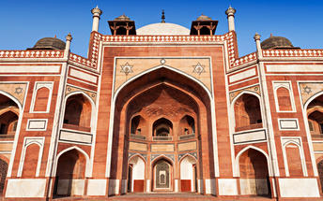

Day 3: New Delhi - Jaipur

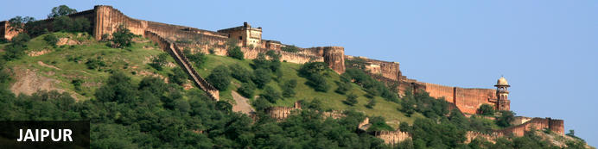
This city is famed for being India’s first planned city featuring a multitude of pink terracotta buildings within the walled historic centre, earning it the nickname,’The Pink City’. Jaipur falls within the Golden Triangle, a popular tourist circuit, which includes Delhi, Jaipur and Agra, and serves as a gateway to the neighbouring desert cities of Jaisalmer and Jodhpur. This colourful city is a combination of tradition and modernity and offers visitors vibrant bazaars, lavish palaces and ancient temples. The salmon-hued old city is home to the opulent City Palace, encompassing an impressive assortment of palatial structures, sprawling gardens, courtyards and buildings. Don’t miss the fairy-tale splendour of the Amber Fort, set against the backdrop of the arid landscape.

Day Itinerary
Morning, after breakfast, you will drive to Jaipur (260 Kms/ 06 Hrs approx). Upon arrival, transfer to the hotel. Check-in at hotel.

Day 4: In Jaipur

Day Itinerary
After breakfast, proceed for a full day tour of Jaipur, visiting Amer Fort (en-route photo stop at Hawa Mahal – Palace of Winds), City Palace and Astronomical Observatory.

Amer Fort
Amer Fort, officially known as the ‘Amer Palace’, is one of the most famous forts of Rajasthan attracting around 4000 to 5000 visitors a day during peak tourist season. The palace was named after the small town of Amer, where it is situated - only eleven kilometres from Jaipur. Perfectly picturesque, this 16th century hillside residence is well preserved, boasting grand pavilions and mirrored halls that open onto flourishing gardens and courtyards. Although the palace’s main construction started in 1592 by Maharaja Man Singh, it was added to over the years by successive rulers and continued to be occupied by them until Jaipur was built.
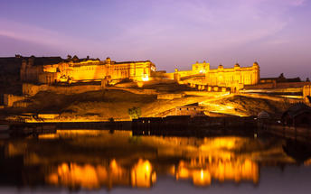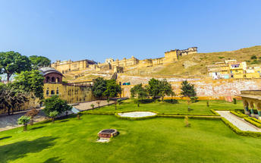

Photo stop at Hawa Mahal (Palace of Winds)
One of Jaipur’s most recognised buildings, the Hawa Mahal (Palace of Winds) is known for its iconic façade. Small windows, decorated with intricate latticework create a honeycomb-like appearance. The original intention of the lattice was to allow the royal ladies to observe everyday life in the street below without being seen. The cooling effect, provided by the breeze passing through the small windows, gave the palace its name. Built in 1799 by Maharaja Sawai Pratap Singh, the unique construction was originally designed to look like the crown of Krishna. A panoramic view of Jaipur can be had from the top of the building.
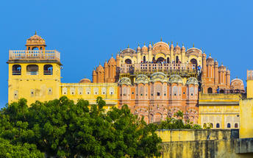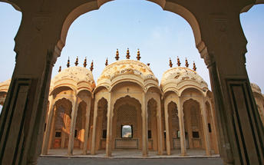

Jaipur City Palace
City Palace forms one of the most famous tourist attractions and a major landmark in Jaipur. The beautiful palace was built by Maharaja Sawai Jai Singh during his reign. Among the various forts and palaces of Jaipur, City Palace stands apart, with its outstanding art and architecture.
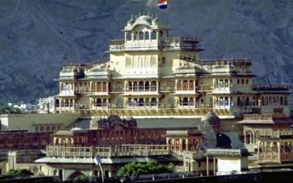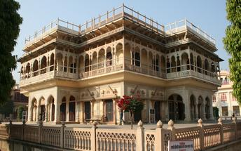

Jantar Mantar Jaipur
Built by Jai Singh, the first Maharaja of Jaipur who founded the city in 1727, the observatory is one of a handful. Jai Singh, fulfilling a lifelong interest in mathematics and astronomy, built observatories in Delhi, Jaipur, Ujjain, Mathura and Benares. The Jaipur observatory is the largest and best preserved of these.
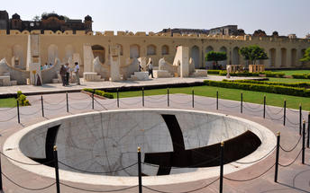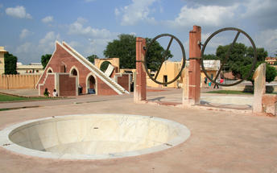

Day 5: Jaipur - Agra

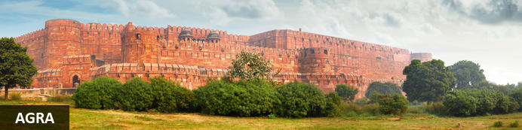
Home of the world-famous Taj Mahal, Agra is one of India’s prime tourist destinations for specifically this reason, though its attractions also extend to an array of other impressive historical sights. These include the red-hued Agra Fort, the sacred Jama Masjid mosque and Itmad-ud-Daulah’s tomb, with its white marble facade embellished with intricate inlaid designs and semi-precious gems. The Taj, however, is in a league of its own and needless to say is a must-see for any visitor to the city. Commissioned by the Mughal emperor Shah Jahan in the 15th century as a memorial to his beloved wife Mumtaz Mahal, it is an architectural masterpiece of exquisite craftsmanship and perfect proportions.

Day Itinerary
Morning, after breakfast, you will drive onwards to Agra (250 Kms/ 06 Hrs approx.) with an en-route visit to Fatehpur Sikri.

Fatehpur Sikri
This world heritage site is rated as one of the best preserved collections of Mughal architecture in India. Surrounded by a six kilometre wall, with the fourth being a lake at the time, a day can be spent exploring the elaborate structures within. Marvel at the impressive Jama Masjid mosque, the detailed palaces built for Emperor Akbar’s wives, the public and private discussion halls and vast ornamental pool; all of which took over 15 years to conceptualise and build.
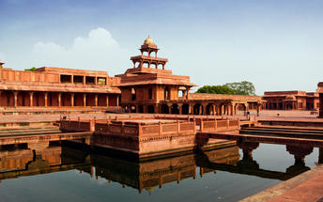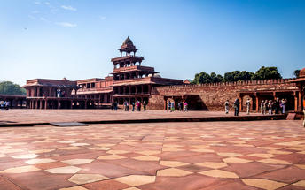
Upon arrival at Jaipur, you will be transferred to your hotel.

Day 6: Agra – Delhi
xx

Day Itinerary
Morning visit Taj Mahal at Sunrise. Later return to the hotel for breakfast. Thereafter in the morning visit Agra Fort and leave for Delhi – with a visit of Itmad-ud-daula (Baby Taj) enroute. (Hotel’s check-out time is 1200 hrs).

Taj Mahal (Closed on Fridays)
The iconic Taj Mahal is not only an architectural masterpiece, a UNESCO World Heritage Site and one of the new Seven Wonders of the World – it’s also the enduring legacy of a royal love story. It was commissioned in the 15th century by the Mughal Emperor Shah Jahan after the death of his third and favourite wife, Mumtaz Mahal, to serve as her final resting place and a symbol of his eternal affection for her. Combining Islamic, Persian, Ottoman Turkish and Indian design elements, it’s an awe-inspiring structure of elegant domes and white marble, which changes colour along with the light – pink at sunrise, pearly white in the afternoon and silver-gold in the full moon.
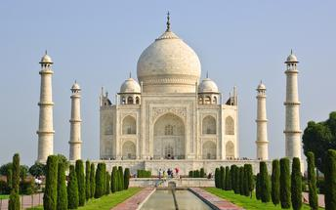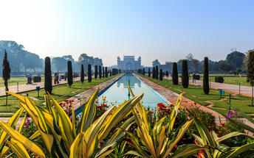

Agra Fort
Known as the Red Fort of Agra, this walled imperial city was founded in 1565 by the Emperor Akbar (1556-1605) and is a well-deserving UNESCO World Heritage site, located just 2.5 kilometres from the famous Taj Mahal. Its palaces, grand mosques and elaborate public hall are crafted from pink-red sandstone and are testament to an era when Indo-Muslim art, strongly marked by influences from Persia, was at its height. Emperor Shah Jahan, who built the Taj Mahal for his deceased wife, was imprisoned by his son Aurangzeb in Agra Fort. He is said to have died in the Musamman Burj, a marble tower he himself built, with one of the most alluring views of the Taj Mahal.
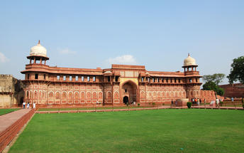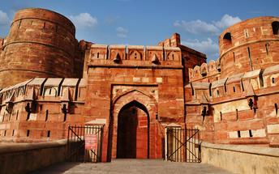

Tomb Of Itmad-Ud-Daulah (Baby Taj)
Tomb of I'timad-ud-Daulah is a Mughal mausoleum built for the grandfather of the Mumtaz Mahal, who the Taj Mahal was in turn built for. The tomb colloquially known as the "jewel box", or the "Baby Taj".
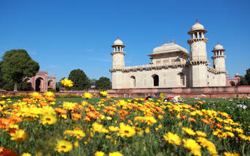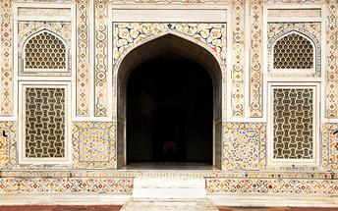

After the visits, proceed to Delhi (210 Kms/ 05 Hrs approx.). Upon arrival, Check-in at the hotel in Delhi

Day 7: Delhi - Corbett
xx
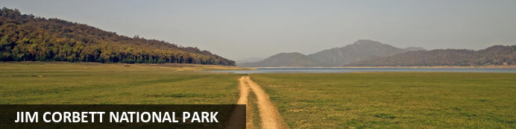
Jim Corbett National Park forms part of the larger Corbett Tiger Reserve and is the oldest national park in India. This forested wildlife sanctuary is known for its rich variety of fauna and flora. Established in 1936 to protect the endangered Bengal tiger, the park is an ecotourism destination which offers visitors exhilarating wildlife safaris, rich biodiversity and breath-taking landscapes. It is home to an abundance of wildlife including: 110 kinds of trees, 50 species of mammals, 25 species of reptiles as well as over 600 species of birds such as the crested serpent eagle, blossom-headed parakeet and the red jungle fowl.
Afternoon at appropriate time, you will be transferred to railway station to board the train to Ramnagar.
Train UTR SAMPRK Express
Departs Delhi 1600 Hrs
Arrives Ramnagar 2055 Hrs

Upon arrival at Ramnagar, you will be transferred to Corbett (approx. 30 minutes drive), on arrival check-in at hotel.

Day 8 & 9: In Corbett

Day Itinerary
Enjoy morning and afternoon shared jeep safari at the Jim Corbett National Park.

Jim Corbett National Park
Jim Corbett National Park is one of the best natural destinations where the richest concentrations of animals occur. Game drives in an open jeep safari vehicles are the best way to discover the beauty and wilderness. Sheltering a healthy population of tigers and rare species like Otters and the endemic fish eating crocodile, the national park is one of the most sought after destinations for the wildlife buffs.

Day 10: Corbett - Delhi

Morning at appropriate time, you will be transferred to Ramnagar railway station to board the train to Delhi.
Train RMR DLI Link Express
Departs Ramnagar 1000 Hrs
Arrives Delhi 1525 Hrs

Upon arrival in Delhi, you will be met and transferred to your hotel.

Day 11: Depart Delhi

Day Itinerary
At an appropriate time, you will be assisted & transferred to Delhi airport to board your flight back home.
(Hotel’s check-out time is 1200 hrs).

