

IN - 44

Rajasthan tour with heritage properties
Delhi - Churu - Jaipur - Shahpura - Barli - Jodhpur - Jojawar – Udaipur - Delhi
18 Days / 17 Nights
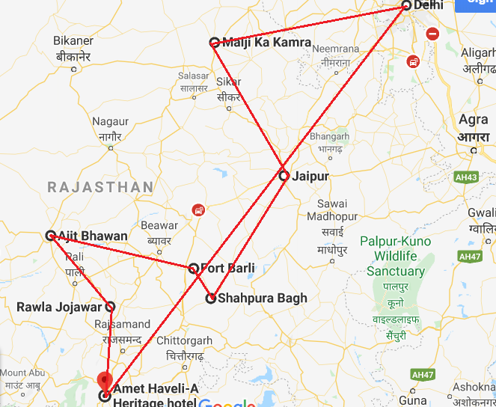

Day 1: Arrive Delhi
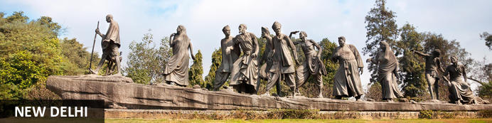
India’s largest city, Delhi, has been one of the country’s commercial and economic hubs for centuries and, as a result, is incredibly rich in culture and history. Made up of the ancient walled city of Old Delhi and the more modern sector, New Delhi, the city encompasses a staggering array of beautiful architecture, notable monuments and age-old temples, including three UNESCO World Heritage Sites – the Red Fort, Qutab Minar and Humayun's Tomb. Other key attractions include the 17th century Chandni Chowk marketplace – still one of the city’s most popular retail centres today, particularly for jewellery and traditional Indian saris; the iconic Bahà’i Lotus Temple – an award-winning architectural gem; and the Jama Masjid, India’s largest mosque.
On arrival in Delhi: Having cleared immigration, collected your luggage and passed through customs, please make your way towards the exit of the terminal building where you will see a bank of people waiting for you. Amongst them will be Travel Counsellors Representative who will be waiting to greet you with a paging board with your name on.
You will be transferred to your hotel and assisted with check in. (Standard check in time at hotel is 1400 hrs).
Rest of the day is at leisure

Overnight: The Claridges
Built in 1952, The Claridges offers elegance and contemporary luxury in close proximity to the capital’s bustling commercial and cultural centers. The hotel offers exquisitely appointed rooms and suites, an array of celebrated dining options, as well as dedicated leisure and business facilities. Hotel facilities also include a delightful temperature controlled swimming pool, complete with sun decks, cabanas, loungers and a bar, where guests can savor exotic cocktails, amidst uplifting music and ambient lighting. Surrounded by expansive lawns, the hotel is designed to offer Indian warmth and hospitality.
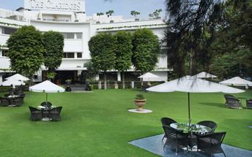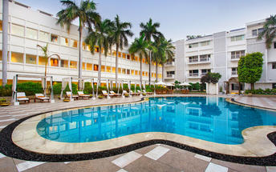

Day 2: Delhi
After breakfast, proceed for a full day sightseeing tour of Delhi, beginning with a heritage walk through Old Delhi followed by a visit through the UNESCO world heritage sites in New Delhi

Heritage Walk
This ancient history and influx of people from all over the world has given Delhi a culture and heritage matched by only a handful of places. Delhi is one of very few places where the ancient and modern co-exist side by side complementing each other perfectly. Our heritage walks of Delhi are a perfect way of exploring this amalgam of old traditions, modern development and the unique heritage which makes it so interesting. These heritage walks are a perfect way to explore some of the lesser visited places and gain a new insight about the history, people and sights of Delhi city.
Drive past the imposing India Gate, the Parliament building and the Rashtrapati Bhawan, the President’s residence.

Qutub Minar
Standing tall at 73-metres, the tower consists of 5 storeys with a flight of spiral stairs leading to its top. The walls are adorned with decorative motifs and Quranic inscriptions. At the foot of the tower lie other monuments of historical significance, such as the Quwwat-ul-Islam Mosque and the Iron Pillar of Delhi. The Amazing race Australia used this site as a pitstop in the second series. Visitors can take advantage of stunning photo opportunities.
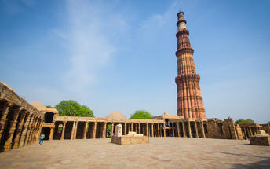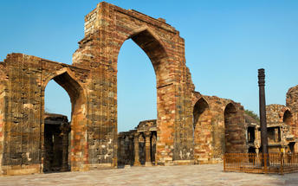

Humayun's Tomb
The mausoleum complex of Humayun, India’s second Mughal Emperor, was commissioned by his widow in 1565 and was the first garden tomb to be built in India, taking seven years to complete. Humayun had travelled widely in Persia and Central Asia during his lifetime, and many of the architectural principles he brought back from these journeys were incorporated into the building at his wife’s instructions. With its double domes, decorative inlaid marble and vast garden with pools connected by channels, this 16th Century building set the stage for the style that culminated in the Taj Mahal almost 100 years later.
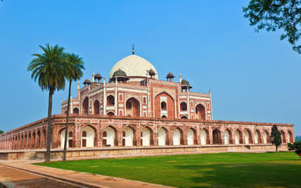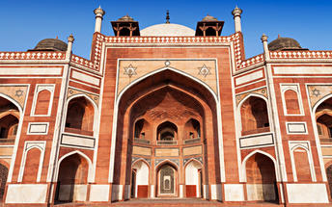

Day 3: Delhi - Churu

This charming city in the Thar Desert is often used as a stopover on rail journeys to or from Bikaner, and boasts some notable cultural sights. Begin at the grand Churu Fort, a 1739 structure with ornate carvings and the on-site Gopinath Temple, before continuing to the 18th-century memorial of Aath Kambh Chhatri (Eight Pillar Dome), located near Churu’s bustling vegetable market. Other key sights include the city’s collection of havelis (traditional mansions): Kanhaiya lal Bangla ki Haveli features incredible frescoes, and the walls of Surana Haveli are inlaid with hundreds of small windows. Finally, nature lovers will relish an excursion to the Tal Chhapar Sanctuary (85 kilometres away), which is home to blackbuck and several rare bird species.

Breakfast at the hotel and later leave for Churu (approx. 6 hours). Upon arrival in Churu, you will be transferred to Malji Ka Kamra.

Overnight: Malji Ka Kamra
Malji Ka Kamra is a century old, restored mansion (haveli). The turquoise blue, Wedding cake like tiered structure is an architectural marvel – a unique combination of Shekhawati’s famous fresco paintings with European pillared architecture, Italian art-deco influences and Mughal style doors and arches.
One of the most remarkable merchant havelis in region, the property works as a unique gateway to discover Shekhawati’s “open art gallery” beyond its touristic town of Mandawa. Churu’s havelis, quiet and unhustled as they are, serve as a fresh breath of air and take you to a different era of artistic beauty. At the same time, there is much to discover in town making it one of the best Rajasthan experiences – if your idea of a travel involves knowing the people, their story and culture, enjoying your own space in tranquil environment and not simply finding the monuments.
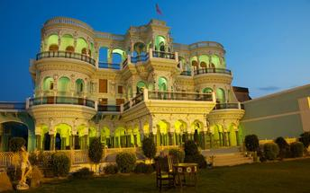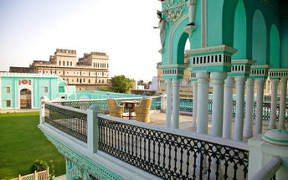

Day 4: In Churu
After breakfast enjoy a Heritage walking tour.
Go back centuries and dream about camels, caravans, traders and their lifestyles in the desert. Go back to the British colonial times and think of banking channels, moneylenders, and baniyas. Or think of contemporary India and its family has driven business empires, enterprise and the quintessential, thrifty Marwari Seths in all corners of India – the Marwari community is at the heart of it. Churu is a 450-year-old town and is a homeland to Marwaris – India’s most successful business community since the time of Mughals. This guided tour offers the opportunity to explore town’s old quarter: majestic havelis, beautiful fresco paintings, knowing untold stories and people behind this entire legacy… Immerse yourself in immaculate works of art all around you. Get transported to another era in the treasure trove of havelis’ fading, crumbling glory in the maze of streets of this secret town.
Remainder of the day at leisure.

Day 5: Churu - Jaipur
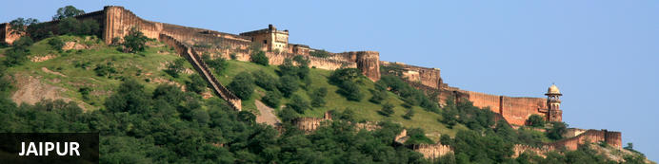
Fringed by the rugged Aravali Hills, Jaipur is the capital and largest city in India’s northern state of Rajasthan. This city is famed for being India’s first planned city featuring a multitude of pink terracotta buildings within the walled historic centre, earning it the nickname,’The Pink City’. Jaipur falls within the Golden Triangle, a popular tourist circuit, which includes Delhi, Jaipur and Agra, and serves as a gateway to the neighbouring desert cities of Jaisalmer and Jodhpur. This colourful city is a combination of tradition and modernity and offers visitors vibrant bazaars, lavish palaces and ancient temples. The salmon-hued old city is home to the opulent City Palace, encompassing an impressive assortment of palatial structures, sprawling gardens, courtyards and buildings. Don’t miss the fairy-tale splendour of the Amber Fort, set against the backdrop of the arid landscape.
After breakfast, you will be driven to Jaipur [approx.. 04 Hrs ].
On arrival in Jaipur, check in to hotel.

Overnight: Alsisar Haveli Heritage Hotel
The Alsisar Haveli is a heritage hotel situated in Jaipur. The hotel is centrally based making it convenient for guests to visit tourist attractions such as the Hawa Mahal, Jantar Mantar, Amer, Nahargarh and Jaigarh.
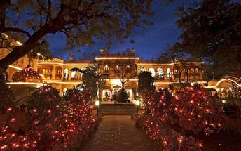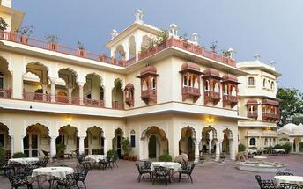

Day 6: Jaipur
After breakfast, proceed for a full day tour of Jaipur, visiting Amer Fort, City Palace and Astronomical Observatory Take a photo stop at Hawa Mahal – Palace of Winds.

Amer Fort
Amer Fort, officially known as the ‘Amer Palace’, is one of the most famous forts of Rajasthan attracting around 4000 to 5000 visitors a day during peak tourist season. The palace was named after the small town of Amer, where it is situated - only eleven kilometres from Jaipur. Perfectly picturesque, this 16th century hillside residence is well preserved, boasting grand pavilions and mirrored halls that open onto flourishing gardens and courtyards. Although the palace’s main construction started in 1592 by Maharaja Man Singh, it was added to over the years by successive rulers and continued to be occupied by them until Jaipur was built.
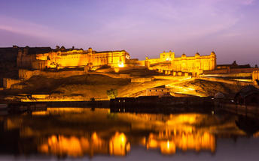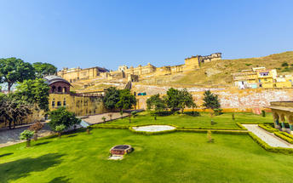

Photo stop at Hawa Mahal (Palace of Winds)
One of Jaipur’s most recognised buildings, the Hawa Mahal (Palace of Winds) is known for its iconic façade. Small windows, decorated with intricate latticework create a honeycomb-like appearance. The original intention of the lattice was to allow the royal ladies to observe everyday life in the street below without being seen. The cooling effect, provided by the breeze passing through the small windows, gave the palace its name. Built in 1799 by Maharaja Sawai Pratap Singh, the unique construction was originally designed to look like the crown of Krishna. A panoramic view of Jaipur can be had from the top of the building.

Jaipur City Palace
City Palace forms one of the most famous tourist attractions and a major landmark in Jaipur. The beautiful palace was built by Maharaja Sawai Jai Singh during his reign. Among the various forts and palaces of Jaipur, City Palace stands apart, with its outstanding art and architecture.
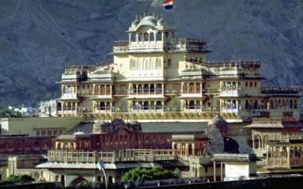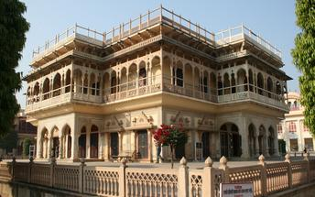

Jantar Mantar
Built by Jai Singh, the first Maharaja of Jaipur who founded the city in 1727, the observatory is one of a handful. Jai Singh, fulfilling a lifelong interest in mathematics and astronomy, built observatories in Delhi, Jaipur, Ujjain, Mathura and Benares. The Jaipur observatory is the largest and best preserved of these.
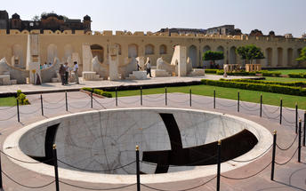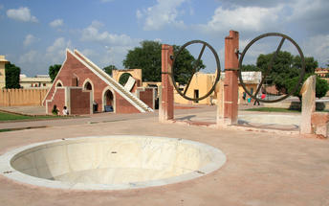

Day 7: Jaipur - Shahpura
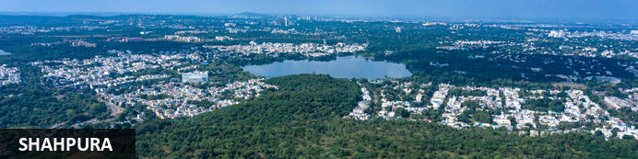
Shahpura serves as a midway stopover between Jaipur and Udaipur. This city is a little oasis amidst the dry hills of Rajasthan and is a place of pilgrimage for the Ram Snehi, a spiritual and religious group with traditions originating in the early 19th century. Shahpura is primarily untouched by modernity and seems eternally preserved in time. Surrounded by over 250 small lakes, the area is a bird watching paradise and an idyllic setting for visitors to enjoy boating on Shahpura’s picturesque lake. Other attractions include: the Ramdwara Temple, an ancient place of worship; the annual Phooldol Mela, a five-day religious festival; and the ancient, crumbling Dhikhola Fort, a great location for visitors to enjoy evening sundowners with views of the expansive landscape.
After breakfast, you will be driven to Shahpura Bagh [approx.. 04 Hrs ].
On arrival in Shahpura, check in to hotel.

Overnight: Shahpura Bagh
This establishment has been a summer residence for the rulers of Shahpura Bagh and has since become an attraction for travellers. Shahpura Bagh has 5 royal suites & 4 deluxe rooms with comfortable amenities. The rooms are decorated with antique paintings and photographs of the Shahpura rulers. Shahpura is known for their appreciation for traditional food and the meals served at the Shahpura Bagh are authentic and prepared over wood fire.
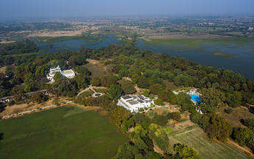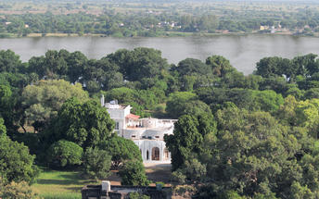

Day 8: Shahpura
Breakfast at hotel.
Enjoy activities/ tour offered at this unique home.
A trip into Shahpura reveals the town’s rich multi-cultural vibrancy and its fascinating arts and crafts tradition. Visit the organic farm, a local school, the village and the fort are some of the activities one can do here.
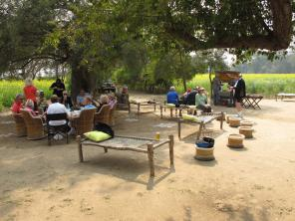 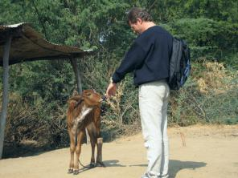

Day 9: Shahpura – Barli
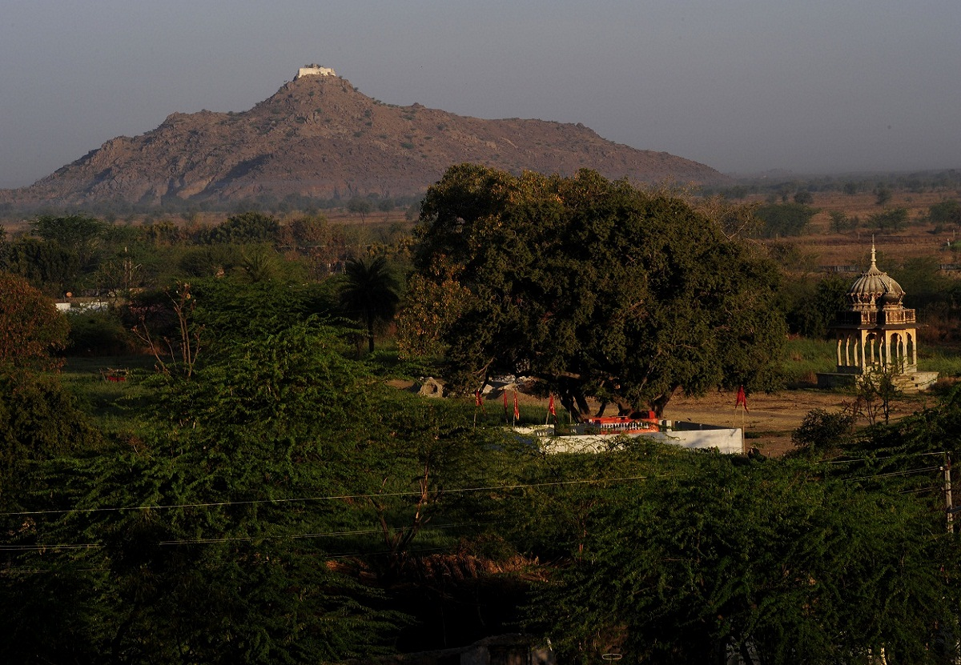

Barli
The small rural village of Barli is conveniently set halfway between Jaipur and Jodhpur. The village boasts narrow winding streets lined with colourful market stalls. The surrounding landscape is characterised by verdant rolling hills peppered with sacred temples, ancient ruins, and an impressive fort. The undoubtable highlight of the village is Fort Barli, a beautifully restored and converted fort featuring eight elegant rooms. Visitors can immerse themselves in authentic everyday life in this small Indian village, visit the nearby Lake Dev Sagar for excellent hiking and bird watching opportunities, and browse the locally-made handicrafts including jewellery, pottery, and woven carpets.
After breakfast, you will be driven to Barli [approx.. 02 Hrs ].
On arrival in Barli, check in to hotel.
Afternoon explore the village and inter-act with the locals.

Overnight: Fort Barli
Fort Barli is a heritage hotel which maintains its traditional structure whilst providing modern amenities and services.
There's lots to experience in and around Fort Barli. Visitors can relax and rejuvenate in a rural setting away from the hustle bustle of the cities and experience the real Rajasthan! Property has large appointed rooms with big windows and excellent views of the countryside. The guests can indulge in may activities that we offer- Bullock cart ride, Wellness retreat program, Birding tour, Heena , Astologer, Yoga, Cooking Demonstration,Traditional massage, Royal Dressing, Royal Traditional Dinner, Fort tour, Alfresco dining, Romantic dinner, cycling etc.
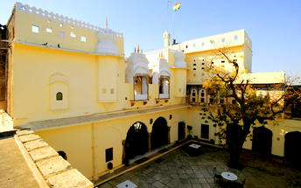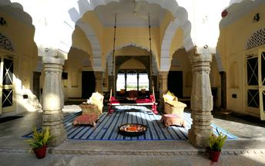

Day 10: Barli - Jodhpur
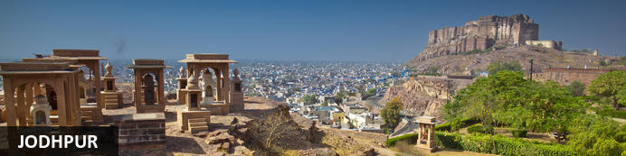
Known as the gateway to the Thar Desert, Jodhpur is the second largest city in the state of Rajasthan, India. It is a popular tourist destination featuring a variety of ornate palaces, age-old forts and sacred temples. Dubbed “The Blue City", most houses in the old city are painted a beautiful shade of indigo. While Jodhpur is largely a sprawling modern metropolis, enclosed within its old city walls is a labyrinth of winding, narrow medieval streets and bazaars. Jodhpur is home to one of the largest forts in India, the massive 15th-century Mehrangarh Fort, which towers over the city from its sandstone plinth. Other must-see attractions include: the Umaid Bhawan Palace, one of the world's largest private residences; and the Jaswant Thada, an intricately carved white marble mausoleum.
After breakfast, you will be driven to Jodhpur [approx.. 05 Hrs ].
On arrival in Jodhpur, check in to hotel.

Overnight: Ajit Bhawan
Ajit Bhawan is a palace resort which often plays host to royalty and artists. The accommodation structure comprises of an assortment of rooms and suites decorated with antiques and photographs.
Recreational activities available at the Ajit Bhawan is the swimming pool, gym, spa, health center, village and desert safaris, shopping arcade as well as a variety of dining venues.
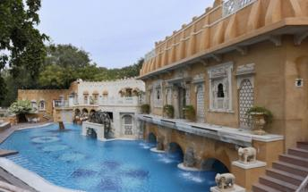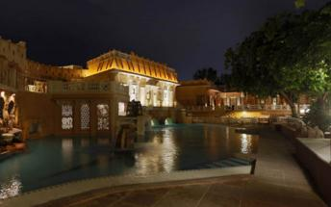

Day 11: Jodhpur
After breakfast, explore the "Blue city" of Jodhpur visiting the majestic Mehrangarh Fort, Jaswant Thada – the royal cenotaphs and the interesting markets around the Clock-Tower.

Mehrangarh Fort
Mehrangarh Fort rises four hundred feet above the skyline of Jodhpur from its rock precipice on Bhaurcheeria hill. The foundation of Mehrangarh Fort was laid on May 12, 1459 by Rao Jodha, the fifteenth Rathore ruler who wanted to shift the capital from nearby Mandore to Jodhpur. In all its history, Mehrangarh Fort has never been taken in a siege. Mammoth and imposing from the outside, the interiors of the fort are light and detailed in contrast. Several palaces can be found inside the complex, boasting intricate carvings and sprawling courtyards.
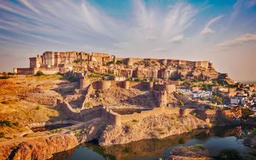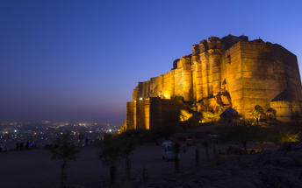

Jaswant Thada
Jaswant Thada, popularly known as the ‘Taj Mahal of Marwar’, this architectural landmark was built in 1899 by Maharaja Sardar Singh of Jodhpur State, in memory of his father, Maharaja Jaswant Singh I. Built from intricately carved marble sheets and boasting some beautiful carved marble lattice work, the impeccable design and architecture is symbolic of the fine craftsmanship of a bygone era. Beautiful sculptures, carved gazebos and frescos characterise the cenotaph, with the tiered garden offering superb views across to the fort and over the city.
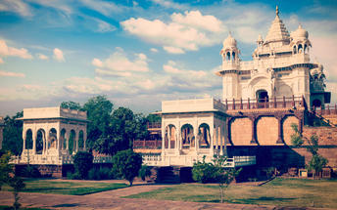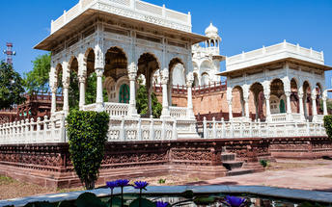

Day 12: Jodhpur - Chanoud Garh
After breakfast, you will be driven to Chanoud Garh [approx.. 03 Hrs ].
On arrival in Chanoud, check in to hotel.
Afternoon enjoy the walk around the Fort to explore.

Overnight: Chanoud Garh
Chanoud Garh is a carefully preserved 300-year-old palace. This 200 000 square foot property has been home to 13 generations of the descendants of Thakur Anoop Singh ji, who built the palace. Guests find themselves ensconced within small snippets of history. These include the delicate stone filigree Jharokhas, the rough marble pillared corridors, the Grand Durbars, the winding doorways that lead to courtyards or opulent lawns and the strong colonial and local influence in the rooms. There are seven meticulously renovated spacious deluxe suites to choose from. Each suite is unique in its décor and its stories, but all are furnished with the most modern of amenities, that are masterfully hidden in its authentic interiors. The palace kitchen serves up traditional cuisine and guests can partake in a village experience, either by jeep, camel or on a guided walk.
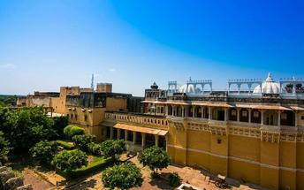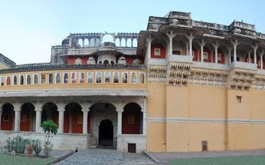

Day 13: Chanoud Garh
This day will be at leisure OR take part the visits / other experiences offered at Chanoud Garh.
Other experiences are as follows

- Royal Culinary Experience
- Village Safari with school visit
- Visit to local wilderness areas.

Day 14: Chanoud Garh - Jojawar
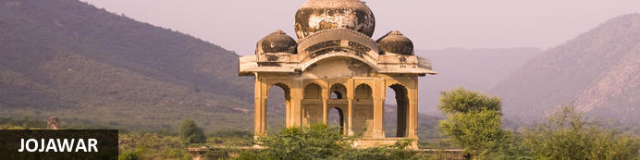
Easily accessed from the busy tourist hubs of Ajmer, Jodhpur or Udaipur, Jojawar gives visitors a taste of authentic Rajasthani village life, and also offers excellent outdoor adventures in the nearby Aravalli Hills. Walking in this region is a real highlight, with the 300-year-old Jojawar Fort to explore, and rabaris (camel herders) and shepherds tending to their animals, which roam freely in the surrounding landscape. Jeep tours, horseback trails and camel safaris are easily organised in Jojawar for travellers looking to explore the desert, while the town’s bustling market is an excellent place to shop for silverware and textiles (such as the brightly-coloured saris the region is known for).
After breakfast, you will be driven to Jojawar [approx.. 03 Hrs ].
On arrival in Jojawar, check in to hotel.
Rest of the day at leisure.
Optional : Jeep safari through the village
It is said that the real India is its rural areas, the country around Jojawar boasts of very interesting landscapes, with the picturesque Aravalli Hills in the east, and broken rocky hills interspersed with farms and scrub forests all around. The Pre- Cambrian Aravalli Hills are one of the oldest mountain ranges of the world, and a geologist’s paradise. The camel herding Rabaris are an ethnic group only to be found around Jojawar. All this makes our Jeep Safaris the most popular excursion.

Overnight: Rawla Jojawar
The Rawla Jojawar is a fort converted into a heritage hotel. It is located in the Aravalli hills. There are 35 guest rooms containing modern amenities. The hotel grounds feature a range of dining venues, a swimming pool, pool deck, bar terrace and dining hall.
At the Rawla Jojawar are stables where visitors can book horse rides. Visitors have a choice between full or half day rides and the trips are accompanied by a guide. Other activities that can be arranged through the hotel include a Jeep Safari to explore the countryside and the train safari - train route between the cities of Jodhpur and Udaipur and goes up the scenic Kambli Ghat Pass.
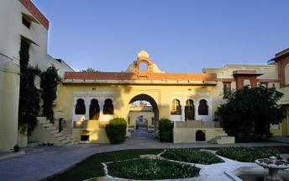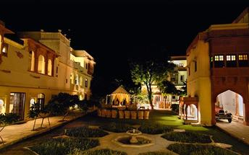

Day 15: Jojawar – Udaipur
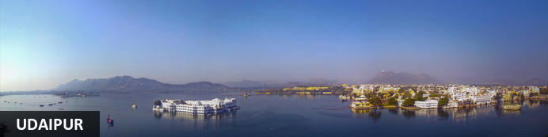
Dubbed the ‘Venice of the East’, the city of Udaipur is built around three interconnected lakes – Lake Pichhola, Fateh Sagar Lake and the smaller Swaroop Sagar Lake – and encircled by the hills of the Aravalli mountain range. It is home to an array of ancient temples and fairy-tale palaces (several of the latter have been converted into luxury heritage hotels) and is known as one of Rajasthan’s most beautiful and romantic cities. Must-see attractions include the City Palace, the Lake Palace (set on a small island in the middle of Lake Pichola) and the Udaipur Solar Observatory – Asia’s premier solar-gazing site.
After breakfast, enjoy a rural train ride
It’s an amazing one and a half hours spent on a meter gauge train which is the lifeline of locals here.The journey starts from Kamblighat. The ride ends at Phulad. This is also the highest track on the Western Railways.
The entire excursion is escorted by one of the hotels staff guides.

Later, leave for Udaipur [approx. 4 Hrs] enroute visiting Ranakpur Jain Temples.

Ranakpur Jain Temples
The complex rests on a lush mountain slope and encompasses a series of temples dating to the 15th century, all constructed from white marble and featuring exquisite decorative detail. The main temple, Chamukha, is a multi-tiered structure with no less than 80 domes and over 1400 pillars, all of which are intricately carved with unique designs – no two are alike.
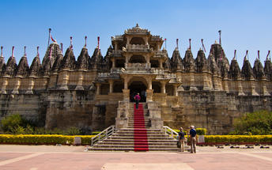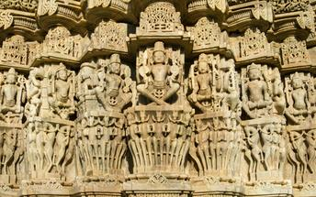
Note : Leather items like Belts, purses or wallets etc. are not allowed inside Ranakpur Temple complex. Also local guides are not available in the temple, Only Audio guide will be provided.
Upon arrival in Udaipur, check in at the hotel.

Overnight: Amet Haveli
The Amet Haveli is a traditional hotel situated on the western banks of Lake Pichola. The hotel overlooks the Lake Palace as well as the City Palace. The dining facility at the Amet Haveli is called the Ambrai restaurant. The restaurant serves multi cuisine delicacies. Dining takes place outdoors with views of the Jagdish Temple, Gangaur Ghat, City Palace, Lake Palace, Jag Mandir and Sajjangarh Fort.
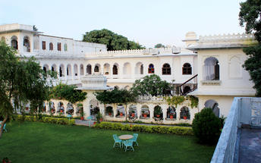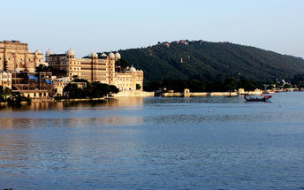

Day 16: Udaipur
After breakfast enjoy half day sightseeing tour of Udaipur visiting the City Palace, Saheliyon ki bari, Jagdish temple and in the evening enjoy a Shared Boat Ride on Lake Pichola (subject to water level)

Udaipur City Palace
Situated above Lake Pichola, Udaipur City Palace has housed many royals over four centuries who have each added their own unique preferences to the establishment. The palace is a one of a kind in Rajasthan. The Palace was constructed entirely out of marble and granite which makes it highly luxurious. The inside is even more so with its inlays of coloured glass, engravings, towers, and balconies.
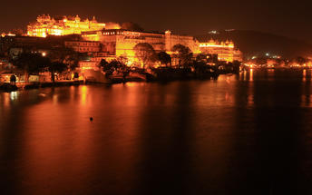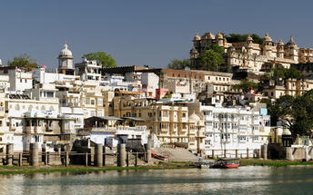

Saheliyon ki Bari
Built by Maharana Sangram Singh II as a garden for women, Saheliyon-ki-Bari or the Garden of the Maidens is a popular tourist destination. Along with a small museum, it has several attractions such as marble elephants, fountains, kiosks and a lotus pool.

Jagdish Temple
Completed in 1651, Jagdish Temple is situated just outside the royal palace. The temple can be seen as soon as visitors enter the city. Puja’s and prayer time are the best time to visit when melodious chants from devotees float through the small interior. Visitors should make a point of climbing the temple's many steps which invite them on a journey of discovery of the rich and vibrant history of Udaipur.
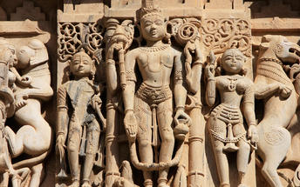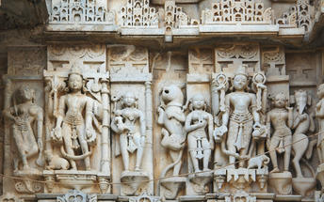
Shared Boat Ride on Lake Pichola
Pichola Lake is one of the most beautiful lakes in Rajasthan. Located in the heart of Udaipur, Pichola is the oldest and one of the largest lakes in all of Udaipur. In 1362 AD Pichola Lake was built by Banjara. Later, Maharana Udai Singh, affected by the charm of this lake and extended the lake when he founded the city of Udaipur and also built a dam made of stone that is in the Badipol region on the shore of the lake. Pichola Lake is enveloped by lofty Palaces, temples, bathing ghats and elevated hills on all its sides.

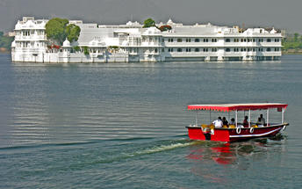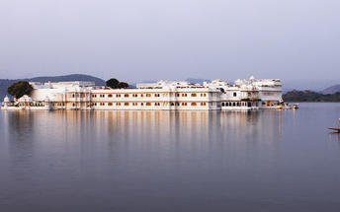

Day 17: Udaipur - Delhi
After breakfast, you will be assisted & transferred to Udaipur airport to board flight for Delhi.
On arrival in Delhi, you will be assisted & transferred to hotel for check in.

Overnight: Hotel Novotel New Delhi Aerocity
Novotel New Delhi Aerocity is ideally located at Aerocity, in close proximity to the IGI Airport and within driving distance from business hubs of Gurgaon & New Delhi. A combination of 400 Suites & Rooms features multipurpose convention space with 11 meeting rooms, 5 boardrooms and one of the largest ballrooms in Delhi NCR. The hotel offers an array of food & beverage options and leisure facilities include a fully-equipped health club and outdoor swimming pool & bar.
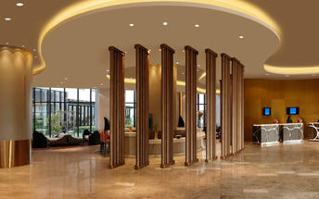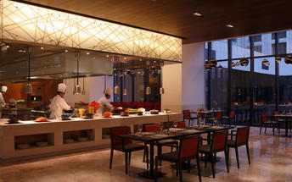

Day 18: Depart Delhi
At an appropriate time, you will be assisted and transferred to airport to board flight to back home.

