

IN – 52

GOLDEN TRIANGLE AND TIGER WITH VOLUNTEERING AT SCHOOL
New Delhi - Agra - Sawai Madhopur – Jaipur - Delhi
14 Days / 13 Nights

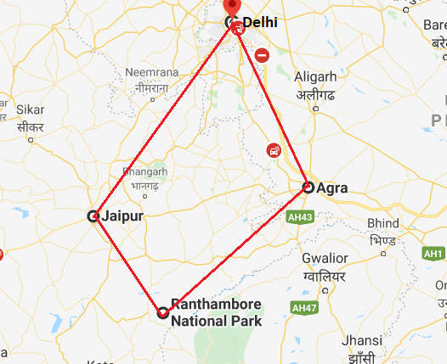

Day 01: Arrive Delhi

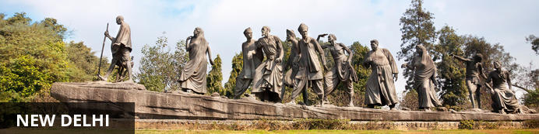
India’s largest city, Delhi, has been one of the country’s commercial and economic hubs for centuries and, as a result, is incredibly rich in culture and history. Made up of the ancient walled city of Old Delhi and the more modern sector, New Delhi, the city encompasses a staggering array of beautiful architecture, notable monuments and age-old temples, including three UNESCO World Heritage Sites – the Red Fort, Qutab Minar and Humayun's Tomb. Other key attractions include the 17th century Chandni Chowk marketplace – still one of the city’s most popular retail centres today, particularly for jewellery and traditional Indian saris; the iconic Bahà’i Lotus Temple – an award-winning architectural gem; and the Jama Masjid, India’s largest mosque.

On arrival in Delhi: Having cleared immigration, collected your luggage and passed through customs, please make your way towards the exit of the terminal building where you will see a bank of people waiting for you. Amongst them will be Travel Counsellors Representative who will be waiting to greet you with a paging board with your name on.

You will be transferred to your hotel and assisted with check in. (Standard check in time at hotel is 1400 hrs).

Day 02 - 06: Delhi

Day Itinerary
Volunteering at Non-Government Organisation (Clients can choose from the below programs)
The organisation recognize that contributions of time and talent are just as important as financial contributions. Therefore, they encourage people to contribute their time by making a conscious effort in participating in their programs to accelerate social and economic change in the country. Volunteers can volunteer during summer vacations as well (May-June) to teach the children something more than what is in the books. Volunteers are required for different projects who are enthusiastic and can help the children bring out their latent talents. One can volunteer on the following issues:-
Academic
- Teaching
- Preparing teaching learning aids
- Latent Talent Development (Theatre, Dance, Singing, Painting etc.)
- SUPW (Gardening, School Sanitation, Tree Plantation etc.)
Community Program
- Assist in campaigning on various issues.
- Community Mobilization – Enhance community participation, Sensitize on community issues.
Institutional Care
- Counselling, spending time with children.
- English Conversation.
- Latent Talent Development.
- Academic support.
Special Unit for Differently abled children
- Spend time with children; introduce them in learning process.
- Training in creative exercises.
Corporate Office
- Designing of Documents.
- Computer Classes.
- Software products.
- Trainings.
- Process Documentation.
- Research and Documentation.
- Fundraising.
- Administrative support (data entry, dispatching, packing etc).
Education on Wheels/ Music Bus
- MSW interns/volunteers to conduct case studies and community mobilization and take awareness session/workshops on various social issues.
- Volunteers to teach life skills, latent talents, health & hygiene to children at project place.
- Volunteers who play guitar/harmonium/keyboard to instruct children of age group 6-18 years and to encourage them to express themselves through music, singing and rhymes.
*Above volunteer program can be conducted subject to school authorities’ permission and subject to school operational days (School remains closed on Saturday-Sunday)
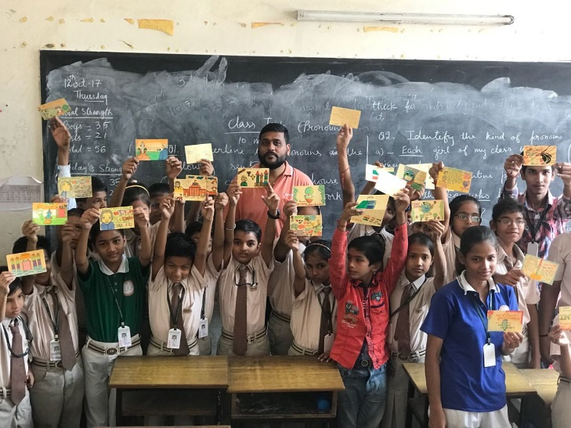

Day 07: Delhi

Day Itinerary
After breakfast, leave for a heritage walk through Old Delhi following by the tour of New Delhi

Old Delhi Heritage Walk
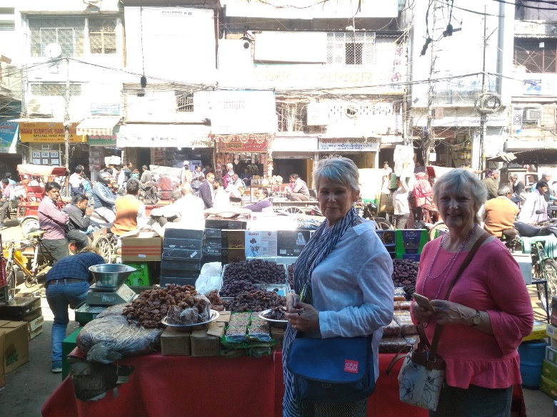
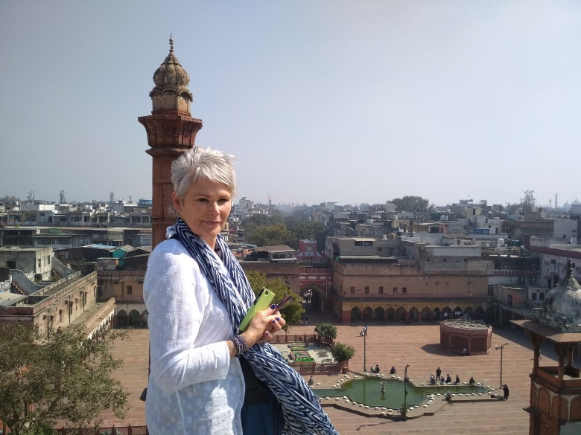
Delhi is one of very few places where the ancient and modern co-exist side by side complementing each other perfectly. Our heritage walks of Delhi are a perfect way of exploring this amalgam of old traditions, modern development and the unique heritage which makes it so interesting. It is the perfect way to explore some of the lesser visited places and gain a new insight about the history, people and sights of Delhi city.

The tour of New Delhi covers the UNESCO world Heritage sites of Humyauns tomb, Qutab Minar along with a photo stop at India Gate – the war memorial and drive past the Govt. Secretariat building and the President Palace.

Humayun's Tomb:
The mausoleum complex of Humayun, India’s second Mughal Emperor, was commissioned by his widow in 1565 and was the first garden tomb to be built in India, taking seven years to complete. Humayun had travelled widely in Persia and Central Asia during his lifetime, and many of the architectural principles he brought back from these journeys were incorporated into the building at his wife’s instructions. With its double domes, decorative inlaid marble and vast garden with pools connected by channels, this 16th Century building set the stage for the style that culminated in the Taj Mahal almost 100 years later.
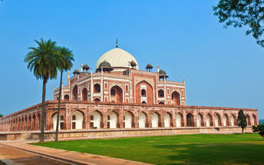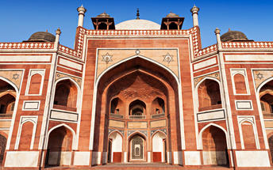

Qutub Minar
Standing tall at 73-metres, the tower consists of 5 storeys with a flight of spiral stairs leading to its top. The walls are adorned with decorative motifs and Quranic inscriptions. At the foot of the tower lie other monuments of historical significance, such as the Quwwat-ul-Islam Mosque and the Iron Pillar of Delhi. The Amazing race Australia used this site as a pit stop in the second series. Visitors can take advantage of stunning photo opportunities.
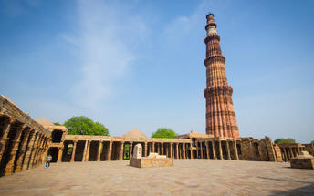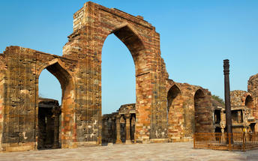

Day 8: Delhi - Agra

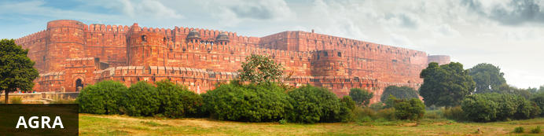
Home of the world-famous Taj Mahal, Agra is one of India’s prime tourist destinations for specifically this reason, though its attractions also extend to an array of other impressive historical sights. These include the red-hued Agra Fort, the sacred Jama Masjid mosque and Itmad-ud-Daulah’s tomb, with its white marble facade embellished with intricate inlaid designs and semi-precious gems. The Taj, however, is in a league of its own and needless to say is a must-see for any visitor to the city. Commissioned by the Mughal emperor Shah Jahan in the 15th century as a memorial to his beloved wife Mumtaz Mahal, it is an architectural masterpiece of exquisite craftsmanship and perfect proportions.

Day Itinerary
After breakfast, you will be transferred to railway station to board the train to Agra.
Upon arrival at Agra, you will be assisted & transferred and taken directly to Agra Fort for the visit followed by check-in at the hotel. (Standard check in time at the hotel is 1400 Hrs).
Later in the evening, visit Taj Mahal at sunset.

Agra Fort
Known as the Red Fort of Agra, this walled imperial city was founded in 1565 by the Emperor Akbar (1556-1605) and is a well-deserving UNESCO World Heritage site, located just 2.5 kilometres from the famous Taj Mahal. Its palaces, grand mosques and elaborate public hall are crafted from pink-red sandstone and are testament to an era when Indo-Muslim art, strongly marked by influences from Persia, was at its height. Emperor Shah Jahan, who built the Taj Mahal for his deceased wife, was imprisoned by his son Aurangzeb in Agra Fort. He is said to have died in the Musamman Burj, a marble tower he himself built, with one of the most alluring views of the Taj Mahal.
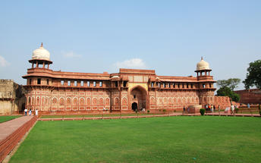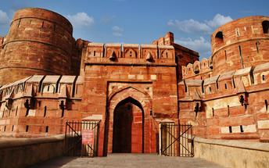

Taj Mahal (Closed on Fridays)
The iconic Taj Mahal is not only an architectural masterpiece, a UNESCO World Heritage Site and one of the new Seven Wonders of the World – it is also the enduring legacy of a royal love story. It was commissioned in the 15th century by the Mughal Emperor Shah Jahan after the death of his third and favourite wife, Mumtaz Mahal, to serve as her final resting place and a symbol of his eternal affection for her. Combining Islamic, Persian, Ottoman Turkish and Indian design elements, it’s an awe-inspiring structure of elegant domes and white marble, which changes colour along with the light – pink at sunrise, pearly white in the afternoon and silver-gold in the full moon.
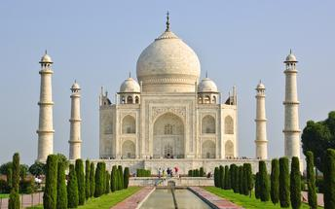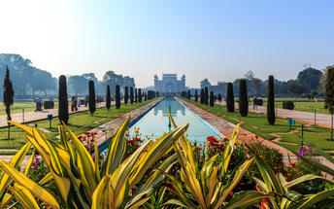

Day 09: Agra - Bharatpur - Ranthambore National Park

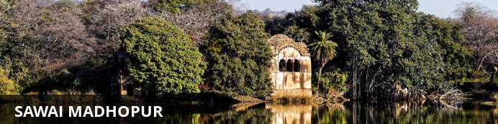
Sawai Madhopur, the lively capital city of the greater Sawai Madhopur District, rests within southeast Rajasthan, on the northern extension of the sprawling Vindhyan Plateau. Famously known for its flourishing fauna and flora; and mouth-watering cuisine, travellers can meander through the enchanting public gardens and sample the delicious local dishes. Both a history and nature enthusiasts dream, Sawai Madhopur, opens a world of enjoyable excursions with some of the most notable attractions being the UNESCO World Heritage Site of Ranthambore Fort; the religiously significant Chamatkar Temple; and the remarkable Ranthambhore National Park, famously known for its abundance of free-roaming wildlife including the majestic Bengal tiger and Indian leopard.

Day Itinerary
After breakfast you will be driven to Bharatpur train station to board the train for short ride to Sawai Madhopur.
Upon arrival check in at the hotel.
Located in the Sawai Madhopur district, the Ranthambore National Park, in the western state of Rajasthan, is one of the most visited wildlife parks in India. Spanning over an impressive 1300-square-kilometer stretch of wilderness, the park’s outstanding natural beauty is characterized by its dense jungle, golden savanna, dramatic cliffs and lotus-filled lakes. Considered the best spot to catch a glimpse of tigers in the wild, the park offers visitors a spellbounding combination of mystical temples, wild beauty and crumbling ruins. While the main attraction is undoubtedly the elusive Bengal tiger, the park provides a sanctuary for other wildlife including, among others: sambar, gazelle, caracal, black buck, crocodile, chital, wild boars and a wide array of birds. Don’t miss the ancient Ranthambore Fort, perched high on the cliffs overlooking the vast expanse of this spectacular park.
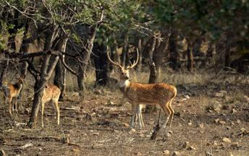

Day 10: Ranthambhore National Park

Day Itinerary
Enjoy morning and afternoon shared jeep safari with a naturalist into the Park.

Day 11: Ranthambore - Jaipur

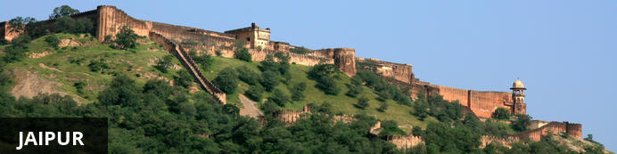
Fringed by the rugged Aravali Hills, Jaipur is the capital and largest city in India’s northern state of Rajasthan. This city is famed for being India’s first planned city featuring a multitude of pink terracotta buildings within the walled historic centre, earning it the nickname,’The Pink City’. Jaipur falls within the Golden Triangle, a popular tourist circuit, which includes Delhi, Jaipur and Agra, and serves as a gateway to the neighbouring desert cities of Jaisalmer and Jodhpur. This colourful city is a combination of tradition and modernity and offers visitors vibrant bazaars, lavish palaces and ancient temples. The salmon-hued old city is home to the opulent City Palace, encompassing an impressive assortment of palatial structures, sprawling gardens, courtyards and buildings. Don’t miss the fairy-tale splendour of the Amber Fort, set against the backdrop of the arid landscape.

Day Itinerary
After breakfast, leave for Jaipur (Approx. 145 Kms / 4 Hrs).
Upon arrival check in at your hotel.
Remainder of the day at leisure. Evening you can stroll around the vibrant and bustling local markets of Jaipur city famous for textiles and jewellery.

Day 12: Jaipur

Day Itinerary
After breakfast, proceed for a full day tour of Jaipur, visiting Amer Fort (en-route photo stop at Hawa Mahal – Palace of Winds), City Palace and Astronomical Observatory.

Amer Fort
Amer Fort, officially known as the ‘Amer Palace’, is one of the most famous forts of Rajasthan attracting around 4000 to 5000 visitors a day during peak tourist season. The palace was named after the small town of Amer, where it is situated - only eleven kilometres from Jaipur. Perfectly picturesque, this 16th century hillside residence is well preserved, boasting grand pavilions and mirrored halls that open onto flourishing gardens and courtyards. Although the palace’s main construction started in 1592 by Maharaja Man Singh, it was added to over the years by successive rulers and continued to be occupied by them until Jaipur was built.
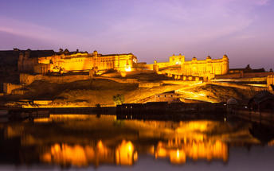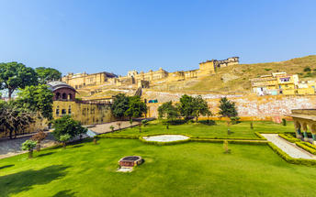

Photo stop at Hawa Mahal (Palace of Winds)
One of Jaipur’s most recognised buildings, the Hawa Mahal (Palace of Winds) is known for its iconic façade. Small windows, decorated with intricate latticework create a honeycomb-like appearance. The original intention of the lattice was to allow the royal ladies to observe everyday life in the street below without being seen. The cooling effect, provided by the breeze passing through the small windows, gave the palace its name. Built in 1799 by Maharaja Sawai Pratap Singh, the unique construction was originally designed to look like the crown of Krishna. A panoramic view of Jaipur can be had from the top of the building.
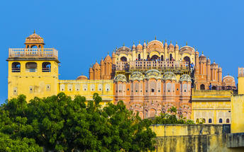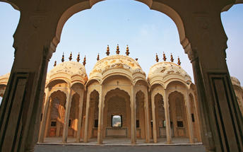

Jaipur City Palace
City Palace forms one of the most famous tourist attractions and a major landmark in Jaipur. The beautiful palace was built by Maharaja Sawai Jai Singh during his reign. Among the various forts and palaces of Jaipur, City Palace stands apart, with its outstanding art and architecture.
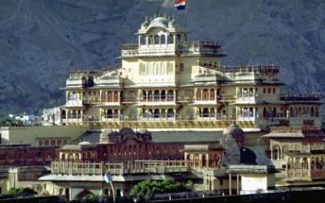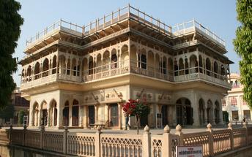

Jantar Mantar Jaipur
Built by Jai Singh, the first Maharaja of Jaipur who founded the city in 1727, the observatory is one of a handful. Jai Singh, fulfilling a lifelong interest in mathematics and astronomy, built observatories in Delhi, Jaipur, Ujjain, Mathura and Benares. The Jaipur observatory is the largest and best preserved of these.

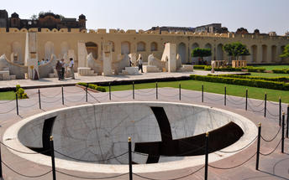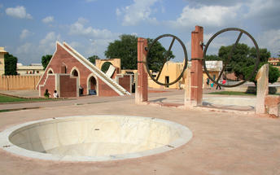

Day 13: Jaipur - Delhi

Morning at leisure.
Later in the day leave for Delhi (approx. 260 kms / 06 hrs) and stay at an airport hotel.

Day 14: Depart Delhi

At an appropriate time, you will be assisted and transferred to the airport for your flight back home.

