

IN – 53

GOLDEN TRIANGLE AND TIGERS WITH ANIMAL VOLUNTEERING
New Delhi - Mathura - Agra - Sawai Madhopur – Jaipur - Delhi
15 Days / 14 Nights

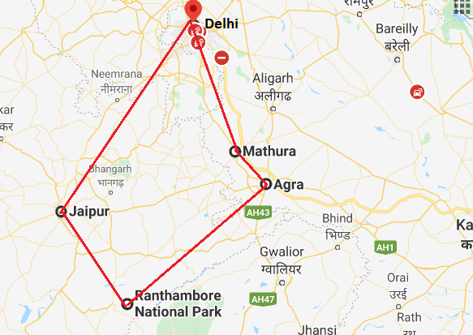

Day 1: Arrive Delhi

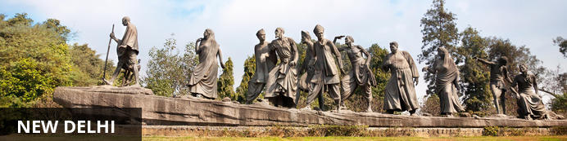
India’s largest city, Delhi, has been one of the country’s commercial and economic hubs for centuries and, as a result, is incredibly rich in culture and history. Made up of the ancient walled city of Old Delhi and the more modern sector, New Delhi, the city encompasses a staggering array of beautiful architecture, notable monuments and age-old temples, including three UNESCO World Heritage Sites – the Red Fort, Qutab Minar and Humayun's Tomb. Other key attractions include the 17th century Chandni Chowk marketplace – still one of the city’s most popular retail centres today, particularly for jewellery and traditional Indian saris; the iconic Bahà’i Lotus Temple – an award-winning architectural gem; and the Jama Masjid, India’s largest mosque.

Day Itinerary

On arrival in Delhi: Having cleared immigration, collected your luggage and passed through customs, please make your way towards the exit of the terminal building where you will see a bank of people waiting for you. Amongst them will be Travel Counsellors Representative who will be waiting to greet you with a paging board with your name on.
You will be transferred to your hotel and assisted with check in.
Standard Check in time is 1400 hrs.
Rest of the day at leisure.

Day 2: Delhi

Day Itinerary
After breakfast, leave for a heritage walk through Old Delhi following by the tour of New Delhi

Old Delhi Heritage Walk
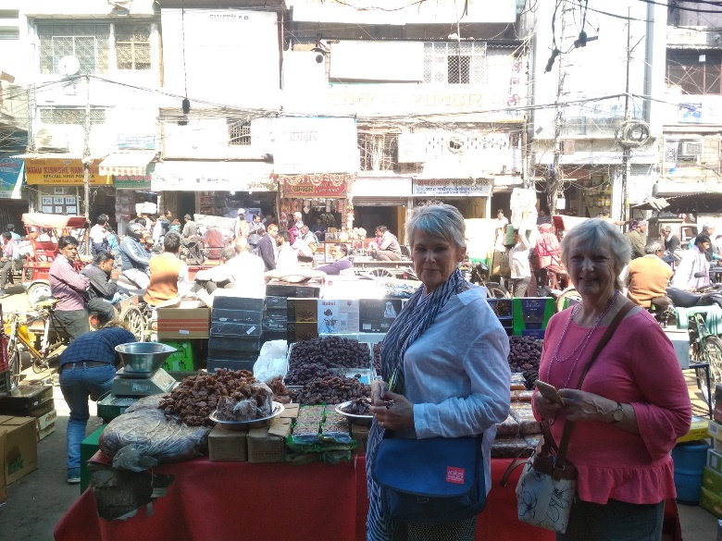
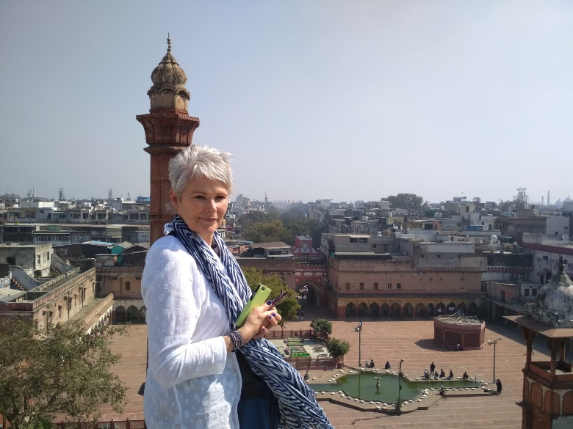
Delhi is one of very few places where the ancient and modern co-exist side by side complementing each other perfectly. Our heritage walks of Delhi are a perfect way of exploring this amalgam of old traditions, modern development and the unique heritage which makes it so interesting. It is the perfect way to explore some of the lesser visited places and gain a new insight about the history, people and sights of Delhi city.

The tour of New Delhi covers the UNESCO world Heritage sites of Humyauns tomb, Qutab Minar along with a photo stop at India Gate – the war memorial and drive past the Govt. Secretariat building and the President Palace.

Humayun's Tomb:
The mausoleum complex of Humayun, India’s second Mughal Emperor, was commissioned by his widow in 1565 and was the first garden tomb to be built in India, taking seven years to complete. Humayun had travelled widely in Persia and Central Asia during his lifetime, and many of the architectural principles he brought back from these journeys were incorporated into the building at his wife’s instructions. With its double domes, decorative inlaid marble and vast garden with pools connected by channels, this 16th Century building set the stage for the style that culminated in the Taj Mahal almost 100 years later.
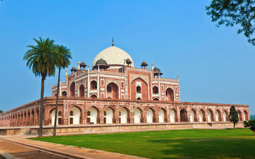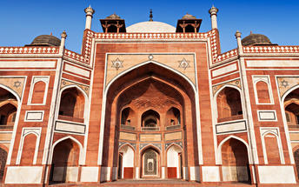

Qutub Minar
Standing tall at 73-metres, the tower consists of 5 storeys with a flight of spiral stairs leading to its top. The walls are adorned with decorative motifs and Quranic inscriptions. At the foot of the tower lie other monuments of historical significance, such as the Quwwat-ul-Islam Mosque and the Iron Pillar of Delhi. The Amazing race Australia used this site as a pit stop in the second series. Visitors can take advantage of stunning photo opportunities.
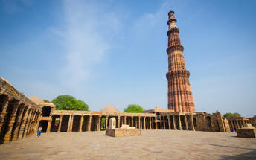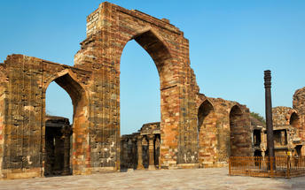

Day 3: Delhi - Animal Volunteering Mathura

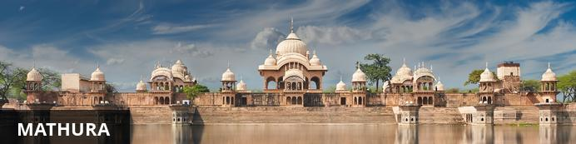
Situated in the heart of the Braj (or Vraj Bhumi) region within the Golden Triangle of Delhi-Jaipur-Agra, Mathura in Uttar Pradesh is renowned as the birthplace of the Hindu god Krishna. The city attracts crowds of devout worshippers who flock here to see the Krishna Janmabhoomi, the prison cell where the Lord's parents, Vasudev and Devaki were held captive and where Devaki gave birth to Krishna. The main shrine of the city, the Dwarkadheesh Temple, is also a major attraction for the devout. In addition to religious sites, Mathura has plenty to offer visitors. Don’t miss the chance to stroll along the River Yamuna, discovering temples along your way. Also worth a visit is the Mathura Government Museum which houses an excellent array of ancient treasures including countless ornaments, terracotta sculptures and bronze objects.

Day Itinerary
After breakfast, drive from Delhi to Mathura [Approx. 4 hrs].
Afternoon visit, the Volunteering centre/Charity Organisation for the volunteering for next 5 days.
**Volunteering in Mathura can be done from 01 week to 6 months. They provide accommodation as well and for this we need to have the complete details of the clients, including any allergies, food habits etc.
With regards to the accommodation provided by the Elephant sanctuary, please be advised that they have a 6 night package wherein they provide a neat and clean Non air-conditioned accommodation including all meals (not to expect any high standards). Breakfast and Dinner is provided at the place of stay, however, lunch during the day is provided at the sanctuary itself. The accommodation provided includes the cook, house-keeping and security. Normally the people volunteering at the sanctuary stays at the accommodation provided by them. They recommend clients to stay with them as this is the source on income they have for animals’ welfare. The services and food provided are as per the foreigners only. At the Elephant sanctuary, please note that everyday clients can indulge in feeding, bathing and walking with the elephants. Though feeding is done every day, however for bathing and walking, it depends upon the mood of the animal. Also be advised that Elephant riding is a strict NO there.

Overnight: Volunteering Accommodation

Day 4-8: Animal Volunteering Mathura

Day Itinerary
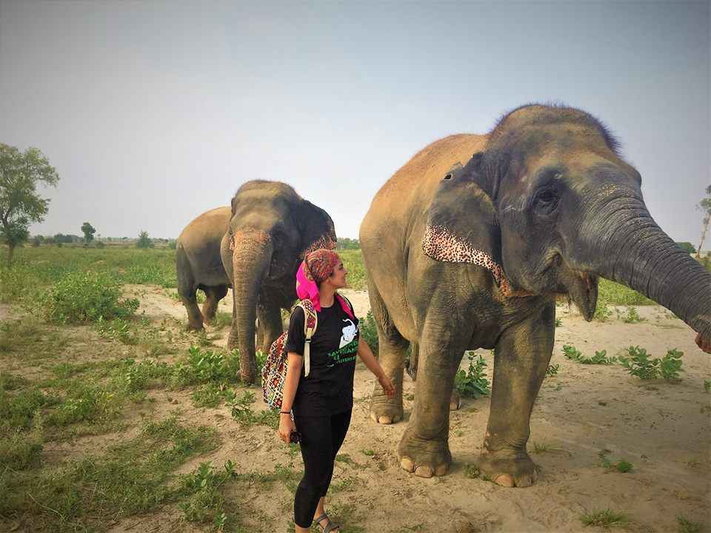
These days, volunteer at the Volunteering centre/Charity Organisation.
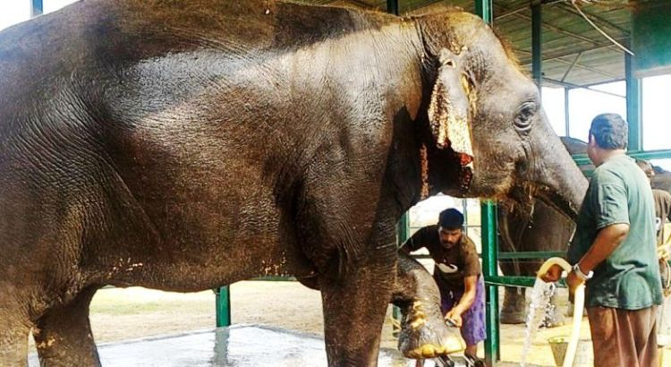

Day 9: Mathura - Agra

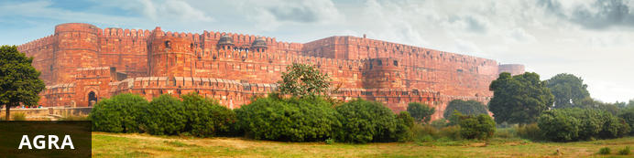
Home of the world-famous Taj Mahal, Agra is one of India’s prime tourist destinations for specifically this reason, though its attractions also extend to an array of other impressive historical sights. These include the red-hued Agra Fort, the sacred Jama Masjid mosque and Itmad-ud-Daulah’s tomb, with its white marble facade embellished with intricate inlaid designs and semi-precious gems. The Taj, however, is in a league of its own and needless to say is a must-see for any visitor to the city. Commissioned by the Mughal emperor Shah Jahan in the 15th century as a memorial to his beloved wife Mumtaz Mahal, it is an architectural masterpiece of exquisite craftsmanship and perfect proportions.

Day Itinerary
Morning drive to Agra (Approx. 1-1½ hrs).
Afternoon visit Agra Fort and Sunset visit to Taj Mahal (Closed on Friday).

Agra Fort
Known as the Red Fort of Agra, this walled imperial city was founded in 1565 by the Emperor Akbar (1556-1605) and is a well-deserving UNESCO World Heritage site, located just 2.5 kilometres from the famous Taj Mahal. Its palaces, grand mosques and elaborate public hall are crafted from pink-red sandstone and are testament to an era when Indo-Muslim art, strongly marked by influences from Persia, was at its height. Emperor Shah Jahan, who built the Taj Mahal for his deceased wife, was imprisoned by his son Aurangzeb in Agra Fort. He is said to have died in the Musamman Burj, a marble tower he himself built, with one of the most alluring views of the Taj Mahal.
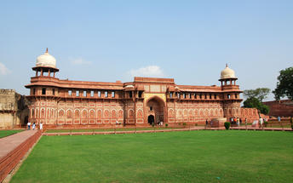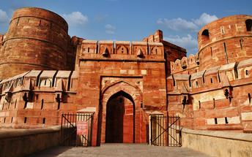

SUNSET VISIT TAJ MAHAL (Closed on Fridays)
Taj Mahal is everything that has been said about it and more. Taking 22 years and 20,000 men to build, the white marble was quarried 200 miles away and was transported to the site by a fleet of 1000 elephants. Built by the Mughal Emperor Shah Jahan as an expression of his love for his wife Mumtaz Mahal, in mid-17th century, it is truly one of the wonders.

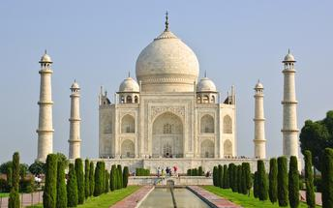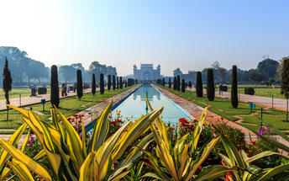

Day 10: Agra - Bharatpur - Ranthambore National Park

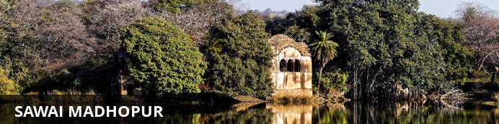
Sawai Madhopur, the lively capital city of the greater Sawai Madhopur District, rests within southeast Rajasthan, on the northern extension of the sprawling Vindhyan Plateau. Famously known for its flourishing fauna and flora; and mouth-watering cuisine, travellers can meander through the enchanting public gardens and sample the delicious local dishes. Both a history and nature enthusiasts dream, Sawai Madhopur, opens a world of enjoyable excursions with some of the most notable attractions being the UNESCO World Heritage Site of Ranthambore Fort; the religiously significant Chamatkar Temple; and the remarkable Ranthambhore National Park, famously known for its abundance of free-roaming wildlife including the majestic Bengal tiger and Indian leopard.

Day Itinerary
After breakfast you will be driven to Bharatpur train station to board the train to Sawai Madhopur.
Upon arrival check in at the hotel.

Day 11: Ranthambhore National Park

Day Itinerary
Enjoy morning and afternoon shared jeep safari with a naturalist into the Park.

Ranthambore National Park
Located in the Sawai Madhopur district, the Ranthambore National Park, in the western state of Rajasthan, is one of the most visited wildlife parks in India. Spanning over an impressive 1300-square-kilometer stretch of wilderness, the park’s outstanding natural beauty is characterized by its dense jungle, golden savanna, dramatic cliffs and lotus-filled lakes. Considered the best spot to catch a glimpse of tigers in the wild, the park offers visitors a spellbounding combination of mystical temples, wild beauty and crumbling ruins. While the main attraction is undoubtedly the elusive Bengal tiger, the park provides a sanctuary for other wildlife including, among others: sambar, gazelle, caracal, black buck, crocodile, chital, wild boars and a wide array of birds. Don’t miss the ancient Ranthambore Fort, perched high on the cliffs overlooking the vast expanse of this spectacular park.

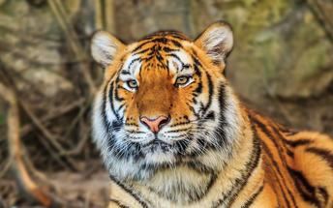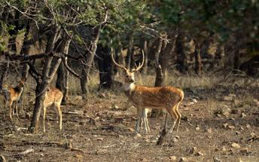

Day 12: Ranthambore - Jaipur

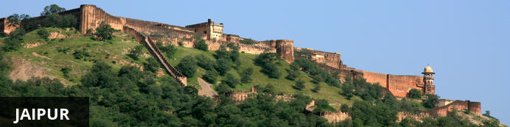
Fringed by the rugged Aravali Hills, Jaipur is the capital and largest city in India’s northern state of Rajasthan. This city is famed for being India’s first planned city featuring a multitude of pink terracotta buildings within the walled historic centre, earning it the nickname,’The Pink City’. Jaipur falls within the Golden Triangle, a popular tourist circuit, which includes Delhi, Jaipur and Agra, and serves as a gateway to the neighbouring desert cities of Jaisalmer and Jodhpur. This colourful city is a combination of tradition and modernity and offers visitors vibrant bazaars, lavish palaces and ancient temples. The salmon-hued old city is home to the opulent City Palace, encompassing an impressive assortment of palatial structures, sprawling gardens, courtyards and buildings. Don’t miss the fairy-tale splendour of the Amber Fort, set against the backdrop of the arid landscape.

Day Itinerary
After breakfast, you will be driven to Jaipur by your private chauffeur driven car (Approx. 170 Kms / 4 Hrs).
Upon arrival check in at your hotel.
Remainder of the day at leisure. Evening you can stroll around the vibrant and bustling local markets of Jaipur city famous for textiles and jewellery.

Day 13: Jaipur

Day Itinerary
After breakfast visit of Amber fort with Jeep ride to ascend to the fort, en-route photo stop at Hawa Mahal.
Afternoon visit City Palace and Astronomical observatory.

Amer Fort
Amer Fort, officially known as the ‘Amer Palace’, is one of the most famous forts of Rajasthan attracting around 4000 to 5000 visitors a day during peak tourist season. The palace was named after the small town of Amer, where it is situated - only eleven kilometres from Jaipur. Perfectly picturesque, this 16th century hillside residence is well preserved, boasting grand pavilions and mirrored halls that open onto flourishing gardens and courtyards. Although the palace’s main construction started in 1592 by Maharaja Man Singh, it was added to over the years by successive rulers and continued to be occupied by them until Jaipur was built.

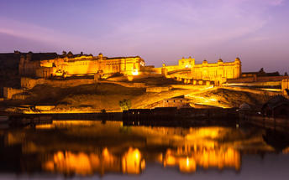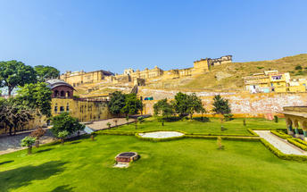

Photo stop at Hawa Mahal (Palace of Winds)
One of Jaipur’s most recognised buildings, the Hawa Mahal (Palace of Winds) is known for its iconic façade. Small windows, decorated with intricate latticework create a honeycomb-like appearance. The original intention of the lattice was to allow the royal ladies to observe everyday life in the street below without being seen. The cooling effect, provided by the breeze passing through the small windows, gave the palace its name. Built in 1799 by Maharaja Sawai Pratap Singh, the unique construction was originally designed to look like the crown of Krishna. A panoramic view of Jaipur can be had from the top of the building.
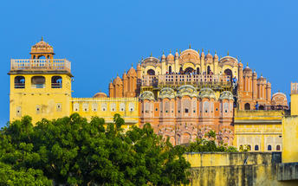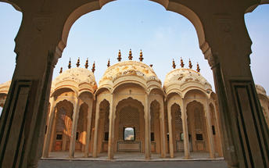

Jaipur City Palace
City Palace forms one of the most famous tourist attractions and a major landmark in Jaipur. The beautiful palace was built by Maharaja Sawai Jai Singh during his reign. Among the various forts and palaces of Jaipur, City Palace stands apart, with its outstanding art and architecture.
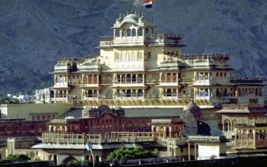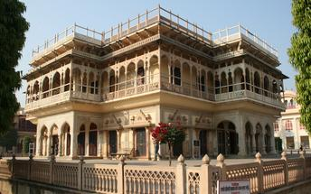

Jantar Mantar Jaipur
In 1734, the year of its completion, the Jai Singh Observatory was the last outpost of medieval science. From the outside, the eighteen fixed observational instruments look more like playground apparatus than sighting devices, but they were used to measure the position of the sun, stars and planets. Built by Jai Singh, the first Maharaja of Jaipur who founded the city in 1727, the observatory is one of a handful. Jai Singh, fulfilling a lifelong interest in mathematics and astronomy, built observatories in Delhi, Jaipur, Ujjain, Mathura and Benares. The Jaipur observatory is the largest and best preserved of these.

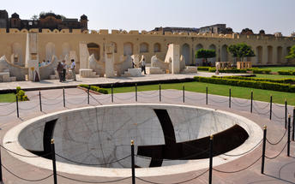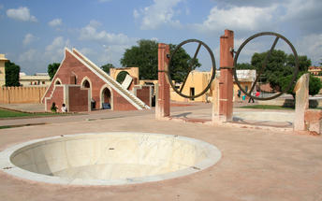

Day 14: Jaipur - Delhi

Day Itinerary
Breakfast at the hotel.
Morning at leisure.
Check out as per standard time and drive back to Delhi (approx. 05 - 06 hrs drive) and stay at an airport hotel.

Day 15: Depart Delhi

Day Itinerary
At an appropriate time, you will be assisted and transferred to the airport for your flight back home.

