

IN - 59

Golden Chariot – Pride of Karnataka
Bangalore - Bandipur - Mysore - Chikamagalur - Hampi - Badami - Goa - Bangalore
09 Days / 08 Nights

Day 01 (Saturday): Arrive Bangalore

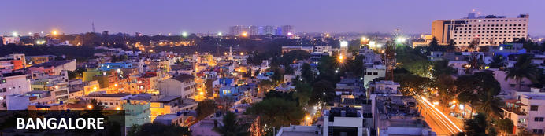
Known as the ‘garden city’, Bangalore offers a leafy backdrop from which to explore the bustling streets of India’s third largest city. Cosmopolitan restaurants line wide avenues where foodies can delight in a smorgasbord of south Indian flavours. Tea lovers can indulge in fragrant cups of Chai and a spell of people watching from any of the tea stalls dotted around the city. A booming IT industry coupled with a city that seeks to preserve its green and colonial heritage has created a modern and sophisticated metropolis. Recently voted the most liveable city in India, Bangalore makes a great base for travelling southern India.

On arrival in Bangalore: Having cleared immigration, collected your luggage and passed through customs, please make your way towards the exit of the terminal building where you will see a bank of people waiting for you. Amongst them will be Travel Counsellors Representative who will be waiting to greet you with a paging board with your name on.
You will be transferred to your hotel and assisted with check in. (Standard check in time at hotel is 1400 hrs).

Day 02 (Sunday): Board Golden Chariot (Bangalore - Bandipur)

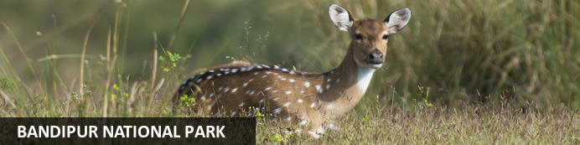
Situated in the lush southern state of Karnataka, Bandipur National Park is only 80 kilometres from the city of Mysore. Once the hunting grounds of the Maharaja of the kingdom of Mysore, the park was extended in 1973 to include 874 square kilometres of protected flora and fauna.

Early morning, you will be assisted & transferred to Yeshvantpur Railway Station to embark the Luxury train Golden Chariot.
- 08:45 Welcome and Check in at Yeshvantpur railway station
- Tour Breifing on-board
- Lunch on-board
- 14:00 Deboard at ananjagud Town
- 16:30 Evening Safari at Bandipur
- 18:30 Return to train for dinner
- Train proceeds to Mysore and stationed overnight at Mysore

Bandipur National Park

Bandipur National Park second highest Tiger population in India. Bandipur National Park is located in Gundulpet taluk, Chamarajanagar district. Park is the part of Nilgiri Biosphere Reserve making it largest protected area in Southern India and largest habitant of Wild Elephants in South Asia. Bandipur National Park shares its boundary with 3 other National park namely Nagarahole National Park, Wayanad National Park and Mudumalai National park. There is ban of traffic from 9 PM to 6 AM of dusk to dawn to help to drawn down the death rate of wildlife. Tigers, Indian Elephants, Leopard, Dhole, Sambar, Sloth bear, Chital many more animals and Birds can be spotted in the Bandipur National park.
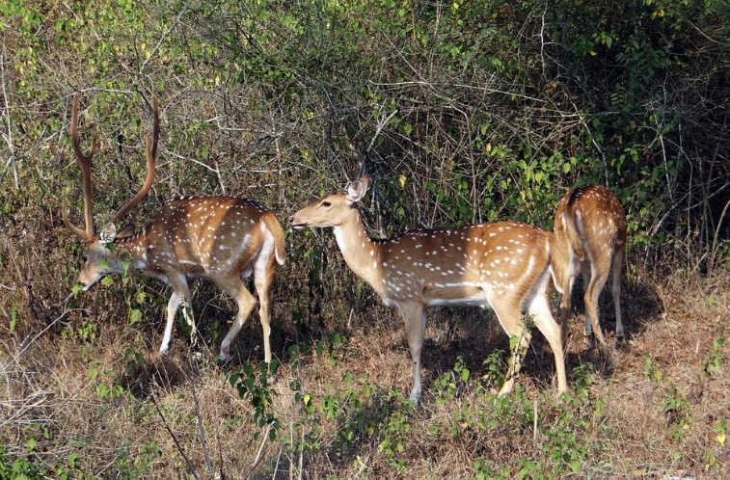
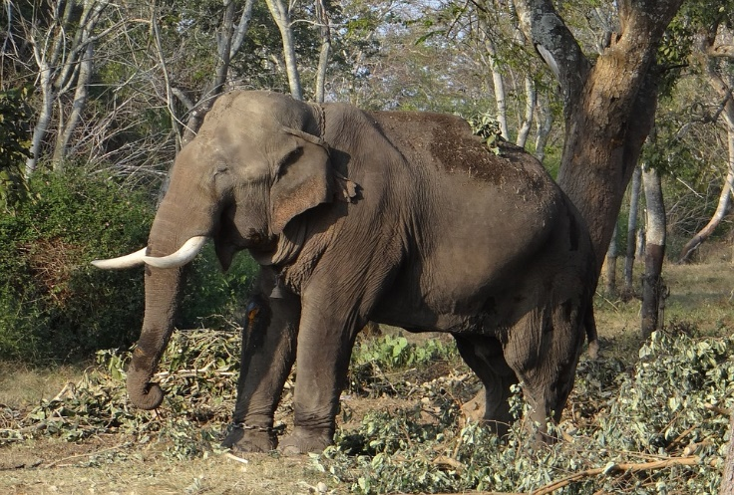

Golden Chariot

The only luxury train in South India, "Golden Chariot" offers an insight into treasure trove of archaeological wealth, abundant bounty for wildlife seekers and a kaleidoscope of culture for it's esteemed guests. It offers a mix of heritage, culture, eco-tourism and beach life. Recline & relax as the magnificent scenery unfolds outside your window with luxury on the inside, thus far reserved for royalty. We present the Golden Chariot-a fine balance between a glorious yesterday and an omnipresent tomorrow in a magical land ... that is Karnataka. The Golden Chariot Train is a joint venture of State Government of Karnataka & Ministry of Railways.

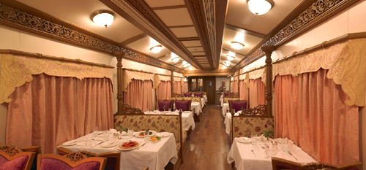
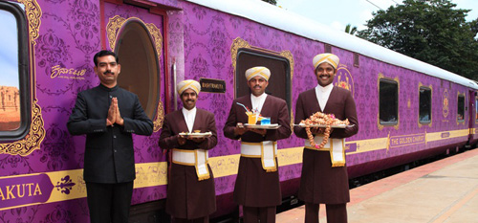
Overnight: Golden Chariot Train

Day 03 (Monday): On Board Golden Chariot (Mysore)

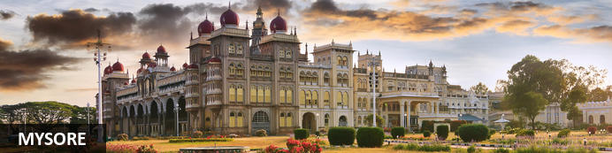
Serving as the capital of the Kingdom of Mysore from 1399 until 1947, the city of Mysore is a rich cultural and historical centre renowned for its beautiful Hindu palaces. Arguably the most captivating of these is the opulent Mysore Palace or Amba Vilas, particularly during the annual Dasara Festival, when every day after sunset it turns incandescent with the light of nearly 100 000 bulbs. In the modern context, Mysore is considered one of India’s cleanest and most efficiently planned cities, and has earned a reputation for its high quality sandalwood and silk.

- Breakfast on-board
- Visit Mysore Palace
- Return to the train for lunch
- Optional visit to Srirangapatnam
- Dinner on-board

Mysore Palace
Welcome to the Royal Splendour of Mysuru, the home of the Wodyers who ruled Mysuru for more than 500 years. Known as the City of Palaces, Mysuru retains a quaint charm, that never fails to enchant. The royal lineage can be traced back to 1399, when Yaduraya, a royal prince of the Yadava dynasty, was on a pilgrimage visit to Chamundi Temple with his brother Vijaya,. They took shelter in the Kodi Bhairava temple on the banks of Doddakere, the ‘Big Lake’. There they came to learn that the local royal family was in great danger. Their ruler had just died, and Maranayaka, a neighbouring chief, was threatening the queen. He wanted her daughter’s hand in marriage. The queen and the princess were in very vulnerable position. With the help of Jangama (Wadiyar) killed Maranayaka and married the daughter of Chamaraja and succeeded to the Mysuru principality. And so the Wodyer dynasty was established – a succession of 25 kings who ruled until 1947, when Mysuru became part of the Indian Union. The Wadiyars were great patrons of the arts, and the finest craftsmen in the state were employed to work on the Palaces. Wadiyar period was a new era of prose literature as an independent literary medium and it was in other words a prose writing in the form of the history of the Mysuru rulers. Chamaraja Wadiyar encouraged Kannada scholars like Ramachandra, author of Hayasaara Samuchchaya.
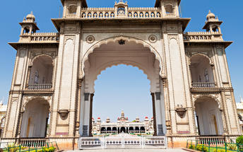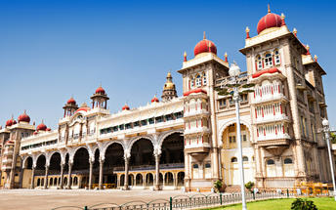

Srirangapatna (Optional)
This river island town's name is sourced from the famous Ranganathaswamy Temple which dominates the town, and this temple resembles Hoysala and Vijayanagar architecture as it was re-strengthened and modified after its initial construction in the 9th century.

Overnight: On Board Golden Chariot.

Day 04 (Tuesday): On Board Golden Chariot (Halebidu - Chikamagalur)

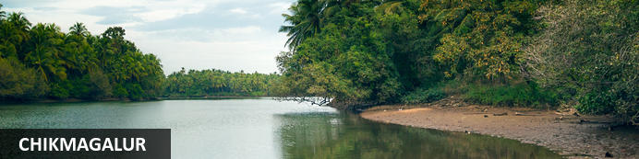
Situated in the state of Karnataka in southwest India, the hill station of Chikmagalur is remarkable for its stunning natural scenery, extraordinary temples, and delicious coffee. Boasting bright green hills and mountains jutting into the sky at extreme angles, Chikmagalur’s terrain is one which inspires near disbelief.

- Breakfast on-board as train arrives at Banavar railway station
- 08:00 Visit Halebidu
- 11:30 Return to the train
- Train proceed to Chikamagalur and lunch on-board
- 15:00 De-board the train to visit plantations followed by coffee tasting and dinner
- Return to the train

Halebidu
Halebid is known for the presence of two architectural splendors. Hoysaleshawara and Kedareshwara temples are internationally famous and draws in large number of Hindu pilgrims from all over. Two Jain basadi are also the major attractions for the tourists visiting Halebid in Karnataka. You can find two huge pools in front of the temples. It is from these lakes, that the temples have been named. The Hoysaleshwara temple has two nandi bull figures built of monolithic rock at the side of it.
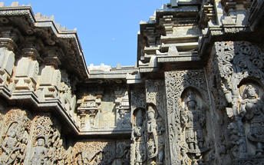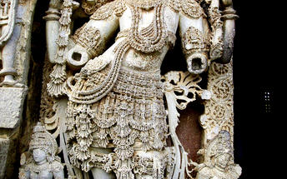

Chikmagalur
A wealth of waterfalls, accessed by picturesque trails through dense forests on the slopes and coffee plantations in the valleys, provide wonderful spots for refreshing dips. Several ancient and exquisitely decorated temples adorn the landscape. The area is known for its abundance of coffee plantations and delicious varietals.

Overnight: On Board Golden Chariot.

Day 05 (Wednesday): On Board Golden Chariot (Hampi)

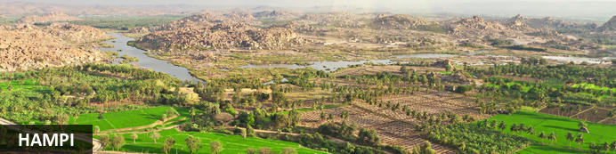
An enchanting ancient city and hippy backpacker destination, Hampi offers the perfect heady mix of Indian charms that make it hard for visitors to leave. Here history and modernity meet: impressive ancient remnants of Vijayanagara, the former capital of the Vijayanagara Empire, are dotted around the congested buildings of Hampi town. Cross the river and you’ll find laid back restaurants and rooms bordered by banana plantations and paddy fields, with a view over the river and ruins. Sightseeing can take up most of your time but don’t neglect to visit the Monkey Temple, a 572-stair climb, to catch the sunset.

- Early breakfast on-board
- Proceed to visit Hampi ruins
- Lunch on-board
- Indian evening on-board

Hampi
Hampi, The World Heritage Center, is the most beautiful and evocative of all the ruins of Karnataka. Capital of Vijayanagar kingdom is full of delightful surprises, viz., Kings Balance where kings were weighed against grain, gold or money which was then distributed to the poor, other attractions are Queen's Bath with its arched corridors, projecting balconies, Lotus Mahal Vittala Temple, Virupaksha Temple, Ugra Narasimha are not to be missed.

The best way to experience this World Heritage Site is to take a leisurely stroll through the eloquent ruins. Most of the important structure and ruins are located in tow areas, which are generally referred to as the Royal Centre and the Sacred Centre. The Royal Centre contains structures that seem to have been palaces, baths, pavilions, royal stables, and temples for ceremonial use. The sacred center is situated on the banks of the holy Tungabhadra River. Visit Vittthala temple and Virupaksha temple.

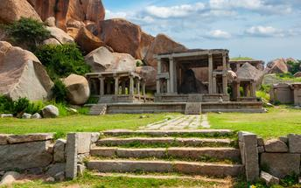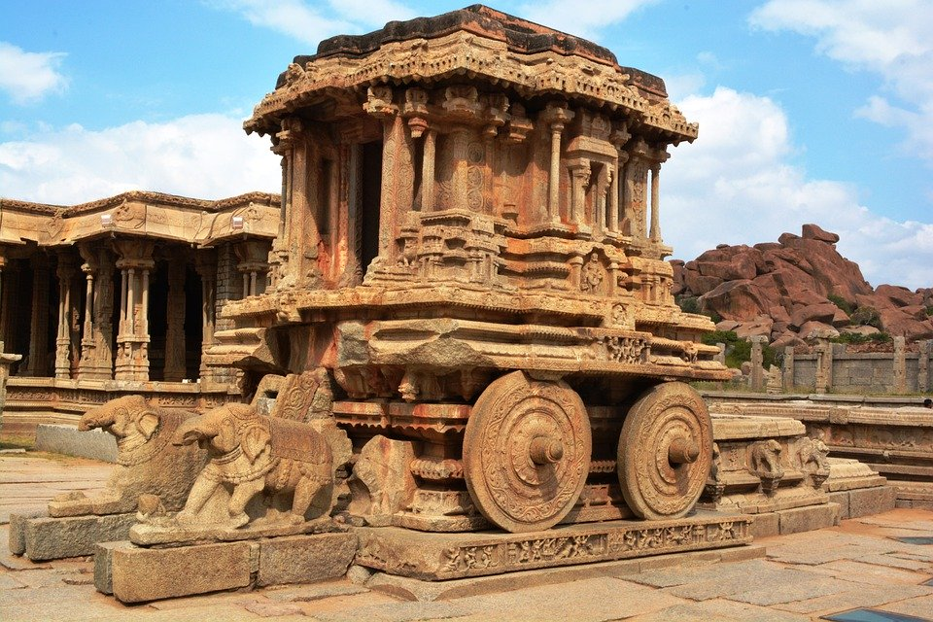

Overnight: On Board Golden Chariot.

Day 06 (Thursday): On Board Golden Chariot (Badami)

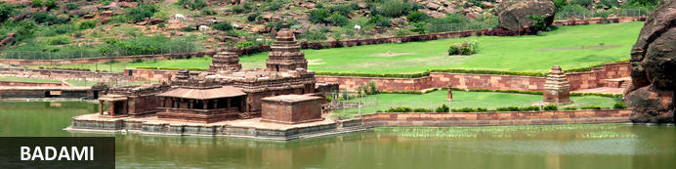
The quiet village of Badami is home to a series of ancient cave temples. Between the 6th and 7th centuries Badami was the capital of the Early Chalukyas, who ruled much of Karnataka and Andhra Pradesh. They carved out sacred spaces into the rust-coloured cliffs above Agstya Lake, and decorated the walls of these holy caves with bold, detailed reliefs of their deities. Out of the shimmering waters below rise the steps of the Bhutanatha temple complex, a cluster of sandstone shrines devoted to this god.

- Breakfast on-board
- Optional: visit to Badami caves (200 steps to climb)
- Lunch on-board
- 14:15 De-board the train to visit Pattadakal and Aihole
- Dinner on-board

Badami Caves Temple (Optional)
Architectural wonders in the true sense of the word, the Cave Temples of Badami are its most enchanting attractions. The history of these temples dates back to the period between the 6th and the 8th century. The striking feature of the temple is the flawless carving of Nataraja (the cosmic dancer) in 81 dance poses. The temple has numerous idols of the Hindu deities which have been beautifully carved. Some of the deities enshrined here are Ganapati, Shanmuka, Mahishasura Mardhini, Ardha Nariswara, Sankara Narayana, Vishnu and Trivikrama. The fourth cave temple was built in honor of the Jain Tirthankara Mahavira, Parshwanatha and Padmavati.

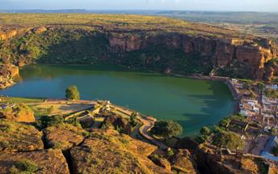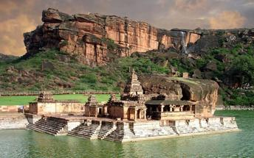

Aihole
The ancient walled city Aihole, which dates back to the 6th century in Karnakata served as the former capital of the region during the early Chalukyas period. Visitors can enjoy exploring the historic fortified complex comprised of over a hundred stone temples featuring a blend of fascinating architectural styles, Jain monuments, and ancient caves displaying unique traditional art depicting Hindu deities and legends.

Pattadakal
Declared a world heritage site in 1987, Pattadakal, situated on the banks of the Malaprabha river in the Bagalkot district of Karnataka, represents the high point of temple architecture under the Chalukya dynasty in the 7th and 8th centuries. Earlier called Kisuvolal or Pattada Kisuvolal, that literally translates to City of Crown Rubies, Pattadakal along with Aihole and Badami provide an incredible concentration of religious monuments that reveal a beautiful fusion of north (Nagara, Indo-Aryan) and south (Dravidian) Indian architectural forms. All the Hindu temples in the city are dedicated to Lord Shiva and are noteworthy for their craftsmanship and architectural brilliance. The Virupaksha Temple built around 740 by Queen Lokamahadevi to commemorate the victory of her husband, King Vikramaditya II in 731 over the Pallavas stands out among them all. The inscriptions in the temple say that the King had brought an architect and a team of sculptors from the south and reveal his admiration for the art of the Pallavas.
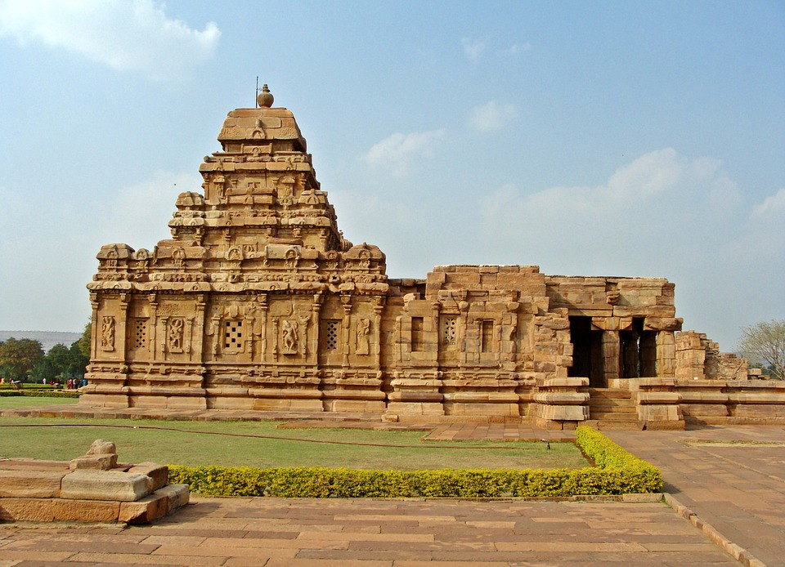

Overnight: On Board Golden Chariot.

Day 07 (Friday): On Board Golden Chariot (Goa)

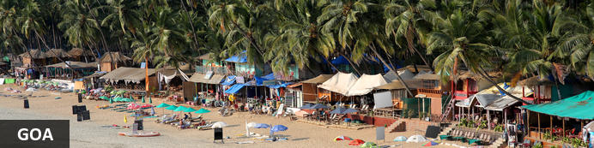
Situated in Western India, one of India’s most popular seaside destinations - Goa - offers a heady mix of warm azure waters, white-sand beaches, atmospheric cafes, electronic festivals, vibrant markets and antiquated colonial architecture - a legacy of its time under Portuguese rule. This hippy paradise boasts a cultural mix of Indian and Portuguese influences, delicious fresh seafood, and offers a spiritual sanctuary. Browse the Anjuna Flea market, relax on Palolem - Goa’s most picturesque beach and view the magnificent waterfalls at Dudhsagar. Other highlights include the elegant historical whitewashed churches of Old Goa and the spice plantations near Ponda, as well as several wildlife sanctuaries, which make up approximately one-fifth of the entire state, and encompass a wealth of bird and animal life.

- Breakfast on-board
- Proceed to visit Churches of North Goa and Museum
- Lunch on-board
- De-board the train for Bollywood evening and dinner at resort/hotel
- 21:45 Return to the train
- Dinner on-board
- Train proceeds for Yeshwantpur railway station, Bangalore

Churches of North Goa

Being a UNESCO heritage site, Bom Jesus Basilica Church is world renowned to still host the mortal remains of St. Francis Xavier. The interesting thing about the saint’s mortal remains is that it is extremely well preserved. Even today, thousands of visitors throng the church to witness this miracle. A Jesuit church amongst churches in Goa, this structure is considered to be amongst the finest representations of Baroque architecture.

Se Cathedral Church is one of the largest in India whilst being amongst the famous churches in Goa too. Being one of the oldest in the country, the Se Cathedral was built to celebrate the victory of the Portuguese ruler Afonso de Albuquerque for capturing a Goan city in 1510. Given that the day when the enemies were vanquished was also the feast of St Catherine, this church was built commemorating her.

Displaying a Portuguese-Manueline architectural style, the church has Tuscan exteriors and Corinthian interiors. Inside the church, there is a large bell called the Golden Bell – which is the largest in the state.

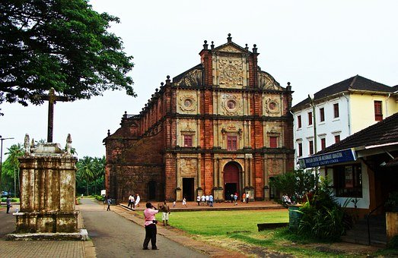

Overnight: On Board Golden Chariot.

Day 08 (Saturday): Disembark Golden Chariot - Bangalore

- Breakfast on-board
- Disembark the train
Reach Yeshwanthpur Railway station and bid adieu to this magical journey.
You will be picked up at Yeshwantpur railway station and transferred to the hotel for check In.
(Standard check in time is 1400 hrs)
Rest of the day at leisure.

Day 09 (Sunday): Bangalore Departure

At an appropriate time, your Travel Counsellor Representative will provide the necessary transfer to the Banglaore airport for your onward flight back home.

