

IN - 60

Deccan Odyssey – Indian Odyssey
Delhi - Sawai Madhopur – Agra – Jaipur – Udaipur – Vadodara – Aurangabad - Mumbai
10 Days / 09 Nights

Dates 2025-26 | Nights | City | Hotel (Room Category) | Meal Type
Day 01 – 02 | 01 | Delhi | Imperial [Imperial room] | BB
Day 02 – 09 | 07 | Delhi – Mumbai | Indian Odyssey (Deluxe Cabin Twin) | FB
Day 09 – 10 | 01 | Mumbai | Trident Nariman Point [Premier Ocean View] | BB

Day 01 (Fri): Arrive Delhi

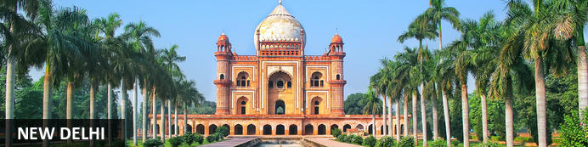
New Delhi, India’s national capital, is a relatively modern confection of imposing government buildings including Parliament, museums and wide leafy boulevards loosely centred on circular Connaught Place (officially now called Rajiv Chowk). To its north lies the formerly walled city of Old Delhi, or Shahjahanabad, built in the 17th-century by the Mughal Emperor Shah Jahan. Though long merged into one metropolis, the two have very different characters. New Delhi has space, parks, distinct neighbourhoods and a clutch of important monuments and architecture that reflect its ancient history. Old Delhi’s crowded streets, lanes and bazaars reflect its colourful medieval character and they cradle some of the city’s most memorable sights

Flight TBA
Arrives Delhi TBA
On arrival in Delhi: Having cleared immigration, collected your luggage and passed through customs, please make your way towards the exit of the terminal building where you will see a bank of people waiting. Amongst them will be Travel Counsellors Representative who will be waiting to greet you with a paging board with your name on.
You will then be transferred to your hotel and assisted with check in. Standard check in time is at 1400 Hrs.
Rest day at leisure

Overnight at Hotel Imperial

Day 02 (Sat): Board Deccan Odyssey (Delhi – Sawai Madhopur)

After breakfast, check-out from the hotel and proceed for a full day Five Senses Tour.
A sensory journey through Delhi covering everything from its food, local arts and crafts, the must-see architectural marvels, to expertly navigating and allowing you to witness the organized cultural chaos that is Delhi.
A complete tour of Old and New Delhi! We’ve carefully curated a selection of experiences that will transport you across Delhi’s rich cultural history. Experience for yourself the syncretism that has served as both Delhi’s greatest strength and vulnerability.
There isn’t a dearth of iconic sightseeing locations in the city, but for this tour, we focus on the two most beloved monuments that became inspirations or templates for all the other beautiful heritage structures. Humayun’s tomb, a spellbinding mausoleum is a favourite for any Delhiite! Your visit will be followed by a heritage craft workshop organised by an all-women NGO group that will touch your heart. Next, take a rickshaw ride through Shahjahanabad. Chaos thrives in the streets of Chandni Chowk, but as you cycle down, you’re transported by the magic in the air to the thriving Mughal era.
Next, you will indulge your sense of smell with an Ittar or perfume-making workshop. Visit an 8th-generation Ittar studio where you will get to smell and mix your unique concoction that can be named after you!
We’ll quickly stop to snack on some mouth-watering street food before proceeding to witness the glory and quietness of the Jama Masjid: a beautiful pocket of calm at the heart of Old Delhi's mayhem.
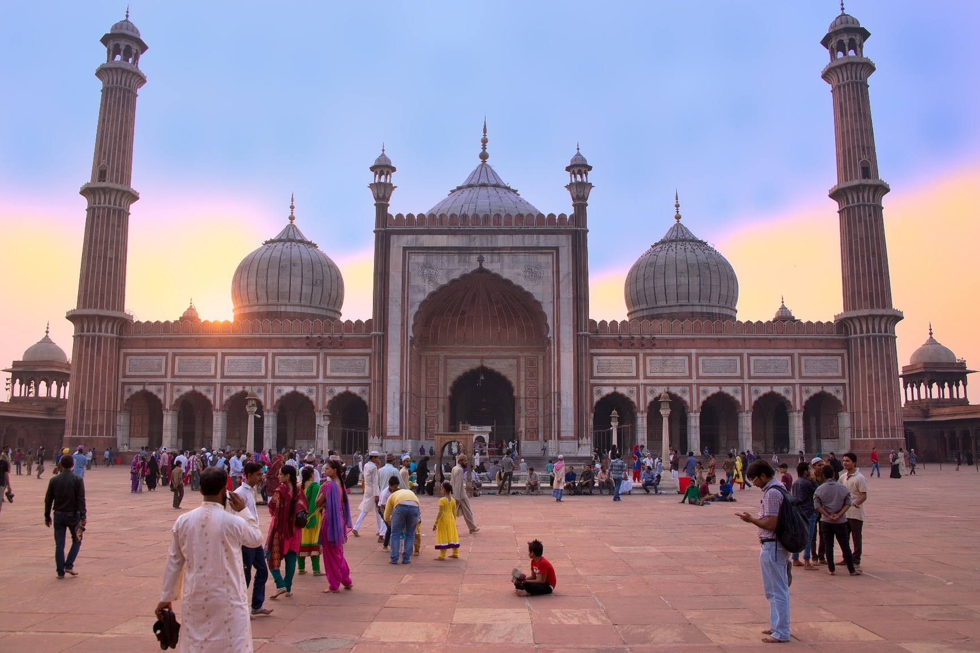
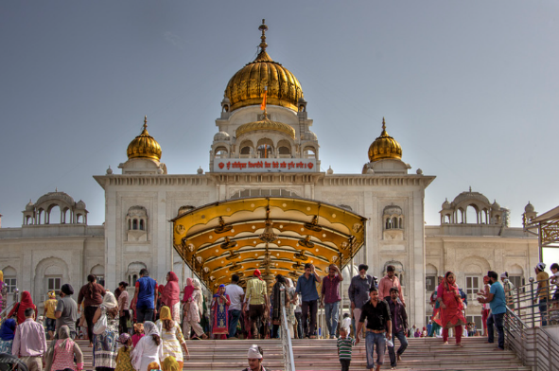
To engage your sense of sound, we bring you to Bangla Sahib. The magic of seva (selfless service) that the Gurudwara envelopes you into is undeniable. What ties together this beautiful experience is the sweet sound of the Gurbani playing in the background. Next, head to calm your favourite sense - taste! You will enjoy a meal at a contemporary Indian restaurant!
Before going back to the hotel, on the way, we show you the parts of Delhi with British influence and talk about the architectural contrast as well as some interesting stories from that time!

After the tour you will be transferred to Safdarjung Railway station to our wonderful journey aboard the Deccan Odyssey – Indian Odessey Journey (Reporting time around 1745 Hrs.)
While the Ranthambore National Park thrills you, the Taj Mahal will soothe your senses. On the one hand, the streets of Udaipur and Jaipur will fill your sight with hues, and on the other, the rusty rugged landscape of Ellora Caves will pick your collar backs and slowly land you on the land of history. But that is just a glimpse of all the Indian Odyssey holds. Deccan Odyssey, with its luxurious amenities and gracious services, is reminiscent of the lifestyle lived by the maharajas in the erstwhile era.
Guests gather at the railway station at 17:45 hours and complete the formalities related to check-in and reservations.
A traditional welcome with welcome drink is arranged for the guests and are then taken to their respected cabins. As guests relax, the train leaves for the next destination Sawai Madhopur.
Welcome drink and dinner on-board.
(Departure at 18:00)

Overnight: The Deccan Odyssey Train
Welcome to luxury train travel in India! Embark on a voyage across the magnificent landscapes and territories of India. Sail into an age of romance and royalty, discover the soul of this incredible country. From world heritage sites, forts and palaces to an array of cultural experiences crafted exclusively for you. Select from 6 great rail journeys in India on board the Deccan Odyssey and rediscover the art of elegant train traveling. Deccan Odyssey comprises 21 luxuriously appointed coaches. Out of these 21 coaches, 11 are to accommodate guests, and the rest are used for different purposes such as dining, lounge, conference car, and health spa. Inspired by the imperial carriages used by the Maharajas of the yore for traveling, each of the coaches of this luxury train is inspired by a different royal era of Maharashtra ruled by diverse dynasties. All the cabins of Deccan Odyssey are fully equipped with facilities like air-conditioning, internet connectivity, and personalized guest amenities that ensure your journey is comfortable and memorable. Moreover, the multi-cuisine restaurant, well-stocked bar, high-tech conference cart, and spa & massage cabin onboard add the colors of merriment to your entire tour.
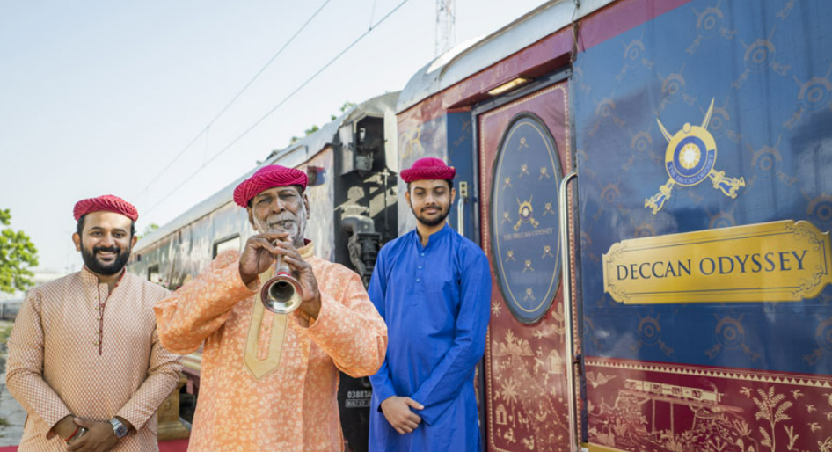

Day 03 (Sun): On Board Deccan Odyssey (Ranthambhore – Agra)

Sawai Madhopur - Ranthambore National Park
The train reaches Sawai Madhopur, which is mainly popular for Ranthambore National Park. Have your breakfast and set out for the game drive. Ranthambore National Park is one of the biggest and most popular national parks in North India.
The park is also a tiger reserve. Other than tigers you can spot nilgai antelope, chinkara gazelles, sambhar deer, chital, leopard, crocodile, jungle fowl, quails, partridges, crested serpent eagle, flycatchers, woodpeckers, among others.
Return to the train for lunch and relax for a while. Later, proceed for a village tour and interact with locals. After this, it is time for high-tea at the Sawai Madhopur Lodge, which served as a royal hunting ground for the erstwhile royal family of Jaipur.
Return to the train as it leaves for Agra. Overnight stay and dinner onboard.
(Departure at 19:30)

Ranthambore National Park
Located in the Sawai Madhopur district, the Ranthambore National Park, in the western state of Rajasthan, is one of the most visited wildlife parks in India. Spanning over an impressive 1300-square-kilometer stretch of wilderness, the park’s outstanding natural beauty is characterized by its dense jungle, golden savanna, dramatic cliffs and lotus-filled lakes. Considered the best spot to catch a glimpse of tigers in the wild, the park offers visitors a spellbounding combination of mystical temples, wild beauty and crumbling ruins. While the main attraction is undoubtedly the elusive Bengal tiger, the park provides a sanctuary for other wildlife including, among others: sambar, gazelle, caracal, black buck, crocodile, chital, wild boars and a wide array of birds. Don’t miss the ancient Ranthambore Fort, perched high on the cliffs overlooking the vast expanse of this spectacular park.
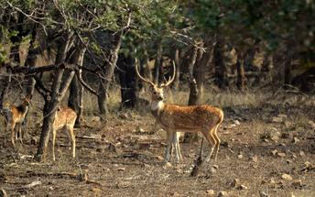

Overnight: On Board Deccan Odyssey.

Day 04 (Mon): On Board Deccan Odyssey (Agra – Jaipur)

Agra
On the third day of the tour, you luxury train reaches the City of Taj, Agra. Have your breakfast onboard and proceed to visit Taj Mahal. This white-marble mausoleum was built by Emperor Shah Jahan for his wife.
Today it stands as a testimony of true love and magnificent architecture. Lunch is arranged in a city hotel, after which you visit Itmad-ud-Daulah (Also known as Baby Taj).
This tomb belongs to Ghiyas Beg and was commissioned by his daughter Nur Jahan, years before the Taj Mahal. Afterwards explore the popular Agra Fort. Later, you can shop in the local markets or opt for massages in a spa.
Return to the comforts of the luxury train and stay overnight.
(Departure at 20:30)

Taj Mahal
The iconic Taj Mahal is not only an architectural masterpiece, a UNESCO World Heritage Site and one of the new Seven Wonders of the World – it’s also the enduring legacy of a royal love story. It was commissioned in the 15th century by the Mughal Emperor Shah Jahan after the death of his third and favourite wife, Mumtaz Mahal, to serve as her final resting place and a symbol of his eternal affection for her. Combining Islamic, Persian, Ottoman Turkish and Indian design elements, it’s an awe-inspiring structure of elegant domes and white marble, which changes colour along with the light – pink at sunrise, pearly white in the afternoon and silver-gold in the full moon.
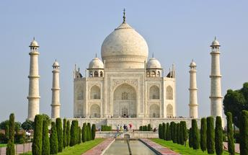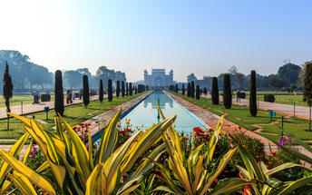

Tomb Of Itmad-Ud-Daulah (Baby Taj)
Tomb of I'timad-ud-Daulah is a Mughal mausoleum built for the grandfather of the Mumtaz Mahal, who the Taj Mahal was in turn built for. the tomb colloquially known as the "jewel box", or the "Baby Taj".
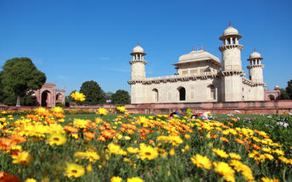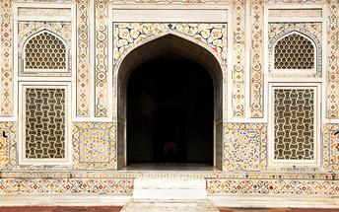

Agra Fort
Known as the Red Fort of Agra, this walled imperial city was founded in 1565 by the Emperor Akbar (1556-1605) and is a well-deserving UNESCO World Heritage site, located just 2.5 kilometres from the famous Taj Mahal. Its palaces, grand mosques and elaborate public hall are crafted from pink-red sandstone and are testament to an era when Indo-Muslim art, strongly marked by influences from Persia, was at its height. Emperor Shah Jahan, who built the Taj Mahal for his deceased wife, was imprisoned by his son Aurangzeb in Agra Fort. He is said to have died in the Musamman Burj, a marble tower he himself built, with one of the most alluring views of the Taj Mahal.
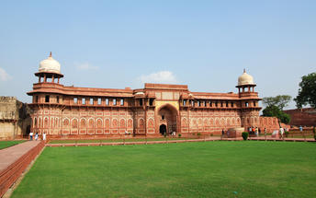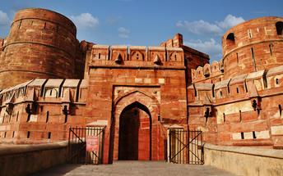
Overnight: On Board Deccan Odyssey.

Day 05 (Tue): On Board Deccan Odyssey (Jaipur)

Jaipur
Welcome to the Pink City today, the capital of Rajasthan, Jaipur. Once you have your breakfast, leave for Amer Fort. This is a star attraction of the city and a UNESCO World Heritage Site along with other Hill Forts of Rajasthan.
The fort was built in the 17th century by Maharaja Mansingh, but its grace and charm don't seem to have faded. While on the way to Amer Fort, you can stop at other attractions of Jaipur, such as Hawa Mahal, City Palace and Jantar Mantar.
Hawa Mahal is an iconic spot, with intricately placed windows that look like a honeycomb. Jantar Mantar is a UNESCO World Heritage Site and houses world's largest stone sundial. Lunch is to be arranged in a city hotel.
After lunch, you can either indulge in a spa session in a city hotel or take a stroll in the colorful markets of Jaipur which are stocked with handicraft, paintings, bangles, lehenga cholis and other knick-knacks.
Return to the comforts of your luxury train, have dinner and stay overnight as it leaves for the next destination- Udaipur.
(Departure at 20:00)

Amer Fort
Amer Fort, officially known as the ‘Amer Palace’, is one of the most famous forts of Rajasthan attracting around 4000 to 5000 visitors a day during peak tourist season. The palace was named after the small town of Amer, where it is situated - only eleven kilometres from Jaipur. Perfectly picturesque, this 16th century hillside residence is well preserved, boasting grand pavilions and mirrored halls that open onto flourishing gardens and courtyards. Although the palace’s main construction started in 1592 by Maharaja Man Singh, it was added to over the years by successive rulers and continued to be occupied by them until Jaipur was built.
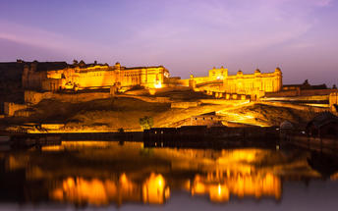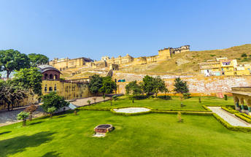

Drive past Hawa Mahal (Palace of Winds)
One of Jaipur’s most recognised buildings, the Hawa Mahal (Palace of Winds) is known for its iconic façade. Small windows, decorated with intricate latticework create a honeycomb-like appearance. The original intention of the lattice was to allow the royal ladies to observe everyday life in the street below without being seen. The cooling effect, provided by the breeze passing through the small windows, gave the palace its name. Built in 1799 by Maharaja Sawai Pratap Singh, the unique construction was originally designed to look like the crown of Krishna. A panoramic view of Jaipur can be had from the top of the building.
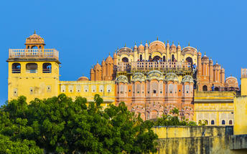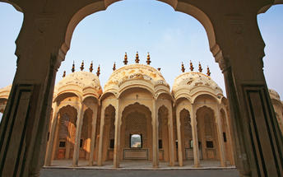

Jaipur City Palace
City Palace forms one of the most famous tourist attractions and a major landmark in Jaipur. The beautiful palace was built by Maharaja Sawai Jai Singh during his reign. Among the various forts and palaces of Jaipur, City Palace stands apart, with its outstanding art and architecture.
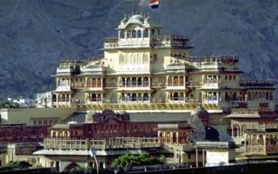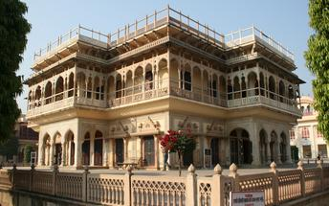

Jantar Mantar Jaipur
In 1734, the year of its completion, the Jai Singh Observatory was the last outpost of medieval science. From the outside, the eighteen fixed observational instruments look more like playground apparatus than sighting devices, but they were used to measure the position of the sun, stars and planets. Built by Jai Singh, the first Maharaja of Jaipur who founded the city in 1727, the observatory is one of a handful. Jai Singh, fulfilling a lifelong interest in mathematics and astronomy, built observatories in Delhi, Jaipur, Ujjain, Mathura and Benares. The Jaipur observatory is the largest and best preserved of these.
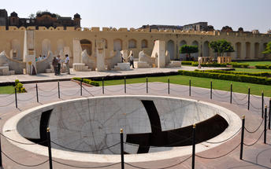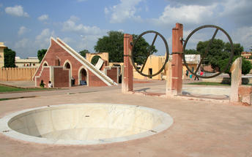
Overnight: On Board Deccan Odyssey.

Day 06 (Wed): On Board Deccan Odyssey (Udaipur)

Udaipur
The train arrives in the City of Lakes, Udaipur, on the fifth day of your tour. Owing to the spectacular backgrounds of the Aravali Range and scintillating lakes, Udaipur is also known as Venice of the East.
Breakfast is served onboard.
First site of the day is City Palace, the largest complex in Rajasthan with a beautiful Crystal Gallery in it. Then, take a ferry on the Lake Pichola in order to reach Jagmandir Palace. This is where lunch is to be served, accompanied with the taps of Tabla and rhythm of Jal Tarang.
The palace dates back to 17th century and looks upon a brilliant view of the Aravalis. Return to Deccan Odyssey and relax for some time. After this, take a heritage-walk through the Old City of Jaipur. Board the train yet again in the evening.
Dinner is served onboard as the train leaves for Vadodara. Overnight stay onboard.
(Departure at 19:30)

Udaipur City Palace
Situated above Lake Pichola, Udaipur City Palace has housed many royals over four centuries who have each added their own unique preferences to the establishment. The palace is a one of a kind in Rajasthan. Udaipur City Palace was constructed entirely out of marble and granite which makes it highly luxurious. The inside is even more so with its inlays of coloured glass, engravings, towers, and balconies.
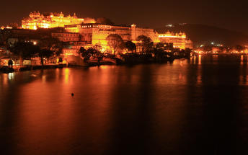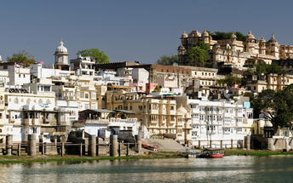

Crystal Gallery
Located in Udaipur, India, Crystal Gallery is the biggest private collection of crystals in the world. Situated inside the Fateh Prakash Palace, this attractive collection was established by Maharana Sajjan Singh in 1877 and opened to the public in 1994.
Overnight: On Board Deccan Odyssey

Day 07 (Thu): On Board Deccan Odyssey (Vadodara)

Vadodara
As you reach the Capital of Gaekwads, Vadodara, have your breakfast and disembark for visiting the Champaner-Pavagadh Archeological Park (UNESCO World Heritage Site). This is the only unchanged and complete Islamic city in India that belongs to the Pre-Mughal era.
In one of its attractions (Jami Masjid), a blend of Hindu and Islamic architecture is seen. Drive back to the train and savor leisure lunch. Later, visit Maharaja Fateh Singh Museum, which in the erstwhile era served as an educational institute for the children of royal households.
Today, however it has turned into a treasure for an art-aficionado. Enjoy high tea at the Laxmi Vilas Palace, the royal residence even today. The palace was built in 1890 and is four times the size of Buckingham Palace.
There also is a collection of old armory and sculptures made of marble, terracotta and bronze. Treat your taste-buds with local delicacies and your eyes with the cultural show.
Return onboard as the dinner gets served and the train chugs off for Aurangabad. Overnight stay onboard.
(Departure at 20:00)
Overnight: On Board Deccan Odyssey.

Day 08 (Fri): On Board Deccan Odyssey (Aurangabad)

Aurangabad
On the seventh day of the tour, you reach Aurangabad, the Mughal city named after its Great Emperor Aurangzeb. The morning is to be spent at leisure, so can enjoy an unhurried breakfast session.
The train arrives in Aurangabad as the lunch gets served. Take a scenic drive to Ellora Caves (UNESCO World Heritage Site). This consists of 30 rock-cut shrines that represent Hindu, Buddhist and Jain forms of art, dating back to a time between 4th and 5th century AD.
Return to the comforts of luxury train once you are done exploring Ellora Caves. Enjoy sun-downer at Mumbai-Hi in the evening, followed by dinner. Overnight stay onboard.
Welcome to the Ellora Caves, a captivating UNESCO World Heritage Site nestled in the charming Chhatrapati Sambhaji Nagar of Maharashtra. As you meander through its winding paths, you will be instantly transported back in time to an era of breathtaking architecture, intricate carvings, and a rich cultural heritage. This historical gem is an absolute must-visit for all travellers with a passion for Indian history and architecture. The caves are a treasure trove of history, art, and culture, offering an unforgettable experience that will stay with you for a lifetime. Each cave has its own story to tell, making it an enticing journey into the religious and cultural diversity of ancient India. One of the most awe-inspiring sights within the Ellora Caves is the magnificent Kailasa Temple, a grand dedication to Lord Shiva. This colossal rock-cut temple, taking over a century to complete, is the largest of its kind globally. With intricate sculptures depicting episodes from Hindu mythology and surrounded by high walls, this temple replicates Mount Kailash, the mythical abode of Lord Shiva. The Jain temples at Ellora are equally remarkable, with the Indra Sabha standing out as the largest and most ornate. Dedicated to Lord Indra, the king of gods in Jain mythology, this temple showcases the finest craftsmanship of its time. The Buddhist caves are equally fascinating, with the Chaitya Hall being a highlight. This rock-cut Buddhist temple features a large stupa in its centre, flanked by intricately carved pillars and Buddha statues, making it a place of meditation and religious rituals in ancient times.
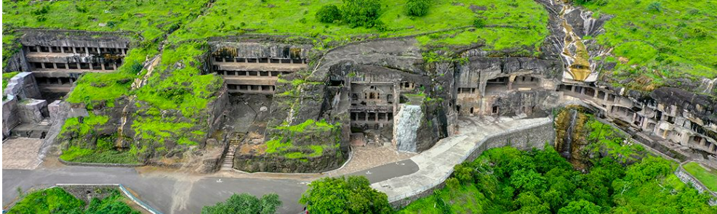
(Departure at 19:00)
Overnight: On Board Deccan Odyssey

Day 09 (Sat): Disembark Deccan Odyssey - Mumbai

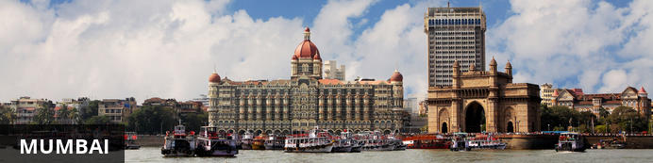
The thriving metropolis of Mumbai is a go-to destination for travellers curious to experience a modern Indian city. Lapped by the Arabian Sea, this urban seaside peninsula is a melting pot of old and new India. Towering office blocks and shiny apartment buildings shoulder crumbling grand dames of architecture. Men play cricket in the leafy central parks, taxis navigate the jam packed streets and families stroll along the seaside promenades of Mumbai, while kilometres away children beg on the peripheries of Asia’s biggest slum. In the wide avenue of Colaba’s high street, western culture overshadows the brightly lit storefronts, where Levi’s, Adidas and McDonalds vie for retail space.

Mumbai
The Deccan Odyssey reaches the final leg of its tour, Indian Odyssey, on the eighth day. The train stations at Chhatrapati Shivaji Terminus Railway Station of Mumbai.
After having breakfast onboard, guests disembark and bid farewell to the Deccan Odyssey.
You will be met by our representative at the platform who will introduce you to the local guide, thereafter proceed for half-day Mumbai city tour. You will end your tour by driving past Flora Fountain, Dhobi Ghat, Marine Drive.
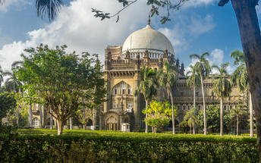
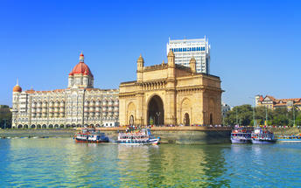

Visit Gateway of India: The Gateway of India is an arch-monument built in the early 20th century in the city of Mumbai, India. It was erected to commemorate the landing of King-Emperor George V, the first British monarch to visit India, a monument built in the Indo-Saracenic style, incorporating elements of 16th-century Gujarati architecture. The final design of the monument by architect George Wittet was sanctioned only in 1914, and construction was completed in 1924.
Drive past Marine Drive: Marine Drive is a 3-kilometre-long Promenade was constructed by Pallonji Mistry. It Marine Drive is situated on reclaimed land facing west-south-west. Marine Drive is also known as the Queen's Necklace because, when viewed at night from an elevated point anywhere along the drive, the street lights resemble a string of pearls in a necklace.
Drive past Chowpatty Beach: Girgaon Chowpatty is a quaint beach in the southern part of Mumbai and is known widely for its street food, rather than sunbathing or other water activities. Girgaon Chowpatty sea face is flocked with tourists and street food vendors. Girgaon Chowpatty is one of the most crowded tourist attractions in Mumbai, with locals frequenting this place with family and friends after a tiring day at work.
Drive past Malabar Hill: Malabar Hill is a hillock and upmarket residential neighbourhood in South Mumbai, Maharashtra, India. Malabar Hill is the most exclusive residential area in Mumbai. It is home to several business tycoons and film personalities. As of 2014 it is one of the most expensive areas in the world regularly featuring in the top 10 world-wide localities.
Mani Bhavan: Mani Bhavan is a place where Gandhiji lived and interacted with his colleagues to mould the freedom movement in the image of the cherished ideals of Truth and Non-violence. It was from Mani Bhavan that his followers and devotees went forth in the world inspired and charged with a sense of service and sacrifice. Even today, Mani Bhavan is a source of inspiration for the lovers of freedom and peace the world over.
Drive past Dhobi Ghat: The world’s largest outdoor laundry! See the dhobiwallahs, or washermen, scrubbing sheets from Mumbai’s largest hospitals and hotels at this busy outdoor laundry area.
Drive past CST Station: See the famous facade of CST and visit inside one of the busiest railway stations in the country. Gaze up at the station’s Victorian Gothic architecture as you learn about Mumbai’s only UNESCO World Heritage Site.
Colaba Causeway: Colaba Causeway is a commercial street, it lies close to the Fort area, and also close by many Mumbai's famous landmarks like, the Gateway of India and Taj Mahal Palace & Tower. The place is famous for various shopping options including cheap, street clothes to fashionable shops, this lane offers everything. One can stroll through the footpaths and window shop for clothes, shoes, purses, jewellery etc. It also has several restaurants. The place is generally crowded in most of the time and a good place for some interesting photo stops.
After the visit, proceed to the hotel for check in. (Standard check in time is 1400 hrs)
Overnight at Hotel Trident Nariman Point

Day 10 (Sun): Mumbai Departure

At an appropriate time, your Travel Counsellor Representative will provide the necessary transfer to the airport for your onward flight back home. Standard check out at 1200 Hrs.
Flight TBA
NOTE :- Check-in venue is subject to change with prior intimation
All arrival and departure timings are approximate and subject to change by the Indian Railways.

End of itinerary

