

Journey with the Oberoi Resorts - IN51
New Delhi - Agra - Sawai Madhopur - Jaipur - Udaipur - Gurgaon
12 Days / 11 Nights

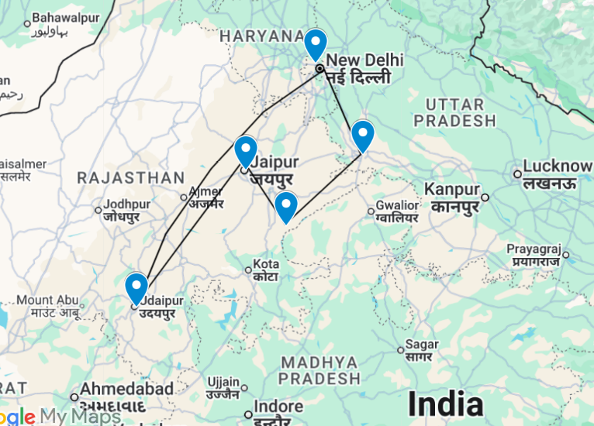
Journey with the Oberoi Resorts
This is the classic cultural tour of North India combining New Delhi, Agra Ranthambore National Park, Jaipur and Udaipur.
New Delhi, the national capital, offers several key sights and historic monuments while Agra is synonymous with the Taj Mahal – a high-point of Mughal architecture and one of the world’s most celebrated buildings. Ranthambore offers superb wild tiger sightings in a rugged hilly landscape while Jaipur, Rajasthan’s state capital, boasts some of the region’s finest palaces and impressive forts along with an eclectic array of crafts and shopping. Udaipur – or ‘Lake City’ after its lakeside location – is probably the state’s most picturesque city with an imposing palace complex overlooking Lake Pichola and a charming island palace, now a famous luxury hotel.

Introduction

Accommodation | Destination | Start | End | Meal Plan | Room Type | Duration
The Oberoi New Delhi | New Delhi | Day 01 | Day 03 | BB | Premier room | 02 Night
Oberoi Amarvilas | Agra | Day 03 | Day 05 | BB | Premier room | 02 Nights
Oberoi Vanyavilas | Sawai Madhopur | Day 05 | Day 07 | FB | Luxury Tent | 02 Nights
Oberoi Rajvilas | Jaipur | Day 07 | Day 09 | BB | Premier Room | 02 Nights
Oberoi Udaivilas | Udaipur | Day 09 | Day 11 | BB | Premier Room | 02 Nights
Oberoi Gurgaon | New Delhi | Day 11 | Day 12 | BB | Luxury room | 01 Night

Day 01: Arrival Delhi
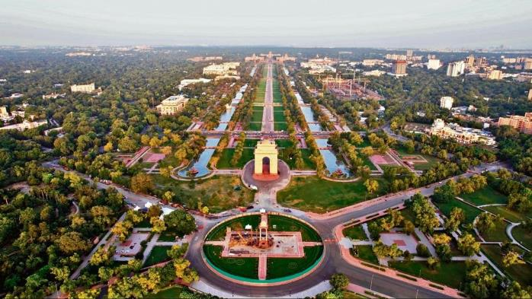
New Delhi, India’s national capital, is a relatively modern confection of imposing government buildings including Parliament, museums and wide leafy boulevards loosely centred on circular Connaught Place (officially now called Rajiv Chowk). To its north lies the formerly walled city of Old Delhi, or Shahjahanabad, built in the 17th-century by the Mughal Emperor Shah Jahan. Though long merged into one metropolis, the two have very different characters. New Delhi has space, parks, distinct neighbourhoods and a clutch of important monuments and architecture that reflect its ancient history. Old Delhi’s crowded streets, lanes and bazaars reflect its colourful medieval character and they cradle some of the city’s most memorable sights.

Day Itinerary
Flight TBA
Arrives Delhi TBA
On arrival in Delhi: Having cleared immigration, collected your luggage and passed through customs, please make your way towards the exit of the terminal building where you will see a bank of people waiting. Amongst them will be Travel Counsellors Representative who will be waiting to greet you with a paging board with your name on.
You will then be transferred to your hotel and assisted with check in.

Overnight: The Oberoi New Delhi
The Oberoi New Delhi boast breathtaking views of the UNESCO World Heritage Site of Humayun’s Tomb and a forested golf course. The guest rooms and suites are bright, spacious and elegantly decorated, equipped with air conditioning, Wi-Fi, TVs and private bathrooms. The suites boast generous floor space and separate living rooms with TVs. Guests can enjoy dining at the on-site restaurants serving delicious Indian, Chinese and international cuisine or relax at the rooftop bar with a handcrafted cocktail. Additional amenities and services include a swimming pool, a fitness centre, a spa, meeting facilities, event hosting, a lobby lounge, parking and a reception.
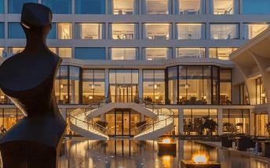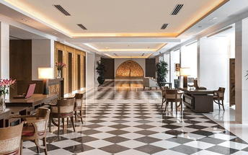

Day 02: In Delhi

Day Itinerary
Breakfast at Hotel.
Today proceed for The Five Senses Delhi Tour
A sensory journey through Delhi covering everything from its food, local arts and crafts, the must-see architectural marvels, to expertly navigating and allowing you to witness the organized cultural chaos that is Delhi.
USP - Delhi 101: A complete tour of Old and New Delhi! We’ve carefully curated a selection of experiences that will transport you across Delhi’s rich cultural history. Experience for yourself the syncretism that has served as both Delhi’s greatest strength and vulnerability.
There isn’t a dearth of iconic sightseeing locations in the city, but for this tour, we focus on the two most beloved monuments that became inspirations or templates for all the other beautiful heritage structures. Humayun’s tomb, a spellbinding mausoleum is a favourite for any Delhiite! Your visit will be followed by a heritage craft workshop organised by an all-women NGO group that will touch your heart. Next, take a rickshaw ride through Shahjahanabad. Chaos thrives in the streets of Chandni Chowk, but as you cycle down, you’re transported by the magic in the air to the thriving Mughal era.
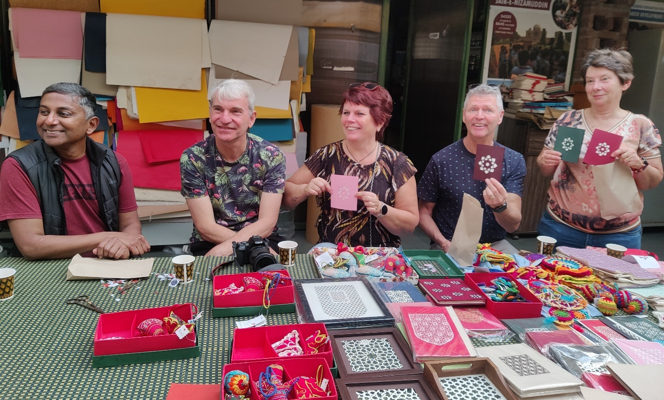

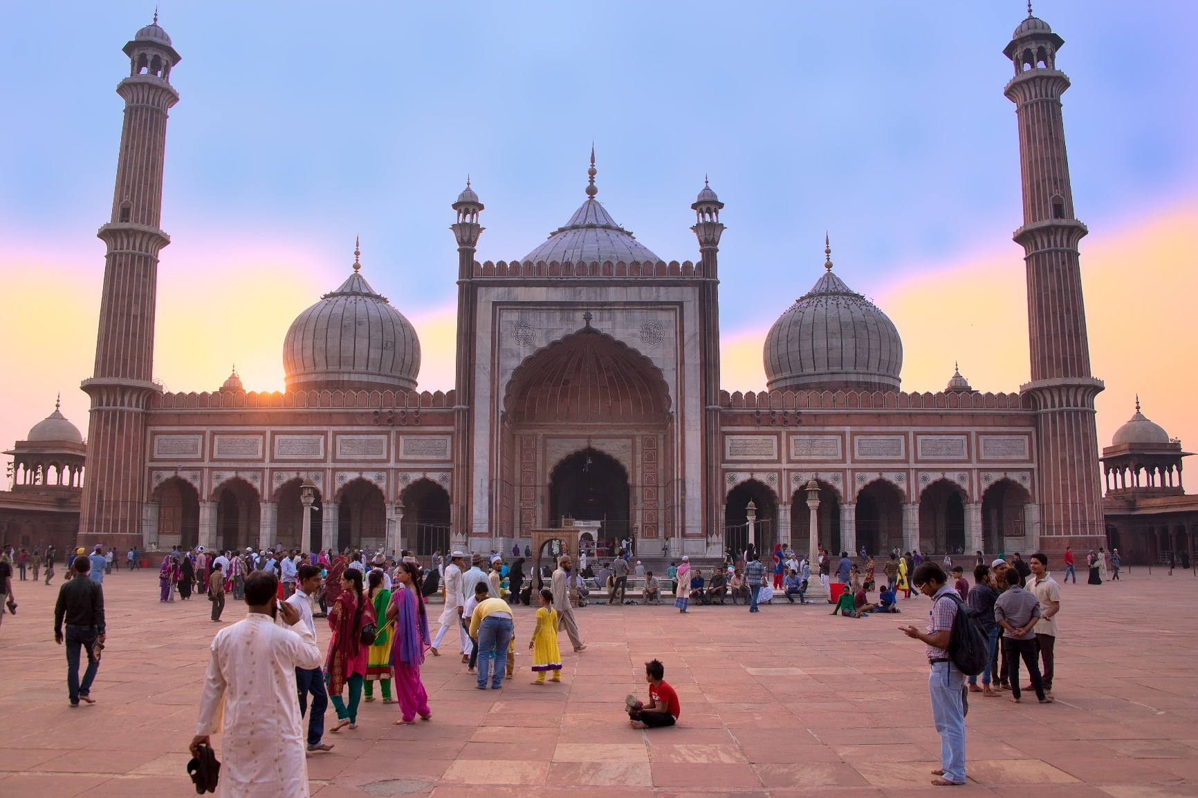
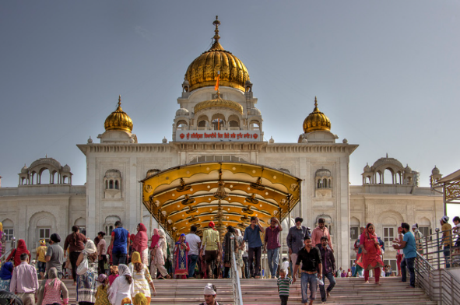
Next, you will indulge your sense of smell with an Ittar or perfume-making workshop. Visit an 8th-generation Ittar studio where you will get to smell and mix your unique concoction that can be named after you!
We’ll quickly stop to snack on some mouth-watering street food before proceeding to witness the glory and quietness of the Jama Masjid: a beautiful pocket of calm at the heart of Old Delhi's mayhem.
To engage your sense of sound, we bring you to Bangla Sahib. The magic of seva (selfless service) that the Gurudwara envelopes you into is undeniable. What ties together this beautiful experience is the sweet sound of the Gurbani playing in the background. Next, head to calm your favourite sense - taste! You will enjoy a meal at a contemporary Indian restaurant!
Before going back to the hotel, on the way, we show you the parts of Delhi with British influence and talk about the architectural contrast as well as some interesting stories from that time!

Day 03: Delhi – Agra

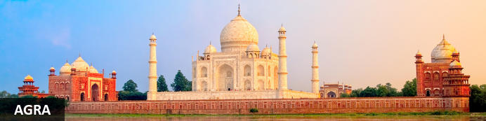
Straddling the broad Yamuna River 180km south of Delhi, Agra’s fame rests almost entirely on one building – the iconic Taj Mahal. Yet from the early 16th-century it was the Mughal empire’s capital endowed with numerous buildings and monuments that still make it a major draw for visitors. Apart from the Taj, Agra Fort (with its strong resemblance to Delhi’s Red Fort), the exquisite Tomb of Itmad-ud-Dalah (often called the ‘Baby Taj’), earthy bazaars and the evocative ‘ghost city’ of Fatehpur Sikri 40km to the west all make it a key tourist destination.

Day Itinerary
Breakfast at the hotel.

Late morning drive to Agra, upon arrival check-in at hotel. (approx.. 4 – 5 hours drive).

Rest of the day at leisure.

Overnight: The Oberoi Amarvilas
The Oberoi Amarvilas offers guests an elegant stay near the Taj Mahal. The hotel’s rooms and suites feature ensuite bathrooms, TVs, Wi-Fi, safes, and air conditioning. Guests can indulge in delicious meals from the on-site dining facilities. Other services and facilities include a swimming pool, wellness services, and meeting facilities.
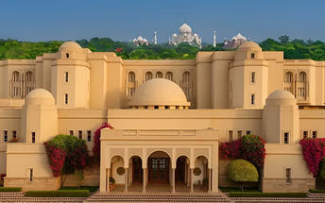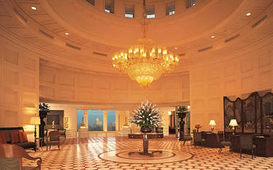

Day 4: Agra

Day Itinerary
Early morning proceed for Sunrise visit to the Taj Mahal (best light, fewer crowds)

After the visit return to hotel for breakfast. Later proceed to visit Agra Fort.

Rest of the day at leisure.

Taj Mahal (Taj Mahal remains closed on Friday)
The iconic Taj Mahal is not only an architectural masterpiece, a UNESCO World Heritage Site and one of the new Seven Wonders of the World – it’s also the enduring legacy of a royal love story. It was commissioned in the 15th century by the Mughal Emperor Shah Jahan after the death of his third and favourite wife, Mumtaz Mahal, to serve as her final resting place and a symbol of his eternal affection for her. Combining Islamic, Persian, Ottoman Turkish and Indian design elements, it’s an awe-inspiring structure of elegant domes and white marble, which changes colour along with the light – pink at sunrise, pearly white in the afternoon and silver-gold in the full moon.

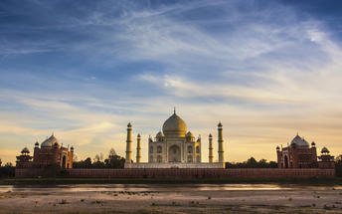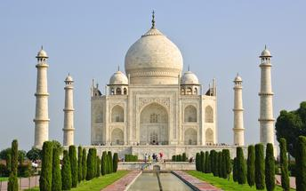
Agra Fort
With its striking resemblance to Delhi’s Red Fort, Agra Fort’s massive sandstone walls stretch for over two kilometres with their eastern flanks overlooking a bend in the Yamuna River. Commissioned by the Mughal Emperor Akbar in 1573, its 90-acres of part-manicured gardens, imposing pavilions, royal apartments and audience halls are an impressive counterpoint to the Taj Mahal’s more delicate beauty and finesse. Built as a virtually self-contained imperial city, the fort came to symbolise Mughal military power. Here famously the Taj’s builder Emperor Shah Jahan was imprisoned by his own son and spent his final days gazing across the river at his beloved Taj Mahal.
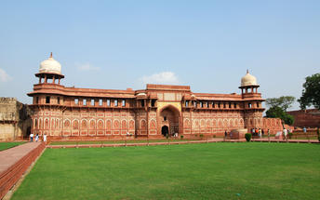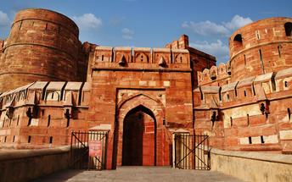

Day 5: Agra – Sawai Madhopur (Ranthambore)


Named after a rambling 10th-century fortress which still stands sentinel on a 200m-high plateau, Ranthambore is one of India’s most famous national parks. One a royal hunting ground, today its 1334km² of dry forests, grassy meadows, lakes, streams and rugged picturesque hills are home to a sizeable population of wild tigers. Other wildlife includes leopards, antelopes, deer, hyenas, jackals, sloth bears, crocodiles and over three hundred species of birds. Access is closely regulated with a set number of vehicles, visitors and driving routes allocated each day to evenly distribute the human impact on its flora and fauna. Nearby Sawai Madhopur is the closest town to Ranthambore and most visitors stay here or in its outskirts.

Day Itinerary
Breakfast at the hotel.

Morning at leisure.

Later proceed for Bharatpur Junction railway station to board your express train for Sawai Madhopur also known and famous as “Ranthambore National Park” is situated 14 km away from Sawai Madhopur & 180 km away from Jaipur, the eastern district of Rajasthan in India. As a matter of fact, the sanctuary of Ranthambore forests was previously a private hunting ground of the Maharajas of Jaipur.

Train Kota Jan Shatabdi Express (AC Chair Car)
Depart Bharatpur 1452 Hrs
Arrive Sawai Madhopur 1713 Hrs.

Upon arrival at Sawai Madhopur Jn, you will be met by our representative, who will then escort you to your resort and assist you with check-in formalities at the resort for your 02-night stay!

Overnight: The Oberoi Vanyavilas Wildlife Resort
The Oberoi Vanyavilas Wildlife Resort is situated in Ranthambhore, India, near Ranthambhore Park, the Rajiv Gandhi Regional Museum of Natural History and Amreshwar Temple Gate. Accommodation consists of luxury tents equipped with air-conditioning, a television, a safe, a hairdryer, a personal bar, a bathroom and tea and coffee facilities. There is an on-site restaurant where guests can enjoy meals. Additional facilities include a bar, a spa, a swimming pool and a fitness centre.
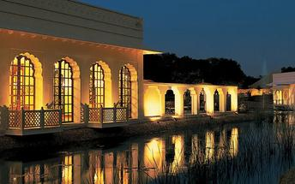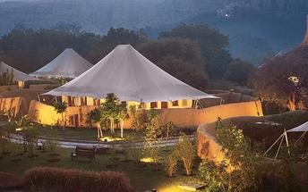

Day 6: Ranthambore

Day Itinerary
Today your morning jungle safari (Private Jeep) exploration takes a higher level, an early morning ride enables more chances for sighting the animals. You explore the deep jungles of the National Park on an open-roof vehicle, tracking for tigers. This mission lasts for around three hours!
Return to the hotel for breakfast and spend the rest of the morning relaxing in the comfort of the hotel.

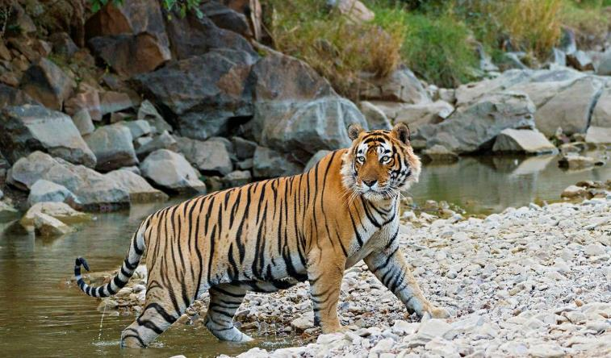

Then post lunch, your afternoon jungle safari (Private Jeep) continues into the Ranthambore National Park for wildlife viewing. In the evening you return to the hotel to relax and after dinner, you retire for the night.

Day 7: Ranthambore – Jaipur

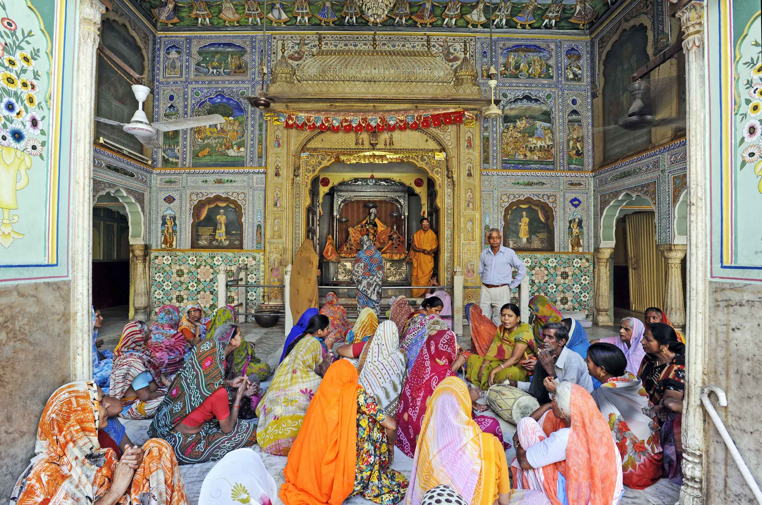

Founded in the early 1700s by Maharaja Jai Singh II as his new capital, the original ‘Pink City’ (so-called because almost all buildings were painted terracotta pink to honour the 1876 visit of the future King Edward VII) was laid out in a traditional grid with colonnaded streets and uniform façades. That layout remains intact and the city, now state capital of Rajasthan, has evolved and expanded into a modern metropolis with its own metro system. Yet its key sights and attractions lie within a relatively compact area.

Day Itinerary
Today after breakfast, you'll make your way to Jaipur – land of the Rajput’s, also is known as the 'Pink City', home to ancient forts and palaces. (Approximately 4 Hrs drive)

Upon arrival Jaipur, you will check-in to your hotel.
Rest of the day at leisure.
Overnight: The Oberoi Rajvilas
The Oberoi Rajvilas, located in Jaipur, Rajasthan, offers a luxurious experience amidst beautifully landscaped gardens. The hotel features elegantly designed rooms with modern amenities such as air conditioning, flat-screen TVs, and Wi-Fi access. Guests can dine at Surya Mahal for international cuisine, Rajmahal for Indian specialties, and Rajwada Library Bar for wines and spirits. Additional facilities include a temperature-controlled pool, a fitness centre, and a spa offering body treatments.
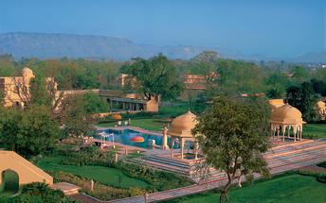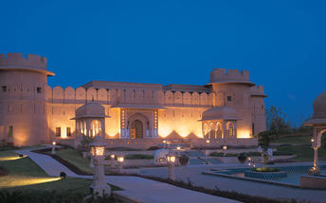

Day 8: Jaipur

Day Itinerary
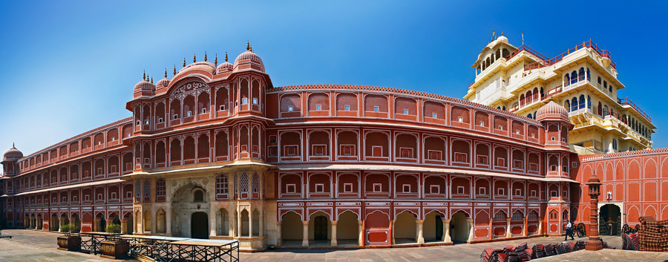
Begin exploring this city visit the City Palace complex which is spread over a large area occupying one-seventh of the old city of Jaipur .It is comprised of two palaces, Chandra Mahal and Mubarak Mahal, museum, a vast array of courtyards, gardens, and buildings. The palace is a blend of the Shilpa Shastra of Indian architecture with Rajput, Mughal, and European styles. Diwan-I-Aam (Hall of Public Audience), Bhaggi Khana (a museum), Pitam Niwas Gate, and Peacock Gate are a must-see. Its outer boundary was built by Raja Jai Singh and the other structures by his successors to add charm to it. It also served as a residence for the former Maharaja of Jaipur, also visit the famous Jantar Mantar (an observatory)

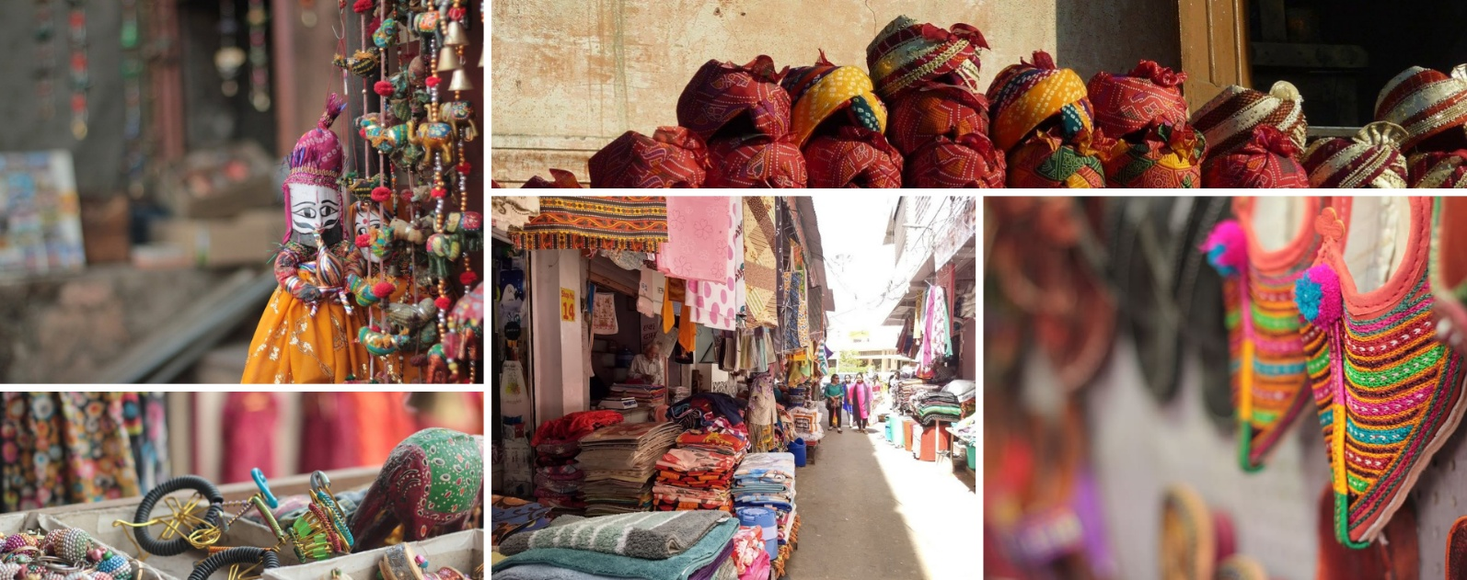
Thereafter, head for a walking tour in the bazaars, this immersive experience offers a unique opportunity to explore the city’s vibrant bazaars, renowned for their exquisite textiles, distinctive artisanal goods, and delectable street food. A specially curated selection of Jaipur’s vibrant textile market and street delicacies, each reflecting the region’s rich culinary and cultural heritage, awaits your discovery.

The textile market, in particular, stands as a testament to Jaipur’s centuries-old tradition of craftsmanship, where intricate patterns, vivid colours, and fine fabrics come together to embody the artistic soul of the Pink City.
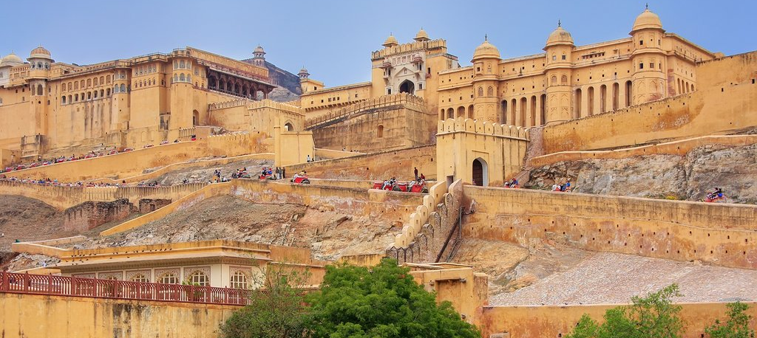
Later in the evening proceed for the majestic Amber Fort that’s perched on a hill on the outskirts of Jaipur. The fort was once the capital of Rajasthan. Former residence of Rajput Maharajas, this fort is notable for its grand architecture showcasing the Hindu style of architecture. The Amber Fort was used by the Rajputs for the dual purpose of defence and for private residence. The fort encompasses charming gardens and magnificent palaces made from marble and precious stones, richly decorated with intricate stonemason works and paintings.

Day 9: Jaipur – Udaipur

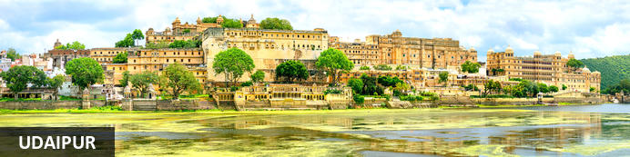
Cradled by the Aravalli Hills and watered by five lakes, Udaipur was founded in 1559 by Udai Singh, ruler of the Kingdom of Mewar. The city became his new capital complete with man-made lakes (hence the common epithet ‘Lake City’) and palaces. It’s still considered one of Rajasthan’s most romantic destinations, a reputation enhanced by the celebrated Lake Palace Hotel and given an unlikely if not surreal global boost by featuring in a James Bond movie.

Day Itinerary
Breakfast at the hotel.

Morning at leisure. [ Standard check out is 1200 Hrs We will request for late check out however the same will be subject to availability]

Afternoon transfer to Jaipur airport to board flight to Udaipur.

Flight 6E 7517
Depart Jaipur 1730 Hrs
Arrive Udaipur 1835 Hrs

Upon arrival in Udaipur, you will be met and transferred to hotel.

Overnight: The Oberoi Udaivilas Udaipur
The Oberoi Udaivilas offers guests luxurious accommodations in Udaipur, on the banks of Lake Pichola. The hotel boasts a selection of rooms and suites, all equipped with TVs, hairdryers, air conditioning, and Wi-Fi. Guests can visit the on-site restaurants and indulge in delicious meals. Other services and facilities include meeting facilities, spa services, two swimming pools, and a fitness centre.
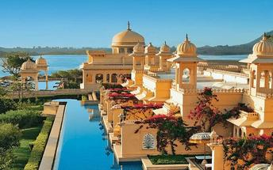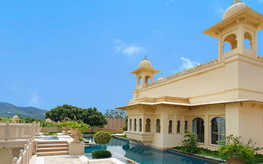

Day 10: Udaipur

Day Itinerary
Morning proceed for city tour of Udaipur visit City Palace, Crystal Gallery, Jagdish Temple, Sahelion-ki-bari and Monsoon Palace.

Rest of the day at leisure.

Udaipur City Palace
Situated above Lake Pichola, Udaipur City Palace has housed many royals over four centuries who have each added their own unique preferences to the establishment. The palace is a one of a kind in Rajasthan. Udaipur City Palace was constructed entirely out of marble and granite which makes it highly luxurious. The inside is even more so with its inlays of coloured glass, engravings, towers, and balconies.

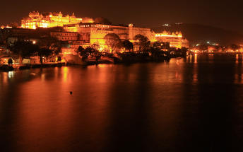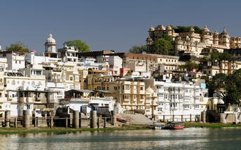

Crystal Gallery
Crystal Gallery has been hailed as probably the single largest private collection of crystal anywhere in the world. The visitors here are privy to one of the most exclusive and exquisite crystal collections. It was in 1877 that Maharana Sajjan Singh (period of reign: 1874-1884) ordered the crystal collection from the Birmingham-based F&C Osler company. The collection includes a bewildering number of objects d'art, dinner sets, perfume bottles, decanters, glasses, washing bowls and even furniture. The Crystal Gallery also houses the only crystal bed in the world! The collection has been customised for the House of Mewar; the Crest of Mewar being delicately etched on the crystal, adding yet another amazing facet.

The Durbar Hall Sabhagaar, which adorns the Fateh Prakash Palace, is of historical significance. In 1909, Lord Minto the Viceroy of India, laid its foundation stone and, in his honour, the hall was originally called Minto Hall. Today its opulent interiors - with huge chandeliers and special lights, portraits of the Maharanas of Mewar, royal artifacts and the legendary armory of the Mewar dynasty - transport you to times past when the Maharanas held forth in The Durbar Hall Sabhagaar.

The Audio Guide Service at Crystal Gallery narrates the history and anecdotes about how the present Custodian of the House of Mewar, Shriji Arvind Singh Mewar of Udaipur, conceptualised the Gallery; how the crystal was unpacked after it had been in crates for over half a century!

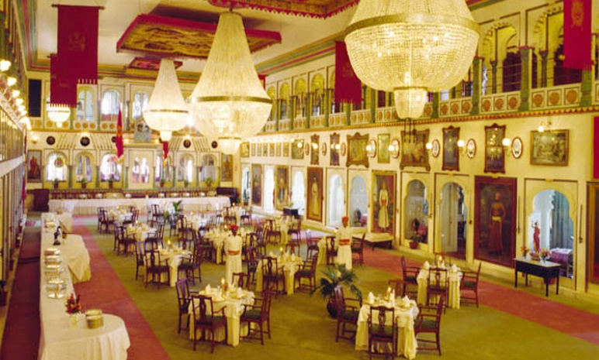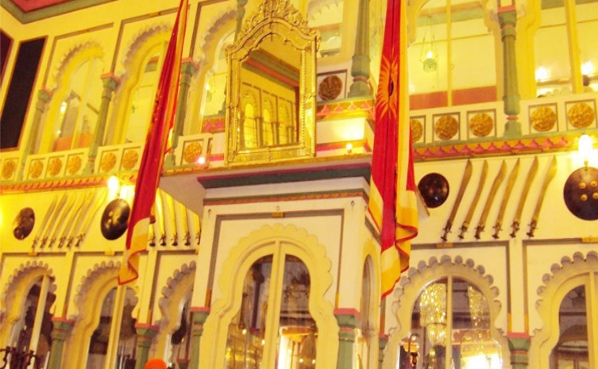

Jagdish Temple
Completed in 1651, Jagdish Temple is situated just outside the royal palace. The temple can be seen as soon as visitors enter the city. Puja’s and prayer time are the best time to visit when melodious chants from devotees float through the small interior. Visitors should make a point of climbing the temple's many steps which invite them on a journey of discovery of the rich and vibrant history of Udaipur.
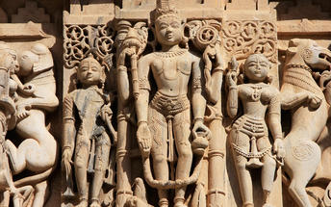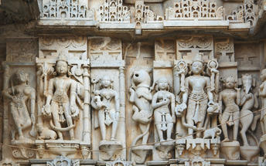

Saheliyon-ki-Bari
Located in Udaipur, India, Saheliyon-ki-Bari is situated in the northern part of the bustling city. The garden is popular amongst local and tourists offering lush green gardens and beautiful fountains. The garden was built by King Rana Sangram Singh for his wife and her 48 maids, to keep them far from political enticements.

Day 11: Udapur – Delhi (Gurgaon)

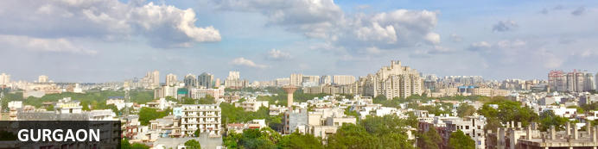
A handful of skyscrapers reach for the sky in the CBD of Gurgaon, a northwestern metropolis in the province of Huryana, near Delhi. Historically known as Guru Gram, the dormant town gathered economic momentum when Indian automobile manufacturer, Maruti Suzuki India Limited, set up a manufacturing plant here in the 1970s. Just a few decades later, half the Fortune 500 companies had opened offices in Gurgaon. Despite the congested urban areas, birding enthusiasts can find respite at Sultanpur Bird Sanctuary, a famous bird-watching spot only 15 km from the city.

Day Itinerary
Breakfast at the hotel.

Morning at leisure.

Afternoon transfer to Udaipur airport to board flight to Delhi.

Flight AI 2622
Depart Udaipur 1520 Hrs
Arrive Delhi 1645 Hrs

Upon arrival in Delhi, you will be met and transferred to hotel.

Overnight: The Oberoi Gurgaon
The Oberoi Gurgaon hotel is located in the prime business and shopping district of Gurgaon. It is a 15 minute drive from Delhi International Airport. The hotel is also within easy reach from the New Delhi city center, major sightseeing destinations and most of the entertainment, shopping and recreation hubs in Gurgaon city.
Dining options range from an all day dining restaurant featuring five interactive show kitchens, and alfresco seating on teak wood decks extended onto the reflection pool, to an Indian coastal cuisine specialty restaurant. A delicatessen, bar and an exclusive Cigar Lounge complete the culinary experience.
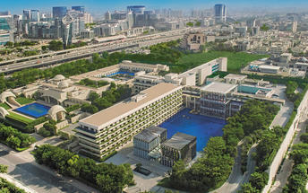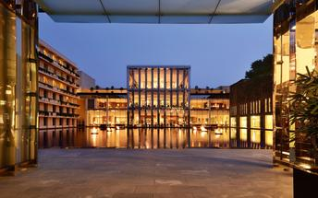

Day 12: Depart Delhi

Day Itinerary
At appropriate time, you will be transferred to Delhi international airport to connect flight for onward destination (the recommended check-in time is 3 hours prior to the flight).
Flight TBA
Depart Delhi TBA
*****END OF SERVICES *****

NOTE:
The distances and time taken for the travel is approximation only this will differ based on the traffic conditions and other unforeseen circumstances.

