

IN - 47

ABN River Cruise - Brahmaputra Maximum
Kolkata – Dibrugarh / Jorhat – Majuli –Kaziranga – Tezpur – Guwahati
14 Days / 13 Nights

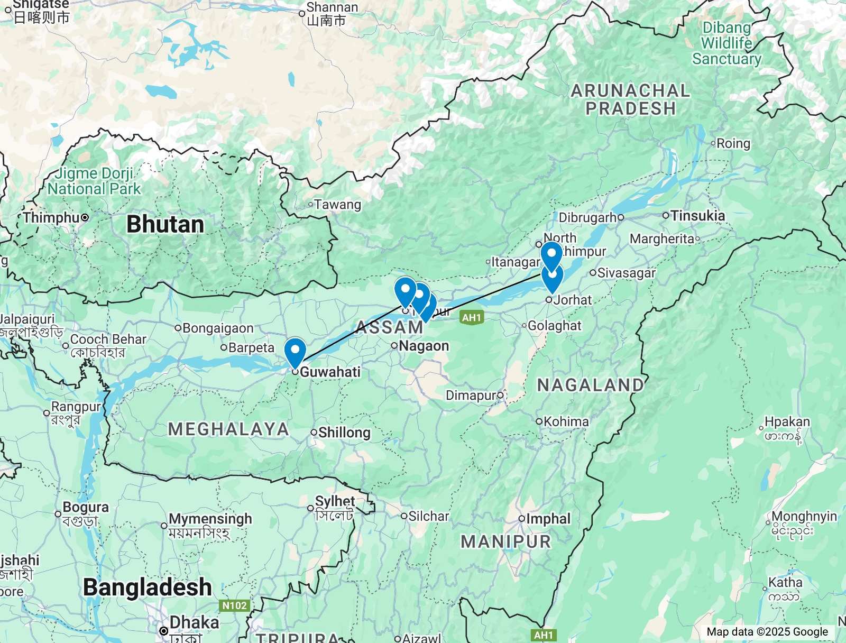

Day 1: Arrive Kolkata

Located along the eastern bank of the Hooghly River in the lower Ganges Delta, Kolkata is the capital of the Indian state of West Bengal. This 350-year-old metropolis is the heart and soul of eastern India with its crumbling colonial architecture, elegant gardens, countless temples and bustling bazaars. Celebrated as the birthplace of the early 20th-century Bengal Renaissance, Kolkata is a major centre for drama, art, film, theatre, literature, spirituality and music. Visitors can roam the streets and soak up the atmosphere of faded grandeur, or take a ride in a rickshaw to one of the many Indian restaurants serving mouth-watering Bengali cuisine. Must-see highlights include: the Victoria Memorial, with its east-meets-west architecture; the Indian Museum, with its range of rare artefacts; and the Kali Temple, an important pilgrimage centre for Hindus.

Flight TBA
Arrive Kolkata TBA Hrs

Arrive Kolkata. Upon arrival, you will be received at the airport and will be assisted for your transfer to the hotel. Check-in at hotel. Hotel's check-in time is 1400 hrs.

Rest of the day is at leisure.

Overnight: Glenburn Penthouse
The Glenburn Penthouse is located in the heart of Kolkata, West Bengal, India, near the Victoria Memorial. Accommodation options consist of nine exquisite suites with workspaces, comfortable beds, and seating areas. Suites with private living rooms and verandas/terraces/balconies are available. Facilities include a rooftop terrace, a restaurant, and a swimming pool.
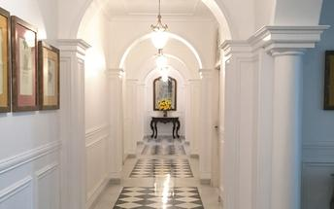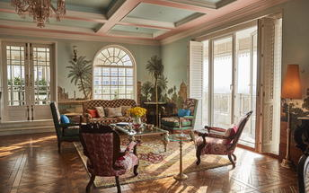

Day 2: In Kolkata

After breakfast, enjoy the Calcutta chronicles tour.

Calcutta has never been just a city; it is an evolving story, a grand stage where history, intellect, and artistry converge in the most unexpected ways. While its museums house exceptional narratives of the past, the city itself is a living museum—a space where culture thrives not behind glass cases but on the streets, in the voices of its people, and in the lanes that echo with stories.

This full-day walking trail is an immersive exploration of Calcutta’s most vibrant characters—artists, poets, bookbinders, rickshaw pullers, intellectuals, and storytellers—each contributing to the city’s distinct charm. This is not just a heritage walk; it is a moving dialogue between the past and the present, an ode to the minds that make Calcutta a depot of intriguing thoughts.

This is not just a heritage walk—it is an invitation to experience Calcutta’s soul through its people. Every street, every shop, every ghat has a voice, waiting to be heard. Whether you are an artist, a thinker, or simply a traveler in search of stories, this full-day journey ensures that you don’t just visit Calcutta—you become a part of its continuing narrative.

Calcutta Chronicles will include visit to the following spots / places

- Tagore House
- Victoria Memorial
- Princep Ghat
- Dalhousie Square (White Town)
- Indian Museum
- Kumartuli
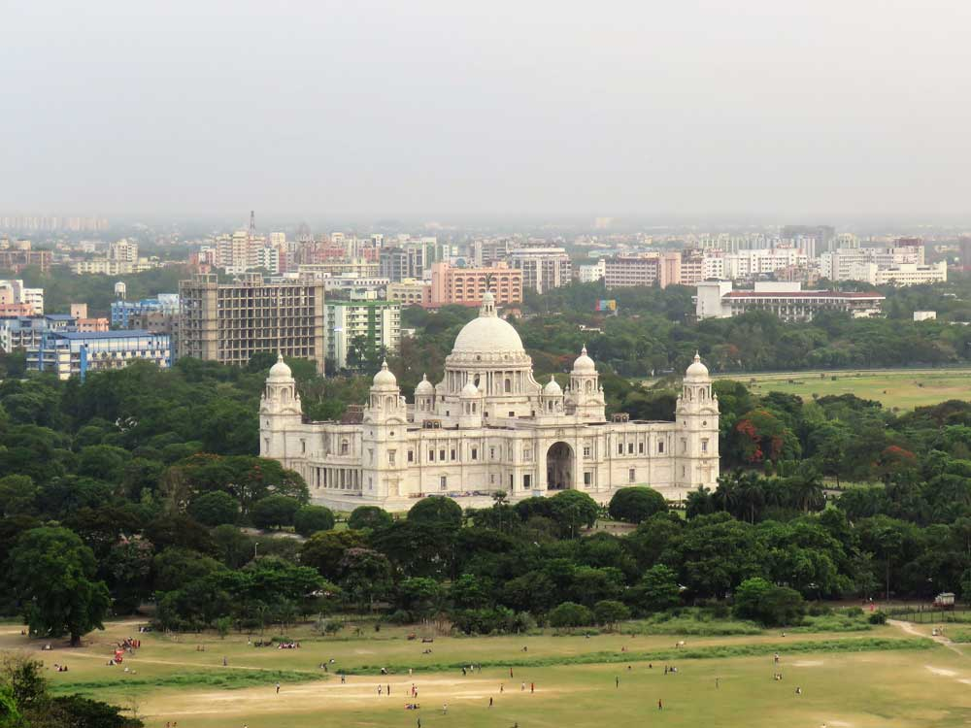
- Public Ferry Ride (If time permits)

Day 3: Kolkata to Dibrugarh / Jorhat & embark ABN Cruise

Morning you will be transferred to Kolkata airport to board the scheduled flight either to Dibrugarh or Jorhat to board the ship at Neamati Ghat.

Both Dibrugarh and Jorhat are approx. 4 ½ and 1 ½ hrs respectively.
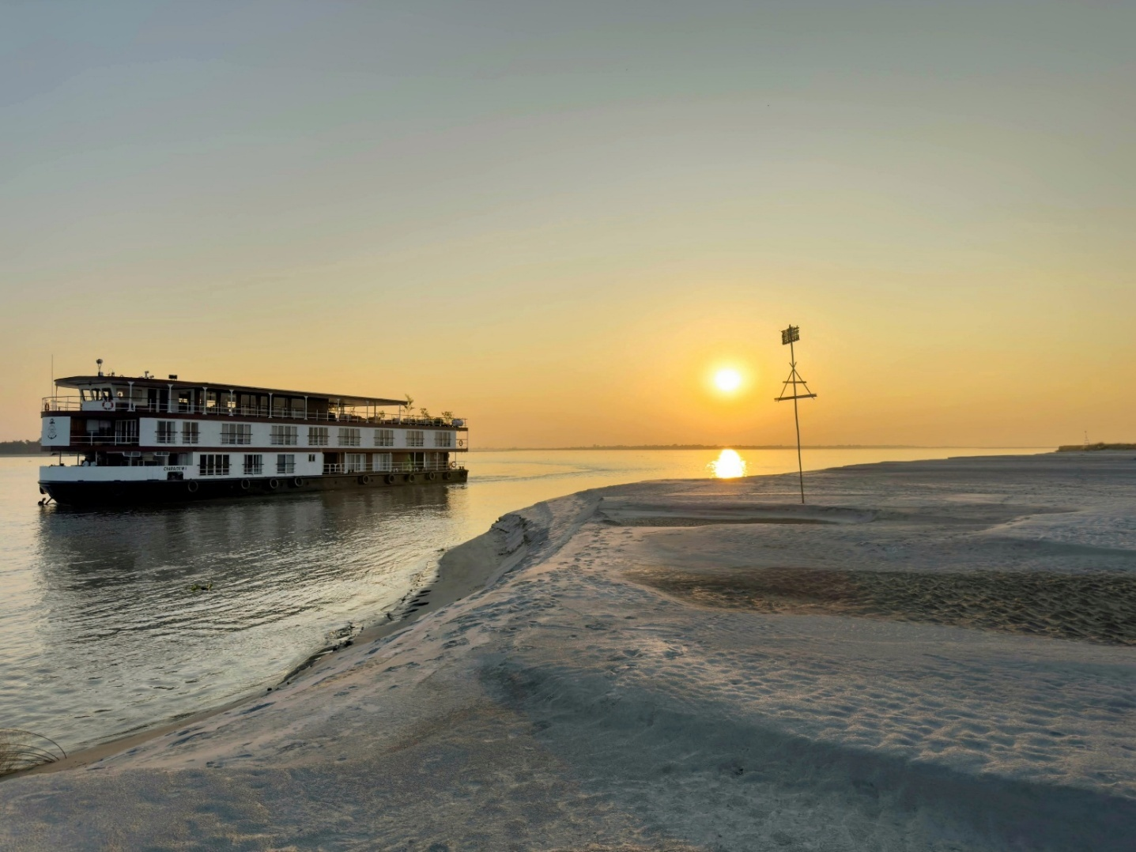

Assam Bengal Navigation (or ABN) is an Indo-British joint venture. With four cruise ships and a houseboat, ABN is the most experienced operator on Indian rivers. In 2003, ABN pioneered long-distance river cruising in India with unique cruises on the Brahmaputra River in Assam. Later in 2007, ABN was also the first to run cruises on the River Hooghly (Lower Ganges) between Kolkata and Farakka.
PS: The boat will change depending on the cruise date

Day 4: ABN Cruise

Your first excursion and experience of the rich variety of cultural life along the Brahmaputra is Sibsagar, which also served as the capital of the Ahom kings. Sibsagar serves as a testament to the Ahoms' enduring legacy and the unique blend of Indian and Southeast Asian influences that shaped their culture. Shan by origin but later converted to Hinduism, the Ahoms ruled Assam for some 600 years until the mid-1820s. One of their many architectural feats was recently awarded the UNESCO World Heritage tag.

You’ll see temples with stupa-like profiles and palaces of distinctive form. The temple tank here is believed to be the world’s largest hand-excavated reservoir and quite the feat of engineering, as you’ll see. Return to the ship and cruise downstream to Majuli island, one of the world’s largest river islands. PM, visit a river side village of Majuli Island.

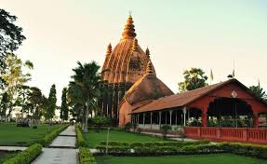
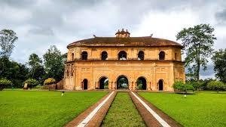

Day 5: ABN Cruise

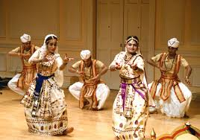
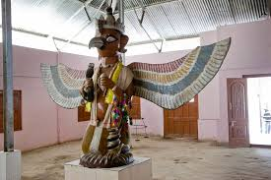
A microcosm of Assamese culture, Majuli represents rural idyll in Assam. A stronghold of the peaceful religion of neo-Vaishnavism, the elegant island satras — some for celibate monks, some for families — showcase a unique way of life where the faithful live simply, offering worship through gayan-bayan (songs and musical instruments) and readings. Visit Auniati monastery and its eclectic museum and, in the afternoon, attend a dance performance at Kamalabari monastery. Later, return to the ship and cruise downstream for one or two hours.

Day 6: ABN Cruise

A day spent mostly sailing languidly along the Brahmaputra taking in the charming rural vistas, though you’ll stop for a short visit to a village by the river. By afternoon, Kaziranga National Park will be on your left – wild elephants are sometimes visible from the boat and once or twice, memorably, a tiger, so keep an eye out for movement on the banks.

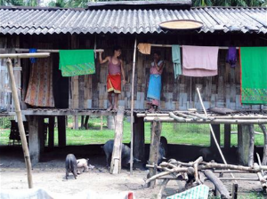


Day 7: ABN Cruise

This morning, you’ll arrive at the delightful temple town of Biswanath, known for its fine Ahom-period temple. Take a walk ashore to explore the architecture and village life with weekly markets before continuing the voyage down to a quaint mooring at Silghat, where butterflies abound in the surrounding jungle.

Go on your first safari in Kaziranga National Park, a jeep ride through the woodlands, grasslands and wetlands of the Burapahar Range.

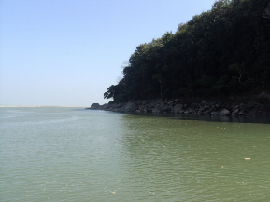

Day 8: ABN Cruise

Today, you’ll be driven to Kaziranga’s Central Range for a morning jeep safari.

Covering an area of approximately 1090 sq. kms, the UNESCO World Heritage Site of Kaziranga National Park is home to the world’s largest population of the Indian One-Horned Rhinoceros as well as the Indian Wild Water Buffalo. It has also earned the distinction of having the highest density of Royal Bengal Tigers (one in every five sq. km.) making this park an incredibly rich biodiversity hotspot. With its marshy swamps and vast swathes of elephant grass, this park supports large populations of Indian elephants, Indian bison, swamp deer, Hoolock Gibbons and Capped Langurs.

​Kaziranga National Park frequently draws comparisons to the Serengeti in Africa due to the park's abundance of water bodies and grasslands full of wildlife, big and small and a birding paradise. Bird species found here include the Oriental Honey Buzzard, Black-shouldered Kite, White-tailed Eagle, Himalayan Griffon and many more.

Enjoy a delightful river-side lunch at our very own Diphlu River Lodge where you will encounter the local community members of Kaziranga who are the fabric of this award-winning eco-lodge. In the afternoon, you’ll explore more of the Kaziranga National Park on another jeep safari in the Western Range.

Day 9: ABN Cruise

​Today, we will visit a picturesque Assam Tea plantation before cruising downstream under the seemingly endless bridge to dock at Tezpur.

​After lunch on board, we will be exploring on local battery- operated rickshaws to thrill you through the bustling bazaars of this riverside Assamese town as we make our way to a well-manicured Cole Park garden for an afternoon stroll to marvel at a beautiful collection of medieval stone carvings and visit the remnants of a 6th century Da Parbatia temple with its exquisitely carved portal


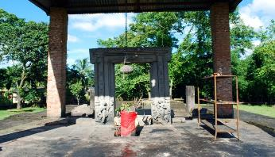

Day 10: ABN Cruise

After an early breakfast, we will embark on a drive of approximately one hour to Nameri National Park, nestled at the foothills of the Eastern Himalayas. This remarkable destination serves as a national park, tiger reserve, elephant reserve, and an important bird area. Nameri is contiguous with the Pakke Tiger Reserve in Arunachal Pradesh, forming a vast expanse of semi-evergreen and evergreen forests in Northeast India.

Once we arrive, you’ll have the opportunity to enjoy a two-hour float trip down the Jia-Bhoreli River, meandering through the park's stunning landscapes. This tranquil journey offers excellent bird-watching opportunities, where you might spot the magnificent Great Hornbills, and possibly even encounter wild elephants in their natural habitat.

We will return to the ship in time for lunch before continuing our cruise downstream, enriched by the beauty and biodiversity of Nameri National Park.

Day 11: ABN Cruise

The day is spent on the river, gently traversing a magical lunar landscape of sand islands before closing in on the range of hills beyond which lies Guwahati. Visit a picturesque river side village and moor for the night near Sualkuchi.

Day 12: ABN Cruise

Take a captivating walk through Sualkuchi, a bustling little silk town that serves as the epicenter of Assam's rich silk heritage and production. As Mahatma Gandhi once famously said, "Assamese women weave dreams on looms." Your visit to the weaving workshops offers a rare opportunity to witness the entire process of silk manufacture, from cocoon to spinning and hand-weaving into exquisite mekhela chadars (a two-piece sari, the traditional attire of an Assamese woman).

Every house in this urban village has a loom, and you'll be amazed to see the skilled weavers, both men and women, effortlessly transforming silk threads into magnificent fabrics.

After immersing yourself in the silk-weaving magic of Sualkuchi, you'll sail up to dock close to the grand Saraighat bridge. From there, you'll embark on a tour of Guwahati, driving up the Nilachal Hill to the Kamakhya temple.

This ancient Hindu temple is dedicated to the Mother Goddess and is known for its unique architecture and cultural significance. Join us for a leisurely stroll around the temple's exteriors and soak in the rich history and spirituality that define this sacred place. Your journey through Sualkuchi and Guwahati offers a captivating blend of Assam's rich silk heritage, vibrant culture, and stunning natural beauty.

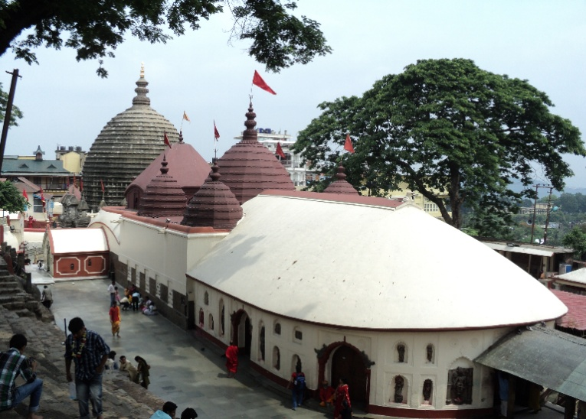


Day 13: Disembark ABN Cruise at Guwahati to Kolkata

After breakfast, disembark ABN Cruise and transfer to Guwahati airport to board your flight to Kolkata.
(The itinerary, including the cruise and approximate driving durations, is subject to river and weather conditions.​ Kaziranga National Park comprises low-lying grassland, which may not be visitable when the river is at or near flood level.)
On arrival at Kolkata, our representative will meet you and transfer to your hotel.
Rest of the day is at leisure.
Overnight at Glenburn Penthouse

Day 14: Depart Kolkata

In time transfer to Kolkata airport to board your fight for onward destination.

