

IN-54 Taj & Rajasthan with Homestays
New Delhi - Agra - Jaipur - Jodhpur - Udaipur
11 Days / 10 Nights
2 Persons

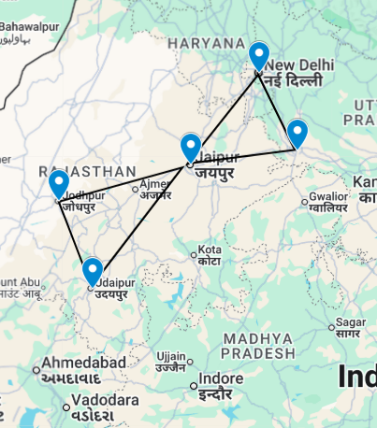

This is the classic cultural tour of North India combining New Delhi, Agra and Jaipur (the so-called ‘Golden Triangle’) with two other key destinations in Rajasthan.

New Delhi, the national capital, offers several key sights and historic monuments while Agra is synonymous with the Taj Mahal – a high-point of Mughal architecture and one of the world’s most celebrated buildings. Jaipur, Rajasthan’s state capital, boasts some of the region’s finest palaces and impressive forts along with an eclectic array of crafts and shopping. Jodhpur and Udaipur were the historic capitals of major Rajput princely states. Jodhpur’s fascinating old town is still overlooked by huge 15th-century Mehrangarh Fort perched atop a rocky ridge while its vast Umaid Bhawan Palace hotel is a unique blend of Indo-Saracenic and Art Deco styles. Udaipur – or ‘Lake City’ after its lakeside location – is probably the state’s most picturesque city with an imposing palace complex overlooking Lake Pichola and a charming island palace, now a famous luxury hotel.

Introduction

Start | Accommodation | Destination | Room Type | Duration
Day 1 | Thikana Delhi | New Delhi | Deluxe Room | 2 Nights
Day 3 | The Coral Tree | Agra | Standard Room | 1 Night
Day 4 | Hotel Suryaa Villa | Jaipur | Deluxe Room | 2 Nights
Day 6 | Indrashan Homestay | Jodhpur | Standard Room | 2 Nights
Day 8 | Devra Hotel | Udaipur | Premium Room | 2 Nights
Day 10 | Thikana Delhi | New Delhi | Deluxe Room | 1 Night

Day 1: Arrive New Delhi

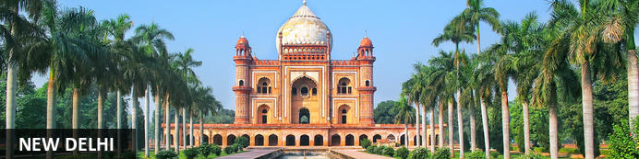
New Delhi, India’s national capital, is a relatively modern confection of imposing government buildings including Parliament, museums and wide leafy boulevards loosely centred on circular Connaught Place (officially now called Rajiv Chowk). To its north lies the formerly walled city of Old Delhi, or Shahjahanabad, built in the 17th-century by the Mughal Emperor Shah Jahan. Though long merged into one metropolis, the two have very different characters. New Delhi has space, parks, distinct neighbourhoods and a clutch of important monuments and architecture that reflect its ancient history. Old Delhi’s crowded streets, lanes and bazaars reflect its colourful medieval character and they cradle some of the city’s most memorable sights.

Day Itinerary
Flight TBA
Arrive Delhi TBA Hrs.

On arrival in Delhi: Having cleared immigration, collected your luggage and passed through customs, please make your way towards the exit of the terminal building where you will see a bank of people waiting for you. Amongst them will be Travel Counsellors Representative who will be waiting to greet you with a paging board with your name on.
You will be transferred to your homestay and assisted with check in. Standard check in time is 1400 hrs.

Overnight: Thikana Delhi
Thikana Delhi offers comfort and simple luxuries in the heart of the city of New Delhi. The establishment’s location affords convenient access for guests to comfortably explore the many tourist attractions in Delhi and the surrounding region. Guest accommodations are nestled in the quiet, green colony of Gulmohar Park in South Delhi. The bed and breakfast services and facilities offer an excellent destination choice for both business and leisure travelers.
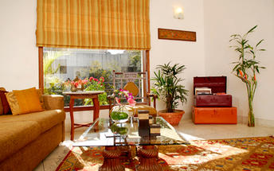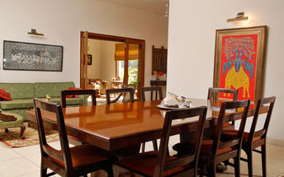

Day 2: In New Delhi

Day Itinerary
Breakfast at Hotel.
Today proceed for The Five Senses Delhi Tour
A sensory journey through Delhi covering everything from its food, local arts and crafts, the must-see architectural marvels, to expertly navigating and allowing you to witness the organized cultural chaos that is Delhi.
USP - Delhi 101: A complete tour of Old and New Delhi! We’ve carefully curated a selection of experiences that will transport you across Delhi’s rich cultural history. Experience for yourself the syncretism that has served as both Delhi’s greatest strength and vulnerability.

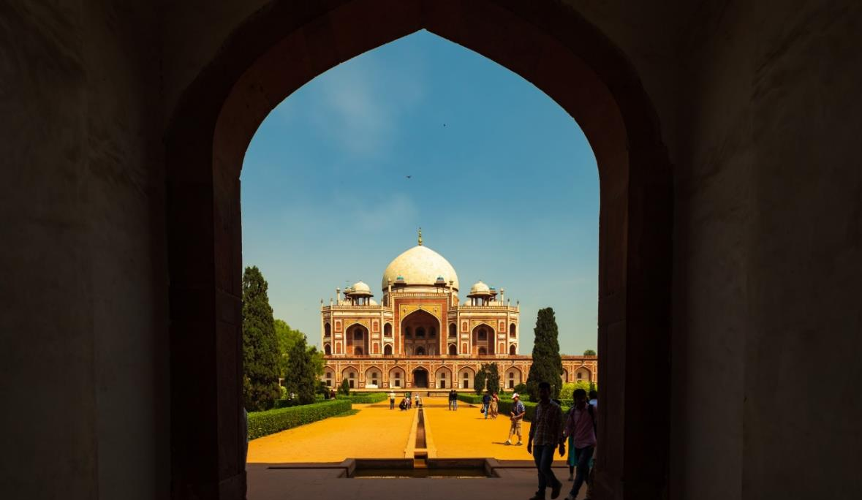

There isn’t a dearth of iconic sightseeing locations in the city, but for this tour, we focus on the two most beloved monuments that became inspirations or templates for all the other beautiful heritage structures. Humayun’s tomb, a spellbinding mausoleum is a favourite for any Delhiite! Your visit will be followed by a heritage craft workshop organised by an all-women NGO group that will touch your heart. Next, take a rickshaw ride through Shahjahanabad. Chaos thrives in the streets of Chandni Chowk, but as you cycle down, you’re transported by the magic in the air to the thriving Mughal era.
Next, you will indulge your sense of smell with an Ittar or perfume-making workshop. Visit an 8th-generation Ittar studio where you will get to smell and mix your unique concoction that can be named after you!
We’ll quickly stop to snack on some mouth-watering street food before proceeding to witness the glory and quietness of the Jama Masjid: a beautiful pocket of calm at the heart of Old Delhi's mayhem.
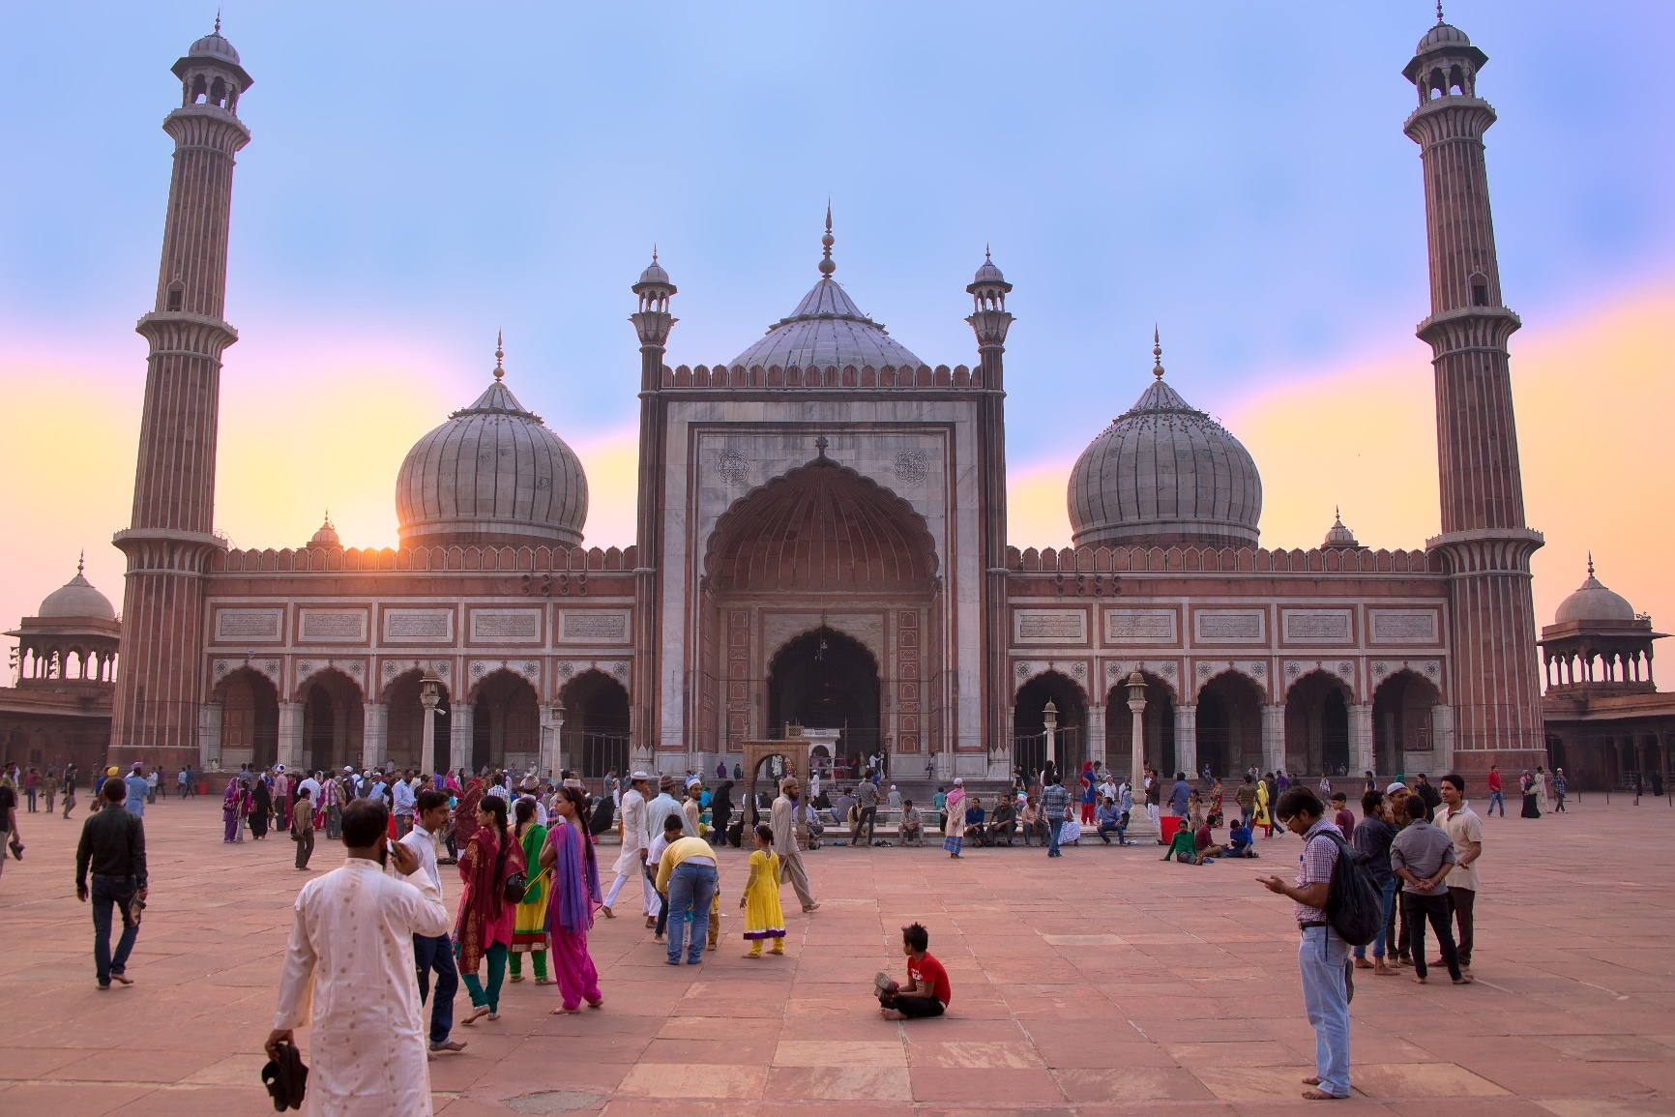
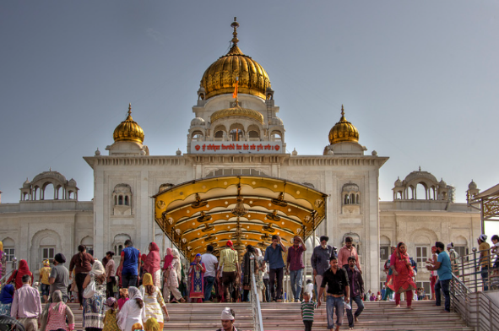
To engage your sense of sound, we bring you to Bangla Sahib. The magic of seva (selfless service) that the Gurudwara envelopes you into is undeniable. What ties together this beautiful experience is the sweet sound of the Gurbani playing in the background. Next, head to calm your favourite sense - taste! You will enjoy a meal at a contemporary Indian restaurant!
Before going back to the hotel, on the way, we show you the parts of Delhi with British influence and talk about the architectural contrast as well as some interesting stories from that time!

Overnight at the hotel.

Day 3: New Delhi – Agra

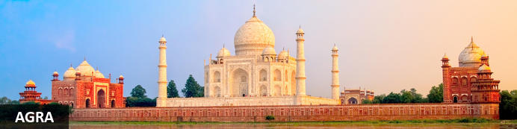
Straddling the broad Yamuna River 180km south of Delhi, Agra’s fame rests almost entirely on one building – the iconic Taj Mahal. Yet from the early 16th-century it was the Mughal empire’s capital endowed with numerous buildings and monuments that still make it a major draw for visitors. Apart from the Taj, Agra Fort (with its strong resemblance to Delhi’s Red Fort), the exquisite Tomb of Itmad-ud-Dalah (often called the ‘Baby Taj’), earthy bazaars and the evocative ‘ghost city’ of Fatehpur Sikri 40km to the west all make it a key tourist destination.

Day Itinerary
After breakfast, you will be transferred to railway station to board the train to Agra.

Train Gatimaan Express [The train does not operate on Fridays]
Departs Delhi 0810 Hrs.
Arrives Agra 0950 Hrs.

Upon arrival at Agra, you will be assisted & transferred to the hotel. (Standard check in time at the hotel is 1400 Hrs.).

Drop your bags at the hotel and freshen up. You will then proceed for a tour of Agra Fort.

Agra Fort
With its striking resemblance to Delhi’s Red Fort, Agra Fort’s massive sandstone walls stretch for over two kilometres with their eastern flanks overlooking a bend in the Yamuna River. Commissioned by the Mughal Emperor Akbar in 1573, its 90-acres of part-manicured gardens, imposing pavilions, royal apartments and audience halls are an impressive counterpoint to the Taj Mahal’s more delicate beauty and finesse. Built as a virtually self-contained imperial city, the fort came to symbolise Mughal military power. Here famously the Taj’s builder Emperor Shah Jahan was imprisoned by his own son and spent his final days gazing across the river at his beloved Taj Mahal.
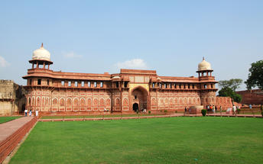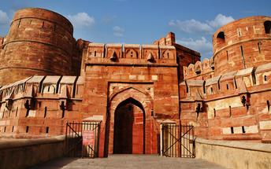

After the visit, return to your homestay for check in and relax.

Overnight: The Coral Tree
Nestled amidst lush greenery, home to many bird species, The Coral Tree offers accommodation near the Taj Mahal in Tajganj, Agra. The property's spacious rooms feature free Wi-Fi, leafy verandahs, telephones, tea/coffee-making facilities and TVs with cable channels. Guests can savour home-cooked meals on-site. The homestay also offers a library, a well-kept garden, a transport service and guided services.
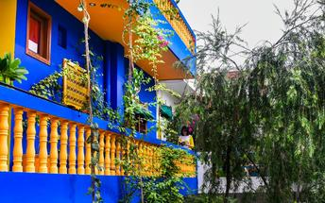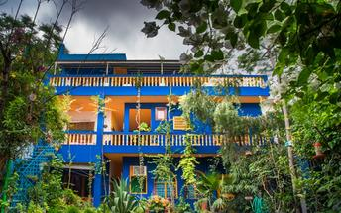

Day 4: Agra – Jaipur

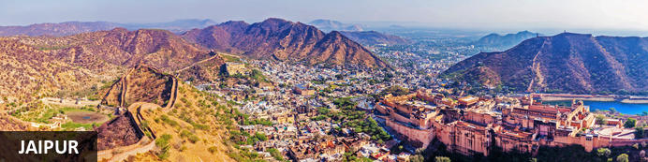
Founded in the early 1700s by Maharaja Jai Singh II as his new capital, the original ‘Pink City’ (so-called because almost all buildings were painted terracotta pink to honour the 1876 visit of the future King Edward VII) was laid out in a traditional grid with colonnaded streets and uniform façades. That layout remains intact and the city, now state capital of Rajasthan, has evolved and expanded into a modern metropolis with its own metro system. Yet its key sights and attractions lie within a relatively compact area. From vibrant bazaars and craft shops to grand palaces and huge forts, an extraordinary outdoor observatory and even one of the country’s most famous cinemas, Jaipur ticks every cultural, architectural and shopping box.

Day Itinerary
Early this morning witnesses the surreal views of the Taj Mahal [Taj Mahal remains closed on Fridays]. Step inside this eternal symbol of love and appreciate the intricate designs and symmetries that rhyme as a poem written in marble. Taj Mahal is an extravagant display of love, built by Shah Jahan in memory of his beloved wife Mumtaz.

After the visit, return to your hotel for breakfast.

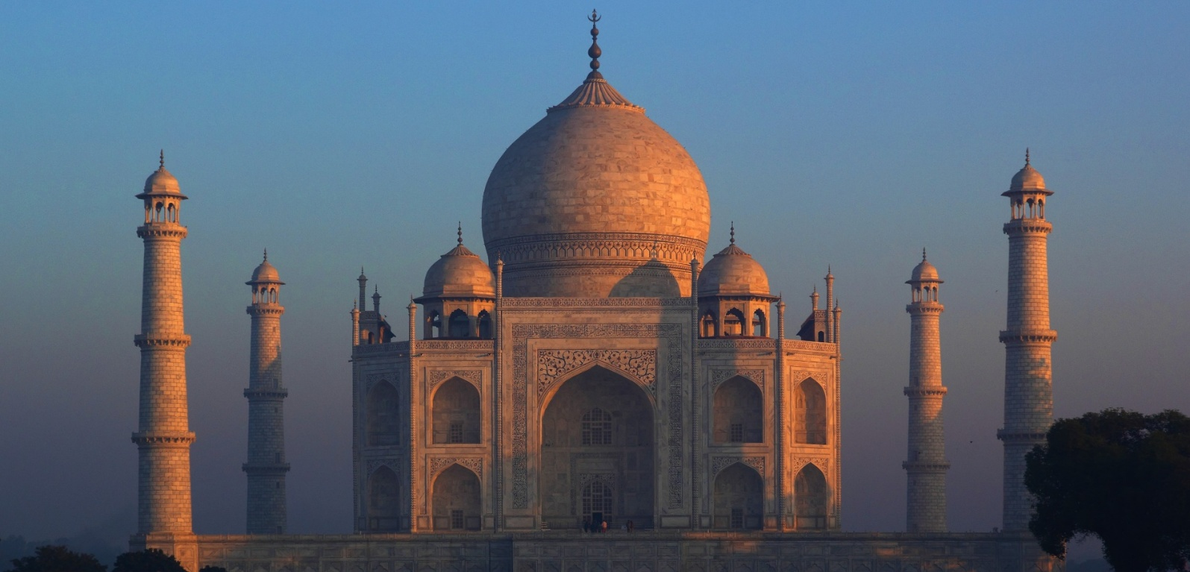
Post breakfast, you will be driven to Jaipur [approx. 5 hours' drive]

Arrive Jaipur and check in at the homestay and relax.

Overnight: Hotel Suryaa Villa
Conveniently located in the Jaipur City Centre, Hotel Suryaa Villa, Jaipur, is bordered by numerous historic attractions which are a resplendent reminder of the royal heritage that respired within the walls of the Pink City. The
Hotel is amongst the finest heritage hotels in Jaipur which have opened their doors to render the precise sense of redefined luxury to guests. Embroidered with rich Rajasthani architecture and design, the hotel, besides serving as a soothing oasis with a refreshing pool overlooking lush courtyards, is committed to preserving Rajasthani traditions for the coming generations to see.
The hotel offers spaciously appointed and elegantly furnished rooms including: Junior suites with sit out, deluxe double or twin room and family rooms outfitted with modern amenities to suit the needs of today's traveler.
For an authentic taste of multi cuisine dishes in Jaipur, enriched with flavors and textures, let them take you on an exceptional food voyage at Rasoda Pool View Restaurant at Hotel Suryaa Villa, Jaipur. Take your taste buds on a culinary excursion and let the gourmet in you indulge in remarkably delicious dishes blended with a local flavor.
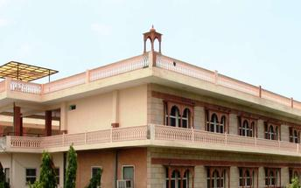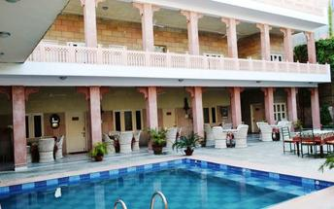

Day 5: In Jaipur

Day Itinerary
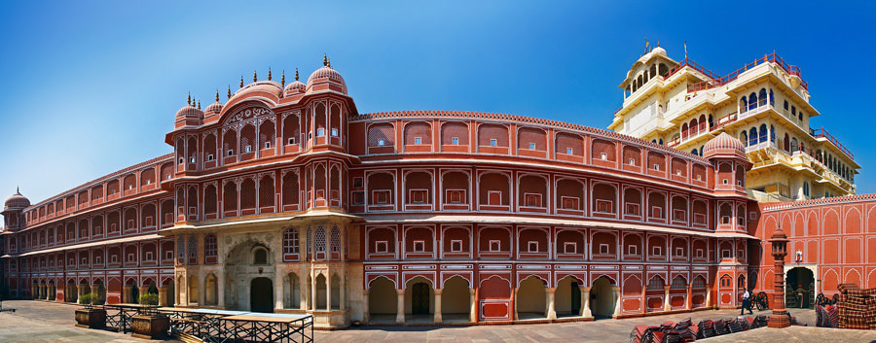
Begin exploring this city visit the City Palace complex which is spread over a large area occupying one-seventh of the old city of Jaipur. It is comprised of two palaces, Chandra Mahal and Mubarak Mahal, museum, a vast array of courtyards, gardens, and buildings. The palace is a blend of the Shilpa Shastra of Indian architecture with Rajput, Mughal, and European styles. Diwan-I-Aam (Hall of Public Audience), Bhaggi Khana (a museum), Pitam Niwas Gate, and Peacock Gate are must-see. Its outer boundary was built by Raja Jai Singh and the other structures by his successors to add charm to it. It also served as a residence for the former Maharaja of Jaipur, also visit the famous Jantar Mantar (an observatory)

Thereafter, head for a walking tour in the bazaars, this immersive experience offers a unique opportunity to explore the city’s vibrant bazaars, renowned for their exquisite textiles, distinctive artisanal goods, and delectable street food. A specially curated selection of Jaipur’s vibrant textile market and street delicacies, each reflecting the region’s rich culinary and cultural heritage, awaits your discovery.

The textile market, in particular, stands as a testament to Jaipur’s centuries-old tradition of craftsmanship, where intricate patterns, vivid colours, and fine fabrics come together to embody the artistic soul of the Pink City.

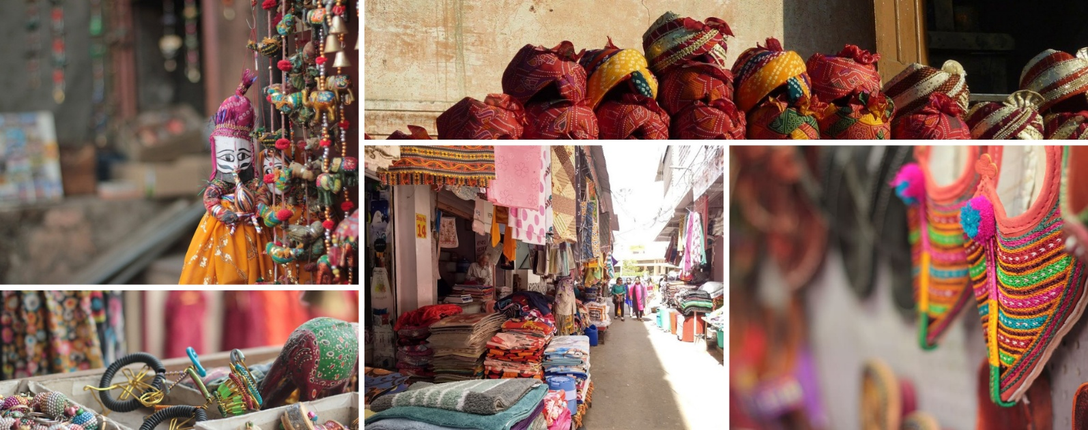

Later in the evening proceed for the majestic Amber Fort that’s perched on a hill on the outskirts of Jaipur. The fort was once the capital of Rajasthan. Former residence of Rajput Maharajas, this fort is notable for its grand architecture showcasing the Hindu style of architecture. The Amber Fort was used by the Rajputs for the dual purpose of defence and for private residence. The fort encompasses charming gardens and magnificent palaces made from marble and precious stones, richly decorated with intricate stonemason works and paintings.
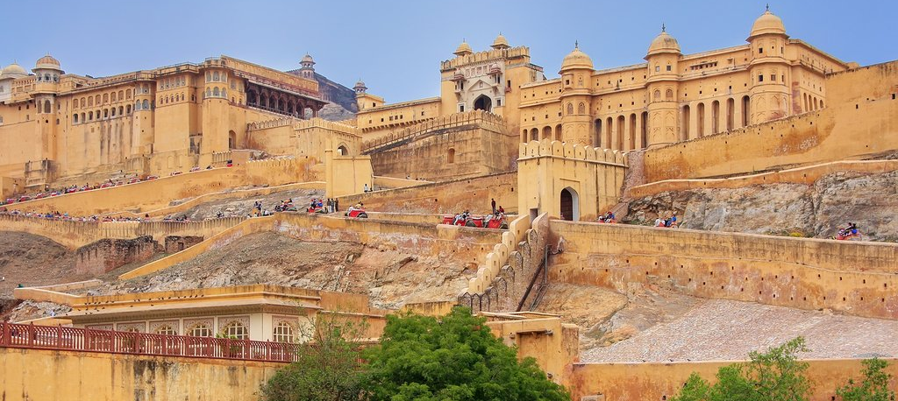

The rest of the day is free for personal activities.

Day 6: Jaipur – Jodhpur

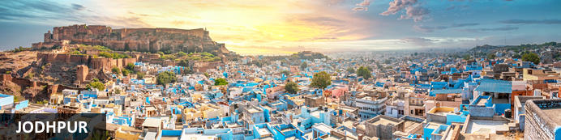
Rajasthan’s second city and the former capital of the Kingdom of Marwar, Jodhpur lies on the eastern edge of the Thar desert which stretches away into neighbouring Pakistan. Found in the 1450s by Rao Jodha, a Rajput chief, it’s a large modern city but the focus for visitors remains its striking fort cresting a pronounced ridge. At its foot clusters the old town, a maze of lanes, alleys and bazaars with many of it houses painted shades of blue – explanations for which range from residents associating themselves with the god Shiva (myths tell how he turned blue after consuming poison) to underlining their Brahmin caste status to warding of termites. Even if you’re not staying in the vast Umaid Bhawan Palace, it’s a key destination on most Rajasthan itineraries.

Day Itinerary
After breakfast you will be driven to Jodhpur [approx. 6 hours' drive]
Arrive Jodhpur and check in at the homestay.

Overnight: Indrashan Homestay
Indrashan Homestay is located in Jodhpur, Rajasthan. The establishment features a total of five spacious rooms which come equipped with TVs, ceiling fans, wardrobes, dressing tables, Wi-Fi and other conveniences. Guests can enjoy breakfast, lunch and dinner on-site. Activities available include cooking lessons and sightseeing trips arranged by the hosts.
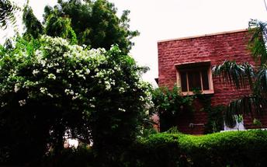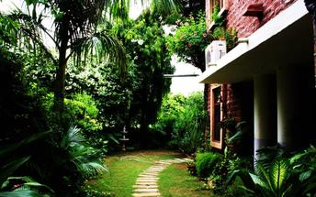

Day 7: In Jodhpur

Day Itinerary
After breakfast do the tour of the city covering the majestic Mehrangarh Fort and Jaswant Thada.

Mehrangarh Fort
Mehrangarh Fort is situated in Jodhpur, Rajasthan, India. The fort was constructed in 1459 by Rajput ruler Rao Jodha and stands a hundred feet in splendour on a perpendicular cliff, four hundred feet above the skyline of Jodhpur. The fort's boundaries house several palaces with intricate carvings, expansive courtyards, and a museum featuring various relics.
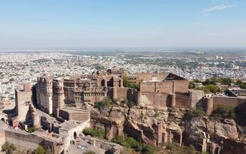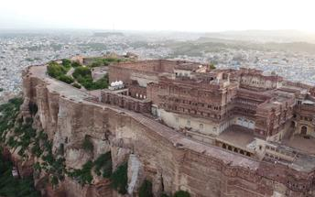

Jaswant Thada
If you’re looking for a quiet place in Jodphur head to Jaswant Thada, popularly known as the ‘Taj Mahal of Marwar’. This architectural landmark was built in 1899 by Maharaja Sardar Singh of Jodhpur State, in memory of his father, Maharaja Jaswant Singh I. Built from intricately carved marble sheets and boasting some beautiful carved marble lattice work, the impeccable design and architecture is symbolic of the fine craftsmanship of a bygone era. Beautiful sculptures, carved gazebos and frescos characterise the cenotaph, with the tiered garden offering superb views across to the fort and over the city.
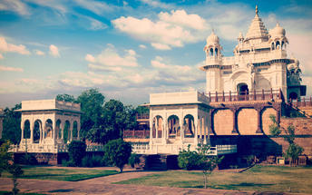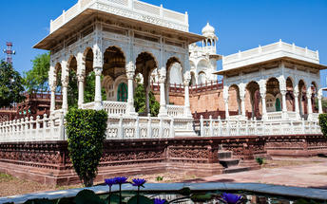

Day 8: Jodhpur – Udaipur

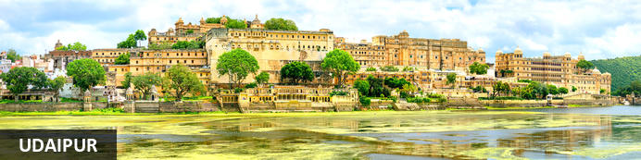
Cradled by the Aravalli Hills and watered by five lakes, Udaipur was founded in 1559 by Udai Singh, ruler of the Kingdom of Mewar. The city became his new capital complete with man-made lakes (hence the common epithet ‘Lake City’) and palaces. It’s still considered one of Rajasthan’s most romantic destinations, a reputation enhanced by the celebrated Lake Palace Hotel and given an unlikely if not surreal global boost by featuring in a James Bond movie.

Day Itinerary
After breakfast, leave with your private chauffeur driven vehicle to Udaipur (approx. 5-6 hours' drive) with a stop at the magnificent 15th century Jain temples at Ranakpur.

Ranakpur
The small town of Ranakpur is home to what is arguably the most spectacular of all India’s Jain temples. The complex rests on a lush mountain slope and encompasses a series of temples dating to the 15th century, all constructed from white marble and featuring exquisite decorative detail. The main temple, Chamukha, is a multi-tiered structure with no less than 80 domes and over 1400 pillars, all of which are intricately carved with unique designs – no two are alike. As the light changes during the day, so does the colour of the temple interior, shifting from golden to cream and then pale blue at dusk.

Note: Leather items like Belts, purses or wallets etc. are not allowed inside Ranakpur Temple complex. Also, local guides are not available at the temple, only audio guide will be provided.

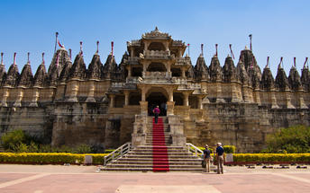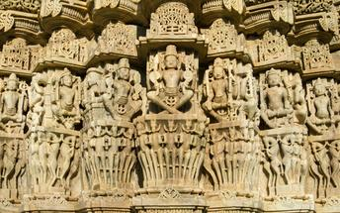
Arrive Udaipur and check in at the homestay.

Overnight: Devra Hotel
Devra Hotel in Udaipur is a privately owned 5 acre estate. The estate house is built on a hill amongst the Aravali Hills overlooking fields, neighbourhoods and views of the City Palace, Lake Pichola and Lake Palace. The hotel is close to tourist sites with only a 15 minute drive away from the city.

Activities for guests at the hotel includes daily yoga classes, board games and reading from the hotel’s exclusive book collection. Outdoor activities can be arranged such as village walks, bird watching, and horse-riding and cycling.

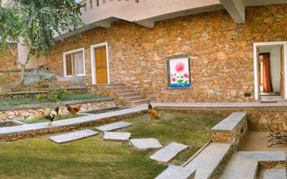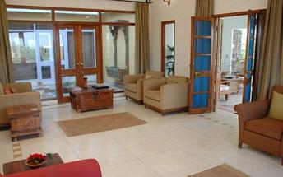

Day 9: In Udaipur

Day Itinerary
After breakfast, do a tour city tour of Udaipur covering City Palace, Jagdish temple and Saheliyon ki Bari.
Later in the afternoon, enjoy a shared boat ride at Lake Pichola. (Subject to Water Level)

Udaipur City Palace
Overlooking the eastern shore of Lake Pichola, Udaipur’s largest lake, City Palace is a monumental complex of palaces, quadrangles, gateways and halls built by more than twenty generations of royals over 400 years. Towers, cupolas and projecting balconies lend an almost whimsical charm while interior murals, mosaic mirror-work, glass inlay and acres of marble combine solidity with indulgence. Parts of the complex are now a luxury hotel. One of its most remarkable sections is the ‘Crystal Gallery’ with extraordinary sets of furniture and crockery made entirely from crystal; ordered from London by a maharaja who died before they arrived, it’s claimed the cases were delivered but remained unopened for over a century.

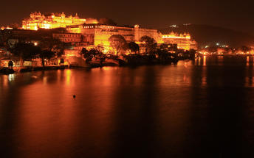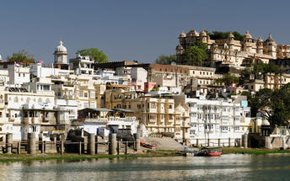

Jagdish Temple
Completed in 1651, Jagdish Temple is situated just outside the royal palace. The temple can be seen as soon as visitors enter the city. Puja and prayer time are the best time to visit when melodious chants from devotees float through the small interior. Visitors should make a point of climbing the temple's many steps which invite them on a journey of discovery of the rich and vibrant history of Udaipur.
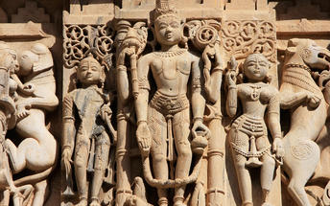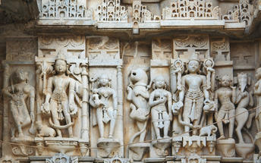

Saheliyon-ki-Bari
Located in Udaipur, India, Saheliyon-ki-Bari is situated in the northern part of the bustling city. The garden is popular amongst local and tourists offering lush green gardens and beautiful fountains. The garden was built by King Rana Sangram Singh for his wife and her 48 maids, to keep them far from political enticements. A small museum can be found on the property which was once a safe haven for the queen and her main servers.

Boat ride at Lake Pichola
Although Udaipur’s best-known lake predates the city’s founding by centuries, it was Mewar’s earliest maharajas who expanded it (and developed others with dams) to safeguard their water supply. Today Pichola spans nearly seven square kilometres framed by the Aravallis with its eastern and northern shores seeing the most development. Boat rides capture the best of the city’s romance with unmatched views of City Palace glowing at sunset plus other lakeside ablutions and bathing at nearby ghats (steps). You can also see if not visit a handful of small islands, one now the celebrated Lake Palace Hotel while the Jag Mandir is a kind of royal pleasure garden.

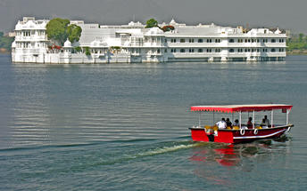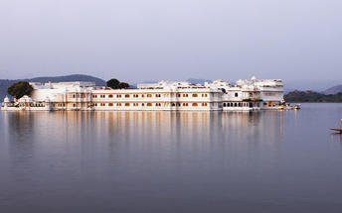

Day 10: Udaipur – New Delhi

Day Itinerary
Breakfast at the hotel.

Later you will be transferred to Udaipur airport for your flight to Delhi.

Flight 6E 2102
Departs Udaipur 1505 Hrs.
Arrive Delhi 1625 Hrs.

Arrive Delhi and transfer to your homestay.

Overnight: Thikana Delhi

Day 11: Depart New Delhi

Day Itinerary
At appropriate time, you will be met and transferred to Delhi airport to board the flight for onward journey.

Flight TBA
Departs Delhi TBA Hrs.

**** END OF SERVICES ****

NOTE:
- The distances and time taken for the travel is approximation only this will differ based on the traffic conditions and other unforeseen circumstances.

