

IN - 55

Textile Tour of Jaipur
Delhi – Jaipur - Delhi
08 Days / 07 Nights

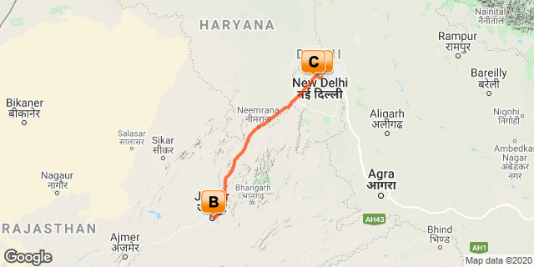

Day 1: Arrive Delhi

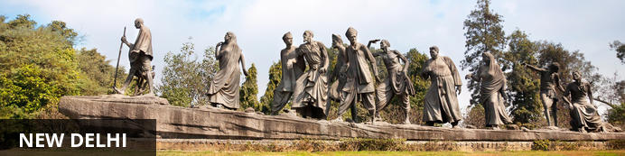
India’s largest city, Delhi, has been one of the country’s commercial and economic hubs for centuries and, as a result, is incredibly rich in culture and history. Made up of the ancient walled city of Old Delhi and the more modern sector, New Delhi, the city encompasses a staggering array of beautiful architecture, notable monuments and age-old temples, including three UNESCO World Heritage Sites – the Red Fort, Qutab Minar and Humayun's Tomb. Other key attractions include the 17th century Chandni Chowk marketplace – still one of the city’s most popular retail centres today, particularly for jewellery and traditional Indian saris; the iconic Bahà’i Lotus Temple – an award-winning architectural gem; and the Jama Masjid, India’s largest mosque.
On arrival in Delhi: Having cleared immigration, collected your luggage and passed through customs, please make your way towards the exit of the terminal building where you will see a bank of people waiting for you. Amongst them will be Travel Counsellors Representative who will be waiting to greet you with a paging board with your name on.
You will be transferred to your hotel and assisted with check in. (Standard check in time at hotel is 1400 hrs).

Day 2: In Delhi

Breakfast at the hotel.

After breakfast proceed for sightseeing tour of Old Delhi including Rickshaw Ride in Chandni Chowk followed by visit to Crafts Museum and Dilli Haat.

Chandni Chowk
Situated in Delhi’s historical old town, frenetic Chandni Chowk – meaning ‘moonlit square’ – is one of the city’s oldest, busiest and most famed shopping areas, built in the 17th century and originally intersected by (now defunct) canals that were designed to capture and reflect the moonlight. It’s a shopper’s paradise – with an eclectic diversity of wares ranging from traditional Indian sweets and other delicacies, to leather goods, electronics, intricately embellished saris and tailor-made suits. But even if you’re not up for any retail therapy, the sights, sounds and atmosphere of this pulsing, labyrinthine marketplace are captivating enough in their own right.
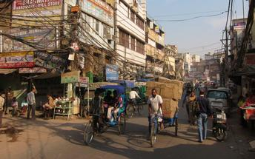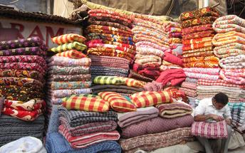

Jama Masjid
The majestic Jama Masjid – meaning ‘world-reflecting’ mosque – is Old Delhi’s principal place of worship, and the largest and most renowned of its kind in India. Built in the 17th century by the Mughal Emperor Shahjahan – who also built the Taj Mahal and the Red Fort – it’s an elaborate structure featuring an expansive geometric base topped with globe-shaped minarets crafted from strips of red sandstone and white marble, and a massive courtyard that can hold up to 25 000 people. Jama Masjid is particularly impressive just before dusk, when its rosy hues intensify in the glow of the setting sun.
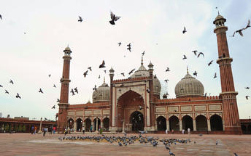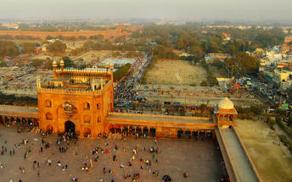

Crafts Museum (Closed on Mondays)
At present the Museum collection consists of over 33,000 specimens in various crafts, acquired over a period of 60 years collected from various states of India named as Andhra Pradesh, Arunachal Pradesh, Assam, Bihar, Delhi, Gujarat, Haryana, Himachal Pradesh, Jammu and Kashmir, Karnataka, Kerala, Madhya Pradesh, Maharashtra, Manipur, Meghalaya, Mizoram, Nagaland, Orissa, Punjab, Rajasthan, Tamil Nadu, Tripura, Uttar Pradesh, West Bengal. The collection reflects the continuing traditions of handicrafts and handlooms.
Museum collection consists of a variety of traditional artifacts such as Textiles, a vast range of metal lamps, sculptures, utensils etc, Wood-works, Folk/tribal paintings , range of cane and bamboo crafts, clay and terracotta figures and a lot more
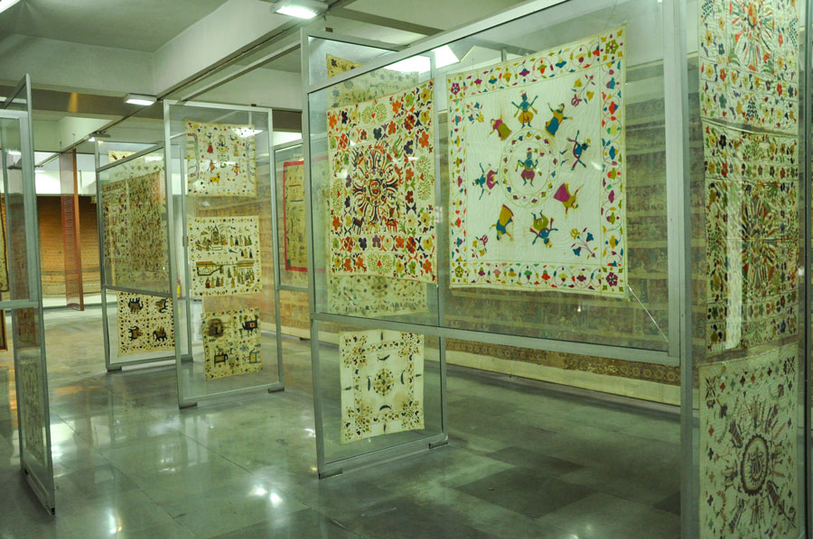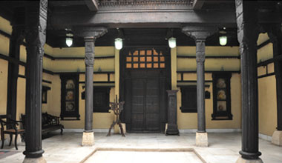

Dilli Haat
The DILLI HAAT provides the ambience of a traditional Rural Haat or village market, but one suited for more contemporary needs. Here one sees a synthesis of crafts, food and cultural activity. This Food and Craft Bazar is a treasure house of Indian culture, handicrafts and ethnic cuisine, A unique bazaar, in the heart of the city, it displays the richness of Indian culture on a permanent basis.
Step inside the complex for an altogether delightful experience by either buying inimitable ethnic wares, savouring the delicacies of different states or by simply relaxing in the evening with the entire family.

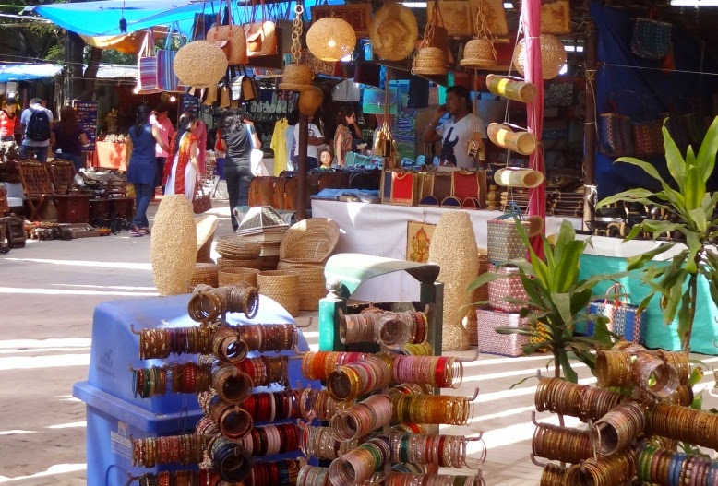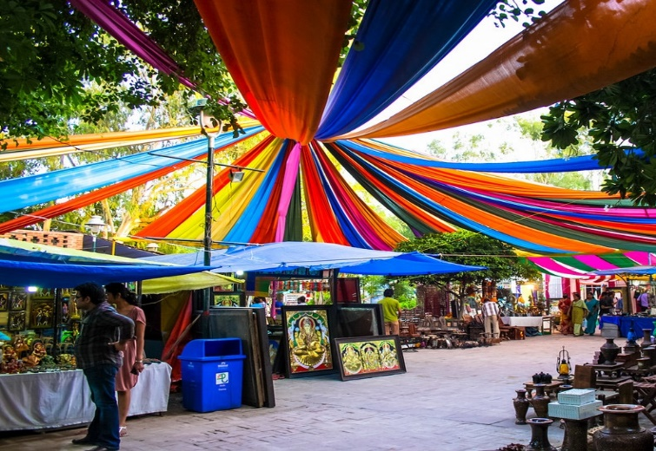

Day 3: Delhi - Jaipur

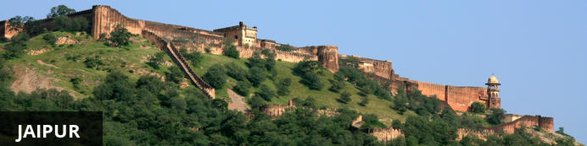
Fringed by the rugged Aravali Hills, Jaipur is the capital and largest city in India’s northern state of Rajasthan. This city is famed for being India’s first planned city featuring a multitude of pink terracotta buildings within the walled historic centre, earning it the nickname,’The Pink City’. Jaipur falls within the Golden Triangle, a popular tourist circuit, which includes Delhi, Jaipur and Agra, and serves as a gateway to the neighbouring desert cities of Jaisalmer and Jodhpur. This colourful city is a combination of tradition and modernity and offers visitors vibrant bazaars, lavish palaces and ancient temples. The salmon-hued old city is home to the opulent City Palace, encompassing an impressive assortment of palatial structures, sprawling gardens, courtyards and buildings. Don’t miss the fairy-tale splendour of the Amber Fort, set against the backdrop of the arid landscape.
After breakfast you will drive to Jaipur [approx. 5-6 hrs].

Upon arrival in Jaipur, check-in at hotel.

Day 4: In Jaipur

After breakfast proceed to visit Amber Fort with Jeep Ride, followed by visit to Anokhi Museum.
Afternoon proceed for city tour of Jaipur visit City Palace, Observatory.
Rest of the day enjoy colourful markets of Jaipur.

Amer Fort by jeep ride
Amer Fort, officially known as the ‘Amer Palace’, is one of the most famous forts of Rajasthan attracting around 4000 to 5000 visitors a day during peak tourist season. The palace was named after the small town of Amer, where it is situated - only eleven kilometres from Jaipur. Perfectly picturesque, this 16th century hillside residence is well preserved, boasting grand pavilions and mirrored halls that open onto flourishing gardens and courtyards. Although the palace’s main construction started in 1592 by Maharaja Man Singh, it was added to over the years by successive rulers and continued to be occupied by them until Jaipur was built.
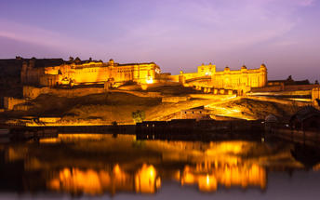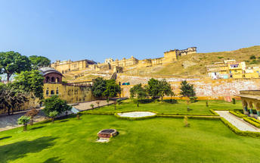

Anokhi Museum (Closed on Mondays)
Located in a magnificently restored haveli or mansion, the museum displays a varied selection of block printed textiles alongside images, tools and related objects – all chosen to provide an in-depth look into the complexity of this ancient tradition. The Anokhi Museum of Hand Printing addresses this fragile situation primarily through education. Dedicated to the art of block printing, AMHP strives to inform both textile specialists and general public alike.

Jaipur City Palace
City Palace forms one of the most famous tourist attractions and a major landmark in Jaipur. The beautiful palace was built by Maharaja Sawai Jai Singh during his reign. Among the various forts and palaces of Jaipur, City Palace stands apart, with its outstanding art and architecture.
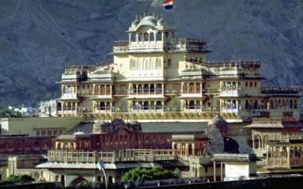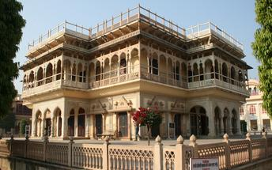

Jantar Mantar Jaipur
In 1734, the year of its completion, the Jai Singh Observatory was the last outpost of medieval science. From the outside, the eighteen fixed observational instruments look more like playground apparatus than sighting devices, but they were used to measure the position of the sun, stars and planets. Built by Jai Singh, the first Maharaja of Jaipur who founded the city in 1727, the observatory is one of a handful. Jai Singh, fulfilling a lifelong interest in mathematics and astronomy, built observatories in Delhi, Jaipur, Ujjain, Mathura and Benares. The Jaipur observatory is the largest and best preserved of these.
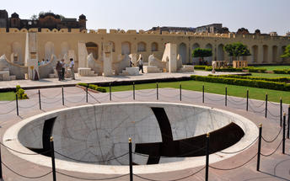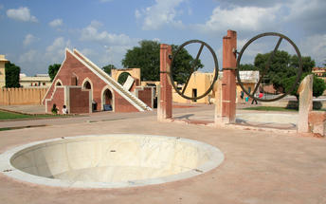

Day 5: Jaipur - Sanganer - Jaipur

After breakfast Excursion to Sanganer to experience Sanganer Block Printing Workshop. (approx. 45 minutes drive one way)
Later visit to a Blue Pottery Factory.
Light snacks will be served during the workshop.
Later visit to Hand Made Paper Factory.
Return back to Jaipur.

Sanganer Block Printing
The Sanganeri printing technique developed between the 16th and 17th century. The constant wars between the Mughals and Marathas caused several craftsmen to migrate from Gujarat to Rajasthan. This craft ultimately found its haven in Sanganer, where it has been thriving ever since. It became one of the major export items for the East India Company, and its trademark was the original dye used for printing designs. This dye soon became a matter of significance in European culture as well. Royal patronage and heritage inspired the great cultivation in this form of craft, which has been around for years, and is almost as old as the country itself. Rich traders and royal families have propagated this art and its influence has spread far and wide into the fundamental nature of Indian tradition and culture.
There is a great variety in the types of designs and patterns used in Sanganeri print, which includes all kinds of flower motifs, the main ones being of sunflower, roses and narcissus’. Apart from flowers, designs depicting various gods, fruits and folk scenes are also popular. The curves and patterns majorly depict the cultural flora and fauna of Sanganer.

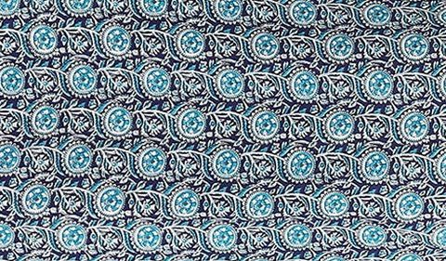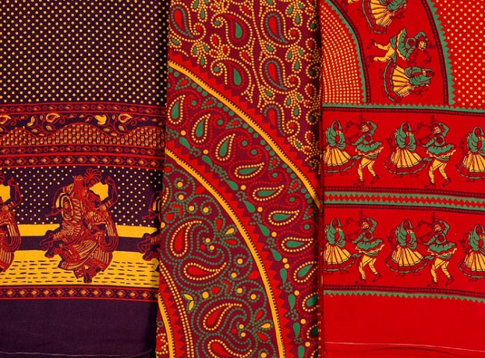

Blue Pottery
The process is very tedious and time consuming. Once made, the blue pottery items cannot be reworked. The clay for blue pottery is made of ground quartz, green glass, multani mitti or fuller’s earth (acts as the binding agent for quartz and glass), borax, katira gum and saaji (soda bicarbonate) ; mixed together in a specific proportion. This is flattened and pressed into open moulds, the top and bottom parts of pots are made on a potter’s wheel. Once dry these pieces are joined together to make the final product. Salt paper is used to give finishing, than white coat is done on these pieces.

Handmade Paper Factory
The paper is made from fabric scraps, and often decorated with petals or leaves. The 200 or so employees produce 40,000 sheets a day, which is exported all over the world. Tours are available and there’s also a beautiful range of paper products for sale in the showroom. The colours and the touch of freshly produced, eco-friendly paper are just fantastic.

Day 6: Jaipur - Bagru - Jaipur

After breakfast Excursion to Bagru to experience Dabu Block Printing Workshop. (approx. 45 minutes drive one way)
Light snacks will be served during the workshop.
Later return back to Jaipur.
In the evening proceed to a local family to enjoy Cooking Demonstration along with Dinner.

Bagru Block Printing
Bagru printing is one of the traditional techniques of printing with natural colour followed by the chippas of a remote place of Rajasthan. The process starts from preparing the cloth to finished printed fabrics through their indigenous methods. Motifs having some specialty are transferred onto light coloured background with wooden blocks following two styles direct and resist style. Although this technique is facing problems against the threat of globalization, this exotic art of creation is required to be encouraged in the present context of environmental consciousness.

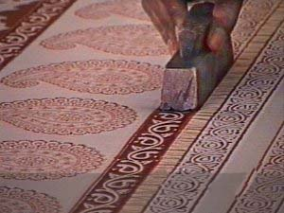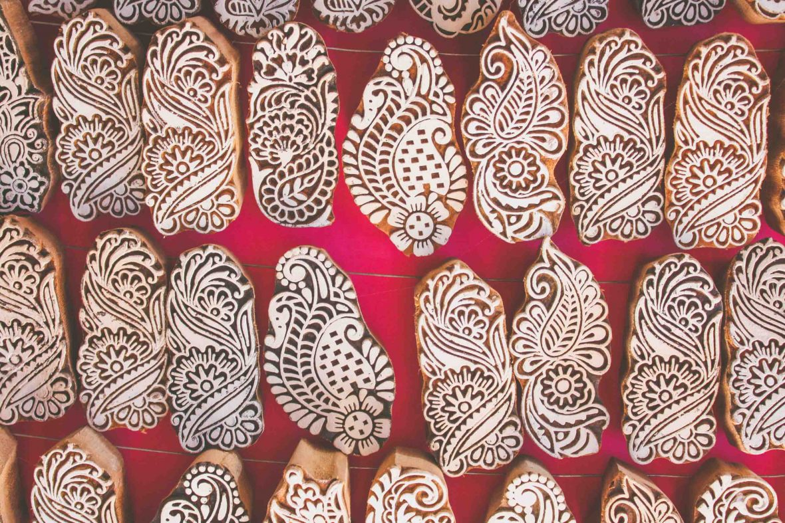

Cooking Demonstration including Dinner with a local family
The popular cooking workshops and demonstrations are personally conducted by ladies of the Peelwa family in coordination with our in-house chefs which takes approximately 2 hours. You'll be taken in to their kitchen where the cooking demonstration will commence. You will be shown how each dish is cooked and your hosts will describe the spices and ingredients used to prepare these wonderful dishes. While you wait for the food to finish cooking you will have the chance to really get to know your hosts. Once the food is ready you will sit at the dining table, where your food will be served. It will be tempered to your specific tastes - so it won't be too hot unless you ask for it that way! You will really be treated as a guest of the family throughout your visit here, it is an authentic experience and a great way to see traditional Indian cooking in action.

Day 7: Jaipur - Delhi

After breakfast, visit to Dera Amer to witness “Rhythm With The Elephants” activity.

Rhythm With The Elephants (most satisfying experience in privacy and exclusivity) - Elephant bathing, (weather permitting), Feeding and walking with our elephants in the wilderness accompanied by our in-house naturalists.
Guests arrives at Dera Amer Camp and are greeted by the Elephants and upon arrival they are allowed to make their first contact with these kind hearted giants by the way of feeding bananas.

Later the guest bathe their own elephants (weather permitting) with the help of the camp staff and mahout.

Walk with the elephants will come to an end at the camp where guest will be served buffet breakfast lunch (one meal). Lot of the vegetables are grown organically on our farm and if needed there would be enough charcoal grills to keep guest warm.
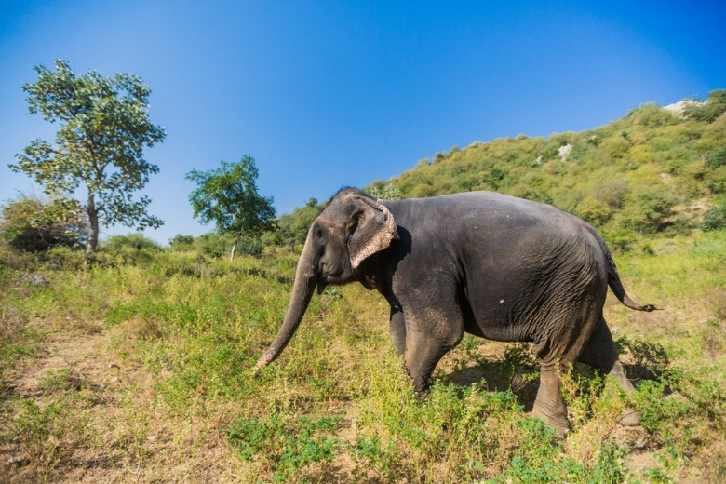
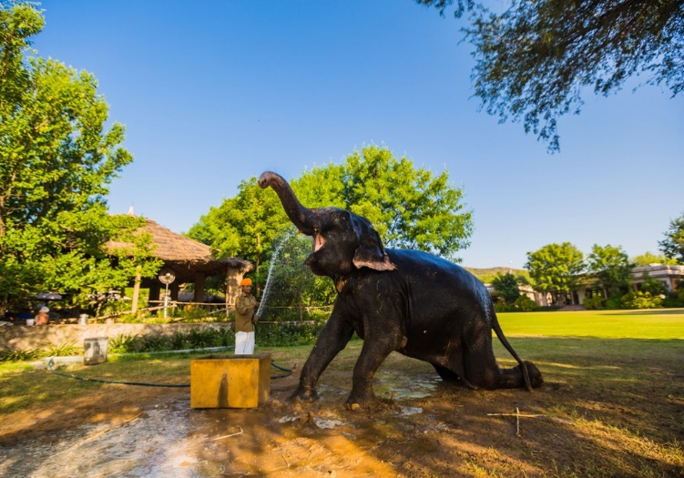

Later you will be drive back to Delhi [approx... 5 -6 hrs].
Upon arrival in Delhi, check-in at hotel.

Day 8: Depart Delhi

At an appropriate time, you will be assisted and transferred to airport to board flight to back home.
**** END OF SERVICES ****

