

IN - 57

Rajasthan Culture & Textile Tour
Delhi - Churu - Bikaner - Pokaran - Jaisalmer - Jodhpur - Udaipur - Delhi
14 Days / 13 Nights

Day 1: Arrive Delhi
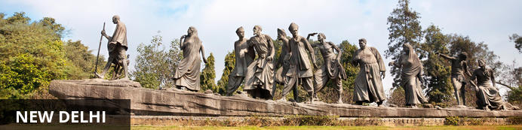
India’s largest city, Delhi, has been one of the country’s commercial and economic hubs for centuries and, as a result, is incredibly rich in culture and history. Made up of the ancient walled city of Old Delhi and the more modern sector, New Delhi, the city encompasses a staggering array of beautiful architecture, notable monuments and age-old temples, including three UNESCO World Heritage Sites – the Red Fort, Qutab Minar and Humayun's Tomb. Other key attractions include the 17th century Chandni Chowk marketplace – still one of the city’s most popular retail centres today, particularly for jewellery and traditional Indian saris; the iconic Bahà’i Lotus Temple – an award-winning architectural gem; and the Jama Masjid, India’s largest mosque.

Flight TBA

Arrives Delhi TBA

On arrival in Delhi : Having cleared immigration, collected your luggage and passed through customs, please make your way towards the exit of the terminal building where you will see a bank of people waiting for you. Amongst them will be Travel Counsellors Representative who will be waiting to greet you with a paging board with your name on.

You will be transferred to your hotel and assisted with check in. (Standard check in time at all hotel is 1400 hrs)

Day 2: In Delhi
Breakfast at the hotel.

After breakfast proceed for sightseeing tour of Old Delhi including Rickshaw Ride in Chandni Chowk followed by visit to Dilli Haat.

Chandni Chowk
Situated in Delhi’s historical old town, frenetic Chandni Chowk – meaning ‘moonlit square’ – is one of the city’s oldest, busiest and most famed shopping areas, built in the 17th century and originally intersected by (now defunct) canals that were designed to capture and reflect the moonlight. It’s a shopper’s paradise – with an eclectic diversity of wares ranging from traditional Indian sweets and other delicacies, to leather goods, electronics, intricately embellished saris and tailor-made suits. But even if you’re not up for any retail therapy, the sights, sounds and atmosphere of this pulsing, labyrinthine marketplace are captivating enough in their own right.
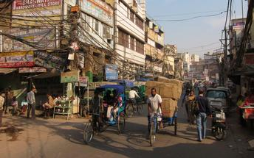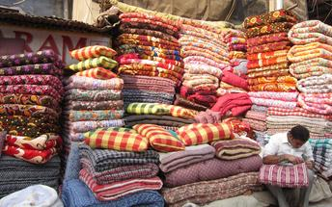

Jama Masjid
The majestic Jama Masjid – meaning ‘world-reflecting’ mosque – is Old Delhi’s principal place of worship, and the largest and most renowned of its kind in India. Built in the 17th century by the Mughal Emperor Shahjahan – who also built the Taj Mahal and the Red Fort – it’s an elaborate structure featuring an expansive geometric base topped with globe-shaped minarets crafted from strips of red sandstone and white marble, and a massive courtyard that can hold up to 25 000 people. Jama Masjid is particularly impressive just before dusk, when its rosy hues intensify in the glow of the setting sun.
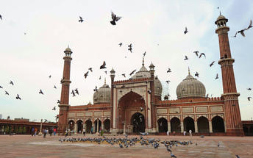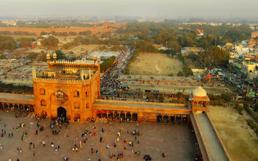

Dilli Haat
The DILLI HAAT provides the ambience of a traditional Rural Haat or village market, but one suited for more contemporary needs. Here one sees a synthesis of crafts, food and cultural activity. This Food and Craft Bazar is a treasure house of Indian culture, handicrafts and ethnic cuisine, A unique bazaar, in the heart of the city, it displays the richness of Indian culture on a permanent basis.
Step inside the complex for an altogether delightful experience by either buying inimitable ethnic wares, savouring the delicacies of different states or by simply relaxing in the evening with the entire family.

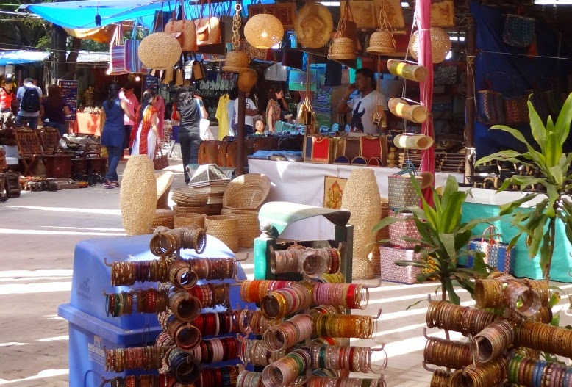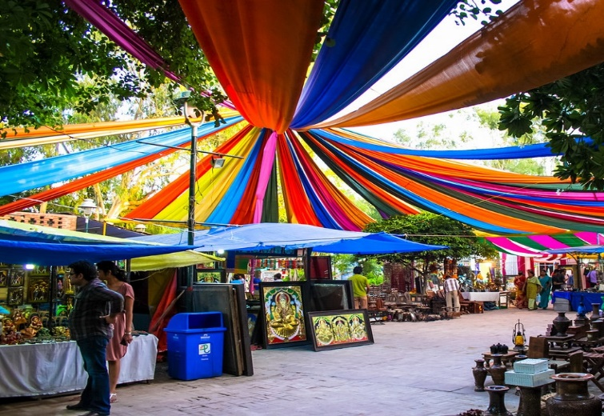

Day 3: Delhi - Churu

Churu is located in the state of Rajasthan in northern India. This charming city in the Thar Desert is often used as a stopover on rail journeys to or from Bikaner, and boasts some notable cultural sights. Begin at the grand Churu Fort, a 1739 structure with ornate carvings and the on-site Gopinath Temple, before continuing to the 18th-century memorial of Aath Kambh Chhatri (Eight Pillar Dome), located near Churu’s bustling vegetable market. Other key sights include the city’s collection of havelis (traditional mansions): Kanhaiya lal Bangla ki Haveli features incredible frescoes, and the walls of Surana Haveli are inlaid with hundreds of small windows. Finally, nature lovers will relish an excursion to the Tal Chhapar Sanctuary (85 kilometres away), which is home to blackbuck and several rare bird species.

Breakfast at the hotel.

At appropriate time, you will be transferred to Railway station to board train to Churu.
(OR OPTION OF DRIVE FROM DELHI TO CHURU WHICH WILL TAKE APPROX 5-6 HRS)

Train Intercity Express
Departs Delhi 0840 Hrs
Arrives Churu 1330 Hrs
(Picnic Hamper will be provided on train)

Upon arrival in Churu, you will be transferred to Malji Ka Kamra.

Malji Ka Kamra is a century old, restored mansion (haveli) in town of Churu, on the edge of Shekhawati region in Rajasthan. The turquoise blue, Wedding cake like tiered structure is an architectural marvel – a unique combination of Shekhawati’s famous fresco paintings with European pillared architecture, Italian art-deco influences and Mughal style doors and arches. One of the most remarkable merchant havelis in region, the property works as a unique gateway to discover Shekhawati’s “open art gallery” beyond its touristic town of Mandawa. Churu’s havelis, quiet and unhustled as they are, serve as a fresh breath of air and take you to a different era of artistic beauty. At the same time, there is much to discover in town making it one of the best Rajasthan experiences – if your idea of a travel involves knowing the people, their story and culture, enjoying your own space in tranquil environment and not simply finding the monuments.

Heritage Walking tour
This guided tour offers the opportunity to explore town’s old quarter: majestic havelis, beautiful fresco paintings, knowing untold stories and people behind this entire legacy… Immerse yourself in immaculate works of art all around you. Get transported to another era in the treasure trove of havelis’ fading, crumbling glory in the maze of streets of this secret town.

Day 4: Churu - Bikaner
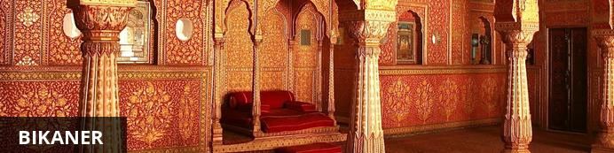
One of the most loved snack exports out of India has its origins in this Rajhastani city. Bikaneri Bhujia, an Indian version of potato chips, has become popular across the globe and today the crispy snack, using gram flour and spices, provides employment to over 2.5 million people. Bikaner boasts many unique architectural features such as the Bikaner Havelis – manifold mansions lining the narrow lanes of old town, signalling a glorious and opulent heyday in Bikaner history – and the beautiful Junagarh Fort, with its tall ochre walls extending for almost a kilometre around the impressive structure.
After breakfast proceed for Artisans Walking Tour in Churu.

Artisan Walking Tour
The streets and corners of Churu offer a number of handcraft opportunities – Bandhej (Tie & Dye work), Block Printing, Miniature Wood Carvings, Lacquer Bangles, Pottery etc. This is a "Hands-On" tour where you get to involve with the artists and try your hand while learning about their trade. You will certainly not be visiting any showrooms and the experience is sure to leave you with a much richer understanding of region's craft, culture and living by going beyond the historical sightseeing.
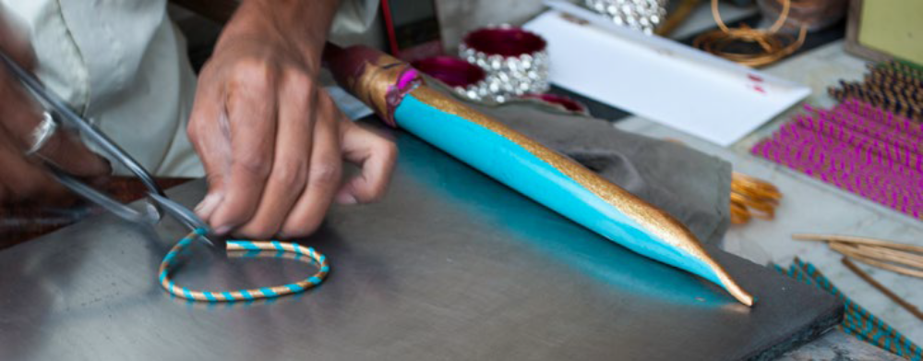
After the tour drive to Bikaner, on arrival check-in at hotel. (approx. 4 hours drive)

Day 5: In Bikaner
After breakfast proceed to visit Raisar Village and Bikaner miniature painting school.

Afternoon visit Junagarh Fort.

Raisar Village to see Meghwal Community work
In Rajasthan, a community of self-effacing people still resides collectively in small hamlets. There mud-brick houses, though modest, showing the carefully designed colorful geometrical patterns embedded with inlay mirrors, tell the tales of their denizens lifestyle, who commands people’s attention through silent artistic ways. Nowadays, only a few Meghwals are engaged in their traditional jobs. Most of them have understood the importance of education and have chosen it to be their means of livelihood. Of those who are still working in the field of textiles, most are women. As a matter of fact, the colorful embroidery accomplished by Meghwal womenfolk has its own entity, and is famous as Meghwal embroidery in the Indian textile industry. The major feature of Meghwal embroidery is the use of vibrantly colorful threads, exuberant patterns, and use of mirrors or similar reflective alternatives. The fabric is most sought-after during festive seasons, for the color these lively designs bring in any occasion still remains unparalleled.

Bikaner Miniature Painting School
Shiv Swami - In keeping with the traditions of Indian art, Shiv Swami uses time-honored methods and tools for this artwork. His original style is strongly influenced by the Mughal and Rajasthani traditions and is well known in the region for his detailed miniature paintings, which can be fully appreciated when seen through a magnifying glass. Shiv Swami primarily specializes in figurative and botanical subjects and has, on several occasions, been commissioned to paint large frescos in Bikaner. He has held exhibitions in Jaipur, Bikaner and Delhi, Italy, Germany, England, China and has recently been invited to do an exhibition in France. Many of his paintings have been featured in local and international magazines and artistic journals. Shiv also worked on Botanical Floral paintings for Famous Hollywood Actress Diana Ricks of U.K.
Junagarh Fort
Junagarh Fort is located in the princely state of Bikaner in India. The fort is a unique illustration of composite culture. It contains antique monuments and objects of art such as the symbolic hands of Sati, seven historic gates, nine attractive temples, and little shrines of various deities. The fort also features four deep wells, three beautiful gardens, post-medieval stables and barracks, an old jail, and armoury stones on the ground floor.

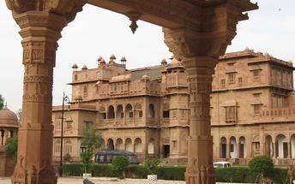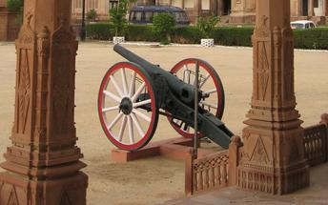

Day 6: Bikaner - Pokaran
After breakfast drive to Pokran, on arrival check-in at Fort Pokaran. (approx. 3 ½ hours drive)

Afternoon visit to Pattu Weavers village and visit to Potters Colony.
Pattu Weavers Village
Rajasthan’s incredibly colorful culture has found its expression in its traditional textile industry. From sturdy carpets to soft light-weight quilts, the skills of Rajasthani artisans know no bound. Originated in west-most part of the state, Pattu is a unique weaving style used for the fabrication/manufacturing of woolen textiles. It is indeed surprising that one of the warmest states of India is the major manufacturer of this winter wear. The most prominent feature of the woolen Pattu of Rajasthan is also the feature that gave the art its name-the narrow striped pattern which in local language is called ‘patti’.

Potters Colony
One of interesting visit while staying in Fort Pokarana visit is to the potter’s colony. Here, a clan of potters live and work in the traditions handed down in their families for many centuries. One of Rajasthan’s most famous handicrafts is their traditional terra cotta pottery, and Pokharan is most famous for both its thin red and white Kagzi type pottery as well as its fine terra cotta statuary traditions.

Fort Pokaran was built in the 14th century and is now a family run heritage hotel in Pokhran. It is en route from Jodhpur to Jaisalmer and Bikaner to Jaisalmer.
A stay at the Fort Pokaran hotel includes tea at the towers, traditional gala evenings, views of the town, folk dancing and cultural programs which are all organized by the Pokaran family. Jeep and camel-car safaris can be organised to nearby villages and wild life spots around Pokhran.
The hotel features an in-house museum where the family collection of armoury, garments, miniature paintings, handicrafts and local artistry are on display. Also found at the hotel is the ‘Grand Library’ containing classic books.

Day 7: Pokaran - Jaisalmer
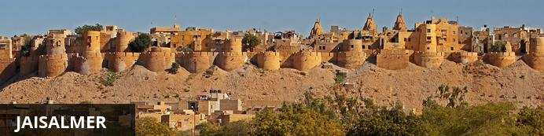
Situated amid the vast expanse of the Thar Desert on the far western border of India’s Rajasthan state, the city of Jaisalmer is home to the world's only inhabited medieval living fort. This 12th-century city served as a bustling trading post along the famous Silk Road and still to this day features markets selling silk, cashmere, silver jewellery, bronze statues and much more. The undeniable star attraction of this city is the spectacular Jaisalmer Fort, which rises from the desert floor like a gigantic sandcastle and encompasses winding streets filled with shops, temples, hotels and ancient mansions. Visitors can also look forward to taking jeep and camel safaris into the surrounding desert and exploring a variety of grand palaces, elaborate Jain temples and ornate havelis.

Morning at leisure.

Afternoon drive to Jaisalmer, on arrival check-in at hotel. (approx. 3 hours drive)

Day 8: In Jaisalmer
After breakfast proceed for city tour of Jaisalmer visit Jaisalmer Fort, Jain Temples and Haveli’s.

Later visit to a Puppet Colony.

Jaisalmer Fort
Jaisalmer Fort is a heritage site in Jaisalmer, a city in Rajasthan. India. It was built in the mid-14th century on a hilltop which offers stunning views of the Thar Desert and beyond. The sandstone colour camouflages the fort to match the surrounding yellow sand desert. The fort complex features four large gates, the Laxminath temple of Jaisalmer, seven Jain temples, the Raj Mahal Palace and several mansions adorned with carvings. Visitors can enjoy sumptuous local and intercontinental cuisines at any of the several restaurants within the fort. Excellent photo opportunities are also available.
Patwon Ki Haveli
Among the largest and the most elaborately carved havelis in Jaisalmer, this five-storey structure sits proudly in a narrow street. While the haveli has lost some of its early glory, a few paintings and mirror work art can still be seen on the inside walls.
Nathmal Ji Ki Haveli
The magnificent Nathmal Ji Ki Haveli is located in the centre of the city of Jaisalmer. The mansion was home to the former prime minister of Jaisalmer, Diwan Mohata Nathmal. It is said that the mansion was designed and built by two brothers who worked on it simultaneously, so the two sides of the building are not the same. A guide will point out the differences, some of which are quite obvious. The building is adorned with carvings, painting and sculptures. Multiple photo opportunities are available.
Salim Singh Ki Haveli
Located in Jaisalmer, India, Salim Singh Ki Haveli has been built on the remains of a previous haveli which was built in the 17th century. This new haveli was built in 1815 and its occupants, the Mehta family of Jaisalmer, were the most influential people at the time. The haveli's well defined structure features a roof in the form of a peacock, tuskers that guard the gateway, 38 distinctive balconies and a front detail which resembles a ship stern. Sometimes resulting in the haveli being referred to as Jahazmahal.

Day 9: Jaisalmer - Jodhpur
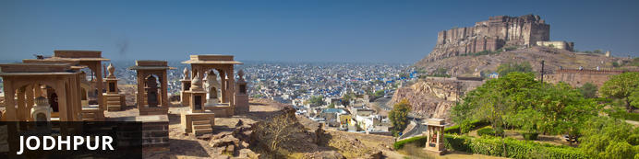
Known as the gateway to the Thar Desert, Jodhpur is the second largest city in the state of Rajasthan, India. It is a popular tourist destination featuring a variety of ornate palaces, age-old forts and sacred temples. Dubbed “The Blue City", most houses in the old city are painted a beautiful shade of indigo. While Jodhpur is largely a sprawling modern metropolis, enclosed within its old city walls is a labyrinth of winding, narrow medieval streets and bazaars. Jodhpur is home to one of the largest forts in India, the massive 15th-century Mehrangarh Fort, which towers over the city from its sandstone plinth. Other must-see attractions include: the Umaid Bhawan Palace, one of the world's largest private residences; and the Jaswant Thada, an intricately carved white marble mausoleum.

After breakfast drive to Jodhpur, on arrival check-in at hotel. (approx. 5 hours drive)

Afternoon proceed for city tour of Jodhpur visit Mehrangarh Fort and clock tower market.

Mehrangarh Fort
Mehrangarh Fort rises four hundred feet above the skyline of Jodhpur from its rock precipice on Bhaurcheeria hill. The foundation of Mehrangarh Fort was laid on May 12, 1459 by Rao Jodha, the fifteenth Rathore ruler who wanted to shift the capital from nearby Mandore to Jodhpur. In all its history, Mehrangarh Fort has never been taken in a siege. Mammoth and imposing from the outside, the interiors of the fort are light and detailed in contrast. Several palaces can be found inside the complex, boasting intricate carvings and sprawling courtyards.
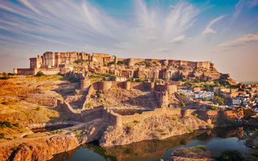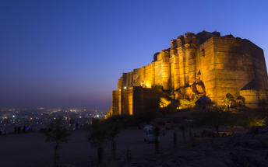

Day 10: In Jodhpur
After breakfast excursion to Pipar to witness Block Printing Workshop. (approx. 2 hrs one way)
Light snacks will be provided during the workshop.
Pipar Village
Pipar Village which is approx. 60 kms from Jodhpur, a small village buzzing with everyday life - Pipar is a goldmine for anyone in love with textiles, art, handicraft or mere colors. This little town of Pipar and family owned units, has become the focal point of textile majors. Visit the Bazaars of Pipar that have been popular and famous for the local crafts and ethnic items. Few know that this sleepy village is also the nerve centre of the natural-dye fabric industry of Rajasthan whose earth colours, indigo dyes, and prints are a rage among the chic ethnic sophistic fashion followers in India and abroad.
Return to Jodhpur and rest of the day at leisure.

Day 11: Jodhpur - Udaipur
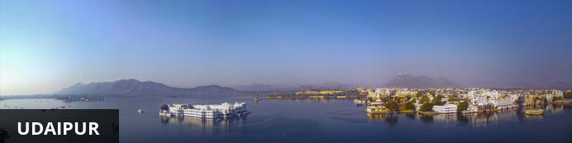
Dubbed the ‘Venice of the East’, the city of Udaipur is built around three interconnected lakes – Lake Pichhola, Fateh Sagar Lake and the smaller Swaroop Sagar Lake – and encircled by the hills of the Aravalli mountain range. It is home to an array of ancient temples and fairy-tale palaces (several of the latter have been converted into luxury heritage hotels) and is known as one of Rajasthan’s most beautiful and romantic cities. Must-see attractions include the City Palace, the Lake Palace (set on a small island in the middle of Lake Pichola) and the Udaipur Solar Observatory – Asia’s premier solar-gazing site.

After breakfast drive to Udaipur en-route visiting Sadhna near Delwara to meet the meet the women artisans and local villages. (approx. 5 hours drive)
Sadhna
Sadhna was established in 1988 to provide alternative incomes for women in Udaipur’s rural, tribal and urban slum belts. As these communities were not dependent on agriculture, handicraft was chosen to be introduced to them. SADHNA taught Patchwork, Appliqué and Tanka embroidery skills to the women for them to earn a secure living. Today, SADHNA provides continuous training to women artisans to improve their skills, a support network to them in their villages and a respectable position in their family and society.
Later continue drive to Udaipur, on arrival check-in at hotel.

Day 12: In Udaipur
After breakfast proceed for city tour of Udaipur visit City Palace, Jagdish Temple, Sahelion-ki-Bari.

Afternoon Boat Ride on Lake Pichola.

Udaipur City Palace
Situated above Lake Pichola, Udaipur City Palace has housed many royals over four centuries who have each added their own unique preferences to the establishment. The palace is a one of a kind in Rajasthan. Udaipur City Palace was constructed entirely out of marble and granite which makes it highly luxurious. The inside is even more so with its inlays of coloured glass, engravings, towers, and balconies.
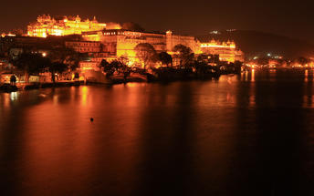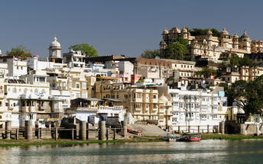

Saheliyon ki Bari
Built by Maharana Sangram Singh II as a garden for women, Saheliyon-ki-Bari or the Garden of the Maidens is a popular tourist destination. Along with a small museum, it has several attractions such as marble elephants, fountains, kiosks and a lotus pool.

Jagdish Temple
Completed in 1651, Jagdish Temple is situated just outside the royal palace. The temple can be seen as soon as visitors enter the city. Puja’s and prayer time are the best time to visit when melodious chants from devotees float through the small interior. Visitors should make a point of climbing the temple's many steps which invite them on a journey of discovery of the rich and vibrant history of Udaipur.

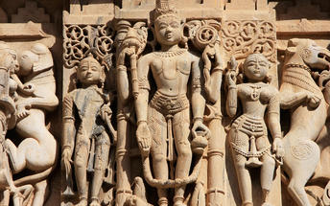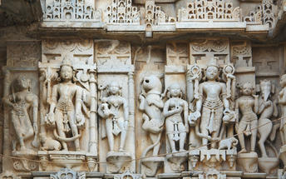

Boat Ride on Lake Pichola
Pichola Lake is one of the most beautiful lakes in Rajasthan. Located in the heart of Udaipur, Pichola is the oldest and one of the largest lakes in all of Udaipur. In 1362 AD Pichola Lake was built by Banjara. Later, Maharana Udai Singh, affected by the charm of this lake and extended the lake when he founded the city of Udaipur and also built a dam made of stone that is in the Badipol region on the shore of the lake. Pichola Lake is enveloped by lofty Palaces, temples, bathing ghats and elevated hills on all its sides.

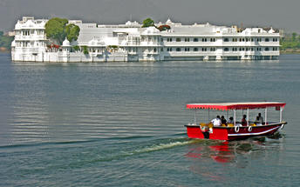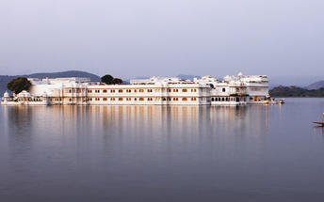

Day 13: Udaipur - Delhi
Breakfast at the hotel.

Afternoon at appropriate time, you will be transferred to Udaipur airport to board flight to Delhi.

Flight TBA
Departs Udaipur TBA
Arrives Delhi TBA

Upon arrival in Delhi, you will be transferred to hotel.

Day 14: Depart Delhi
At appropriate time, you will be transferred to Delhi airport to board flight to onward destination.

