

IN - 61

Sustainable Tourism by CGH
Kochi - Thekkady - Kumarakom - Alappuzha - Mararikulam
11 Days / 10 Nights

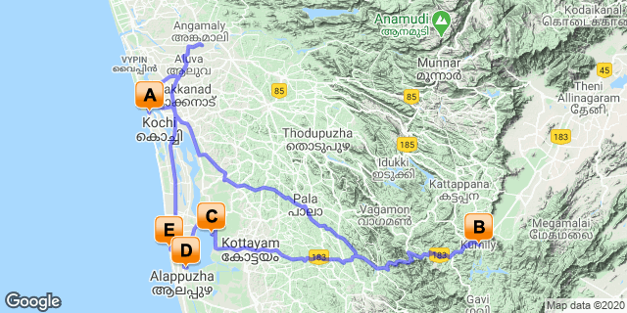

Overview
CGH EARTH’s business model is based on sustainable and responsible tourism. Every thought and action is born out of this commitment to the environment and the local communities where it operates. The experiential character of its holidays does homage to nature and engages closely with local people and their cultures.
This significant aspect of taking responsibility for the environment and its people forms the backbone of the group’s vision as it grows and expands into new geographic areas across the country with an awareness that is as inclusive as it is expansive. This unique identity has been termed ‘the Indian consciousness’, being characterized by those aspects that distinctly make up the Indian soul - variety, beauty, simplicity and caring! These core values are the ideological pillars that give substance to its dreams. They also manifest in a hundred visible ways inspiring and influencing daily actions on the ground. Over the years this boutique hotel chain has created 16 unique properties across Southern India, each a distinct experience unto itself. CGH Earth sees itself as a curator of extraordinary experiences that arise from its intimate bonding with nature and community. This undoubtedly lies at the heart of it’s specialness, making for holidays that are uplifting and transforming. They endorse that less can be more and that true luxury is an experience rooted in simplicity and soul, transcending mere form and ostentation.

Introduction

Start | Accommodation | Destination | Basis | Duration
Day 1 - Day 3 | The Brunton Boatyard | Kochi | B&B | 2 Nights
Day 3 - Day 5 | Spice Village | Thekkady | B&B | 2 Nights
Day 5 - Day 7 | CGH Earth Coconut Lagoon | Kumarakom | B&B | 2 Nights
Day 7 - Day 8 | Spice Coast Cruises Houseboat | Alappuzha | FB | 1 Night
Day 8 - Day 11 | Marari Beach Resort | Mararikulam | B&B | 3 Nights

Day 1: Arrive Kochi

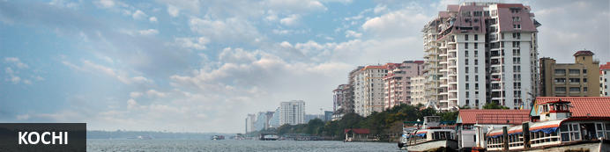
Also known as Cochin, Kochi is a city in southwest India's coastal Kerala state. This attractive city has served as a popular port for over 600 years and is known for its eclectic architecture and its array of religious monuments, museums, galleries, cafes and antique shops. The city stretches across a number of peninsulas and islands, which can be reached by a network of water taxis and bridges. The majority of Kochi’s visitor highlights can be found on the peninsula of Fort Kochi. These highlights include the St Francis Church, the oldest European-built church in India; and Mattancherry Palace, which dates back to 1557 and contains some exceptional Kerala murals and temple art. Other must-see attractions include the Kerala Folklore Museum, displaying more than 4,000 cultural and ethnic artifacts; the 16th-century Jewish Synagogue; and the local market, where the air is filled with the aroma of exotic spices.

Flight TBA

Arrives Kochi TBA

On arrival at Kochi airport you will be received by a Travel Counsellors' representative and will transfer you to your hotel. (Standard check in time - 1400 Hrs).

Overnight: The Brunton Boatyard
The Brunton Boatyard Hotel has been resurrected from a Victorian ship building yard, based on the historic Cochin's harbour. The hotel's interiors are an eclectic blend of English, Portuguese and Dutch influence. The Brunton Boatyard has 22 rooms, all of which has an en-suite bathroom. Each room opens up to views of the sea.
The main attractions of this establishment is the harbour cruise, touring the historic Fort Cochin, visiting the Spice Market and walking to the Chinese fishing nets.
Guests can dine at History Cafe , a multi cuisine restaurant, the Terrace Grill and the Armoury, a coffee shop and bar. Hotel facilities include a swimming pool and the Ayurveda centre.

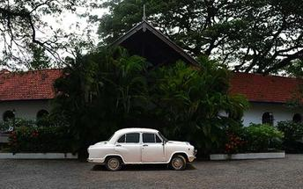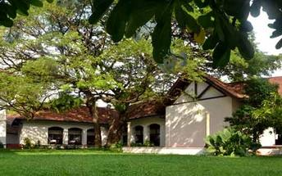

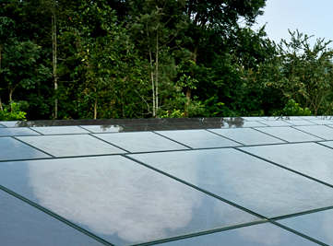
Community, Culture, Ecology at Brunton Boatyard
Hailing the Sun: Our Water is heated using solar photovoltaics mounted on our hotel roofs. It helps us save energy while reducing carbon footprints.

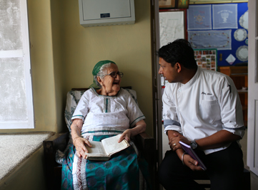
Varied Cuisines: Our integration with the communities where we are located and their culture has bred in us a unique sense of culinary imagination; one that draws inspiration from the age-old and singular recipes of the Jewish, Anglo-Indian, Gujarati and Christian communities of Fort Kochi and its environs.

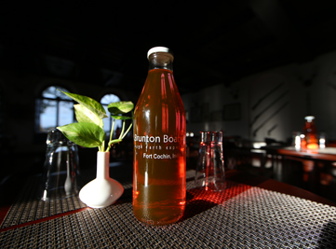
Drinking Pure bottle rainwater: Born out of our undying zeal to reduce waste, we serve treated rainwater in glass bottles for our guests. This single act helps us displace around 15,000 units of plastic water bottles that would have otherwise entered our waste stream. It also enables us to serve water that is both pure & natural.

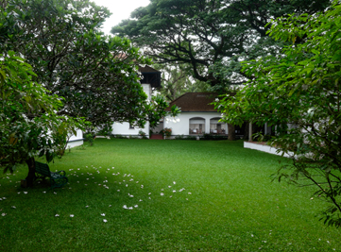
Harvesting the rain: Water is a precious resource and a scarce one too. We take pains to use it judiciously, conserving whatever we can. The rains that come pouring down upon us in the monsoon season provide us an opportunity to collect and store some of this in underground tanks, where they are later treated and used for a variety of purposed that include washing, cooking and drinking. This helps us to bring down our net use of subterranean water, easing the pressure on the environment by reducing our need.

Day 2: In Kochi

Morning enjoy a sightseeing tour of Cochin. The tour allows you to explore the charming Fort Cochin, Jewish Synagogue, Dutch Palace and St Francis church.

In the evening Enjoy Kathakali Dance Drama in a local theatre.

Jewish Synagogue (Closed on Friday afternoon and Saturdays)
This synagogue was built in 1568 by the Malabar Yehudans or Cochin Jewish community. It was built close to the Mattancherry Palace Temple on the land gifted by King Rama Varma, a former ruler of Kochi. The Mattancherry Palace Temple and the Mattancherry synagogue share a common wall. This synagogue is the oldest one in the Commonwealth of Nations.
As one approaches the synagogue on Jew Street, its white facade begins to appear very prominently. A clock tower can also be seen, towering over and close to the facade. This was built in 1760 by Ezekiel Rahabi an affluent Jewish businessman. Of the four faces of the clock, the one facing the maharaja's palace showed the time in Malayalam. And among the other three, the face with etchings in Roman numerals was meant for the traders. Of the remaining two faces of the clock, one had writings in Hebrew while the other remains blank.
Stepping inside the Synagogue, one's eyes would easily go to the glass chandeliers and blue willow-patterned Chinese floor tiles. The chandeliers are of Belgian origin. Also of interest are the Scrolls of the Law housed here and the several gold crowns received as gifts and the brass-railed pulpit. And for some exclusive pieces from history, the synagogue also houses the copper plates of privileges given to Joseph Rabban, the earliest known Cochin Jew, dating from the 10th century, written in Tamil, by the ruler of the Malabar Coast.

Dutch Palace (Closed on Friday for full day)
The Dutch Palace is a beautiful palace that was originally built by the Portuguese. It was only during the 17th century that the Dutch took it over, modified it and then presented it to the Raja of Kochi. The main attractions here are the outstanding collection of mural paintings found inside. These murals beautifully depict scenes from the Hindu epics of Mahabharatha and Ramayana.

St Francis Church
It is one of the ancient European churches in the country and is a marvelous specimen of Portuguese architecture in the country. It is a mark of the colonial struggle of the Europeans to make their presence felt in India at that time. This church, built in 1503 by Portuguese traders, was where Vasco da Gama was buried when he died in 1524 AD. However, fourteen years later, his remains were shifted to Lisbon. Earlier, the church was named after Santo Antonio which was changed by Anglican Communion after the name of patron Saint Francis. It is now considered integral to the history and tourism of Kochi. In April 1923, this church became a protected monument under the Protected Monuments Act of 1904. In 1920, the Cenotaph was set up in the memory of the inhabitants of Kochi who died in the World War-I. Apart from all this, one interesting fact to observe is that, despite being very modest in its architecture, the model of this church has been followed by many churches India.

Chinese Fishing Nets
They are fishing nets that are fixed land installations for fishing. While commonly known as "Chinese fishing nets" in India, the more formal name for such nets is "shore operated lift nets". Try your luck to get the fresh catch with the locals.

Kathakali
Kathakali is a highly stylized classical kerala dance performance noted for its attractive make-up of characters, their elaborate costumes, detailed gestures and well-defined body movements presented in tune with the anchor playback music and complementary percussion.
Kathakali is said to have evolved from other performing arts like Kootiyattam (a classical Sanskrit drama existing in Kerala), Krishnanattam and Kalarippayattu. Kathakali explicates ideas and stories from the Indian epics and Puranas.
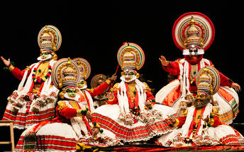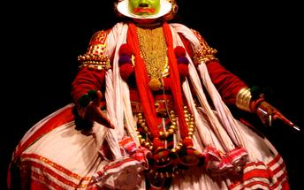

Day 3: Cochin - Thekkady

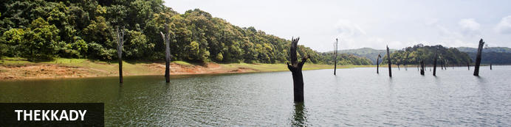
A tourist attraction in Kerala, Thekkady is a district located at the Periyar National Park. Thekkady comprises evergreen forests and savanna grasslands, and is known for its natural spices such as black pepper, cardamom, cinnamon, nutmeg, ginger and clove. Elephants, tigers, sambar and many other species inhabit the park. Top attractions include the exquisite ancient Mangla Devi Temple, the aromatic Abraham’s spice garden, and the massive waterfall at the sleepy, picturesque village of Chellarkovil. Take in panoramic views of the extraordinary landscape from the Chellarkovil viewpoint, and picnic on the rolling, lush green lawns at Pandikuzhi. Don’t miss the opportunity to visit the Kadathanadan Kalari Centre, to see demonstrations of the best traditional martial arts. Thekaddy is home to India’s sole Tiger Reserve, and has a rich living tribal culture.

After breakfast, you will drive to Thekkady/Periyar, on arrival check-in a hotel. [Approx. 170 Kms/5 Hrs.]

Rest of the day at leisure.

Overnight: Spice Village
Spice Village is situated in Periyar. It is a resort with lush gardens, individual cabins and that practices ecological methods during it's day to day running. This resort belongs to the CGH Earth Group. Visitors out for a nature escape is drawn to the Spice Village. This is the tribal village, reborn for the modern traveller. Accommodation at Spice Village is made up of 52 individual, tribal-styled thatch-roof cottages with verandas along with modern plumbing, solar-powered hot water and contemporary furnishings. Facilities include a swimming pool, games and a restaurant. Ayurveda treatment is also available on site.
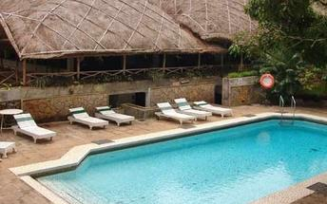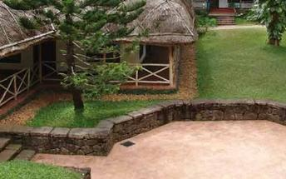
Community, Culture, Ecology at Spice Village
Harnessing the Sun: 75% of our power needs are met from solar energy harnessed on the property. Barring some heavy machinery used in the kitchen and laundry, we can proudly say that we are “off the grid”.

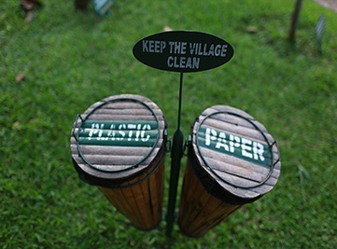
Compost for our gardens: 250 to 400 kg of food waste is turned into nutrient-rich vermicompost at our plant at Spice Village to fertilize the two-acre vegetable and herbal gardens at the property.

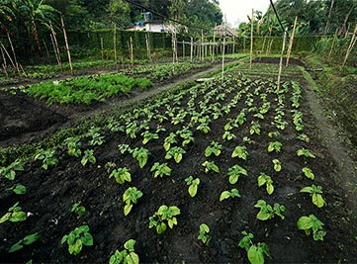
Farming for our tables: Our organic garden at the resort that puts fresh vegetables, fruits and spices on your tables every day is an attempt to reduce our footprints by reducing our food miles. It is stewarded by members of the local community who are skilled farmers who employ traditional methods of crop raising.

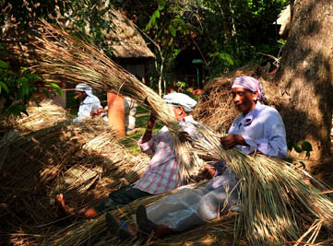
Locally centred: Our engagement with the locals with the local community for our everyday needs is keenly evident at the resort. The list is vast and includes a wide range of people and services; from the person who supplies milk and meat, the lady who makes pappadams, the women’s group who make candles, the farmers who supply us our fresh produce, the local guides who takes you on the treks in the forest, the cooperative that supplies honey or members of the native Mannan tribe who thatch our roof in the indigenous way only they can, our dependence on the local people and their inputs shapes our policies and our operations in large ways.

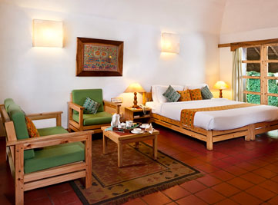
Old Wood = New Furniture: Our quest to lighten the burden upon our environment began 25 years ago, long before it was fashionable to be environment-friendly. We also sought to use and integrate recycled materials as much as possible in our property to add a touch of novelty to our interiors and décor, while reducing our footprints at the same time. The simple yet elegant and comfortable pine furniture in your rooms is a statement to the broad commitment to the environment. They were made from old wood packaging crates that came into our resort. They are as much a work of art for us as a dedication to a cause we take seriously.
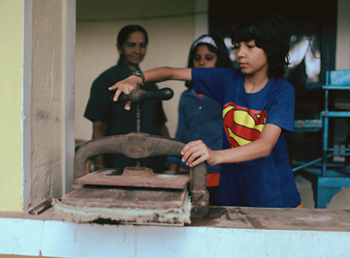
Upgrading Bio-waste to Paper: Paper generated from old newspapers and magazines is used at our handmade Paper Making Centre and turned into useful paper. The centre works on the vision of sustainable use of renewable resources. The method we have employed dates back ages. The paper is created using water paper and the crown of pineapples as a tenacity enhancing agent, which increases the binding quality in handmade paper. The recycled handmade paper is used as in-house guest stationery, invitation letters, manuals, notepads and also paper garlands for our guests.

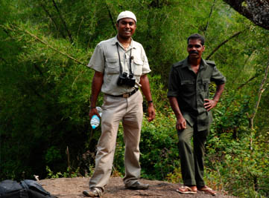
Fostering a spirit of community: We believe in creating a family that is local in its sprit. The girls and boys at Spice Village hail from the village and small towns nearby and have grown within CGH Earth to become professionals, leaders and mascots for the group and its philosophy.

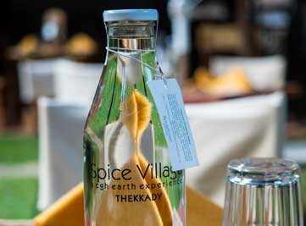
Reducing our footprints: In a conscious move from waste management to waste reduction, Spice Village has outed 45,000 units of plastic bottles from its waste stream. These have been substituted now with RO treated drinking water served in reusable glass bottles. This has reduced our waste and carbon footprints by a considerable degree.

Day 4: In Thekkady

This day proceed for a Nature walk at Periyar National park.
Different nature trails traversing diverse habitats form the trekking routes, generally 4 to 5 km. in length. This is an interpretive program offering excellent opportunity to watch birds, butterflies and other wildlife. The trails often pass through evergreen and moist deciduous forests interspersed with marshy grasslands. The program is offered between 7.00 am and 10.30 am and between 2.00 pm. and 3.00 pm. and lasts for about 3 hours. A maximum of 5 persons can go for trekking at a time along each nature trail, accompanied by a trained tribal guide. The Nature walk is the right program to feel nature, hear her whispers and smell her flowers.
Return to the hotel for breakfast.
Later in the afternoon, visit the Spice Plantation. Gift wrapped in lush green spice plantations, Periyar is the heartland of spices. The trip covers spice plantations such as cardamom, pepper, vanilla, clove, cinnamon, nutmeg, ayurvedic herbs etc. Over twelve varieties of spices including ginger, garlic, cardamom, vannilla, pepper, cinnamon, coffee, tea, clove and nutmeg is cultivated in Thekkady and its neighbouring villages.

Day 5: Thekkady - Kumarakom

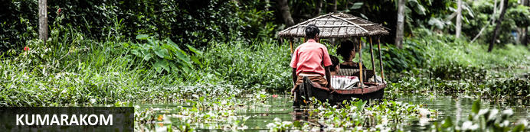
One of Kerala’s most alluring backwaters is Kumarakom, a hub of biodiversity where mangrove forests are mixed in with rice paddies, coconut palms and bursts of white lilies. This vivid subtropical peninsula juts into Vembanad Lake and is a popular place to study yoga, meditation and Ayurvedic massage, and from which to take bird-watching, boating and fishing trips. Nearby attractions include the Aruvikkuzhi Waterfalls, just two kilometres from Kumarakoram, which cascade down the mountain slopes from roughly 30 metres above, and Pathiramanal (meaning ‘sands of midnight’) a beguiling island and bird sanctuary in the middle of the lake.

After breakfast, you will drive to Kumarakom, on arrival check-in a hotel. [Approx. 140 kms / 4 Hrs.]
Rest of the day at leisure.

Overnight: CGH Earth Coconut Lagoon
The Coconut Lagoon is located in the Kerala district of Kuttanad. The resort is accessed by boat. From the jetty, the boat courses out over a breeze-laden watery highway. With a sharp turn into a narrow canal with banks decked with wildflowers, the Coconut Lagoon can then be seen.
The accommodation at the Coconut Lagoon comprises of villas will have different beds, cupboards and chests of drawers that has been sourced from traditional homes and made by craftsmen of the region. Furnishings, too, rely on local materials, offset with linen, rough-woven cotton and other natural fabrics.
At the Coconut Lagoon, visitors get to watch a Kalaripayattu match (traditional form of martial arts) in the morning, lounge at the liquid pool by the reception area and then attend evening shows featuring Kerala’s traditional arts.
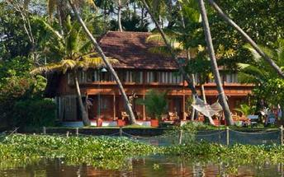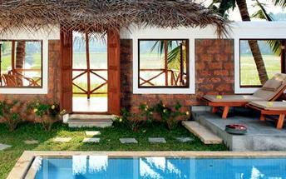

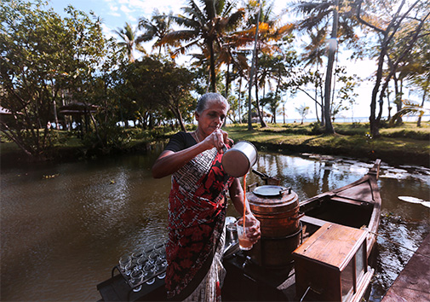
Community, Culture, Ecology at Coconut Lagoon
One with the local Community: We believe Coconut Lagoon is an extension of the village with no physical or metaphorical walls. We interact closely with the local community and have built up an intimate association with them, who deem as friends and neighbours. They also benefit economically from our operations as we give due priority to local sourcing.

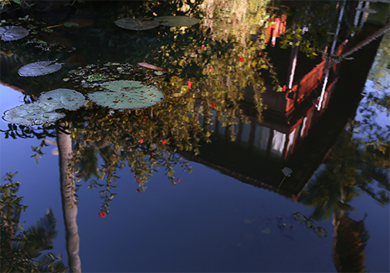
No wasting waste: We turn our wet waste into biogas and vermicompost, used as a cooking fuel and manure respectively. Some of our dry waste is used in truly creative ways. Plastic bottles make for an attractive interim building material while paper cans, cups and bottles are up-cycled into decorative items for various events at the resort.

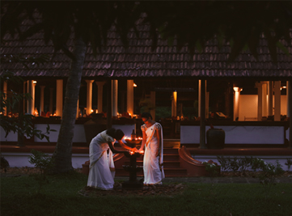
Local in spirit: Our people hail from local communities and neighbourhoods, and the experiences we offer stem from the character of our location and reflect the true face of the land.

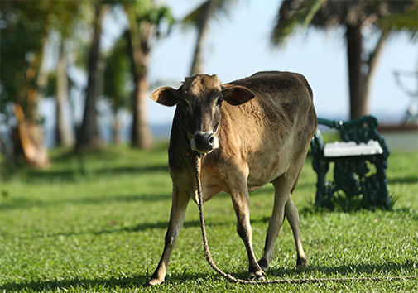
Speaking of Cows!: Few resorts have cows in their gardens and permit guests to interact with them closely. Coconut Lagoon is a home and museum to the rare breed of cows that originate from a region nearby called Vechoor. This unique breed of indigenous cattle, recognised by their short stature, are dying out and we at Coconut Lagoon are hoping to revive it through our small but committed interventions for its wellbeing.

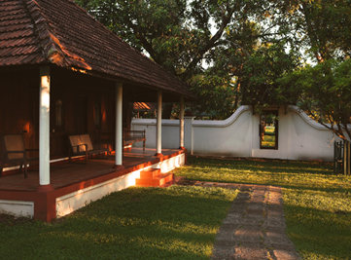
Heritage conscious: The traditional wooden homes you see at Coconut Lagoon are actually old houses. They have been carefully dismantled and relocated to this property from nearby villages to create a singular living experience for our guests. We also did this in order to protect from being stripped down and sold as souvenirs in the vast antique market. It is our way of paying homage to and preserving an old but venerable style of architecture and house building that is fast approaching.

Day 6: In Kumarakom

Full day at leisure to enjoy the activities offered by the resort.

Day 7: Kumarakom - Alappuzha (Alleppey)

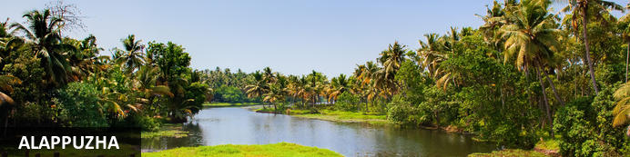
Located in the Indian state of Kerala, the bustling city of Alappuzha, also known as Alleppey, is set along the coast of the Laccadive Sea. Dubbed the ‘Venice of the East’, it is renowned for its houseboat cruises which float along the tranquil backwater canals of Kerala. It is said to be one of the most popular tourist centres in the state. While cruising the palm-shaded canals is the main attraction, visitors can also enjoy visiting Alappuzha’s beautiful beaches, exploring the little riverside villages dotting the lush countryside and discovering an array of resplendent temples. Don’t miss the annual Nehru Trophy Boat Race held at Punnamada Lake.

After leisurely breakfast, you will drive to Alleppey to board Houseboat. [Approx. 45 minutes.] for a cruise over the backwaters of Kerala.
Note:
Houseboat will be anchored in the evening till morning as per regulations.
Also note that air-conditioner in the room will operate only from 9 pm till 7 am.

Overnight: Spice Coast Cruises
The Spice Coast Cruises is part of the CGH Group and organises cruises on houseboats along the inland sea of the Vembanad. Staying true to eco-friendly practices of the CGH Group, the houseboats are made from natural materials and are powered by solar energy.
The houseboats contain comfortable amenities and an on-board chef. There’s also a cane lounger on the foredeck to view the surroundings while passing rice fields, palm trees and nearby villages.
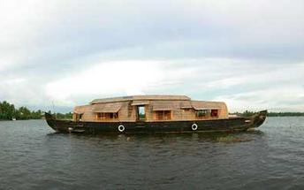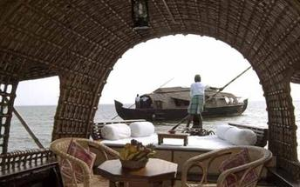
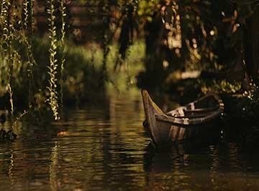
Community, Culture, Ecology at Spice Coast Cruises
Caring for the lake: We are aware of the great burden placed upon the Vembanad through various activities it supports. On our part, we are deeply committed to its care and ensure that we do not pollute it with our waste, which is duly treated before being disposed of.

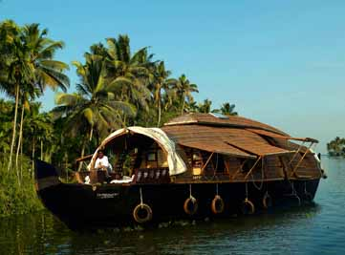
A new lease of life: The Spice Coast Cruise is set upon the magic of the Kettuvallams - the old boats that cruised the backwaters of these regions for as far back as memory can take us. They were designed for easy navigation, comfort and for carrying cargoes of spice and grain. The cruise is designed to give you an understanding of the uniqueness of these vessels that are part of a tradition that has not changed much over time, still being built of the same materials and employing the same modes of construction.
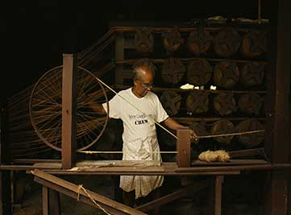
Keeping local skills alive: Our requirements for hand spun coir products needed for the Kettuvalam - the traditional boats of these waterways - comes from Kunjunni Chetan’s traditional wooden coir making unit. It is a gesture of commitment on our part to this old craft, once was a major economic activity of these parts, and hope thereby to keep it alive.

Day 8: Alappuzha (Alleppey) - Mararikulam

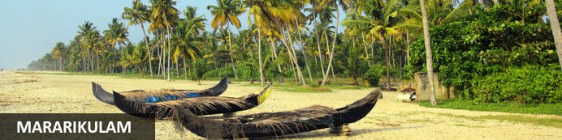
Situated only 40 km from the city of Cochin, in the Alappuzha district of Kerala, Mararikulam is a charming little coastal village known for its pristine sand beaches, swinging coconut palms and quiet, laidback atmosphere. The village has managed to avoid the mass development associated with many of the other beach towns in the area resulting in an untouched natural environment dotted with only a handful of small resorts. The main attraction in the area is the exquisite Marari beach where you will find fishermen heading out daily to fish the waters of this stretch of the Malabar coast, much as their ancestors have done for generations.

After breakfast, disembark the Houseboat and drive to Mararikulam, on arrival check-in at Marari Beach Resort. (Approx. 30 minutes)

Overnight: Marari Beach Resort
Marari Beach is part of the CGH Group and provides an authentic experience of Kerala traditional and recreation. The small resort is set in the coconut grove at the sandy Marari Beach surrounded by flowering plants and herb gardens.
Deluxe pool villas and cottages provide accommodation at the Marari Beach Resort. Most cottages have French windows opening up to a private garden. All materials used are naturally resourced and processed using simple methods as a means of practising ecological methods in the day to day running.
There’s plenty to experience at the Marari Beach Resort. The locals often host festivals showcasing their traditions and culture. At the Ayurveda Centre, guests can experience an authentic Kerala massage from trained therapists. Also available are yoga classes from a master yoga teacher. Furthermore, visitors have the option of attending a cooking class at the Farm Kitchen.
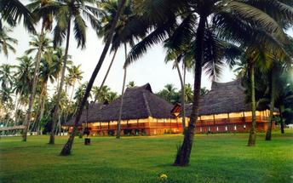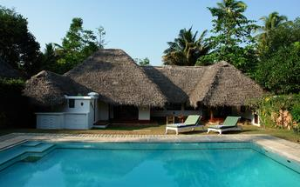
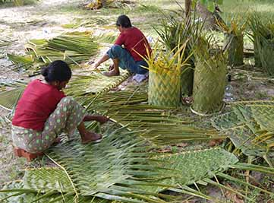
Community, Culture, Ecology at Marari Beach Resort
Community Integration: The ladies from the fishing village nearby are employed to re-thatch our cottages every year with fresh palm leaves, just as they do their homes. They also produce and sell to us a variety of hand spun and handmade coir products for use at the resort.

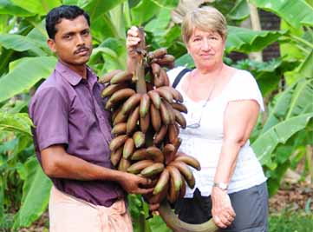
Working with local farmers: Additionally, the 4 acres of the property dedicated to organic farming are maintained by local farmers who bring their traditional knowledge and skills to the table, helping us raise a fine cluster of healthy corps throughout the year.

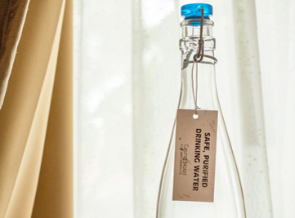
Reducing our footprints: In a conscious move from waste management to waste reduction, Marari Beach has outed around 100,000 units of packaged drinking water in plastic bottles from its waste stream. These have been substituted now with RO treated drinking water served in reusable glass bottles. This has reduced our waste and carbon footprints by a considerable degree.

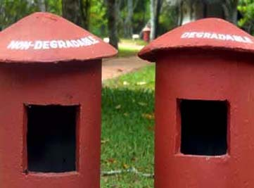
Managing our waste: Waste Management is a sacred ritual for us as we operate in ecologically sensitive areas. We take pains to segregate our degradable and non-degradable waste. Food waste goes into our biogas plants to generate methane for the kitchen while our dry waste is recovered for recycling as much as possible.

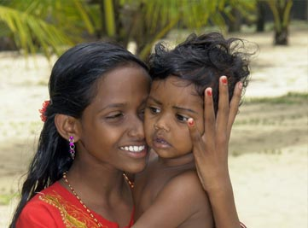
Enhancing local diets: The people of the fishing community, especially the young, tend to be malnourished. Though a nutritional program that we run at the resort’s organic farm, we have managed to inspire the local community to grow their own vegetables supplements to their regular diets. We believe that this step, however small, can add immense value to their health in the long run.

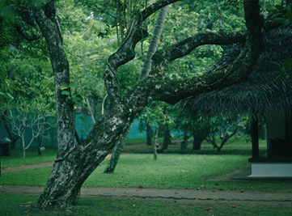
In tune with nature: Our proximity to the coast and a delicate ecosystem make care and preservation of the natural habitats a priority for us. This large expanse of land is home to 11 natural ponds, many varieties of fruit, trees, birds and butterflies.

Day 9 & 10: In Mararikulam

Days are at leisure at the resort. Option to take yoga/meditations, visit to the fishermans village, fishlanding, cycling through the village or to rejuvenate with some spa/Ayurveda massages !

Day 11: Mararikulam - Cochin Depart

At an appropriate time, your Travel Counsellor Representative will assist and transfer you to Kochi international airport [approx. 2 hours drive] to board your flight back home.

Flight TBA
Departs Kochi TBA
*** END OF SERVICES ****

