

IN - 62

Buddhist Circuit Itinerary
New Delhi - Varanasi - Bodhgaya - Patna - Kushinagar - Lumbini - Shravasti - Lucknow
14 Days / 13 Nights

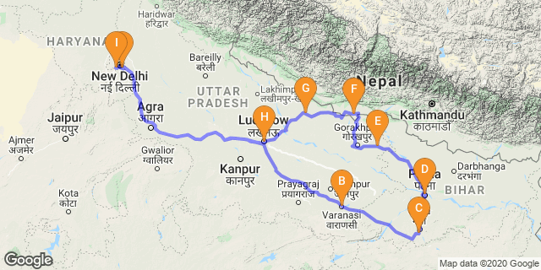

Day 1: Arrive Delhi

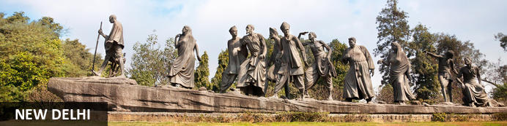
India’s largest city, Delhi, has been one of the country’s commercial and economic hubs for centuries and, as a result, is incredibly rich in culture and history. Made up of the ancient walled city of Old Delhi and the more modern sector, New Delhi, the city encompasses a staggering array of beautiful architecture, notable monuments and age-old temples, including three UNESCO World Heritage Sites – the Red Fort, Qutab Minar and Humayun's Tomb. Other key attractions include the 17th century Chandni Chowk marketplace – still one of the city’s most popular retail centres today, particularly for jewellery and traditional Indian saris; the iconic Bahà’i Lotus Temple – an award-winning architectural gem; and the Jama Masjid, India’s largest mosque.

On arrival in Delhi: Having cleared immigration, collected your luggage and passed through customs, please make your way towards the exit of the terminal building where you will see a bank of people waiting for you. Amongst them will be Travel Counsellors Representative who will be waiting to greet you with a paging board with your name on.
You will be transferred to your hotel and assisted with check in. (Standard check in time at hotel is 1400 hrs).

Day 2: In Delhi

Day Itinerary
After breakfast, leave for a heritage walk through Old Delhi following by the tour of New Delhi

Old Delhi Heritage Walk
Delhi is one of very few places where the ancient and modern co-exist side by side complementing each other perfectly. Our heritage walks of Delhi are a perfect way of exploring this amalgam of old traditions, modern development and the unique heritage which makes it so interesting. It is the perfect way to explore some of the lesser visited places and gain a new insight about the history, people and sights of Delhi city.
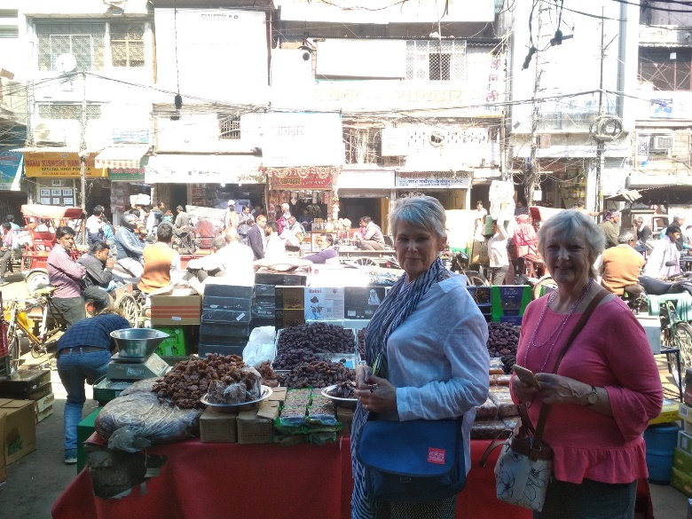
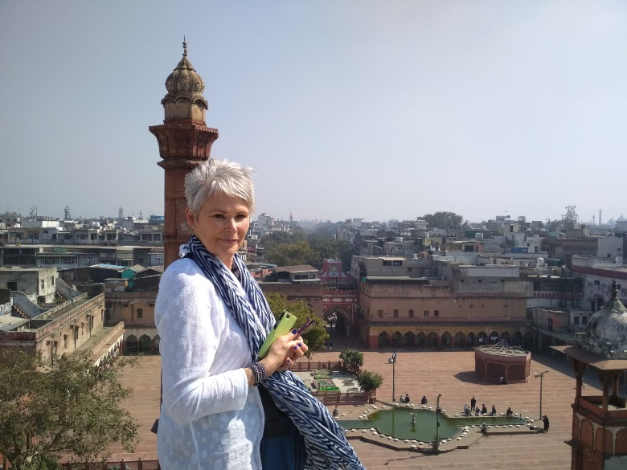

The tour of New Delhi covers the UNESCO world Heritage sites of Humyauns tomb, Qutab Minar along with a photo stop at India Gate – the war memorial and drive past the Govt. Secretariat building and the President Palace.

Humayun's Tomb:
The mausoleum complex of Humayun, India’s second Mughal Emperor, was commissioned by his widow in 1565 and was the first garden tomb to be built in India, taking seven years to complete. Humayun had travelled widely in Persia and Central Asia during his lifetime, and many of the architectural principles he brought back from these journeys were incorporated into the building at his wife’s instructions. With its double domes, decorative inlaid marble and vast garden with pools connected by channels, this 16th Century building set the stage for the style that culminated in the Taj Mahal almost 100 years later.
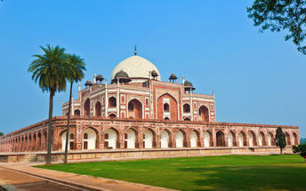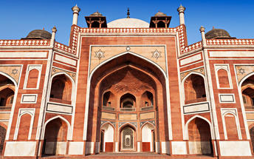

Qutub Minar
Standing tall at 73-metres, the tower consists of 5 storeys with a flight of spiral stairs leading to its top. The walls are adorned with decorative motifs and Quranic inscriptions. At the foot of the tower lie other monuments of historical significance, such as the Quwwat-ul-Islam Mosque and the Iron Pillar of Delhi. The Amazing race Australia used this site as a pit stop in the second series. Visitors can take advantage of stunning photo opportunities.
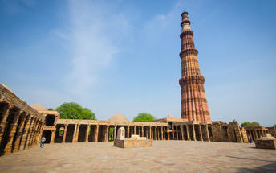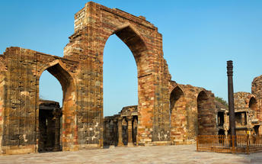

Day 3: Delhi - Varanasi

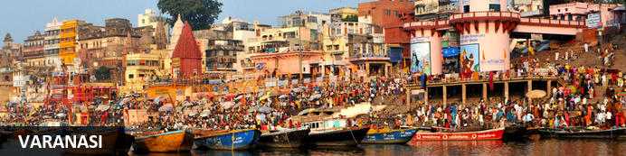
An ancient and deeply sacred city, Varanasi rests along the banks of the holy River Ganges and encompasses a wealth of beautiful riverside temples, stately old forts and vibrant markets. It’s considered the spiritual capital of Hinduism, and it’s widely believed that dying here will bring salvation. As a result, the city is home to a multitude of ghats – stone steps leading to the river –some of which are used for bathing rituals and others as cremation sites. An early morning boat ride along the Ganges offers an excellent way to take in the ghats and the bustling activity centred on them.

Day Itinerary
After breakfast, you will be assisted and transferred to Delhi airport for your flight to Varanasi.
Upon arrival you will be met and transferred to your hotel.

Evening Aarti at Ghat
Varanasi is a sacred and oldest city located at the banks of the holy River Ganga. Where, Ganges Aarti is performed daily in the evening by a group of priests at the Dashashwamedh Ghat near famous Kashi Vishwanath Temple as a dedication to Shiva, Gange, Surya (Sun), Agni (Fire), and the entire universe.The whole ritual of the Ganges Aarti is performed by the seven students of the Vedas and Upanishads lead by the head priest of the Gangotri Seva Samiti in a well-choreographed manner with a great synchronization. The whole event takes around 45 minutes. An announcement at 7.00 pm indicates the beginning of the Aarti.
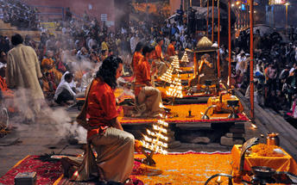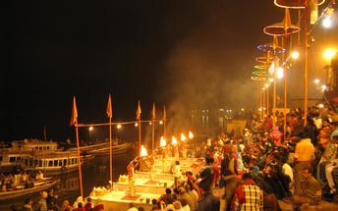

Day 4: In Varanasi

Day Itinerary
Early morning boat ride on River Ganges followed by walk in local bazaar (market)
Later in the day, visit Sarnath.

Boat ride on the River Ganges
Sunrise boat ride on Ganga in Varanasi is a spiritual experience in itself. Sunrise boat ride on Ganga in Varanasi is a memorable experience and not be missed. It gives a glimpse of morning life along the ghats in Varanasi. If you are lucky you can see stunning views of sun rising in the eastern horizon. Ganga is Varanasi and Varanasi is Ganga. For locals it is the lifeline. For devout pilgrims she is “Ganga Mayya – the mother who will wash away all the sins”. We are fascinated by the energy of the people, their beliefs and devotion to god. We could see people from all walks of life gathering on the ghat to worship the sun as he came up in the eastern horizon.
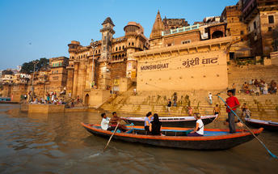

Sarnath
Sarnath is one of the most important Buddhist pilgrimage centres in India. It is here that Buddha came after reaching enlightenment at Bodh Gaya (present-day Bihar), and where he first began his teachings of Dharma and the four noble truths to his five disciples. It is also an important place for the followers of Jainism. While many of the ancient buildings and structures at Sarnath were damaged or destroyed by the Turks, relics remain in the form of ruins that can be visited, or artefacts held in the Sarnath Archeological Museum, which also houses some of the greatest treasures of Indian Buddhist art, including almost 300 images. The Deer Park, which is the site of Buddha’s first teachings, is maintained as an animal park and still home to resident deer.
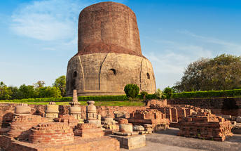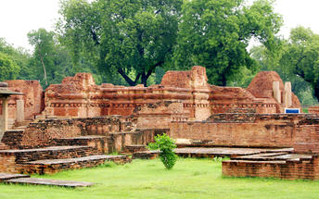

Day 5: Varanasi - Bodhgaya

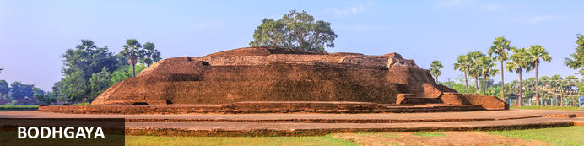
A sacred Buddhist pilgrimage site, Bodh Gaya is where Gautama Buddha is said to have reached enlightenment. Bodh Gaya is one of four Buddhist sites related to the life of Buddha; two others can be found in northern India and one in Nepal. The giant Bodhi Tree commands an impressive presence alongside the temple. Visitors are able walk beneath its sacred green canopy to see the site where Buddha sat in deep meditation. Today, the temple complex includes the 50-metre-high Grand Temple – built in the 3rd century B.C by Emperor Asoka, a patron of Buddhism – the Bodhi Tree and six sacred sites, surrounded by numerous stupas (commemorative monuments).

Day Itinerary
After breakfast you will be driven to Bodhgaya (approx.. 6-7 Hrs/ 260 Kms)
Upon arrival, check in at your hotel.

Remainder of the day at leisure to relax.

Day 6: In Bodhgaya

Day Itinerary
After breakfast visit the Mahabodhi Temple, a sacred place for the Buddhists and the Mahabodhi tree, where Buddha attained enlightenment.
Mahabodhi Temple is one of the ancient and most important shrines of India. Located at Bodhgaya, it is a renowned place where Lord Buddha got enlightenment. Perched on the banks of Niranjana River, Bodhgaya is a highly revered site of Buddhists. Pilgrims from all over the globe come to visit Bodhgaya, the awakening site. In the folklores, Bodhgaya has been mentioned as the place of great importance. According to Jatakas, Bodhgaya is the navel of the earth. This is only place that could abide the power of the Buddha's attainment. Mahabodhi Temple is regarded to have been constructed by Emperor Ashoka, who visited the place after 250 years of enlightenment. It boasts of a 52 m tall spire that houses the colossal gilded image of Lord Buddha. In the sanctum sanctorum, the huge image of Buddha looks mesmerizing in which he is sitting in a 'Bhumisparsh Mudra' (touching the ground). It is said that the image is 1700 years old and positioned in a manner that Lord Buddha faces the east. Mahabodhi Temple along with Bodhi Tree completes the holy pilgrimage to Bodhgaya.
Bodhi Tree is actually a fig tree, which grew from the original tree under whose kind shelter Lord Sakyamuni meditated and ultimately attained enlightenment. Owing to this, he became Buddha. Bodhi Tree is a significant part of Bodh Gaya, which is believed to grow on the day, Gautama Buddha was born
Also visit monasteries of different countries in the town and the Archaeological Museum.

Day 7: Bodhgaya - Patna

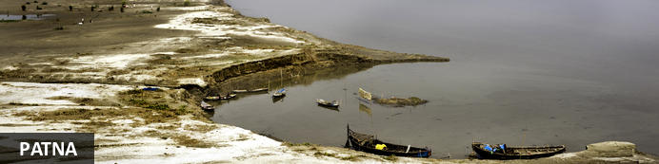
One of the oldest, continuously inhabited places in the world, Patna is the modern capital of Bihar. Ancient Patna was known as Pataliputra and was founded in 490 BCE by the king of Magadha. Artefacts from this ancient city can be found at Kumhrar, five kilometres east of the railway station. The population of Pataliputra around 300 BCE was reportedly 400 000 inhabitants. Patna is also the birthplace of Guru Govind Singhji, the tenth Sikh Guru, born in 1666. A memorial and place of worship is reserved for him at Takht Sri Patna Sahib, an impressive mosque-like building and residence of Sikh authorities through the ages.

Day Itinerary
After breakfast, you will be driven to Patna, visiting Rajgir and Nalanda en-route. Both sites hold great significance in the Buddhism circuit. (approx. 180 kms/5-6 hrs)

Rajgir
Rajgir is a city and a notified area in Nalanda district in the Indian state of Bihar and was the first capital of the kingdom of Magadha, a state that would eventually evolve into the Mauryan Empire. Its date of origin is unknown, although ceramics dating to about 1000 BC have been found in the city. This area is also notable in Jainism and Buddhism as one of the favorite places for Lord Mahavira and Gautama Buddha and the well known "Atanatiya" conference was held at Vulture's Peak mountain.
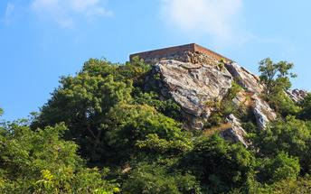

Nalanda
Nalanda was once a large, acclaimed Buddhist monastery in the ancient kingdom of Magadha (modern-day Bihar) which was partially destroyed by Turkish invaders in 1193. What was once a center for learning, attracting countless educators and monk-students from far and wide, is now a popular tourist site drawing in visitors from around the world with its remarkable ancient ruins. Excavations in the early 1900s revealed eleven monasteries and six brick temples neatly arranged on grounds 12 hectares in area. A trove of sculptures, coins, seals, and inscriptions have also been discovered in the ruins, many of which are on display in the nearby Nalanda Archaeological Museum. Other popular attractions in the area include The Great Stupa and the Nalanda Multimedia Museum.

After visit continue your drive to Patna, upon arrival check in at your hotel.

Day 8: Patna - Kushinagar

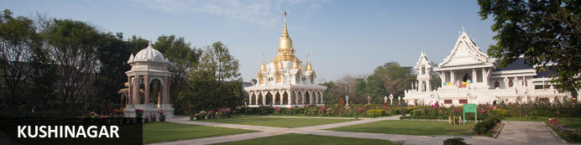
Situated 51 kilometres from Gorakhpur in the north Indian state of Uttar Pradesh, the quiet town of Kushinagar is a famous pilgrimage town. Buddhists and travellers seeking enlightenment flock to the town, as it is said to be the site of the death (Mahaparinirvana) of Lord Buddha, and is included in the renowned Buddhist trail which encompasses Bihar, Uttar Pradesh and Nepal. Visitors can see the Muktabandhana Stupa, under which the last cremated remains of Buddha are kept, and the seven-metre-long reclining Buddha statue at Mahaparinirvana Temple, among many other religious sites, in the province. Other highlights include: The charming gardens at Meditation Park, the enthralling Buddha Museum, and the fascinating Kushinigar Museum. The town also serves as a convenient base from which to explore the neighbouring cities of Luckynow, Gorakhpur and Patna.

Day Itinerary
After early breakfast you will be driven to Kushinagar (approx 05 - 06 Hrs / 220 Kms)
Upon arrival check in at your hotel.
Afternoon visit of Kushinagar.
Mahaparinirvana Temple (where Buddha took his last breathe) is located in Kushinagar in UP. It houses the 6.10 m long idol of Lord Buddha lying in a position when he left his mortal remains at the age of 80 and achieved the supreme state of salvation or permanent bliss. The monolithic statue of Buddha is built out of a single piece of red sandstone of Chunar. It shows him reclining on his right side with his face facing the west. It was considered the right posture for Mahaparinirvana. The statue is built upon a large brick platform supported by stone pillars in its corners. There is an inscription on the platform stating that it was built by Swami Haribala, a disciple of the Buddha in 5th century AD. Both the temple and the vihar were a gift of a grateful disciple to his august teacher. The temple attracts huge crowds of tourists and pilgrims from all over the world.
Later visit Ramabhar Stupa, Ramabhar Stupa, Kushinagar is more than 50 feet high and stands on a high mound that faces the road. The Ramabhar Stupa, Kushinagar is built to mark the actual cremation site. From the ancient Buddhist texts one gets to know that the Ramabhar Stupa, Kushinagar has been referred to as the Mukut-Bandhan Vihar. Near the Ramabhar Stupa, Kushinagar, there is a sheet of water which is the Ramabhar Jheel that completely dries up in the hot summer months. According to the legends, the word Ramabhar might be derived from this pond or the mound. Some people even associate the name with the event of Lord Buddha’s death.

Day 9: Kushinagar - Lumbini

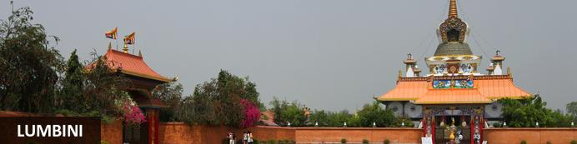
According to Buddhist belief, the Lord Buddha (originally known as Siddharta Gautama) was born in the sacred gardens of Lumbini circa 600 BC. As a result of this connection, the city has developed into an important Buddhist holy place and pilgrimage site. It encompasses an impressive archaeological complex that contains beautifully preserved remains of Buddhist temples, monasteries, pagodas and shrines dating as far back as the 3rd century BC. The area was designated a UNESCO World Heritage Site in the late 1990s. Two key attractions within the holy complex are the ancient Ashoka temple, dating to the 3rd century and bearing an inscription that declares Lumbini as Buddha’s birthplace, and the modern Maya Devi Temple, said to mark the exact spot where Queen Maya Devi gave birth to her now-famous son.

Day Itinerary
After breakfast you will be driven to Lumbini (approx 04-05 Hrs / 190 Kms)
Upon arrival check in at your hotel.

Afternoon visit of birth place of Buddha - Mayadevi Temple. This place is a blessed one for its serenity and the natural beauty, purely coinciding to the perception of a place where the legend was born. The spiritual heart of Lumbini, Maya Devi Temple marks the spot where Queen Maya Devi gave birth to Siddhartha Gautama in around 563 BC. In the adjoining sacred garden you’ll find the pillar of Ashoka, ancient ruins of stupas, and maroon- and saffron-robed monks congregating under a sprawling Bodhi (pipal) tree decorated with prayer flags. The sacred pond beside the temple is believed to be where Maya Devi bathed before giving birth to the Buddha. Dotted around the grounds are the ruined foundations of a number of brick stupas and monasteries dating from the 2nd century BC to the 9th century AD.

Day 10: Lumbini - Shravasti

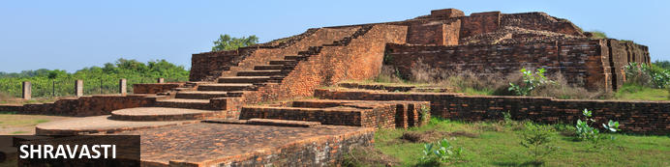
The ancient city of Shravasti (Sravasti) deemed sacred by both Buddhist and Jains, is at present a collection of ruins named Sahet - Mahet. This twin name refers to two distinct groups of remains: Maheth where you will find the fascinating remains of the ancient city; and Sahet which is primarily known as the site of the Jetavana monastery. It is widely believed that the Buddha spent 25 years in this ancient city. His hut, now adorned with a carpet of flowers continuously left by devoted pilgrims, is one of the most significant and sacred Buddhist sites in the area. With its spectacular array of holy temples, historic stupas, sacred shrines, and mammoth monasteries, the ruins of Shravasti are an essential addition to any Uttar Pradesh itinerary.

Day Itinerary
After breakfast you will be driven to Sravasti (approx 05-06 Hrs / 170 Kms) where the Buddha preached most of his sermons. Here he is said to have performed many miracles. During the monsoon, he used to stay at the Jetavana monastery on the outskirts of this town.
Upon arrival check in at your hotel.
Afternoon visit Shravasti.
The ancient city of Shravasti, a flourishing habitation that is an important landmark in the history of Buddhism and Jainism alike, is at present but a collection of ruins called Sahet-Mahet. This twin name has been given to two distinct groups of remains, Sahet and Mahet. Sahet is the site of the famous Buddhist monastery known as Jetvahana Vihar, which lay outside the limits of the Shravasti city proper. Mahet on the other hand is identified with the city of Shravasti. The ruins at Sahet consist mainly of plinths and foundation of Buddhist monasteries and stupas, and Mahet, situated about 500m from Sahet denotes the ancient city proper. Both Sahet and Mahet are now popular tourist attractions in Shravasti Uttar Pradesh.

Day 11: Shravasti - Lucknow

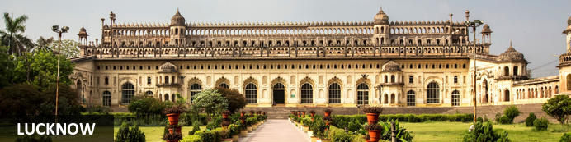
Known as the Constantinople of the east, Lucknow was a hub of Nawabi art, music, dance and architecture. Now the busy capital city of Uttar Pradesh, Lucknow sits in the centre of the state on the north-western shore of the Gomti River. A major centre of the Indian rebellion of 1857, Lucknow’s population participated actively in India's independence movement, cementing its role as a major city in north India. Dining out in Lucknow is highly recommended, and a local delicacy is the traditional North Indian kebab is king, with many variations to feast on. Spend your days here admiring British era buildings, mausoleums, and the bazaars of the bustling old town.

Day Itinerary
After breakfast you will be driven to Lucknow (approx.. 05 Hrs / 180 Kms), upon arrival check-in at the hotel.
Rest of the day at leisure.

Day 12: In Lucknow

After breakfast, enjoy a city tour of Lucknow.

Bara Immambara
Visit Bara Immambara, also called Asafi Imambara. Bara Imambara is an imambara complex in Lucknow built by Asaf-ud-Daula, a Nawab of Lucknow in 1784. Bara means big and an imambara is a shrine built by Shia Muslims for the purpose of Azadari. This magnificent monument recalls the glorious past of the Nawabs and stands out for its austerity in style, proportion and symmetry along with its unique in architecture.
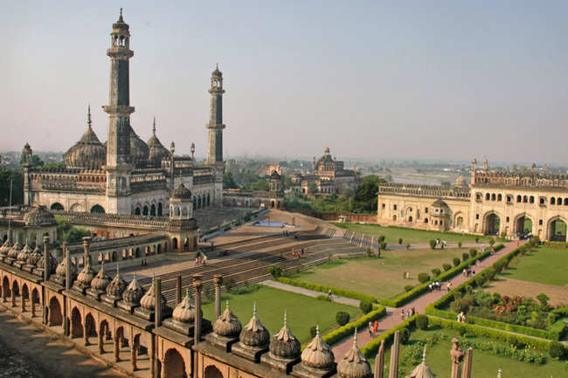
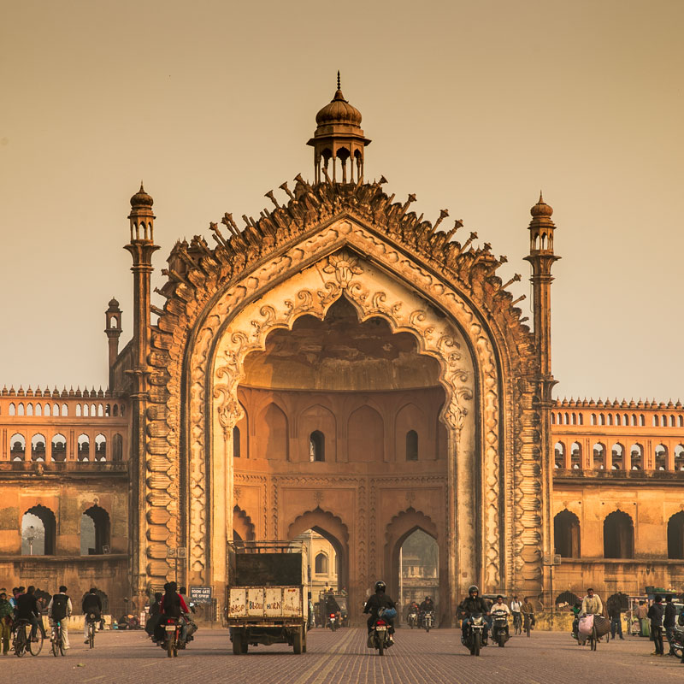
Chota Imambara
The imposing Chota Imambara is located in the town of Lucknow in India. Its grandeur architecture is a reflection of the Mughal era. The complex served as an Islamic congregation hall and has a notable collection of Chandeliers from foreign countries and exquisite glass works. The tomb of the Nawab Muhammad Ali Shah and some of his family members are housed here. Also featured are a dome, large halls, a crafted mural where the whole Koran is written with a grain of rice, a bath chamber and well-manicured gardens.

La Martiniere College
La Martiniere College in Lucknow was established in 1845, by the will of Major General Claude Martin. Over the span of one and a half centuries, the college has produced soldiers, sailors, and airmen who have done the school and their country proud in the two world wars and the wars of Independent India.
It has also produced engineers, doctors, educationists, administrators and outstanding athletes - now scattered over the globe. At the 150th anniversary of the opening of the college, the president of India acknowledged the contribution of the college by releasing a postage stamp of the denomination of Rs 2.00, as a mark of honour - also a mark of distinction that only a few other institutions in India enjoy.﻿

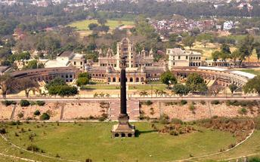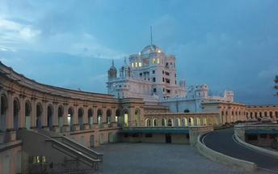

The Residency Lucknow
The Residency Lucknow is a complex of historical buildings located in the heart of Lucknow in India. The complex was the seat of power and the official residence of British diplomats and officers who represented the court of Nawab. The ruins still bear the marks of bullet holes as well as tombs of those who lost their lives during the siege of 1857. There is an on-site museum featuring collections of portraits, models and a short video that provides some insight into the history of the residence. The well-maintained lawns offer a good spot for relaxing.

Rumi Darwaza.
This beautiful structure is also said to be part of the famine relief plans for which the Bara Imambara was commissioned. Built in 1783, this gigantic gate is 60 feet tall as one of the famous landmarks of the city. We will stop by Picture Gallery near by built by Nawab Mohammad Ali Shah with a life size portrait of the Nawabs of Avadh.

Day 13: Lucknow - Delhi

Day Itinerary
At appropriate time, you will be transferred to Lucknow airport for your flight to Delhi.
Upon arrival in Delhi, you will be transferred to hotel.

Day 14: Depart Delhi

Day Itinerary
At an appropriate time, you will be transferred to Delhi airport for your flight back home.

