

The Golden Triangle Tour – 05 Days
Delhi - Agra – Jaipur – Delhi
05 Days / 04 Nights
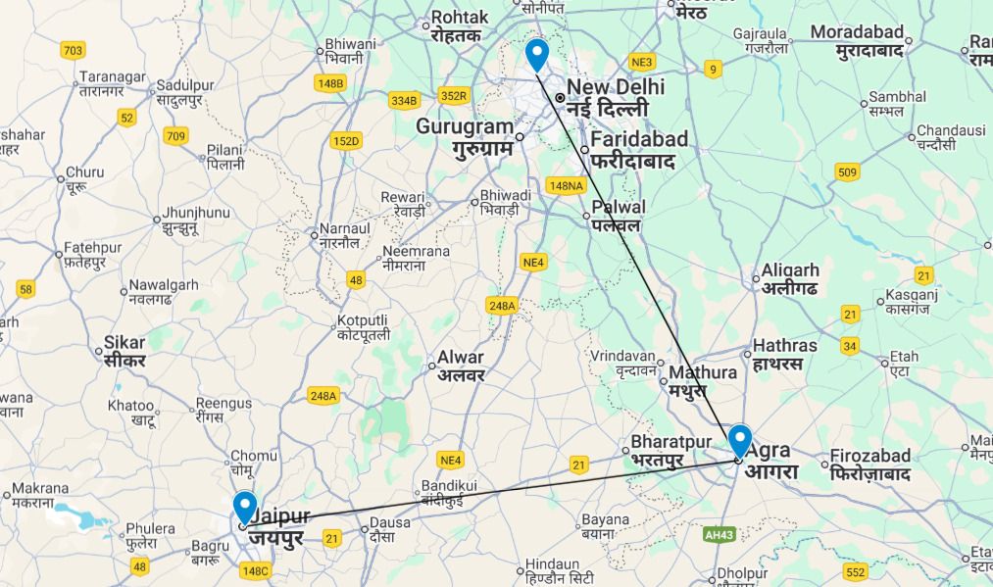
The Golden Triangle Tour
This is the classic cultural tour of North India combining New Delhi, Agra and Jaipur (the so-called ‘Golden Triangle’)
New Delhi, the national capital, offers several key sights and historic monuments while Agra is synonymous with the Taj Mahal – a high-point of Mughal architecture and one of the world’s most celebrated buildings. Rajasthan’s state capital, boasts some of the region’s finest palaces and impressive forts along with an eclectic array of crafts and shopping.

Introduction

Accommodation | Destination | Start | End | Meal Plan | Room Type | Duration
The Lalit New Delhi | New Delhi | Day 01 | Day 02 | BB | Deluxe Room | 01 Night
Courtyard Marriott | Agra | Day 02 | Day 03 | BB | Deluxe Room | 01 Night
Hilton Jaipur | Jaipur | Day 03 | Day 05 | BB | Guest Room | 02 Nights

Day 01: Arrival Delhi

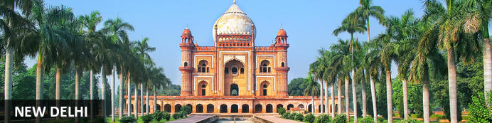
New Delhi, India’s national capital, is a relatively modern confection of imposing government buildings including Parliament, museums and wide leafy boulevards loosely centred on circular Connaught Place (officially now called Rajiv Chowk). To its north lies the formerly walled city of Old Delhi, or Shahjahanabad, built in the 17th-century by the Mughal Emperor Shah Jahan. Though long merged into one metropolis, the two have very different characters. New Delhi has space, parks, distinct neighbourhoods and a clutch of important monuments and architecture that reflect its ancient history. Old Delhi’s crowded streets, lanes and bazaars reflect its colourful medieval character and they cradle some of the city’s most memorable sights.

Day Itinerary
Flight TBA
Arrives Delhi TBA
On arrival in Delhi: Having cleared immigration, collected your luggage and passed through customs, please make your way towards the exit of the terminal building where you will see a bank of people waiting. Amongst them will be Travel Counsellors Representative who will be waiting to greet you with a paging board with your name on.
You will then be transferred to your hotel and assisted with check in. Standard check in time – 1400 Hrs.
Later proceed for Zero Point Delhi Tour
Get a closer look at the city through tales of love, deceit, mysticism, horror and even politics from the time when Delhi’s rise to glory had just begun!
USP - Explore the first city of Delhi all lit up and beautiful in the evening!
Walk through the picturesque locales of the first recorded district of Delhi! You will see insignias of architecture that dot the area of Mehrauli and hear stories in stone that have been laid here for centuries.
We’ll start with a lesser-known location and speak about the first rulers. As you hear tales of Hindu, Turk, Mongol and Afghani kings, you will stumble upon a mosque that is often visited by Djinns (thought to be angels in Islamic culture, that can take human or animal forms). We’ll wander through rose gardens and find ourselves in a tomb which was once a part of a British Mansion complete with a boat house. We’ll pass through and talk about step wells, tombs, graves and burials that dot this beautiful historic precinct.
Further ahead, we will enter the Qutub complex: a must-do in any Delhi itinerary and home to the famous Indian minaret – the Qutub Minar. As you hear about the minaret’s history and gape at its stunning architecture, we’d have timed your entry perfectly to see this stunner light up.
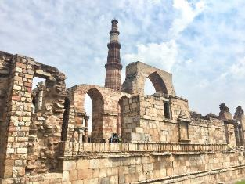
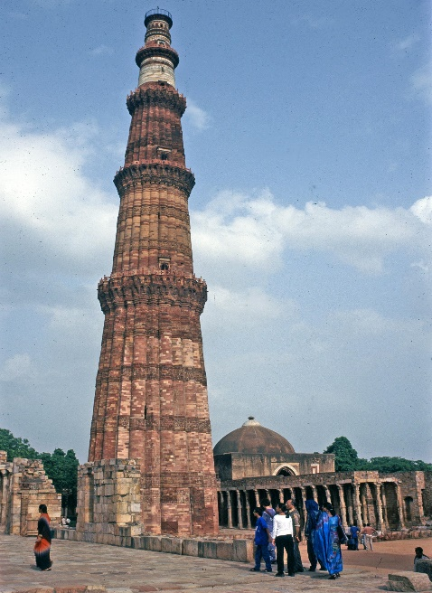
After which, we’ll walk through the beautiful lit-up complex and enter old temple ruins which surprisingly is also the venue of Delhi’s first mosque. Built by the erstwhile slave dynasty, this mosque and its complex is a mix of Hindu and Islamic architecture. The complex is a treasure trove of artefacts, stories and folklore, and we will discover it one monument at a time.

Overnight: The LaLiT New Delhi
Offering five-star accommodation, The LaLiT New Delhi is located in Connaught Place, India. The hotel boasts 461 luxury rooms and suites with conveniences such as minibars/fridges, electronic safes, TVs, interactive entertainment systems and free Wi-Fi. Guests can delight their palates at an array of on-site restaurants. The hotel also features a spa, an art gallery, a state-of-the-art gym and a swimming pool.
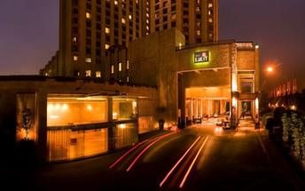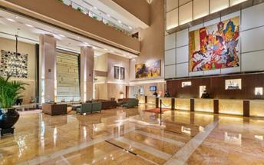

Day 02: Delhi - Agra

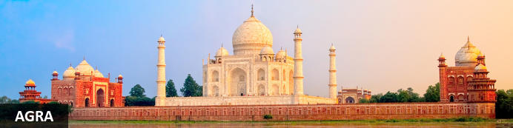
Straddling the broad Yamuna River 180km south of Delhi, Agra’s fame rests almost entirely on one building – the iconic Taj Mahal. Yet from the early 16th-century it was the Mughal empire’s capital endowed with numerous buildings and monuments that still make it a major draw for visitors. Apart from the Taj, Agra Fort (with its strong resemblance to Delhi’s Red Fort), the exquisite Tomb of Itmad-ud-Dalah (often called the ‘Baby Taj’), earthy bazaars and the evocative ‘ghost city’ of Fatehpur Sikri 40km to the west all make it a key tourist destination.

Day Itinerary
Early morning in time you will be picked up and transferred to railway station, board train to Agra. Packed breakfast can be collected from the hotel on departure.

Train Gatimaan Express (AC Executive Chair Car)
Depart Delhi 0810 Hrs
Arrive Agra 0950 Hrs.

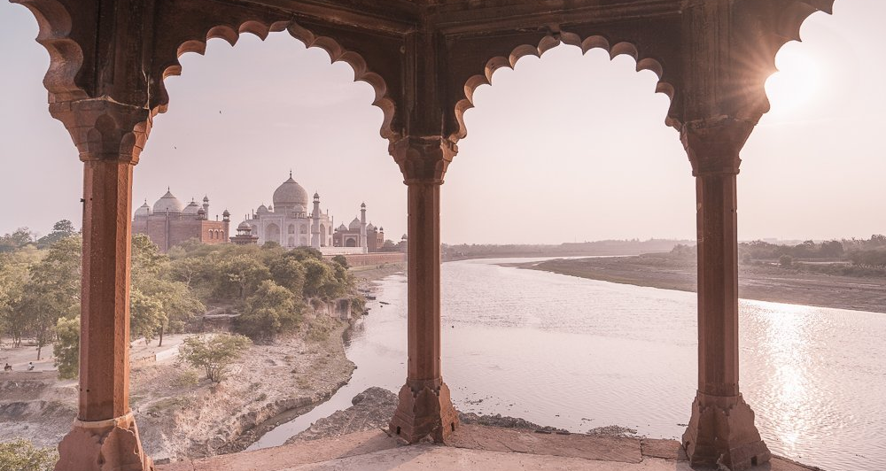
Upon arrival proceed for sightseeing tour of Agra, starting with the splendid Agra Fort built in red sandstone, encapsulating magnificent palaces, halls of public, private audience & beautiful gardens and hundreds of rooms within the Fortified Fort. The worth seeing point of this place from where the Taj Mahal can be seen is the Diwan-I-Khas.
After visit you will be transferred to your hotel for check in (standard check-in time is 1400 hrs).
A trip to Agra is incomplete without experiencing dazzling path beyond the Taj Mahal; A transformative walk tour that goes further than the iconic Taj Mahal and dives into the enticing soul of Agra’s Taj Ganj. A crowded street that holds and narrates the fascinating tales of Agra’s unfolded heritage. Our passionate guides led this tour wanders through the streets of undiscovered places and underrated monuments, giving you an extensive glance of Taj Mahal.
Engage in this unique adventure and go beyond the Taj Walk, fostering healthy interaction with locals and navigating lively streets, experiencing stories of traditions that breathe the Agra City enchantment.

Overnight: Courtyard Agra
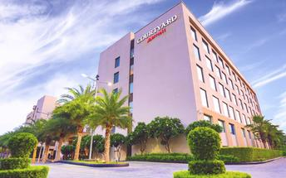

Courtyard Agra is located on Fatehabad Road, close to iconic landmarks such as the Taj Mahal and Agra Fort. The hotel offers comfortable rooms with air-conditioning, minibars, and free Wi-Fi. Guests can enjoy dining at MoMo Café, which serves international buffet options and à la carte dishes, or relax at the poolside restaurant, Grills by the Pool. Leisure facilities include an outdoor pool, a spa, and a fitness centre. The hotel also features versatile event venues suitable for business functions and weddings.

Day 03: Agra - Jaipur

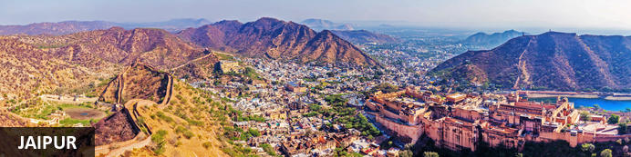
Founded in the early 1700s by Maharaja Jai Singh II as his new capital, the original ‘Pink City’ (so-called because almost all buildings were painted terracotta pink to honour the 1876 visit of the future King Edward VII) was laid out in a traditional grid with colonnaded streets and uniform façades. That layout remains intact and the city, now state capital of Rajasthan, has evolved and expanded into a modern metropolis with its own metro system. Yet its key sights and attractions lie within a relatively compact area.

Day Itinerary
Early this morning witnesses the surreal views of the Taj Mahal. Step inside this eternal symbol of love and appreciate the intricate designs and symmetries that rhyme as a poem written in marble. Taj Mahal is an extravagant display of love, built by Shah Jahan in memory of his beloved wife Mumtaz.

Then return to your hotel, spend some time on relaxing and after breakfast check-out and, you'll make your way to Jaipur – land of the Rajput’s, also is known as the 'Pink City', home to ancient forts and palaces. (Approximately 180 Kms – 4 Hrs)

En Route make a short stop to visit The Chand Baori “Abhaneri” Small village of Rajasthan, which is one of the largest Step well in the world and one of the most beautiful ones.

Upon arrival Jaipur, you will check-in to your hotel.

Overnight: Hilton Jaipur
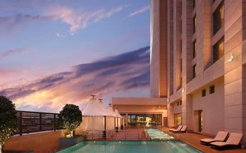
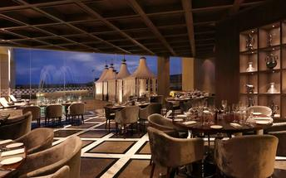
Hilton Jaipur is ideally located on the outskirts of Jaipur, just 1km from Ram Nagar metro stop and 11km from Jaipur International Airport. The accommodation features comfortable guest rooms and suites equipped with modern amenities including coffee makers, LCD TVs, hairdryers, air conditioning, desks and Wi-Fi. Guests can enjoy dining at the on-site restaurant and bar. Leisure facilities include a swimming pool, fitness centre and spa.

Day 04: Jaipur

Day Itinerary
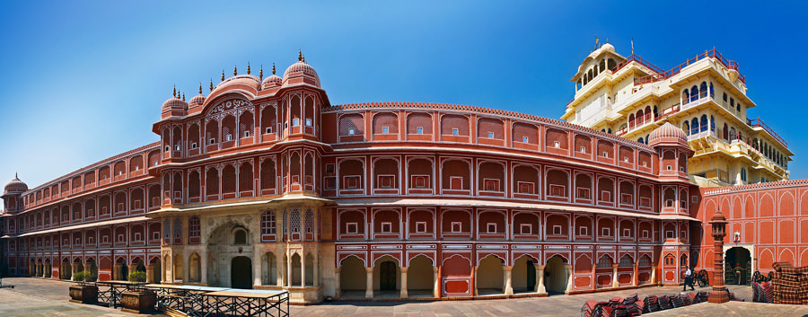
Begin exploring this city visit the City Palace complex which is spread over a large area occupying one-seventh of the old city of Jaipur .It is comprised of two palaces, Chandra Mahal and Mubarak Mahal, museum, a vast array of courtyards, gardens, and buildings. The palace is a blend of the Shilpa Shastra of Indian architecture with Rajput, Mughal, and European styles. Diwan-I-Aam (Hall of Public Audience), Bhaggi Khana (a museum), Pitam Niwas Gate, and Peacock Gate are a must-see. Its outer boundary was built by Raja Jai Singh and the other structures by his successors to add charm to it. It also served as a residence for the former Maharaja of Jaipur, also visit the famous Jantar Mantar (an observatory)
Thereafter, head for a walking tour in the bazaars, this immersive experience offers a unique opportunity to explore the city’s vibrant bazaars, renowned for their exquisite textiles, distinctive artisanal goods, and delectable street food. A specially curated selection of Jaipur’s vibrant textile market and street delicacies, each reflecting the region’s rich culinary and cultural heritage, awaits your discovery.

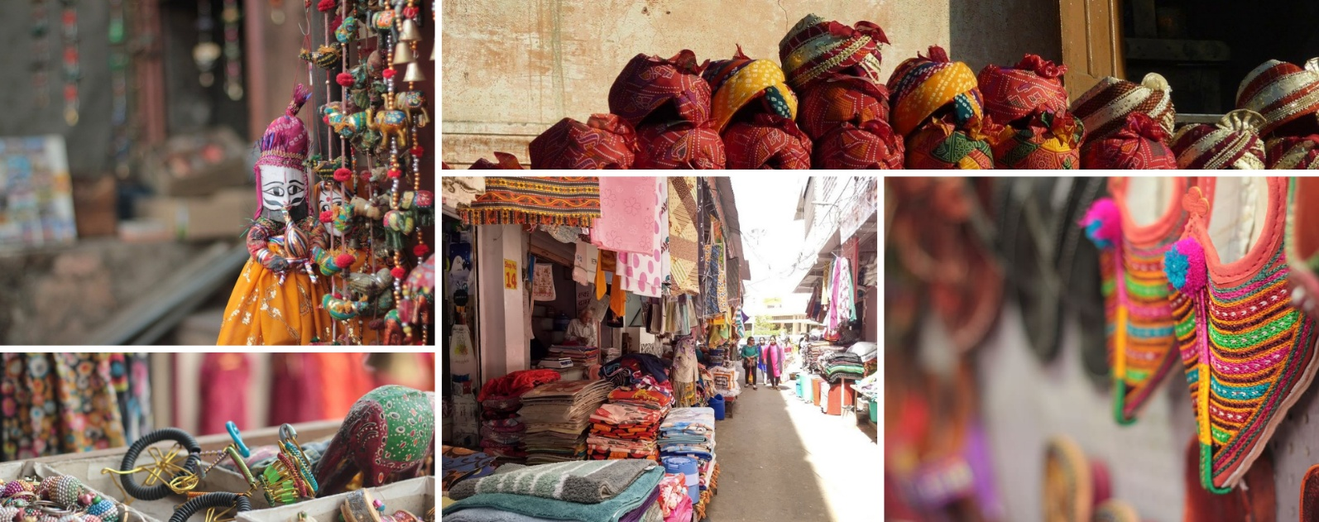
The textile market, in particular, stands as a testament to Jaipur’s centuries-old tradition of craftsmanship, where intricate patterns, vivid colours, and fine fabrics come together to embody the artistic soul of the Pink City.

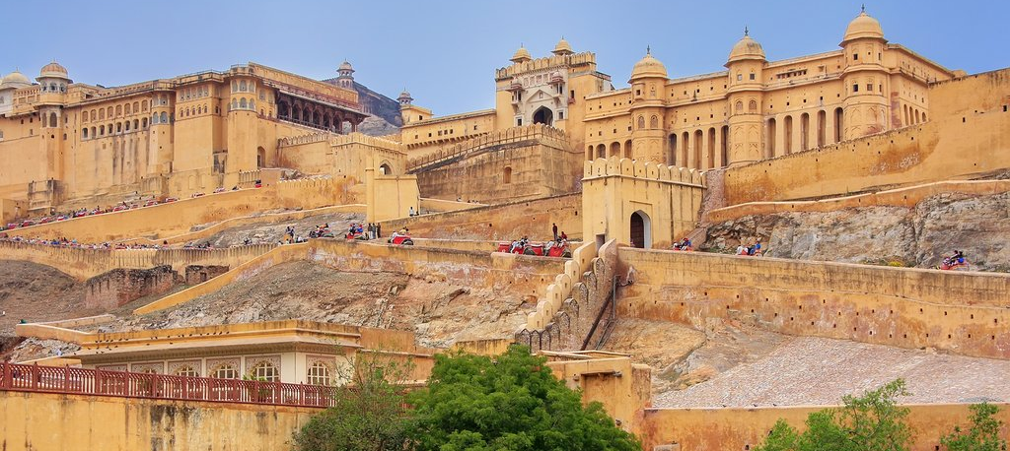
Later in the evening proceed for the majestic Amber Fort that’s perched on a hill on the outskirts of Jaipur. The fort was once the capital of Rajasthan. Former residence of Rajput Maharajas, this fort is notable for its grand architecture showcasing the Hindu style of architecture. The Amber Fort was used by the Rajputs for the dual purpose of defence and for private residence. The fort encompasses charming gardens and magnificent palaces made from marble and precious stones, richly decorated with intricate stonemason works and paintings.

The rest of the day is free for personal activities.

Day 05: Jaipur – OUT

Day Itinerary
After breakfast, You will be transferred to Jaipur Airport to connect flight for onward destination (the recommended check-in time is 3 hours prior to the flight).

