

Highlights of Kerala
Kochi - Munnar - Thekkady - Kumarakom - Alappuzha - Mararikulam
12 Days / 11 Nights

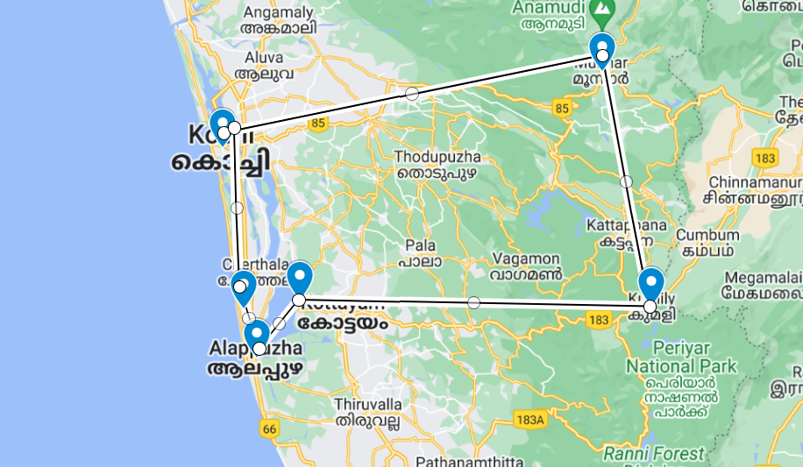

Tucked away on India’s south-western coast, Kerala is one of the country’s scenic and cultural gems: lush tropical beaches and landscapes threaded by coastal lagoons and waterways while inland the Western Ghats offer picturesque undulating hills dotted with spice plantations.
Cochin, the state’s largest city, has expanded well beyond the original settlement of Fort Kochi which retains its cosy heritage atmosphere and sights. Up in the Western Ghats, Munnar is one of South India’s eminent hill stations with numerous tea plantations while Periyar National Park’s forested hills and montane grasslands cradle some of the region’s highest peaks and are home to tigers and elephants along with thriving spice plantations. Overlooking Vembanad Lake, Kumarakom’s resorts offer fine food, yoga and ayurvedic treatments while charming houseboats ply the so-called ‘backwaters’, or inland lagoons. For relaxing beach downtime, Mararikulam is a notably untouched fishing village with fine golden sands and relaxing low-key atmosphere.

Introduction

Start | Accommodation | Destination | Room Type | Duration
Day 1 | Fragrant Nature Kochi | Kochi | Duke's Chamber | 2 Nights
Day 3 | The Tall Trees Munnar | Munnar | Cinnamon Cottage | 2 Nights
Day 5 | Cardamom County | Thekkady | Periyar Cottage | 1 Night
Day 6 | Rhythm Kumarakom | Kumarakom | Lakeview Premium Terrace | 2 Nights
Day 8 | Houseboat | Alappuzha | 01 Bedroom | 1 Night
Day 9 | Xandari Pearl | Mararikulam | Green Pearl Villa | 3 Nights

Day 1: Arrive Kochi

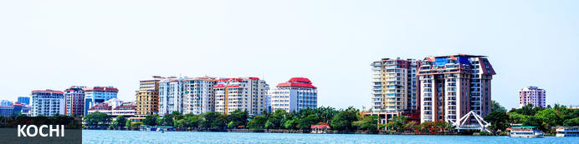
Also known as Cochin, Kochi is a city in southwest India's coastal Kerala state. This attractive city has served as a popular port for over 600 years and is known for its eclectic architecture and its array of religious monuments, museums, galleries, cafes and antique shops. The city stretches across a number of peninsulas and islands, which can be reached by a network of water taxis and bridges. The majority of Kochi’s visitor highlights can be found on the peninsula of Fort Kochi. These highlights include the St Francis Church, the oldest European-built church in India; and Mattancherry Palace, which dates back to 1557 and contains some exceptional Kerala murals and temple art. Other must-see attractions include the Kerala Folklore Museum, displaying more than 4,000 cultural and ethnic artifacts; and the 16th-century Jewish Synagogue; and the vibrant local market.

Day Itinerary
Flight TBA
Arrives Kochi TBA Hrs.
On arrival you would be met and transferred to the hotel for check in. Standard check in time is 1400 Hrs.
Rest of the day is free to relax or explore the Fort Kochi area

Overnight: Fragrant Nature Kochi
Fragrant Nature Kochi is within walking distance of Mattancherry Palace. Jawaharlal Nehru Stadium Kochi is only a short car ride from the hotel. Boasting a swimming pool, it also features 24-hour room service, valet parking and an executive floor. There are 41 rooms at Fragrant Nature Kochi, each offering all the necessities to ensure a comfortable stay. On-site dining options include a restaurant, which is a convenient place to have a meal. In the evening, guests are able to wind down in the comfortable lounge bar.
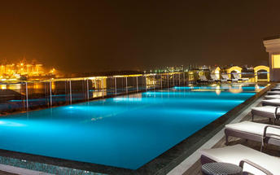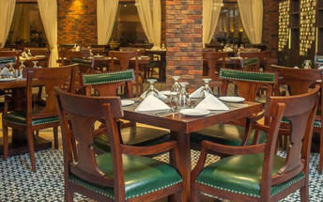

Day 2: Kochi

Day Itinerary
After breakfast, you will be driven to your hotel in Fort Kochi (approx. 2 to 2.5 hrs).
On arrival, check in at the hotel or if rooms are not ready as the check-in time is 2 pm, you may proceed for the sightseeing tour of Kochi visiting the beautiful churches, Jewish synagogue, Dutch Palace, the markets and try your luck with the locals to get the fresh catch on the Chinese fishing nets.
Fort Kochi
Fort Kochi takes its name from a long-gone fort which was built during its occupation by the Portuguese. The Portuguese were followed by the Dutch, who left their own legacy, and hot on their heels came the British with their own unique ways. Independent now for many years, Fort Kochi remains a colourful melting pot of diversity, retaining its colourful history in its architecture and culture.
Jew Town
Jew Town is located in Mattancherry in the southern Indian city of Kochi. The history of Jew Town dates back to 1492 when a group of Sephardic Jews came to Kochi after being expelled from the Iberian Peninsula. In 1524 more Jews faced persecution and were granted refuge by the Raja of Cochin who granted them land near his own palace. In 1568 the Paradesi Synagogue, which still functions today and is the oldest in India, was built, and the Jew Town neighbourhood developed around it.
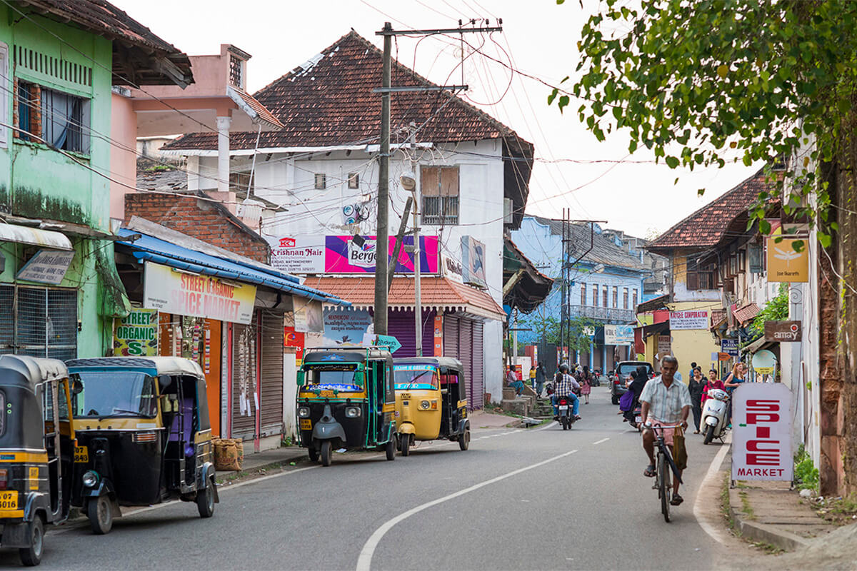
Jewish Synagogue (Closed on Fridays afternoon and Saturdays Full day)
Stepping inside the Synagogue, one's eyes would easily go to the glass chandeliers and blue willow-patterned Chinese floor tiles. The chandeliers are of Belgian origin. Also of interest are the Scrolls of the Law housed here and the several gold crowns received as gifts and the brass-railed pulpit. And for some exclusive pieces from history, the synagogue also houses the copper plates of privileges given to Joseph Rabban, the earliest known Cochin Jew, dating from the 10th century, written in Tamil, by the ruler of the Malabar Coast.
Dutch Palace (Closed on Fridays)
The Dutch Palace is a beautiful palace that was originally built by the Portuguese. It was only during the 17th century that the Dutch took it over, modified it and then presented it to the Raja of Kochi. The main attractions here are the outstanding collection of mural paintings found inside. These murals beautifully depict scenes from the Hindu epics of Mahabharatha and Ramayana.
St Francis Church
St. Francis Church is located in Kochi (previously called Cochin). It is one of the ancient European churches in the country and is a marvelous specimen of Portuguese architecture in the country. It is a mark of the colonial struggle of the Europeans to make their presence felt in India at that time. This church, built in 1503 by Portuguese traders, was where Vasco da Gama was buried when he died in 1524 AD. However, fourteen years later, his remains were shifted to Lisbon. Earlier, the church was named after Santo Antonio which was changed by Anglican Communion after the name of patron Saint Francis. It is now considered integral to the history and tourism of Kochi. In April 1923, this church became a protected monument under the Protected Monuments Act of 1904. In 1920, the Cenotaph was set up in the memory of the inhabitants of Kochi who died in the World War-I. Apart from all this, one interesting fact to observe is that, despite being very modest in its architecture, the model of this church has been followed by many churches India.
Chinese Fishing Nets
Chinese fishing nets are a type of stationary lift net in India. They are fishing nets that are fixed land installations for fishing. While commonly known as "Chinese fishing nets" in India, the more formal name for such nets is "shore operated lift nets".
In the evening Enjoy Kathakali Dance Drama in a local theatre.
Kathakali
Kathakali is a highly stylized classical kerala dance performance noted for its attractive make-up of characters, their elaborate costumes, detailed gestures and well-defined body movements presented in tune with the anchor playback music and complementary percussion. Kathakali is said to have evolved from other performing arts like Kootiyattam (a classical Sanskrit drama existing in Kerala), Krishnanattam and Kalarippayattu. Kathakali explicates ideas and stories from the Indian epics and Puranas.
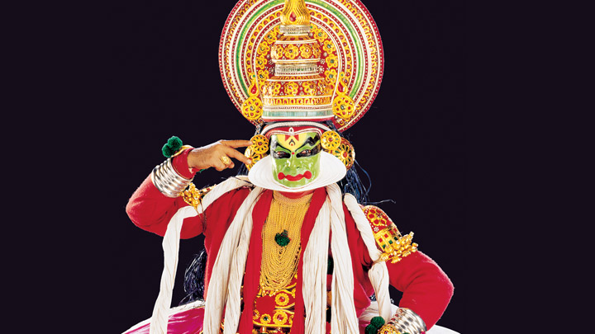

Day 3: Kochi - Munnar

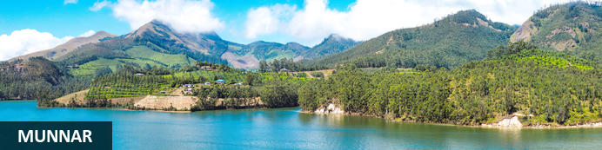
Idyllically set at the confluence of three mountain streams, Munnar is a beautiful hill station in the Western Ghats mountain range in India’s Kerala state. The village once served as a popular vacation resort for the British Raj elite who flocked to here to enjoy the pleasant cool climate and the scenic natural surroundings characterised by rolling hills dotted with colonial bungalows, streams, waterfalls and 19th-century tea plantations. The main attraction in the area is the extraordinary Eravikulam National Park, which is famous for its diverse array of wildlife including the endangered mountain goat known as Nilgiri tahr. The park is also home to the exquisite Lakkam Waterfalls, some excellent hiking trails, and the impressive 2,695 metre-highl Anamudi Peak.

Day Itinerary
Breakfast is at the hotel
After breakfast you would be driven to Munnar [Approx 126 Kms: 04 Hrs].
On arrival check in at hotel
Afternoon is at leisure.

Overnight: The Tall Trees Munnar
Not far away from the most sought-after wild-life sanctuaries of South India and close to one of the most popular hill stations on the Western Ghats, the Tall Trees Resorts nestles on a verdant slope among misty mountains and evergreen forests. It is a unique property of 66 acres that has successfully preserved the pristine nature without any change to the delicate ecologic equilibrium, even though all the modern creature comforts are tastefully arranged in each of the well appointed cottages nestling among the greenery. The property has hundreds of old and tall trees overshadowing the resort landscape covered with stretches of preserved wilderness, carefully nurtured cardamom plantations, gurgling streams, rocky formations, wet and green with moss and lichens and the numerous orchids and wild plants covering the tree barks and rocks. The highly endemic species of birds, butterflies, moths, small and harmless wild animals and several varieties of wild flowers all cohabit and make this piece of nature a reflection of the Garden of Eden.The whole air is suffused with the honeymoon ambience with all the privacy and security that you have ever dreamed of. The sound of birds singing, humming of the bumble bees and chirping of the crickets, the rustle of leaves and the swishing of branches as the perennial breeze plays with them, the gurgling sound of the stream, all add to the 'honeymoon in the lap of nature' ambience. The shady trees, the flower-bedecked bushes and vines, the aroma of exotic flora and the colourful butterflies add to the enchanting aura.
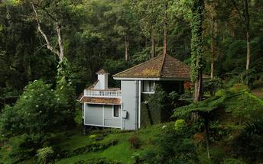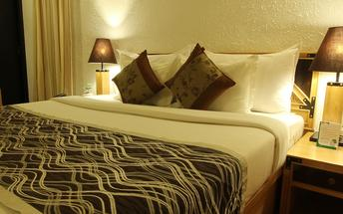

Day 4: Munnar

Day Itinerary
Breakfast is at the hotel
After breakfast you would be taken for half day sightseeing tour of Munnar
Activities
Tea Museum and Tea Factory

Lockhart Factory
Lockhart Tea Factory is the hometown of various artifacts created in the terms of ancient cultural, historical, and artistic works. It is one such place which nurture their customers by providing historical voyage about the first plantations of Munnar which was started during 1879. The Factory here was constructed in 1936 that means before Independence Day. This living Factory gives a handful of knowledge about orthodox tea processing and the operations that go into the making of black tea, green tea, and white tea in traditional ways still. Lockhart Tea factory contains various olden equipment used in the plantation like Shears, Mechanical Harvesting Machine, Drake and Fletcher Sprayer etc.

Tea Museum (Closed on Mondays)
Tata Tea Museum is a popular tourist spot situated in Munnar of Kerala. It is situated at a distance of about 12 km from the resort. This tea museum is first of its kind in India. It is located at KDHP’s Nullatanni estate in Munnar. The aim of this museum according to its founders is to showcase the growth of more-than-a-century-old tea plantations in this region. Anyone visiting this museum will get a clear picture of how laborious this tea processing really is.

Day 5: Munnar - Thekkady

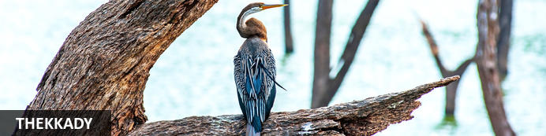
A tourist attraction in Kerala, Thekkady is a district located at the Periyar National Park. Thekkady comprises evergreen forests and savanna grasslands and is known for its natural spices such as black pepper, cardamom, cinnamon, nutmeg, ginger and clove. Elephants, tigers, sambar and many other species inhabit the park. Top attractions include the exquisite ancient Mangla Devi Temple, the aromatic Abraham’s spice garden, and the massive waterfall at the sleepy, picturesque village of Chellarkovil. Take in panoramic views of the extraordinary landscape from the Chellarkovil viewpoint, and picnic on the rolling, lush green lawns at Pandikuzhi. Don’t miss the opportunity to visit the Kadathanadan Kalari Centre, to see demonstrations of the best traditional martial arts. Thekaddy also has a rich living tribal culture.

Day Itinerary
Breakfast is at the hotel.
After breakfast you would be driven to Thekkady [Approx 92 Kms : 03 Hrs]
On arrival you would check in at hotel.
Afternoon you would be taken for Spice Plantation tour.

Activities
Spice Plantation

Spice Plantation
There are many factors that make the plantation experience a memorable one. For some, it could be the unassuming beauty of the tiny flowers of the cardamom that grow at the base of the plant; for others, the tantalising aroma of cinnamon or cloves, and for some others, the cool breeze that lovingly strokes the green plantations and everything in it. Apart from being enjoyable, these plantation tours give tourists an insight into the growing, harvesting and processing of spices. The peeling and drying of cinnamon, and the painstaking task of hand-pollination of vanilla can be observed on such trips.
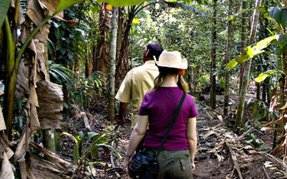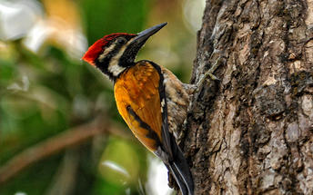

Overnight: Cardamom County
Muthoot Cardamom County sits between the Periyar National Park and Tiger Reserve and its lush highland forest and wetlands ecosystem and a spice-trading community of hill stations. It is within walking distance from both the entry to the Periyar and the village. The rooms and cottages all provide expansive views of the reserve. The resort has a wellness centre, Ayura Spa, offering therapies and yoga sessions. Cardamom County organizes carbon-neutral activities such as nature walks, jungle patrols, border hiking, bamboo rafting, tribal heritage visits and Periyar tiger trails, bullock cart rides and visits to the elephant park. Other activities hosted by the resort that are not entirely carbon-neutral include full day Jeep safaris, plantation tours and visits to Gavi and Grampi.
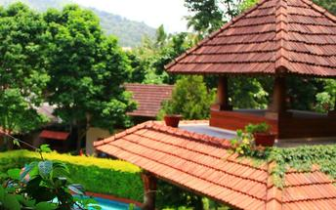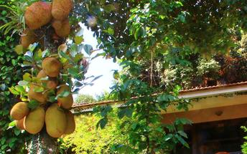

Day 6: Thekkady - Kumarakom

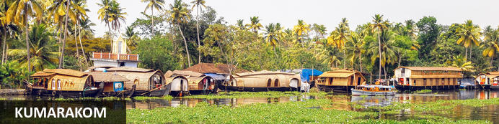
One of Kerala’s most alluring towns is Kumarakom, a hub of biodiversity where mangrove forests are mixed in with rice paddies, coconut palms, and bursts of white lilies. This vivid subtropical peninsula juts into Vembanad Lake and is a popular place to study yoga, meditation, and Ayurvedic massage, and from which to take bird-watching, boating, and fishing trips. Nearby attractions include the Aruvikkuzhi Waterfalls, just two kilometres from Kumarakoram, which cascade down the mountain slopes from roughly 30 metres above, and Pathiramanal (meaning ‘sands of midnight’) a beguiling island and bird sanctuary in the middle of the lake.

Day Itinerary
Early morning you would be taken for a Nature Walk

Activities
Thekkady Periyar Nature Walk

Thekkady Periyar Nature Walk
There are several nature trails along Thekkady Periyar Nature Walk. Most of the trails are generally four-to-five-kilometres long and takes roughly two and a half hours to complete the trails, starting at the Periyar Lake. Nature enthusiasts can enjoy the breathtaking sights and sounds of the forest from birds to butterflies, wildlife, and wildflowers.
Return to the hotel for breakfast.
After breakfast you would be driven to Kumarakom [ Approx. 122 Kms : 04 Hrs]
On arrival you will check in at your hotel.

Overnight: Rhythm Resorts and Spa
Rhythm Kumarakom formerly Aveda is the newest boutique luxury resort in the picturesque and naturally endowed lake Vembanad area, the famous backwaters of Kerala. The resort is designed to relax and rejuvenate soul, body and mind. Enjoy the solitude and immense natural beauty that will simply delight you and connect you to the nature and God. An untouched, rustic and timeless beauty surrounds the resort. Watch the slowly changing scenery pass you by. A perfect setting for a relaxing holiday with endless memories etched on your soul. Luxury residences in Rhythm Kumarakom include lakefront and lakeview villas with private plunge pool, luxury cottages, suites and rooms as well as the largest infinity swimming pool in Kerala. The resort offers an open poolside restaurant cum lounge named Vembanad . Enjoy some delicacies at Rhythm Kumarakom's indoor & outdoor dining outlet, Hummingbird. Considered as the best restaurant in Kumarakom, the restaurant sits on a lawn overlooking the outdoor space
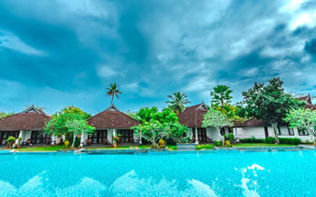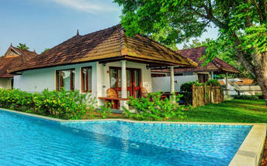

Day 7: Kumarakom

Day Itinerary
Breakfast is at the hotel.
After breakfast you will be at leisure.

Overnight: Rhythm Resorts and Spa

Day 8: Kumarakom - Alappuzha

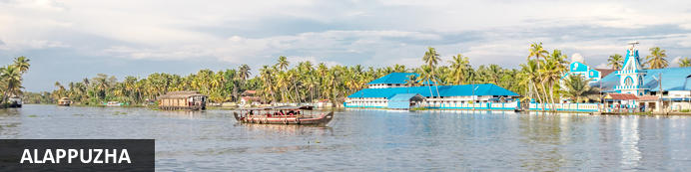
Located in the Indian state of Kerala, the bustling city of Alappuzha, also known as Alleppey, is set along the coast of the beautiful Laccadive Sea. Dubbed the ‘Venice of the East’, it is renowned for its sublime houseboat cruises which float along the tranquil canals of Kerala. Alappuzha is also said to be one of the most beloved tourist centres in the state. While cruising the palm-shaded canals is the most popular thing to do, visitors can also enjoy visiting Alappuzha’s beautiful beaches, exploring the little riverside villages dotting the lush countryside and discovering an array of resplendent temples. Don’t miss the annual Nehru Trophy Boat Race held at Punnamada Lake.

Day Itinerary
Breakfast is at the hotel.
After breakfast you would embark the houseboat for backwater cruise.

Overnight: Deluxe AC Houseboat
The Kerala houseboats takes tourists on a cruise along the emerald waterways. Modified to meet a novel concept of holidaying, the kettuvalloms (houseboats) are comfortably furnished with an open lounge, one or two bath attached bedrooms and a kitchenette, and are extremely eco-friendly, merging smoothly into the panorama. Every houseboat is manned by a crew of 3 men, usually a cook, guide and oarsman

Day 9: Alappuzha - Mararikulam

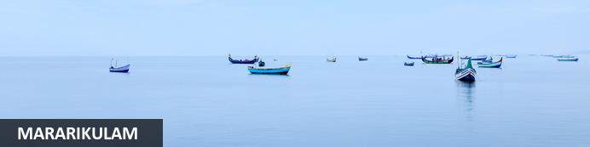
Situated only 40 km from the city of Cochin, in the Alappuzha district of Kerala, Mararikulam is a charming little coastal village known for its pristine sand beaches, swinging coconut palms, and quiet, laidback atmosphere. The village has managed to avoid the mass development associated with many of the other beach towns in the area resulting in an untouched natural environment dotted with only a handful of small resorts. The main attraction here is the exquisite Marari beach where you will find fishermen heading out daily to explore the Malabar coast, much as their ancestors have done for generations.

Day Itinerary
After breakfast you would disembark the houseboat and would be driven to Mararikulam [Approx 30 Kms :45 Mins]
On arrival you will check in at your hotel.

Overnight: Xandari Pearl
The Xandari Pearl is an 18 acre coastal estate that has 20 villas designed for privacy and relaxation. Each villa has a large private garden, hammocks, outdoor shower and a private dining area. Featured at the Xandari Pearl is an all-day dining restaurant serving meals prepared with organic produce grown within the resort. The beach is a 200 metre walk from the restaurant. Other resort amenities include a swimming pool and a spa.
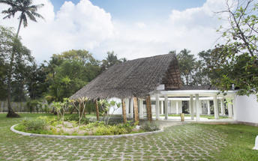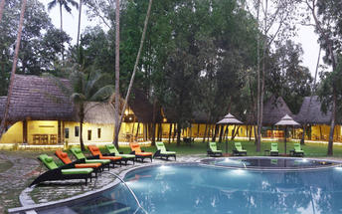

Day 10: Mararikulam

Day Itinerary
Breakfast at the hotel.
After breakfast you will be at leisure to relax on the beach.

Day 11: Mararikulam

Day Itinerary
Breakfast at the hotel.
After breakfast you will be at leisure to relax on the beach.

Day 12: Mararikulam – Depart Kochi

Day Itinerary
Breakfast is at the hotel.
Standard check out time is 1200 Hrs.
After breakfast you would be transferred to Kochi airport for onward flight [72 Kms: 02 Hrs]
Flight TBA
Depart Kochi TBA Hrs
**** END OF SERVICES ****
The distances and time taken for the travel is approximation only this will differ based on the traffic conditions and other unforeseen circumstances.

