

Maharaja Express
New Delhi
5 Days / 4 Nights
Date of Issue: 16 June 2025

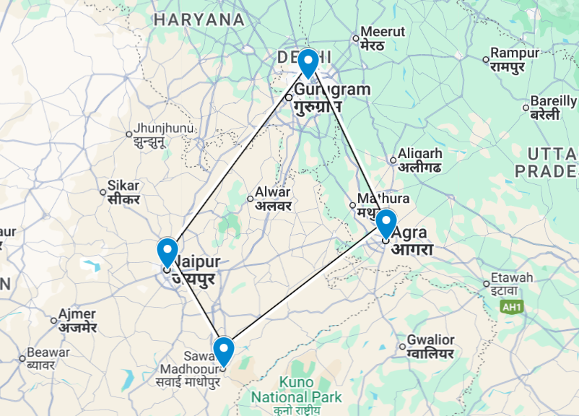

Introduction

Start | Accommodation | Room Type | Duration
Day 1 | The Imperial | Heritage room | 1 Night
Day 2 | Maharajas' Express | Deluxe Cabin | 3 Nights

Day 1: Arrive New Delhi

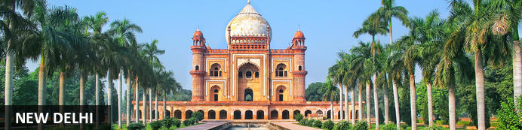
India’s capital, New Delhi, lies on the Indo-Gangetic Plain, within the National Capital Territory of Delhi. Made up of the ancient walled city of Old Delhi and the more modern sector, New Delhi, the city encompasses a staggering array of beautiful buildings, including three UNESCO World Heritage Sites – the grand, sandstone Red Fort, striking Qutab Minar, and fascinating Humayun's Tomb. Architecture enthusiasts will delight in the iconic Lotus Temple. Hear ‘qawwalis’ (devotional music) at the dargah (tomb) of the Sufi saint Nizam-ud-din Auliya; or wander through the 17th century Chandni Chowk marketplace – still one of the city’s most popular retail centres today, famous for its traditional jewellery and saris. The gorgeous Sunder Nursery and Lodi Garden provide calm, flower-filled oases for picnicking.

Day Itinerary
Today your flight arrives in Delhi.

Flight TBA
Arrives TBA Hrs

On arrival Delhi you will be met and transferred to the hotel for check in (standard check-in time is 1400 hrs).

Afternoon Past, Present and Parallel tour.

Uncover hidden gems, experience rewarding craft workshops, find solace in spirituality, and witness the intriguing contrast between the past and present juxtaposed perfectly together in what became Delhi’s last city and the capital of independent India.

Join this journey through the heart of Delhi, where history, culture, and architecture converge to create an unforgettable experience. Delhi, with its rich archaeological heritage and diverse cultural tapestry, is a testament to the legacy of kingdoms that once ruled over the city, nurturing it into a melting pot of cultures.

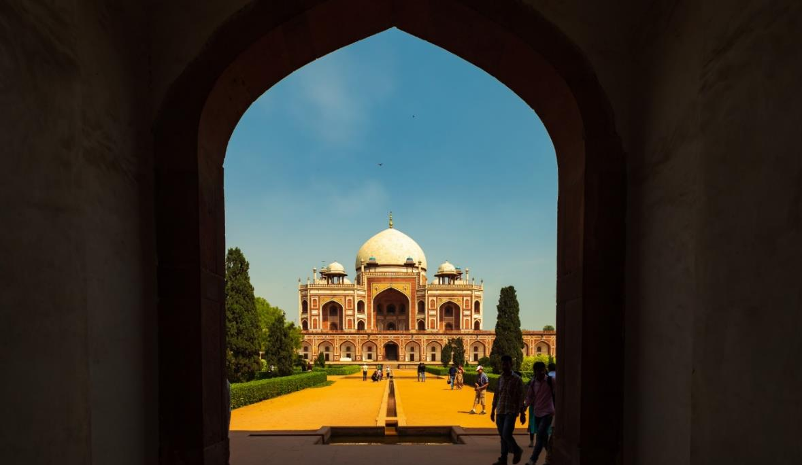
Begin your tour with a visit to Humayun's Tomb, a magnificent example of Mughal architecture and the precursor to the iconic Taj Mahal. Explore the spellbinding mausoleum, revered by Dilliwalas for its unparalleled beauty and historical significance.

Afterwards, engage in a unique workshop organized by an all-women NGO group, drawing inspiration from the monument you just visited. Delve into the artistic process and create a meaningful keepsake that will leave a lasting impression on your heart.

Continue your journey to the serene oasis of Bangla Sahib Gurudwara, where the melodic strains of Gurbani fill the air, offering solace and reflection amidst the bustling cityscape. Immerse yourself in the tranquil ambience of the Gurudwara, appreciating the syncretism and spirituality it embodies.

Marvel at the architectural contrast between the Mughal and British colonial structures that define the cityscape. Gain insights into the British vision for their new capital and the enduring legacy of colonial architecture in Delhi.

Conclude your tour with a newfound appreciation for the multifaceted beauty of Delhi, leaving with memories that encapsulate the essence of Dilliwalas' love for their city.

Overnight: The Imperial
The Imperial is a luxury hotel located in New Delhi, India. The hotel is near to several points of interests such as Jantar Mantar, the National Philatelic Museum and the Sri Bangla Sahib Gurudwara. Away from the city's hustle and bustle, the hotel is an oasis of calm and comfort, offering guests a peaceful atmosphere. The accommodation is both elegant and spacious, with rooms and suites fitted with modern amenities such as a minibar, Wi-Fi and a bathroom. Guests may enjoy an array of delicious meals at any of the on-site restaurants and refreshing drinks at any of the hotel's bars. Leisure facilities include a spa and salon with massage and beauty treatments.
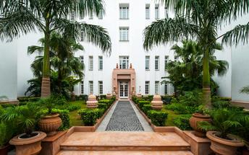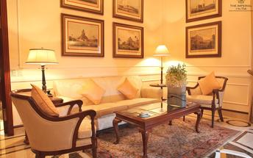

Day 2: Maharajas' Express

Day Itinerary
Breakfast is at the hotel.
After breakfast transfer to the Safdurjung railway station to board the train
- 09:00 Welcome and check-in at Delhi Safdurjung Railway Station
- 09:15 Breakfast on-board
- 10:35 Maharajas’ Express proceeds to Agra
- 12:00 Tour Briefing on-board
- 13:30 Lunch on-board
- 15:00 Train Arrives into Agra & proceed to visit the Taj Mahal
- 18:30 Return to the comforts of Maharajas’ Express. You may relax on-board or may choose optional activities.
- 19:30 Dinner on-board, overnight at Agra

Overnight: Maharajas' Express
Travellers can explore India by rail on one of five fascinating journeys offered by the luxurious Maharajas Express. The train’s décor recreates the elegance and pageantry of erstwhile Maharajas and guests can enjoy state-of-the-art facilities in the spacious, well-appointed cabins and suites. There are two dining cars where guests can feast on gourmet dishes served on gold-edged plates and drink wine from hand-cut Swarovski crystal glasses. Cocktails and snacks can be enjoyed in the Safari Bar while the lounge car also offers a well-stocked bar, library, souvenir shop, and board and card games. Other onboard facilities include live television and CCTV cameras in all public areas, free Wi-Fi, a 24-hour paramedic on board, and an air ambulance in case of emergencies. Activities offered include guided tours to historical and World Heritage sites and cultural experiences such as folk dances.
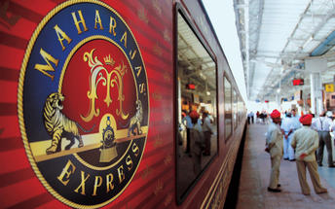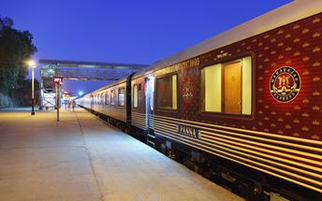

Day 3: Maharajas' Express

Day Itinerary
- 06:00 Proceed to visit the Agra Fort.
- 08:00 Return to the comforts of Maharajas’ Express
- 08:10 Breakfast on-board and Maharajas’ Express proceeds to Sawai Madhopur (Ranthambore)
- 13:00 Lunch on-board
- 14:30 Proceed for a game drive at Ranthambore National Park
- 17:30 Return to the comforts of Maharajas’ Express
- 18:00 Maharajas’ Express proceeds to Jaipur
- 19:30 Dinner on-board

Overnight on board Maharajas Express

Day 4: Maharajas' Express

Day Itinerary
- 02:00 Maharajas’ Express arrives at Jaipur
- 07:00 Breakfast on-board
- 08:30 Proceed to visit the Amber Fort
- 13:00 Return to the comforts of Maharajas’ Express
- 13:30 Lunch on-board. Post lunch relax on-board or may choose optional activities
- 18:00 Proceed for dinner at Hotel Rambagh Palace
- 21:30 Return to the comforts of Maharajas’ Express
- 22:30 Maharajas' Express proceeds to Delhi

Overnight on board Maharajas Express

Day 5: Maharaja’s Express – Delhi & Depart Delhi

Day Itinerary
- 07:30 Breakfast on-board
- 09:35 Disembark and bid farewell to the Maharajas' Express as your journey comes to an end !

On arrival you will be met and transferred to the Delhi airport to connect the onward flight
Flight TBA
Departs Delhi TBA Hrs

**End of services**

- Itinerary, sightseeing, timings and scheduled destinations may change without prior notice due to local/ weather conditions.
- Please contact your Guest Relations Executive for further details, prices and bookings of optional activities.

