

Jaipur with Tigers - 05 Days
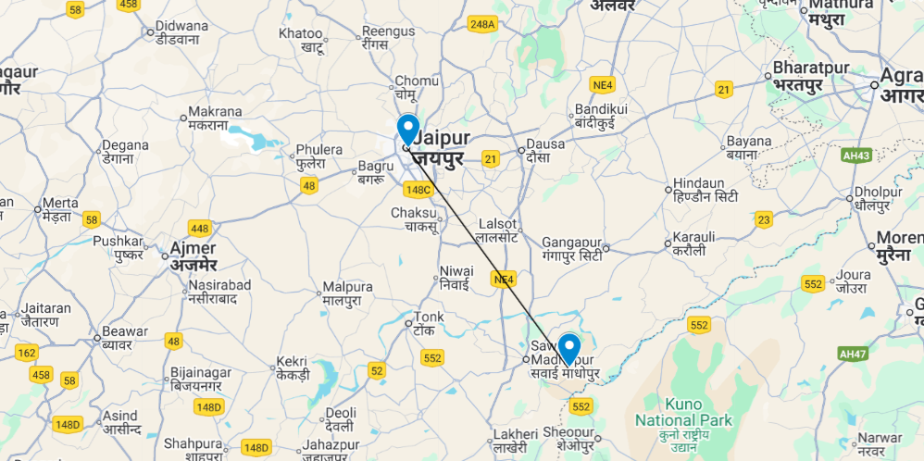
Jaipur - Ranthambore National Park – Jaipur
05 Days / 04 Nights

Jaipur with Tigers - 05 Days
Ranthambore offers superb wild tiger sightings in a rugged hilly landscape while Jaipur, Rajasthan’s state capital, boasts some of the region’s finest palaces and impressive forts along with an eclectic array of crafts and shopping.

Introduction

Accommodation | Destination | Start | End | Meal Plan | Room Type | Duration
Hilton Jaipur | Jaipur | Day 01 | Day 03 | BB | Hilton Guest Room | 02 Nights
Ranthambore Kothi | Sawai Madhopur | Day 03 | Day 05 | FB | Regal Room | 02 Nights

Day 01: Arrival Jaipur

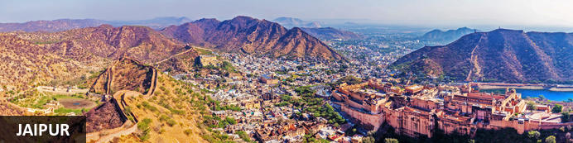
Founded in the early 1700s by Maharaja Jai Singh II as his new capital, the original ‘Pink City’ (so-called because almost all buildings were painted terracotta pink to honour the 1876 visit of the future King Edward VII) was laid out in a traditional grid with colonnaded streets and uniform façades. That layout remains intact and the city, now state capital of Rajasthan, has evolved and expanded into a modern metropolis with its own metro system. Yet its key sights and attractions lie within a relatively compact area. From vibrant bazaars and craft shops to grand palaces and huge forts, an extraordinary outdoor observatory and even one of the country’s most famous cinemas, Jaipur ticks every cultural, architectural and shopping box.

Day Itinerary
Flight TBA
Arrives Delhi TBA
On arrival in Jaipur: Having cleared immigration, collected your luggage and passed through customs, please make your way towards the exit of the terminal building where you will see a bank of people waiting. Amongst them will be Travel Counsellors Representative who will be waiting to greet you with a paging board with your name on.
You will then be transferred to your hotel and assisted with check in.

Overnight: Hilton Jaipur
Hilton Jaipur is ideally located on the outskirts of Jaipur, just 1km from Ram Nagar metro stop and 11km from Jaipur International Airport. The accommodation features comfortable guest rooms and suites equipped with modern amenities including coffee makers, LCD TVs, hairdryers, air conditioning, desks and Wi-Fi. Guests can enjoy dining at the on-site restaurant and bar. Leisure facilities include a swimming pool, fitness centre and spa.
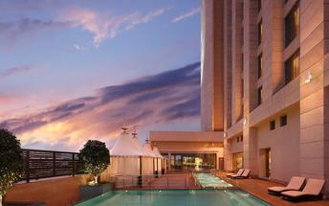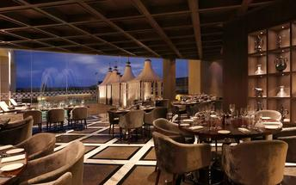

Day 02: Jaipur

Day Itinerary
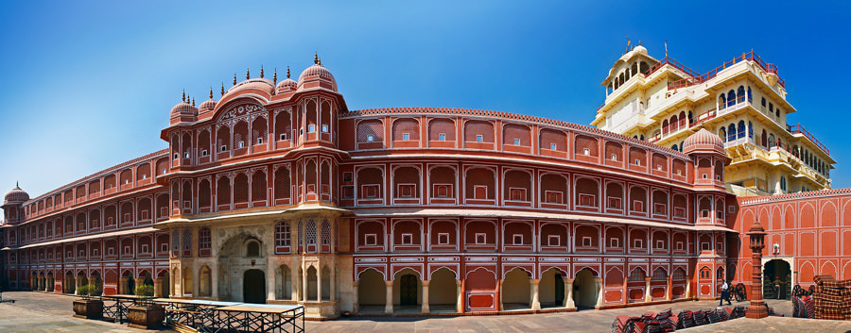
Begin exploring this city visit the City Palace complex which is spread over a large area occupying one-seventh of the old city of Jaipur .It is comprised of two palaces, Chandra Mahal and Mubarak Mahal, museum, a vast array of courtyards, gardens, and buildings. The palace is a blend of the Shilpa Shastra of Indian architecture with Rajput, Mughal, and European styles. Diwan-I-Aam (Hall of Public Audience), Bhaggi Khana (a museum), Pitam Niwas Gate, and Peacock Gate are a must-see. Its outer boundary was built by Raja Jai Singh and the other structures by his successors to add charm to it. It also served as a residence for the former Maharaja of Jaipur, also visit the famous Jantar Mantar (an observatory)

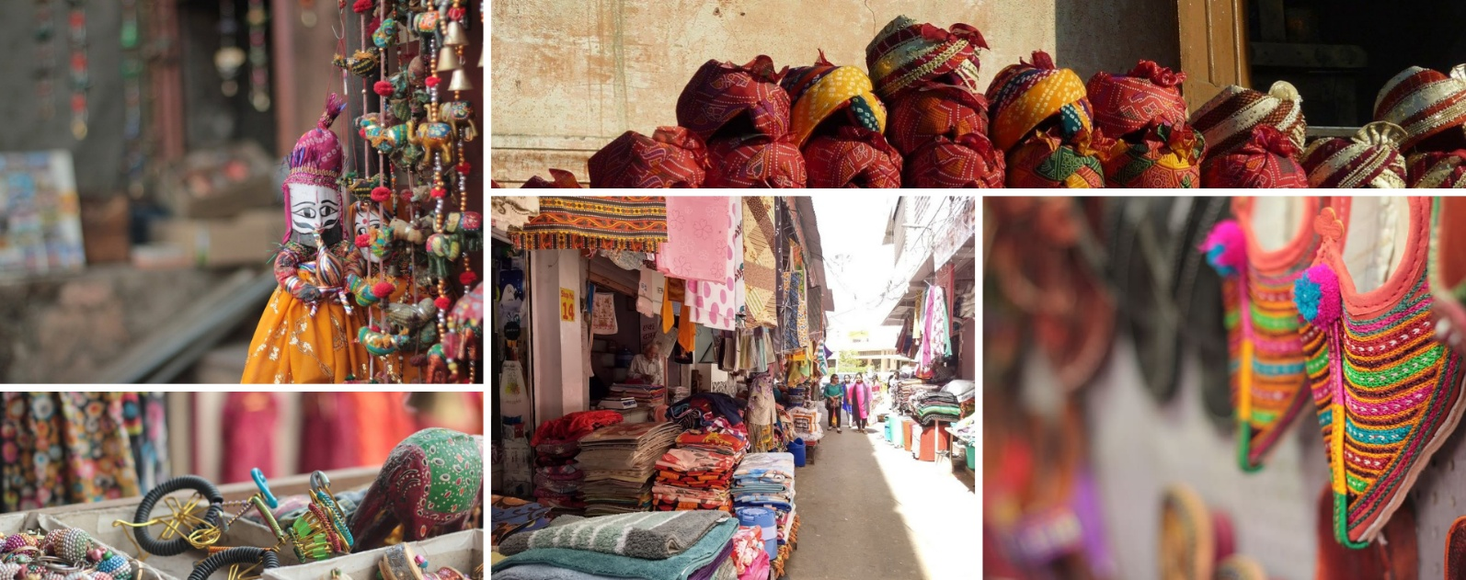
Thereafter, head for a walking tour in the bazaars, this immersive experience offers a unique opportunity to explore the city’s vibrant bazaars, renowned for their exquisite textiles, distinctive artisanal goods, and delectable street food. A specially curated selection of Jaipur’s vibrant textile market and street delicacies, each reflecting the region’s rich culinary and cultural heritage, awaits your discovery.

The textile market, in particular, stands as a testament to Jaipur’s centuries-old tradition of craftsmanship, where intricate patterns, vivid colours, and fine fabrics come together to embody the artistic soul of the Pink City.

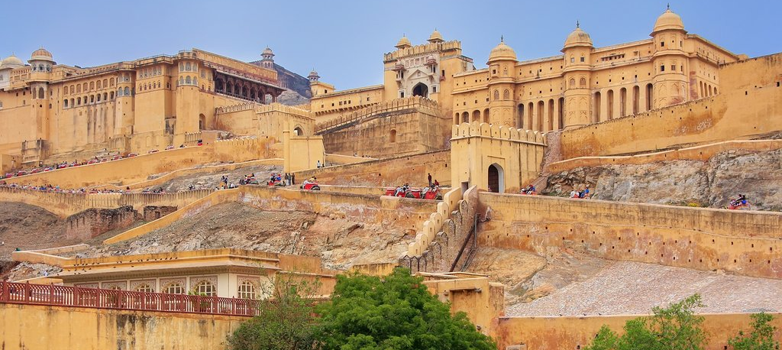
Later in the evening proceed for the majestic Amber Fort that’s perched on a hill on the outskirts of Jaipur. The fort was once the capital of Rajasthan. Former residence of Rajput Maharajas, this fort is notable for its grand architecture showcasing the Hindu style of architecture. The Amber Fort was used by the Rajputs for the dual purpose of defence and for private residence. The fort encompasses charming gardens and magnificent palaces made from marble and precious stones, richly decorated with intricate stonemason works and paintings.

The rest of the day is free for personal activities.

Day 03: Jaipur – Ranthambore

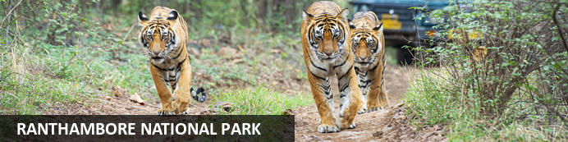
Named after a rambling 10th-century fortress which still stands sentinel on a 200m-high plateau, Ranthambore is one of India’s most famous national parks. One a royal hunting ground, today its 1334km² of dry forests, grassy meadows, lakes, streams and rugged picturesque hills are home to a sizeable population of wild tigers. Other wildlife includes leopards, antelopes, deer, hyenas, jackals, sloth bears, crocodiles and over three hundred species of birds. Access is closely regulated with a set number of vehicles, visitors and driving routes allocated each day to evenly distribute the human impact on its flora and fauna.

Day Itinerary
After breakfast, check-out and proceed for Sawai Madhopur also known and famous as “Ranthambore National Park” is situated 14 km away from Sawai Madhopur, & 180 km away from Jaipur, the eastern district of Rajasthan in India. As a matter of fact, the sanctuary of Ranthambore forests was previously a private hunting ground of the Maharajas of Jaipur.

Upon arrival at Sawai Madhopur Jn, you will be met by our representative, who will then assist you with check-in formalities at the resort for your 02-night stay!

Overnight: Ranthambhore Kothi
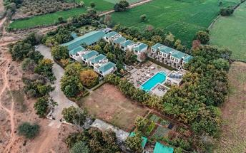
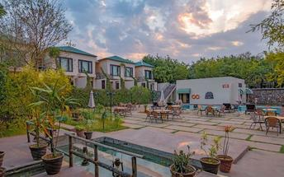
Ranthambhore Kothi is set by a natural water lake and surrounded by green forests in India. The rooms at the hotel come equipped with a mini-bar, safe, tea and coffee making facilities, and a private balcony. The hotel features an on-site restaurant, bar, outdoor swimming pool, gardens, spa, and a tiger sanctuary.

Day 04: Ranthambore

Day Itinerary
Today your morning jungle safari (Private Jeep) exploration takes a higher level, an early morning ride enables more chances for sighting the animals. You explore the deep jungles of the National Park on an open-roof vehicle, tracking for tigers. This mission lasts for around three hours!
Return to the hotel for breakfast and spend the rest of the morning relaxing in the comfort of the hotel.

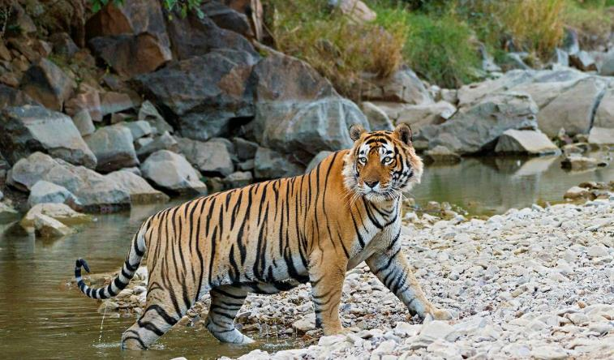
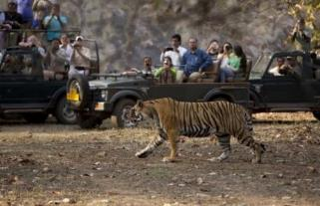
Then post lunch, your afternoon jungle safari (Private Jeep) continues into the Ranthambore National Park for wildlife viewing. In the evening you return to the hotel to relax and after dinner, you retire for the night.

Day 05: Ranthambore – Jaipur

Day Itinerary
Morning after breakfast you will be transferred to Jaipur airport [Approx. 180 Kms – 4 Hrs] to connect with your onward flight.

Flight TBA
Depart Jaipur TBA

