

TC Led Kerala Tour
Kochi - Thekkady - Kumarakom – Alleppey - Mararikulam
11 Days / 10 Nights

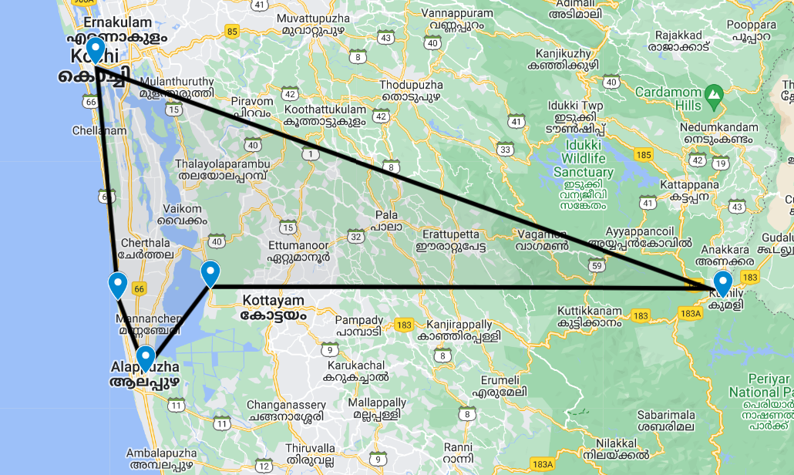
Tucked away on India’s south-western coast, Kerala is one of the country’s scenic and cultural gems: lush tropical beaches and landscapes and beaches threaded by coastal lagoons and waterways while inland the Western Ghats offer pretty vistas of undulating hills dotted with spice plantations.
Cochin, the state’s largest city, has expanded well beyond the original settlement of Fort Kochi which retains its cosy heritage atmosphere and sights. Up in the Western Ghats, Munnar is one of South India’s eminent hill stations with numerous tea plantations while Periyar National Park’s forested hills and montane grasslands cradle some of the region’s highest peaks and are home to tigers and elephants. Overlooking Vembanad Lake, Kumarakom’s resorts offer fine food, yoga and ayurvedic treatments while charming houseboats ply the so-called ‘backwaters’, or inland lagoons. Mararikulam is a notably untouched fishing village with a fine beach and relaxing low-key atmosphere.

Introduction

Days | Accommodation | Destination | Room Type | Duration
Day 1 – Day 3 | Fragrant Nature Kochi | Kochi | Dukes Chamber | 2 Nights
Day 3 – Day 5 | Cardamom County | Thekkady | AC Periyar Cottage | 2 Nights
Day 5 – Day 7 | Coconut Lagoon | Kumarakom | Heritage Bungalow | 2 Nights
Day 7 – Day 8 | Houseboat | Alleppey | 03 bedroom | 1 Night
Day 7 – Day 10 | Xandari Pearl | Mararikulam | Green Pearl Villa | 3 Nights

Day 1: Arrive Kochi

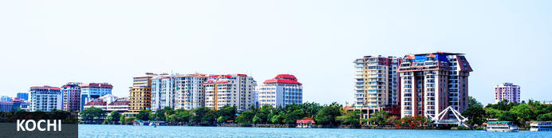
Also known as Cochin, Kochi is a city in southwest India's coastal Kerala state. This attractive city has served as a popular port for over 600 years and is known for its eclectic architecture and its array of religious monuments, museums, galleries, cafes and antique shops. The city stretches across a number of peninsulas and islands, which can be reached by a network of water taxis and bridges. The majority of Kochi’s visitor highlights can be found on the peninsula of Fort Kochi. These highlights include the St Francis Church, the oldest European-built church in India; and Mattancherry Palace, which dates back to 1557 and contains some exceptional Kerala murals and temple art. Other must-see attractions include the Kerala Folklore Museum, displaying more than 4,000 cultural and ethnic artifacts; and the 16th-century Jewish Synagogue; and the vibrant local market.

Day Itinerary
Flight TBA
Arrive Kochi TBA
On arrival in Kochi: Having cleared immigration, collected your luggage and passed through customs, please make your way towards the exit of the terminal building where you will see a bank of people waiting for you. Amongst them will be Travel Counsellors Representative who will be waiting to greet you with a paging board with your name on.
You will be transferred to your hotel and assisted with check in. [Standard check time is 1400 Hrs]

Overnight: Fragrant Nature Kochi
Fragrant Nature Kochi is within walking distance of Mattancherry Palace. Jawaharlal Nehru Stadium Kochi is only a short car ride from the hotel. Boasting a swimming pool, it also features 24-hour room service, valet parking and an executive floor. There are 41 rooms at Fragrant Nature Kochi, each offering all the necessities to ensure a comfortable stay. On-site dining options include a restaurant, which is a convenient place to have a meal. In the evening, guests are able to wind down in the comfortable lounge bar.
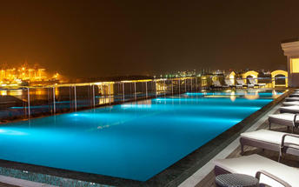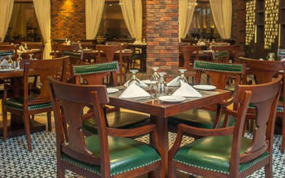

Day 2: Kochi

Day Itinerary
Day in Kochi visit the beautiful churches, Jewish synagogue, Dutch Palace, the markets and try your luck with the locals to get the fresh catch on the Chinese fishing nets.
Fort Kochi
Fort Kochi takes its name from a long-gone fort which was built during its occupation by the Portuguese. The Portuguese were followed by the Dutch, who left their own legacy, and hot on their heels came the British with their own unique ways. Independent now for many years, Fort Kochi remains a colourful melting pot of diversity, retaining its colourful history in its architecture and culture.
Jew Town
Jew Town is located in Mattancherry in the southern Indian city of Kochi. The history of Jew Town dates back to 1492 when a group of Sephardic Jews came to Kochi after being expelled from the Iberian Peninsula. In 1524 more Jews faced persecution and were granted refuge by the Raja of Cochin who granted them land near his own palace. In 1568 the Paradesi Synagogue, which still functions today and is the oldest in India, was built, and the Jew Town neighbourhood developed around it.
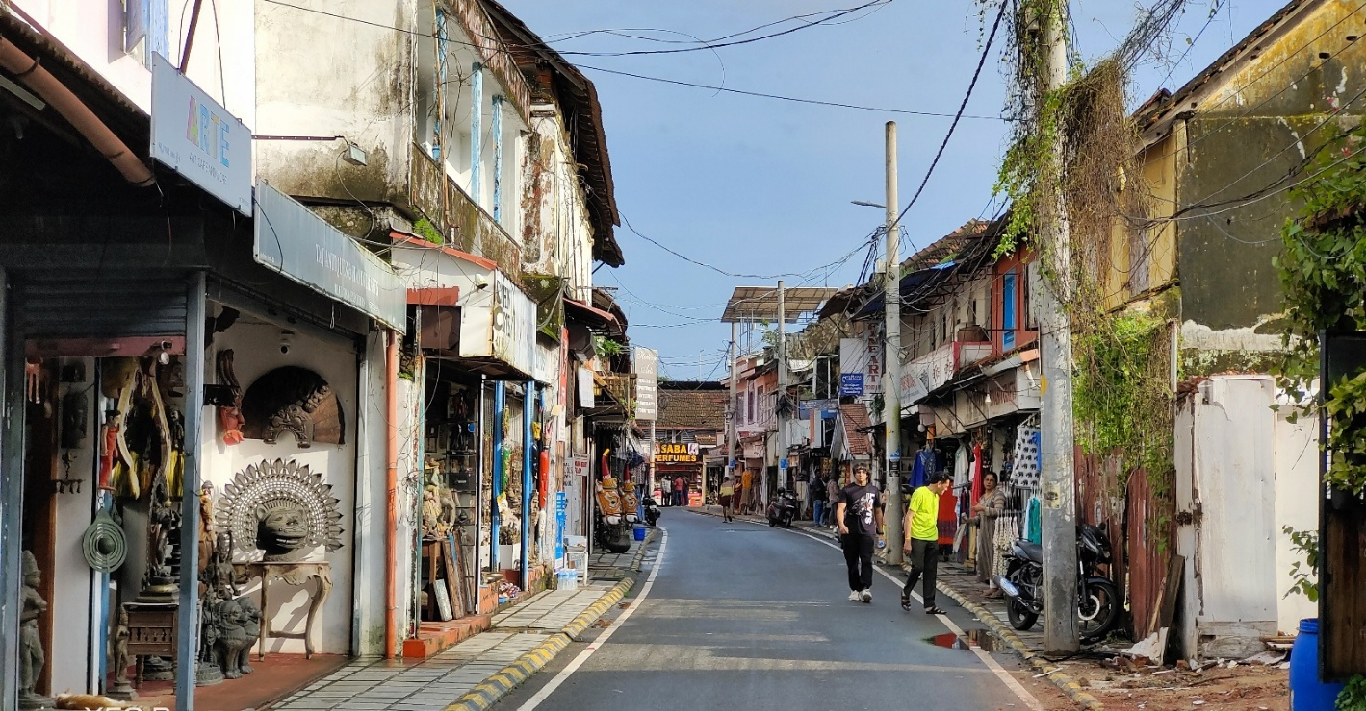

Jewish Synagogue (Closed on Fridays afternoon and Saturdays Full day)
Stepping inside the Synagogue, one's eyes would easily go to the glass chandeliers and blue willow-patterned Chinese floor tiles. The chandeliers are of Belgian origin. Also of interest are the Scrolls of the Law housed here and the several gold crowns received as gifts and the brass-railed pulpit. And for some exclusive pieces from history, the synagogue also houses the copper plates of privileges given to Joseph Rabban, the earliest known Cochin Jew, dating from the 10th century, written in Tamil, by the ruler of the Malabar Coast.
Dutch Palace (Closed on Fridays)
The Dutch Palace is a beautiful palace that was originally built by the Portuguese. It was only during the 17th century that the Dutch took it over, modified it and then presented it to the Raja of Kochi. The main attractions here are the outstanding collection of mural paintings found inside. These murals beautifully depict scenes from the Hindu epics of Mahabharatha and Ramayana.
St Francis Church
St. Francis Church is located in Kochi (previously called Cochin). It is one of the ancient European churches in the country and is a marvelous specimen of Portuguese architecture in the country. It is a mark of the colonial struggle of the Europeans to make their presence felt in India at that time. This church, built in 1503 by Portuguese traders, was where Vasco da Gama was buried when he died in 1524 AD. However, fourteen years later, his remains were shifted to Lisbon. Earlier, the church was named after Santo Antonio which was changed by Anglican Communion after the name of patron Saint Francis. It is now considered integral to the history and tourism of Kochi. In April 1923, this church became a protected monument under the Protected Monuments Act of 1904. In 1920, the Cenotaph was set up in the memory of the inhabitants of Kochi who died in the World War-I. Apart from all this, one interesting fact to observe is that, despite being very modest in its architecture, the model of this church has been followed by many churches India.
Chinese Fishing Nets
Chinese fishing nets are a type of stationary lift net in India. They are fishing nets that are fixed land installations for fishing. While commonly known as "Chinese fishing nets" in India, the more formal name for such nets is "shore operated lift nets".
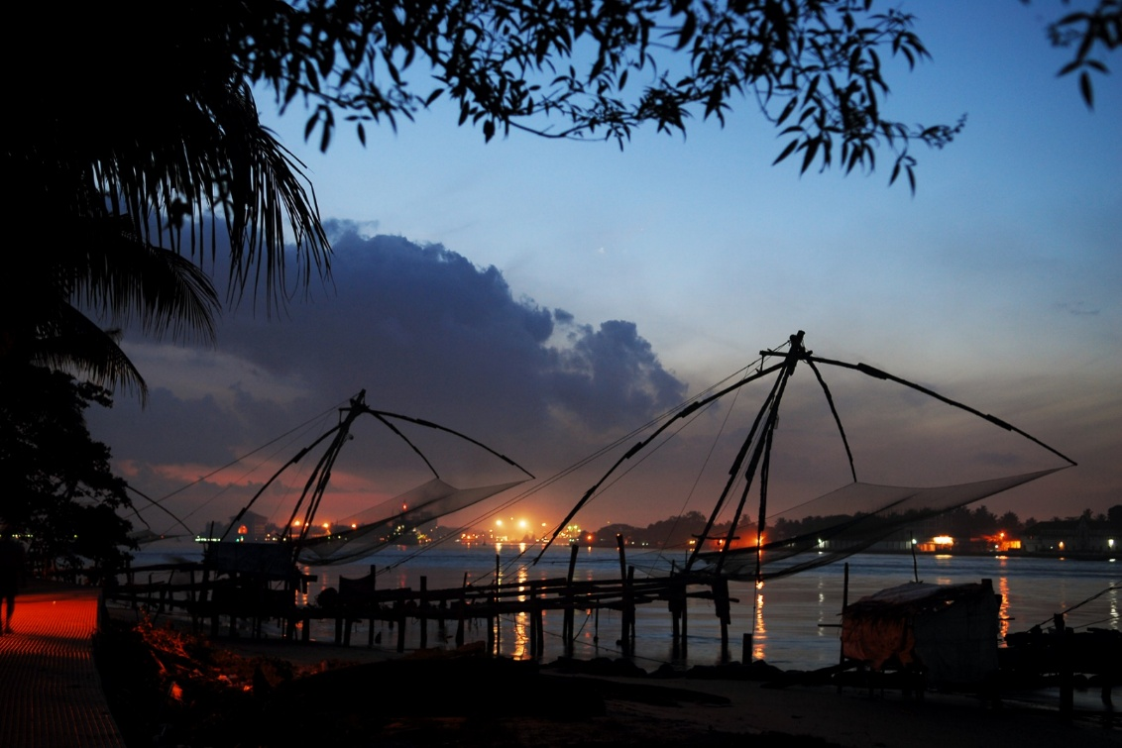
In the evening Enjoy Kathakali Dance Drama in a local theatre.
Kathakali
Kathakali is a highly stylized classical kerala dance performance noted for its attractive make-up of characters, their elaborate costumes, detailed gestures and well-defined body movements presented in tune with the anchor playback music and complementary percussion. Kathakali is said to have evolved from other performing arts like Kootiyattam (a classical Sanskrit drama existing in Kerala), Krishnanattam and Kalarippayattu. Kathakali explicates ideas and stories from the Indian epics and Puranas.
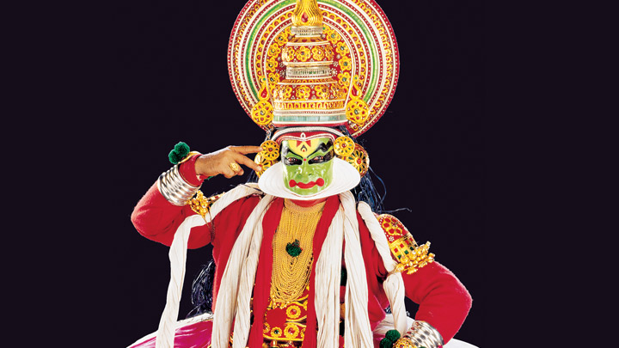
Overnight: Fragrant Nature Kochi

Day 3: Kochi – Thekkady

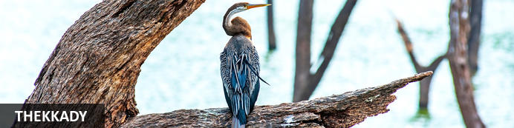
A tourist attraction in Kerala, Thekkady is a district located at the Periyar National Park. Thekkady comprises evergreen forests and savanna grasslands and is known for its natural spices such as black pepper, cardamom, cinnamon, nutmeg, ginger and clove. Elephants, tigers, sambar and many other species inhabit the park. Top attractions include the exquisite ancient Mangla Devi Temple, the aromatic Abraham’s spice garden, and the massive waterfall at the sleepy, picturesque village of Chellarkovil. Take in panoramic views of the extraordinary landscape from the Chellarkovil viewpoint, and picnic on the rolling, lush green lawns at Pandikuzhi. Don’t miss the opportunity to visit the Kadathanadan Kalari Centre, to see demonstrations of the best traditional martial arts. Thekaddy also has a rich living tribal culture.

Day Itinerary
Leave Kochi for Periyar/Thekkady (approx. 135 kms / 4 hrs) – enjoy the drive.
Upon arrival transfer and check in at the hotel.
Afternoon visit a local Spice Plantation.
Spice Plantation
The trip covers spice plantations such as cardamom, pepper, vanilla, clove, cinnamon, nutmeg, ayurvedic herbs etc. Over twelve varieties of spices including ginger, garlic, cardamom, vannilla, pepper, cinnamon, coffee, tea, clove and nutmeg is cultivated in Thekkady and its neighbouring villages.
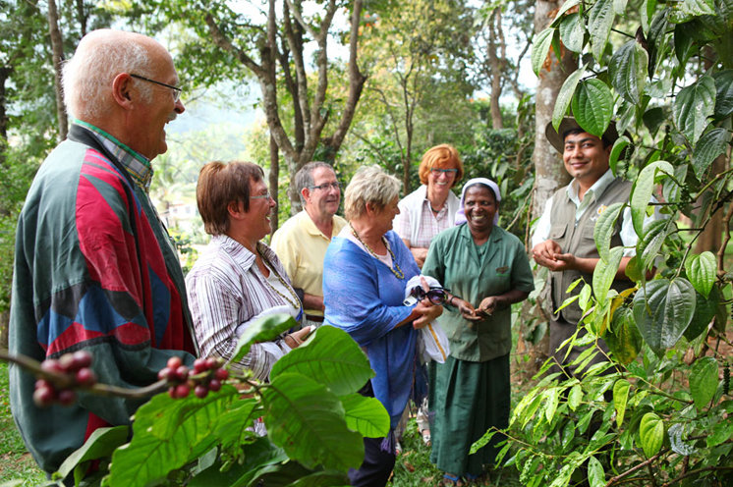

Overnight: Cardamom County
Cardamom County sits between the Periyar National Park and Tiger Reserve and its lush highland forest and wetlands ecosystem and a spice-trading community of hill stations. It is within walking distance from both the entry to the Periyar and the village. The rooms and cottages all provide expansive views of the reserve. The resort has a wellness centre, Ayura Spa, offering therapies and yoga sessions. Cardamom County organizes carbon-neutral activities such as nature walks, jungle patrols, border hiking, bamboo rafting, tribal heritage visits and Periyar tiger trails, bullock cart rides and visits to the elephant park. Other activities hosted by the resort that are not entirely carbon-neutral include full day Jeep safaris, plantation tours and visits to Gavi and Grampi.
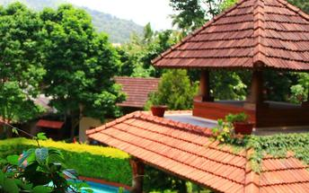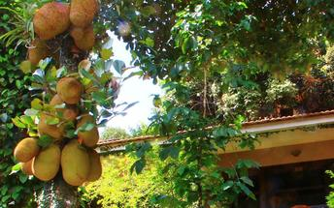

Day 4: Thekkady

Day Itinerary
Breakfast at hotel.
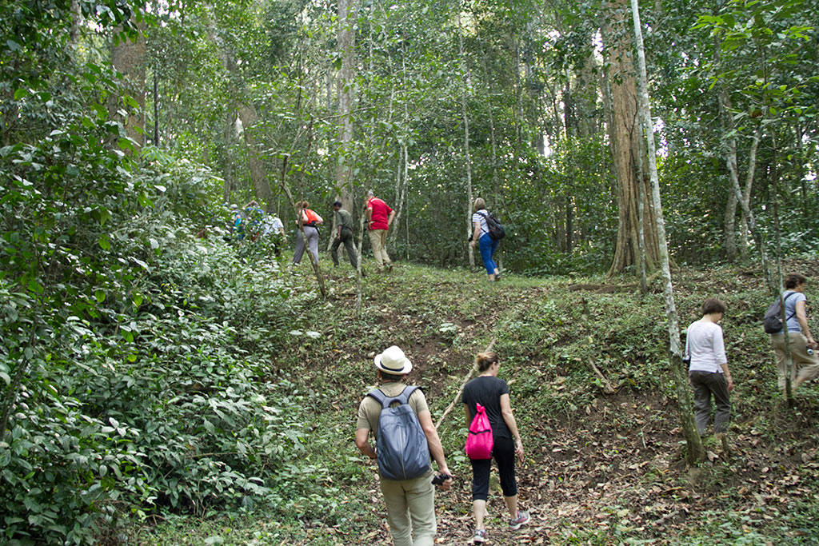
Early morning, proceed for a Nature walk at Periyar National park
Nature Walk
Different nature trails traversing diverse habitats form the trekking routes, generally 4 to 5 km. in length. This is an interpretive program offering excellent opportunity to watch birds, butterflies and other wildlife. The trails often pass through evergreen and moist deciduous forests interspersed with marshy grasslands. The program is offered between 7.00 am and 10.30 am and between 2.00 pm. and 3.00 pm. and lasts for about 3 hours. A maximum of 5 persons can go for trekking at a time along each nature trail, accompanied by a trained tribal guide. The Nature walk is the right program to feel nature, hear her whispers and smell her flowers.
Rest of the day at leisure.

Overnight: Cardamom County

Day 5: Thekkady - Kumarakom

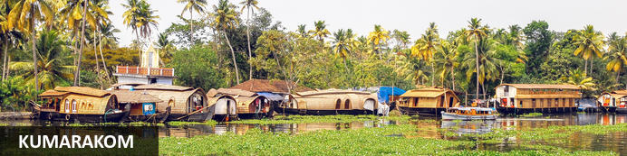
One of Kerala’s most alluring towns is Kumarakom, a hub of biodiversity where mangrove forests are mixed in with rice paddies, coconut palms, and bursts of white lilies. This vivid subtropical peninsula juts into Vembanad Lake and is a popular place to study yoga, meditation, and Ayurvedic massage, and from which to take bird-watching, boating, and fishing trips. Nearby attractions include the Aruvikkuzhi Waterfalls, just two kilometres from Kumarakoram, which cascade down the mountain slopes from roughly 30 metres above, and Pathiramanal (meaning ‘sands of midnight’) a beguiling island and bird sanctuary in the middle of the lake.

Day Itinerary
Breakfast at hotel.
Check - out and drive to Kumarakom (approx. 130 Kms / 4 hrs), on arrival check in at the resort.
Rest of the day is at leisure.

Overnight : CGH Earth Coconut Lagoon
CGH Earth Coconut Lagoon is located upon the Vembanad lake, one of India’s largest inland lakes with its distinctive ecology that supports a plethora of natural life. The accommodation consists of bungalows and villas equipped with modern conveniences such as air-conditioning, Wi-Fi, minibars, hairdryers and tea/coffee-making facilities. The villas offer private pools and separate living rooms. When it comes to dining, guests are treated to a lakeside dining experience at the on-site Aymanam restaurant. Other facilities and services include a swimming pool, Ayurveda centre, workout room and yoga classes.
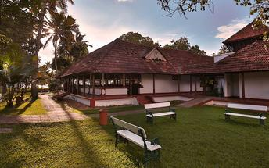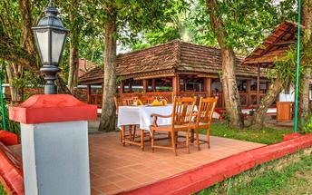

Day 6: Kumarakom

Day Itinerary
Breakfast at the resort.
Day at leisure.
Enjoy the various activities at the hotel.
Overnight at hotel

Day 7: Kumarakom - Alleppey

Breakfast at the hotel
After breakfast, you will be driven to Alleppey [approx. 45 Minutes’ drive]. On arrival, you will check in at the houseboat on the backwaters by 1230 Hrs.
Cruise on the backwater and overnight stay on the houseboat.
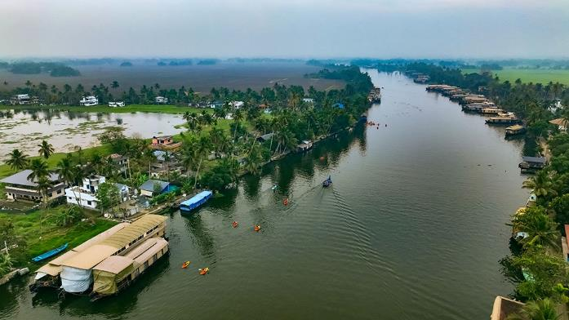
Note:
The check-in time on the Houseboat is at 1230 hrs - 1300 hrs and the boat then sets off cruising along the backwaters of Alleppey and Kumarakom till sunset. Around 1800 hrs, the boat will be anchored to avoid interfering with the fishermen of the lake and their nets. The boats come with en-suite bedrooms that are air-conditioned (from 1900 hrs to 0700 hrs). On the following day after breakfast, you will be dropped back to the jetty by about 1000 hrs.

Overnight: Deluxe Houseboat
The houseboats or Kettuvallam as they are traditionally called were at one time the mode of transportation for man and goods. Today, these are made to cater to the discerning guests who can lay back and enjoy the gentle cruise. Cruise the backwaters from the main Vembanad Lake through the small estuaries that link small villages to the mainland. Today, these are refurbished and all modern conveniences have been added for tourists who visit this beautiful water locked region of the country.

The houseboat cruise takes you through the intricate maze of backwaters, mesmerizing and surprising you at every turn with its serene beauty & simple charm. Enjoy the countryside of Kerala at its best. Soak your eyes & soul with array of coconut trees & endless paddy fields. You will also get chance to take a small stroll through the villages & interact with the locals.
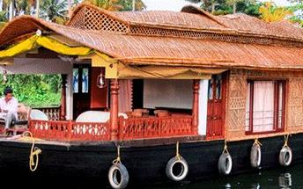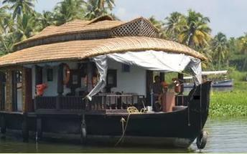

Day 8: Alleppey – Mararikulam

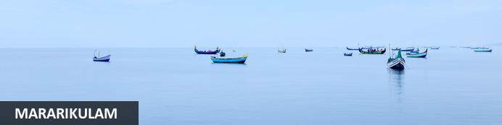
Situated only 40 km from the city of Cochin, in the Alappuzha district of Kerala, Mararikulam is a charming little coastal village known for its pristine sand beaches, swinging coconut palms, and quiet, laidback atmosphere. The village has managed to avoid the mass development associated with many of the other beach towns in the area resulting in an untouched natural environment dotted with only a handful of small resorts. The main attraction here is the exquisite Marari beach where you will find fishermen heading out daily to explore the Malabar coast, much as their ancestors have done for generations.

Day Itinerary
Breakfast at hotel.
You will be driven to Mararikulam for the beach stay, check in on arrival at the resort. (approx. 1 hour drive)

Overnight : Xandari Pearl
The Xandari Pearl is an 18 acre coastal estate that has 20 villas designed for privacy and relaxation. Each villa has a large private garden, hammocks, outdoor shower and a private dining area. Featured at the Xandari Pearl is an all-day dining restaurant serving meals prepared with organic produce grown within the resort. The beach is a 200 metre walk from the restaurant. Other resort amenities include a swimming pool and a spa.
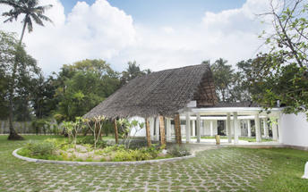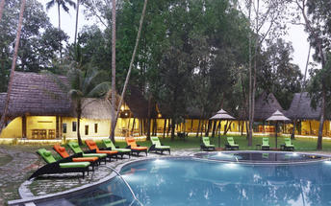

Day 9 – 10: At Mararikulam

Day Itinerary
Breakfast at hotel.
Enjoy activities offered by the resort like Nature Walk, local village walk.
Day at leisure to relax at the beach/ independent activities.
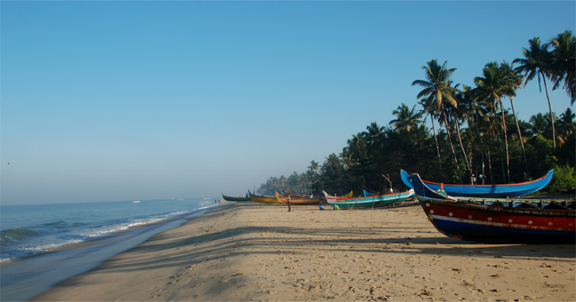

Overnight at hotel.

Day 11: Mararikulam – Cochin Departure

Day Itinerary
Breakfast at the hotel.
In time, you will be met & transferred to Cochin airport (approx. 2½ hrs) to board your flight to onward destination.
Flight TBA
Departs Cochin TBA
**** END OF SERVICES ****

NOTE:
- The distances and time taken for the travel is approximation only this will differ based on the traffic conditions and other unforeseen circumstances.

