

TC Led North India Group Tour – October 2026

Golden Triangle with Tigers
New Delhi - Agra - Ranthambore National Park - Jaipur
9 Days / 8 Nights
8-15 Persons

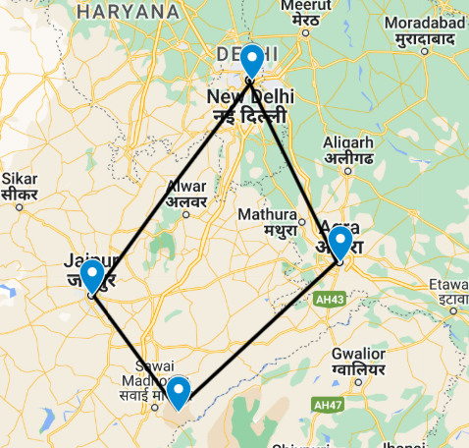

Golden Triangle with Ranthambore
This is the classic cultural tour of North India combining New Delhi, Agra and Jaipur (the so-called ‘Golden Triangle’) with a short detour to Ranthambore National Park.
New Delhi, the national capital, offers several key sights and historic monuments while Agra is synonymous with the Taj Mahal – a high-point of Mughal architecture and one of the world’s most celebrated buildings. Ranthambore offers superb wild tiger sightings in a rugged hilly landscape while Jaipur, Rajasthan’s state capital, boasts some of the region’s finest palaces and impressive forts along with an eclectic array of crafts and shopping.

Start | Accommodation | Destination | Room Type | Duration
Day 1 | Le Meridien | New Delhi | Executive Room | 2 Nights
Day 3 | Double Tree by Hilton | Agra | Guest Room | 1 Night
Day 4 | Ranthambhore Kothi | Ranthambore | Deluxe Room | 2 Nights
Day 6 | Shahpura House | Jaipur | Suite Room | 2 Nights
Day 8 | Lemon Tree Premier | New Delhi | Superior Room | 1 Night

Day 1: Arrive Delhi

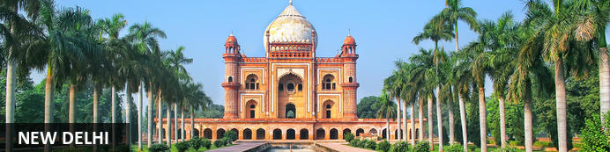
India’s capital, New Delhi, lies on the Indo-Gangetic Plain, within the National Capital Territory of Delhi. Made up of the ancient walled city of Old Delhi and the more modern sector, New Delhi, the city encompasses a staggering array of beautiful buildings, including three UNESCO World Heritage Sites – the grand, sandstone Red Fort, striking Qutab Minar, and fascinating Humayun's Tomb. Architecture enthusiasts will delight in the iconic Lotus Temple. Hear ‘qawwalis’ (devotional music) at the dargah (tomb) of the Sufi saint Nizam-ud-din Auliya; or wander through the 17th century Chandni Chowk marketplace – still one of the city’s most popular retail centres today, famous for its traditional jewellery and saris. The gorgeous Sunder Nursery and Lodi Garden provide calm, flower-filled oases for picnicking.

Day Itinerary
Flight TBA
Arrives Delhi TBA Hrs

On arrival in Delhi: Having cleared immigration, collected your luggage and passed through customs, please make your way towards the exit of the terminal building where you will see a bank of people waiting for you. Amongst them will be Travel Counsellors Representative who will be waiting to greet you with a paging board with your name on.

You will then be transferred to your hotel. Standard check in tiem – 1400 Hrs.

Overnight: Le Meridien New Delhi
Le Meridien New Delhi is ideally located in the heart of the city and within walking distance of the shopping hubs Connaught Place and Janpath Market. The accommodation features comfortably designed guest rooms and suites equipped with modern amenities such as TVs, air conditioning, tea/coffee makers, complimentary bottled water, hairdryers and Wi-Fi access. Guests can enjoy a meal or a refreshing drink at the various on-site restaurants and bars. Leisure facilities include a swimming pool, health club and spa.
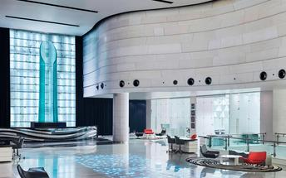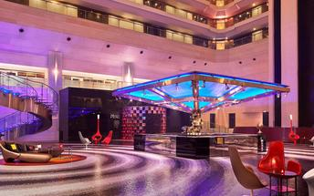

Day 2: In Delhi

Day Itinerary
After a light breakfast, morning proceed for a visit of Old Delhi. Drive paste the Red fort, Explore the Chandni Chowk Heritage Street and market, enjoy a short rickshaw ride. Proceed to visit Rajghat.
After visit proceed for lunch at a local restaurant (on direct payment)
Later proceed for New Delhi tour. Visit Qutub Minar, Humayun's Tomb. End the tour with a drive past India gate and other government buildings.

Old Delhi
Old Delhi is an ancient walled city located in northern India. Also known as Shahjahanabad, the city was founded in the 17th century during the reign of the Mughal emperor, Shah Jahan. Old Delhi once boasted fourteen great gates, mansions, the Red Fort, a congregational mosque and elegant gardens. Today, some of its ruins still stand making it a symbolic city as well as a famous attraction for tourists and locals alike.

Raj Ghat
Named after a historical ghat of Old Delhi located nearby, Raj Ghat is a memorial to Mahatma Gandhi, marking the spot where he was cremated after his assassination in 1948. Housed in an open-air garden area inside a walled complex, the memorial consists of a simple, flat black platform (reflecting the simplicity of Gandhi’s life) that is kept constantly decorated with an abundance of fresh flowers. An eternal flame burns at one end, symbolising the ever-lasting legacy of this great man. Two museums devoted to Mahatma Gandhi, his life and teachings are located nearby.

Chandni Chowk
Situated in Delhi’s historical old town, frenetic Chandni Chowk – meaning ‘moonlit square’ – is one of the city’s oldest, busiest and most famed shopping areas, built in the 17th century and originally intersected by (now defunct) canals that were designed to capture and reflect the moonlight. It’s a shopper’s paradise – with an eclectic diversity of wares ranging from traditional Indian sweets and other delicacies, to leather goods, electronics, intricately embellished saris and tailor-made suits. But even if you’re not up for any retail therapy, the sights, sounds and atmosphere of this pulsing, labyrinthine marketplace are captivating enough in their own right.
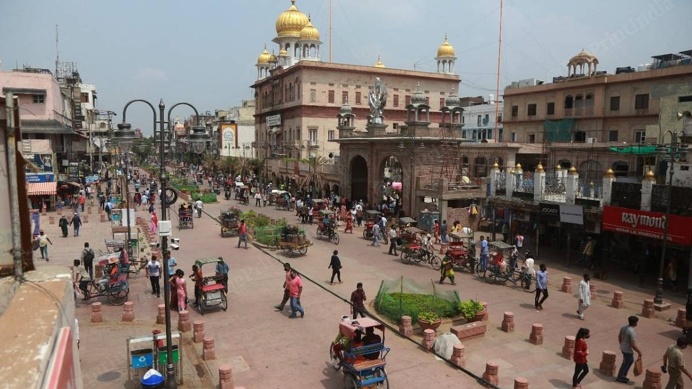

Humayun's Tomb
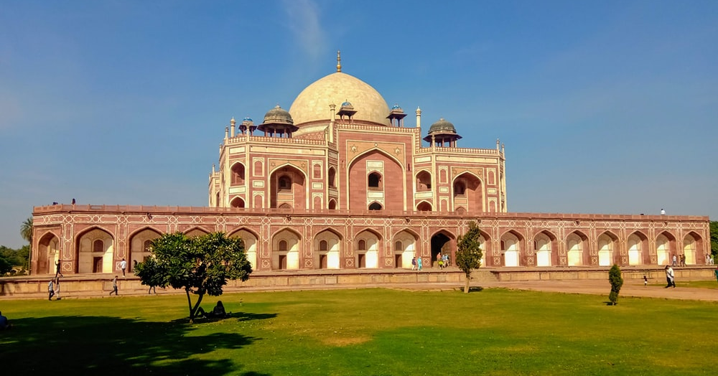
The mausoleum complex of Humayun, India’s second Mughal Emperor, was commissioned by his widow in 1565 and was the first garden tomb to be built in India, taking seven years to complete. Humayun had travelled widely in Persia and Central Asia during his lifetime, and many of the architectural principles he brought back from these journeys were incorporated into the building at his wife’s instructions. With its double domes, decorative inlaid marble and vast garden with pools connected by channels, this 16th Century building set the stage for the style that culminated in the Taj Mahal almost 100 years later.

Qutub Minar
The majestic Qutub Minar is a heritage building located in downtown Mehrauli in India. Standing tall at 73-metres, the tower consists of 5 storeys with a flight of spiral stairs leading to its top. The walls are adorned with decorative motifs and Quranic inscriptions. At the foot of the tower lie other monuments of historical significance, such as the Quwwat-ul-Islam Mosque and the Iron Pillar of Delhi. The Amazing race Australia used this site as a pitstop in the second series. Visitors can take advantage of stunning photo opportunities.

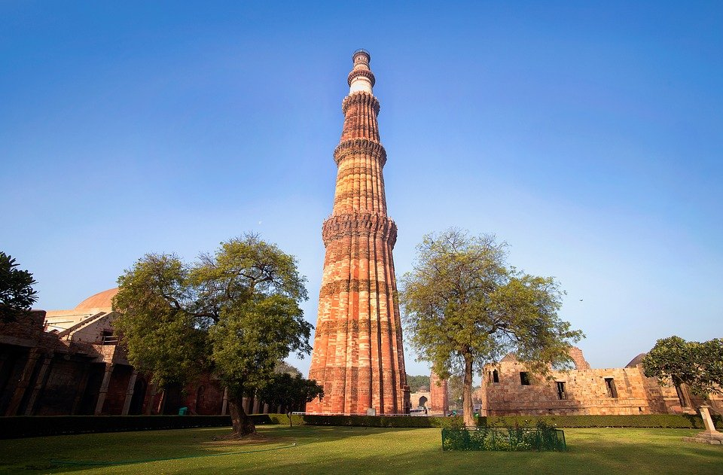

India Gate
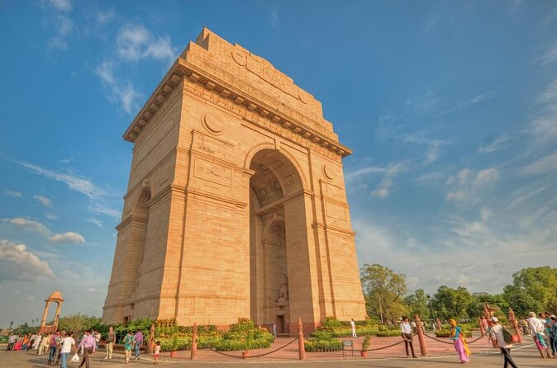
Also known as the Delhi Memorial or the All India War Memorial, the India Gate was built in commemoration of the roughly 80 000 Indian soliders who died representing their country in World War One and on various other battlefields, and whose names are inscribed on the structure. Unveiled in 1931, its distinctive arch is reminiscent of the Arc de Triomphe in Paris and the Gateway of India in Bombay, and is one of the trademark sights of New Delhi.

Overnight: Le Meridien New Delhi

Day 3: Delhi – Agra

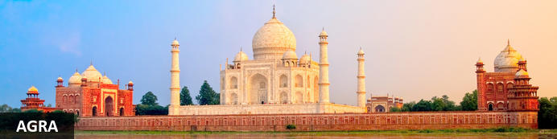
Set on the banks of the Yamuna River in Uttar Pradesh, Agra is a beautiful city famous for its incredible Taj Mahal building, one of the seven wonders of the world. Commissioned by the Mughal emperor Shah Jahan in the 15th century as a memorial to his beloved wife Mumtaz Mahal, this is an architectural masterpiece of exquisite craftsmanship and perfect proportions. The city boasts numerous other superb attractions, including the red-hued sandstone Agra Fort, built in the 16th century; the Shahi Jama Masjid mosque, a 17th-century congregational mosque located in the historic core of Agra, and Itmad-ud-Daulah’s tomb, with its white marble facade embellished with intricate inlaid designs, also called the' Baby Taj'.

Day Itinerary
After breakfast, Travel Counsellor Representative will assist & transfer you to railway station to board the train for Agra.

Train Gatimaan Express (runs daily except Friday)
Departs Delhi 08:10 Hrs.
Arrives Agra 09:50 Hrs.

Upon arrival in Agra, proceed to visit Agra Fort. Thereafter check in at Hotel (Standard check in at 1400 Hrs)

Evening visit Taj Mahal at sunset (Closed on Fridays)

Activities
Agra Fort
Taj Mahal

Agra Fort
Known as the Red Fort of Agra, this walled imperial city was founded in 1565 by the Emperor Akbar (1556-1605) and is a well-deserving UNESCO World Heritage site, located just 2.5 kilometres from the famous Taj Mahal. Its palaces, grand mosques and elaborate public hall are crafted from pink-red sandstone and are testament to an era when Indo-Muslim art, strongly marked by influences from Persia, was at its height. Emperor Shah Jahan, who built the Taj Mahal for his deceased wife, was imprisoned by his son Aurangzeb in Agra Fort. He is said to have died in the Musamman Burj, a marble tower he himself built, with one of the most alluring views of the Taj Mahal

Taj Mahal
The iconic Taj Mahal is not only an architectural masterpiece, a UNESCO World Heritage Site and one of the new Seven Wonders of the World – it’s also the enduring legacy of a royal love story. It was commissioned in the 15th century by the Mughal Emperor Shah Jahan after the death of his third and favourite wife, Mumtaz Mahal, to serve as her final resting place and a symbol of his eternal affection for her. Combining Islamic, Persian, Ottoman Turkish and Indian design elements, it’s an awe-inspiring structure of elegant domes and white marble, which changes colour along with the light – pink at sunrise, pearly white in the afternoon and silver-gold in the full moon.

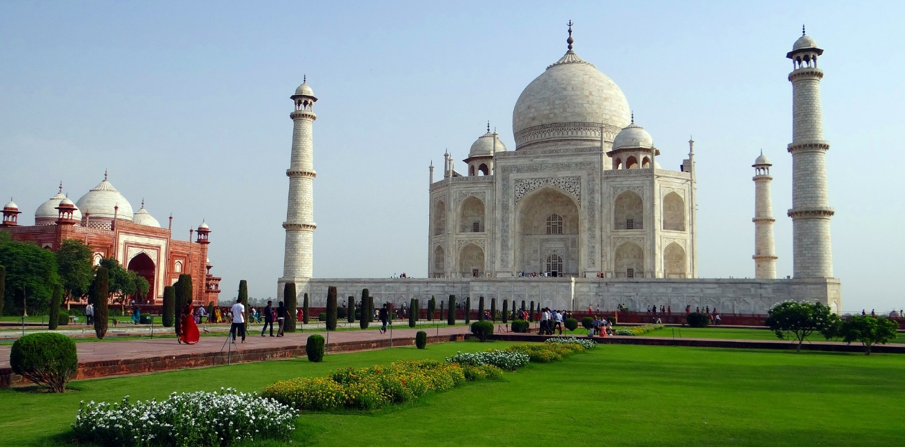

Overnight: DoubleTree by Hilton Agra Hotel
Choose a room overlooking the Taj Mahal when staying at Double Tree by Hilton Hotel Agra. Located in the heart of Agra city center, this Double Tree hotel is one of the few hotels in Agra offering views of this legendary monument located only 2 km from the hotel.

Whether in a garden view or city view room, the hotel offers breath taking views of the Taj Mahal from the pool area, and convenient access to Agra attractions such as the Agra Fort, Akbar’s Tomb and Sadar Bazaar. Upgrade to a suite for an additional living room with a dining area.

Enjoy fine dining at this hotel in Agra with 4 stylish food and beverage outlets offering cuisines from around the globe. Savor selections in the Indian specialty restaurant, or refresh with a cool drink in the poolside lounge. In the evening, enjoy live music and cultural performances in the inviting courtyard. Energize in the 24-hour fitness center or swim in the sparkling outdoor pool. After a busy day, indulge in a treatment in the luxurious spa.

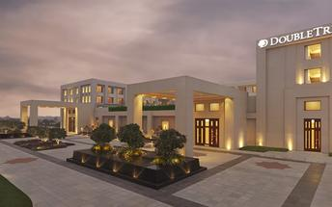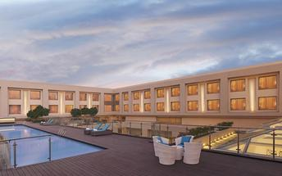

Day 4: Agra – Ranthambore National Park


Located in the Sawai Madhopur district, the Ranthambore National Park, in the western state of Rajasthan, is one of the most visited wildlife parks in India. Spanning over an impressive 1300-square-kilometer stretch of wilderness, the park’s outstanding natural beauty is characterized by its dense jungle, golden savanna, dramatic cliffs and lotus-filled lakes. Considered the best spot to catch a glimpse of tigers in the wild, the park offers visitors a spellbounding combination of mystical temples, wild beauty and crumbling ruins. While the main attraction is undoubtedly the elusive Bengal tiger, the park provides a sanctuary for other wildlife including, among others: sambar, gazelle, caracal, black buck, crocodile, chital, wild boars and a wide array of birds. Don’t miss the ancient Ranthambore Fort, perched high on the cliffs overlooking the vast expanse of this spectacular park.

Day Itinerary
After leisurely breakfast checkout from hotel and transfer to Bharatpur railway station [approx. 60 kms /1 ½ Hrs) for your train to Sawai Madhopur.

Train Kota Jan Shatabdi
Departs Delhi 14:50 Hrs.
Arrives Agra 17:13 Hrs.

On arrival you will be met and transferred to the the hotel for check in.

Overnight: Ranthambhore Kothi
Ranthambhore Kothi is set by a natural water lake surrounded by green forests in Rajasthan, India. The rooms at the hotel come equipped with a mini-bar, safe, tea-kettle, and a private balcony. The hotel features an on-site dining facility, bar, outdoor swimming pool, gardens, spa, and a tiger sanctuary. Popular activities include a safari in the Ranthambhore National Park, the National Chambal Sanctuary Boat Rides, and exploring the Ranthambhore Fort.

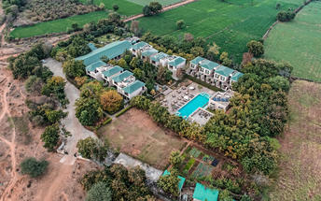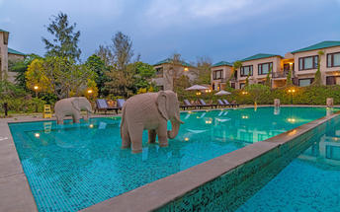

Day 5: Ranthambore National Park

Day Itinerary
Enjoy morning and afternoon safari by an exclusive jeeps with an English speaking naturalist at Ranthambore National Park.

Note:
- On Tuesdays the core zones from 1 to 5 are open for safaris and buffer zones 6 to 10 are closed for safaris.
- On Wednesdays the core zones from 1 to 5 remain closed for safaris and buffer zones 6 to 10 are open for safaris.
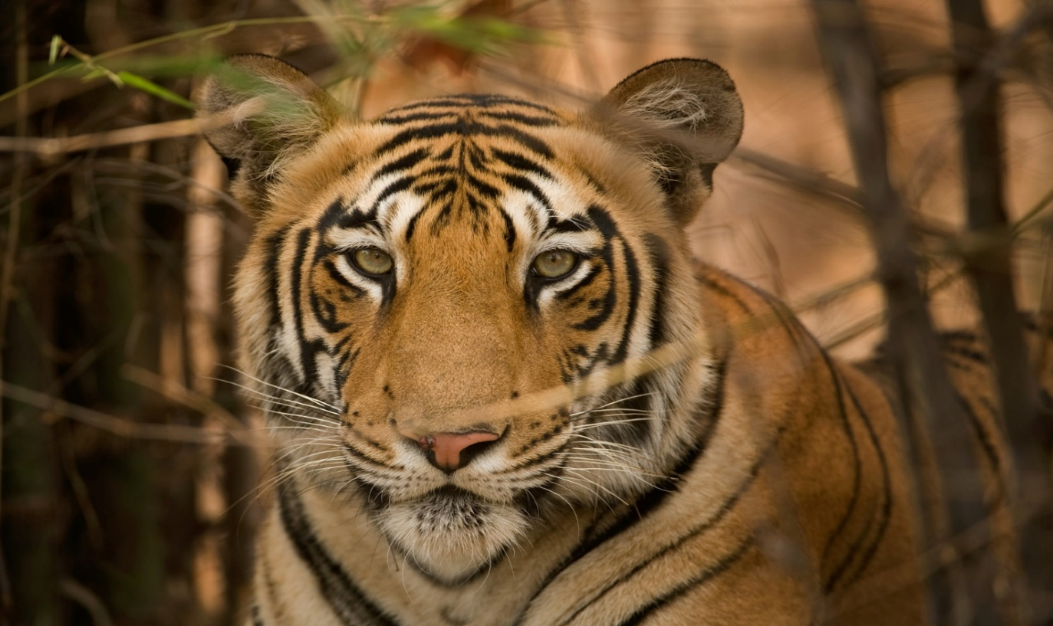

Overnight: Ranthambhore Kothi

Day 6: Ranthambore – Jaipur

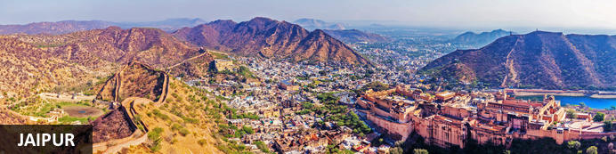
Fringed by the rugged Aravali Hills, Jaipur, nicknamed the ‘Pink City’ for its salmon-hued terracotta buildings, is the capital and largest city in the Rajasthan State. This metropolis combines tradition and modernity with its vibrant bazaars, lavish palaces, and ancient temples. Don’t miss the fairy-tale splendour of the Amber Fort, set against the backdrop of the arid landscape and hosting enthralling sound and light shows; the UNESCO-listed Jantar Mantar, a collection of 300-year-old astronomical tools which look like contemporary art; and the opulent City Palace, with its palatial structures, sprawling gardens, and atmospheric courtyards. Jaipur falls within the Golden Triangle, a popular tourist circuit, which includes Delhi, Jaipur, and Agra, and it also serves as a gateway to the neighbouring desert cities of Jaisalmer and Jodhpur.

Day Itinerary
Breakfast at hotel.

Check-out and drive to Jaipur (approx. 4 hours’ drive), check-in on arrival.

Later in the afternoon, enjoy the Pink city rickshaw ride.

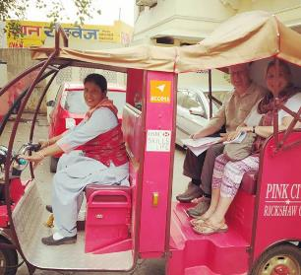
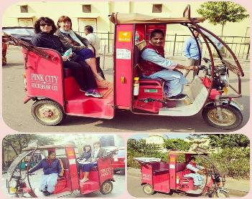
Launched by ACCESS Development Services (a national livelihoods support network), Pink City Rickshaws has around 200 women from low-income households driving customised eco-friendly two-passenger auto-rickshaws around Jaipur on a range of tours. With tour themes ranging from food to shopping, local crafts to key cultural sights, this is probably the quirkiest and most off-beat way of exploring the city

Overnight: Shahpura House
The Shahpura House derives it's name from the ruler of Shekhawat Maha Rao Shekhaji and the Manoharpur Shahpura family. The establishment is 200 years old and is set amidst green surroundings. All of the 38 guest rooms at Shahpura House are equipped with modern facilities to make a guest feel at home. Each room is embellished with marble and semi-precious stones accompanying the marble bathrooms, private porches and lobbies. Facilities available for use in each room includes LCD TV, satellite television, wired and wireless broadband internet access, electronic safe, direct dial telephone with voice mail, personal minibar and a tea or coffee maker. Activities of leisure at the hotel are open to all guests. There is a cocktail bar, rooftop restaurant serving Rajasthani dishes, the Shahpura Spa, cooking classes with the chef, outdoor pool and pool area. Additionally, guests can go on horse buggy rides or on camel safaris.

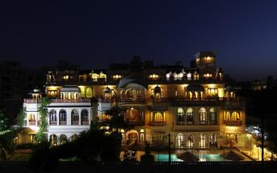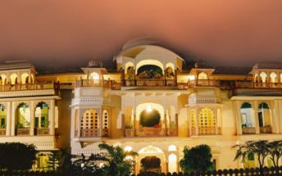

Day 7: Jaipur

Day Itinerary
Breakfast is at the hotel.

A morning visit to Govind Dev Ji Temple in Jaipur is a spiritually enriching experience. Located within the City Palace complex, this temple is dedicated to Lord Krishna. The devotees gather to wake the deity with hymns and chants. The atmosphere is serene and spiritually charged. As it's a popular temple, especially for locals, you'll find a large gathering of devotees offering their prayers. The morning visit offers a calming and introspective start to the day in the vibrant city of Jaipur.

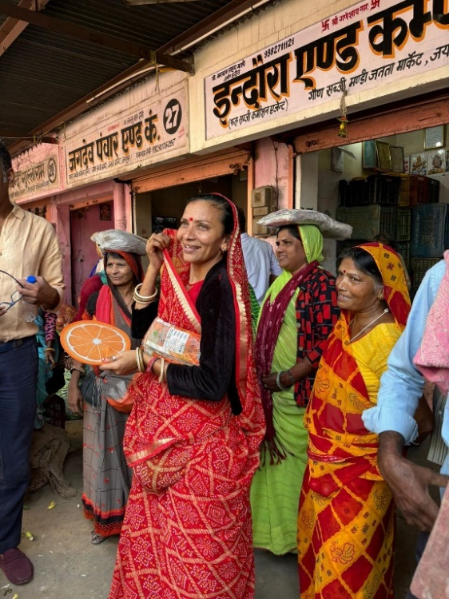
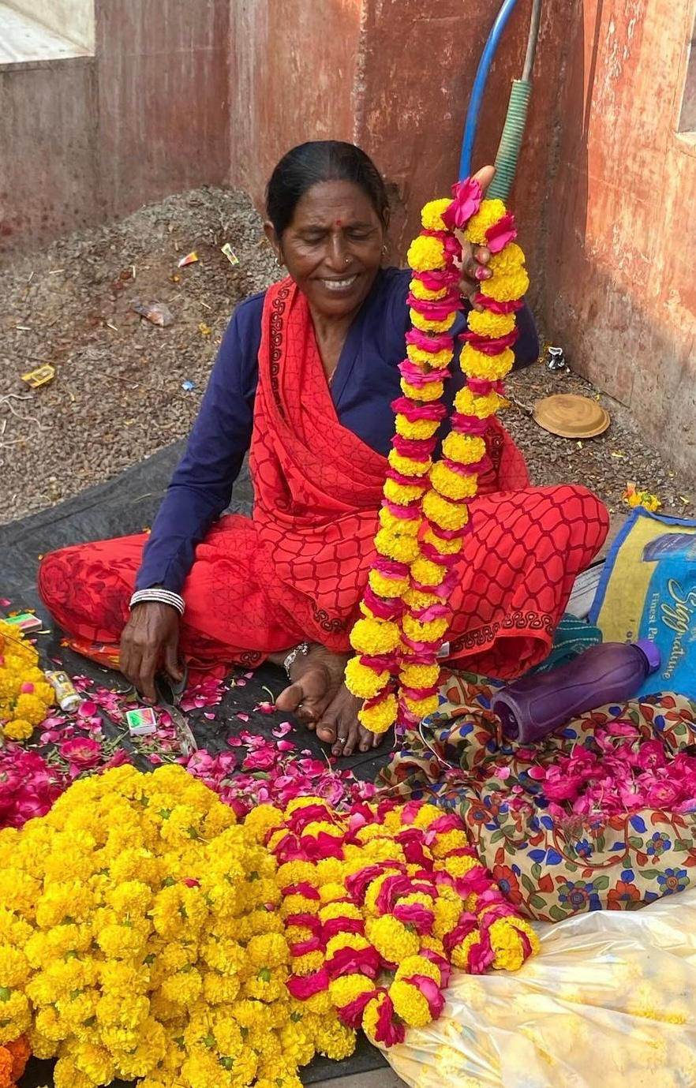
Later enjoy the walk in the flower and vegetable market and you get an opportunity to interact with the locals.

Later visit to City palace.
Jaipur City Palace
Up until India’s Independence in 1947, Jaipur’s City Palace was the ceremonial and bureaucratic seat of power of the Maharaja of Jaipur. Standing in the heart of the Old City founded by his ancestor, the 18th-century palace remains one of the city’s key sights. It’s a huge complex of courtyards, opulent audience halls, royal apartments, temples and pretty pavilions, some of which are still occupied by the royal family. It’s also home to a large museum with galleries devoted to textiles and armaments.
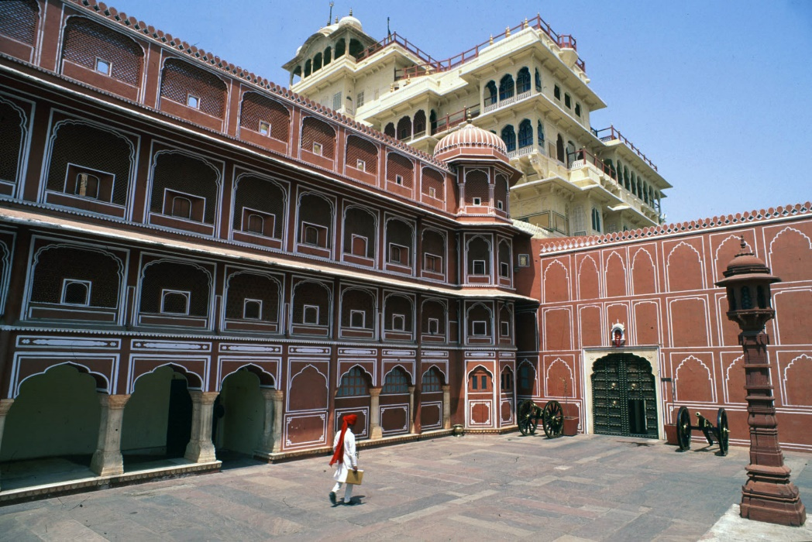

Photo stop at Hawa Mahal (Palace of Winds)
One of Jaipur’s most recognised buildings, the Hawa Mahal (Palace of Winds) is known for its iconic façade. Small windows, decorated with intricate latticework create a honeycomb-like appearance. The original intention of the lattice was to allow the royal ladies to observe everyday life in the street below without being seen. The cooling effect, provided by the breeze passing through the small windows, gave the palace its name. Built in 1799 by Maharaja Sawai Pratap Singh, the unique construction was originally designed to look like the crown of Krishna. A panoramic view of Jaipur can be had from the top of the building.

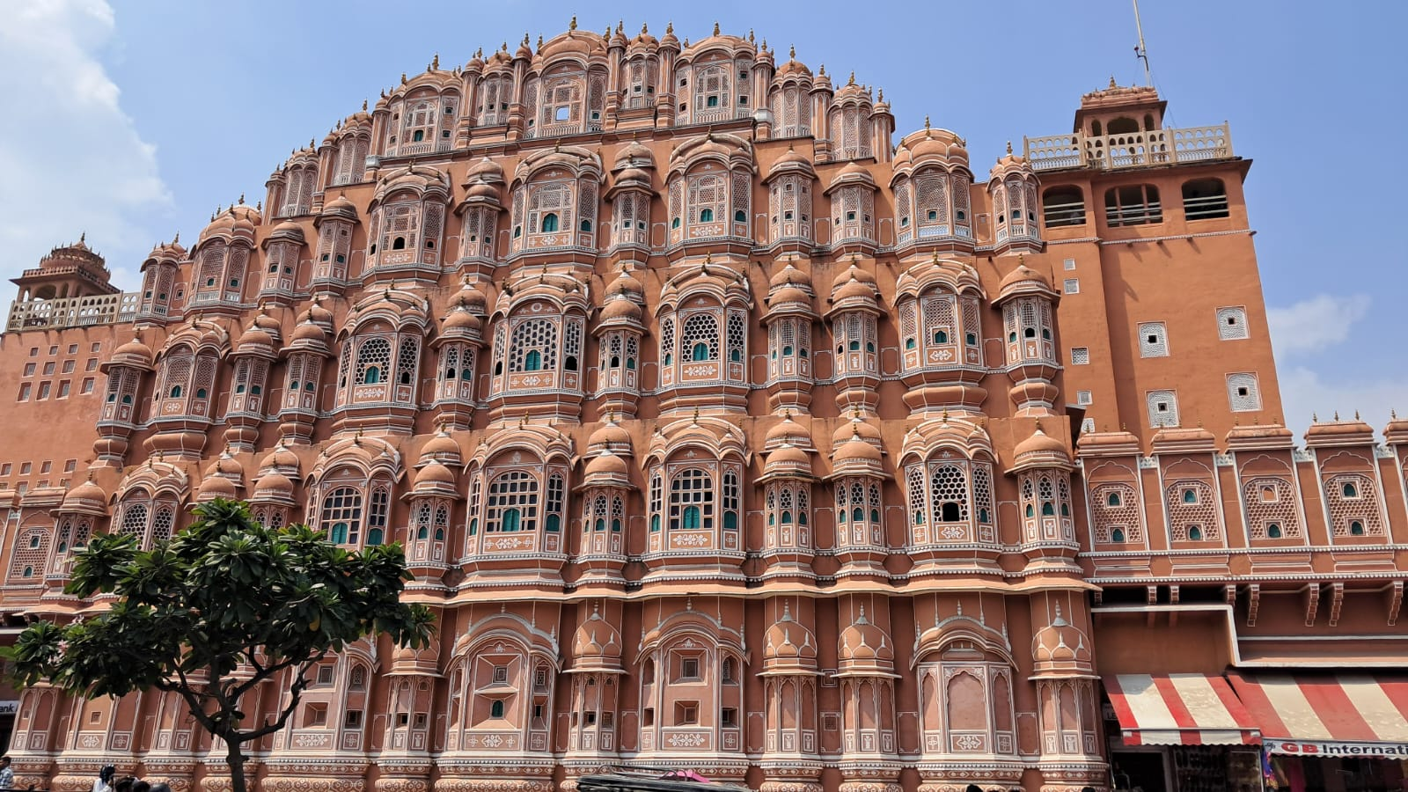

Evening enjoy the visit at Amer Fort by jeep ride
Cresting a stark rocky ridge on the hilly northern fringes of Jaipur, 16th-century Amber (or Amer) Fort is one of the finest examples of a Rajput fort-palace. Overlooking a lake and enclosed by kilometres of wide crenellated walls that wriggle across the enclosing hills, this huge complex of audience halls, pavilions and royal apartments is a compelling blend of Hindu and Mughal architecture. Although its once lavish interiors are now diminished, sufficient part-marble interiors, decorative frescoes, coloured glass and mirror-mosaics still reveal some of the grandeur of life in a maharaja’s court in what was one of Rajasthan’s most powerful princely states.

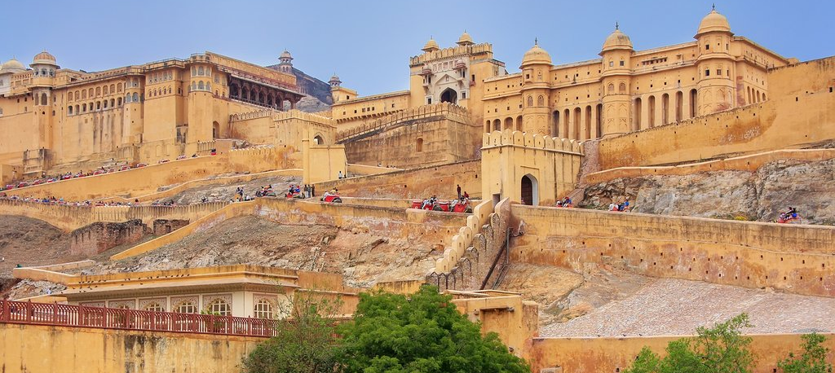

Return to the hotel after the visits or enjoy shopping at the Old Jaipur market.

Overnight: Shahpura House

Day 8: Jaipur – Delhi

Day Itinerary
After breakfast, you will be driven to Delhi [approx. 5 hours’ drive].

Arrive Delhi and you will be transferred to an airport hotel.

Overnight: Lemon Tree Premier Delhi Airport
Lemon Tree Premier Delhi Airport is 4-kilometres away from Indira Gandhi International Airport and 5-kilometres away from the domestic airport. The hotel features 280 smartly furnished rooms and suites that are equipped with a range of world-class facilities including Wi-Fi, satellite television, minibars and well-appointed bathrooms including one for differently-abled guests. The rooms also have a workstation and an ergonomically designed chair, to make business on the move productive. Guests can explore delicacies in the award-winning pan-Asian restaurant or enjoy lip-smacking delights in the multi-cuisine café.

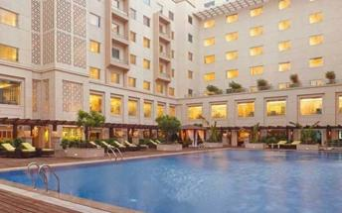

Day 9: Depart New Delhi

Day Itinerary
At appropriate time, you will be assisted & transferred to airport to board the flight for onward destination.

Flight TBA
Departs Delhi TBA Hrs.

**** END OF SERVICES ****

NOTE:
- The distances and time taken for the travel is approximation only this will differ based on the traffic conditions and other unforeseen circumstances.

