

Highlights of Kerala
Kochi - Munnar - Periyar - Kumarakom
09 Days / 08 Nights
2 Persons
01 May – 30 September 2026

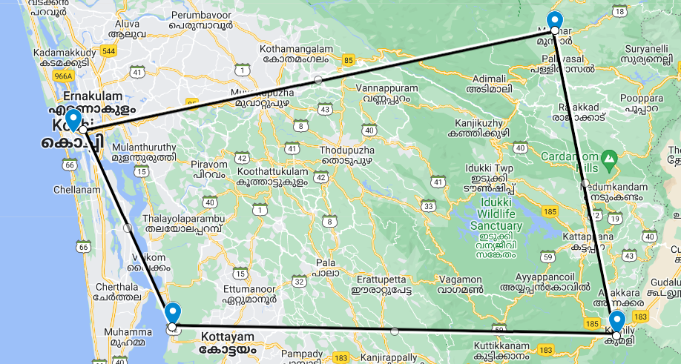
Tucked away on India’s south-western coast, Kerala is one of the country’s scenic and cultural gems: lush tropical beaches and landscapes threaded by coastal lagoons and waterways while inland the Western Ghats offer picturesque undulating hills dotted with spice plantations.
Cochin, the state’s largest city, has expanded well beyond the original settlement of Fort Kochi which retains its cosy heritage atmosphere and sights. Up in the Western Ghats, Munnar is one of South India’s eminent hill stations with numerous tea plantations while Periyar National Park’s forested hills and montane grasslands cradle some of the region’s highest peaks and are home to tigers and elephants along with thriving spice plantations. Overlooking Vembanad Lake, Kumarakom’s resorts offer fine food, yoga and ayurvedic treatments while charming houseboats ply the so-called ‘backwaters’, or inland lagoons.

Introduction

Accommodation | Destination | Start | End | Room Type | Duration
Eighth Bastion | Kochi | Day 1 | Day 3 | Bastion room | 2 Nights
Windermere Estate | Munnar | Day 3 | Day 5 | Garden room | 2 Nights
Spice Village | Periyar | Day 5 | Day 7 | Spice Garden Cottage | 2 Nights
CGH Earth Coconut Lagoon | Kumarakom | Day 7 | Day 9 | Heritage Mansion | 2 Nights

Day 1: Arrive Kochi

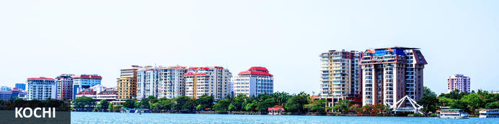
A major spice trading centre since the 14th century, Kochi (previously Cochin) is Kerala’s largest city and an essential destination for travelers to southern India. From ancient times it was known to an array of traders from Arabs to Portuguese, Greeks to Chinese, and was also home to India’s oldest Jewish community. Straddling several islands, a peninsula and part of the mainland, the city faces both ocean and backwaters so – unusually for India – all but the narrowest exploration of its sights involves bridges, ferries and water taxis. The main highlights are on Fort Kochi peninsula: built in 1503 the Church of St Francis is one of India’s oldest churches (and briefly interred the remains of Portuguese explorer Vasco da Gama) while the 16th-century Mattancherry Palace displays an extensive set of medieval murals inspired by the great Indian epics.

Day Itinerary
Today, you will arrive Kochi.
Flight TBA
Arrives Kochi TBA Hrs
On arrival in Kochi: Having cleared immigration, collected your luggage and passed through customs, please make your way towards the exit of the terminal building where you will see a bank of people waiting for you. Amongst them will be Travel Counsellor Representative who will be waiting to greet you with a paging board with your name on.
On arrival, you will be met and transferred to your accommodation.
Rest of the day will be at leisure.
Overnight: CGH Eighth Bastion Hotel
Eighth Bastion is a CGH Earth luxury boutique hotel in the heart of Fort Kochi in Kerala. A hotel of preference, its design is inspired by a Dutch nautical theme with scale models of Dutch ships, Batavia and Friesland decorating the interior. Accommodation at the Eighth Bastion comprises of 19 guest rooms that blends contemporary and colonial styles. The hotel restaurant has a bold menu inspired by the East Indian Company’s ancient trading routes in Asia. Also featured at the Eighth Bastion is a swimming pool as well as a service desk to arrange rickshaw rides to explore places of interest in Fort Kochi.
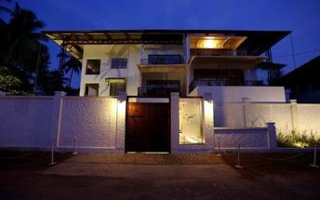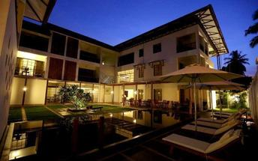

Day 2: In Kochi

Day Itinerary
Breakfast at the hotel
Morning you will be taken for half day tour of Kochi.
Fort Kochi
Fort Kochi takes its name from a long-gone fort which was built during its occupation by the Portuguese. The Portuguese were followed by the Dutch, who left their own legacy, and hot on their heels came the British with their own unique ways. Independent now for many years, Fort Kochi remains a colourful melting pot of diversity, retaining its colourful history in its architecture and culture.
Jew Town
Jew Town is located in Mattancherry in the southern Indian city of Kochi. The history of Jew Town dates back to 1492 when a group of Sephardic Jews came to Kochi after being expelled from the Iberian Peninsula. In 1524 more Jews faced persecution and were granted refuge by the Raja of Cochin who granted them land near his own palace. In 1568 the Paradesi Synagogue, which still functions today and is the oldest in India, was built, and the Jew Town neighbourhood developed around it.
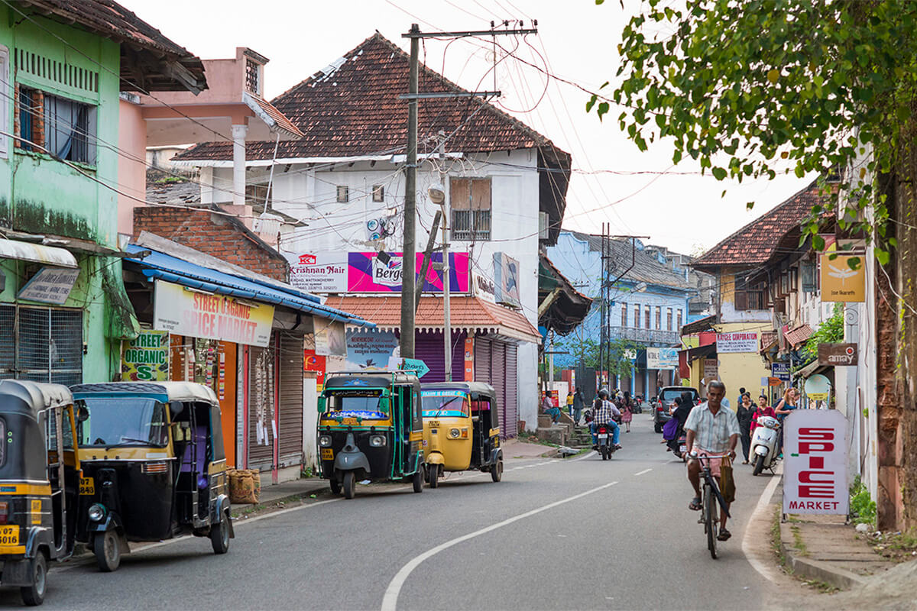
Jewish Synagogue (Closed on Fridays afternoon and Saturdays Full day)
Stepping inside the Synagogue, one's eyes would easily go to the glass chandeliers and blue willow-patterned Chinese floor tiles. The chandeliers are of Belgian origin. Also of interest are the Scrolls of the Law housed here and the several gold crowns received as gifts and the brass-railed pulpit. And for some exclusive pieces from history, the synagogue also houses the copper plates of privileges given to Joseph Rabban, the earliest known Cochin Jew, dating from the 10th century, written in Tamil, by the ruler of the Malabar Coast.
Dutch Palace (Closed on Fridays)
The Dutch Palace is a beautiful palace that was originally built by the Portuguese. It was only during the 17th century that the Dutch took it over, modified it and then presented it to the Raja of Kochi. The main attractions here are the outstanding collection of mural paintings found inside. These murals beautifully depict scenes from the Hindu epics of Mahabharatha and Ramayana.
St Francis Church
St. Francis Church is located in Kochi (previously called Cochin). It is one of the ancient European churches in the country and is a marvelous specimen of Portuguese architecture in the country. It is a mark of the colonial struggle of the Europeans to make their presence felt in India at that time. This church, built in 1503 by Portuguese traders, was where Vasco da Gama was buried when he died in 1524 AD. However, fourteen years later, his remains were shifted to Lisbon. Earlier, the church was named after Santo Antonio which was changed by Anglican Communion after the name of patron Saint Francis. It is now considered integral to the history and tourism of Kochi. In April 1923, this church became a protected monument under the Protected Monuments Act of 1904. In 1920, the Cenotaph was set up in the memory of the inhabitants of Kochi who died in the World War-I. Apart from all this, one interesting fact to observe is that, despite being very modest in its architecture, the model of this church has been followed by many churches India.

Chinese Fishing Nets
Chinese fishing nets are a type of stationary lift net in India. They are fishing nets that are fixed land installations for fishing. While commonly known as "Chinese fishing nets" in India, the more formal name for such nets is "shore operated lift nets".
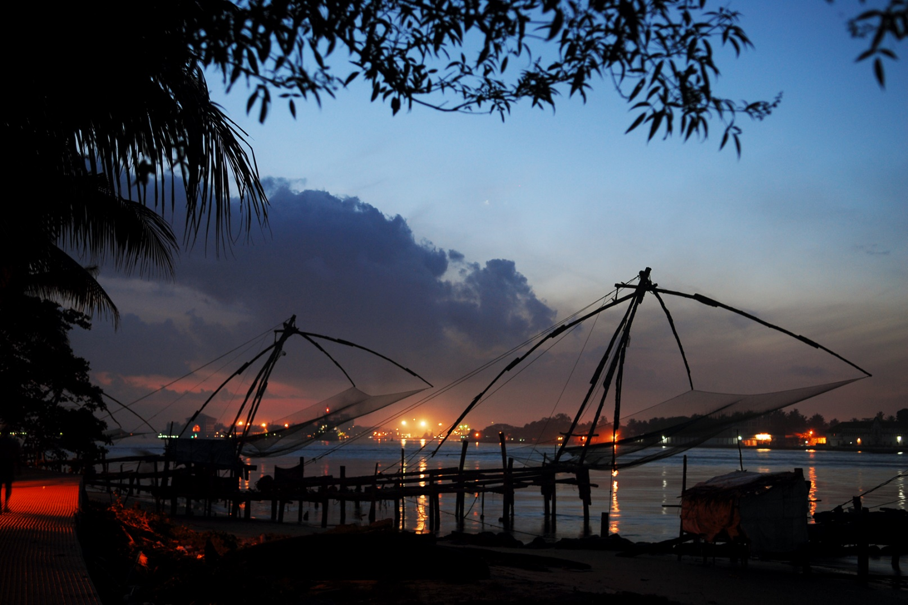
Kathakali
Kathakali is a highly stylized classical kerala dance performance noted for its attractive make-up of characters, their elaborate costumes, detailed gestures and well-defined body movements presented in tune with the anchor playback music and complementary percussion. Kathakali is said to have evolved from other performing arts like Kootiyattam (a classical Sanskrit drama existing in Kerala), Krishnanattam and Kalarippayattu. Kathakali explicates ideas and stories from the Indian epics and Puranas.
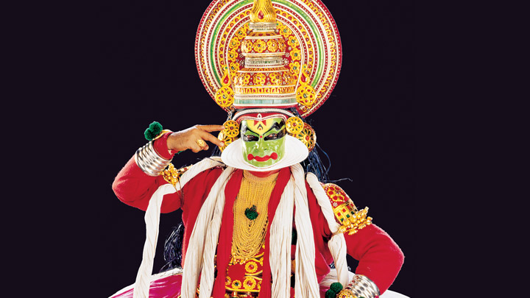
Overnight at hotel

Day 3: Kochi - Munnar

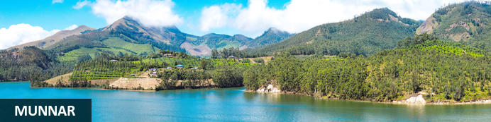
Perched around 5000ft up in Kerala’s Western Ghats, Munnar is one of South India’s eminent hill stations. The name is derived from its location by the confluence of three rivers. Originally viewed by the British as an idyllic rural retreat (especially to build sanatoria for their homesick administrators) and its cooler climate offering respite from the heat of the plains, by the 1880s the region was quickly given over to tea plantations. Lush hills with peaks up to 8,800ft high, charming tea-planter bungalows, streams and waterfalls lend a pleasing tranquil atmosphere. Highlights include the Eravikulam National Park and the Lakkam waterfalls with nearby hiking trails.

Day Itinerary
After breakfast, you will be driven to Munnar (approx. 4 ½ hrs).
On arrival, check-in at the hotel.
Rest of the day will be at leisure.

Overnight: Windermere Estate
The Windermere Estate is a plantation and retreat set on 55 acres of undulated slopes that consist of cultivated areas. The retreat sits on the slopes overlooking the Western Ghats.
Featured at the Windermere Estate is the View Point which is the highest point of the estate that sits on a rock in the center of the property. The View Point provides views of the valleys and hills and is ideal for bird watching. There’s also the Glen, a secluded section of the property surrounded by tall trees with a hammock in the center. This area encourages quiet and relaxation time and has the look of a little hideaway. The Boulder is an area on the property with tree stumps creating the atmosphere of an informal sitting area that is ideal for campfires.
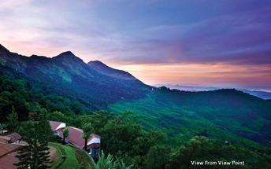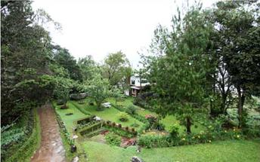
- Complimentary Inclusions while your stay at Windemere Estate
- Plantation / Nature walk from 1600 – 1730 Hrs
- Bird Watching from 0700 - 0800 Hrs

Day 4: In Munnar

Day Itinerary
Breakfast at the hotel
Morning enjoy the visit to Tea Factory and Tea museum.

Tea Factory
Visit to the Tea factory. Tea was first brought to Munnar by James Finlay & Sons who formed the Kannan Devan Hill Produce Company which has ultimately become Tata Tea Company. A visit to the tea factory gives one an insight into the fascinating process of tea.
Overnight at hotel

Day 5: Munnar - Periyar

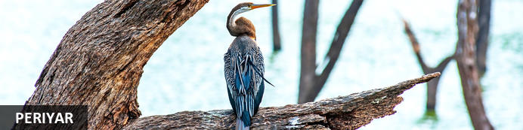
High in the evocatively-named Cardamom Hills by the state border with Tamil Nadu, Kerala’s Periyar National Park is known for its rolling thickly forested hills, montane grasslands, temperate climate and array of flora and fauna, some of it endemic. These are southern India’s loftiest peaks – the highest exceed 6,500ft – and their rolling topography forms the watershed for two of Kerala’s major rivers. Within the park lies Periyar Lake, a strangely convoluted 31-square kilometre stretch of water created in the 1890s by the Mullaperiyar Dam. While nearly 2000 species of flowering plants including 140 orchids might fade into the background, Periyar’s forests of teak, sandalwood, banyan and bamboo lend a more prominent backdrop to an array of wildlife. Elephants and tigers head a list of mammals including sloth bears, bison, flying squirrels, jungle cats, wild dogs along with around 270 species of birds, among them hornbills, flycatchers and storks.
Other nearby attractions include Chellarkovil waterfalls (the former at its best doing the monsoon season) and nearby Pandikuzhi, a lofty viewpoint. Just north of Periyar in Kumily town, the Kadathanadan Kalari Centre is a cultural centre featuring displays of kathakali (traditional Keralan theatre) and kalaripayattu (an ancient form of martial arts)

Day Itinerary
Breakfast at the homestay.
After breakfast, you will be driven to Thekkady (Approx. 03 Hrs).
On arrival, you will check in at your accommodation.
Afternoon is at leisure.

Overnight: Spice Village
Spice Village is situated in Periyar. It is a resort with lush gardens, individual cabins and that practices ecological methods during it's day to day running. This resort belongs to the CGH Earth Group.
Visitors out for a nature escape is drawn to the Spice Village. This is the tribal village, reborn for the modern traveller.
Accommodation at Spice Village is made up of 52 individual, tribal-styled thatch-roof cottages with verandas along with modern plumbing, solar-powered hot water and contemporary furnishings.
Facilities include a swimming pool, games and a restaurant. Ayurveda treatment is also available on site.
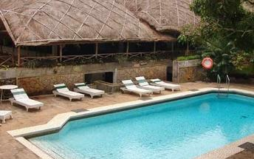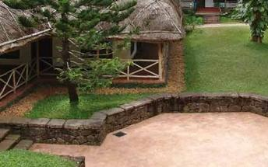
- Complimentary Inclusions while your stay at Spice Village
- Yoga and Meditation Session at 0730 Hrs & 0830 Hrs
- Handmade Paper Making at 1400 Hrs
- Pepper Vine at 1000 Hrs and 1600 Hrs for 01 Hr
- Organic Garden Vegetable Harvest at 1130 Hrs [prior booking needed]
- Introduction to Spices from 1845 to 1930 Hrs
- Night Walk from 2000 to 2030 Hrs

Day 6: In Periyar

Day Itinerary
Early morning, you will be taken on nature walk.

Periyar Nature Walk
Periyar‘s charming nature trails and guided nature walks (for up to six guests and usually led by tribal guides as part of efforts to promote community-based eco-tourism) traverse diverse habitats. They generally range from around 4 to 5 km in length over a period of two 3 hours. Typically you’ll encounter evergreen and moist deciduous forests interspersed with marshy grasslands.
Afternoon enjoy the visit to Spice Plantation Visit
Periyar Park’s hinterland comprises numerous villages and spice plantations – not for nothing are the regional Cardamom Hills so-named. And it’s not merely cardamom that’s the main crop; peppers, vanilla, cloves, cinnamon, nutmeg, ginger and a multitude of ayurvedic herbs grow abundantly to such an extent that even the air can here seem aromatic and fragrant. Plantation tours lend an insight into the cultivation, harvesting and processing of spices we almost take for granted.
Overnight at hotel

Day 7: Thekkady - Kumarakom

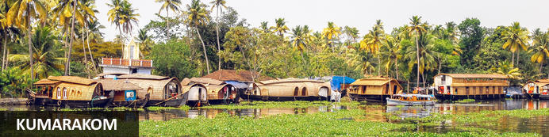
By the south-eastern shores of Vembanad Lake between the towns of Kottayam and Alappuzha, Kumarakom is essentially a lush coconut palm- and paddy-filled stretch of countryside dotted with mainly high-end resort-hotels. Fine food, spas, yoga and ayurvedic treatments are very much part of the scene while the beautiful lake is a focus for Keralan houesboats that rest up here or cruise up and down the region’s celebrated ‘backwaters’. There’s a small bird sanctuary here on the eastern shore and around 4km opposite on uninhabited 20-hectare Pathiramanal (or ‘midnight sand’) island only accessible by boat; roughly 90 endemic and 50 migratory species reside here depending on the season. If you can pull yourself away from the lake, nearby Aruvikuzhy Waterfalls make a modestly pleasing distraction but only during the monsoon season when there’s sufficient flow in the river.

Day Itinerary
After early breakfast, you will be driven to Kumarakom [Approx. 4 ½ hrs drive].
On arrival, you will check in at the hotel.

Overnight: CGH Earth Coconut Lagoon
CGH Earth Coconut Lagoon is located upon the Vembanad lake, one of India’s largest inland lakes with its distinctive ecology that supports a plethora of natural life. The accommodation consists of bungalows and villas equipped with modern conveniences such as air-conditioning, Wi-Fi, minibars, hairdryers and tea/coffee-making facilities. The villas offer private pools and separate living rooms. When it comes to dining, guests are treated to a lakeside dining experience at the on-site Aymanam restaurant. Other facilities and services include a swimming pool, Ayurveda centre, workout room and yoga classes.
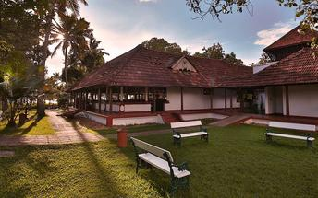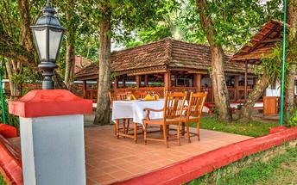
- Complimentary Inclusions while your stay at Coconut Lagoon
- Birdwatching activity at 0700 Hrs
- Yoga Session at 0700 Hrs
- Eco Walk with the Naturalist at 1000 Hrs
- Butterfly Garden at 1100 Hrs
- Sunset Cruise at 1730 Hrs
- Cultural Performances at 1930 Hrs

Day 8: In Kumarakom

Breakfast is at the hotel
Morning enjoy the canoe ride (motorized) which will take you to multiple canals that web across Kumarakomʼs waterscape, to get an intimate glimpse of life on the backwaters.
Rest of the day is at leisure.
Overnight at hotel

Day 9: Kumarakom – Kochi & Depart

Day Itinerary
Breakfast at hotel
Today in time you will be transferred to airport (approx. 2.5 hrs) to connect with your onward flight
Flight TBA
Departs Kochi TBA Hrs

