

Highlights of Bhutan
Thimphu - Punakha - Paro
7 Days / 6 Nights
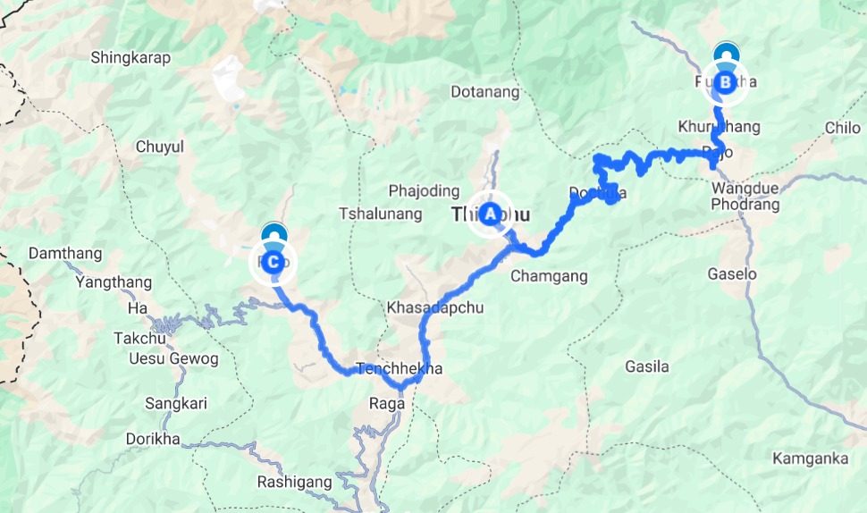

Day 1: Arrive Paro - Thimphu

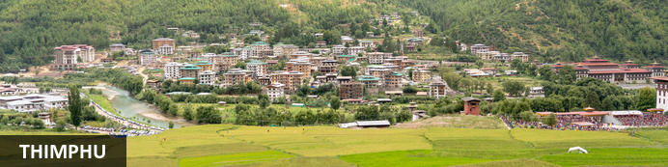
Resting in a lush green valley of hills and rice paddies, Bhutan’s capital city of Thimphu is the country’s commercial and religious hub, and is known for its interesting fusion of ancient and modern elements. Historical architecture and ancient traditional elements juxtapose with contemporary buildings and sensibilities. The imposing, stately 350-year-old Tashicho Dzong Fortress is currently used as the administrative centre of the county, and is also the king’s office. Visitors can explore the gold-spired Memorial Chorten, a revered Buddhist shrine; see the intricate frescoes and slate carvings at Simtokha Dzong; and discover the Bhutanese way of live through exhibits and folk dances at the fascinating National Folk Heritage Museum. The city bustles with cafes, clubs and restaurants, thereby offering the best of old- and new-world charms.

Day Itinerary
Today you will arrive in Paro.

Flight TBA
Arrives Paro TBA hrs

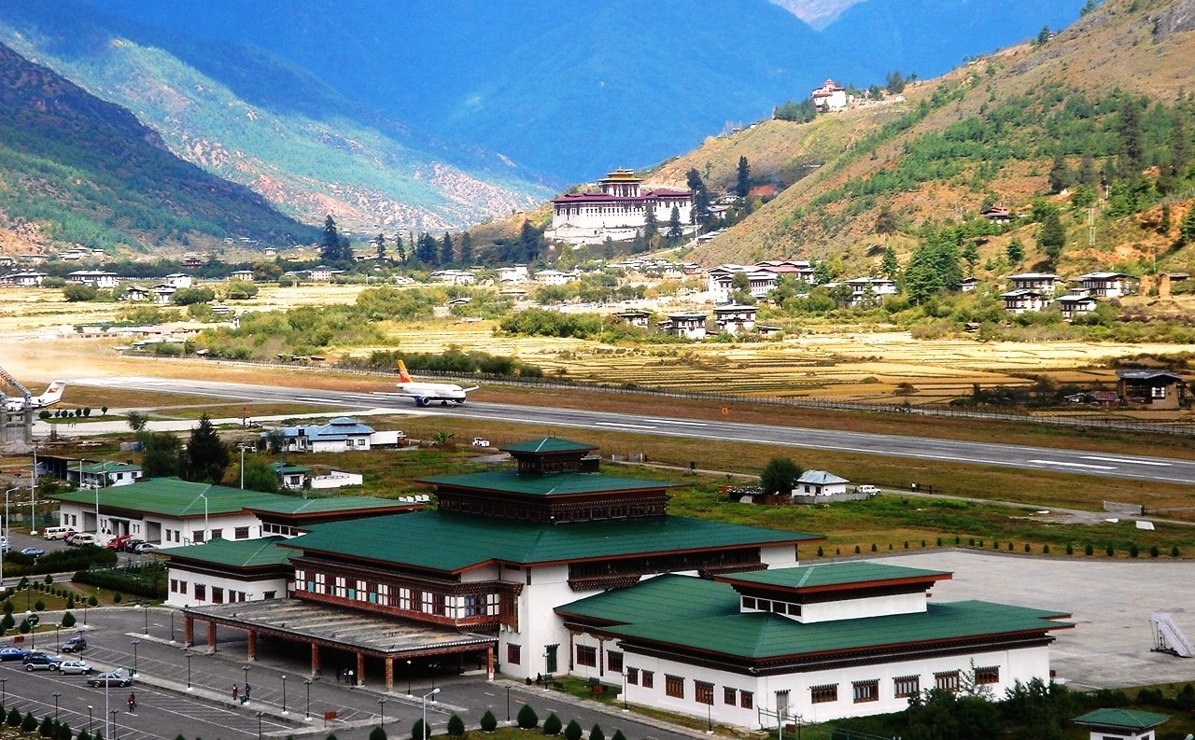
The flight to Paro is renowned as one of the most breathtaking journeys across the entire Himalayan region. Whether approaching along the majestic Himalayan range from Kathmandu or over the foothills from Kolkata, the route offers mesmerizing vistas and an exhilarating descent into the Kingdom of Bhutan. Upon disembarking, the first gift from Bhutan is its crisp, pristine mountain air.

Once you've completed immigration procedures and collected your luggage, our representative will extend a warm welcome, presenting you with a traditional 'tashi khaddar' – a white scarf symbolizing an auspicious reception for guests.

Following this heartfelt greeting, you will embark on a road journey to Thimphu (approx. 1.5 hrs), Bhutan's capital town. The road takes you through the picturesque Paro valley, eventually leading to the convergence of the Paro and Thimphu rivers at a place called Chuzom. Here, three distinct styles of stupas—Tibetan, Nepalese, and Bhutanese—adorn the confluence. After a brief photo stop at Chuzom, continue onward to Thimphu.

Upon arrival in Thimphu, check-in at the hotel. As Bhutan's capital and the hub of government, religion, and commerce, Thimphu blends modern development with ancient traditions in a unique manner. It remains one of the few capital cities globally without traffic lights.

In the evening, take an exploratory stroll along Thimphu's main street and through its bustling market area.

Overnight: Six Senses Thimphu
Six Senses Thimphu is located on an auspicious hillside overlooking the shimmering lights of Thimphu. With its grand design and outdoor ponds reflecting the sky above, Six Senses Thimphu offers spacious villas and suites, fitted with amenities to ensure guests a comfortable and pleasant stay. Some of these amenities include a wine fridge and minibar, a traditional wood-burning bukhari stove, tea and coffee making facilities, a TV with cable service, and unlimited Wi-Fi. Guests will enjoy the hotel restaurant with its healthy cuisine with an emphasis on local ingredients picked fresh from the lodge’s own organic gardens.
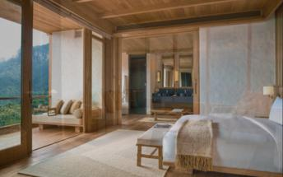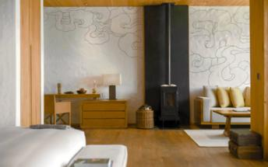

Day 2: In Thimphu

Day Itinerary
Breakfast at the hotel.

After breakfast, embark on a short drive to visit Buddha Dordenma, situated on a hill in Kuenselphodrang Nature Park, commanding a panoramic view of the southern entrance to Thimphu Valley. This majestic statue fulfils an ancient prophecy dating back to the 8th century AD, discovered by Terton Pema Lingpa, a renowned Religious Treasure Discoverer. Believed to radiate an aura of peace and happiness worldwide, the bronze statue of Shakyamuni is gilded in gold and stands 51.5 meters tall, making it one of Bhutan's largest statues. Within the Buddha Dordenma are 125,000 smaller bronze statues of Buddha, each also gilded. The throne beneath the statue serves as a spacious meditation hall.
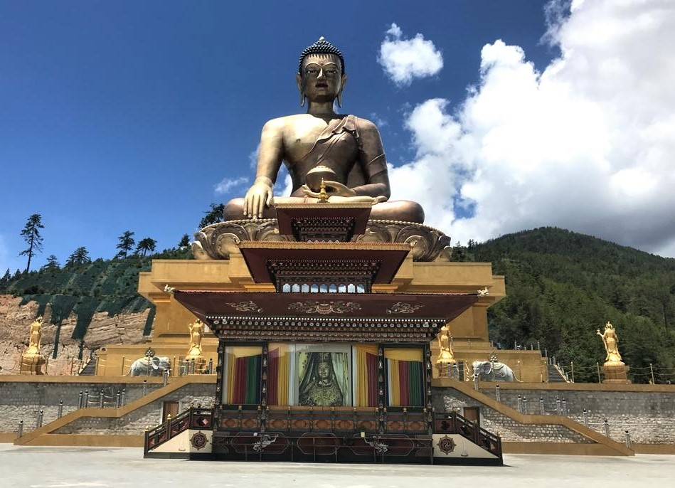
Next, descend to visit the King's Memorial Chorten, where devotees continuously circumambulate, murmuring mantras and spinning prayer wheels. Conceived by Bhutan’s third king, His Majesty Jigme Dorji Wangchuk—known as "the father of modern Bhutan"—the landmark was constructed to embody his vision of global peace and prosperity. Completed in 1974 following his premature passing, the chorten stands both as a tribute to the Late King and as a symbol of peace.

Then explore Centenary Farmers Market & Ka Ja Thom (local market). Centenary Farmers Market, popularly known as Weekend market, is bustling, colourful market centre where farmers from different part of the country gather to sell their farm products. With its wide assortment of products including handicrafts and its picturesque and colourful setting, the Farmer’s Market is a favourite spot for many.

Next, proceed to Sangaygang Viewpoint, home to the transmitter tower of Bhutan Broadcasting Services (BBS). This captivating viewpoint is renowned among photographers for its panoramic vistas. On clear days, the hills are adorned with fluttering prayer flags, creating picturesque scenes that encapsulate the beauty of the Wang valley and offer perfect moments for photography.

Continue to Simply Bhutan Museum - an exclusive project under the Bhutan Youth Development Fund. It is a living Museum and Studio encapsulating the cultural heritage of the Bhutanese people. The infrastructure portrays ancient Bhutanese architecture which is being lost to modernization.

Wrap of your sightseeing of the day with visit to Trashichhoedzong. This is the center of government and religion, site of monarch’s throne room and seat of Je Khenpo or Chief Abbot. Built in 1641 by the political and religious unifier of Bhutan, Zhabdrung Ngawang Namgyal, it was reconstructed in 1960s in traditional Bhutanese manner, without nails or architectural plans.

Evening time can be spent strolling through Thimphu city centre and local crafts bazaar, to browse through example of Bhutan's fine traditional arts. Here you can buy hand-woven textiles, thangkha paintings, masks, ceramics, slate and wood carvings, jewellery, interesting items made from local materials.

Overnight at the hotel

Day 3: Thimphu - Punakha

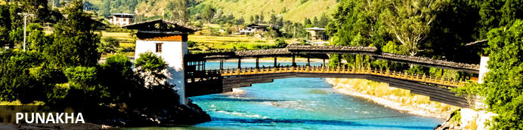
Located in the Himalayas of Bhutan, the Punakha rests at the confluence of the Puna Tsang Chhu and Mo Chhu rivers. This ancient Bhutanese capital serves as an excellent base from which to explore the scenic temple-dotted Punakha Valley and beyond. The town’s star attraction is undoubtedly the incredibly picturesque riverside Punakha Dzong, a 17th-century fortress which plays host to the annual religious Punakha Festival featuring traditional dancing and music. Lucky birdwatchers can spot the critically endangered white-bellied herons. Visitors can enjoy epic views of the Himalayas from the renowned Dochula Pass, explore the Royal Botanical Park, and discover the picturesque mountain-top village of Talo. Other popular activities include: hiking through the valley, visiting the Chimi Lhakhang ‘fertility’ Temple, and the traditional architecture of Punakha Ritsha Village.

Day Itinerary
Breakfast at the hotel.

After breakfast, embark on a scenic drive to Punakha (approx. 3 hrs) via Dochu La Pass, situated at an altitude of 3,088m (10,130 ft). Dochula Pass offers breathtaking views adorned with chortens, a mani wall, and prayer flags. On clear days, you might catch sight of majestic peaks such as Masagang (7,158m), Tsendagang (6,960m), and Gangkar Puensum (7,570m), the highest peak in Bhutan.

At Dochula Pass, marvel at the Druk Wangyal Chortens, 108 stupas built by Ashi Dorji Wangmo Wangchuk, the Queen Mother. These chortens are arranged in three layers around the main stupa, symbolizing various spiritual concepts.

Visit the Druk Wangyal Lhakhang at Dochula Pass, a temple dedicated to His Majesty the fourth Druk Gyalpo, Jigme Singye Wangchuck. The temple’s architecture blends historical elements with mythological symbolism, reflecting the visionary leadership of Bhutan.

After experiencing nature’s splendour at Dochula pass, continue onto Punakha. Once the capital of Bhutan and the seat of government until 1955, Punakha still serves as the winter residence of the Je Khenpo, the chief abbot. Nestled in a temperate climate and blessed with natural drainage from the Pho Chhu (male) and Mo Chhu (female) rivers, the fertile Punakha valley yields abundant crops and fruits.
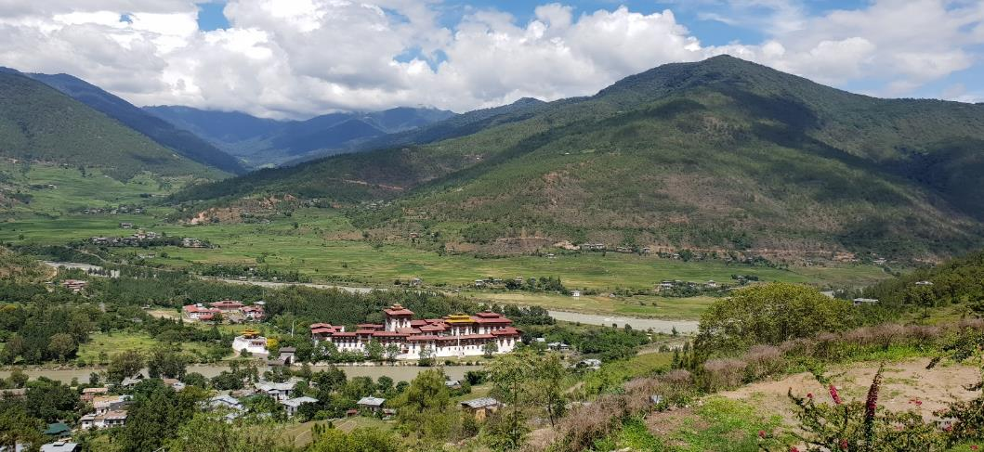

In the afternoon, explore Wangduephodrang Dzong, founded by Zhabdrung Ngawang Namgyal in 1638. Perched on a high ridge between the Punak Tsang Chhu and Dang Chhu rivers, this dzong commands panoramic views of the valley below. Historically significant, it was strategically located to safeguard routes to Trongsa, Punakha, Dagana, and Thimphu, solidifying its governor's position as one of Bhutan's most powerful leaders.

Continue your journey to Punakha Dzong, also known as the Palace of Great Happiness, built in 1637 by Zhabdrung Ngawang Namgyal at the confluence of the Phochu and Mochu rivers. This magnificent dzong served as both a religious and administrative centre in Bhutanese history. Its impressive dimensions and intricate architecture, including a six-story gold-domed tower, reflect the deep spiritual and cultural traditions of Bhutan.

Overnight: Six Senses Punakha
This beautiful lodge has a rustic feel and is blessed with a warmer climate. Six Senses Punakha offers a choice of suites and villas, pool, library, yoga and meditation huts, and serves as an excellent base from which to visit the majestic Punakha Dzong. This spectacular lodge takes on a more rustic rural feel complementing the warmer climate of its surroundings and offers sweeping views of the valley filled with rice paddy fields and dotted with traditional farmhouses. Guests can start the day with breakfast on the terrace overlooking the rice paddies as the mist clears through the valley, order a poolside barbecue for lunch and sample traditional Bhutanese dishes with a Western twist at Ari for dinner.
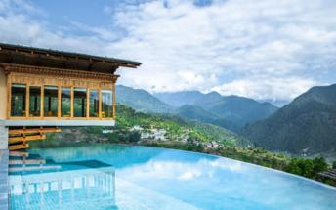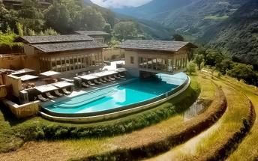

Day 4: In Punakha

Day Itinerary
Breakfast at the hotel.

After breakfast, embark on a short and easy walking excursion to Chimi Lhakhang.

The Chimi Lhakhang, situated on a hillock in the centre of the valley, also known as the temple of fertility. It is widely believed that couples who do not have children and wanting one, if they pray at this temple, they are usually blessed with a child very soon. The trail leads across rice fields to the tiny settlement of Pana, meaning ‘field’. A walk through the village near the temple will give you rare glimpses into the daily life and lifestyle of the villagers

Afternoon excursion to Talo village. The village of Talo (altitue 2,800m) which is scattered along the hill slopes, known for its cleanliness and hygiene among Punakha villages. Talo Sangnacholing is built on a plateau and has majestic view of surrounding villages. The beautiful farmhouses of the village have its own flower gardens, and, on the hill, slope corns and sweet peas are grown in abundance. Take a stroll in this lovely village.

While return to town, on the way visit Sangchhen Dorji Lhuendrup Lhakhang Nunnery. Perched on a ridge amid pine trees and overlooking valleys of Punakha and Wangdue gleams Sangchhen Dorji Lhuendrup temple. It houses a 14-foot main bronze statue of Avalokiteshvara and of Guru Padsambhava, Gautam Buddha, Zhabdrung Ngawang Namgyal, Tsela Namsum, the 21 Taras and Tsepamay (Buddha of longevity). The temple complex also houses a permanent higher learning and meditation centre for nuns where, apart from religious training, it provides life skill training such as tailoring, embroidery, statue making and thangkha painting.

Overnight at the hotel

Day 5: Punakha - Paro

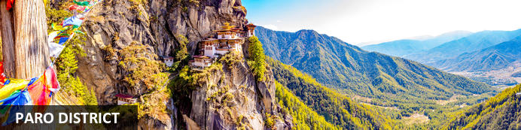
Sitting pretty at an altitude of 2200 metres above sea level, Paro is the gateway to beautiful Bhutan. Planes make an incongruous sight, flying low as they prepare for landing in this Himalayan oasis, home to many of Bhutan's oldest temples and monasteries. Resting on the banks of the Paro River, there is plenty to observe in this traditional town, from quaint farmhouses scattered across the valley to emerald green terraced paddy fields . For outdoor enthusiasts and adventure seekers alike, a great day excursion is to trek to the famous Tiger's Nest Temple, on the face of a sheer 1000-metre-high cliff. This acclaimed temple houses the National Museum, which shows hundreds of ancient Bhutanese artefacts and artwork. It's advised to do this at the end of a trip, once travellers have acclimatised.

Day Itinerary
Breakfast at the hotel.

After breakfast, drive back to Paro descending back down from Dochu La (approx. 4.5 hs).

Follow the way back up the dramatic Wang Chhu and Paro Chhu river valleys to Paro town.

The beautiful valley of Paro encapsulates within itself a rich culture, scenic beauty and hundreds of myths and legends. It is home to many of Bhutan’s oldest temples and monasteries, National Museum and country’s only international airport. Mount. Chomolhari (7,314m) reigns in white glory at the northern end of the valley and its glacial water plunge through deep gorges to form Pa Chhu (Paro River). Paro is also one of the most fertile valleys in the Kingdom producing a bulk of the locally famous red rice from its terraced fields.

Later in the day proceed to visit Ta Dzong, originally built as Watchtower, which now houses National Museum. The extensive collection includes antique thangkha paintings, textiles, weapons & armour, household objects and a rich assortment of natural and historic artifacts.

Then walk down the trail to visit Rinpung Dzong, meaning (“fortress of the heap of jewels”), which has a long and fascinating history. Along the wooden galleries lining the inner courtyard are fine wall paintings illustrating Buddhist lore such as four friends, the old man of long life, the wheel of life, scenes from the life of Milarepa, Mount. Sumeru and other cosmic Mandala.

Rest of the day at leisure.

Overnight: Six Senses Paro
Designed to maximize what is surely one of the most scenic settings within the Six Senses Bhutan journey, Six Senses Paro is known as Stone Ruins – and guests will understand why when dining among them. The generous suites are designed with large windows and awe-inspiring valley views in mind. Neutral, relaxing tones are complemented by the simple lines of natural timber furniture and the presence of local touches such as Bukhari's (traditional wood-burning stoves) and vegetable-dyed, antique-washed Himalayan rugs. Eat With Six Senses is the guiding philosophy for tasty and wholesome dishes created from organic local produce. Guests can head back in time for a feudal dinner set among 12th-century ruins or visit a local farmhouse for a truly authentic Bhutanese dining experience.
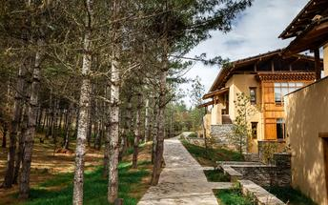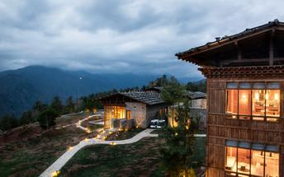

Day 6: In Paro

Day Itinerary
After breakfast, excursion to Taktshang Monastery (approx. 5 hours round trip walk). It is one of the most famous of Bhutan’s monasteries, perched on the side of a cliff 900m above the Paro valley floor. As per local legends Guru Rinpoche arrived here on the back of a tigress and meditated at this monastery and hence it is called ‘Tiger’s Nest’. This site has been recognized as a most sacred place and visited by Zhabdrung Ngawang Namgyal in 1646 and now visited by all Bhutanese at least once in their lifetime.

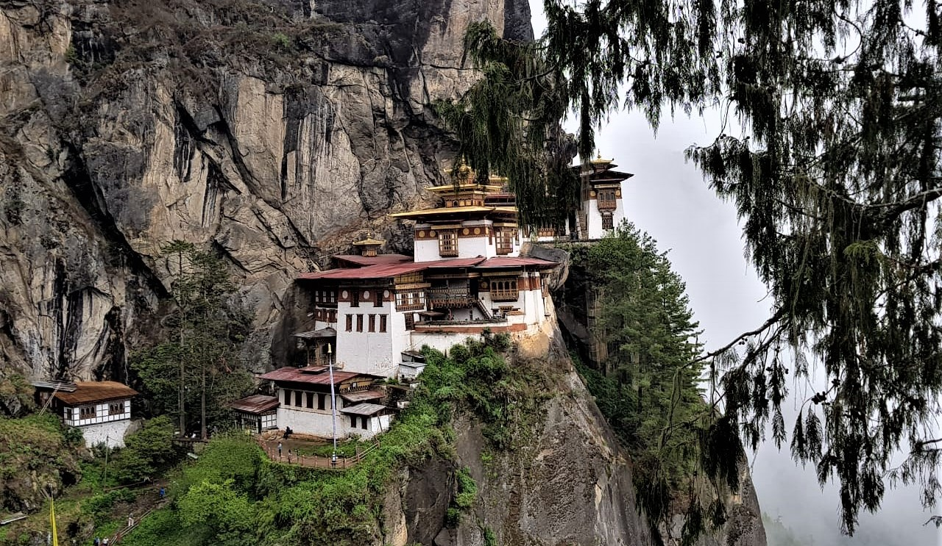

Evening at leisure in Paro city centre, exploring charming, petite shops selling wide range of handicrafts and local farm products.

Overnight at the hotel

Day 7: Depart Paro

Day Itinerary
In time, you will be driven to the airport for flight to onward destination.

Flight TBA
Departs Paro TBA hrs

**End of services**

