

TOUR IN SRI LANKA
Kotugoda - Sigiriya - Kandy - Ella - Yala - Weligama
13 Days / 12 Nights

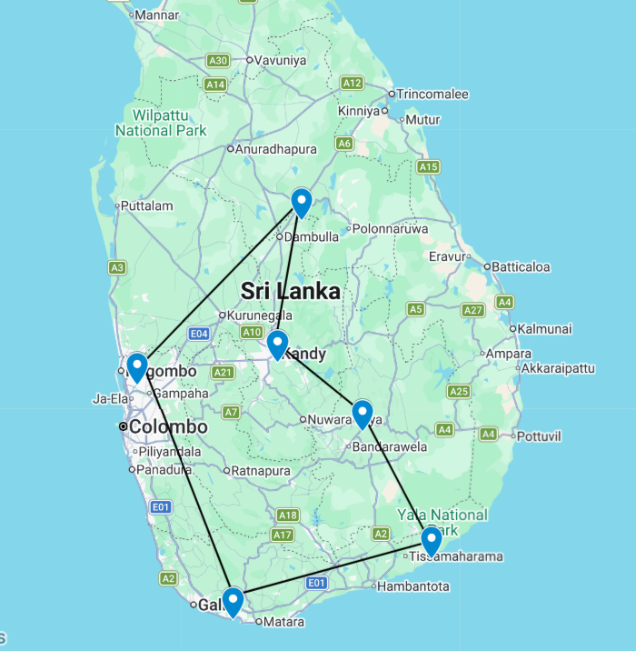

Day 1: Arrive Colombo - Kotugoda

Located in southwestern Sri Lanka just 20 minute drive from Colombo airport, Kotugoda is a charming town surrounded by coconut plantations, rice paddies, and tea fields. The sleepy village makes a perfect laid-back base for trips to the stunning Negombo Lagoon, pristine beaches, wonderful fish markets, and enthralling sacred temples, cultural sites, and museums. Sample local Sri Lankan cuisine such as seeni sambal and chicken curry, enjoy a spot of high-tea overlooking the valleys, walk among the breathtaking Wallawwa formal gardens, or indulge in a massage at one of the local luxury spas. Other popular activities include bird watching, fishing, guided nature as well as city tours of Colombo in the south and Negombo in the north.

Day Itinerary
Flight TBA
Arrive Colombo TBA Hrs

Our chauffeur guide & your travel companion during your tour in Sri Lanka will meet you at the airport and you will be transferred to Kotugoda. (Private Transfer – approximate driving duration 25–30 minutes)
Upon arrival, check-in at the hotel. [Standard check-in time is 1400 hrs]
Rest of the day at leisure.

Overnight: Wallawwa
Ease into or out of your Sri Lankan holiday in style. Nestled within seven acres of tropical gardens just 20 minutes from the international airport, our intimate 18-room boutique hotel offers the perfect space to relax and recharge. Unwind by the jungle-fringed swimming pool, enjoy long, leisurely meals in the alfresco restaurant, and indulge in a rejuvenating massage at our heavenly spa - long-haul flights and jet lag will be a distant memory.
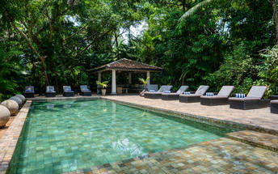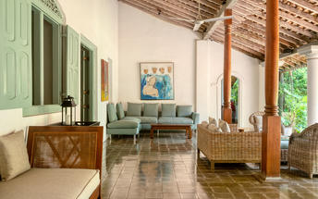

Day 2: Kotugoda - Sigiriya

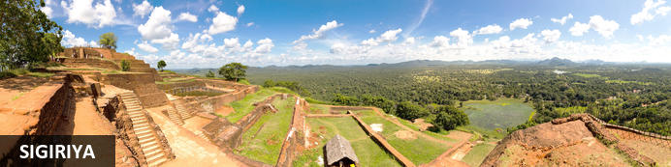
Situated in the northern Matale District of Sri Lanka, the small village of Sigiriya is best known for its proximity to the magnificent Sigiriya ‘Lion Rock’. The village offers some comfortable accommodations and a variety of restaurants for visitors to enjoy when stopping over to view the famous rock. This ancient rock fortress rises abruptly from the lush landscape and reaches over 200 metres in height. Crowning this massive outcrop are the ruins of an ancient civilisation, which are considered one of the best-preserved examples of ancient urban planning and have been listed as a UNESCO World Heritage Site. Visitors can walk through the lily-dotted moats, lush gardens and cave shrines, through the grand lion-paw entrance, and climb the series of steep staircases passing beautiful murals painted on the sheer rock walls, and enjoy exploring the ruins and soaking up spectacular views of the surrounds.

Day Itinerary
After breakfast, head to Sigiriya. Drive Approximately: 3 Hours (145 KMS).
On arrival, commence Hiriwadunna village experience and explore Sri Lanka’s countryside with a visit to Hiriwadunna, combining village life and a traditional cooking class.
Head into the countryside to experience a traditional Sri Lankan village. Walk through the peaceful village where your guide will talk to you about the daily lives of the local people. After a short walk, start your adventure with a scenic tractor ride through the countryside, enjoying the ride like a local farmer as you take in the sights of lush fields and rural landscapes. Then, you will stop at a village house to enjoy a traditional cooking session. Sri Lankan traditional cooking techniques take their best form in the villages. The cuisine relies heavily on the core ingredients of coconut, vegetables, rice, fresh chillis, spices, and curry leaves, all of which grow in abundance on several parts of the island. Spend the morning, learning how to cook a traditional Sri Lankan meal and enjoy lunch.
You can also try your hand at traditional pottery-making with a local artisan, a hands-on experience that offers a glimpse into age-old village crafts. Afterwards, meet one of the local villagers and continue along a scenic trail past crop fields and enjoy a peaceful boat ride in an ancient reservoir, where you can spot many birds, butterflies, and perhaps other wildlife.
On completion, head back to your accommodation.
Upon arrival, check-in and relax.

Overnight: Water Garden Sigiriya
Water Garden Sigiriya is where luxury meets nature, surrounded by lakes & water streams. This breathtakingly beautiful resort boasts a modern-day water harvesting design revisiting the 2,000-year-old water garden on Sigiriya Rock fortress. The villas are set amongst an expansive property and feature a bathtub, bathrobes, and slippers. Flanked by winding tributaries and veiled by the abundant flora, the 30 immaculately appointed villas combine chic, spacious interiors, secret gardens, and exclusive private plunge pools. The on-site restaurant serves an exciting new twist on traditional local fare in the dining room and outdoors. A swimming pool and spa are offered at the resort, complimenting the relaxing environment.
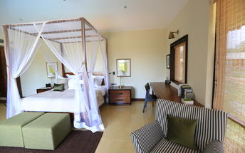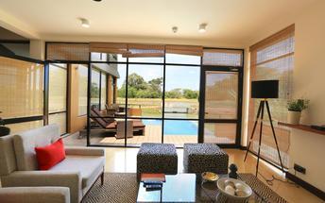

Day 3: Sigiriya

Day Itinerary
After breakfast, climb Sigiriya Rock.
This UNESCO World Heritage Site is one of Sri Lanka’s major attractions. A spectacular pillar of rock visible from miles around, geologically Sigiriya is a hardened magma plug of an extinct volcano. Historically, the origins of the remains are disputed and thought to have been either a royal fortress built under the reign of King Kashyapa (477 - 495 AD) or a Buddhist monastery.
The climb up the rock and back down will take from 1.5 hours to 3 hours. (Depending on your fitness, age and the crowds.) There are some 1,200 steps to the top of the rock, where you will be rewarded with panoramic views and most certainly, a sense of accomplishment for completing the climb.
You will pass beautiful frescoes and a sheer ‘mirror wall’ before arriving at the massive stone lion’s paws, which lend the rock its nickname ‘Lion Rock’. The old stairway to the top led through the mouth of a crouching lion but today only the huge paws remain giving an indication of the massive proportions of the head. The summit, covering an area of 1.6 hectares, was originally completely covered by buildings, but only remains of the royal citadel can be seen today.
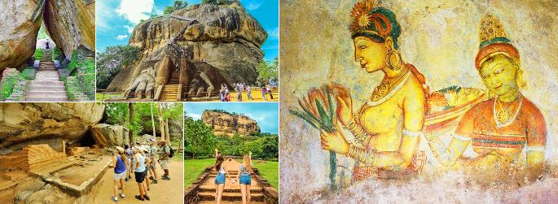
Afternoon commence a jeep safari in the Minneriya National Park by private jeep accompanied by a tracker.
Located between Sigiriya and Polonnaruwa the 8890 hectares of Minneriya National Park is an ideal eco-tourism location in Sri Lanka. The park consists of mixed evergreen forest and scrub areas.
However, the central feature of the park is the ancient man-made lake, Minneriya Tank -built in 3rd century AD by King Mahasena. During the dry season this tank is an incredible place to observe the elephants that come to bathe and graze on the grass as well as the huge flocks of birds (cormorants and painted storks to name but a few) that come to fish in the shallow waters.
Making your way through the park, you will see elephants, Spotted Deer and also the Sambar, which is a deer with no spots and an apt scientific name, carves unicolor.
Depending on the movement of the elephants you may visit the nearby Kaudulla National Park or Eco Park instead.
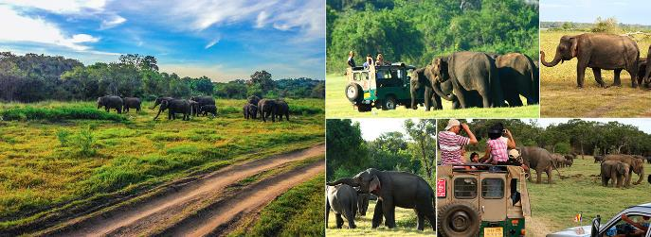
Once completed, return to the hotel.

Day 4: Sigiriya - Kandy

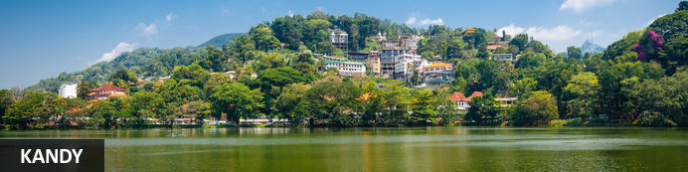
The second major city in Sri Lanka (the other being Colombo) lies at the centre of the Kandy Plateau, an area of beautiful tropical tea plantations. A magnificent must-see feature of the area is Kandy Lake, to the north of which lies the golden-roofed Temple of The Tooth (a UNESCO World Heritage Site and important place for Buddhist worship, as it is said to house a tooth relic of Buddha). Other fascinating places to visit include the Ceylon Tea Museum, the Buddhist Publication Society, the Ayurvedic centre in the Amaya Hills nearby, the Kandyan Art Association and Cultural Centre, where craftspeople can be seen at work, and the Kandy Muslim Hotel, which offers the finest spiced curries served with naan or Rotis.

Day Itinerary
After breakfast, head to Kandy. Drive Approximately: 3½ Hours (100 KMS). Enroute, visit Dambulla Cave Temple and Matale Spice Garden.
Dambulla Golden Rock Cave temple which has been declared a UNESCO World Heritage Site. The hike up to the caves is short but steep. At the top you can explore the caves and enjoy spectacular far-reaching views over the surrounding countryside.
Dambulla is the largest and best-preserved cave temple complex in Sri Lanka. The rock towers 160 m over the surrounding plains. There are more than 80 documented caves in the surrounding area. Major attractions are spread over five caves, which contain statues and paintings. These paintings and statues are related to Gautama Buddha and his life. There are a total of 153 Buddha statues, three statues of Sri Lankan kings and four statues of gods and goddesses. The latter include Vishnu and the Ganesha. The murals cover an area of 2,100 square metres (23,000 sq ft). Depictions on the walls of the caves include the temptation by the demon Mara, and Buddha's first sermon. Prehistoric Sri Lankans would have lived in these cave complexes before the arrival of Buddhism in Sri Lanka as there are burial sites with human skeletons about 2700 years old in this area, at Ibbankatuwa near the Dambulla cave complexes.
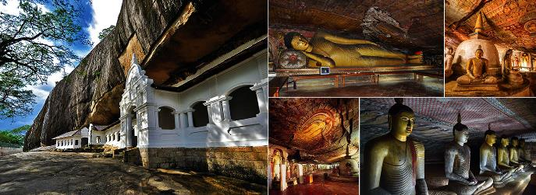
Matale Spice Garden - Explore the world of spices that shape Sri Lanka’s culinary and cultural heritage. Unlike herbs, which come from the leaves, flowers, or stems of plants, spices are often derived from roots, bark, seeds, and other parts, and are valued not only for flavoring food but also for their use in traditional medicine, religious rituals, cosmetics, and perfumes.

Stroll through the lush green garden to see how spices and herbs are cultivated in their natural environment. Learn how cinnamon, cardamom, cloves, nutmeg, and other spices are grown and discover their role in creating the vibrant flavors of traditional Sri Lankan dishes, renowned for their taste and nutritional value.

(Spice gardens can be a fascinating stop to learn about local ingredients and Ayurveda. However, please be aware that these visits sometimes include high-pressure sales pitches, and prices may be significantly marked up. Feel free to enjoy the educational experience without feeling obliged to make purchases—you can always buy quality spices at supermarkets or local markets along your journey.)

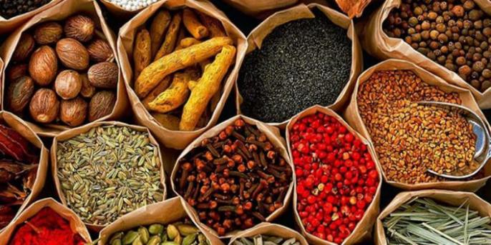

Upon arrival in Kandy, check-in at the hotel.
Rest of the day at leisure.

Overnight: W15 Hanthana Estate
W15 Hanthana Estate is centrally located in Sri Lanka, southwest of the island’s cultural capital, Kandy, near the Nuwara Eliya Golf Club and the Peradeniya Royal Botanical Garden. Accommodation is comprised of exquisitely appointed rooms with private gardens, air conditioning, minibars, tea/coffee-making facilities, flat-screen TVs, and safes. Guests can enjoy delicious meals on-site. Facilities and services include a library, a piano room, a tennis court, a swimming pool, deckchairs, and Wi-Fi.
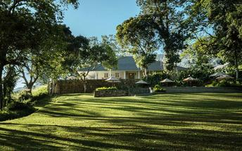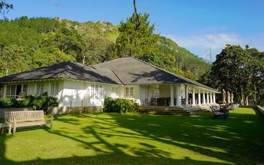

Day 5: Kandy

Day Itinerary
After breakfast, commence the city tour of Kandy.
Discover the city of Kandy, renowned for its scenic beauty and cultural heritage. Begin with a leisurely walk along the scenic Kandy Lake, built in 1807, which forms an attractive centerpiece for the town. Continue into the city center, wandering through bustling shopping streets and visiting key sights such as the central market, a local church, the Garrison Cemetery, the clock tower, and the historic railway station.

You may also wish to visit a gem museum, a traditional hand-carved woodcraft workshop, or a batik studio to observe local artisans at work.

Also visit the Sacred Temple of the Tooth, locally known as Sri Dalada Maligawa, considered the most sacred temple in all of Sri Lanka. This magnificent shrine is a deeply significant monument for both the Sinhalese Buddhist community and Buddhists worldwide, as it houses the sacred Tooth Relic of the Buddha (Danta Dhatu), an object of profound religious veneration.

The temple complex is adorned with intricate carvings and exquisite Sri Lankan art. During the daily puja ceremonies, throngs of pilgrims visit to glimpse the golden casket said to hold the relic and to make offerings of flowers, creating a deeply spiritual and atmospheric experience.

(Please note: The Temple of the Tooth can become very crowded during puja times, particularly on Poya (full moon) days and during the Esala Perahera festival in July–August. Guests preferring a quieter experience may wish to visit outside these peak times.)

(Please dress modestly when visiting the Temple of the Tooth Relic, ensuring shoulders and knees are covered.)

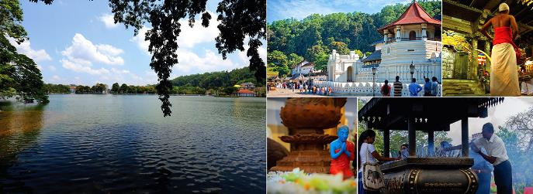
In the evening, enjoy the Kandyan Cultural Show at the Kandyan Arts & Cultural Centre. The performance features graceful dancers and rhythmic drummers, culminating in an
Head back to accommodation and relax.

Day 6: Kandy - Ella

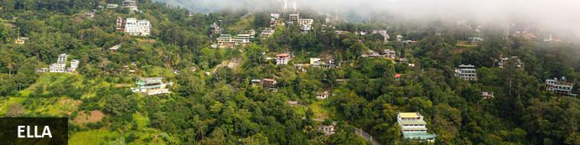
Resting on the southern edge of Sri Lanka’s picturesque Hill Country, the small, sleepy village of Ella is known for its exceptional natural scenery, its wonderfully tranquil atmosphere, and its pleasantly moderate climate. This popular backpacker-hub has become a well-established, must-see tourist destination and an ideal base for travellers exploring the idyllic surrounding countryside cloaked in tea plantations and lush forest. With only a handful of essential stores and tourist facilities, Ella has managed to retain its rural charm and visitors will find a single street winding its way down the hillside past a few quaint cafés, guesthouses and cottages enclosed in neat, flower-filled gardens. At the edge of the escarpment, you will find a classic view past the renowned Ella Rock on the right and through a cleft in the hills – the so-called Ella Gap – to the plains far below.

Day Itinerary
After breakfast, proceed from Kandy to Nuwara Eliya. Drive Approximately: 2½ Hours (80KM) On Arrival, head to Nanu Oya Railway Station where you will board the train to Ella - a journey often described as one of the most scenic train rides in the world.
This picturesque route takes approximately 2 to 3 hours, winding through misty mountains, emerald-green tea plantations, cascading waterfalls, and deep valleys.
Upon arrival at Ella Station, meet your driver and transfer to your hotel in Ella. Check in and relax for the rest of the day.
(Note: Reserved seating tickets for the train journey are limited, in high demand, and released only 30 days before travel. We will make every effort to secure your tickets as soon as they become available. While it’s rare for tickets to be completely unavailable, as availability is beyond our control, we kindly ask for your understanding if tickets cannot be obtained.
Should this happen, we will explore alternative train journeys for you on a different sector if possible, or your chauffeur and vehicle will continue the journey with you to your next destination by road. Either way, you can be assured of a scenic and memorable journey through Sri Lanka’s beautiful hill country.)
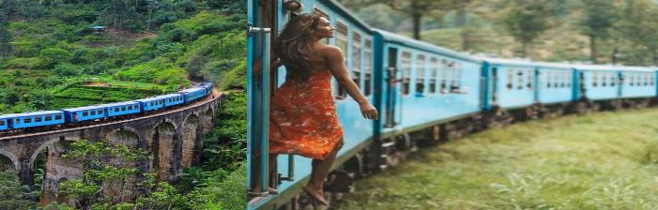

Overnight: Nine Skies
Promising far-reaching hill country views, our stylishly refurbished five-bedroom tea bungalow hotel is majestically perched on a tea-fringed hill near Ella. Dating back to the colonial era, the bungalow epitomises its legacy yet indulges discerning guests with contemporary facilities and high-end personalised service – be pampered by our butlers, feast on gourmet food and dip into a garden pool with stunning views across the valley and famous Demodera Loop.
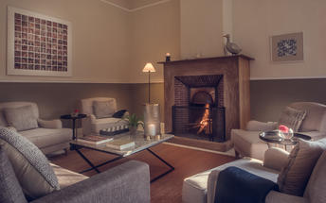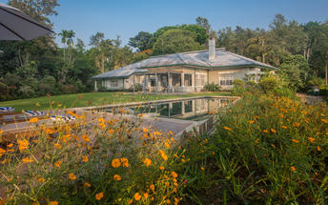

Day 7: Ella

Day Itinerary
Early in the morning hike up to the mountain of Little Adams Peak, it is an ideal place to watch sun rise.
With prodigious views of as far as Ella rock and down to the gap will be gorgeous. Little Adam’s peak this is Ella’s best-known tourist attraction, aptly named since it has a similar shape to Adam’s Peak, which is Sri Lanka’s holy mountain. Little Adam’s Peak is a much shorter and easier climb though – it takes half an hour to climb to the top of the 1141-meter peak. The walk is enjoyable and clearly marked as you meander through tea plantations and take in breath taking views of Ella Rock.
Once completed, come back to the hotel for breakfast and rest.
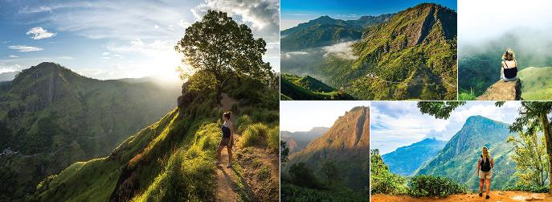
Afterwards head back to accommodation for breakfast. Head to Nine Arch Bridge afterwards.
Later visit the Nine Arch Bridge in Ella, also known as the ‘Bridge in the Sky’ was constructed by connecting two bog mountains when constructing the Badulla – Colombo railway. This bridge is 300 feet in length, 25 feet in width and 80-100 feet in height. It is one of the best examples of colonial-era railway construction in the country.
Commissioned under the British in the year 1921, the Nine Arch Bridge stands proudly, a testament to the engineering and architectural brilliance of the early 20th century. Ideally placed between the Ella and Demodara railway station, those choosing to walk along the bridge will be presented with scenes of rolling hills and dense jungle to delight in.
Once concluded, head back to your accommodation and relax.

Day 8: Ella - Yala

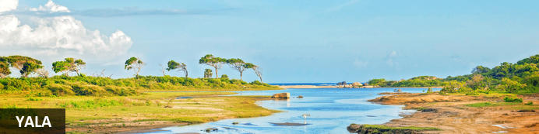
Yala, Sri Lanka, is a picturesque region located in the southeast corner of the island nation. This beautiful area boasts stunning landscapes, majestic wildlife, and extraordinary cultural attractions. One of the must-visit destinations in Yala is Buduruwagala, a fascinating complex of ancient Buddhist rock carvings that date back to the 8th century. Visitors can marvel at the intricate details and impressive size of the sculptures, which include a towering 51-foot-high image of the Buddha. For nature lovers, Yala National Park is the island's undisputed centrepiece, with a leopard density that's reportedly higher than anywhere else on this planet and a varied landscape from dense forests to moist wetlands. For the spiritually inclined, Kebiliththa in Block 4 of the Yala National Park is a place considered highly sacred by Buddhists and Hindus alike, who flock here to meditate.

Day Itinerary
After breakfast, proceed to Yala. Drive Approximately: 3½ Hours (120 KMS). Enroute, witness Ravana Falls – a picturesque waterfall set against forested mountains, linked to the Ramayana epic as the place where Sita is said to have bathed during her captivity.
Upon arrival in Yala, transfer to your accommodation.
Check-in and relax.

Overnight: Uga Chena Huts
Set amongst the golden dunes and the lush greenery in Yala Sri Lanka, Uga Chena Huts blends Sri Lanka’s most celebrated features – its tropical beaches and exotic wildlife. The accommodation offers easy access to the Yala National Park. All cabins are luxuriously designed and feature TVs, minibars, and tea/coffee-making facilities. Select cabins feature private swimming pools. Other amenities include an on-site restaurant and a spa.
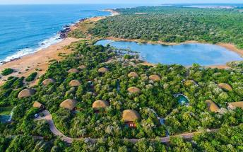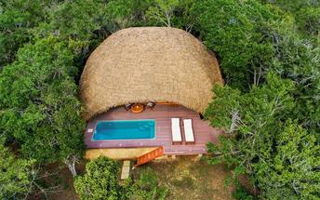

Day 9: Yala

Day Itinerary
Enjoy morning and afternoon jeep safari at Yala National Park by a private jeep.
Yala National Park is the most visited and second largest national park in Sri Lanka, bordering the Indian Ocean. It is situated in the southeast region of the country, and lies in Southern Province and Uva Province. Yala was designated as a wildlife sanctuary in 1900 and The Park is best known for its variety of wild animals. It is important for the conservation of Sri Lankan elephants, Sri Lankan leopards and aquatic birds.
There are six national parks and three wildlife sanctuaries in the vicinity of Yala. Yala hosts a variety of ecosystems ranging from moist monsoon forests to freshwater and marine wetlands. It is one of the 70 Important Bird Areas (IBAs) in Sri Lanka. Yala harbour 215 bird species including six endemic species of Sri Lanka. The number of mammals that has been recorded from the park is 44, and it has one of the highest leopard densities in the world.
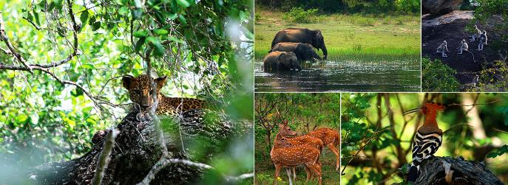
Once completed head back to accommodation and relax.

Day 10: Yala - Weligama

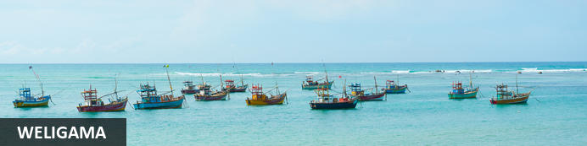
Weligama is a serene and unspoilt seaside town, with a lovely beach that stretches around a wide, half-moon-shaped bay. It’s an interesting blend of an authentic fishing village and an upscale resort town - with a dusting of five-star accommodation complemented by a traditional coastal culture. It’s located just a 40-minute drive from the cosmopolitan city of Galle - one of southern Sri Lanka’s premier tourist destinations - and offers both a tranquil diversion from the city’s pulsating pace and smorgasboard of activities. If it’s rest and relaxation you’re after, you need look no further than Weligama’s pristine shores. Don’t forget to pick up some of the handcrafted lace for which the town is renowned.

Day Itinerary
After breakfast, proceed to Weligama. Drive Approximately: 3 Hours (150 KMS).
Upon arrival in Weligama, transfer to your accommodation.
Check-in and relax.

Overnight: Cape Weligama
Cape Weligama is a luxury clifftop resort located along the south coast of Sri Lanka. The resort features suites and villas with conveniences such as verandah's, minibars, tea/coffee-making facilities, TVs with international channels, free Wi-Fi, air conditioning, telephones and safes. Guests can enjoy gourmet dining experiences at a choice of three on-site dining options. Additional resort amenities include swimming pools and a fitness centre.
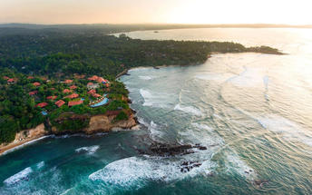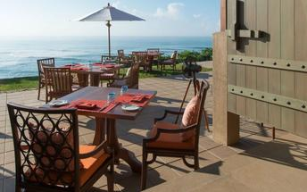

Day 11: Weligama

Day Itinerary
After breakfast, proceed to Galle. Drive Approximately: 1 Hours (25KM).
Upon arrival, explore Galle Fort City, southern province with a colorful history. Galle Fort offers the best-preserved example of a European built fortified city in Asia. It was built by the Dutch from the 17th Century and is now a UNESCO World Heritage Site.
Walk along the ramparts, pass the lighthouse and the old Portuguese harbour and stop to see some of the many colonial era buildings, including the Dutch Reformed Church, the Anglican All Saints Church and the former house of the Dutch governor, built in 1684 and now the luxurious Amangalla hotel.
Stroll the winding streets of this immensely charming town and discover its decaying colonial buildings, grand fort walls and numerous boutiques and cafés. Stretching along the coast nearby are ruggedly beautiful beaches, which may be narrow but are peaceful and secluded.
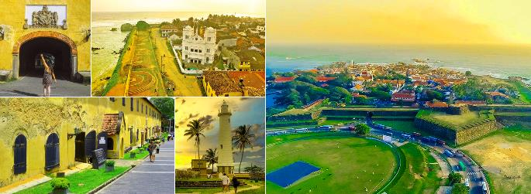
On completion, head back to your accommodation and relax.

Day 12: Weligama

Day Itinerary
Enjoy this day at leisure. (No vehicle/driver will be provided on this day)

Day 13: Weligama - Colombo Depart

Day Itinerary
After breakfast, you will be picked up from the hotel in Weligama & transfer to Bandaranaike International Airport in time for the departure flight. Drive Approximately: 2½ Hours (170KM).
Flight TBA
Depart Colombo TBA Hrs

**** END OF SERVICES ****

NOTE: Driving times mentioned are an approximate measure of the time taken to travel between destinations. Please note that these times are subject to change depending on road traffic on the particular day, weather conditions as well as conditions of the particular road, all of which are beyond our control.

TRAVEL TIPS & ARRIVAL FORMALITIES
Travel Tips
- Sri Lanka being a tropical county, ideal clothing would be cotton and comfortable clothing. Shorts and T shirts are ideal other than when visiting the temples. Ladies are required to cover the shoulders as well.
- Temperature throughout the year in lowland areas ranges between 25 to 35 C and in hill country between 20 to 25 C during day time. During the nights it can drop a little below 15 C in certain months of the year.
- Liquor will NOT be served on Poya days (Full Moon) and on any other religious holidays. These are considered dry days. There is a Poya day for each calendar month.
- All major credit cards will be widely accepted in all reputable outlets (restaurants/shops etc.)
- Tipping is customary, but not obligatory. But if you are keen to know what is acceptable in local terms, it ranges between US$ 15/- per day up to US$.40/- per day depending on the level of satisfaction of your driver when it comes to individual / family travel. For group travel other than the guide, the coach crew is to be tipped too. The amount for a day can vary depending on group size, but the recommended amount is US$.20/- to 50/- per day.
ARRIVAL FORMALITIES
- On Arrival at the Airport, you will first reach Immigration, then to collect your ‘checked-in’ baggage. Once you clear customs, our representative will page you and meet you just outside the arrival hall. In an unlikely event if you are unable to locate him, kindly get in touch with us on the emergency number provided to you on your service voucher.

